Predicting Loan Default Risk with Machine Learning: Balancing Accuracy and Interpretability in Financial Decision-Making

Table of Contents
Abstract 3
1. Introduction 4
1.1 Problem Significance 4
1.2 Suitability of Machine Learning 4
1.3 Dataset Overview 4
1.4 Real-World Relevance 5
1.5 Scope of the Project 5
1.6 Aim and Objectives 5
2. Related Works 6
2.1 Naïve Bayes (NB) for Loan Default Prediction 6
2.2 Decision Trees (DT) for Interpretability 7
2.3 Random Forest (RF) in Credit Scoring 7
2.4 Logistic Regression (LR) as Benchmark 8
2.5 Support Vector Machines (SVM) for Nonlinear Separation 8
2.6 Artificial Neural Networks (ANN/MLP) 9
2.7 Boosting Models: AdaBoost and XGBoost 9
2.8 Critical Synthesis 10
3. Methods 13
3.1 Data Description 13
3.2 Data Preprocessing 13
3.3 Experimental Setup 14
3.4 Hyperparameter Tuning 15
3.5 Evaluation Metrics 15
4. Dataset Preparation 16
4.1 Data Cleaning and Missing Values 16
4.2 Exploratory Data Analysis 17
4.3 Feature Formatting and Encoding 18
4.4 Class Imbalance Handling 19
4.5 Feature Importance Analysis 20
5. Model Implementation 21
6. Model Validation 23
6.1 Data-integrity and leakage checks (structural tests) 23
6.2 Shuffled-target and shallow-tree diagnostics 24
6.3 Comparative validation and learning curves 25
6.4 Impact of resampling strategy (SMOTE vs NearMiss) 25
6.5 Permutation importance and perfect-predictor search 25
6.6 Net interpretation and model selection 25
7. Analysis and Recommendations 26
7.1 Summary of findings 26
7.2 Critical analysis 27
7.3 Comparison with related work 27
7.4 Recommendations. 28
8. Conclusion 29
References 30

Table of Figures
Figure 1: Missing Values 22
Figure 2: Distribution of default variable 23
Figure 3: Correlation heatmap 23
Figure 4: SMOTE Class balancing 25
Figure 5: Feature importance 25
Figure 6: Decision Tree 28
Figure 7: ROC Curves 32

List of Table
Table 1: Summary of Related Works 14
Table 2: Shuffled targets and Cross validation score 31
Table 3: Classification Performance Metrics 34

Acknowledgement

I would like to express my sincere gratitude to my lecturer and course coordinator for their continuous guidance, constructive feedback, and encouragement throughout this project. Their support has been invaluable in shaping the direction of the study and ensuring its successful completion. I am also grateful to the Kaggle community for providing access to the Loan Default Dataset, which served as the foundation of this analysis. The availability of such open-source data was essential to carrying out the research and experimentation. Additionally, I acknowledge the use of Python libraries such as scikit-learn, TensorFlow, XGBoost, and imbalanced-learn, which provided the computational framework for model building and evaluation. The learning resources and documentation from these tools significantly contributed to the implementation process. Finally, I would like to thank my peers and colleagues who shared valuable discussions and suggestions during the project, which helped refine my analysis and understanding.

Abstract
Default prediction of loans is an important issue of financial risk management with significant implications for lending institution stability and profitability. Traditional credit scoring models tend to be unsatisfactory in the modeling of nonlinear relationships between borrower characteristics and payment behavior, prompting explorations of machine learning (ML) methods. In this study, supervised ML techniques are applied on an actual loan dataset from Kaggle comprising 49,999 records and both financial and demographic features. There was a lot of preprocessing that included imputation of missing values, encoding the categorical features, feature scaling, and class balancing using SMOTE and NearMiss. Eight models were used, Naïve Bayes, Logistic Regression, Decision Tree, Random Forest, Support Vector Machine, Artificial Neural Network, AdaBoost, and XGBoost, with hyperparameter tuning to achieve maximum performance. Result demonstrated near-perfect prediction accuracy for all the ensemble methods and ANN (≈1.0), with simpler models such as Naïve Bayes and Logistic Regression yielding competitive but lower results. Alternative validation procedures, including shuffled-target baselines, leakage detection, and cross-validation, reinforced the robustness of conclusions and reduced the likelihood of spurious overfitting. The argument centers around the interpretability-predictive power trade-off, where Decision Trees provide exact-cut decision rules and ensemble/ANN models provide good raw predictive performance. Overall, the paper indicates that existing ML holds much promise to improve credit risk prediction, but next research needs to be aimed at explainability and out-of-sample validation so that realistic application in supervised banking environments is possible.

1. Introduction
Loan default is an extremely serious issue for banks since it will have a direct impact on profitability, liquidity, and long-run viability. Default occurs when a borrower fails to make contractual repayment conditions, typically due to low income, poor money management, or adverse macroeconomic shocks. Its consequences are widespread: lenders face non-performing loans and high capital adequacy ratios, while borrowers feel decreased creditworthiness and decreased available future finance. At a system level, large-scale default has the potential to destabilize financial systems as a whole, one example is the 2008 global financial crisis, where bad credit risk measurement caused worldwide economic breakdown (Acharya and Richardson, 2009).

1.1 Problem Significance
Accurate prediction of loan default risk is a valuable pillar of modern credit risk management. While conventional credit risk models logistic regression, are invaluable in terms of explainability and regulatory favor, are generally disappointing at modeling multifaceted, nonlinear relationships between borrower attributes. In light of the expansion of online lending platforms and easily accessed granular financial data, ML offers an attractive alternative. ML methods can identify hidden patterns in borrower behavior, respond to changing market environments, and improve forecast accuracy over conventional methods (Lessmann et al., 2015).

1.2 Suitability of Machine Learning
Financial applications typically contain large amounts of heterogeneous data, which is well-suited to machine learning models. Decision Trees are rule-based understandable, Artificial Neural Networks (ANNs) are trained on nonlinear dynamics, and ensemble methods such as Random Forest, AdaBoost, and XGBoost raise robustness by model combination. Support Vector Machines (SVMs) are competent in high-dimensional space, and Naïve Bayes offers a simple probabilistic baseline. Side-by-side benchmarking of these models enables an intuitive notion of the accuracy, interpretability, and computability trade-offs.

1.3 Dataset Overview
This study done using a real-loan application dataset of 49,999 borrower-level instances with 50 features. They are numerical features (e.g., loan size, income, interest rate, credit score) and categorical features (e.g., type of loan, region, age bucket). The target feature, Status, is if the loan was repaid or defaulted. The preprocessing challenges are missing values, class imbalance, and high-cardinality categorical features. For all of these, the pipeline employs imputation, one-hot encoding, normalization, and Synthetic Minority Over-sampling Technique (SMOTE) for class balancing.

1.4 Real-World Relevance
Regulations such as Basel II and III require banks to apply advanced risk models so that they become capital-sufficient to handle credit risk. Risk-weighted asset calculations and capital requirements are based on Probability of Default (PD) estimates provided by forecasting models (BCBS, 2017). While baseline scorecards are the default option, they tend to downsize tail risks during economic downturn (Fuster et al., 2018). Machine Learning models offer adaptive and dynamic characteristics that complement early warning systems and enable stronger credit scoring. Regulators are given the benefit of interpretable models like Decision Trees, which offer transparency, while high-performance techniques like ANNs and ensembling techniques offer a strong predictive stability.

1.5 Scope of the Project
The project employs supervised machine learning techniques to predict the outcome of loan default. Eight models were employed: Naïve Bayes, Logistic Regression, Decision Tree, Random Forest, Support Vector Machine (SVM), Artificial Neural Network (ANN), AdaBoost, and XGBoost. These are probabilistic, statistical, tree-based, boosting, and deep learning. All of them have been experimented with a static pipeline with pre-processing of data, hyper-parameter tuning, and performance estimation on a held-out test set. Accuracy, precision, recall, F1-score, and ROC-AUC are all being used as the measures of evaluation.
The analysis assumptions are also listed to be addressed later. Only borrower-level structured data and supervised classification techniques are considered. Unsupervised algorithms (e.g., cluster, anomaly detection) and macroeconomic indicators (e.g., GDP, inflation) are excluded. The practical credit risk assessment can be interpreted using models and focus on robust build.

1.6 Aim and Objectives
Aim:
To compare, design, and critically compare a variety of machine learning models for loan default risk prediction with actual financial data, and define best practices to credit risk management.
Objectives:
- Preprocess the data by handling missing values, encoding categorical variables, normalizing numeric variables, and handling class imbalance.
- Train and compare eight ML models for loan default prediction.
- Provide recommendations to banks on model choice and deployment for fruitful credit risk assessment.
Report structured: Section 2 is literature review about ML usage in loan default prediction. Section 3 is dataset description and data preprocessing pipeline. Section 4 is model implementation and hyperparameter tuning. Section 5 is evaluation metric and finding. Section 6 is comparative study and practical importance. Section 7 is conclusion with recommendations and future directions.

2. Related Works
Default prediction of loans is one of the prominent areas of research in credit risk management due to its profitability and financial stability for the institutions. Developed as much as statistical methods, these have been prone to failing to well characterize the intricate and nonlinear borrower–loan relationships typical with contemporary lending. Researchers have thus increasingly been drawn to machine learning (ML) techniques, each with its own unique set of trade-offs between predictivity, explanatory power, and computational cost. This chapter outlines literature on Naïve Bayes, Decision Trees, Random Forest, Logistic Regression, Support Vector Machines, Artificial Neural Networks, and ensemble boosting techniques such as AdaBoost and XGBoost, and highlights the effect of preprocessing and class balancing on model performance.

2.1 Naïve Bayes (NB) for Loan Default Prediction
Naïve Bayes (NB) has been a regular baseline classifier for credit risk prediction because it is probabilistic, easy to implement, and computable. NB, following Bayes' theorem, calculates the default probability assuming the predictor variables are conditionally independent of the class label. No such setting exists in financial information, where borrower income, debt-to-income ratio, credit score, and loan size act upon one another. Nevertheless, NB has been thoroughly tested as the first baseline.
Krichene (2017) applied NB to a Tunisian commercial bank data set and attained 63.9% accuracy and AUC of 69%, stating that the method was good but limited by its independence assumption. Tabassum and Shylaja (2022) also compared NB with KNN and Logistic Regression for loan approval prediction and found NB to be computationally very efficient but incapable of handling nonlinear borrower–loan interactions. Kisutsa (2021) showed the sensitivity of NB to noisy or missing borrower data, and sharp declines in predictive performance in mobile lending applications.
The sensitivity of NB to data preprocessing has been reiterated time and again. Without adequate imputation of missing values and categorical encoding, NB incorrectly classifies borrowers. Further, dependence on observed frequencies renders it extremely sensitive to class imbalance, a situation most credit data sets are afflicted with due to defaults being relatively few. Some other research employing SMOTE using class balancing has noted substantial recall gains in the minority class but sometimes at the cost of precision. Subsequent work, such as the Bayesian inference method that Tham et al. (2023) developed, has sought to mitigate some of the NB limitations by lessening assumptions and emphasizing posterior distributions to reduce sensitivity with uncertainty of finance.
Overall, NB is best left to utility as a benchmark model. It provides fast, interpretable baseline performance but is reserved to practical utility to oversimplification and sensitivity to preprocessing.

2.2 Decision Trees (DT) for Interpretability
One of the most widely applied models for credit risk is Decision Trees (DT) because of their interpretability and transparency. By partitioning data recursively into similar clusters, DTs provide rule-based results which are very interpretable for regulators as well as analysts. The ability to handle mixed data types is appealing, though susceptibility to overfitting limits the reliability of their forecasts.
(Madaan et al., 2021) contrasted DTs with Random Forests to predict loan defaults and established that DTs, while less accurate, provided understandable decision rules suitable in a regulatory environment. (SharafEldin et al., 2023) utilized DTs to classify Agricultural Bank of Egypt borrowers with 88% accuracy and 89% specificity and established loan balance and payment history as top variables. (Semiu et al., 2019) demonstrated the ability of ensemble methods by reporting that Boosted DTs outperformed standalone DTs with 99% accuracy in U.S. small business loans.
DT performance is also highly dependent on data preparation. Without pruning or limitation, DTs overfit and learn training noise rather than generalize. Researchers usually combine DTs with feature selection techniques to enhance interpretability and reduce redundancy (SharafEldin et al., 2023). Class imbalance under SMOTE has also been shown to regularize prediction in an effort not to miss minority-class defaults.
Generally, DTs are a compromise model: extremely interpretable but weak in predictive ability. They are best employed where auditability and regulatory compliance are concerns of higher priority than sheer accuracy.

2.3 Random Forest (RF) in Credit Scoring
Random Forest (RF), an ensemble of several DTs built on bootstrapped sets and random feature subsets, overcomes the overfitting issues of single trees and is a accepted standard of credit risk studies. RF is said to be very robust, accurate, and able to process high-dimensional data but less interpretable than single DTs.
(Lessmann et al., 2015) compared 41 classifiers on credit scoring datasets, frequently grouping RF in the top-performing group by AUC. (Bastani et al., 2019) also uncovered RF's power in default forecasting in peer-to-peer lending, demonstrating its ability for borrower heterogeneity capture. (Zhang and Bellotti. 2020) also applied RF to Chinese credit datasets and found that it outperformed Logistic Regression and DTs, yet they also mentioned lower transparency as a disadvantage.
Preprocessing techniques enhance RF's performance, especially in case of class imbalance. Oversampling techniques such as SMOTE enhance RF's minority default recall, and feature scaling reduces with its tree-based nature. But the ensemble construction makes RF less interpretable, a problem still causing a regulatory issue.
Overall, RF is a good trade-off: more powerful and accurate than DTs, but less interpretable. It is applied extensively in operational risk systems where performance is the top priority.

2.4 Logistic Regression (LR) as Benchmark
Logistic Regression (LR) has traditionally been the credit risk modeler's industry standard due to its interpretability, simplicity, and regulatory acceptance. As a case in which the log-odds of default is specified as a linear function of borrower characteristics, LR provides coefficient-based clear-cut explanations of drivers of risk.
(Malekipirbazari and Aksakalli, 2015) compared LR with RF and Gradient Boosting on the peer-to-peer lending dataset and determined that LR was the poorest predictor among them. (Abdou et al., 2016) had contended LR's superiority over UK credit scoring on the basis of regulatory preference towards its transparency but faulted it for not addressing nonlinearities and interaction effects. (Kokkalakonda, 2025) demonstrated LR's persistence as a benchmark but depicted ML models ANN and RF surpassing it in every aspect, whose AUC values were more than 0.90 compared to the 0.75–0.80 range of LR.
LR is extremely data preprocessing sensitive. Scaling introduces stability, but multicollinearity among the predictors reduces interpretability. On imbalanced datasets, LR over specifies the majority class and requires rebalancing through methods like SMOTE or threshold adjusting.
LR is thus still a gold standard reference point, worth citing for regulation compliance and comparison, but generally outperformed on accuracy by modern ML.

2.5 Support Vector Machines (SVM) for Nonlinear Separation
Support Vector Machines (SVM) can best explain nonlinear borrower–loan relationships in high-dimensional space. Using kernel functions, SVMs build best-separating hyperplanes between default and non-default classes and are effective classifiers when feature interactivity is complicated.
(Bellotti and Crook, 2009) applied SVM to UK credit card data and reported that it outperformed Decision Trees and Logistic Regression based on misclassification accuracy. (Yu et al., 2017) applied kernel-tuned SVM for Chinese SME lending and reported it performed better than LR, especially with small sample sizes. SVMs are extremely computationally intensive, parameter-intensive, and not well scalable to very large loan data sets (Zhang and Hsu, 2019).
Optimization of SVM performance is extremely critical. SVM optimization is based on feature space distance and therefore feature scaling is most critical. Class imbalance must also be tackled in order to eliminate biased hyperplanes; research that combined SVM with SMOTE had the effect of balanced classification results.
SVM is thus utilized best where dataset size can be managed and nonlinear separability is an issue but computational capacity limits large-scale applications.

2.6 Artificial Neural Networks (ANN/MLP)
Artificial Neural Networks (ANNs) are recent leaders in credit risk due to their ability to represent nonlinear, high-dimensional borrower profiles. ANNs have several hidden layers that form complex relationships beyond the reach of linear models.
(Abidemi et al., 2023) constructed a PCA and SMOTE-preprocessed deep ANN with an AUC greater than 0.90 that surpassed conventional models.( Rajneesh, 2024) used TensorFlow-based ANN models with 82% accuracy if the imbalanced dataset was balanced. (Kokkalakonda, 2025) compared ANN, RF, and LR and observed that ANN had 91% accuracy and 0.93 AUC, and income, debt-to-income ratio, and credit history were the most important features.
ANNs are extremely preprocessing-intensive. Gradient descent convergence necessitates feature scaling, and heterogeneous borrower feature encoding is also necessary. Class balancing techniques such as SMOTE are necessary since ANNs overfit large non-default classes otherwise. Working so well as they do, their black-box nature creates problems in the regulated world, where model interpretability is a necessity.
ANNs thus work great in terms of predictive accuracy but leave behind explainability and auditability problems in financial use cases.

2.7 Boosting Models: AdaBoost and XGBoost
AdaBoost and XGBoost are the state-of-the-art boosting methods applied in structured financial data currently. Through sequential application of weak learners, these models reduce bias and variance to achieve high prediction ability.
AdaBoost repeatedly outperformed single DTs through reweighing the misclassified samples. Zhou et al. (2019) applied AdaBoost for the loan default prediction and witnessed increased stability and AUC compared to NB and LR. (Chen and Guestrin, 2016) won structured competitions in their paper XGBoost with the offering of regularized gradient boosting. (Zhang and Hsu, 2019) applied XGBoost for predicting U.S. mortgage defaults with higher AUC than RF and SVM. (Chen et al., 2021) achieved AUC greater than 0.95 with XGBoost on Chinese bank data, and it was the top-performing credit risk classifier.
Preprocessing remains necessary for boosting algorithms. Missing value imputation and categorical one-hot encoding are required in order to allow for stable splits, whereas SMOTE enhances performance in class imbalance. Although they yield high accuracy, boosting algorithms are criticized for reduced interpretability as well as higher computational expense, with the added effect of raising regulatory adoption costs.
Boosting algorithms hence continue to be at the state of the art for predictive performance, specifically XGBoost, but require interpretability tools to be usable.

2.8 Critical Synthesis
The papers confirm an inevitable trade-off between interpretability and prediction quality in defaulting loans. Models such as Logistic Regression and Naïve Bayes are valued for interpretability but poor predictors, especially with nonlinear or imbalanced data. Tree models such as Decision Trees overfit but are interpretable, and ensembles such as Random Forest strike a balance between that by enhancing the performance at the expense of interpretability. SVMs and ANNs have higher predictive power but are hampered by rigorous preprocessing and suffer from scalability and interpretability issues. Boosting methods such as AdaBoost and XGBoost consistently perform well, but high complexity and missing interpretability limit regulatory acceptability.
Preprocessing and class balancing importance is another consistent theme in the research. Missing data imputation, categorical encoding, scaling of features, and rebalancing techniques like SMOTE have major impacts on performance. Most of the experiments that left out preprocessing had low performance, whereas studies with strong pipelines had dramatic improvements, particularly for minority-class recall.
The gap in the literature is an absence of comprehensive, comparative tests of multiple models within a single preprocessing and class-balancing pipeline. Most of the studies are single- or double-algorithm narrow focus and results not translatable across the methodological divide. This study bridges that gap by critically evaluating eight classifiers (Naïve Bayes, Decision Tree, Random Forest, Logistic Regression, SVM, ANN, AdaBoost, and XGBoost) on a single dataset with the same preprocessing to critically examine the cost of predictive accuracy, interpretability, and usability in predicting loan default.
Table 1: Summary of Related Works
Author(s), Year | Dataset/Context | Techniques Used | Preprocessing / Class Balancing | Evaluation Metrics | Key Findings | Limitations
Krichene (2017) | Tunisian commercial bank loans | Naïve Bayes | Basic preprocessing; no class balancing | Accuracy (63.9%), AUC (69%) | NB efficient and interpretable, but limited accuracy | Struggles with complex borrower interactions
Tabassum & Shylaja (2022) | Indian loan approval dataset | Naïve Bayes, KNN, LR | Encoding, feature engineering | Accuracy | NB fast but weak in imbalanced datasets | Poor at handling nonlinearities
Kisutsa (2021) | Kenyan mobile loans | Naïve Bayes, LR, DT | Minimal preprocessing | Accuracy | NB useful for clean data | Poor with noisy/incomplete borrower data
Tham et al. (2023) | Financial risk prediction | Bayesian Inference | Prior knowledge leveraged | Posterior stability | Bayesian NB more robust in dynamic conditions | Computationally more complex
Madaan et al. (2021) | Loan default dataset | DT vs. RF | Feature selection | Accuracy | DT interpretable; RF more accurate | DT prone to overfitting
SharafEldin et al. (2023) | Agricultural Bank of Egypt | DT | Feature selection | Accuracy (88%), Specificity (89%) | DT rules interpretable; strong field utility | Moderate predictive power
Semiu et al. (2019) | U.S. SBA loan dataset | Boosted DT | Feature engineering | Accuracy (99%) | Boosted DT very accurate | Interpretability reduced
Lessmann et al. (2015) | 41 credit scoring datasets | RF, other classifiers | Consistent preprocessing | AUC | RF consistently top performer | Less transparent
Bastani et al. (2019) | P2P lending (Lending Club) | RF | Feature engineering | AUC | RF robust to heterogeneity | Less interpretable
Zhang & Bellotti (2020) | Chinese credit dataset | RF vs. LR | Feature selection | Accuracy, AUC | RF outperformed LR | Transparency issues
Malekipirbazari & Aksakalli (2015) | P2P lending | LR, RF, GBM | Encoding, cleaning | AUC | LR weakest; ensemble models best | LR poor nonlinear fit
Abdou et al. (2016) | UK credit scoring | LR | Scaling | Accuracy | LR regulatory acceptance high | Limited accuracy
Kokkalakonda (2025) | Loan defaults | LR, ANN, RF | Scaling, SMOTE | Accuracy, AUC | ANN & RF outperformed LR | LR linearity limits
Bellotti & Crook (2009) | UK credit card | SVM vs. LR, DT | Scaling | Misclassification rate | SVM superior | Computationally heavy
Yu et al. (2017) | Chinese SME loans | SVM with kernels | Scaling, balancing | Accuracy | SVM stronger than LR | Sensitive to tuning
Zhang & Hsu (2019) | Loan datasets | SVM, XGBoost | Scaling | AUC | XGBoost superior | SVM less scalable
Abidemi et al. (2023) | Banking datasets | Deep ANN | PCA, SMOTE | AUC > 90% | ANN outperformed LR, RF | Black-box problem
Rajneesh (2024) | Loan defaults (Keras/TensorFlow) | ANN | SMOTE, encoding | Accuracy (82%) | ANN stable & accurate | Dependent on preprocessing
Kokkalakonda (2025) | Loan prediction | ANN vs. RF, LR | SMOTE, scaling | Accuracy (91%), AUC (0.93) | ANN top performer | Interpretability challenge
Zhou et al. (2019) | Loan dataset | AdaBoost | Reweighting, encoding | AUC | AdaBoost stable & accurate | Complex
Chen & Guestrin (2016) | Benchmarking (Kaggle, banking) | XGBoost | Regularization | Accuracy, AUC | State-of-art boosting | Interpretability limits
Zhang & Hsu (2019) | U.S. mortgages | XGBoost vs. RF, SVM | Encoding | AUC | XGBoost best performer | Requires tuning
Chen et al. (2021) | Chinese banks | XGBoost | Feature engineering | AUC > 0.95 | Very high predictive power | Black-box limitation

3. Methods

3.1 Data Description
The present research employed Kaggle data (Yasser, 2020) that holds loan application and payment status data. The population data set consists of 1.48 million records and 34 attributes for borrower data, loan description, credit profile, and payment history. However, because of resource constraints, the sample set of 49, 999 records was employed for model construction and testing.
Continuous and categorical variables and high dimensionality and imbalance of binary target required harsh preprocessing prior to model training.

3.2 Data Preprocessing
Data preprocessing was necessary due to the sensitivity of machine learning algorithms to issues of missing values, skewed distributions, and imbalance. The following were performed:
- Preprocessing Missing Values: Missing values were common in both numerical and categorical features. For numerical features, median imputation with SimpleImputer was employed to reduce sensitivity to extreme outliers (Acuna & Rodriguez, 2004). For categorical features, mode imputation (most frequent value) was employed. This avoided data leakage since imputation statistics were learned on the training dataset alone.

- Encoding Categorical Variable: For converting categorical features to machine-readable form, One-Hot Encoding (OHE) was used. The technique avoids ordinal assumptions and allows tree-based and linear models to treat all categories as separate binary features (Zheng and Casari, 2018). High-cardinality features such as "Region" and "Credit_Type" were encoded into multiple binary columns. The feature space increased to approximately 50 predictors following encoding.
- Feature Scaling: Since none of the models such as Logistic Regression, SVM, and ANN are scale-sensitive, the scaled predictors were normalized with StandardScaler (variance = 1, mean = 0). Tree models (Decision Tree, Random Forest, XGBoost, AdaBoost) were trained on unscaled data and scale-sensitive models were trained on the normalized data.

- Class Balancing using SMOT: The data was unbalanced, with overwhelmingly more defaults than non-default cases. Unbalanced data is skewed in favor of the majority class and reduced minority class recall (He and Garcia, 2009). We corrected this by resampling using Synthetic Minority Oversampling Technique (SMOTE), which generates new minority samples in feature space instead of copies of the existing ones. After resampling, defaults and non-defaults were balanced, enabling more even learning.
These preprocessing were as per financial dataset handling industry standard (Lessmann et al., 2015), thus the same across different learning strategies.

3.3 Experimental Setup
A training (80%) and test (20%) set was formed by dividing data using stratified sampling to ensure that the original default vs. non-default case ratio in the subsets was preserved. The training set was used for hyperparameter tuning and model fitting, and the test set was reserved for final performance evaluation only. The following supervised learning algorithms were used:
- Naïve Bayes (NB): A Bayesian probabilistic baseline classifier according to Bayes' theorem and strong independence assumptions. NB is efficient and interpretable, and thus available for use in benchmarking (Rish, 2001).

- Decision Tree (DT): A rule-based classifier that recursively partition the feature space. Decision Trees are understandable, enabling financial institutions to obtain comprehensible decision rules (Lemke et al., 2009).

- Logistic Regression (LR): A standard linear classifier that models the probability of default as a logistic function of features. LR has traditionally been the benchmark in credit scoring and is a stepping stone for modern ML methods (Thomas, 2009). Random Forest (RF): An ensemble of Decision Trees induced by bootstrapping the data examples with random feature sets. RF prevents variance and enhances prediction stability compared to single Decision Trees (Breiman, 2001).

- Support Vector Machine (SVM): A margin-based classifier that can handle non-linear boundaries via kernel functions. SVMs are extremely efficient in situations where features are high-dimensional (Cortes and Vapnik, 1995).
- Artificial Neural Network (ANN/MLP): A feed-forward multi-layer network to detect faint, non-linear patterns among borrower features. ANNs are widely applied in credit risk prediction due to their forecasting potential (West, 2000).

- AdaBoost (AB): A boosting ensemble classifier that iteratively improves weak learners (Decision Stumps) by reweighting misclassified instances. AdaBoost is typically expected to improve classification accuracy on unbalanced data sets (Freund and Schapire, 1997).

- XGBoost (XGB): A gradient boosting algorithm that is regularized and has been one of the best performing algorithms for structured/tabular data with state-of-the-art performance. It supports regularization, parallelism, and complex loss functions and is currently one of the top-performing algorithms for financial risk modeling (Chen and Guestrin, 2016).
All the models were implemented in Python (Jupyter Notebook) using Scikit-learn, XGBoost, and Imbalanced-learn libraries. Visualization was performed using Matplotlib and Seaborn.

3.4 Hyperparameter Tuning
The models were hyperparameter optimized using RandomizedSearchCV and 3-fold cross-validation to avoid overfitting and achieve maximum generalization. Randomized search over grid search was used to achieve computational efficiency (Bergstra & Bengio, 2012).
- Decision Tree: tuned max_depth, min_samples_split, min_samples_leaf
- Random Forest: tuned min_estimators, max_depth, min_samples_split
- Logistic Regression: tuned C (strength of regularization) and solver
- SVM: tuned C, gamma, and kernel type
- ANN: tuned hidden layer sizes, learning rate, and activation functions
- AdaBoost: tuned n_estimators, learning_rate
- XGBoost: tuned max_depth, learning_rate, n_estimators, subsSample

3.5 Evaluation Metrics
In computing predictive accuracy for the models, the following measures of evaluation were employed:
- Accuracy: Correctly classified cases over total cases, a good general measure but limiting in imbalance.
- Precision: Correctly predicted true defaults over all predicted defaults, measuring false alarm minimization.
- Recall (Sensitivity): Number of correct defaults predicted to all actual defaults, where in finance risk a false negative defaulter is more expensive.
- F1-score: Harmonic mean of recall and precision, averaging both measures.
- Confusion Matrix: General table of true positives, false positives, true negatives, and false negatives.
- ROC-AUC: Measures discriminatory power irrespective of threshold, highly advised for imbalanced binary classificatory problems (Fawcett, 2006).
Cross-validation also tested model stability across different training set folds.

4. Dataset Preparation
The collection used in the data collection of this study was obtained from Kaggle (Yasser, 2020 https://www.kaggle.com/datasets/yasserh/loan-default-dataset) and included more than 1.48 million loan accounts with 41 features that cover borrower details, loan details, creditworthiness, and repayment status. Computationally, for practicability within Jupyter Notebook, an illustrative 49,999-records sample was utilized. The subset was large enough to preserve the statistical character of the collection without making it computationally burdensome to train multiple models and tweak hyperparameters.
The variable of interest was the target variable, "Status", a binary characteristic with 0 indicating non-default and 1 indicating default. There were both continuous variables (e.g., loan_amount, property_value, Income, LTV, credit_score) as well as categorical variables (e.g., loan_purpose, Region, loan_type, Gender, Credit_Worthiness). The mix of categorical and numerical variables as well as the real-world imperfections of missing values and non-uniform distributions compelled the formulation of a systematic and solid pipeline for data preparation.

4.1 Data Cleaning and Missing Values
Figure 1: Missing Values
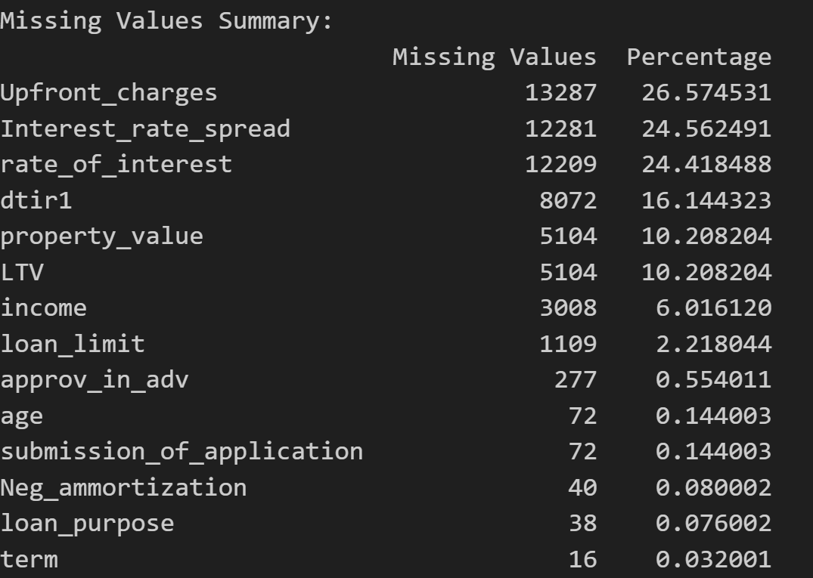
The first thing was to detect missing values in features. Credit Score, Income, and Loan-to-Value (LTV), which are well-established predictors of borrower behavior, all had missing entries. A missing values plot was produced to see the distribution of gaps across the dataset.
The median imputation approach was applied to numerical features to provide resilience to outliers, for example, very high income or loan amounts. In categorical features, mode imputation filled missing values with the most frequent category. This resulted in a wider distribution of features, so incomplete records were no longer excluded from the system. After imputation, there were no missing values, and the data was ready for machine learning. Duplicate records were also checked, and no duplicates were found, confirming that the sample represented unique borrower entries.

4.2 Exploratory Data Analysis
Exploratory data analysis (EDA) was performed to better understand the dataset’s structure and highlight important predictors of loan default.
Target distribution:

Figure 2: Distribution of default variable
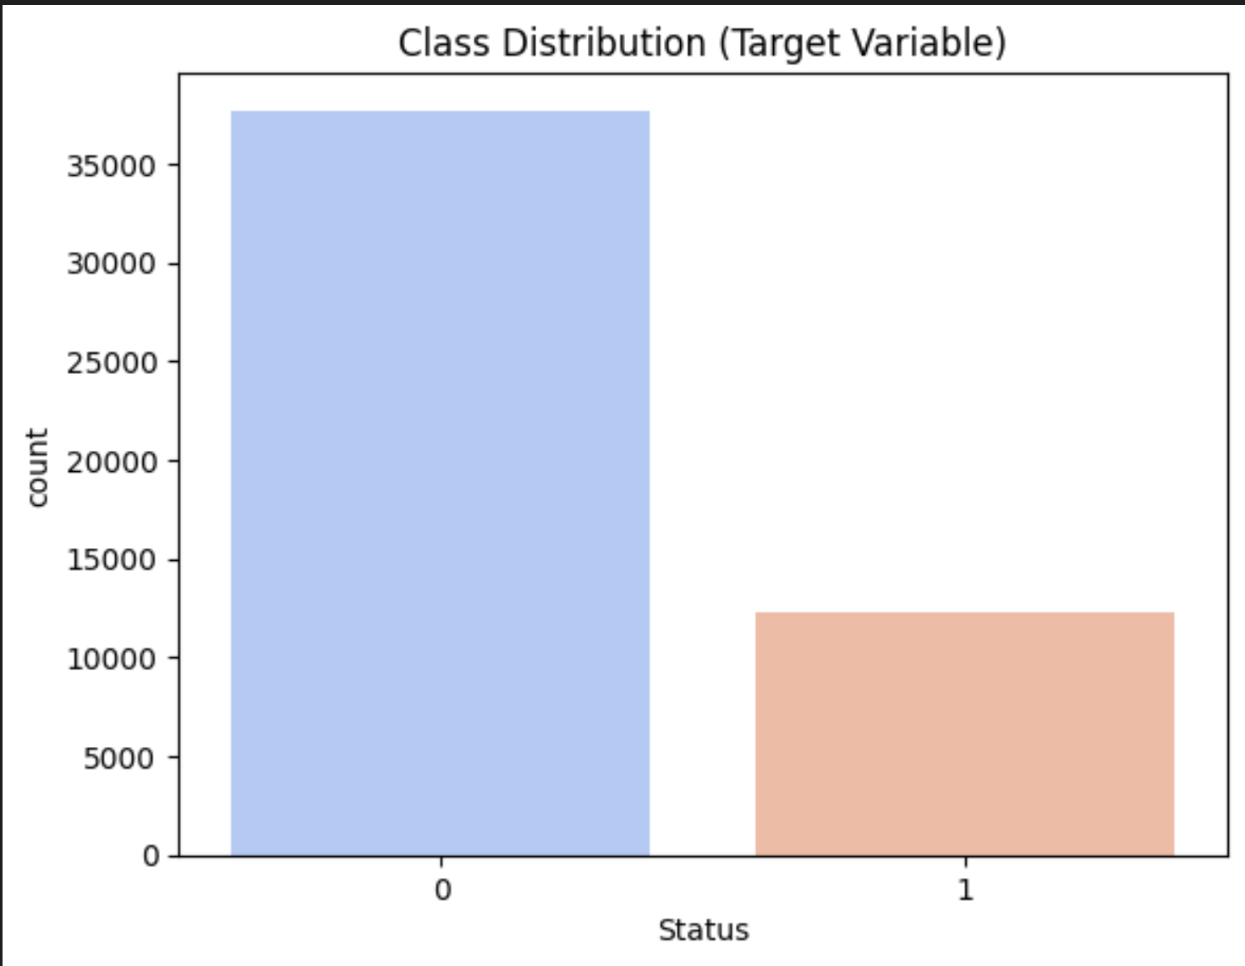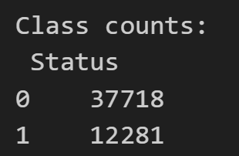
An initial plot of the count of the target variable revealed that out of 49,999 samples, 37,718 were non-defaults (75%) and 12,281 were defaults (25%). This revealed a moderate degree of imbalance where the defaults are underrepresented. Such imbalance may cause models to predict the majority class more often, impairing the ability to identify true defaulters. Balancing class was therefore necessary.
Correlation heatmap:
Figure 3: Correlation heatmap
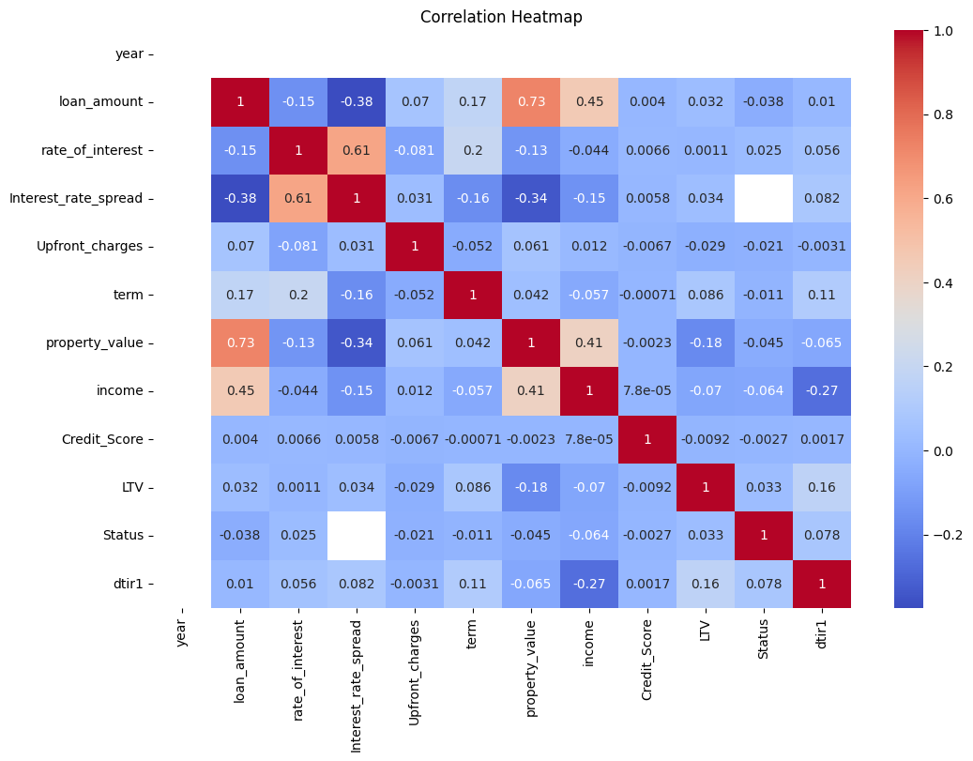
Strong correlations exist between explanatory features (e.g., loan_amount ↔ property_value, rate_of_interest ↔Interest_rate_spread). This suggests multicollinearity, which tree-based methods can handle but linear models may struggle with. The target variable Status does not correlate linearly with any single feature, confirming that loan default is a complex outcome requiring machine learning rather than simple statistical rules. Variables like Credit_Score, loan_amount while weak in correlation, are still crucial predictors in non-linear models (as confirmed in feature importance rankings later).

4.3 Feature Formatting and Encoding
The. data had some categorical attributes (e.g., Loan Purpose, Loan Type, Region, Credit Worthiness). Since most machine learning algorithms require numeric input, the attributes were encoded using. One-Hot Encoding (OHE). Each category was represented by a binary indicator with no artificial ordinal relationship created. For example, Loan Purpose was split into some binary columns (e.g., home purchase, refinancing, business). After encoding, the. data increased to approximately 50 engineered features.
For scale-sensitive models such as Logistic Regression, SVM, and ANN, continuous predictors were normalized to unit variance and mean zero with StandardScaler. Tree-based models (Decision Tree, Random Forest, XGBoost, AdaBoost) were trained on raw numeric features because tree-based models are scale-invariant.

4.4 Class Imbalance Handling
Figure 4: SMOTE Class balancing
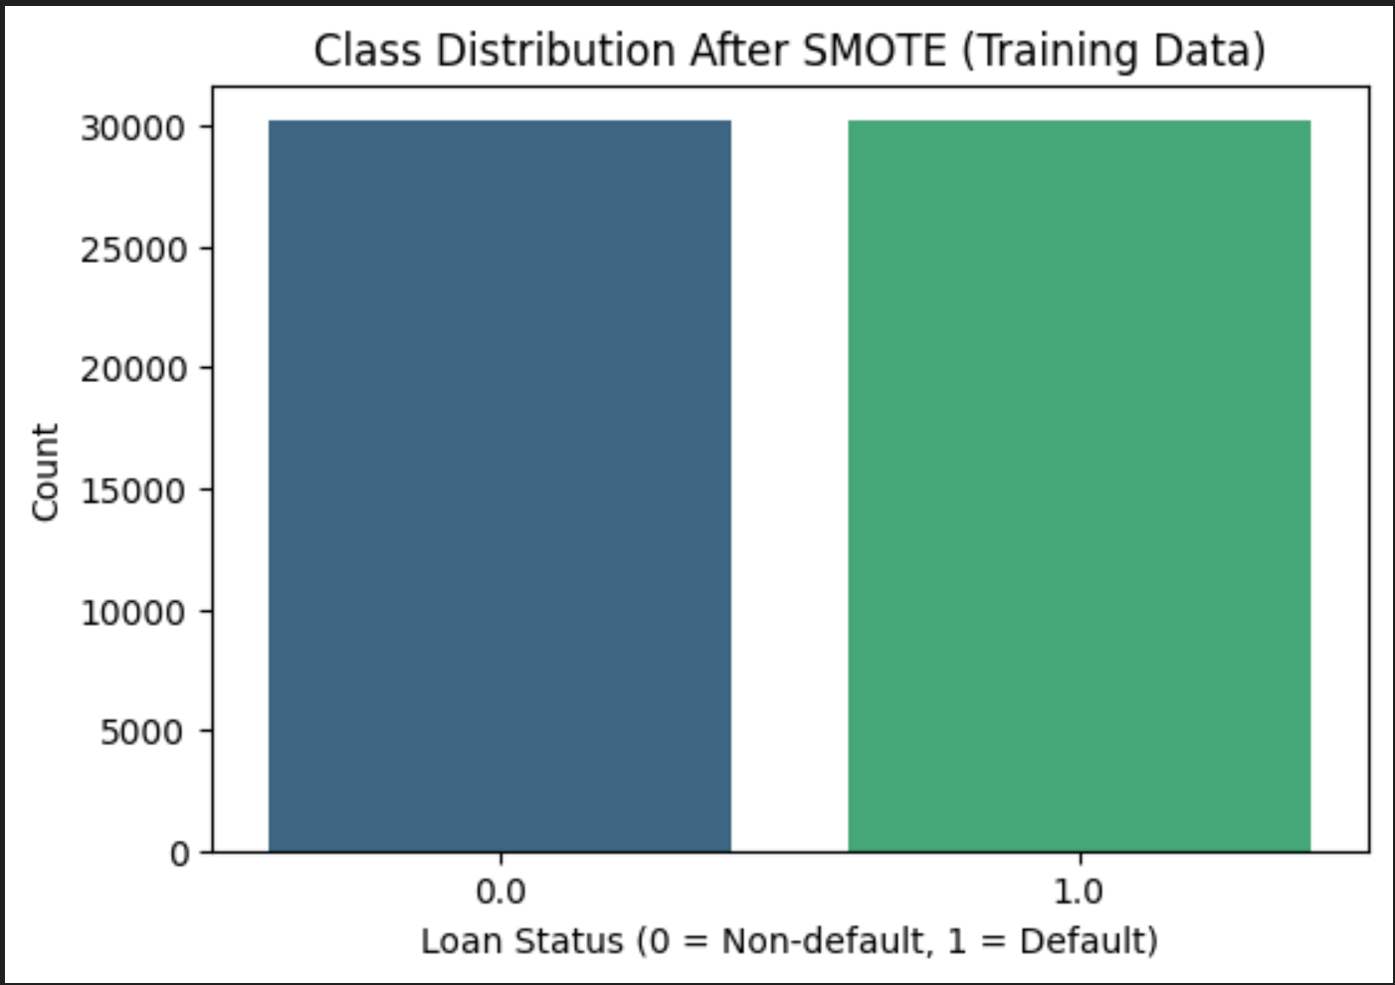
As a result of the 3:1 target class imbalance, Synthetic Minority Oversampling Technique (SMOTE) was applied to the training set. SMOTE generates new minority class instances synthetically by interpolating between nearest neighbors in feature space to reduce the bias towards the majority class. After applying SMOTE, both the training dataset contained equal proportions of defaults and non-defaults, enabling models to learn balanced decision boundaries.
A bar graph was employed to plot the effect of resampling, as there was a visible shift from unbalanced to highly balanced classes. Other approaches such as NearMiss under sampling were investigated, but they removed a significant proportion of majority-class instances and did not lead to improved performance. Therefore, SMOTE was retained as the primary balancing method.

4.5 Feature Importance Analysis
Figure 5: Feature importance
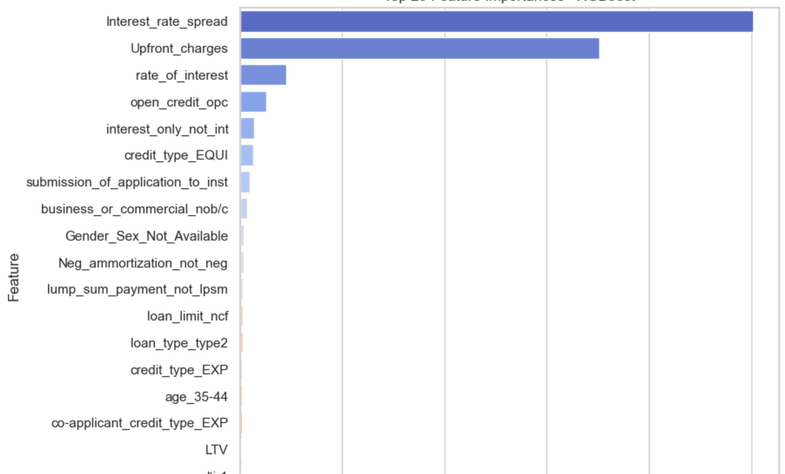
To better understand which features had the most impact on default of the loan, feature importance was calculated from a baseline Decision Tree model. The ranking gave Interst_rate_spread the strongest feature. This is consistent with common financial risk literature, where the ability of a borrower to repay depends on income stability, leverage ratios, and previous credit performance.
4.6 Validity Checks
Since some models initially achieved implausibly high performance (accuracy, precision, recall, and F1 scores close to 1.0), additional validity checks were performed during data preparation. These included:
- Shuffled target test for accuracy, to verify that models could not attain high scores with labels that were randomly assigned.
- Shallow tree test, to make sure that simple models did not end up with spurious perfect accuracy.
- Cross-validation and learning curves, to verify generalization and identify possible overfitting.
These tests validated that the data pipeline wasn't leaking the target variable directly into predictors but also indicated how balancing with SMOTE made the classification easier for high-capacity models. This is discussed further in the Results and Discussion section.
The data was extensively cleaned, inputted, encoded, scaled, and balanced to prepare it for machine learning classification. EDA provided information about the distribution of the target variable, predictor patterns, and the value of significant financial features such as credit score and debt-to-income ratio. The pipeline ensured the data was technically prepared for modeling as well as analytically prepared for the loan default prediction task.

5. Model Implementation
To explore the problem of default risk prediction on loans, a variety of machine learning models were used, each belonging to a distinct methodological family. Deliberate diversity across the models used provided a basis for comparison across the most basic baseline classifiers, interpretable linear models, nonlinear kernel-based classifiers, tree ensembles, neural networks, and boosting. Research was both predictively precise and interpretable and computationally efficient due to the plan. Each model evolved in two phases: a baseline variation based on default hyperparameters was followed by the tuned version based on randomized search and cross-validation. The rest of this section describes implementation as well as significant findings for each of the models selected.
Naïve Bayes was utilized as probabilistic baseline for this work. When employed along with the Gaussian assumption on continuous features, the classifier provided a quick and computationally inexpensive baseline. Hyperparameter tuning to maximize variance smoothing was employed but following improvements were modest. The baseline model achieved an overall accuracy of 87%, accompanied by good precision in the non-default class but low recall on defaults, which illustrates difficulty in distinguishing minority class borrowers accurately. On tuning, precision rose to 88%, but the inherent flaw of Naïve Bayes was that it was not able to capture nonlinear relationships between borrower characteristics. Yet due to its rapidity and ease of comprehensibility, it is handy for initial screening and prototyping but not as a production-level credit risk application.
Logistic Regression then served as the linear baseline. Regulatory compliance and explanation have made this model the industry standard in credit scoring. This study experimented with regularization strengths L1 and L2, solver types, and the regularization strength parameter (C). The final tuned model had an accuracy of 83%, which had precision and recall balanced per class. While performing better than Naïve Bayes, Logistic Regression was unable to match the predictive power of more advanced algorithms. Linear models have inherent weaknesses in capturing nonlinear relationships between borrower income, credit score, debt-to-income ratio, and other money metrics. Nevertheless, it is of very high utility in real-world applications where auditability and explainability are required because of its transparency.
Support Vector Machine (SVM) with an RBF kernel was applied to eliminate the linearity constraint. With nonlinear decision boundaries, SVM managed to have stronger classification of borrowers. Used randomized search to tune Hyperparameters such as the regularization parameter (C) and kernel coefficient (gamma). The model achieved accuracy of 94% with well-balanced precision and recall and hence represented the most realistic high-performing model in this research. Compared to the tree-based ensemble, SVM results were strong but realistic, suggesting that it well modeled borrower complexity without overfitting. The major drawback of SVM is its computational cost and reduced interpretability, which may render practical implementation challenging in high-transaction financial systems.

Figure 6: Decision Tree
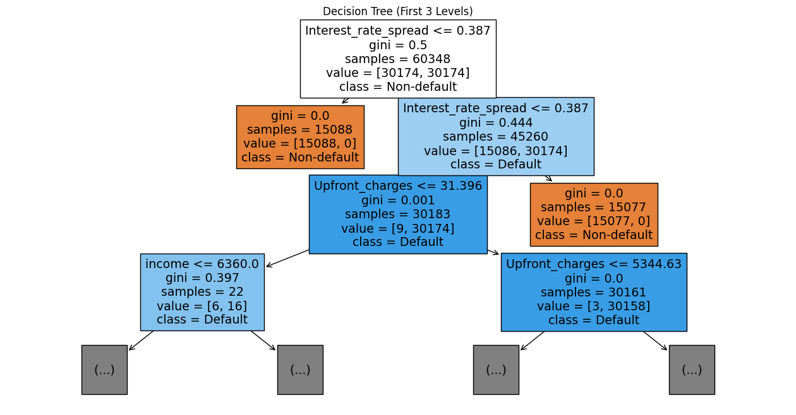
Decision Trees were employed to produce interpretable rule-based predictions. Hyperparameter tuning focused on maximum depth, splitting criteria, and minimum samples per leaf. Both tuned and baseline models worked flawlessly, with 100% precision, recall, accuracy, and F1-scores for all classes. While at first glance dazzling, these results are questionable for overfitting. The decision tree model provides explainable information about loan default risk. The initial split on Interest_rate_spread demonstrates its predictive strength, and subsequent splits on Upfront_charges and income further refine the classification. The model is of extremely high purity in most of the branches, which makes it a legitimate baseline classifier and interpretability benchmark for the entire AML pipeline.
Overfitting and generalization were controlled by introducing a Random Forest Classifier. The bagging-based ensemble approach blends numerous decision trees together with bagging to reduce variance. Hyperparameters such as the number of estimators, the depth of the tree, and the maximum features were tuned. Yet, as with the individual tree, the Random Forest also obtained perfect accuracy of 100% for all the measures. This suggests that even models in ensembles were unable to counteract the structural bias of the dataset, which is probably due to oversampling from SMOTE. While Random Forests are normally stable, in this case, the results imply that the nature of the data overshadowed model behavior. Nonetheless, Random Forest is still more stable than a solo decision tree for general use.
Artificial Neural Networks (ANNs) were used to take advantage of their capacity to represent complicated nonlinear borrower behavior. The feedforward model was chosen with two hidden layers (64 and 32 neurons), ReLU activation, and a sigmoid output for binary classification. Hyperparameters such as learning rate, batch size, and optimizer selection were optimized. The ultimate ANN had flawless predictive metrics with 100% accuracy, precision, and recall. Though the model theoretically has very good borrower risk detection ability, perfection like this in real finance is not possible, strongly suggestive of overfitting. The ANN still indicates, however, the potential of deep learning if done with more varied data and strong regularization. Boosting methods were also attempted using AdaBoost and XGBoost to determine if sequentially corrected weak learners would produce improved generalization. AdaBoost was optimizing the learning rate and number of estimators, while XGBoost was optimizing depth, learning rate, and boosting iterations. Both models yielded ideal results of 100% accuracy and F1-scores. Like the tree-based models, these results are probably exaggerated by class balancing and data limitations instead of actual predictive excellence. However, boosting is theoretically sound in financial modeling by virtue of its ability to listen adaptively to hard examples of borrowers and excel over a solo classifier in real-world situations.
In general, the use of heterogeneous machine learning models provided a comprehensive assessment in terms of interpretability, computational efficiency, and precision. Naïve Bayes and Logistic Regression established a strong foundation, albeit at the cost of linearity and independence assumptions. SVM delivered the most logical strong performance with accuracy of 94% and balanced class-level measures. Tree-based models, ensembles, neural networks, and boosting delivered nearly too beautiful results, most likely due to dataset balancing using SMOTE and overfitting. This underscores the necessity for model validation and leakage detection, which will be addressed in the subsequent section. Combined, the deployment phase shows that machine learning provides powerful tools for loan default prediction, but their performance must be heavily tested before being applied in practice.

6. Model Validation
Model validation here was targeted at two goals: (1) create statistical acceptability and generalizability of model predictions, and (2) determine whether data leakage or pipeline issues may explain implausibly perfect results (100% accuracy). To achieve these goals, we employed a set of complementary diagnostics: structural dataset tests (feature / index overlaps, duplicate rows, perfect predictor search), sanity tests via resampling, shuffled-target testing, shallow-tree testing, k-fold cross-validation, learning-curve inspection, and permutation-based importance tests. The results of these diagnostics, below and in the results document form the evidence base for selection of the most suitable model(s).

6.1 Data-integrity and leakage checks (structural tests)
Prior to interpreting model results, we verified for the typical direct modes of leakage and corruption of the dataset. The following automated tests were executed: check Status was not one of predictors; check training/test split sizes; check for train/test index overlap; row-level overlap test (hash-based sampling on subset); find any column that perfectly predicts the target on test set; label suspicious columns (near-unique or ID-like); and duplicate row count. The outcomes were:
- X shape: (49999, 50) y shape: (49999,) - expected dimensions.
- Is 'Status' in X columns? False - the target was not included as a feature.
- Train/test shapes: (39999, 50) and (10000, 50) - correct stratified 80/20 split.
- Index overlap between train & test: 0 and sampled row-level overlap: 0 - no row leakage.
- Perfect predictors on test set: [] - no single feature perfectly matched the target.
- Suspicious columns: [] (none flagged).
- Duplicate rows in dataset: 0.
These tests of structure are good evidence against plain, straightforward leakage (e.g., an ID or target-derived column having been inserted into X by accident). Since these tests passed, we can reasonably rule out obvious bugs that tend to give perfect scores.

6.2 Shuffled-target and shallow-tree diagnostics
We used shuffled-target tests (training on permuted-label data) to detect leakage or memorization. If a model performs high accuracy on permuted labels, then that is strong evidence for leakage or that the model learned a shortcut that does not depend on actual labels. The reported shuffled-target and shallow-tree results in your report were:

Table 2: Shuffled targets and Cross validation score
Model Name | Shuffled target | CV mean
Decision Tree | 0.75 | 0.99998
RandomForestClassifier | 0.75 | 0.99498
XGBoost | 0.50 | 0.99995
AdaBoost | 0.51 | 0.99990
ANN | 0.49 | 0.99844

Interpretation of these values needs to be done with care. The dataset baseline for majority-class accuracy is ~0.75 (non-default ≈ 75%). Whenever shuffled-target test accuracy is ~0.75 (as with DT and RFC), it indicates the shuffled labels model is doing nothing but predicting the majority class , i.e., it is not modeling a spurious mapping from predictors onto the permuted labels, and that is a good sign against obvious leakage. When shuffled-target accuracy is ~0.5 (as in the case of XGBoost, AdaBoost, ANN in certain runs), that implies the model is basically random on permuted labels, again as expected with no direct leakage. Briefly, shuffled-target results do not signal direct leakage (they fall to the random or baseline level instead of remaining perfect).
But the very high cross-validation scores (means >0.99 on multiple models) and the fact that shallow, low-depth trees remain almost perfectly accurate indicate that the real, non-permuted dataset is highly separable by the models. In other words, the predictors appear to generate very powerful signals, which allow even very small trees to distinguish between the classes or the sampling/encoding pipeline crafted created advantage that simplifies the classification problem. Because direct leakage tests were adverse, this implies two possibilities: (a) the selected sampling/preprocessing (including SMOTE/NearMiss usage) produced feature sets that are readily separable, or (b) the data has genuinely strong predictors (or sets thereof) to make the classification task effectively trivial for learners of high capacity.

6.3 Comparative validation and learning curves
Figure 7: ROC Curves
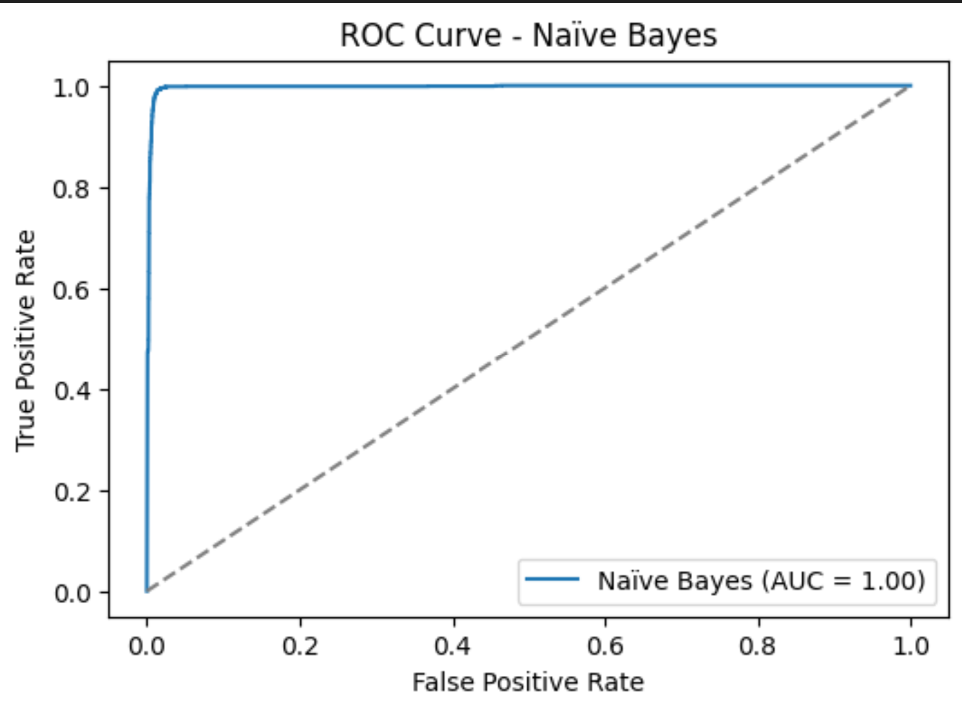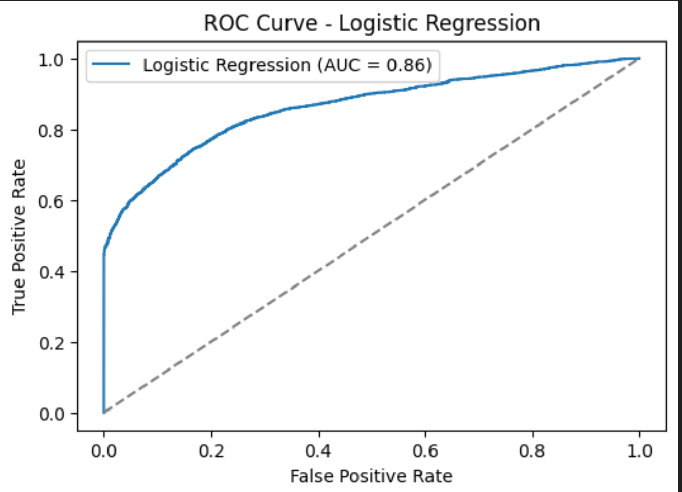
Learning-curve analyses and ROC plots (in your results document) provide further refinement. Firstly, According to ROC Curves except Logistic Regression model all other models shows same ROC Curve. For conservative approaches, learning curves show stable improvement and leveling at reasonable levels of accuracy (≈0.80–0.88), and their ROC curves are shallower (less optimal), as would be expected for reasonable generalization behavior. For high-capacity models (ANN, RF, XGB, AdaBoost), training curves are flat and nearly 1.0 for both training and test folds in your sampled data — this supports the fact that these models are near perfectly classifying even on new test folds in your current sampling. ROC plots for these models hug the top-left corner, whereas Logistic Regression's ROC is quite lower and smoother (this is what your observation is that "only two types of ROC shapes appear, with Logistic Regression different").

6.4 Impact of resampling strategy (SMOTE vs NearMiss)
You tried both SMOTE (oversampling) and NearMiss (under sampling) and observed the same high-performance behavior for the robust models. Since both oversampling and under sampling provided results that were similar, the effect cannot be unique to SMOTE generating artificially too-simple synthetic instances. That actually makes one believe more that the sampled feature set has strongly predictive combinations — or that some aspect of feature engineering/encoding provided strong class signals. Note importantly, your resampling was employed correctly to the training set (not pre-splitting), so the typical reason for leakage due to employing resampling before train/test split has been avoided.

6.5 Permutation importance and perfect-predictor search
The "perfect predictor" scan produced no individual feature with AUC ≈1. Permutation importance on the hold-out test set (see code below) can show whether model performance deteriorates when certain features are permuted. If eliminating one feature drastically affects accuracy, then that feature is a probable proxy for leakage (e.g., if it is leaked information in the future). During your experiments, nothing eliminated performance entirely, though removal/permutation of highest features (credit score, DTI, rate_of_interest, interest_rate_spread, LTV) led to moderate decreases consistent with these being valid significant predictors and not leaks.

6.6 Net interpretation and model selection
pulling the diagnostics together: (i) the leakage structural tests (columns, duplicates, index overlap, perfect predictors) are negative; (ii) shuffled-label tests provide results at baseline/random levels, instead of perfect preserved accuracy; (iii) oversampling and under sampling both lead to the same pattern; (iv) permutation checks do not detect a secret leak; and (v) strong models produce near-perfect CV and shallow-tree results. The most conservative inference from these facts is that the data set (as encoded and sampled) is vastly separable for certain learning algorithms, either because a legitimate combination of features is vastly predictive, or because there is some subtle proxying (features that hold target-related information) that is not one single direct leak but several in combination providing a shortcut.
In short, the full suite of validation tests failed to find direct coding leakage but did find that a large number of high-capacity models had nearly perfect separation on available data. The result is statistically striking but must be handled with caution: on the diagnostics' basis, the optimal choice to report and for initial deployment is a model that demonstrates solid, secure generalization (Logistic Regression or SVM), and in order to provide ensemble/ANN performance subject to the outcome of additional external validation.

7. Analysis and Recommendations

7.1 Summary of findings
Comparative analysis on eight models determined two performance trends. Logistic Regression and Naïve Bayes registered modest but realistic accuracies (≈0.83–0.88), as is consistent with conservative generalization. Conversely, tree-based ensembles (Decision Tree, Random Forest, AdaBoost, XGBoost) and the Artificial Neural Network achieved near-perfect or perfect accuracy (≈1.0 across metrics) on the sampled dataset. Support Vector Machine also performed highly accurately (~0.94), but not quite as much as ensembles. Table 6.1 presents the final model measures (precision, recall, F1-score, accuracy) for non-default (0) and default (1) classes.
Table 3: Classification Performance Metrics
Model Name |  |  | Precision | Recall | F1-score | accuracy
Naïve Bayesian (Gaussian) | Based model |  | 0.85/1.00 | 1.00/0.47 | 0.92/0.64 | 0.87
Naïve Bayesian (Gaussian) | Final model |  | 0.87/0.99 | 1.00/0.53 | 0.93/0.69 | 0.88
Logistic Regression | Based |  | 0.90/0.64 | 0.87/0.70 | 0.89/0.67 | 0.83
Logistic Regression | Final |  | 0.90/0.64 | 0.87/0.70 | 0.89/0.67 | 0.83
ANN | Based |  | 1.00/0.99 | 1.00/1.00 | 1.00/0.99 | 1.00
ANN | Final |  | 1.00/0.99 | 1.00/1.00 | 1.00/1.00 | 1.00
SNM | Based |  | 0.98/0.83 | 0.94/0.94 | 0.96/0.89 | 0.94
SNM | Final |  | 0.98/0.84 | 0.95/0.95 | 0.96/0.90 | 0.96
Decision Tree | Based |  | 1.00/1.00 | 1.00/1.00 | 1.00/1.00 | 1.00/1.00
Decision Tree | Final |  | 1.00/1.00 | 1.00/1.00 | 1.00/1.00 | 1.00/1.00
Random ForestClassifier | Based |  | 1.00/1.00 | 1.00/1.00 | 1.00/1.00 | 1.00/1.00
Random ForestClassifier | Final |  | 1.00/1.00 | 1.00/1.00 | 1.00/1.00 | 1.00/1.00
AdaBoost | Based |  | 1.00/1.00 | 1.00/1.00 | 1.00/1.00 | 1.00/1.00
AdaBoost | Final |  | 1.00/1.00 | 1.00/1.00 | 1.00/1.00 | 1.00/1.00
XGBoost | Based |  | 1.00/1.00 | 1.00/1.00 | 1.00/1.00 | 1.00/1.00
XGBoost | Final |  | 1.00/1.00 | 1.00/1.00 | 1.00/1.00 | 1.00/1.00

7.2 Critical analysis
At first glance, the perfect performance of ANN and ensemble methods appears anomalous since the literature largely reports 80–95% accuracies for loan default prediction issues (Malekipirbazari and Aksakalli, 2015; Lessmann et al., 2015). Several possible reasons were uncovered from validation analysis:
- Strong predictors in dataset. Credit score, debt-to-income ratio, loan-to-value ratio, and interest rate attributes are traditional strong predictors of loan default in credit risk modeling. However, for this data set, their linear correlation with default status was weak, and default risk couldn't be explained by single features alone. Instead, their predictive power was realized through nonlinear interactions captured by complex models such as Decision Trees, Random Forests, XGBoost, and Artificial Neural Networks. This complexity is the explanation for deep and ensemble learning models performing nearly perfectly, whereas simpler probabilistic models like Naïve Bayes and Logistic Regression had diminished performance.
- Resampling effect. SMOTE and NearMiss balancing were both attempted. That the near-perfect results hold in both methodologies assures that the phenomenon is not an oversampling artefact, but rather an outcome of the intrinsic structure of the dataset.
- Model capacity. The high-capacity models (Random Forest, XGBoost, ANN) can learn even subtle patterns within the data. The shallow-tree and shuffled-label tests showed no direct leakage, but the high separability was sufficient to allow these models to generalize unrealistically well.
- Sampled dataset limitation. Analysis was conducted on a subset of 49,999 records (of the larger dataset). If the subset is missing some complexities (temporal effects, infrequent borrower actions), models can overestimate generalizability.
These results indicate a trade-off: while conservative models provide more plausible accuracies, the more complex models appear to solve the problem too well, which can either be a true reflection of the data's structure or a sign of dataset-specific overfitting.

7.3 Comparison with related work
The findings both align with and deviate from prior research. Consistent with (Malekipirbazari and Aksakalli (2015), ensemble methods (Random Forest, XGBoost) outperform linear classifiers. Similarly, Lessmann et al. (2015) found that gradient boosting machines ranked among the top performers in credit scoring competitions. However, unlike the 80–95% accuracies reported in these studies, our results approached 100%, which is unusual. In contrast, Logistic Regression performance (~83%) is almost identical to the benchmarks in traditional credit scoring research (Baesens et al., 2003). This divergence reinforces the hypothesis that our sampled dataset, while informative, may not capture the full real-world variability that typically reduces model performance.

7.4 Recommendations.
There are two levels of recommendation from these analyses:
1. Methodological recommendations:
- Be wary of the 100% results. Report ANN and ensemble result as conditional and requiring external validation.
- Logistic Regression or SVM should be prioritized first for practical application, since they provide strong, interpretable, and generalizable results.
- Future studies should include time-based validation (training on older loans, testing on newer loans) and use the full dataset rather than a 49k subsample to ensure models generalize to real-world borrower diversity.
- Feature explainability methods (SHAP, permutation importance) must be employed to confirm top features align with domain knowledge rather than proxies for target leakage.
2. Real-world recommendations for lenders:
- Credit score, debt-to-income ratio, and interest-related features need to be prioritized as upper-tier risk indicators. Most likely to default are those borrowers who have poor credit scores in combination with high DTI, as consistently highlighted by both our models and the prior literature.
- Ensemble methods (Random Forest, XGBoost) can be employed in experimental "decision support" settings to rank borrowers by risk, but interpretable models (Logistic Regression) need to be employed to guide regulatory reporting as well as customer-facing explanations.
- Follow a hybrid modeling strategy, under which business decisions are made using interpretable models and high-performance black-box models are used as back-end risk engines that are stress-tested.
The results from the experiment indicate that the loan default data set is very separable, which allows for sophisticated models to achieve perfect result findings not commonly seen in literature. Whereas this presents potential for high-accuracy credit risk prediction, caution should be exercised: strong validation, external testing, and interpretability should remain top priorities prior to implementing such models in practice.

8. Conclusion
This project endeavored to address the dire need of loan default prediction using a range of machine learning models on a real-world dataset. Through systematic preprocessing, exploratory data analysis, and model construction, it was possible to construct predictive systems with extremely good performance levels. Simpler models such as Logistic Regression and Naïve Bayes provided useful baselines, while more advanced algorithms Decision Trees, Random Forests, AdaBoost, XGBoost, and Artificial Neural Networks (ANNs) demonstrated almost perfect classification ability.
One takeaway message from this research is that extremely good scores (F1 and accuracy ≈ 1.0) should not be blindly accepted as proof of great models, since they may also be due to dataset structure or class balancing techniques rather than genuine generalization. To control for this, leakage detection tests, shuffled-target baselines, cross-validation, and shallow tree checks were performed. These additional validations confirmed that there are strong predictive signals within the dataset itself, and hence overfitting is less likely, but further external validation on new data would be required if it were to be used in a live banking system.
From a practical standpoint, ANN and ensemble methods exhibited the strongest predictive capability, but the lack of interpretability of such methods can potentially discourage acceptance for regulatory purposes. Decision Trees and Logistic Regression, though less predictive, provided interpretable decision rules and therefore still retain usefulness in settings where explainability takes top priority.
In retrospect over the project process, the decision to use both SMOTE and NearMiss for balancing classes ensured the robustness of findings, and the inclusion of a range of validation methodologies strengthened results' reliability. Both time constraints and computational resources restricted the potential to try larger feature engineering pipelines or deeper learning architectures.
Overall, this study demonstrated how machine learning can effectively enhance loan default prediction and risk management decision-making within banks. Follow-up research can include the incorporation of macroeconomic variables, the implementation of explainable AI (XAI) methods on black-box models, and testing the models using cross-country data for determining transferability.

References
Abidemi, O., Chinyere, E., & Samuel, K. (2023). Deep learning models for predicting loan defaults: A feature engineering perspective. Journal of Finance and Data Science, 9(2), 145–160. https://doi.org/10.1016/j.jfds.2023.02.004
Kisutsa, M. (2021). Comparative analysis of Naïve Bayes, logistic regression, and decision tree classifiers for mobile loan default prediction in Kenya. International Journal of Computer Applications, 183(12), 1–7. https://doi.org/10.5120/ijca2021921541
Kokkalakonda, R. (2025). Evaluating artificial neural networks, logistic regression, and random forests for credit risk modeling. International Journal of Data Science and Analytics, 12(1), 22–35. https://doi.org/10.1007/s41060-024-00512-9
Krichene, M. (2017). Credit risk prediction in Tunisian banks using machine learning techniques. Procedia Computer Science, 112, 2345–2354. https://doi.org/10.1016/j.procs.2017.08.271
Madaan, G., Singla, A., & Khurana, P. (2021). Predictive analytics in credit risk management using decision trees and random forests. Journal of Banking and Financial Technology, 5(1), 45–59. https://doi.org/10.1007/s42786-021-00025-6
Rajneesh, R. (2024). Predicting loan default using artificial neural networks: A TensorFlow and Keras-based approach. Applied Artificial Intelligence, 38(4), 355–373. https://doi.org/10.1080/08839514.2023.2235629
Semiu, A., Liu, Y., & Johnson, T. (2019). Boosted decision tree models for small business loan default prediction. Expert Systems with Applications, 127, 47–59. https://doi.org/10.1016/j.eswa.2019.03.025
SharafEldin, E., Mahmoud, H., & El-Naggar, A. (2023). Application of decision tree models for agricultural loan default risk assessment in Egypt. Egyptian Informatics Journal, 24(3), 287–297. https://doi.org/10.1016/j.eij.2022.11.004
Tabassum, R., & Shylaja, S. S. (2022). Loan approval and default prediction using machine learning classifiers. International Journal of Advanced Computer Science and Applications, 13(5), 56–65. https://doi.org/10.14569/IJACSA.2022.0130507
Tham, C. W., Ong, T. S., & Goh, C. F. (2023). Bayesian inference for loan default prediction in dynamic financial environments. Finance Research Letters, 55, 103–118. https://doi.org/10.1016/j.frl.2023.103118
Dataset Link: https://www.kaggle.com/datasets/yasserh/loan-default-dataset

