1. Create your own resume data in JSON format Please check the link for the above task.

<https://github.com/thilipd/zenclass/blob/main/resume%20copy.json>

1. For the given JSON iterate overall for loops (for, for in, for of, forEach)

For… in … loop:

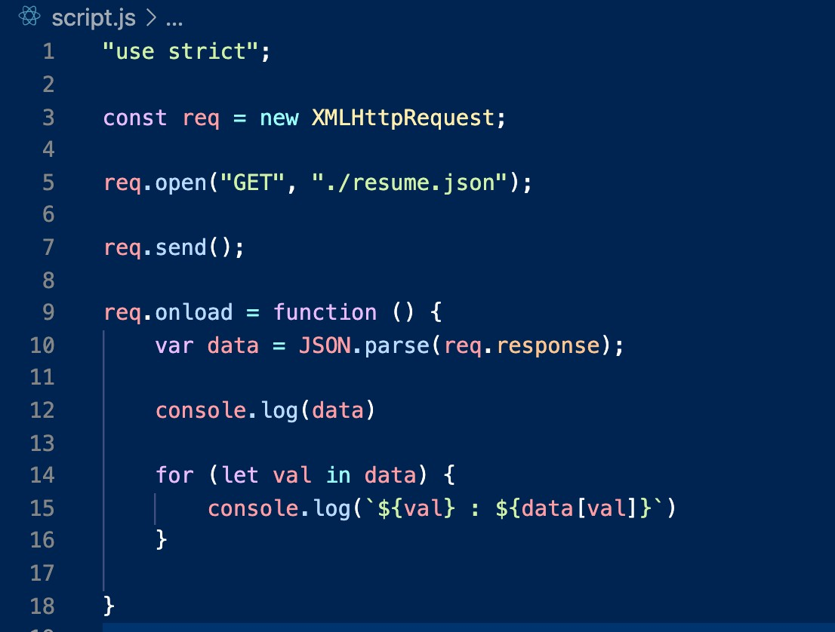

Please scroll down…..

Console:

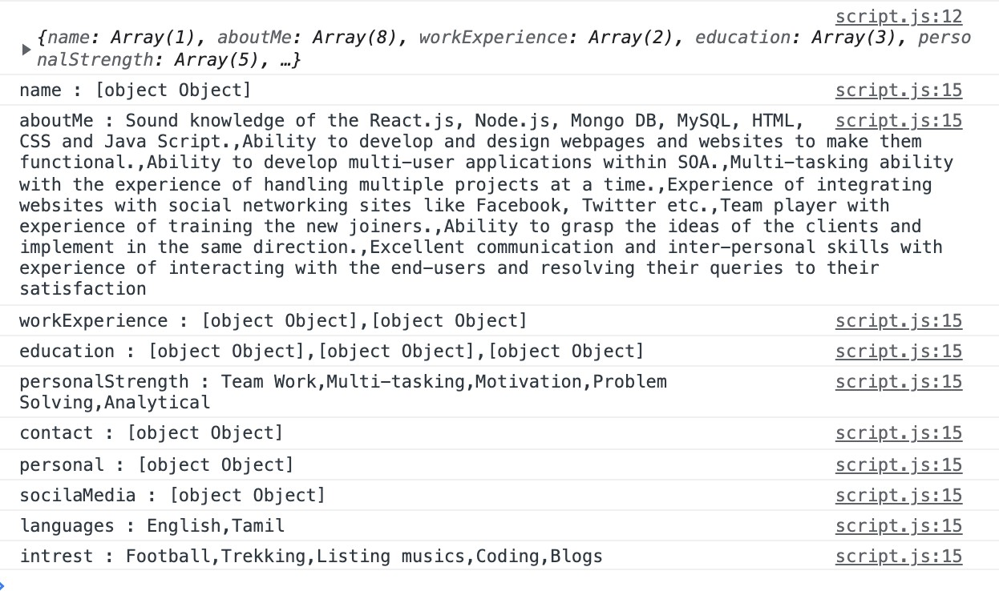

Please scroll down…..

For… of … loop:

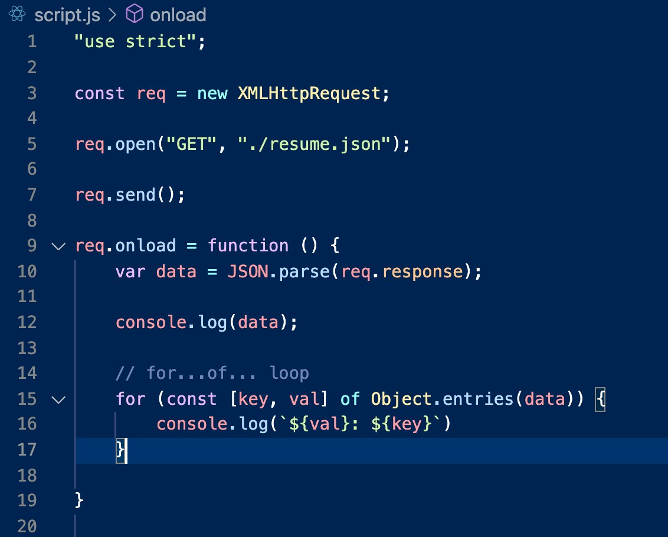

Please scroll down…..

Console:



Please scroll down…..

forEach loop:

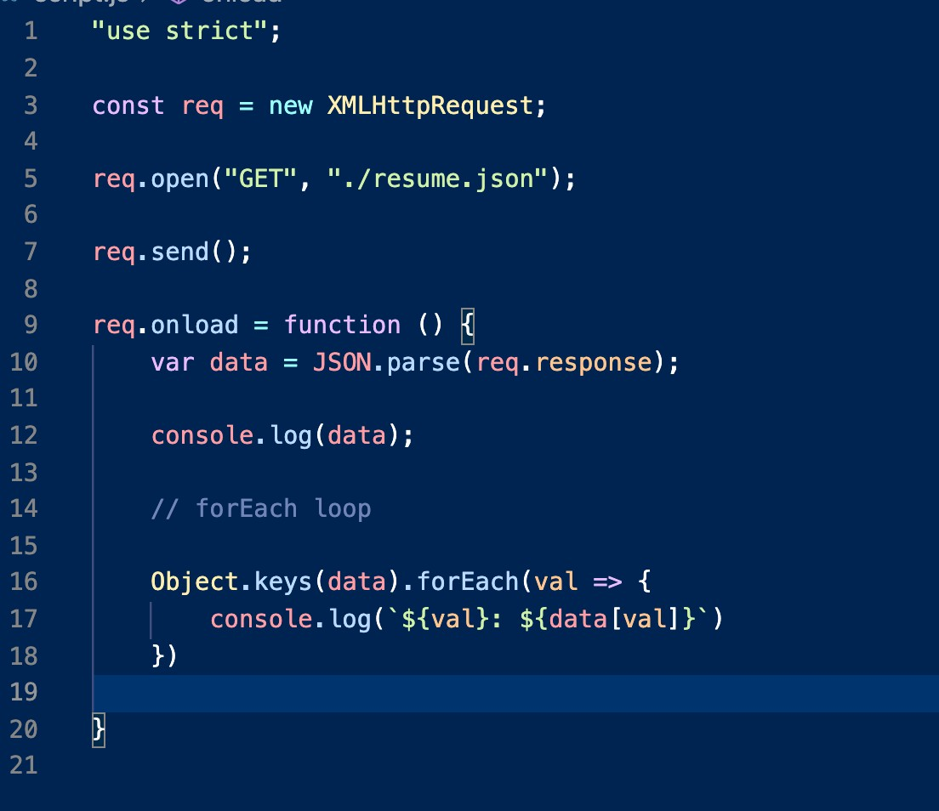

Please scroll down…..

Console:

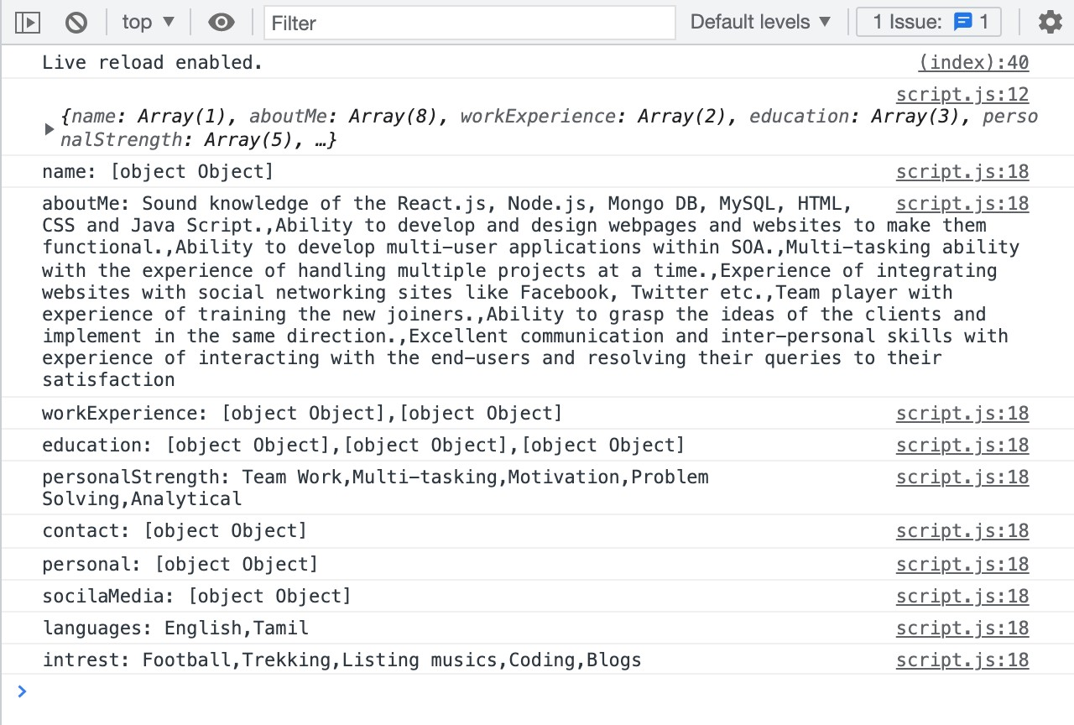

Thank you!!!

Have a good day!!!