**Automated Weld Path Generation Using Random Sample Consensus and Iterative Closest Point Model-Workpiece Registration**

**Abstract**

Jobs performed by small to medium enterprises (SMEs) are infrequently automated due to high setup costs and lack of technical expertise needed for robot training, however productivity and worker safety can be improved in SMEs with the use automated tooling. In a traditional automated manufacturing environment, tasks such a welding or painting are accomplished through execution of pre-programmed tool motions which rely on the location and orientation of the workpiece to be fixed and known. The lack of this spatial information is typically treated through positioning of the workpiece with respect to the robot arm using jigs or fixtures which are costly in initial setup and not easily modified. Further, the resulting toolpath associated with a desired task is typically defined through manual teaching resulting in a path appropriate for an individual job. For this reason, SMEs requiring variation in part geometry or arrangement are not commonly automated. This work presents a method for automated weld path generation for a 6DOF co-bot arm using random sample consensus (RANSAC) and iterative closest point (ICP) model-workpiece registration. A collection of algorithms is employed to register or locate a pointcloud source representing the workpiece in a pointcloud of the working environment collected by a LIDAR scanner located on the robot. Once the known is located with respect to a fixed frame, an automated weld path generation routine is used to generate series of tool poses offline. A representative set of welding processes in which a cylinder or rectangular tube is joined to a flat plate through weldment is investigated and a physical implementation of the method is demonstrated using a 3D LIDAR mounted to a 6DOF co-bot carrying a MIG welding torch.

**Introduction**

Small to medium enterprises perform manufacturing tasks associated with relatively low part volume and increased variation in assembly geometry as compared to jobs performed in large scale manufacturing environments. This type of manufacturing operation is infrequently automated due to high setup costs; however, productivity and worker safety can be improved in small to medium enterprises with the use of automated tooling.

In a traditional automated manufacturing environment, a task such a welding or painting is accomplished through execution of pre-programmed tool motions which rely on the location and orientation of the workpiece to be fixed and known with respect to a global coordinate system. The need for spatial information is typically treated through positioning of the workpiece with respect to the robot arm using jigs or fixtures which are costly in initial setup and are not easily modified. In large scale production environments, this can be accomplished with dedicated infrastructure built into the environment such as moving jigs on assembly lines and other features available in a highly structured environment. Further, the resulting toolpath associated with a desired task is typically defined through manual teaching resulting in a path appropriate for an individual job.

For this reason, SMEs requiring variation in part geometry or arrangement are not commonly automated. This paper presents a method for automated weld path generation for a 6DOF co-bot arm using random sample consensus (RANSAC) and iterative closest point (ICP) model-workpiece registration developed within Point Cloud Library (PCL). Point Cloud Library presents a modern C++ library for 3D point cloud processing and features a multitude of algorithms for: filtering, feature estimation, surface reconstruction, registration, model fitting, and segmentation. [5]

This work employs a collection of these algorithms to locate, or register, a point cloud representing the workpiece in a point cloud of the working environment collected by a LIDAR scanner located on the robot. Once the known part is located with respect to a fixed frame, an automated weld path generation routine is used to plan a weld tool-path offline. A representative set of welding processes in which a cylinder or rectangular tube is joined to a flat plate through weldment is investigated and a physical implementation of the method is demonstrated using a 3D LIDAR mounted to a 6DOF co-bot carrying a MIG welding torch.

As technology advances humans and robots must adapt to remain relevant in our respective environments and we are currently seeing this in the emergence of the co-bot workcell paradigm.

**Approach**

A fillet weld in which a circular or rectangular tube is joined to a flat plate is considered. The two workpieces, the required weldment, and the working environment are modeled as well the 6DOF co-bot which sits in the center of a planar welding table.

Variation in surface quality and workpiece dimension and shape are likely present however these are not the focus of this process. The workpiece geometries are generally assumed to match those in the model within a working tolerance. These local model inaccuracies certainly affect the global information produced regarding the geometry and location of the weld, but these affects are minor.

The proposed approach to automated weld path generation is shown in **Figure 1** and consists of a sensing stage, an offline model registration stage, followed by the path generation stage.

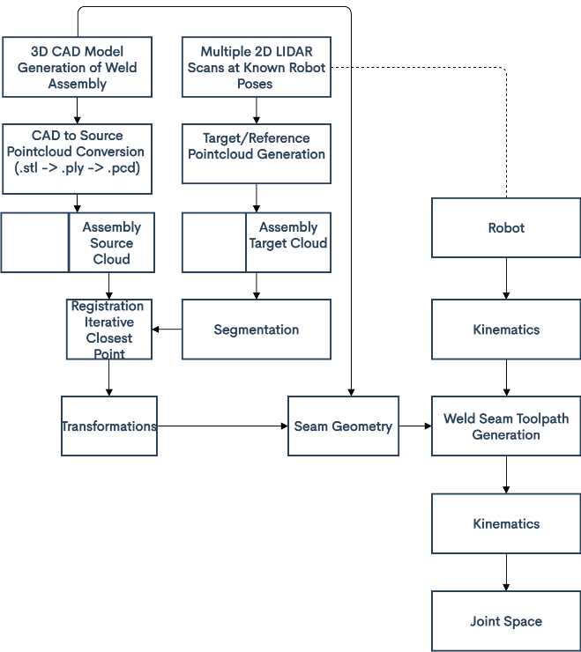

Figure Method for Automated Weld Path Generation

Prior to the sensing stage the two workpieces are manually placed in the robot workspace in the proper relative orientation to be joined by a weldment. The relative orientation of the parts must match that of the model to an extent and the global location of the workpieces is restricted to the usable workspace of the robot.

In the scanning stage a sweeping motion of the arm is performed, and the workpiece and environment are scanned with the 2D lidar mounted linkX of the robot. Multiple 2D lidar scans are measured along with corresponding sensor poses at (linkS). As the scanning stage continues the 2D lidar scans are transformed from the sensor frame linkS to the base frame link0 through the robot forward kinematics and accumulated into a 3D pointcloud with respect to the base frame. By nature, 3D lidar produces large sparse and redundant data sets. Therefore, the scans are filtered and reduced to the usable workspace to improve results and lower the computational requirements of stages of this process. This 3D scan of the workspace is saved as the reference cloud.

Prior to the model registration stage, an ideal model of the joined workpieces including the weldment, and environment is generated using CAD. The models of the workpieces alone are used to generate two separate source pointclouds with respect to their individual local frames. In the model registration stage, the source clouds derived from CAD are compared to the reference cloud acquired from lidar in the sensing stage. The relative transformation between clouds is found using the iterative closest point algorithm (ICP). The pose of the two parts can be used to determine the required location of the weld seam in a global sense.

The geometry and location of the desired weld seam in the workspace is required for offline generation of an appropriate toolpath. This information is determined by measuring the pose of the two individual workpieces with respect to a frame fixed to the robot base. Once this is information is known the appropriate toolpath can be generated. Determination of the poses of the individual workpieces represents to majority of this work and the method is described in detail.

**Implementation**

The objective of the original ICP algorithm is to find a rigid transformation, with which the reference cloud is in the best alignment with the source pointcloud set. This is done by iteratively registering the reference cloud with the source cloud by applying a rotation matrix R and a translation vector *t.*

This process begins with an initial rigid transformation, and then repeats the above two steps until the clouds have reached convergence. “However, it has been proved that this method is locally convergent, which means that the algorithm is easily failed when the rotation angle between two point sets is large. For this reason, a good initial transformation is so important that it guarantees that the algorithm converges to the global minimum finally” [7].

What steps and why we chose them.

Prefiltering Stage with RANSAC prior to ICP

Do not get very deep into the steps of ICP (main steps) – Point-to-point, kd-tree searching, and SVD. All for registration

Section discussing the process of getting the CAD to cloud

Sampling

Possible sampling methods in PCL:

1. index space sampling (taking every n-th point)
2. Uniform sub-sampling in the input 3D space
3. Sampling in the space of local surface normal

Correspondence Matching

1. kd-tree rapid matching **
2. PCL depends on FLANN (open source library for fast (approximate) nearest neighbor searches)

Rejection (Filtering)

1. Distance Based * (Max correspondence Distance)
2. Median Distance based
3. Duplicate target matches
4. RANSAC-based rejection **

Alignment

1. Point-to-point **

Termination Criteria

1. Max iterations
2. Absolute transformation threshold
3. Relative transformation threshold
4. Maximum number of similar iterations
5. Relative mean square
6. Absolute mean square error

Rigid transformation composed of rotation R and translation t

Using point-to-point error metric instead of point-to-plane

**Correspondence Matching and Alignment**

Let $R_{Part}=\left\{{\vec{r}}_{i}\right\}$ be the CAD pointcloud set for $i=1,2,…, N_{P}$ to be aligned with the source cloud set $S=\left\{{\vec{s}}_{k}\right\}$ for $k=1,2,…, N_{S}$ where $N_{i}= N_{k}$, and where each point ${\vec{r}}_{i}$ corresponds to the point ${\vec{s}}_{k}$ with the same index. The mean square objective function to be minimized is

$E\left(R,t\right)=E\left(T\right)= \frac{1}{N_{s}}\sum_{i=1}^{N_{S}}{{\left\|r_{i}-Rs_{i}-t\right\|}^{2}}$

If the correct correspondences are known, the correct relative rotation/translation can be calculated in closed form. The close form implementation from PCL consists of using singular value decomposition (SVD). The process of using SVD to begin minimizing distances between corresponding point requires the center of mass be calculate for each point set where, $μ_{r}= \frac{1}{N_{r}}\sum_{i=1}^{N_{r}}{r_{i}}$ and $μ_{s}= \frac{1}{N_{s}}\sum_{i=1}^{N_{s}}{s_{i}}$

For the reference point set and the target point set, respectively. The idea is to subtract the corresponding centers of mass from every point in the two point sets before calculating the transformation. The resulting point sets are given as:

$$R^{'}= \left\{r_{i}-μ_{r}\right\}=\left\{r_{i}^{'}\right\}$$

$$S^{'}= \left\{s_{i}-μ_{s}\right\}=\left\{s_{i}^{'}\right\}$$

Let $W= \sum_{i=1}^{N_{r}}{r_{i}^{'}{s^{'}}_{i}^{T}}$

denote the singular value decomposition (SVD) of W by:

$$W=U\left[\begin{matrix}σ_{1} & 0 & 0 \\ 0 & σ_{2} & 0 \\ 0 & 0 & σ_{3}\end{matrix}\right]V^{T}$$

where U, V $∈R^{3x3}$ are unitary, and $σ_{1 }≥σ_{2}≥σ_{3 }$ are the singular values of W

$T_{P1,S}^{P1,R}$ Transformation from source to reference of part1

$T_{P2,S}^{P2,R}$ Transformation from source to reference of part2

CODE QUESTION

Set TransofrmationEpsilon

Set EuclidianFitnessEpsilon

**Results**

“PCL incorporates methods for the initial alignment of point clouds using a variety of local shape feature descriptors as well as for refining initial alignments using different variants of the well-known Iterative Closest Point (ICP) algorithm.” [6]

Registraction (ICP or TEASER): The registration stage is required for the alignment of two or more pointcloud sets by finding the relative position and orientation between views in a global coordinate frame, iteratively aligning the point clouds such that processing stages such as segmentation can be applied. In this paper, registration of two pointclouds is carried out by the classical variant of Iterative Closest Point (ICP).

“Due to the non-convexity of the optimization, ICPbased approaches require initialization with a rough initial transformation in order to increase the chance of ending up with a successful alignment. Good initialization also speeds up their convergence.” [6]

General Notes

* This approach provides a benefit over classical online seam tracking in that it does not require measuring the joint itself.
* It is important to distinguish between ‘assembly variations’ and ‘form variations’
* This process could be extended and used to check for unacceptable workpiece geometries and or relative placement.
* The ability to locate objects in the working environment could also be used to assist the operator in workpiece placement as in [] where a laser projector is used to provide a visual guide for manual placement of the workpiece prior to weldment.
* The group at ‘Fraunhofer’ then uses the transformations to update the reference models…
* Rajaraman Dawson-Haggerty Shimada Bourne use a ‘laser projector’ to help the operator in ‘placement’ of the workpeice. ‘robot guided placement procedure’ + ‘3d sensing for preplanned tool paths’

**Bibliography**

Numbered references are tied to notes, please do not change.

[1] Segal, A. V., Haehnel, D., and Thrun, S., 2010, “Generalized-ICP,” Robotics: Science and Systems.

[4] Zhang, J., Yao, Y., & Deng, B. (2021). Fast and Robust Iterative Closest Point. IEEE Transactions on Pattern Analysis and Machine Intelligence.

[5] Rusu, R. B., and Cousins, S., 2011, “3D Is Here: Point Cloud Library (PCL),” Proceedings - IEEE International Conference on Robotics and Automation.

[6] Zhao, H., Anwer, N., et. Al., 2016, “Registration with the Point Cloud Library PCL,” IEEE Int. Conf. Intell. Robot. Syst.

[7] Du, S., Xu, Y., Wan, T., Hu, H., Zhang, S., Xu, G., and Zhang, X., 2017, “Robust Iterative Closest Point Algorithm Based on Global Reference Point for Rotation Invariant Registration,” PLoS One.

Detection of Assembly Variations for Automatic Program Adaptation in Robotic Welding Systems

Alexander Kuss, Ulrich Schneider, Thomas Dietz Fraunhofer

Automated Planning of Robotic MAG Welding Based on Adaptive Gap Model

Alexander Kuss, Ulrich Schneider, Thomas Dietz Fraunhofer

Generalized-ICP

Aleksandr V. Segal, Dirk Haehnel, Sebastian Thrun

Automated workpiece localization for robotic welding

Rajaraman Dawson-Haggerty Shimada Bourne

A method for registration of 3D shapes

Paul Besl, Neil McKay