1. **OVERVIEW OF APPROACH**

The proposed approach to automated weld path generation shown in figure 2 consists of a model preparation stage, a workspace sensing stage, a workpiece localization stage, followed by an offline robot path generation stage. The resulting path can be used to automate a welding process on the component in the workspace with a 6-DOF co-bot carrying a welding torch.

Uniqueness

* 1. **Model Preparation Stage**

In the model preparation stage, the geometry of the workspace and the workpiece is defined based on the prescribed application. An ideal model of the workpiece (including the weldment?) is generated using CAD. Part models are first generated of the individual workpiece components which are then assembled to represent the workpiece. The CAD assembly representing the workpiece is converted into a pointcloud through a uniform sampling technique to be used for workpiece registration. The pointcloud associated with the CAD model is known as the source pointcloud.

A simplified model of the workspace and environment including the welding table and the robot base is also created for simulation purposes, and the environment model is also converted into a pointcloud file. The 3D models are generated using standard CAD software from which they can be exported as .ply files or other standard file formats.

* 1. **WORKSPACE SENSING STAGE**

Prior to the sensing stage, the workpiece is placed in the robot workspace by the operator in the proper relative orientation to be joined by a weldment. The relative orientation of the parts must match that of the model to an extent and the global location of the workpieces is restricted to the usable workspace of the robot.

In the sensing stage a sweeping motion of the arm is performed, and the workpiece and environment are scanned with the 2D LiDAR mounted on link 5 of the robot. Multiple 2D lidar scans are measured along with corresponding sensor poses. As the scanning stage continues, the data are transformed from the sensor frame link 5 to the base frame link 0 through the robot forward kinematics and accumulated into a 3D pointcloud with respect to the base frame. This process produces sparse data sets with redundant points. Therefore, the scans are filtered and downsampled (with methods within PCL) to improve results and reduce the resource requirements of storage and processing. The resulting pointcloud contains an image of the workpiece and fixtures as well as the top of the welding table and the background. The pointcloud associated with the LiDAR scan is known as the reference or target cloud. The sensing stage along with the methods of filtering and downsmpling can be seen below in figure 3.

* 1. **WORKSPACE LOCALIZATION STAGE**

In the workpiece localization stage, the source pointcloud derived from the CAD model is compared to the reduced reference cloud acquired from lidar in the sensing stage. The relative transformation between clouds is found using the iterative closest point algorithm (ICP). The pose of the workpeice can be used to determine the required location of the weld seam in a global sense.

The reference cloud, collected from LiDAR, contains a larger volume of points, but not necessarily more points, than the source cloud. Also, the percentage of the workpiece represented in the LiDAR cloud depends on the sweeping motion used in the scanning stage and the amount of interference caused by the clamps or other obstructions. In the best-case scenario, approximately half of the points associated with the external faces of the workpiece are available in the LiDAR cloud.

The LiDAR cloud is first reduced to the usable workspace of the robot using a 3D bounding box removing points from the surrounding walls and extents of the table. Next, the point cloud is downsampled with a voxel filter [15] to ensure uniform density of points in the reference pointcloud and reduce computational requirements[]. The remaining image contains points from the workpiece, the clamps holding the workpiece, and the table. The robot arm may also be included in the remaining pointcloud. At this point, RANSAC based segmentation is used to compare geometrical information such as the planar nature of the table or the orthogonality of the workpiece to the LiDAR cloud to separate, or segment, the points associated with the workpiece. The results of a cascaded RANSAC segmentation are stored as the reference pointcloud cloud. Finally, the rigid transformation between the reference and source pointcloud is found with the iterative closest point (ICP) cloud registration algorithm. This transformation matrix represents the location and orientation of the workpiece with respect to a fixed origin.

* 1. **PATH GENERATION STAGE**

In the path generation stage the transformation resulting from workpiece localization is used to plan a set of tool poses appropriate for a specified application. The welding application of interest can be accomplished with a combination of straight-line segments and circular arcs. Therefore, the tool path can be determined by transforming the description of the desired weld seam in the local frame of the workpiece to the global frame. Once the coordinates of the seam are known a typical path planning strategy is applied to compute the appropriate joint velocities required to accomplish the desired application.

Model Preparation

Workpiece CAD

Model Generation

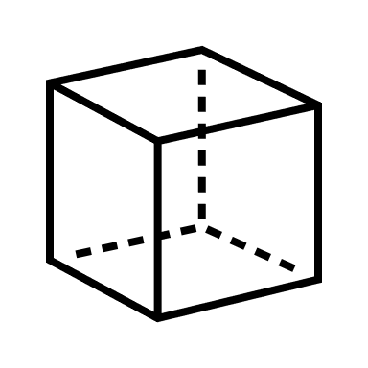

Conversion to

Pointcloud



Workspace Sensing

Collection of

2D LiDAR Scans

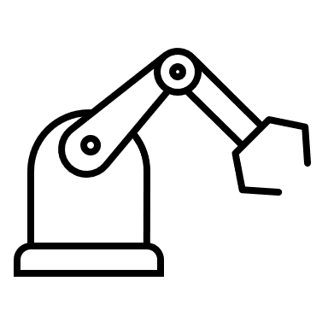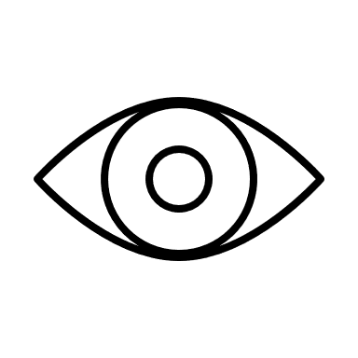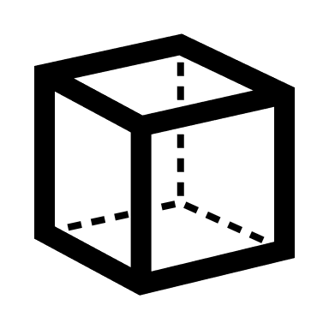

Conversion to

Pointcloud



Path Generation

Weld Seam

Transformation

Joint Velocity

Profile Generation

Workpiece Localization

Voxel

Filtering

RANSAC

Segmentation

ICP

Registration

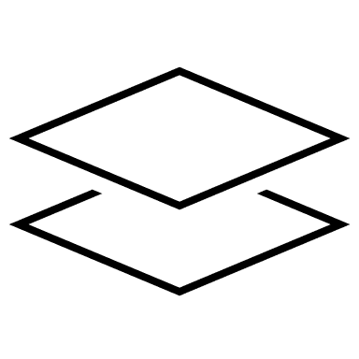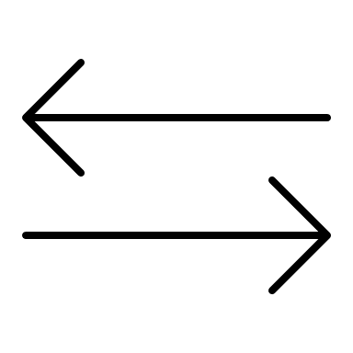

Figure 2 - Method for Automated Weld Path Generation