Model Preparation

Workpiece CAD

Model Generation

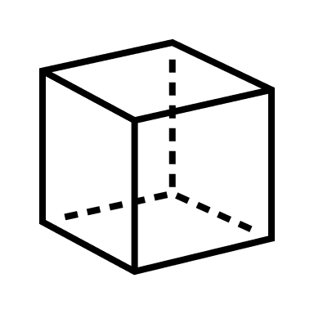

Conversion to

Pointcloud



Workspace Sensing

Collection of

2D LiDAR Scans

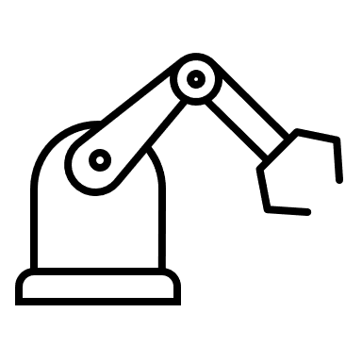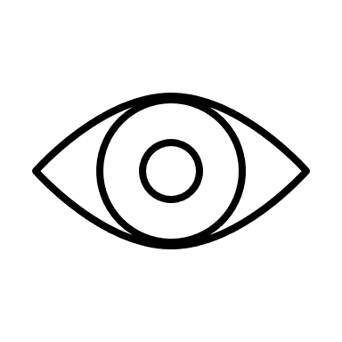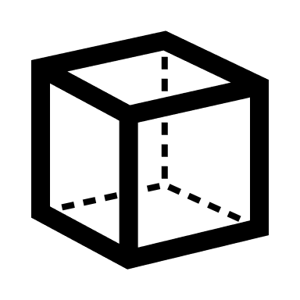

Conversion to

Pointcloud



Path Generation

Weld Seam

Transformation

Joint Velocity

Profile Generation

Workpiece Localization

PassThrough + Voxel

Filtering

RANSAC

Segmentation

ICP

Registration

