

**COLLEGE CODE : 9504**

**COLLEGE NAME :DR G U POPE COLLEGE OF ENGINEERING**

**DEPARTMENT : CSE**

**STUDENT NM-ID:4122921B2EE9B7EB97042BD86E090B16**

**ROLL NO: 9504231004047**

**DATE:06/10/2025**

**Completed the project named as Phase__5**

**TECHNOLOGY PROJECT NAME : PRODUCT CATALOG WITH FILTERS**

**SUBMITTED BY,**

**NAME:THILLAI RAJA M**

**MOBILE NO:63693 55154**

Project Title: Product Catalog with Filters

Final Demo Walkthrough

Overview:

The “Product Catalog with Filters” project is a web application that allows users to browse a list of products and filter them based on specific criteria such as category, price, rating, or availability. Demo Steps:

1. Open the deployed link .
2. View all products on the homepage.
3. Use the filter panel to select categories (e.g., Mobile,Laptop,Watch,Shoes).
4. Adjust the price range slider to narrow down products.
5. Use the search bar to find specific products.
6. Click on a product card to view more details.
7. Observe that the product list updates dynamically without page reloads.

Tech Stack :

* Frontend: React.js, Tailwind CSS
* HDaotsatibnags: eG: iMthounbg oDB

•

Project Report

Objective:

To develop an interactive product catalog web application with dynamic filtering, sorting, and search capabilities that enhance user experience and usability.

Key Features:

* Responsive UI displaying products in grid layout.
* RFieltaelr-sti mfoer csaetaergcohr yfu, npcritcioen raalnitgye., rating, and availability.
* Product details modal/page. API integration for fetching product data.
* Deployed live for public access.

Screenshots / API Documentation Screenshots:

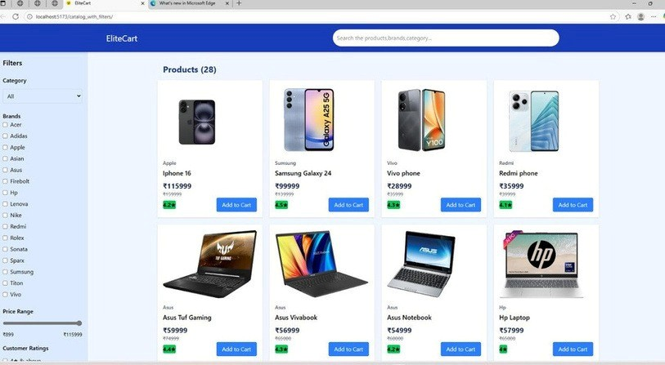

API Documentation Example (if applicable):

Method Endpoint Description

GET /api/products Fetch all products GET /api/products/:id Fetch product by ID

/api/products?

GET category=electronics Filter products by category

/api/products

POST Add a new product (Admin only)

Challenges & Solutions

Challenge Solution

Integrating multiple filters Used query parameters and state management

dynamically (React useState)

Slow API response due to

filtering Implemented server-side filtering and pagination

Responsive layout issues on mobile

Data not updating on filter Used Tailwind CSS responsive utilities change

Used React state hooks and dependency tracking in useEffect

GitHub README & Setup Guide Final Submission

GitHub Repo[:](https://github.com/siva-codez/catalog_with_filters) [Github Repo Lin](https://github.com/thillai001y-afk/catalog--with--filters)[k](https://github.com/siva-codez/catalog_with_filters)

Live Deployment: [Project Deploy Link](https://siva-codez.github.io/catalog_with_filters/):

Documentati[on](https://siva-codez.github.io/catalog_with_filters/): [(README): Included](https://siva-codez.github.io/catalog_with_filters/) in repository