PROJECT REPORT

Nurse Care
Management System
A Cloud-Hosted, Cross-Platform Nurse Staffing & Booking Platform

Web Application • Android Application • REST API Backend • Cloud Database

Prepared for: Company Management
Document Type: Technical & Functional Project Report
Version: 1.0
Date: July 4, 2026

Table of Contents

1. Executive Summary
The Nurse Care Management System is a full-stack healthcare staffing platform developed to digitize and streamline the process of managing, discovering, and booking qualified nurses for short-term and long-term care assignments. The system replaces manual coordination between hospitals/agencies and nursing staff with a structured digital workflow spanning two dedicated portals — an Administrative Portal for workforce management and a Member Portal for care-seekers to browse, book, and track nursing services.
The platform has been engineered as a cross-platform solution: it runs as a responsive website accessible from any modern browser, and it has been packaged as a native, installable Android application (APK) so that end users can access the same functionality from their mobile devices without depending on a browser. Both the website and the mobile app connect to a single, centrally hosted backend and database, ensuring that data (nurse records, bookings, accounts) stays perfectly synchronized across every device and access point.
The backend is a custom-built REST API written in plain Java (no third-party framework), backed by a cloud-hosted PostgreSQL database. The entire system is deployed using modern DevOps practices — containerized with Docker, version-controlled on GitHub, and continuously deployed to a cloud hosting provider — meaning the application is reachable over the public internet from any network, not limited to a single office or WiFi connection.
This report documents the system's objectives, functional modules, technical architecture, database design, API surface, security measures, deployment pipeline, and recommended next steps for the platform's continued growth.

2. Project Objectives
The system was designed to achieve the following goals:
- Provide a centralized digital record of all nursing staff, including qualifications, experience, availability, and contact details.
- Enable administrators to add, update, and remove nurse profiles through an intuitive management interface, with changes reflected instantly across the platform.
- Allow members (patients / care-seekers) to search and filter available nurses by specialization, and to book short-term or long-term nursing services.
- Maintain a single source of truth for data so the Admin Portal, Member Portal, website, and mobile app are always in sync.
- Support secure account creation and login for both administrators and members, with passwords stored using industry-standard hashing.
- Deliver the platform as both a responsive web application and a native Android mobile application from one shared codebase.
- Host the system on reliable cloud infrastructure so it is accessible from any location or network, with no dependency on a local machine being powered on.
- Keep the technology stack lightweight, transparent, and framework-free on the backend for maximum control and minimal operating overhead.

3. Scope of the System

3.1 In Scope
- Admin authentication (sign up / login) and an Admin Dashboard summarizing key workforce statistics.
- Full CRUD (Create, Read, Update, Delete) management of nurse records via the "Add New Nurse" and "Manage Nurse Database" modules.
- Member authentication (sign up / login) with a dedicated Member Home Portal.
- Nurse discovery and booking module ("Find a Nurse") for short-term and long-term care categories.
- Booking history and status tracking for members.
- In-app notifications tied to booking activity.
- A Contact Us / support messaging module.
- A Reports module summarizing member activity.
- A production-grade REST API backend with a persistent cloud database.
- A native Android application built from the same web codebase using Capacitor.
- Cloud deployment of the backend (Docker + Render) and database (Neon PostgreSQL).

3.2 Out of Scope (Current Release)
- Payment gateway integration for booking transactions.
- Real-time chat between members and nurses.
- iOS application packaging.
- Automated shift scheduling / calendar-conflict detection for nurses.
- Multi-language localization of the interface.

4. Technology Stack
The project deliberately uses a lightweight, transparent technology stack — avoiding heavyweight frameworks on the backend (such as Spring Boot) in favor of Java's native HTTP server APIs, giving full visibility and control over the request lifecycle with minimal operating overhead.
Layer | Technology | Purpose
Frontend (Web) | HTML5, CSS3, Vanilla JavaScript | Structure, styling, and client-side logic for both portals — no frontend framework overhead
Mobile Packaging | Capacitor (Ionic) | Wraps the existing web app into a native, installable Android APK
Backend / API | Java 17, com.sun.net.httpserver.HttpServer | Custom REST API — no Spring Boot or third-party web framework
Database | PostgreSQL (hosted on Neon) | Persistent, cloud-hosted relational data storage
Build Tool | Apache Maven (+ Shade Plugin) | Dependency management and fat-JAR packaging for deployment
Authentication | Salted SHA-256 password hashing | Secure credential storage for Admin and Member accounts
Containerization | Docker (multi-stage build) | Reproducible build & runtime environment for the backend
Hosting | Render.com (Web Service) | Public cloud hosting of the backend API, auto-deployed from GitHub
Version Control | Git & GitHub | Source control and CI trigger for automatic redeployment
Data Format | JSON over HTTP/HTTPS | Communication contract between all clients and the backend

5. System Architecture
The system follows a layered client-server architecture. A shared JavaScript module (api-client.js) is the single communication gateway used by every page in both the website and the Android app, ensuring identical behavior across platforms. All client requests travel over HTTPS to a single publicly hosted backend, which in turn is the only component with direct access to the cloud database.
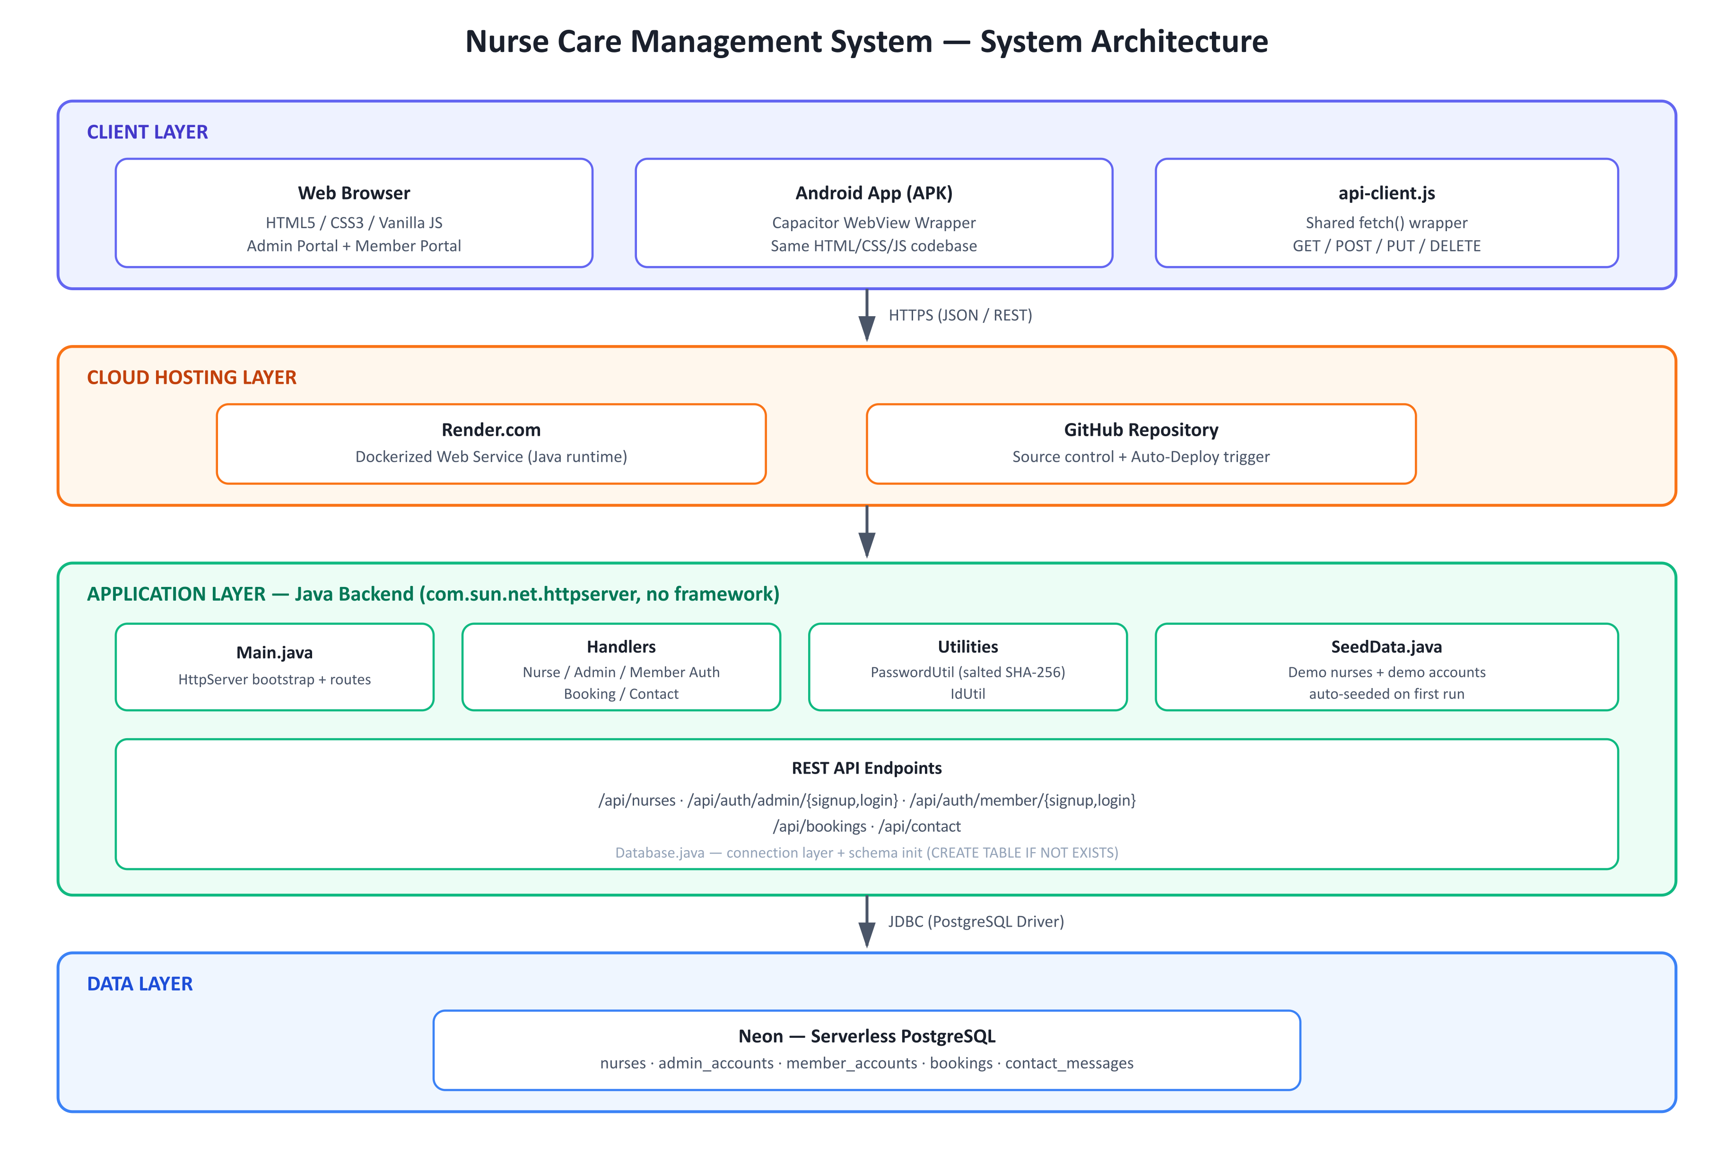

5.1 Architecture Layers
- Client Layer — The Web Browser and the Android APK both render the same HTML/CSS/JS pages and call the backend through the shared api-client.js fetch wrapper.
- Cloud Hosting Layer — GitHub stores the source code and triggers an automatic redeploy on every push; Render.com builds the Docker image and runs the live backend service.
- Application Layer — The Java backend (Main.java) starts an HttpServer, wires up route handlers for nurses, authentication, bookings, and contact messages, and seeds demo data on first run.
- Data Layer — Neon's serverless PostgreSQL database stores all persistent records — nurses, admin accounts, member accounts, bookings, and contact messages.

5.2 Why This Architecture
Centralizing all state in one cloud-hosted backend and database (rather than per-device local storage) was a deliberate architectural decision. It guarantees that a nurse added by an administrator is immediately visible to every member searching for care, that a booking made from the Android app appears instantly on the web dashboard, and that the system works correctly regardless of which network or device a user is on — a core requirement identified during development.

6. Functional Modules

6.1 Admin Module
The Admin Module gives hospital/agency staff full control over the nursing workforce and account administration.

6.1.1 Admin Authentication
- Admin Sign Up — creates a new administrator account, protected by a required invite code so that admin accounts cannot be created by the general public.
- Admin Login — authenticates against the backend using hashed credential verification.

6.1.2 Admin Dashboard
- Displays live, aggregated statistics about the nurse workforce (e.g. total nurses, availability breakdown), computed directly from the current database state rather than static or cached figures.

6.1.3 Add New Nurse
- A structured form capturing: full name, gender, age, nationality, years of experience, qualification, contact number, email, languages known, monthly salary (for a 12-hour duty schedule), equivalent one-day salary, skills, address, and additional operational fields (blood group, employee type, shift preference, joining date, certifications, emergency contact, availability status).
- Also supports Edit Mode, allowing an existing nurse record to be loaded and updated in place.

6.1.4 Manage Nurse Database
- A responsive, searchable table view of every nurse in the system with full Create, Read, Update, and Delete (CRUD) capability.
- Any change made here is immediately reflected in both the Admin Dashboard and the Member Portal's nurse search results.

6.2 Member Module
The Member Module is the patient/care-seeker-facing side of the platform.

6.2.1 Member Authentication
- Member Sign Up and Member Login, mirroring the security model of the Admin Module but scoped to member-level accounts.

6.2.2 Member Home
- A service catalog presenting the two core service categories — Short-Term Nursing Care and Long-Term Nursing Care — each with descriptive information to help members choose the right type of service.

6.2.3 Find a Nurse
- Live search and filtering across the full nurse database (sourced from the same backend used by the Admin Module), allowing members to identify suitable nurses and initiate a booking.

6.2.4 Bookings
- Members can create a booking request for a selected nurse and view the status and history of all their past and current bookings.

6.2.5 Notifications
- Automatically generated notifications related to booking activity, keeping members informed of status changes.

6.2.6 Contact Us
- A support/contact form that submits messages to the backend for follow-up by staff.

6.2.7 Reports
- A summary view of the member's activity and booking history within the platform.

6.3 Backend API Module
A plain-Java REST API exposing all functionality consumed by both the web and mobile clients. Full endpoint reference is provided in Section 7.
- NurseHandler — nurse CRUD operations.
- AdminAuthHandler / MemberAuthHandler — signup and login for each role.
- BookingHandler — booking creation and status updates.
- ContactHandler — contact/support message submission.
- SeedData — automatically populates demo nurses and demo accounts on first run so the system is immediately usable.

6.4 Database Module
A relational PostgreSQL schema (see Section 8) persisting all application state — nurses, admin accounts, member accounts, bookings, and contact messages — with schema creation handled automatically at backend startup.

6.5 Mobile Application Module
The same website is packaged into a native Android APK using Capacitor, configured to communicate securely with the live backend over HTTPS. This allows the platform to be distributed and installed as a standalone mobile app while remaining fully synchronized with the web version.

6.6 Deployment & DevOps Module
- Source code hosted and version-controlled on GitHub.
- Docker multi-stage build compiles the Java backend and produces a lightweight runtime image.
- Render.com hosts the containerized backend as a public web service with automatic redeployment on every GitHub push.
- Neon provides the managed, serverless PostgreSQL database consumed by the backend via environment-variable-based configuration.

7. API Reference
All endpoints are served under the /api base path, exchange JSON payloads, and are consumed identically by the website and the Android application.
Method | Endpoint | Description
GET | /api/nurses | List all nurse records
GET | /api/nurses/{id} | Retrieve a single nurse record
POST | /api/nurses | Add a new nurse
PUT | /api/nurses/{id} | Update an existing nurse record
DELETE | /api/nurses/{id} | Remove a nurse record
POST | /api/auth/admin/signup | Create an admin account (requires invite code)
POST | /api/auth/admin/login | Authenticate an admin account
POST | /api/auth/member/signup | Create a member account
POST | /api/auth/member/login | Authenticate a member account
GET | /api/bookings | List all bookings
POST | /api/bookings | Create a new booking
PUT | /api/bookings/{id} | Update a booking's status (e.g. cancel)
GET | /api/contact | List submitted contact messages
POST | /api/contact | Submit a new contact/support message

8. Database Design
The database schema is created automatically at application startup and is fully managed by the backend, requiring no manual database administration.
Table | Purpose | Key Fields
nurses | Nurse workforce records | id, fullName, gender, age, nationality, experience, qualification, contactNumber, email, languages, monthlySalary, perDaySalary, skills, address, availability, and more
admin_accounts | Administrator credentials | id, email, hashed password, salt
member_accounts | Member credentials | id, email, hashed password, salt
bookings | Member booking requests | id, member reference, nurse reference, status, dates
contact_messages | Support/contact submissions | id, sender details, message, timestamp

9. Security Considerations

9.1 Implemented
- Passwords are never stored in plain text — each password is salted and hashed using SHA-256 before persistence.
- Admin account creation is gated behind a required invite code, preventing unauthorized administrator signups.
- All client-to-server traffic runs over HTTPS once deployed to the cloud, protecting data in transit.
- Database credentials and connection details are supplied via environment variables, not hard-coded into the source repository.

9.2 Recommended Hardening for Production
- Restrict CORS to the platform's known domains instead of the current open (wildcard) policy used during development.
- Introduce session tokens / JWT-based authentication so authenticated requests are verified per-call rather than relying solely on login-time checks.
- Add rate limiting on authentication endpoints to mitigate brute-force login attempts.
- Rotate the hardcoded admin invite code periodically and manage it as a secret rather than a fixed constant.
- Add server-side input validation and sanitization on all write endpoints as an additional defense layer.

10. Deployment Architecture
The backend and database are hosted entirely in the cloud, removing any dependency on a local developer machine being powered on or connected to a particular network.
Component | Environment | Details
Backend API | Render.com (Web Service) | Built from a Docker multi-stage image (Maven build stage + JRE runtime stage); auto-deploys on every push to the GitHub repository
Database | Neon (Serverless PostgreSQL) | Managed, always-available Postgres instance; connected via DATABASE_URL, DATABASE_USER, DATABASE_PASSWORD environment variables
Source Control | GitHub | Single repository containing the frontend, backend, Dockerfile, and Android project
Web Client | Static HTML/CSS/JS | Served directly to any modern browser; communicates with the Render-hosted API
Mobile Client | Android APK (Capacitor) | Installed directly on Android devices; communicates with the same Render-hosted API over HTTPS

Because both the website and the Android app point to the same public backend URL, the platform works correctly from any network — home WiFi, office WiFi, or mobile data — fulfilling the requirement that the system not be restricted to a single local network.

11. Testing & Verification
The following verification activities were carried out throughout development:
- End-to-end functional testing of Admin Sign Up, Login, Add Nurse, and Manage Nurse Database (create, edit, delete) flows.
- End-to-end functional testing of Member Sign Up, Login, Find a Nurse, and Booking flows, confirming that admin-side changes are immediately visible on the member side.
- Cross-device consistency testing confirming that data created on the Android app is visible on the website and vice versa.
- Live API verification against the deployed cloud backend (e.g. confirming HTTP 200 responses and correct JSON payloads from the production /api/nurses endpoint).
- Network-independence testing to confirm the mobile app functions correctly while on cellular data rather than the same network as the backend.
- Resolved mobile-specific connectivity issues during development, including cleartext traffic restrictions, mixed-content blocking, and local network/firewall constraints — all addressed prior to the move to cloud hosting.

12. Future Enhancements / Roadmap
- Integrate a secure payment gateway to support paid bookings directly within the platform.
- Add token-based session authentication (JWT) for stronger per-request security.
- Introduce an in-app real-time chat or messaging channel between members and assigned nurses.
- Package an iOS version of the mobile application alongside the existing Android release.
- Add automated shift scheduling with conflict detection for nurse availability.
- Build an analytics dashboard for administrators covering booking trends, nurse utilization, and revenue (once payments are integrated).
- Introduce automated backend testing (unit and integration tests) and a CI pipeline gate prior to deployment.

13. Conclusion
The Nurse Care Management System successfully delivers a unified, cloud-connected platform for nurse workforce management and care-seeker bookings, accessible via both a responsive website and a native Android application. Its framework-free Java backend and managed PostgreSQL database provide a transparent, maintainable foundation, while its cloud deployment ensures reliable availability from any network. The platform is functionally complete for its defined scope and is well positioned for the enhancements outlined in Section 12 as the product grows.

Appendix A — Demo Access Credentials
Role | Email | Password
Administrator | admin@hospital.com | Admin@1234
Member | member@hospital.com | Member@1234

Note: These are seeded demonstration accounts created automatically on first backend startup, intended for internal evaluation and demonstration purposes only. It is recommended that these credentials be rotated or disabled before any public/production release.

