Abstract
The flocking algorithm introduced by Criag Reynolds enables automatic simulation of crowds, flocks, schools, and swarms. This has been useful in situations where large crowds or flocks need to be animated which is extremely difficult using traditional animation techniques. The flocking algorithm uses a number of parameters to influence the behavior of the flocking animation. Depending on how the parameters are set, a large variety of animations can be produced. When attempting to create animations with a particular characteristic, there is not always an intuitive mapping between the parameter values and the desired animation. This project looks at how an Interactive Genetic Algorithm can be used to set flocking parameters to create flocking animations that express a desired characteristic though user voting.

Introduction
Creating an animation that expresses a characteristic such as an emotion or feeling is a difficult task. This becomes more challenging when the animation involves a large number of entities such as large crowd or flock. The flocking algorithm introduced by Criag Reynolds allows for easy creation of large flocking animations, but it does not provide an intuitive way to control an animation to give rise to desirable characteristics. The animator is left with a number of parameters to tweak, that do not have an obvious mapping to characteristic the flock should show.

Even though animations that show a characteristic well are challenging to make, they are easy to recognize. The goal for this project is to automatically generate animations where the user can recognize and select animations that partially express their target characteristic. The selected animations are then combined with added variation to create new animations that are similar to the selections.

A technique that aligns itself well with this idea is an Interactive Genetic Algorithm. This algorithm is used to generate multiple candidate sets of parameters used to control the flocking animation. The interactive part of the algorithm allows the user to rate the generated animations. The algorithm then creates new parameter sets by combining the parameters that led to higher rated animations.

Background
Illustration 1: Cohesion
Illustration 2: Alignment
Illustration 3: Separation
//TODO
Flocking
The flocking algorithm uses the approach of controlling each flock member, or boid, independently based on its surroundings. This similar to the way a real flock of organisms work. Each boid keeps track of its own position and velocity. During each time step step of the animation, each boid changes its position based on its current velocity. It will then check its surroundings to see how its velocity should be adjusted.

The factors that influence a boid’s velocity during an animation time step are called steering behaviors. Each steering behavior is calculated as a force on the boid that changes its current velocity. In the flocking algorithm there are three main steering forces: cohesion, alignment and separation.

Cohesion is the behavior that is responsible for keeping a boid close to surrounding boids. The boid checks to see how many other boids are within its local neighborhood, a predefined distance from the boid. It then calculates the local neighborhood’s center point, not including itself. The cohesion force is the vector from the boid’s own center toward the neighborhood center.

Alignment is the behavior responsible for keeping a boid aligned in the same direction the flock. The boid again checks its local neighborhood to determine which boids are nearby. The average heading of the surrounding flock mates is found. The alignment force is then a vector that directs the boid toward the average heading.

Separation is the behavior responsible for keeping distance buffer between a boid and its surrounding neighbors. First the boid determines which flock mates are in its local neighborhood. For each neighbor in the neighborhood, a force vector from the neighbor to the boid is created. These are scaled so that a closer neighbor contributes more force than a further neighbor. The final separation force is the sum of each of these vectors.

The combination of these steering behaviors is defines the local behavior of each boid in a flocking animation. When each member of the flock has similar local behavior, it gives rise to the appearance of an organized flock.

Interactive Genetic Algorithms
Genetic algorithms in general make use of ideas from evolution as an optimization technique. When finished, the genetic algorithm will return a bit string or list of numbers as a result. This information is then interpreted to use as parameters in a related program or problem. The algorithm attempts to find the best possible list of numbers to return for the problem being solved.
The algorithm maintains a collection of candidate solutions, each one represented by the list of number that wold be returned if selected. Sticking with the theme of evolution the collection of candidate solutions is referred to as the population. A single candidate solution is an individual within the population. The encoded list of numbers that each individual is associated with is the individual's chromosome. As the algorithm runs the population changes, the population associated with a particular iteration is named a generation.
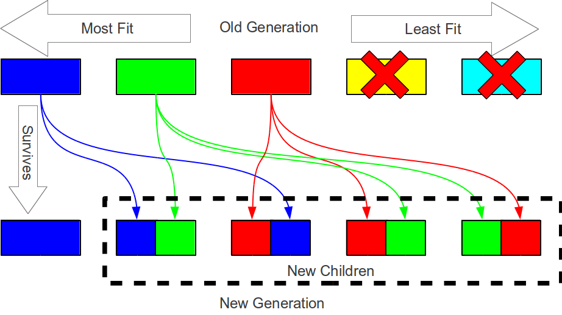Illustration 3: Genetic Algorithm
The first step in a genetic algorithm is to determine the fitness of each individual in the current population and sort the population so the most fit individuals are first. In a normal genetic algorithm the fitness of an individual is determined by a fitness function. The fitness function is able to interpret each individual's chromosome and evaluate how well it solves the current optimization problem without user intervention.
After the current generation's population is sorted by fitness, the next generation's population is created. A small percentage of the most fit individuals of the previous generation live on in the next generation without any alterations to their chromosome. The remainder of the new population is produced by combining the chromosomes of the most fit individuals from the previous generation. This is referred to as breeding. The percentage of fit individuals that live on in the next generation can be different from the percentage of individuals that take place in the breeding process. The least fit individuals do not contribute anything to next generation. An overview of this process is shown in Illustration 3.
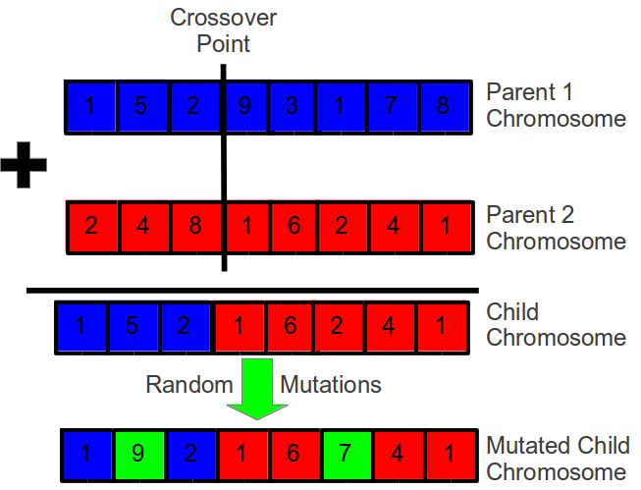Illustration 4: Crossover and Mutation
During the breeding process, a new individual is created by combining the chromosomes of two parent individuals from the previous generation. This combination of two chromosomes is done by crossover and mutation. Crossover works by first randomly selecting a crossover point. The crossover point is a integer between 0 and the size of the chromosome. The child chromosome is created from the beginning of the first parent's chromosome that falls before the crossover point and the end of the second parent's chromosome that falls after the crossover point. Based on a predetermined mutation probability, random values in the newly created child chromosome may be altered to introduce new variation in the population. The child chromosome will always be the same length as the two parent chromosomes.
An interactive genetic algorithm (IGA) differentiates itself from a standard genetic algorithm in that user intervention is required during the fitness evaluation. Because a user needs to evaluate every individual in every generation, interactive genetic algorithms deal with the problem of user fatigue. This prevents the population size and the number of generations from being too large.

The algorithm runs for a predefined number of generations. At the end of the last generation the most fit individual is returned.

Using the Program
When loading the page, the first screen shown is the main menu. If you have a save string from a previously view animation and wish to view it, you can paste it into the load text box and press the 'Load” button. Before running the Interactive Genetic Algorithm, there are a few parameters that need to be set.
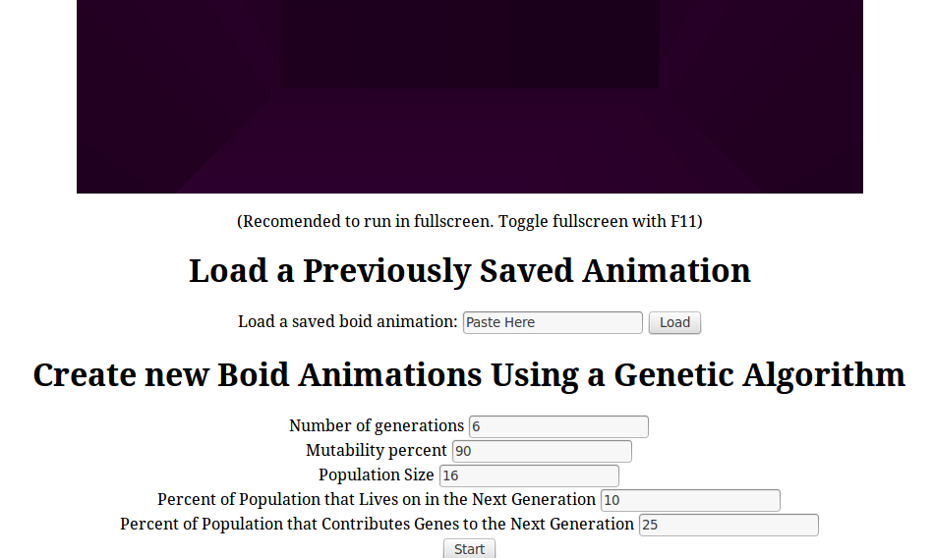Illustration 5: Main Menu
Number of generations: This determines the number of rounds of voting and generation that will take place before a final selection is made.
Mutability percent: This is the probability that a mutation will occur when a new candidate solution is created.
Population Size: This is the number of animations in the population that must be voted on for each generation.
Percent of Population that Lives on in the Next Generation: This determines what percentage of the animations from each generation will continue unaltered to the next generation. The individuals that continue on are the most fit based on voting.
Percent of the Population that Contributes Genes to the Next Generation: This determines what percentage of the highest rated animations will be selected for breeding to produce new animations for the next generation.
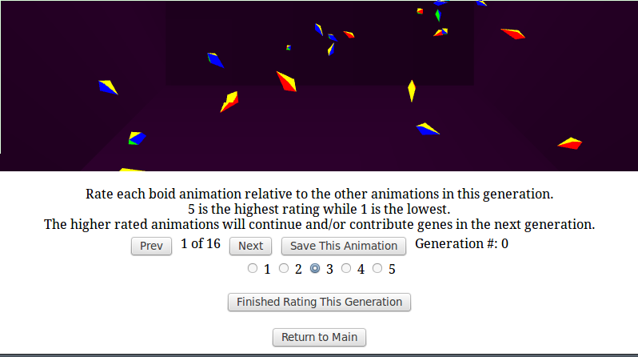Illustration 6: Voting Screen
The voting screen allows the user to rate each animation in the current generation. This is the interactive part of the Interactive Genetic Algorithm. On this screen the rating of the current animation is shown by which radio button is selected, with the default being 3. A new rating is given to the current animation by selecting a different radio button. 5 is the highest rating an animation can get while 1 is the lowest. The animations available in the current generation can be cycled through by pressing the 'Prev' and 'Next' buttons. The rating given to each animation should be relative to the other animations in the current generation. When the rating is finished for the current generation, the 'Finish Rating This Generation' button is pressed to continue to the next generation.
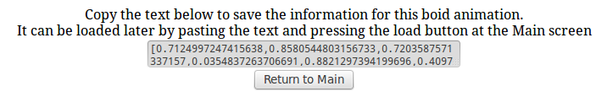Illustration 7: Save Text
If at any point any animation is viewed that should be saved, the 'Save This Animation' button should be pressed. This will cause the save text to appear below the 'Finished Rating this Generation' button. When the text field is clicked it will automatically highlight the save info. Simply copy and paste this information to a safe area. The saved text can be used to load the animation again later at the main menu.
When the voting for the final generation is finished, the user the animation for the highest rated individual is displayed.
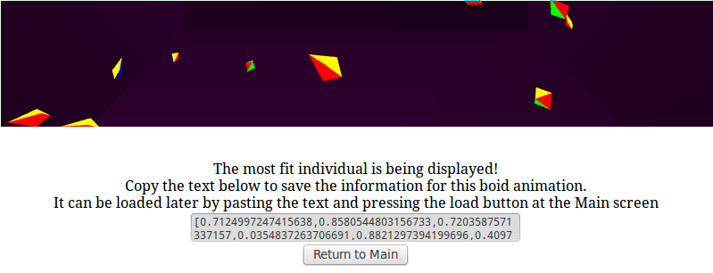Illustration 8: Final Screen

Technical Overview
The core technologies used in this project were HTML5, Java Script and WebGL. Illustration 7 shows a layered architecture of all the technology used and the major components developed in the project.
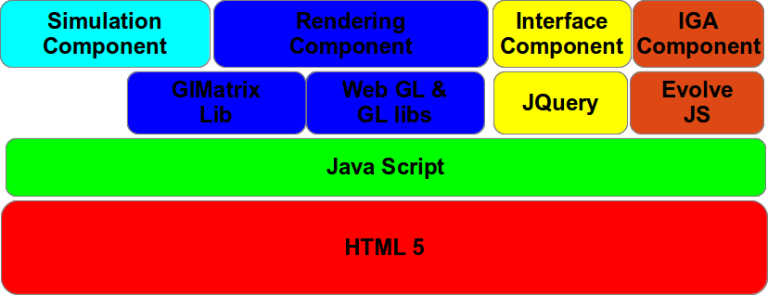Illustration 9: Project Architecture
Simulation Component
The Simulation Component was the first part of the project that was developed. It was implemented directly in javascript and only has dependency on the GL Matrix library to make use of its vector and matrix functionality. The Simulation Component is composed of two files, boid.js and flock.js which are found in the models directory.
Boid.js controls all of the logic that directly deals with creating an individual boid. It contains the functions for updating an individual boid's position, velocity and orientation during a simulation time step. Behaviors are abstracted as functions that keep track of their own local neighborhood and can return a steering force.
Flock.js is where the actual behavior functions, cohesion, separation, and alignment, are implemented. The functionality for spawning a group of boids in a cluster is handled by the spawn flock function. When a group of boids is created an id must be provided. For different groups to interact with each other, they must have the same id. This allows for the option to have groups of independent flocks if desired.
Rendering Component
The Rendering Component is composed of two files, boid-main.js in the main directory and pyramid.js in the models directory. The Rendering component is dependent on WebGL. It handles the definition of the boid models, keeping running the simulation clock, and rendering the simulation. The boid-main.js handles the main program loop along with setting up and interacting with WebGL. Pyramid.js contains the model information for the boid.
Boid-Main.js is composed of three main parts: initialization functionality, environmental variables, and the main rendering/animation loop. The environmental variables are used throughout the program to have a consistent place for constant and shared variables in the program.
Walking through the initialization, it start with a call to initGL which populates the gl variable with the HTML5 cavas's WebGL component. The gl variable is the how the program interacts with WebGL in the remainder of the program. The next call initShaders, is responsible for initialization of the fragment and vertex shades. Since we are working with HTML5, each of the shader are added as their own script components in the index.html web page. The getShader function handles retrieving the shader code for each of the shaders and compiling it with WebGL.
The fragment shader is very simple and only handles the color change in the boid models. The vertex shader is a bit more complex, but not very. The shader expects a position and a color vector for each vertex being rendered. Additionally, WebGL does not automatically support a Model View and Perspective Matrices so they must be implemented and maintained. The uMVMatrix and uPMatrix are the variables uses by the shader to keep track of these matrices for the scene.
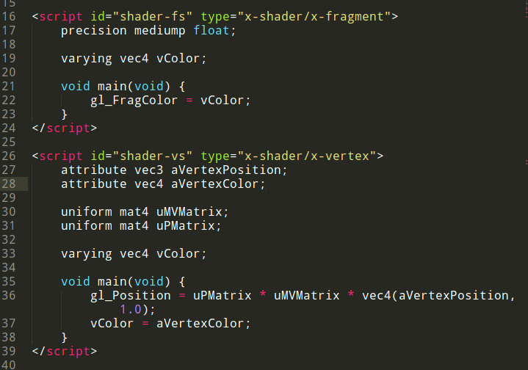Illustration 10: Shader Scripts
After the initShaders function obtains a reference to the combined fragment and vertex shader, it needs to construct a WebGL shader program that links them with the WebGL object. One of the convenient features of javascript as a scripting language is that any object can take on new attributes. In the end of the initGL function, references to the memory location of the shader variables can be stored directly in the shader program object.
Once the shaders are initialized, the buffers must be also initialized. This is done by a call to initBuffers. A vertex and color buffer for the boid model are created by making a call to the WebGL object. The newly created buffers are then passed to the pyramid.js function setupPyramidBuffers. This function adds all of the vertex and color information for the boid model into the WebGL buffers. Similarly buffers are made for the background scene and are initialized by a call to setupWallBuffers.
At this point WebGL is initialized and ready to run. The tick function is the main loop of the program. The requestAnimFrame is function from the webgl-utils library and takes tick as a callback function. The requestAnimFrame function is a browser independent way of making sure the render loop is only called when the tab is visible. The tick main loop makes a call to drawnScene which renders the current scene and then to animate to update the simulation state.
The drawScene function starts by clearing the previously rendered scene and setting the perspective and move matrices to their initial states. The javascript variables mvMatrix and pMatrix keep track of 4x4 matrix objects from the glMatrix lib. Its not until setMatrixUniforms that the mvMatrix and pMatrix are updated in the shader program.
The function then renders the walls in the background of the scene. The call to bind buffer informs WebGL to look at a particular buffer. Any subsequent calls that use a buffer will assume that they should affect the currently bound buffer. The call to vertexAttributePointer is how WebGL knows which buffer is associated with which shader variable. The call to drawTriangles is the WebGL function that actually renders the background and interprets the vertex information as a list of triangles.
The same is then done for the boid color and position buffers. Because each boid has a different position and orientation, we need to change the model view matrix before rendering each one. To make this easier, mvPushMatrix and mvPopMatrix was implemented to keep a stack of transformation matrices similar to the way OpenGL functions. The getTranformation function is called for each boid in simulation. The returned transformation matrix includes the translation and rotation transformations specific to the boid. After updating the model view matrix a call to drawTringles renders the boid. This is repeated for every boid in simulation. Because the boids use the same model, the buffers only have to be loaded once per render step and only the Model View matrix needs to be udpated.
By default, no boids are loaded into the simulation. A call to init boids loads a predefined example or a call to loadBoids takes an array of 43 floats that encode the information for a simulation. The load boids method is there for easy interfacing with the interactive genetic algorithm.
Interactive Genetic Algorithm Component
The interactive genetic algorithm(IGA) is tied to the files environment.js in libs/evolvejs and boids-ga.js. The environment.js is partially from the evolvejs github project which was used. This library was used because it was native to javascript, lightweight, and easy to modify. A number of modifications were necessary to add interactive functionality. The boids-ga.js handles the interface logic and the project specific components of the IGA such as the fitness, mutation, and generation functions.
Environment.js takes care of the main plumbing needed in a genetic algorithm which is the main generation loop. The generation loop calls a evaluation and generation function for every generation. The javascript object 'my' keeps track of all of the parameters and functions being used by the algorithm. The default values of this object are expected to be overwritten by a class making use of the library. Two major changes were made to environment.js. By default, there was no interactive component. The generation function was broken up into two functions, generation and generationAfterInteractiveStep. A callback function named 'interactiveStep' can be overwritten to allow for an interactive step in each generation before the fitness evaluation. When finished 'generationAfterInteractiveStep' is expected to be called to continue to the next generation. The second change was allowing to differentiate the percentage of the population that will contribute genes to the next generation from the percentage of the population that will survive. This allows for more control which is necessary when working with small population sizes.
The boids-ga.js source file contains the project specific functions for the IGA. The Environment.Individual function overrides the default individual constructor. The constructor defines the chromosome as a array of 43 random floats between 0 and 1. It is d efines the the mating function between two individuals. The mating function used is a single crossover between the two parent chromosomes. The last step in the mating function is mutation. The newly created chromosome will continue to be mutated as long as number random number generated is between 0 and the mutation probability. When a mutation occurs, a random index of the chromosome array is chosen and is set to a new random number between 0 and 1.
Interface Component
The interface component is made up of the index.html file along with the interface logic in boids-ga.js. JQuery is used to make selection and registration of callback functions easier and cleaner.
Index.html describes the layout of the page and includes all of the scripts used. The canvas element is the HTML5 element where the WebGL scene renders itself. There are a number of divs that separate different menus.
Boids-ga.js registers callback functions for each of the buttons in the program. Most of the callback functions contain interface logic that changes which menu is visible based on the state of program. The 'start' button's callback function is what launches the IGA with the parameters defined by the user. The raido buttons' callback functions stores the rating the user gives each member of the current population in the userRating array. This is used in the fitness function to give each individual in the population its fitness. The loadMember function interfaces with both the IGA and the boid simulation. It gets the current chromosome from current member of the IGA's population and passes the parameter information to the boid simulation via the loadBoids method.

Results

Future Work

