Cybersecurity

Name:Thiloth b Shetty

USN:4MT19CS171

1. pick 5 website,find its ip address ,give classification of ip address it belongs ?

1 google.com

Ip address: 142.250.195.36

Class:B

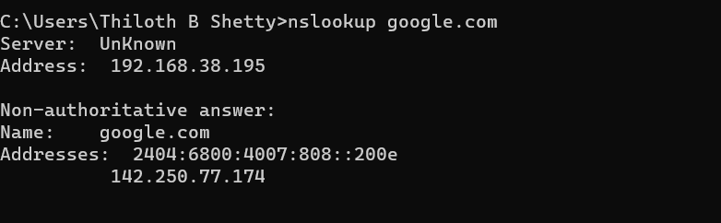

2 amazon.in

Ip address: 54.239.33.92, 52.95.116.115

Class:A

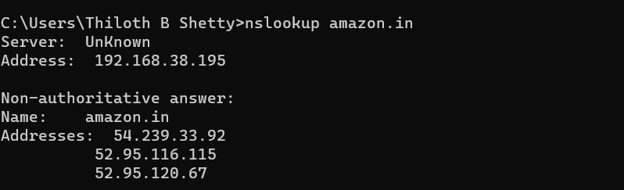

3 Youtube.com

Ip address: 142.250.77.110

Class:B

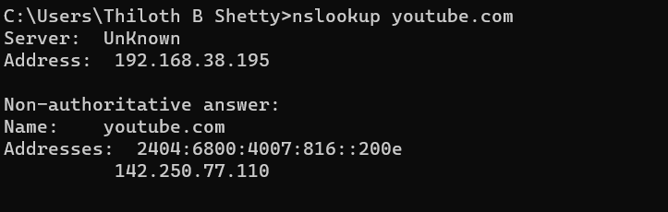

4 mite.org

Ipaddress: Address: 76.76.21.21

Class:A

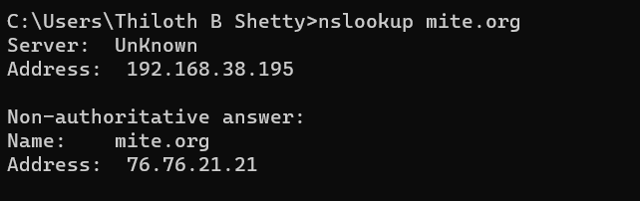

5 flipkart.in

Ip address: 15.197.142.173, 3.33.152.147

Class:A

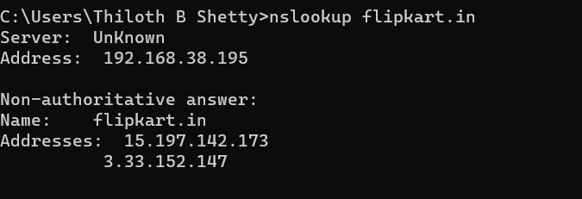

2.check your system ip address and sub net mask,define the network portion and host portion?

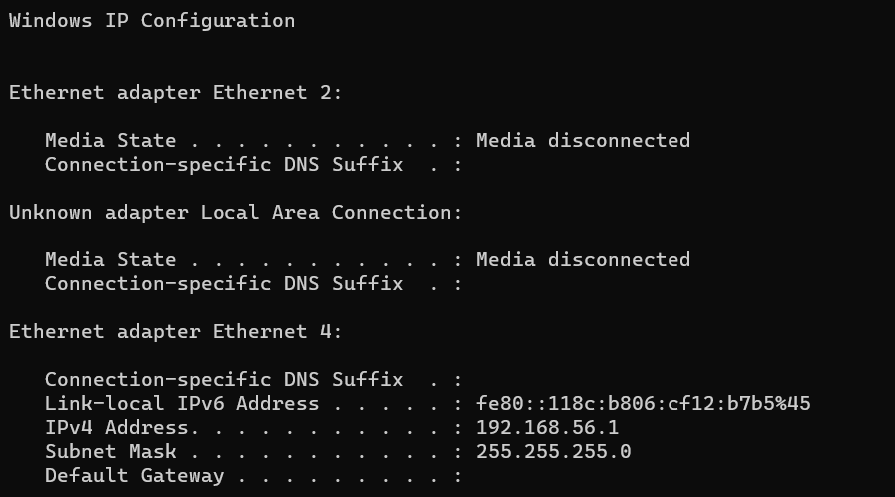

Ip address of the laptop: 192.168.56.1

Subnet mask: 255.255.255.0

Network portion: 192.168.56

Host portion: 1

**Assignment 3**

1.Pick 5 different website and perform passive information gathering using all the tool and write report?

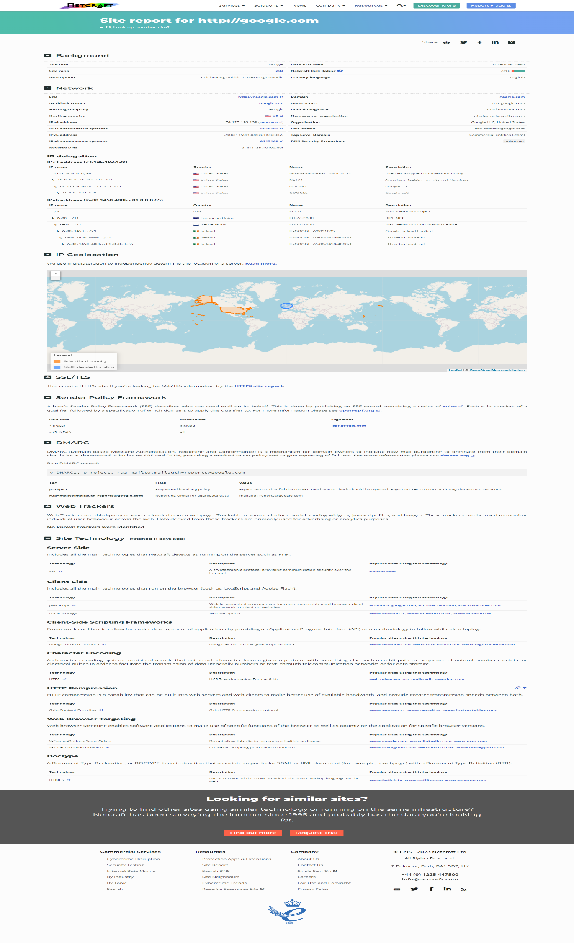

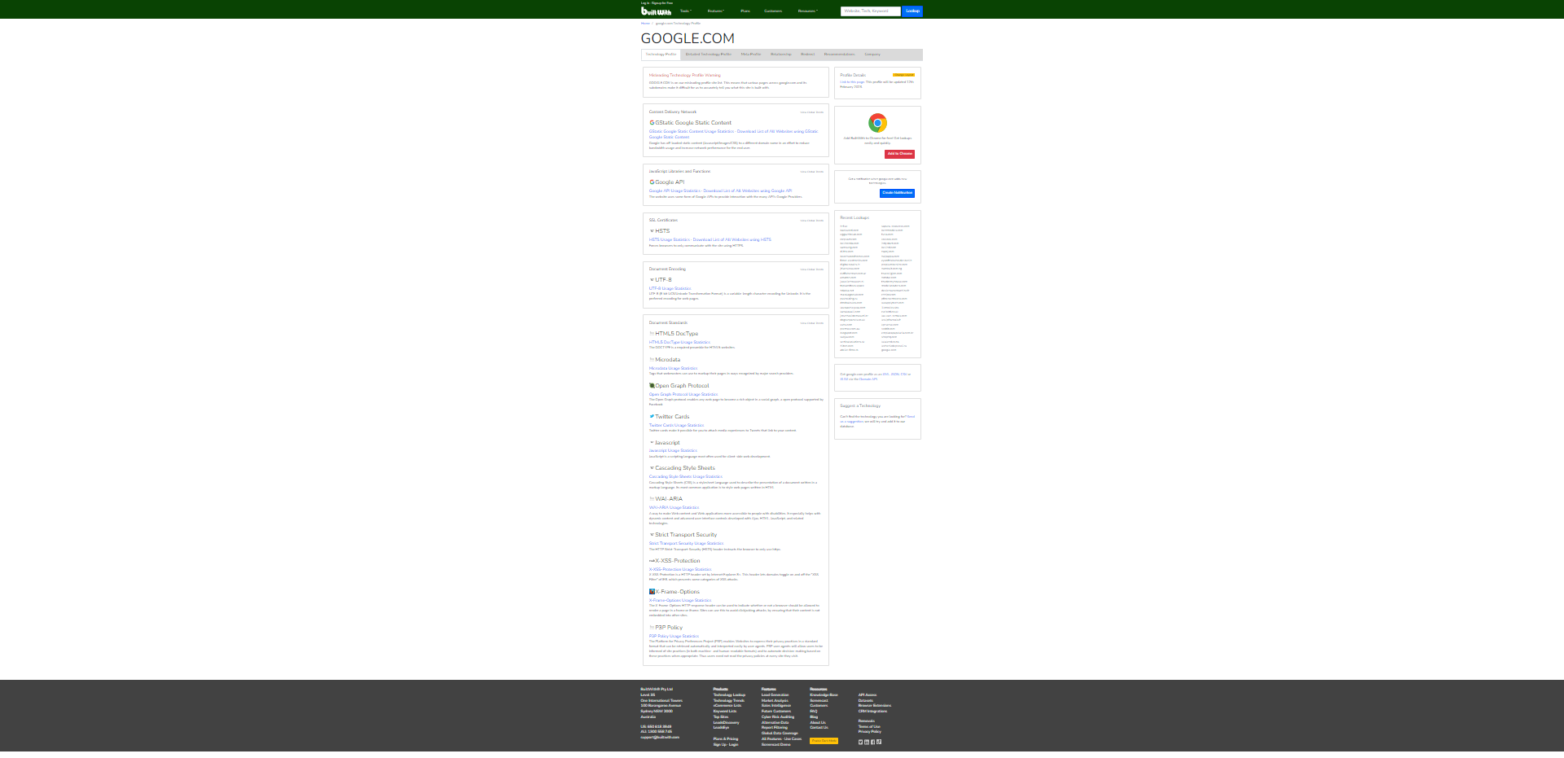**assignment 4**

**1.**check your ipconfig

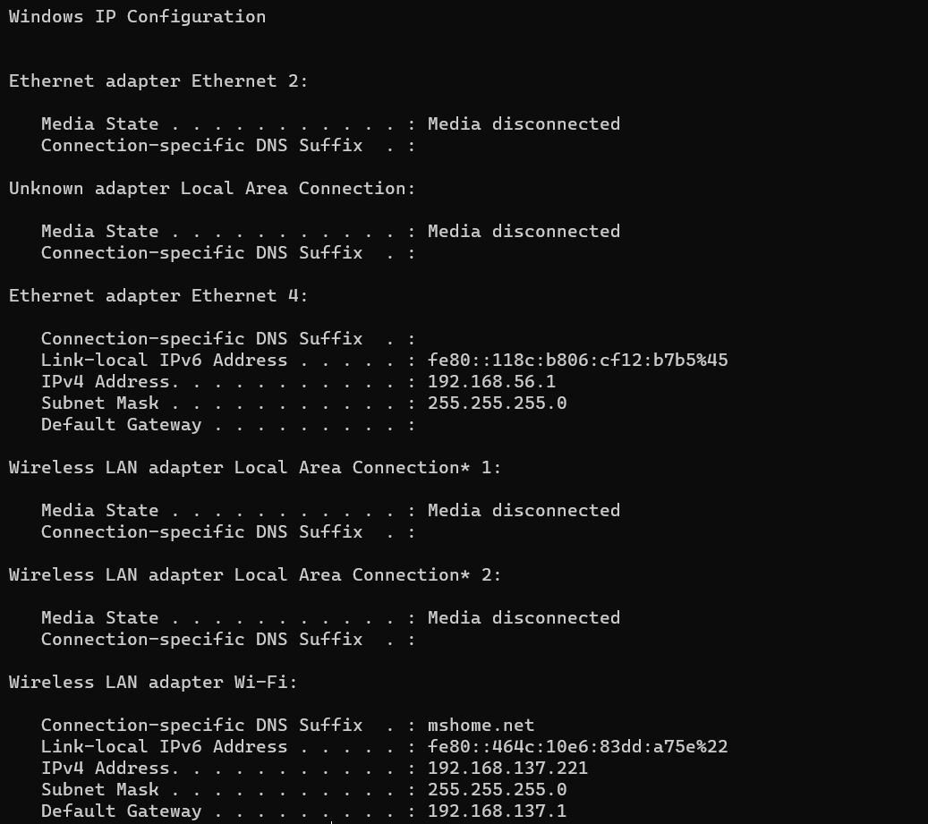

2.check your arp cache and provide the screenshot?

