Ricardo Krause

Kaser23@gmx.de

Exposee

This document contains the user documentation of the simple markdown to html parser tool and describes all possible steps of user interaction with the system.

Simple MD to HTML

User documentation

Inhaltsverzeichnis

Introduction 1

User Interface 1

Parsing 0

Syntax 0

History 0

# Introduction

The simple markdown to html parser is a tool that translate a simple set of markdown syntax into equivalent html syntax.

# User Interface

The user interface is separated in three parts:

* Syntax box

This box (Figure 2) displays the syntax for the parser which can be inserted and parsed.

* Input and results

In the center (Figure 1) is the input box and next to it the output as string and HTML

* History

On bottom (Figure 1) is a history of the last inputs.

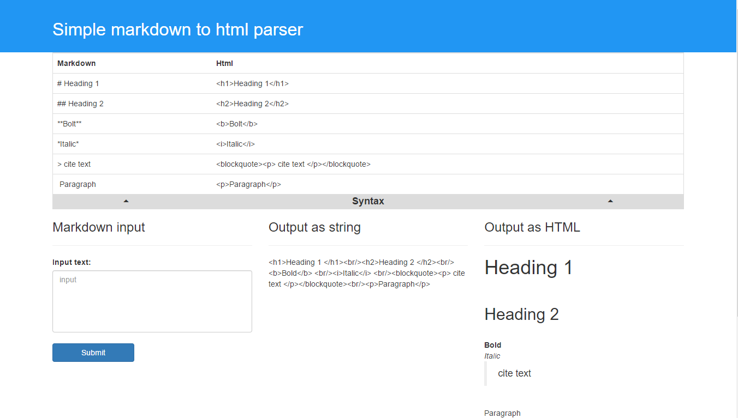

Figure 2: User interface with syntax box

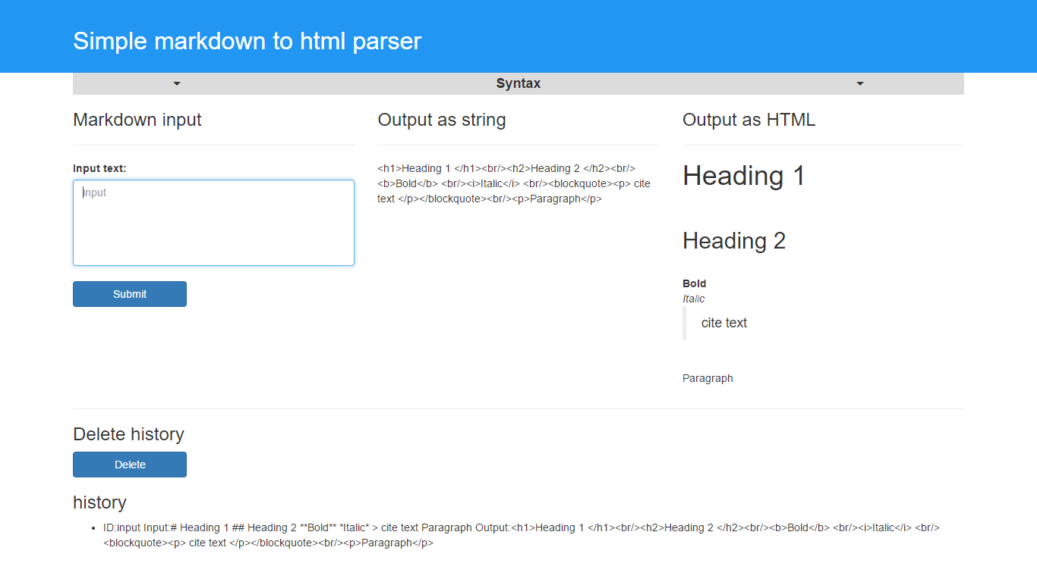

Figure 1:User interface

# Parsing

To parse a markdown text to html, enter the text in the text area **1.** and submit the text by clicking the submit button below. After the parsing process the result is displayed as string **3.** and as html **4.**.



Figure 1: Parsing process

4.

3.

2.

1.

# Syntax

To support the user with the right syntax is a syntax-table **2.** located on top of the user interface under the blue header. To show or hide click on the syntax button **1.** with the two arrows.



Figure 2: Syntax table

2.

1.

# History

On the bottom of the view is a history **1.** of the last inputs. The user can delete this history by clicking the delete button on top of this history **2.**.

Note: On each start the history will be cleaned by the system.

Figure 3: History

2.

1.