PYTHON BASE 20240722 Squadra 1

Agenda:
- Introduzione di base al linguaggio. (funzioni, cicli, tipi di dati, variabili, strutture dati)
- Notebook (Jupyter); Ambienti; Librerie
- Numpy
- Pandas

Link ai disegnini: https://drive.google.com/file/d/1jO22P6Iy49KYoKyNjdCrIy3TcXlpls0S/view?usp=sharing

Link alla cartella dei materiali:
https://drive.google.com/drive/folders/1mx5mF5XwZOv5-1_G8SowONp4vF8-bupv?usp=sharing

PRESENTAZIONI
- Ruolo in azienda
- Perché interessa Python
- Esperienza precedente in Python o in altri linguaggi (SAS, R, Matlab…)
- Argomenti del corso, cosa interessa, cosa manca

LOGISTICA: 9 - 13
pausa 1: 10.30-10.45
pausa 2: 11.45-12.00

Pomeriggio
14-17 (14.05)
1 pausa 15:50 - 16:15

Stack, Heap, Oggetto, Mutabilità e Immutabilità
Garbage Collection, Riferimenti

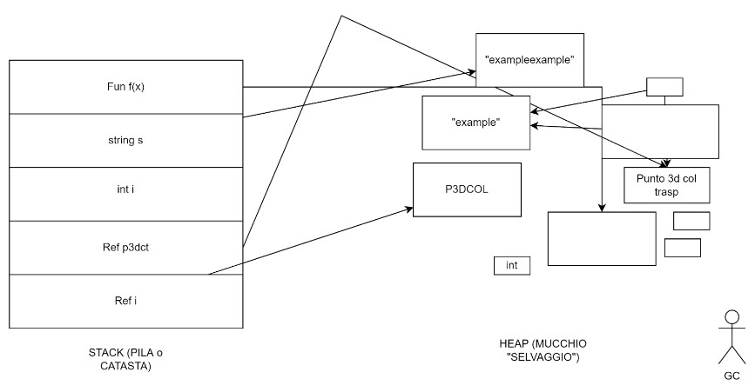
Tipi base e built-in function di base
Container
- Ordinati e non ordinati
- Mutabili e Immutabili

str, list, tuple, set, dict
https://colab.research.google.com/github/thimotyb/real-world-machine-learning/blob/python3/learning-python3.ipynb

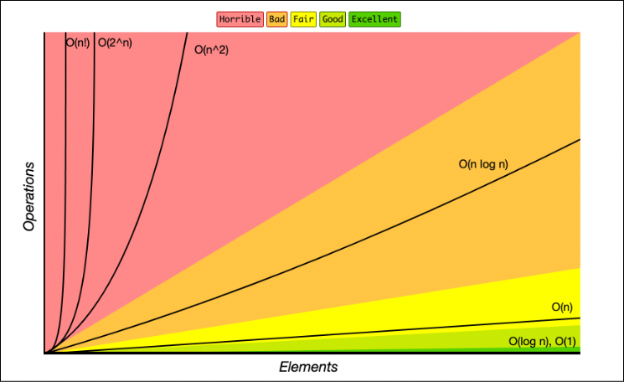

Documentazione più semplice: Python Tutorial: https://docs.python.org/3/tutorial/index.html

Esplorazione dei tipi standard: https://docs.python.org/3/library/stdtypes.html

Metodi Stringa: https://docs.python.org/3/library/stdtypes.html#text-sequence-type-str

String FOrmatting: https://docs.python.org/3/library/string.html#format-specification-mini-language

Operazioni / Metodi su tipi di sequenze: https://docs.python.org/3/library/stdtypes.html#sequence-types-list-tuple-range

Tutte le funzioni in python sono un OGGETTO -> Quando vengono dichiarate entrano nello heap, ricevono un riferimento , e possono essere invocate con (), eventualmente con gli argomenti

Argomenti con default, e la chiamata con chiave oppure posizionale

Pattern con ciclo “ad accumulo” sulla lista

Lambda Functions: dichiarare espressioni da passare come parametro agli argomenti di altre funzioni, creando delle “funzioni anonime”

FOrmat String Syntax: https://docs.python.org/3/library/string.html#format-string-syntax

String FOrmatting: https://docs.python.org/3/library/string.html#format-specification-mini-language

For Loop:

for i in range(0,len(words)):
print("This is number {0} in the {1} loop.".format(i, words[i]))

MODULI
Un modo per esternalizzare e mettere a comune funzioni scritte in python
File esterno: fibo.py
import fibo

Standard Library: una ampia collezione di moduli: statistics, os, sys
import statistics as stat
stat.mean(.....)

Librerie Esterne: numpy, pandas, scikit-learn…. vanno installate separatamente nell’ambiente usando il package manager: PIP
!pip list (per vedere se il package è installato e QUALE VERSIONE). (il ! serve per bypassare python e mandare il comando direttamente al sistema operativo)

import numpy as np
import pandas as pd

Eccezioni:
try: …. except ValueError: ….. (ValueError, una delle possibili eccezioni)
Nel blocco try si mette il codice che potenzialmente genera un’eccezione, e except codice che la gestisce senza necessariamente interrompere il programmo

- Utile ad esempio: gestione file, gestione connessioni al db, conversioni di tipo su variabili che vengono passate per argomento (non siamo sicuri del tipo effettivo della variabile)…..

Numpy:
https://colab.research.google.com/github/thimotyb/AnatomyOfMatplotlib/blob/master/AnatomyOfMatplotlib-Part0-Intro2NumPy.ipynb

- ndarray.shape (10,) … (5,80).... array, matrici, tensori
- numpy.float64 (tipo per numero decimale a precisione controllabile -> indispensabile per fare matematica corretta con grande quantità di numeri - NON USARE float base di python)
- esempi di creazione di array (da una lista, usando arange, rand.random (distribuzione)).
- broadcasting: consente di operare con vettori di dimensionalità diverse, “estrudendo” una delle dimensioni.

4x20x5
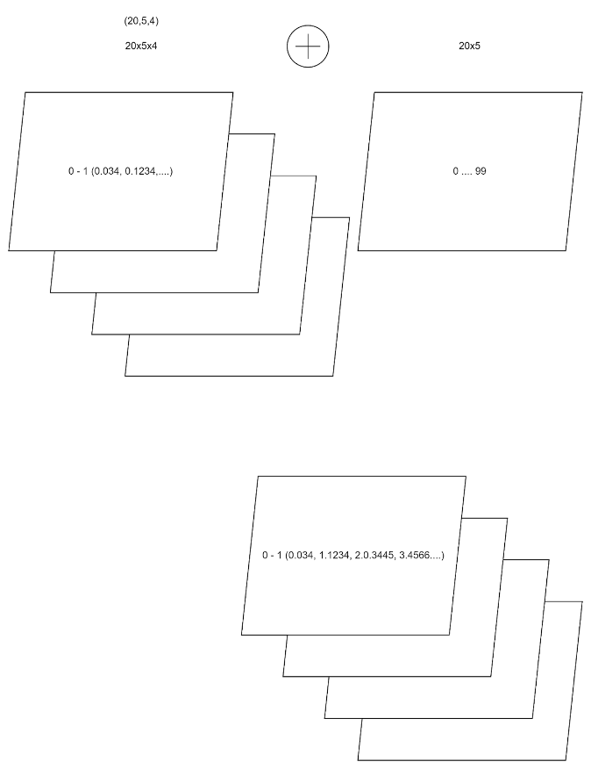

Pandas - Libreria per Data Analysis
Lavora caricando l’intero dataframe in memoria (se si riesce a far stare tutto in memoria, meglio). -> altrimenti bisogna su framework di calcolo distribuito: Hadoop, Spark, Dask. (tutti e tre offrono la possibilità di distribuire calcolo scritto in python).

Dask: https://www.dask.org/ (utilizza la stessa sintassi di Pandas)

Pandas Getting Started: https://pandas.pydata.org/docs/getting_started/intro_tutorials/index.html

PANDAS DATAFRAME NOTEBOOK:
https://colab.research.google.com/github/thimotyb/real-world-machine-learning/blob/python3/pandas-dataframe.ipynb

- Series (unisce una lista di valori, con un vettore di indice), consente di accedere al valore tramite l’indice
- L’indice può essere implicito = RangeIndex (1.2.3.4.5).
- Una Serie tende ad avere un tipo omogeneo (dtype) -> Se i valori lo consentono, la serie converge sul tipo più adatto (1, 3, 4.5, 6, 1.1) -> conversione automatica in numpy.float64. Se invece i tipi sono disomogenei, il dtype è object e ciascun valore mantiene il tipo originale (int, float, str….)
- La Serie coincide concettualmente con una “colonna” di una tabella di un db (-> tende ad omogeneità di tipo)
- Accostando più Serie otteniamo un DataFrame

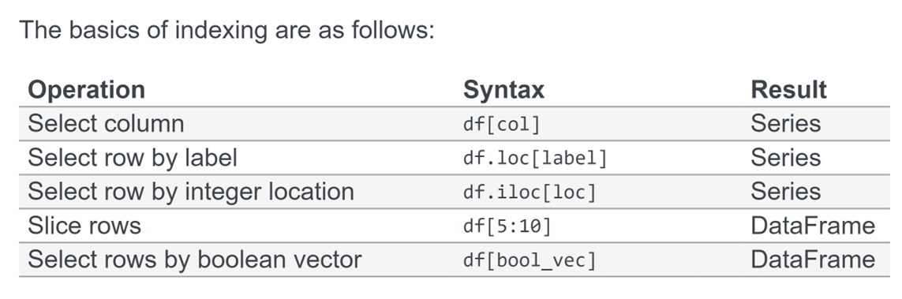
ESERCIZI SU PANDAS

Caricamento e visualizzazione dei dati:
https://colab.research.google.com/github/thimotyb/pandas_exercises/blob/master/01_Getting_%26_Knowing_Your_Data/Chipotle/Exercise_with_Solutions.ipynb

ESERCIZIO AUTONOMO SU CARICAMENTO:
https://colab.research.google.com/github/thimotyb/pandas_exercises/blob/master/01_Getting_%26_Knowing_Your_Data/Occupation/Exercises.ipynb

Esercizi su filtraggio e ordinamento del dataframe:
https://colab.research.google.com/github/thimotyb/pandas_exercises/blob/master/02_Filtering_%26_Sorting/Chipotle/Exercises_with_solutions.ipynb

Esercizi su GROUPING:
https://colab.research.google.com/github/thimotyb/pandas_exercises/blob/master/03_Grouping/Alcohol_Consumption/Exercise_with_solutions.ipynb

Esercizi su VISUALISATION:
https://colab.research.google.com/github/thimotyb/pandas_exercises/blob/master/07_Visualization/Chipotle/Exercise_with_Solutions.ipynb

BIG QUERY:
https://pandas.pydata.org/docs/user_guide/io.html#io-bigquery
https://pandas-gbq.readthedocs.io/en/latest/

INPUT/OUTPUT IN PANDAS:
https://pandas.pydata.org/docs/user_guide/io.html

ALTRA EROGAZIONE (SIMILE)
Python Basic

- Riunione di Microsoft Teams
- Partecipa a: https://teams.microsoft.com/meet/31892789588868?p=kcHwhWgji791taW73U
- ID riunione: 318 927 895 888 68
- Passcode: hT3pE6mG

Agenda:
- Basic Language Introduction to Python
  - General Environment (Distributions, Popular Libraries, IDEs)
    - Local Install: Miniconda + Visual Studio Code + Python Extensions in VSC
    - Library Installs and Versions (pip)
  - Data Types, Objects (Stack vs. Heap)
  - Containers (Mutability/Immutability) / Data Structures
    - str, list, set, tuple, dict
  - Common Built-in Functions
    - type()
    - callable()
    - repr()
    - All data type constructors
      - int()
      - list()
      - set()
      - float()
  - We create “Data Structures” with dicts (à-la JSON)
  - Functions
    - Interfaces (Signatures)
    - Arguments (Positional, Optional, Defaults)
    - Return from a function (return/raise/break)
    - Higher Order Functions (introduction to “Functional programming”)
    - Anonymous Functions (using Lambda)
      - example: sorting an array (tuple pairs)
  - Flow Control
    - “Accumulation” (empty list + for looping over a range)
    - Different idioms for looping with a for
      - Looping over a sliced copy of a list
      - Looping over a generator to use an index i (range)
      - Looping with a double index over tuple pairs
        - enumerate, zip
      - Comprehensions (list cmpr, set cmpr, dict cmpr)
- “Idiomatic” Python (common programming Patterns)
- Hints at “Vibe Coding”: Gemini Prompting within Notebooks
- Notebook (Jupyter)
  - Text cells can have a structure (Title levels)
  - Code cells can be executed in any order
  - Popular for prototyping
- Exceptions
- Modules
  - As external “py” files
  - Importing
- Standard Library (File Handling, Math Handling, Time…)
  - A few examples (stat, os, schedule…)
- Numpy
  - precision types (float64, int64)
  - ndarrays (N-dimensional Arrays)
    - homogeneous by type: numpy converts all types to the “best” type that can hold all elements in the array (normally float64, could be str if at least one string is in the array -> all other elements get “converted” in the array)
    - shape, size, dimension
    - populate an array (list, from a range, from a random generator)
    - Broadcasting: special operations (+, *), NOT linear algebra, the idea is that one array is “copied” and “sent” (i.e. “broadcasted”) to the other array

- Pandas, Dataframes
  - Series, declared with an Index (explicit, implicit). The index is the basis for operating with a Serie (e.g. summing series happens by index label, not by row position)
  - Series have a dtype, when the elements in a series are non-homogeneous, the dtype becomes “object”, and the elements RETAIN their original type (different from ndarray) -> Otherwise if compatible type, all elements are converted to the optimal type (e.g. int64 to float64 if at least 1 element is float in the series)
  - A series of series is a Dataframe. You can create a Dataframe from a dict of Series
  - Filtering by col: df[‘collabel’] -> Series
  - Filter by row: df.loc[‘rowlabel’] -> Series
  - Filter by row position: df.iloc[pos] -> Series
    - Because filtering a df returns a series, you can chain operators
      - df.loc[‘df-rowlabel’][‘series-index-label’] -> Item
  - Dataframes are entirely loaded in memory > capacity limit
    - With pandas you can load read_csv, read_json, read_xml, read_excel, read_sas, read_hdfs, read_sql_query (from oracle, mysql…), read_gbq
    - Avro vs. Parquet
  - Conditional row filtering
    - df.loc[ [ True, False, True….] ],, replace the boolean list with a condition producing that list, e.g. “df[df['one']>1]
    - describing, summarizing
    - Mutability and Immutability of Series and Dataframes (adding vs replacing a transformed column)
    - Grouping
  - Time in Python, Time Series in Pandas
  - Python SQL with Pandas
  - Visualization with Pandas
  - Consuming APIs in Python, REST Services

CLASS SCHEDULE
Mornings: 9.00 (10.30) (12.00) 13.00
Afternoons: 14.00 (15.30) 17.00

Introductions:
- Your name, What is your role
- Do you use Python already? If not, what is your use case?
- Data Analysis? Which tools? Matlab, R, any other language (your other programming experience)
- If the Schedule is ok?

OUR GOALS:
- Using to access data from Oracle
- Working with Data with Pandas
- Python for the Web? Flask, Django, FastAPI?
- Using Python for “automation”. Schedule python procedures?

https://docs.anaconda.com/anaconda/install/
https://docs.anaconda.com/miniconda/install/
https://code.visualstudio.com/
https://jupyter.org/

Python Tutorial
https://docs.python.org/3.7/tutorial/index.html

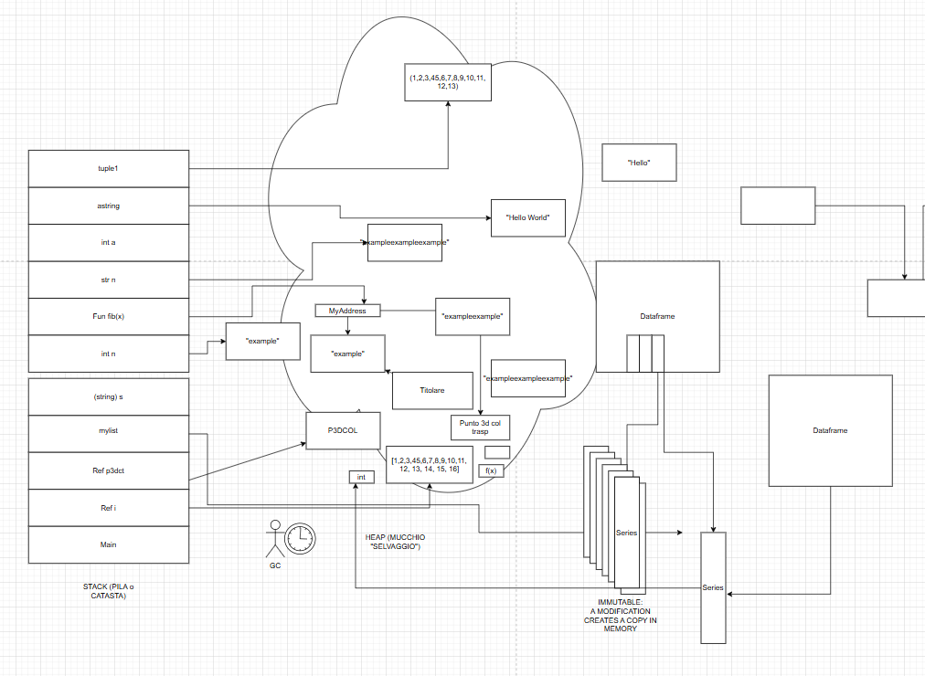
Links to the drawing:
https://drive.google.com/file/d/1jO22P6Iy49KYoKyNjdCrIy3TcXlpls0S/view?usp=sharing

Introduction to Python Notebook
https://colab.research.google.com/github/thimotyb/real-world-machine-learning/blob/python3/learning-python3.ipynb
Drive with Slides and Material:
https://drive.google.com/drive/folders/1mx5mF5XwZOv5-1_G8SowONp4vF8-bupv?usp=sharing
Built In Types:
https://docs.python.org/3.12/library/stdtypes.html#
Standard Library:
https://docs.python.org/3/library/index.html

Manipulating a String: https://docs.python.org/3/library/stdtypes.html#text-sequence-type-str

Sequence types: https://docs.python.org/3/library/stdtypes.html#sequence-types-list-tuple-range

List: https://docs.python.org/3/library/stdtypes.html#lists

Use intersection / set operations instead of double loops:

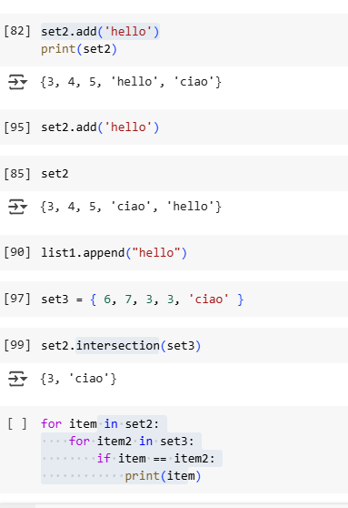

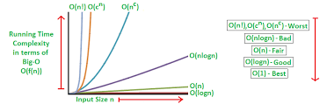

Assignment:
use different lambdas to sort different containers (list, tuple...dicts in lists….)
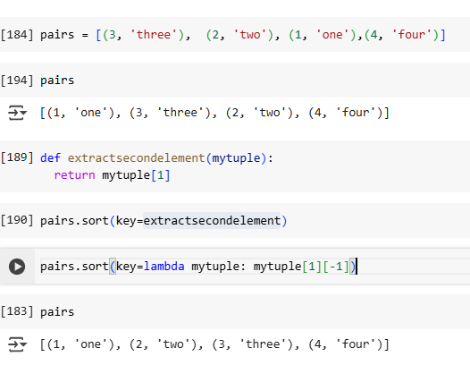

Functions in Python are OBJECTS -> when they are defined (def) they are stored in the heap, they have a reference on the stack, and you can call them with the CALL operator: (), using arguments if necessary. You can call anything which is callable() == true.

String Formatting:
useful for formatting Numbers, % values, Dates….

Format Specification Mini-Language:
https://docs.python.org/3/library/string.html#format-specification-mini-language

Exceptions: try… except ValueError (typical exception when converting into a different object type). Manage the runtime exception without exiting from the block.

Introduction to NumPy:
https://colab.research.google.com/github/thimotyb/AnatomyOfMatplotlib/blob/master/AnatomyOfMatplotlib-Part0-Intro2NumPy.ipynb

https://numpy.org/doc/stable/user/basics.creation.html

Float64
https://numpy.org/doc/stable/reference/arrays.scalars.html#numpy.float64



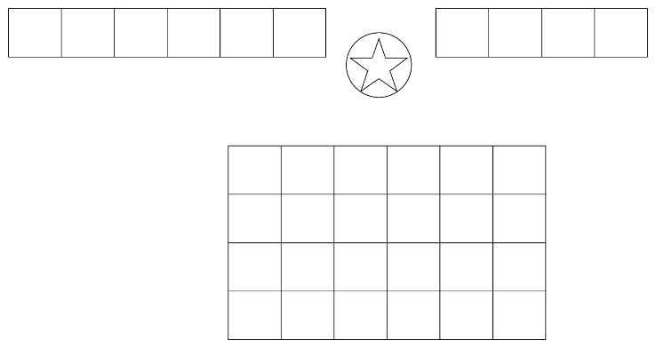

Introduction to Pandas Dataframes: https://colab.research.google.com/github/thimotyb/real-world-machine-learning/blob/python3/pandas-dataframe.ipynb

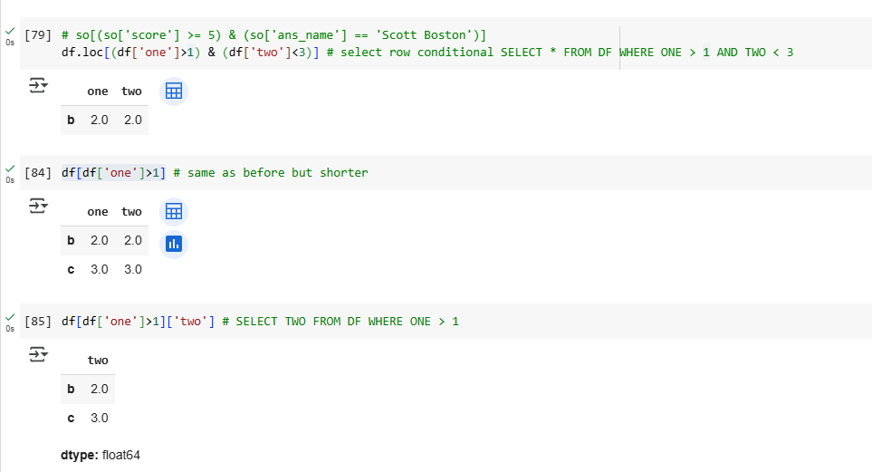

Assignment: create a Pandas dataframe with multiple columns, use conditional row filtering, write the correspondent pseudo-SQL

Pandas Data Exploration:
https://colab.research.google.com/github/thimotyb/pandas_exercises/blob/master/01_Getting_%26_Knowing_Your_Data/Chipotle/Exercise_with_Solutions.ipynb

Exercise:
https://colab.research.google.com/github/thimotyb/pandas_exercises/blob/master/01_Getting_%26_Knowing_Your_Data/Occupation/Exercises.ipynb

Filtering and Sorting:
https://colab.research.google.com/github/thimotyb/pandas_exercises/blob/master/02_Filtering_%26_Sorting/Chipotle/Exercises_with_solutions.ipynb

Grouping:
https://colab.research.google.com/github/thimotyb/pandas_exercises/blob/master/03_Grouping/Alcohol_Consumption/Exercise_with_solutions.ipynb

Grouping Exercise:
https://colab.research.google.com/github/thimotyb/pandas_exercises/blob/master/03_Grouping/Occupation/Exercise.ipynb

Visualisation:
https://colab.research.google.com/github/thimotyb/pandas_exercises/blob/master/07_Visualization/Chipotle/Exercise_with_Solutions.ipynb

Pandas Visualisation guide:
https://pandas.pydata.org/docs/user_guide/visualization.html
Some Data Manipulation Advanced Techniques:
https://colab.research.google.com/github/thimotyb/real-world-machine-learning/blob/python3/pandas_advanced_techniques.ipynb

Importing Data with pandas with Databases and Excel:
https://colab.research.google.com/github/thimotyb/real-world-machine-learning/blob/python3/Importing_data_with_pandas.ipynb

Plolty
https://dash.plotly.com/tutorial

