Topic - Guiding Tips For Parents

Aims : To know how to treat your children

**DQ:** How can we develop an educational website that provides guidance for parents who have under 18 years old kids to assist in becoming a better generation of society?

**EQ:** How can we create an advisory website that specializes to share the guiding tips for parents to foster a proactive mindset for their children under 18 years old, while maintaining a good behavior in the society?

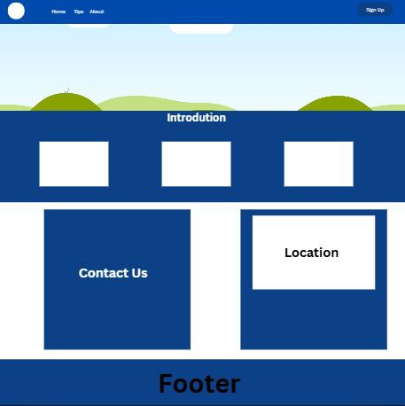

References

<https://kidshealth.org/en/parents/nine-steps.html>

[www.google.com](http://www.google.com)

<https://www.newportacademy.com/resources/restoring-families/tips-for-parenting-teens/>

<https://images.app.goo.gl/aCYofEyWZbdf82EF7>

<https://msn.com>

[**https://www.medicinenet.com/what_are_teenager_problems_with_parents/article.htm**](https://www.bing.com/ck/a?!&&p=312d97c96f752513b3e633838a757352a0cda8a7c208d40581c4c87f0e30b89cJmltdHM9MTczMjc1MjAwMA&ptn=3&ver=2&hsh=4&fclid=2dc00a0a-4e36-6ba7-2480-1f4f4f376a9a&u=a1aHR0cHM6Ly93d3cubWVkaWNpbmVuZXQuY29tL3doYXRfYXJlX3RlZW5hZ2VyX3Byb2JsZW1zX3dpdGhfcGFyZW50cy9hcnRpY2xlLmh0bQ&ntb=1)