

DEPARTMENT OF INFORMATION TECHNOLOGY
24ITT32 - PROGRAMMING IN JAVA
INDIVIDUAL PROJECT ON
ACADEMIC MANAGEMENT SYSTEM
PROJECT REPORT
Submitted by
THINA RAJKUMAR R
25ITR161

JAVA ASSIGNMENT
AIM:
Development of Kongu Engineering College (R2024) Student Academic & Continuous Evaluation System using Java JDBC.
OBJECTIVE:
Design and develop a database-driven Java application using JDBC to manage student records, perform incremental marks entry (Continuous Internal Assessments and End Semester Examinations), enforce attendance eligibility rules, and generate formal academic performance reports according to Kongu Engineering College (Autonomous) - Regulation 2024. System Requirements & Specifications.
FLOW CHART:
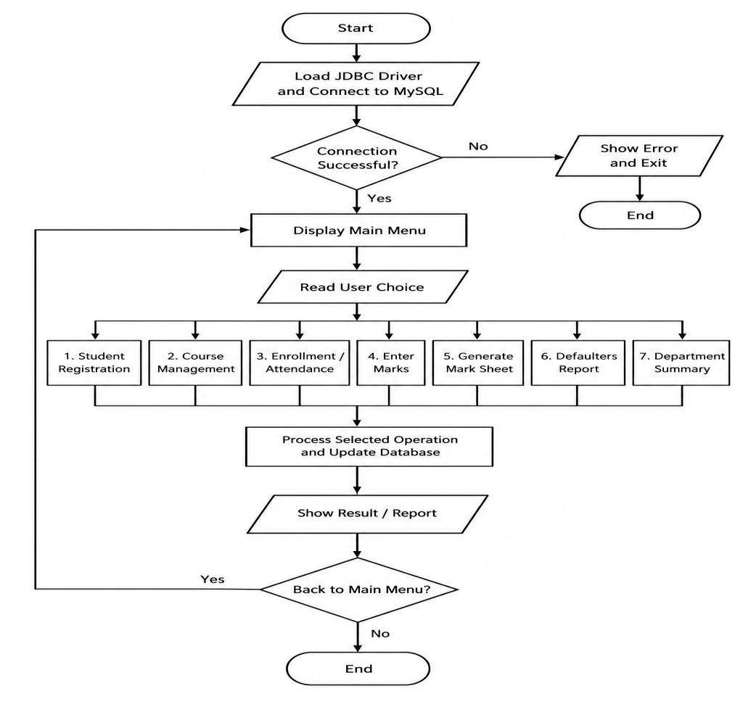

PROCEDURE:
❖ Load the MySQL Connector Java driver to establish seamless communication between the Java application and the database.
❖ Establish a connection to the local MySQL database using the correct login details.
❖ Add and manage student information, including roll number, name, department, and semester, along with course details such as code, name, credits, and category.
❖ Register students for courses and record their attendance by maintaining the number of classes held and attended.
❖ Decide exam eligibility based on attendance percentage. Students with 75% or above can attend exams, those with 65% to 74% need medical condonation, and those below 65% are marked as attendance defaulters.
❖ Enter and maintain internal assessment marks for tests, assignments, quizzes, and practical work.
❖ Record end-semester exam marks and identify absent students. Ensure that students meet the minimum passing marks for each course type.
❖ Calculate total marks using internal and external scores, assign grades and grade points, and identify students who need to reappear for exams.
❖ Prepare semester mark sheets with internal marks, external marks, total marks, and GPA. Also, generate attendance defaulter lists and show the pass percentage for each department through the console menu

DATABASE SCHEMA:
1.STUDENTS TABLE:
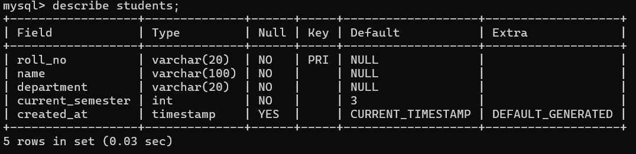
2. COURSES TABLE:
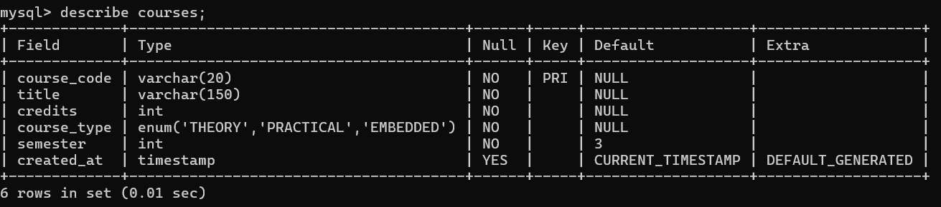
3. ENROLLMENTS TABLE:
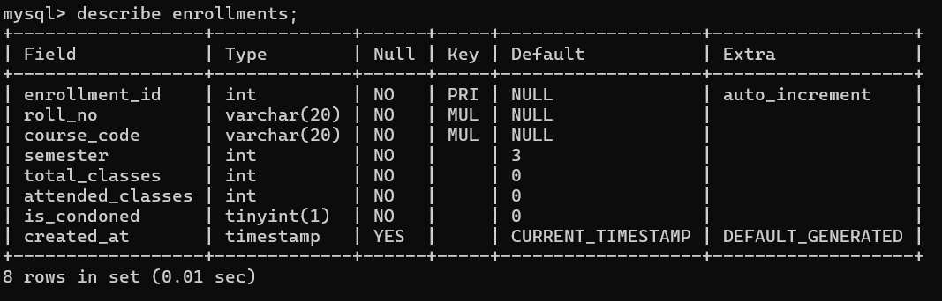

4. ASSESSMENT MARKS TABLE:
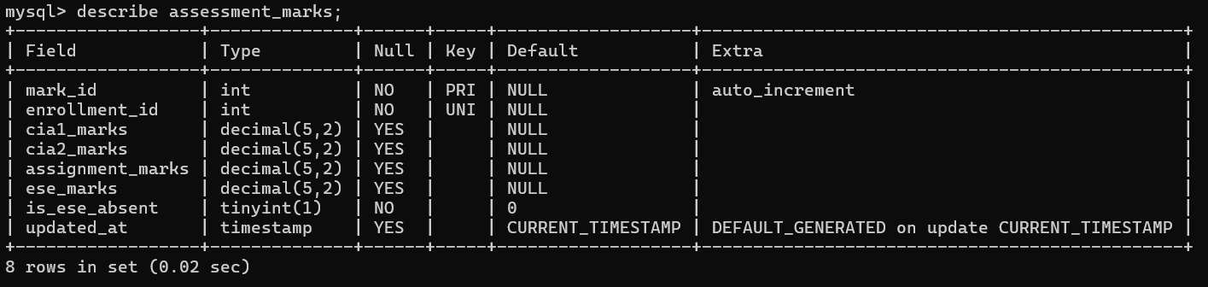
SOURCE CODE:
MAINAPP.JAVA:
import java.util.*;

public class MainApp {
private static final AcademicDAO dao = new AcademicDAO();
private static final Scanner sc = new Scanner(System.in);

public static void main(String[] args) {
if (!DBConnection.testConnection()) { System.out.println("DB Connection failed."); return; }
System.out.println("=== KEC EVALUATION SYSTEM (R2024) ===");
boolean run = true;
while (run) {

System.out.println("\n1.Student 2.Course 3.Enroll/Attn 4.Marks 5.Marksheet 6.Defaulters 7.Summary 0.Exit");
System.out.print("Choice: ");
switch (sc.nextLine().trim()) {
case "1": regStudent(); break;
case "2": addCourse(); break;
case "3": enrollStudent(); break;
case "4": enterMarks(); break;
case "5": System.out.print("Roll: "); dao.printStudentMarkSheet(sc.nextLine().trim(), in("Sem: ")); break;
case "6": dao.printAttendanceDefaulters(in("Sem: ")); break;
case "7": dao.printDepartmentSummary(in("Sem: ")); break;
case "0": run = false; break;
default: System.out.println("Invalid choice.");
}
}
System.out.println("System closed.");
}

private static void regStudent() {
System.out.println(dao.registerStudent(str("Roll: "), str("Name: "), str("Dept: "), in("Sem: ")) ? "Registered." : "Failed.");
}

private static void addCourse() {
System.out.println(dao.addCourse(str("Code: "), str("Title: "), in("Credits: "), str("Type (THEORY/PRACTICAL/EMBEDDED): ")) ? "Added." : "Failed.");
}

private static void enrollStudent() {
String ch = str("1.Enroll 2.Attn: "), r = str("Roll: "), c = str("Course: "); int s = in("Sem: ");
if (ch.equals("1")) {
System.out.println(dao.enrollStudent(r, c, s) > 0 ? "Enrolled." : "Failed.");
} else {
int id = dao.getEnrollmentId(r, c, s);
if (id <= 0) { System.out.println("Not found."); return; }
System.out.println(dao.updateAttendance(id, in("Total: "), in("Attended: "), str("Condonation (y/n): ").equalsIgnoreCase("y")) ? "Updated." : "Failed.");
}
}

private static void enterMarks() {
int id = dao.getEnrollmentId(str("Roll: "), str("Course: "), in("Sem: "));
if (id <= 0) { System.out.println("Not found."); return; }
String p = str("1.CIA 2.Assignment 3.ESE: ");
if (p.equals("1")) System.out.println(dao.recordPhase1Marks(id, db("CIA-1: "), db("CIA-2: ")) ? "Saved." : "Failed.");

else if (p.equals("2")) System.out.println(dao.recordPhase2Marks(id, db("Assignment: ")) ? "Saved." : "Failed.");
else if (p.equals("3")) {
boolean abs = str("Absent? (y/n): ").equalsIgnoreCase("y");
System.out.println(dao.recordPhase3Marks(id, abs ? null : db("ESE: "), abs) ? "Saved." : "Failed.");
}
}

private static String str(String p) { System.out.print(p); return sc.nextLine().trim(); }
private static int in(String p) { return Integer.parseInt(str(p)); }
private static double db(String p) { return Double.parseDouble(str(p)); }
}
DB CONNECTION.JAVA:
import java.sql.Connection;
import java.sql.DriverManager;
import java.sql.SQLException;

/**
* DBConnection - Database Connection Management for KEC Evaluation System
* Kongu Engineering College (Autonomous) - Regulation 2024
*/

public class DBConnection {
private static final String DEFAULT_HOST = "localhost";
private static final String DEFAULT_PORT = "3306";
private static final String DEFAULT_DB = "kec_eval";
private static final String DEFAULT_USER = "root";
private static final String DEFAULT_PASS = "0000";

public static String getUrl() {
String host = System.getenv("DB_HOST") != null ? System.getenv("DB_HOST") : DEFAULT_HOST;
String port = System.getenv("DB_PORT") != null ? System.getenv("DB_PORT") : DEFAULT_PORT;
String db = System.getenv("DB_NAME") != null ? System.getenv("DB_NAME") : DEFAULT_DB;
return "jdbc:mysql://" + host + ":" + port + "/" + db + "?useSSL=false&allowPublicKeyRetrieval=true&serverTimezone=UTC";
}

public static String getUser() {
return System.getenv("DB_USER") != null ? System.getenv("DB_USER") : DEFAULT_USER;
}

public static String getPassword() {

return System.getenv("DB_PASSWORD") != null ? System.getenv("DB_PASSWORD") : DEFAULT_PASS;
}

static {
try {
Class.forName("com.mysql.cj.jdbc.Driver");
} catch (ClassNotFoundException e) {
System.err.println("[ERROR] MySQL JDBC Driver not found in classpath: " + e.getMessage());
}
}

/**
* Obtains a new database connection
*/
public static Connection getConnection() throws SQLException {
return DriverManager.getConnection(getUrl(), getUser(), getPassword());
}

/**

* Tests the database connectivity
*/
public static boolean testConnection() {
try (Connection conn = getConnection()) {
return conn != null && !conn.isClosed();
} catch (SQLException e) {
System.err.println("[ERROR] Connection test failed: " + e.getMessage());
return false;
}
}
}
OUTPUT SCREENSHOTS:
MAIN MENU:
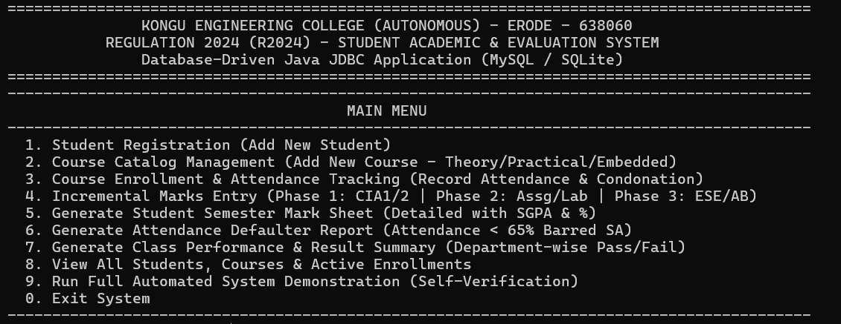
STUDENT & COURSE MANAGEMENT:

1.STUDENT REGISTRATION:
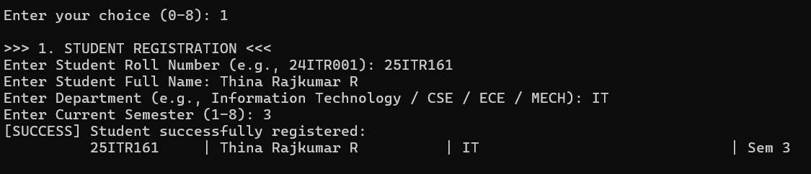
2. COURSE CATALOG:
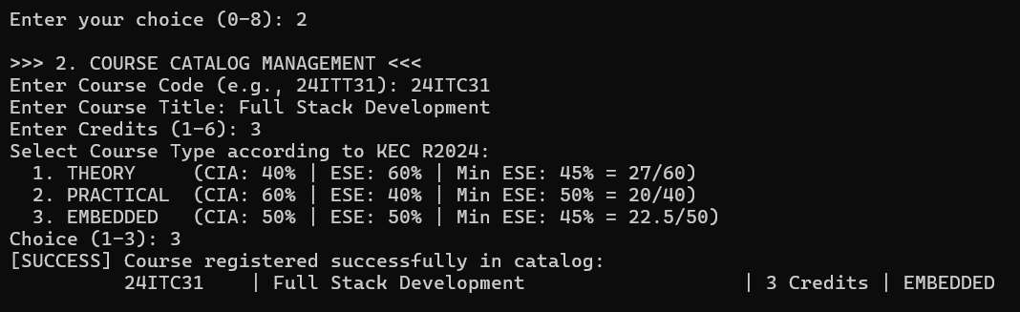
3. COURSE ENROLLMENT - ENROLL STUDENT IN COURSE:
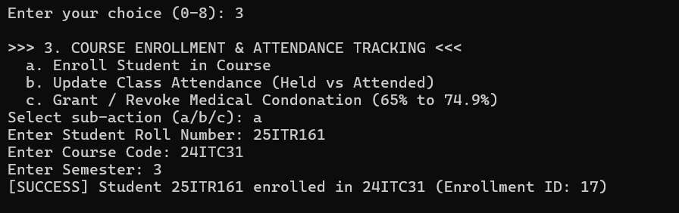
ATTENDANCE TRACKING - UPDATE CLASS ATTENDANCE:
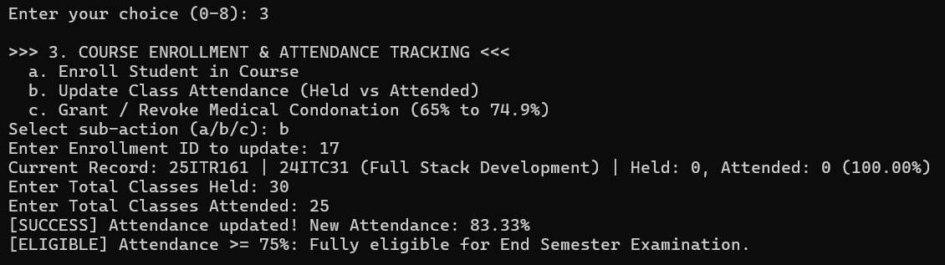

INCREMENTAL MARKS ENTRY - PHASE 1 (MID-SEMESTER):
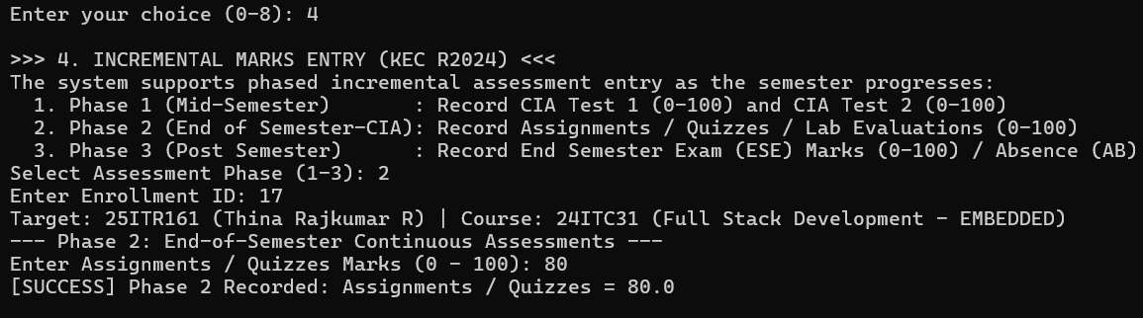
INCREMENTAL MARKS ENTRY - PHASE 2 (END OF SEM CIA) :
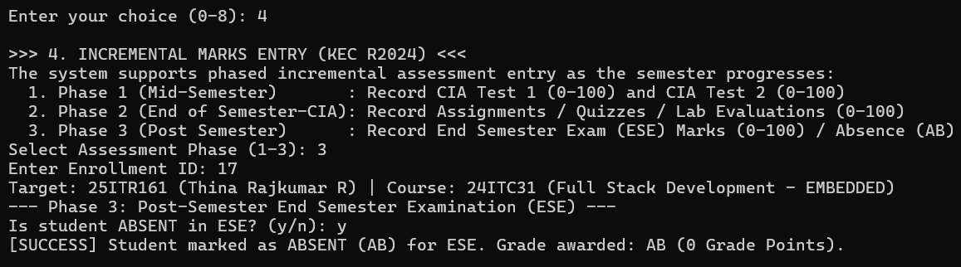
INCREMENTAL MARKS ENTRY- PHASE 3 (POST SEMESTER- ESE):
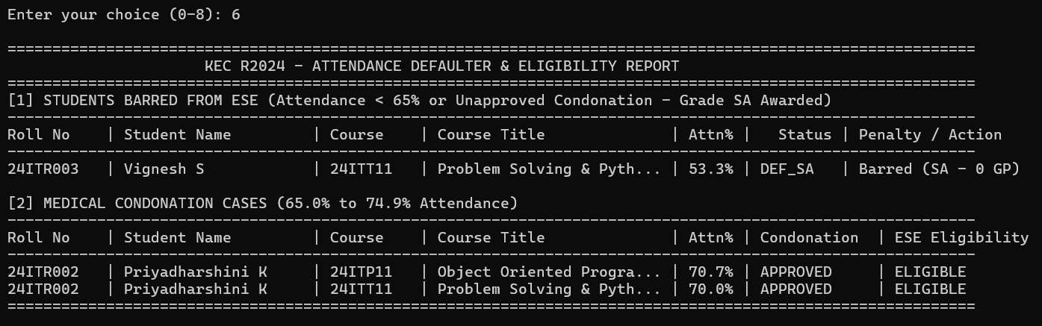
SEMESTER GRADE & PERFORMANCE REPORT (STUDENT MARK SHEET):

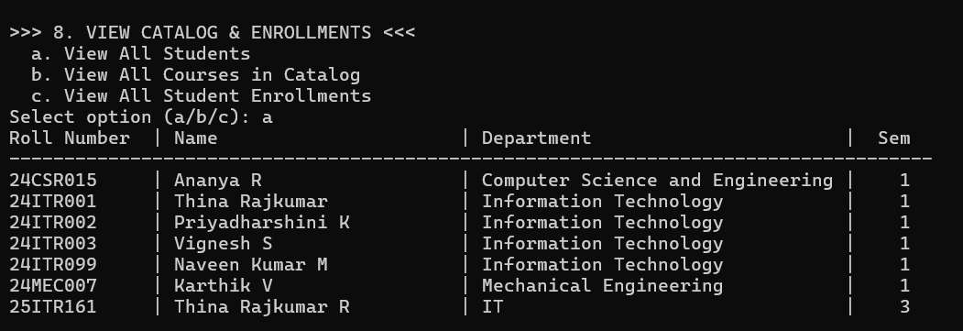
VIEW CATALOG & ENROLLMENTS - VIEW ALL STUDENTS :
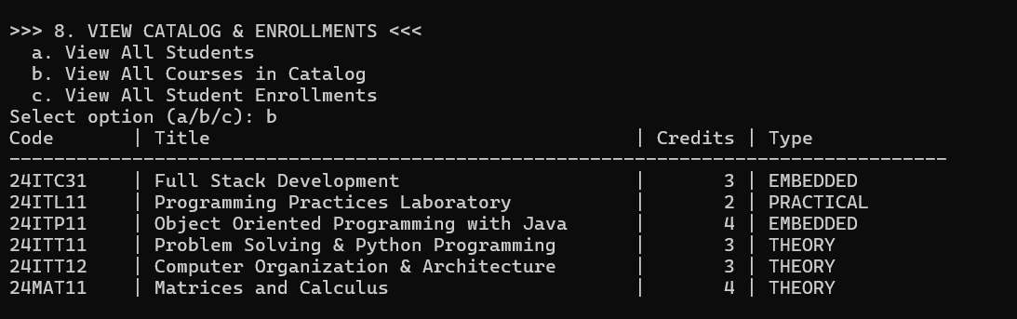
VIEW CATALOG & ENROLLMENTS - VIEW ALL COURSES IN CATALOG:
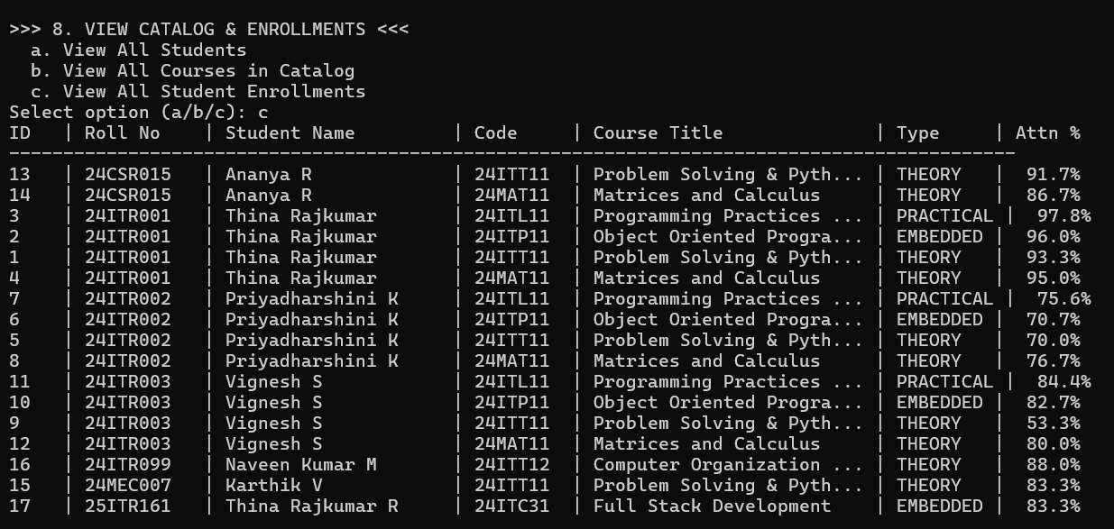

VIEW CATALOG & ENROLLMENTS - VIEW ALL STUDENT ENROLLMENTS:
EXIT SYSTEM - THANK YOU MESSAGE:
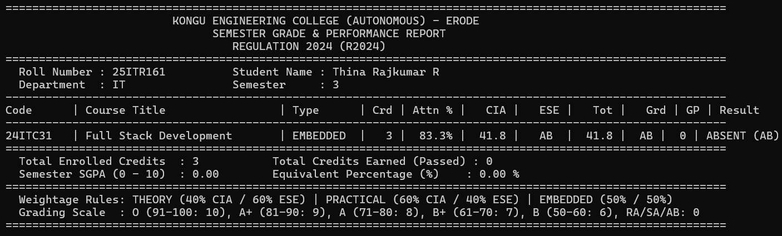
SEMESTER GRADE & PERFORMANCE REPORT:
DATABASE:
STUDENTS DATABASE:

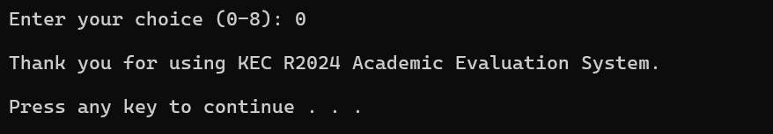
COURSES DATABASE:
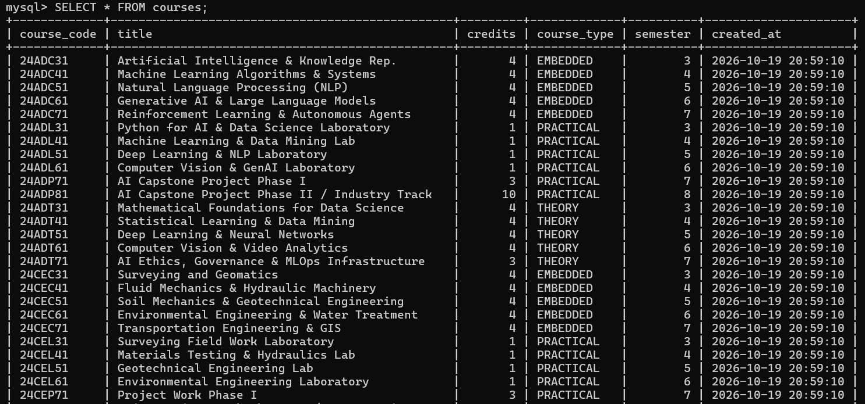
ENROLLMENTS DATABASE:
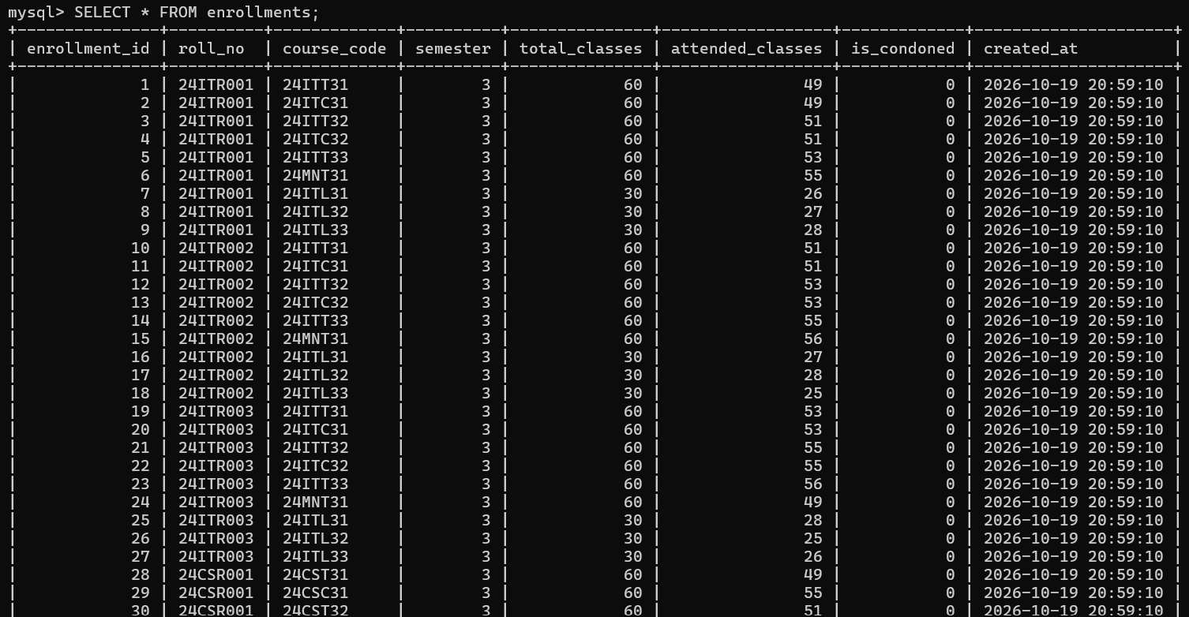

RESULT:
Thus, the Student Academic and Continuous Evaluation System for Kongu Engineering College (Autonomous) Regulation 2024 was successfully designed, developed, and tested using Java (JDBC) and MySQL. The system accurately automates the calculation of Continuous Internal Assessments (CIA), End Semester Examinations (ESE), Letter Grades, Attendance Eligibility, and Semester Grade Point Average (SGPA).

REFERENCES:
1. Oracle, Java SE Documentation – JDBC Overview and Architecture.
https://docs.oracle.com/javase/8/docs/technotes/guides/jdbc/ .
2. Oracle, Java SE API – HttpServer.
https://docs.oracle.com/en/java/javase/17/docs/api/jdk.httpserver/com/sun/net/httpserver/HttpServer.html .
3. Oracle, MySQL 8.0 Reference Manual.
https://dev.mysql.com/doc/refman/8.0/en/ .
4. Oracle, MySQL Connector/J Developer Guide.
https://dev.mysql.com/doc/connector-j/8.0/en/ .
5. University Grants Commission, Guidelines for Choice Based Credit System (CBCS).
https://www.ugc.gov.in/pdfnews/8023719_Guidelines-for-CBCS.pdf .
6. Chart.js, Chart.js Documentation.
https://www.chartjs.org/docs/latest/ .
7. Tailwind CSS, Tailwind CSS Documentation.
https://tailwindcss.com/docs .
8. GeeksforGeeks, Establishing JDBC Connection in Java.
https://www.geeksforgeeks.org/establishing-jdbc-connection-in-java/ .
9. YouTube, Java JDBC with MySQL Tutorial Videos.
https://www.youtube.com/results?search_query=Java+JDBC+MySQL+tutorial .
10. Anthropic, Claude AI Assistant (used for project ideas and guidance).
https://claude.ai/ .
GITHUB:
https://github.com/thinarajkumar2008-source/Student_Evaluation_Using_Java_JDBC

