thingSoC® Teensy3x Adapter Board Errata
The TSOC_Teensy3x is an adapter for the excellent Teensy Development Board from PJRC.
The TSOC_Teensy3x allows you to connect thingSoC , Mikrobus , and/or Grove System Modules all at the same time, either standalone, or with any other thingSoC Processor or Radio module. This gives you maximum flexiblity for sensor and actuator selection and reuse.
Products Affected : Revision 1 (Blue) Boards
SPI Wiring Reversed :
The initial (Rev 1) "Blue" TSOC_Teensy3x boards have the hardware SPI pins reversed,
(the MISO and MOSI pins reversed). Most Arduino librarys will let you specify the
SPI pins to be used explicitly, but will use software (bit-bang) SPI when you do that.
Most users are able to work around this ssue.

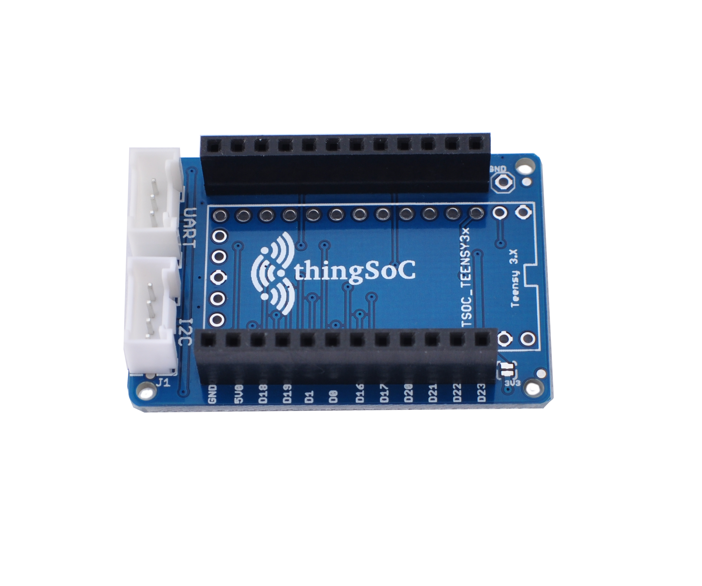

Revision 2.0 (Purple, Black) boards are NOT affected by Errata #1 - If this is a problem for your application, contact us for a Revision 2.0 board, which will be available in 3-4 weeks.

