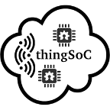

Open Source Sockets
for the
Internet of Things

Contents :

Table of Contents
Contents : 2
Introduction : 3
Overview : 4
Licensing : 5
thingSoC Compliant and Compatible : 5
thingSoC Socket Dimensions : 6
thingSoC Socket Connectors : 7
thingSoC Socket Stacking Levels : 8
thingSoC Socket RF Safe Zones : 10
thingSoC Socket Pin Configurations: 10
thingSoC Socket Signals : 11
thingSoC Socket Termination Resistors : 12
thingSoC Socket Interrupts : 12
thingSoC Compliant EEPROM Base : 13
thingSoC Firmware Meta Data Store : 15
thingSoC Auto-Discovery Algorithm : 16
thingSoC Application Programming Interface (API) : 17
Revision History : 18

Introduction :

There are already a number of popular and well-supported development platforms, like Arduino, Beaglebone, Raspberry Pi, and others, so why is thingSoC needed? While we work with and support all those platforms, each has a particular set of limitations, which thingSoC is designed to address.

There is currently a great deal of fragmentation and incompatibility in the market for development kits, tools, and products for the hobbyist and maker communities. While there is no real “one size fits all” grand solution to this, there are a number of common characteristics, goals, and interfaces that can make life much easier for cross-platform and cross-product interoperability.
One example of this fragmentation and incompatibility is evident with the Arduino platform, in it's various implementations. The Arduino is very popular, and a great number of third parties make “Arduino Shields”, as the Arduino expansion cards are known. However, some are 5.0 volt operation only, while others are 3.3V only, while still others use different pins for I2C, SPI and other control signals.
It causes a great deal of confusion, and leads to customer frustrations with the incompatibilities and lack of interoperability.

Another example of the fragmentation is the proliferation of a number of incompatible “Gumstick” or breadboard friendly, low cost, microprocessor boards, that often do little more than simply bring out the microprocessor signals to the nearest pin. There are literally hundreds of these out in the market, with no common pin assignments, or the ability to utilize peripherals made for one flavor, on any other flavor of pin out. In our humble opinion, this trend is holding back a reusable solution to many of the recurring problems faced in embedded design work and rapid prototyping.
It was out of this frustration with incompatible products and development tools that the thingSoC project was conceived and developed. It has already been used in several Moxon Design and PatternAgents development programs, and is now being released as an Open Source Hardware/Software Specification.

Overview :

The thingSoC specification defines a physical, hardware socket system for inter-operable printed circuit boards, with a data centric firmware model for automatic device discovery, and a software API for interacting with the system.
The thingSoC sockets support both the basic low speed interface standards like I2C, SPI, and UART, but also support higher speed interfaces like USB 3.0, 10/100/1000, and PCI-E for faster performance IoT devices.
The following diagram shows the basic interfaces by group, and color-coded :
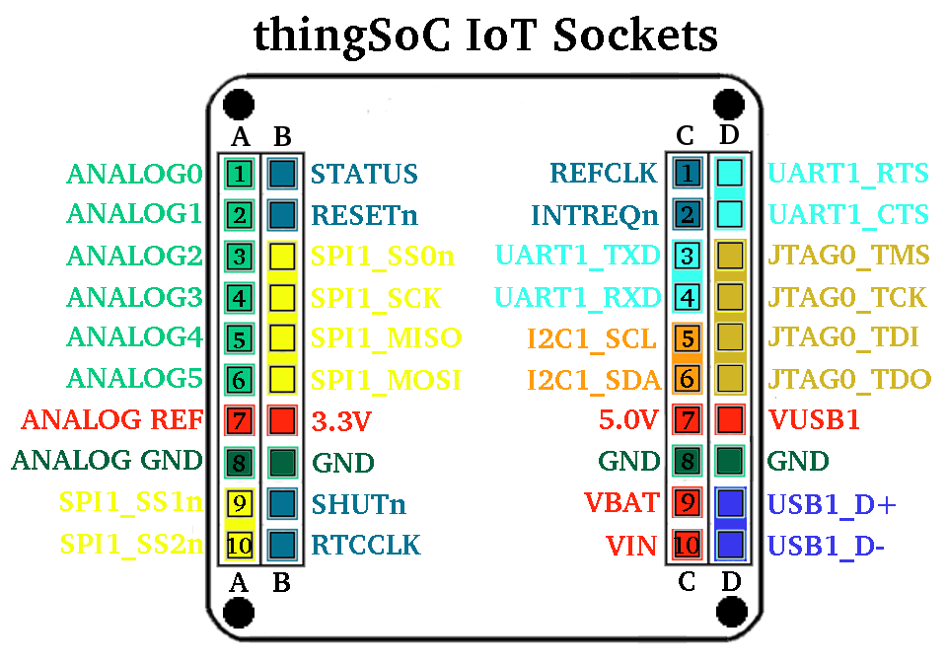
The thingSoC specification allows socket configurations from six (6) to eighty (80) pins, supporting a range from small breakout boards to larger, high density input/output boards.

Licensing :

The thingSoC Specification by PatternAgents is available and licensed under a Creative Commons Attribution-ShareAlike 4.0 International License. There are no licensing fees or other costs associated with the thingSoC specification. Anyone is welcome to make, manufacture, sell, or distribute the thingSoC reference designs that are included with the thingSoC specification.
While the thingSoC Specification is licensed under a Creative Commons Attribution-ShareAlike 4.0 International License, users and adopters of the thingSoC specification may use whatever licensing model they see fit for their own designs and products that utilize the thingSoC Specification. That is to say, we place no restrictions on the use or implementation of the thingSoC Specification.

thingSoC Compliant and Compatible :

thingSoC Compliant devices implement at least the the Minimum PinClass (0) of six (6) pins, and the thingSoC EEPROM based auto-discovery mechanism in a thingSoC single, double, or triple sized PCB, with specified mounting holes, and display the thingSoC logo on the silkscreen.

thingSoC Compatible devices may fit and inter-operate with thingSoC based systems, but do not support the thingSoC EEPROM based auto-discovery mechanism or match the physical PCB size and specified mounting holes. This implies that thingSoC Compatible devices don't have access to thingSoC extended functions or display the thingSoC logo.

thingSoC Compliant devices implement a data centric firmware model for automatic device discovery which is compatible with the Linux 3.8 Kernal and Device Tree Overlays. The thingSoC Compliant meta-data store auto-discovery mechanism also implements additional features, however it is backward compatible with the Linux Beaglebone Cape Manager.

thingSoC Socket Dimensions :
thingSoC Compliant modules and sockets come in standardized sizes with specified mounting hole patterns.
- A single thingSoC module is 38.1mm long by 38.1mm wide
(1.5 inches x 1.5 inches).
- A double thingSoC module is 79.2mm long by 38.1mm wide
(3.12 inches x 1.5 inches).
- A triple thingSoC module is 114.8mm long by 38.1mm wide
(4.52 inches x 1.5 inches).

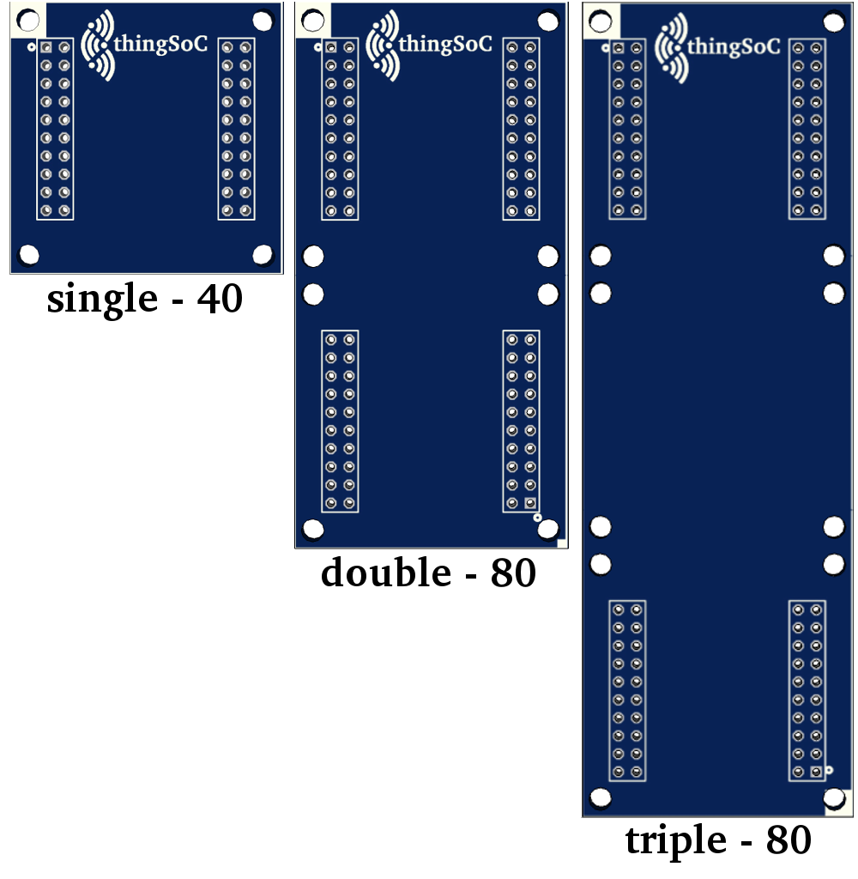
The default sizes have been chosen as a best compromise between cost, ease of assembly and ease of use. They have also been chosen to be compatible with a wide variety of existing packaging options.
thingSoC specification adopters may choose any size BASE or TEST carrier board size that meets their design or packaging requirements provided that the thingSoC sockets conform to the specified module sizes. Larger BASE or TEST carrier boards may provide a number of thingSoC sockets from one (1) to sixteen (16) per carrier board.

thingSoC Socket Connectors :
thingSoC compliant modules can have different I/O connector "bindings", in order to facilitate specific user requirements. The default thingSoC I/O connector binding is the “BB” or "Bread Board" type, which employs common 2.54mm pitch (0.1 inch) female header and male pin connections, and as the name suggests, is capable of being used with commonly available 2.54mm pitch breadboards and prototyping boards.
Pin-Through-Hole (PTH) types, Surface Mount Device Top layer mounting types (SMD-TOP), and Surface Mount Device Bottom layer mounting types (SMD-BOT) are available in the thingSoC PCB libraries, giving thingSoC users a wide variety of connector choices. A Pogo-Pin ("PP" type) I/O connector type is also supported in the thingSoC libraries, in order to facilitate the creation of thingSoC "TEST" modules for production testing applications.
A “CAS” or Castellated I/O connector "binding" is also in development for low cost soldered-on module types that omit the cost, space and weight of connectors.
Other I/O connector type "bindings" are possible, and may be added to the thingSoC specification at some future date.

thingSoC Socket Stacking Levels :

thingSoC compliant module "stacking levels" refer to the type of board function, and it's vertical position in the physical stack of modules.
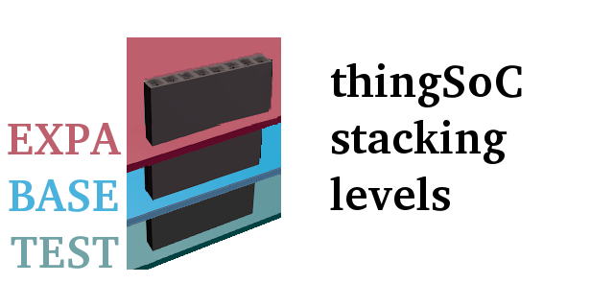

The following diagram shows the typical microprocessor I/O connection between the different stacking levels. TEST levels are typically used in development or production and quality assurance testing usage scenarios. They may also be used for field testing, data logging, and service quality testing usage scenarios.
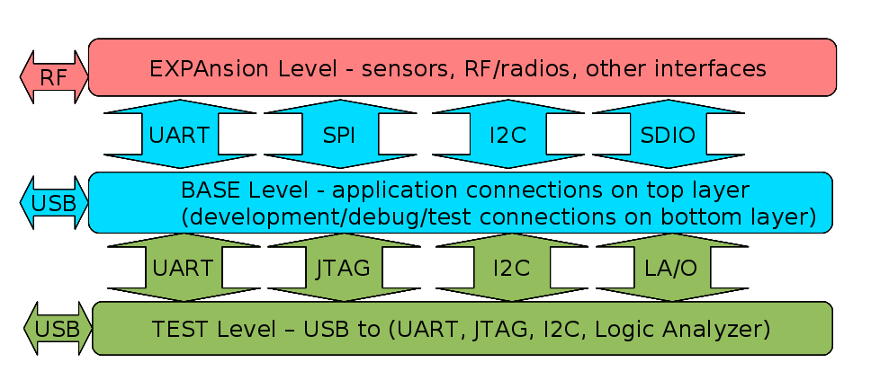
- EXPAnsion Level(s)
Any level above the "BASE" level is refered to be an "EXPA", or EXPAnsion level module. "EXPA" level modules use either "stack-thru" female header connectors, or surface mount (SMD) female headers on the top side of the board and surface mount (SMD) male pins on the bottom side of the board. The majority of thingSoC modules are "EXPA" level modules.
A maximum of four (4) "EXPA" level modules can function in any thingSoC "BASE" socket (i.e. maximum stack height of four (4) "EXPA" level modules in any single thingSoC Socket).
- BASE Level
There will be only one "BASE" level per thingSoC socket stack, and it generally contains the application processor and it's support subsystems. "BASE" level modules use either "stack-thru" female header connectors, or surface mount (SMD) female headers on the top side of the board and surface mount (SMD) male pins on the bottom side of the board.. Please note, this is very different than other small form factors systems, such as the Arduino, that treat the processor board (Uno, Leonardo, Due, etc.) as the bottom of the stack. Most thingSoC "BASE" level module implementations will utilize surface mount (SMD) female headers on the top side of the board, and leave the bottom connectors pads bare, (i.e. no male pins on bottom) in order to utilize Pogo-Pin ("PP") style test connectors on the "TEST" level.
- TEST Level
Any level below the "BASE" level is refered to as an "TEST" level module. "TEST" level modules implement test, measurement, and monitoring functions for the thingSoC "BASE" socket, and any attached "EXPA" levels. The "TEST" level modules can include JTAG programming, debugging, and trace functionality. Oscilloscopes, Logic Analyzers, Protocol Analyzers, Emulators, and similar functions are implemented as "TEST" level modules in the thingSoC standard. "TEST" level modules eliminate common test lead/test jumper wiring and configuration problems by instrumenting standardized buses on known pins that can be easily probed and monitored.

thingSoC Socket RF Safe Zones :

There are designated "RF zones" in the thingSoC specification for supporting on-board antenna and RF interfaces. This is very important for creating a modular IoT platform that yields the maximum radio range with minimum RF interference.
The top 5.0 mm (0.2 inch) of PCB on a single size PCB, and the top and bottom 5.0 mm (0.2 inch) of PCB on double and triple size PCBS are designated "RF zones", and should have no Ground or Power fill (Flood or pour) of copper on any layer of the PCB. Thin traces are permitted for low speed signals, connectors, and indicator LEDs.

thingSoC Socket Pin Configurations:
thingSoC compliant modules can be from a minimum of six(6) pins to a maximum of eighty(80) pins per individual socket. The thingSoC module pin variations are known as "Pin Configurations", and support :

- 6 Pins - The Minimum Pin Configuration
includes Vin, Vbat, 5V, Ground, I2C1_SDA, and I2C1_SCL,
to form a bare minimum connection. The I2C bus is used for both configuration information and data exchange.
- 20 Pins - The Basic Pin Configuration
adds UART and SPI bus pins for higher speed data exchange, as well as additional clocks, interrupt and power saving shutdown control pins.
- 40 Pins - The Standard Pin Configuration
adds USB2.0, JTAG, and Analog.
- 80 Pins - The Maximum Pin Configuration
- adds Superspeed USB3.0, PCI-E, or 10/100 Ethernet, second UART, Second SPI ports.

thingSoC Socket Signals :
thingSoC signals are 3.3 volt (LVCMOS) levels, and may NOT necessarily be 5V tolerant. 5V tolerance is a recommended design practice only, not a requirement.
thingSoC modules can include the following signals in default configurations :

thingSoC Socket Termination Resistors :
In order to insure proper operation, particularly during Shutdown and other low power modes, it is required to reference all pull-up, pull-down, other termination resistors be powered from the VBAT power rail. In order to minimize static current drain during Shutdown and other low power modes, it is recommended to provide a “power disable” to any unused pull-up, pull-down, other termination resistors.
The exception to this is are the RESETn, SHUTn, and INT_REQn(WAKE) signals,
which are active and power during all power modes. They should be powered directly from powered from the VBAT power rail.

thingSoC Socket Interrupts :
All thingSoC socket interrupts are are required to utilize “active-low, level sensitive” behavior for external signals. Interrupts may be shared, and should be asserted until serviced.

thingSoC Compliant EEPROM Base :

thingSoC Compliant modules contain a memory/storage device containing data that identifies the board type, serial number, pin multiplexing, and other setup information. This allows thingSoC Compliant systems to automatically discover what boards have been installed into the system, and to configure itself properly to communicate with them.
thingSoC Compliant firmware is referred to as a "data driven architecture", because the memory/storage device contains only pure data, without any executable code that would be specific to a particular processor. We refer to the data structure contained in the memory/storage device as the thingSoC
Firmware Meta Data Store (FMDS), and it contains information that can be used across different hardware platforms, to support a wide variety of different processor types. (i.e. low-power, high-speed, different architectures/vendors, etc.)

thingSoC Compliant modules implement the thingSoC Firmware Meta Data Store (FDMS) mechanism, which is compatible with the Linux 3.8 Kernal and Device Tree Overlays. The thingSoC Firmware Meta Data Store (FDMS) mechanism implements additional features, however it is backward compatible with the Linux/Beaglebone Black Cape Manager.
There are three (3) requirements for the memory device used for the
thingSoC Firmware Meta Data Store (FDMS) :

- It be I2C bus compatible with 3.3V level signaling
- It be I2C bus addressable from addresses 0x50 to 0x57
- It appear as an I2C EEPROM register address model
for data operations (i.e. CAT24C256 compatible)

So, any memory device that meets those requirements can be used, including an EEPROM emulator function, running within an I2C capable microprocessor.
If frequent data updates are required, the recommended practive is to use an SRAM, FRAM or NVSRAM in order to avoid data wear and leveling issues.

thingSoC Firmware Meta Data Store :

The thingSoC Firmware Meta Data Store (FDMS) mechanism can implement additional features by allowing additional "BLOBs" (Binary Level Objects) to be included in the memory/storage device, located immediately after the Beaglebone Cape Manager "BLOB" in memory.
For example, an IPMI FRU (Intelligent Peripheral Management Interface - Field Replaceable Unit) "BLOB" could be located immediately after the Beaglebone Cape Manager "BLOB", giving access IPMI format data as well. Each "BLOB" type can be identified by a unique "Magic Word" sequence at the beginning of the "BLOB" data section. This mechanism allows for complete backward compatibility, while allowing for the support of many new "BLOB" types within thingSoC Firmware Meta Data Store (FDMS).

thingSoC Auto-Discovery Algorithm :

(A simplified discovery algorithm in english)
The primary processor on the BASE level will use it's I2C1 Master port to :
- Read four (4) bytes from I2C Address 0x50, Offset 0x0000
and compare to the Magic Word (0xAA, 0x55, 0x33, 0xEE)
- If True, then a valid FDMS structure exists on the BASE Level
- Read four (4) bytes from I2C Address 0x51, Offset 0x0000
and compare to the Magic Word (0xAA, 0x55, 0x33, 0xEE)
- If True, then a valid FDMS structure exists on the TEST Level 1
- Read four (4) bytes from I2C Address 0x52, Offset 0x0000
and compare to the Magic Word (0xAA, 0x55, 0x33, 0xEE)
- If True, then a valid FDMS structure exists on the TEST Level 2
- Read four (4) bytes from I2C Address 0x53, Offset 0x0000
and compare to the Magic Word (0xAA, 0x55, 0x33, 0xEE)
If True, then a valid FDMS structure exists on the TEST Level 3
- Read four (4) bytes from I2C Address 0x54, Offset 0x0000
and compare to the Magic Word (0xAA, 0x55, 0x33, 0xEE)
- If True, then a valid FDMS structure exists on the EXPAnsion Level 1
- Read four (4) bytes from I2C Address 0x55, Offset 0x0000
and compare to the Magic Word (0xAA, 0x55, 0x33, 0xEE)
- If True, then a valid FDMS structure exists on the EXPAnsion Level 2
- Read four (4) bytes from I2C Address 0x56, Offset 0x0000
and compare to the Magic Word (0xAA, 0x55, 0x33, 0xEE)
- If True, then a valid FDMS structure exists on the EXPAnsion Level 3
- Read four (4) bytes from I2C Address 0x57, Offset 0x0000
and compare to the Magic Word (0xAA, 0x55, 0x33, 0xEE)
- If True, then a valid FDMS structure exists on the EXPAnsion Level 4

thingSoC Application Programming Interface (API) :

thingSoC Compliant systems are compatible with RSVP-SIS, the
Reference System Virtual Platform - Software Interface Standard,
an open source, vendor agnostic, application programming interface
that has ports to several different IDE's.
Please see the RSVP-SIS Organization Website for more information :
http://www.rsvpsis.com

Revision History :

04-01-2015 First Preliminary Draft – released for review

@TODO : Add “BB” stack-thru connector height & clearance parameters.

