System Requirements Specification

Parley

Authors:

Sydney Norman

Tricia Sallee

Justin Poe

Kirk Hardy

Yang Xi

February 4, 2017

Version 3.0

1. **Introduction**

**1.1.Purpose**

This document describes what the Android messaging app named Parley should do and provides a thorough overview of the system. This includes individual functionalities, definitions of specific items related to the app, mockups to display the intended user interface functions, and definitions of the scope and constraints of the project. The audience for this app includes anyone wanting to communicate with another person on an Android device. This includes clients, system developers, administrators, project managers, and testers. This app will be used by adults and children.

**1.2.Scope**

Parley is a graphical user interface program that allows a person to create a unique username, which will allow them to login and view messages from other users. Users will be able to send messages to a group chat, delete messages, and manipulate the appearance of messages.The user will also be able to customize the font, the text bubble, and the background color within each message thread. The main goal is to provide communication between users while also creating a completely unique communication platform for their group, such as prioritizing some conversations with a loud alert, flashing light, and vibration while silencing others to check later.

**1.3.Definitions, Acronyms, and Abbreviations**

**Background Color** The color of the area behind the text bubble

**Font color** The color of the outline and fill of each letter within a message

**Group Message** Message sent between multiple users consecutively

**Group Message Thread** Compilation of messages within a group message

**Group Chat Messaging Thread** Compilation of messages between all Parley users

**Individual Message** Message sent between two users

**Individual Message Thread** Compilation of messages between the same individual users

**JPG/JPEG** (Joint Photographic Experts Group) The file extension an image must have to be able to be sent

**Login Screen** The first screen displayed when the app is launched. It allows the user to enter their username or to create a username.

**Picture Message** Contains a jpg/jpeg file

**Push Notification** Informs the user they have received a message without any request from the user

**Settings Screen** Allows the user to customize font, text bubble, and background color.

**Text-Based Message** Only contains letters, numbers, or special characters.

**Text Bubble** The shape that provides a boundary to a message

**Username** Unique name consisting of letters or numbers

**1.4.Overview**

The rest of this documentation includes the overall description the specific requirements, and appendices. The overall description includes an overview of the system’s abilities and constraints. The specific requirements include details about each individual functionality. The appendices include mockups of the graphical user interface.

**2. Overall Description**

**2.1.Product Perspective**

**2.1.1.System Interfaces**

Parley uses Firebase Cloud Messaging and Firebase Authentication to communicate with other devices and authenticate the users using common accounts (Email, Google, Facebook, Twitter, etc.).

**2.1.2.User Interfaces**

The application operates using the touch screen of an Android device, which provides the user access to an on-screen keyboard. The system also uses this screen to display the messages and interface to the user.

**2.1.3.Hardware Interfaces**

This system requires an Android device.

**2.1.4.Software Interfaces**

The application will work on Android devices running Android 2.3 or newer.

**2.1.5.Communication Interfaces**

This application uses Firebase Cloud Messaging to send messages and communicate between Android devices. Parley also uses Firebase Authentication to authenticate users via Google or Facebook account.

**2.1.6.Operations**

Login Page: User can log in to the application

Message Thread Screen: Application opens, all saved messaging threads are listed for selection, deletion/addition of threads is available

Individual Message Thread: User can send messages with a single other user

Group Message Thread: User can send messages with multiple other users

Settings Menu: User can edit application or individual thread interfaces and notification settings

**2.1.7.Memory**

Some details will be stored in Firebase Cloud Messaging. Account references needed for message routing is the only Phase 1 requirement.

Some minor data will be automatically cached on user’s phones as the app runs, such as message history and user preferences. These will be stored in the Android app data cache without deviation from the traditional android app method.

**2.2.Product Functions**

The main function of Parley is to serve as a fully-customizable messaging solution in which the user can control the interface they communicate with. This includes the ability to change an individual message thread font, background color, and text bubbles.

**2.3.User Characteristics**

The program is directly designed for many audiences-- anyone with an Android device who uses messaging applications. The recommended age for using the system is at least 7 years old, but user discretion is advised. The user should be able to operate the device and have a desire to communicate via the device.

**2.4.Constraints**

**2.4.1.Regulatory Policies**

**2.4.1.1.** Due to varying regulations in foreign nations, Parley will only be available within regions that do not have regulatory policies for the usage of messaging applications.

**2.4.2.Hardware Limitations**

**2.4.2.1.** This application will require either an internet or cellular connection to send and receive messages.

**2.4.2.2.** Device must have a touch screen to interact with the application.

**2.4.3.Interface with Other Applications**

**2.4.3.1.** Interactions from this application will be limited to Android gallery applications.

**2.4.3.2.** Interactions to this application will be limited to the Android “share” functionality, which is handled by the Android OS.

**2.4.4.Control Functions**

**2.4.4.1.** Control Functions will not be able to change Android system settings.

**2.4.4.2.** Android System settings can override control functions of this application.

**2.4.5.Safety and Security Considerations**

**2.4.5.1.** This application will be unable to prevent users from sending sensitive account information.

**2.4.5.2.** Encryption will be limited to the strength of encryption keys provided by the users.

**2.4.5.3**. User information may not be kept private if the Android device is physically taken from the user.

**2.4.5.4.** This Application should not be used while doing activities that are considered dangerous when distracted.

**3. Specific Requirements**

**3.1.External Interfaces**

This system does not require any external interfaces.

**3.2.Functions**

**3.2.1.Phase I (Essential Requirements)**

**3.2.1.1. Username/Email**

**3.2.1.1.1.** Each person using the app will have a unique email and they will be able to choose a username to display when they send a message. This email will be used to reset a password if the user needs to. The user should ensure they are able to log into the email they use to set up the account.

**3.2.1.1.2.** These usernames will be stored in the Firebase database for verification.

**3.2.1.1.3.** At the login screen, if the user tries to log in using an invalid email, a notification stating the email or password is invalid and to enter the correct email and password or to sign up will be shown.

**3.2.1.1.4.** A first time user will have the ability to create an account. They must register using a valid email.

**3.2.1.2. Password**

**3.2.1.2.1.** Each user chooses a password with a minimum character length of six. The password is suggested to include a mixture of letters and numbers. The password will be created when a valid username/email has been chosen.

**3.2.1.2.2.** The user will be able to click a link if they have forgotten their password. The link will open an activity that gives them the option to send themselves an email. They will be required to enter their email and then be redirected to a page that allows the reset of the password.

**3.2.1.2.3.** This password will be required to login.

**3.2.1.2.4.** The user can choose to have the password be remembered if their Google Smart Lock is enabled.

**3.2.1.3. User Interface**

**3.2.1.3.1.** The user will be able to view old messages. If the messages fill the screen the user will be able to scroll up to view older messages and down to view newer messages.

**3.2.1.3.2.** The user will be able to click in a text box and use the keyboard to enter text.

**3.2.1.3.3.** Messages from users will be displayed within a group chat message thread.

**3.2.1.3.4.** Users can view a Settings Menu from the group chat messaging thread.

**3.2.1.3.4.1.** From the Settings Menu, users can view the font customization menu.

**3.2.1.3.5.** The user can view the dropdown menu from the group chat messaging thread.

**3.2.1.3.5.1.** The user can sign out of the application from the dropdown menu.

**3.2.1.3.5.2.** The user will be able to delete all group chat messages from all user devices from the dropdown menu.

**3.2.1.3.6.** The user can use the microphone to narrate their text message.

**3.2.1.4. Message Delivery**

**3.2.1.4.1.** Messages will be sent to the group chat. Delivery will be completed using Firebase Cloud messaging.

**3.2.1.4.2.** Text-based messages will be able to be sent to the group chat.

**3.2.2.Phase II (Essential Requirements)**

**3.2.2.1 Background colors**

**3.2.2.1.1.** The user will be able to change the background color within a conversation. Each conversation with a different user will be able to have a different color assigned.

**3.2.2.1.2.** Each user can assign a different color to appear on their device without affecting the appearance chosen by a user within the same thread.

**3.2.2.3. Text Bubble Customizations**

**3.2.2.3.1.** The text bubble color will be customizable by the user.

**3.2.2.3.2.** The text bubble shape will be customizable by the user.

**3.2.2.3.3.** Each message thread can be customized differently.

**3.2.2.3.4.** One user changing the text bubbles does not change the text bubbles for the other users within the message thread.

**3.2.2.4. Font Customizations**

**3.2.2.4.1.** The font style within a message can be customized. This includes using different fonts, bolding font, italicized font, and underlined font.

**3.2.2.4.2.** The font color within a message can be customized.

**3.2.2.4.3.** All font customizations can be different for each thread.

**3.2.2.4.4.** One user changing the font customization for their version of the message does not change the font for the other users within the message thread.

**3.2.3.Future Phases (Optional Requirements)**

**3.2.3.1. Password**

**3.2.3.1.1.** The user will be able to change their password to a new password as long as they enter their current password first.

**3.2.3.1.2.** The user will be able to answer security questions to reset their password if forgotten. If these questions are answered correctly the user will be able to reset the password. If it is entered incorrectly the user will receive a notification that the answer is incorrect.

**3.2.3.2. Individual messaging**

**3.2.3.2.1.** A message can be sent to individual users.

**3.2.3.2.2.** If the message is sent to an invalid user the sender will receive a notification that the message was unable to send.

**3.2.2.1. Group messaging**

**3.2.2.1.1.** A message can be sent to multiple users simultaneously. These users are selected and do not include everyone signed up to the app like the chat message does.

**3.2.2.1.2.** A group of users can assign themselves a group name within a group message.

**3.2.2.1.3.** A group messaging thread will have all the same functionality as a chat messaging thread.

**3.2.3.2 SMS Messages**

**3.2.3.2.1.** If a person doesn’t have the app installed on their device then a user that is using the device can send a message through the app using that person’s phone number. This person will receive the message like any other SMS message.

**3.2.3.2.2.** A person without the app will be able to reply to a received message just like they would any other SMS message. This message will be delivered to the initial user within the app.

**3.2.3.3 Encrypted Messages**

**3.2.3.3.1.** When a message is sent it will be encrypted. Then it will be decrypted before the recipient receives the message.

**3.2.3.3.2.** The user will have an option to also sign their messages with an encrypted key.

**3.2.3.4. Notification Settings**

**3.2.2.2.1.** A push notification will be sent to a user when a message is received. They will be able to respond to the message within this notification.

**3.2.2.2.2.** Each message thread can be customized to have a different notification type. The notification types to choose from include silence, vibration, different ringtones (already stored on the device), different lights shining from the device (red, blue, yellow, green), or any combination of these options.

**3.3.Performance Requirements**

**3.3.1.** The system shall arrive at the Login Screen or Message Thread Screen within 10 seconds of being opened.

**3.3.2.** Assuming Internet connection is stable, standard messages should take no longer than 5 seconds to send, and picture messages should take no longer than 1 minute. Receiving messages cannot be guaranteed within a certain amount of time because it relies on if the recipient has internet connection.

**3.4.Logical Database Requirements**

**3.4.1** At this time Firebase Cloud Messaging takes care of all proposed needs of Parley.

**3.5.Security**

**3.5.1.** All of the messages sent by users will be treated in confidence. Any information will not be revealed out of the conversation. The private chats are protected and secured by the system.

**3.5.2.** Password gives a support of security for protecting user’s account and information. A user must be logged into the account to be allowed to edit the chat or information.

**3.5.3.** Creating or Canceling an account will be asked for some information for privacy reason.

**3.6.Response Time**

The system shall respond to user input within 0.05 seconds, except when loading a new screen. There should be no visible lag to the human eye 95% of the time.

**3.7.Design Constraints**

**3.7.1.Firebase Cloud Messenger**

Phase 1 of the project falls within the design constraints of the tool used to construct the initial features. Any Phase 1 work will be constrained by what Firebase does and does not allow the app to work with.

**3.7.2.Phase 2 and Future Work**

Work impossible within the constraints set with Firebase will be the purview of Phase 2 and will involve different tools. These tools have not been discussed yet, as Phase 2 design has not been written.

**3.8.Software system Attributes**

**3.8.1.Reliability**

The software shall be built with many reliable functions, such as stable real time communication and message board system. It will process the real time messages rapidly and records all the historical contents, so that the information can be check any time.

**3.8.2.Availability**

The software system offers many functions of self-custom, and supplies a stable environment for users to chat and leave messages. The application will be available in the Google Play Store.

**3.8.3.Security**

The software system also provide a safe environment. It keeps a high confidentiality for all the private information and data. Users’ data will save in its independent area, and maintains security and privately.

**3.8.4.Maintainability**

The software shall be built in modules for each added customizable function, such as the ability to change fonts or background colors. The first priority is to build a functioning messaging application, so additional modules should be able to be modified without affecting other parts of the system.

**3.8.5.Portability**

This software will only be functional on Android devices, though slight alterations may allow it to expand onto other devices.

**4. Appendix**

**4.1.Start Screen Mockup**

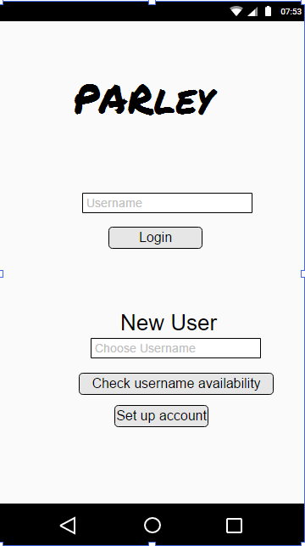

**4.2.Message Screen Mockup**

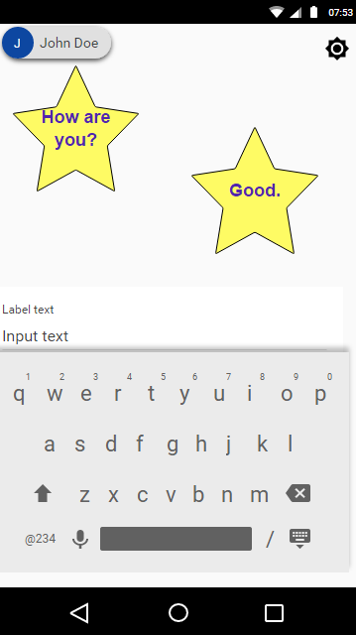

**4.3.Group Message Screen Mockup**

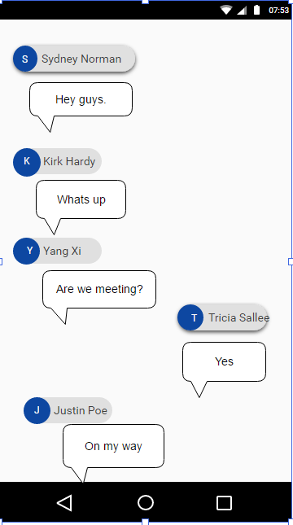

**4.4 Settings Screen**

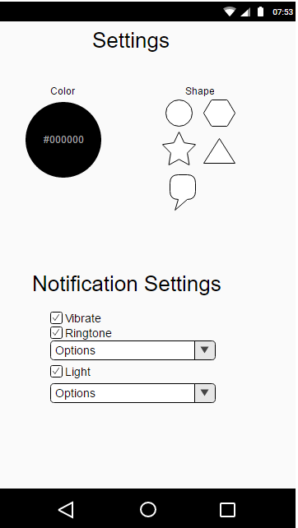

**4.5.Notification on Home Screen**

