VIETNAM GENERAL CONFEDERATION OF LABOUR

**TON DUC THANG UNIVERSITY**

**FACULTY OF INFORMATION TECHNOLOGY**



**FINAL PROJECT OF ENTERPRISE SYSTEM CONCEPT**

**COURSE MANAGEMENT**

*Lecturer*: **Đặng Minh Thắng**

*Editor*: **Le Tien Thinh - 51600082**

**Le Nguyen Thien Tin - 51600090**

Lớp **: 16050310**

Khoá  **: 20**

**THÀNH PHỐ HỒ CHÍ MINH, NĂM 2019**

ACKNOWLEDGEMENT

In order to complete the system requirement specification as soon as possible, we received the support and assistance of many other teacher.

With deep affection, sincerity, we express deep gratitude to all individuals who have helped us in study.

First we’d like to express a special appreciation to the teachers in Ton Duc Thang University for their conscientious guidance and advices throughout the last semester by gave us their modern outlook and meticulous supervision to do the job perfectly.

Especially we’d like to send out thanks to Mr Đặng Minh Thắng has paid attention, help and guide us to complete the system specification well over the past time.

We would like to express our sincere gratitude to the leadership of Ton Duc Thang University for supporting, helping and facilitating us to complete the report well during the study period.

With limited time and experience, this report can not avoid mistakes. We are looking forward to receiving advice and comments from teachers so that we can improve our awareness, better serve the practical work later.

We sincerely thank you!

**THIS FINAL PROJECT WAS COMPLETED AT TON DUC THANG UNIVERSITY**

I pledge that this is a Course Management of our own project and is under the guidance of PhD. Đăng Minh Thắng. The content of research, results in this subject is honest and not published in any form before. The data in the tables used for the analysis, comment, and evaluation were collected by the authors themselves from various sources indicated in the reference section.Ngoài ra, trong đồ án còn sử dụng một số nhận xét, đánh giá cũng như số liệu của các tác giả khác, cơ quan tổ chức khác đều có trích dẫn và chú thích nguồn gốc.

**If any fraud is detected, I am fully responsible for the content of my project**. Ton Duc Thang University is not involved in any copyright infringement or copyright infringement in the course of implementation (if any).

*TP. Hồ Chí Minh, ngày tháng năm*

*Tác giả*

*(ký tên và ghi rõ họ tên)*

*Le Tien Thinh*

*Le Nguyen Thien Tin*

EVALUATION OF INSTRUCTING LECTURER

**Confirmation of the instructor**

_______________________________________________________________________________________________________________________________________________________________________________________________________________________________________________________________________________________________________________________________________________________________________________________________________________

Tp. Hồ Chí Minh, ngày tháng năm

(kí và ghi họ tên)

**The assessment of the teacher marked**

_______________________________________________________________________________________________________________________________________________________________________________________________________________________________________________________________________________________________________________________________________________________________________________________________________________

Tp. Hồ Chí Minh, ngày tháng năm

(kí và ghi họ tên)

MỤC LỤC

ACKNOWLEDGEMENT i

EVALUATION OF INSTRUCTING LECTURER iii

MỤC LỤC 1

DANH MỤC CÁC BẢNG BIỂU, HÌNH VẼ, ĐỒ THỊ 2

CHAPTER 1 – SYSTEM ANALYSIS 4

1.1 Introduction 4

1.1.1 Purpose 4

1.1.1.1 Definations and Acronyms 4

1.1.2 High level Requirements 4

1.1.1.1 System Perspective 4

1.1.1.2 Use case diagrams 4

1.1.1.3 Actor Description 5

1.1.1.4 Use case Description 6

CHAPTER 2 – SYSTEM DESIGN 24

1.1 Class Diagram 24

1.2 Entity Relation Diagram 24

1.3 Sequence Diagram 26

1.1.1 Add and view Course Management 26

1.1.2 Modify user 26

1.1.3 Bill handling 27

DANH MỤC CÁC BẢNG BIỂU, HÌNH VẼ, ĐỒ THỊ

**DANH MỤC HÌNH**

Figure 1 :Use Case 24

Figure 2 : Class Diagram 25

Figure 3 :ERD 26

Figure 4 : Activity Diagram 27

**DANH MỤC BẢNG**

Table 1 : Actor’s Description 6

Table 2 : Add Course Management 7

Table 3 : Delete Course Managements 8

Table 4 : Modify Course Managements. 9

Table 5 : Add Orders. 10

Table 6 : Delete Orders 11

Table 7 : Modify Orders. 12

Table 12 : Delete Customers. 17

CHAPTER 1 – SYSTEM ANALYSIS

1.1 Introduction

1.1.1 Purpose

This system requirements specification provides a complete description of all the functions and specifications of the Course Mangement project developing the Course Management System. This document is intended to be used by the project team that will implement and verify the correct functioning of the system.

1.1.1.1 Definations and Acronyms

1.1.2 High level Requirements

1.1.1.1 System Perspective

This new system allow the customer can check the information when they have the membership card, cashier can search the Course Management by the Course Management ID to look up the Course Management prize and calculate the cost for the consumer and administrator can manage the Course Management business.

1.1.1.2 Use case diagrams

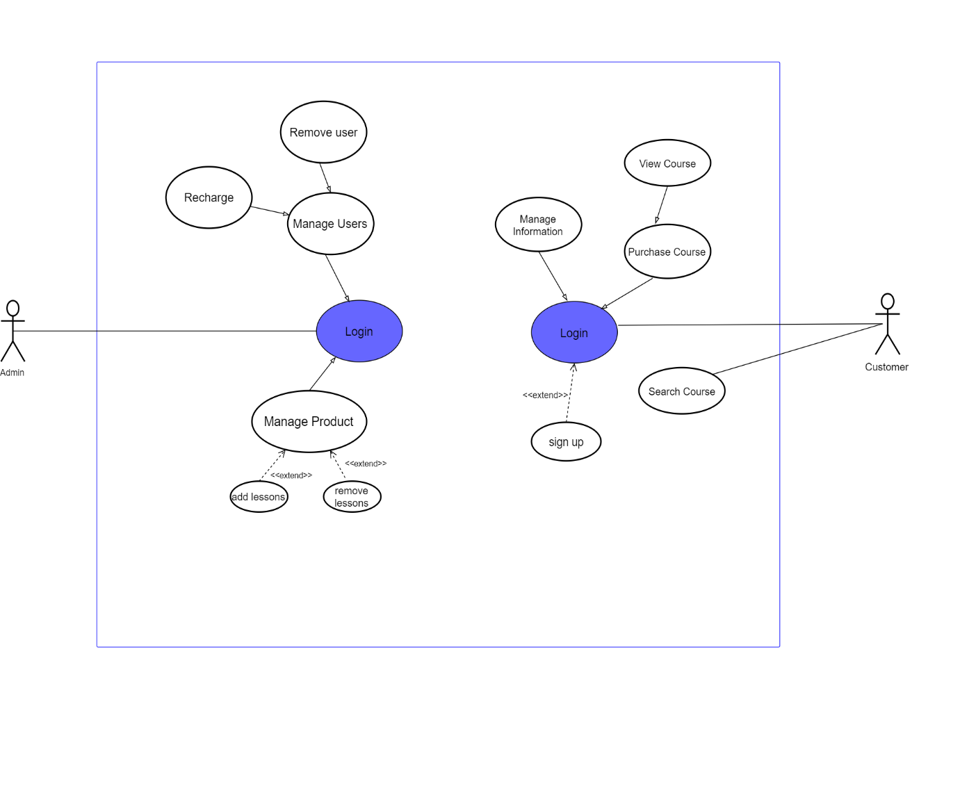

Use Case 1: System use case

1.1.1.3 Actor Description

|  |  |  |
| --- | --- | --- |
| **#** | **Actor name** | **Description** |
| 01 | Admin |  |
| 02 | User |  |

Table 1: Actor’s Description

1.1.1.4 Use case Description

|  |  |  |
| --- | --- | --- |
| **Use case:** | Add Course Managements. | |
| **Scenario:** | Add Course Managements. | |
| **Triggering Events:** | Actors choose add Course Management’s information. | |
| **Actors** | Admin, | |
| **Stakeholder:** | Course Management. | |
| **Pre-condition:** |  | |
| **Post-condition:** | Course Management’s information is saved in the system. | |
| **Flow of events:** | **Actors** | **System** |
| 1 Actors choose add Course Management’s information | 1.1 System will request for Course Management’s information. |
| 2 Actors enter Course Management’s information. | 2.1 System will save the current Course Management’s information. |
| 3 Actor enter another Course Management’s information. | 3.1 System will check that Course Management’s information. |
| **Exception Conditions** |  | |

Table 2: Add Course Management

|  |  |  |
| --- | --- | --- |
| **Use case:** | Delete Course Managements. | |
| **Scenario:** | Delete Course Managements. | |
| **Triggering Events:** | Actors choose remove Course Management’s information. | |
| **Actors** | Admin | |
| **Stakeholder:** | Course Management. | |
| **Pre-condition:** | Actors search that Course Management’s information successful. | |
| **Post-condition:** | Course Management’s information is removed in the system. | |
| **Flow of events:** | **Actors** | **System** |
| 1 Actors choose remove Course Management’s information | 1.1 System will request for Course Management’s id. |
| 2 Actors enter Course Management’s id. | 2.1 System will remove that Course Management’s information. |
| 3 Actor enter another Course Management’s information. | 3.1 System will remove that Course Management has quantity equals to 1.  3.2 The Course Management’s quantity will decrease by 1 when that Course Management has quantity greater than 1. |
| **Exception Conditions** | This Course Management’s is not exist. | |

Table 3: Delete Course Managements

|  |  |  |
| --- | --- | --- |
| **Use case:** | Modify Course Managements. | |
| **Scenario:** | Modify Course Managements. | |
| **Triggering Events:** | Actors choose update Course Management’s information. | |
| **Actors** | Admin, . | |
| **Stakeholder:** | Course Management. | |
| **Pre-condition:** | Actors search that Course Management’s information successful. | |
| **Post-condition:** | Course Management’s information is updated in the system. | |
| **Flow of events:** | **Actors** | **System** |
| 1 Actors choose update Course Management’s information | 1.1 System will request for new Course Management’s information. |
| 2 Actors enter the new Course Management’s information. | 2.1 System will change that Course Management’s information. |
| **Exception Conditions** | This Course Management’s is not exist. | |

Table 4: Modify Course Managements.

|  |  |  |
| --- | --- | --- |
| **Use case:** | Add Orders. | |
| **Scenario:** | Add Orders. | |
| **Triggering Events:** | Actors choose add orders information. | |
| **Actors** | Admin, . | |
| **Stakeholder:** | Course Management. | |
| **Pre-condition:** |  | |
| **Post-condition:** | Order’s information is saved in the system. | |
| **Flow of events:** | **Actors** | **System** |
| 1 Actors choose add order’s information | 1.1 System will request for order’s information. |
| 2 Actors enter order’s information. | 2.1 System will save the current order’s information. |
| 3 Actor enter another order’s information. | 3.1 System will check that order’s information. |
| **Exception Conditions** | This order is existed. | |

Table 5: Add Orders.

|  |  |  |
| --- | --- | --- |
| **Use case:** | Delete Orders. | |
| **Scenario:** | Delete Orders. | |
| **Triggering Events:** | Actors choose remove order’s information. | |
| **Actors** | Admin, . | |
| **Stakeholder:** | Course Management. | |
| **Pre-condition:** | Actors search that order’s information successful. | |
| **Post-condition:** | Order’s information is removed in the system. | |
| **Flow of events:** | **Actors** | **System** |
| 1 Actors choose remove order’s information | 1.1 System will request for order’s id. |
| 2 Actors enter order’s id. | 2.1 System will remove that order’s information. |
| 3 Actor enter another order’s information. | 3.1 Go back to 2.1. |
| **Exception Conditions** | This order is not exist. | |

|  |  |  |
| --- | --- | --- |
| **Use case:** | Modify Orders. | |
| **Scenario:** | Modify Orders. | |
| **Triggering Events:** | Actors choose update order’s information. | |
| **Actors** | Admin, . | |
| **Stakeholder:** | Course Management. | |
| **Pre-condition:** | Actors search that order’s information successful. | |
| **Post-condition:** | Order’s information is updated in the system. | |
| **Flow of events:** | **Actors** | **System** |
| 1 Actors choose update order’s information | 1.1 System will request for new order’s information based on old order’s information. |
| 2 Actors enter the new order’s information. | 2.1 System will change that order’s information. |
| **Exception Conditions** | This order’s is not exist. | |

Table 7: Modify Orders.

|  |  |  |
| --- | --- | --- |
| **Use case:** | Add Customers. | |
| **Scenario:** | Add Customers. | |
| **Triggering Events:** | Actors choose add customer’s account. | |
| **Actors** | Admin, , Cashier. | |
| **Stakeholder:** | Course Management. | |
| **Pre-condition:** |  | |
| **Post-condition:** | Customer’s account is saved in the system. | |
| **Flow of events:** | **Actors** | **System** |
| 1 Actors choose add customer’s information. | 1.1 System will request for customer’s information. |
| 2 Actors enter customer’s information. | 2.1 System will save the current customer’s information. |
| **Exception Conditions** | This customer’s information is existed. | |

Table 11: Add Customers.

|  |  |  |
| --- | --- | --- |
| **Use case:** | Delete Customers. | |
| **Scenario:** | Delete Customers. | |
| **Triggering Events:** | Actors choose remove customer’s information. | |
| **Actors** | Admin, , Cashier. | |
| **Stakeholder:** | Course Management. | |
| **Pre-condition:** | Actors search that customer’s information successful. | |
| **Post-condition:** | Customer’s information is removed in the system. | |
| **Flow of events:** | **Actors** | **System** |
| 1 Actors choose remove Customer’s information | 1.1 System will request for Customer’s information. |
| 2 Actors enter Customer’s information. | 2.1 System will remove that customer’s information. |
| 3 Actor enter another customer’s information. | 3.1 Go back to 2.1. |
| **Exception Conditions** | This customer’s information is not exist. | |

Table 12: Delete Customers.

|  |  |  |
| --- | --- | --- |
| **Use case:** | Modify Sales. | |
| **Scenario:** | Modify Sales. | |
| **Triggering Events:** | Actors choose update sale’s information. | |
| **Actors** | Cashier. | |
| **Stakeholder:** | Course Management. | |
| **Pre-condition:** | Actors search that sale’s information successful. | |
| **Post-condition:** | Sale’s information is updated in the system. | |
| **Flow of events:** | **Actors** | **System** |
| 1 Actors choose update sale’s information | 1.1 System will request for new sale’s information. |
| 2 Actors enter the new sale’s information. | 2.1 System will change that sale’s information. |
| **Exception Conditions** | This sale’s is not existed. | |

1.3

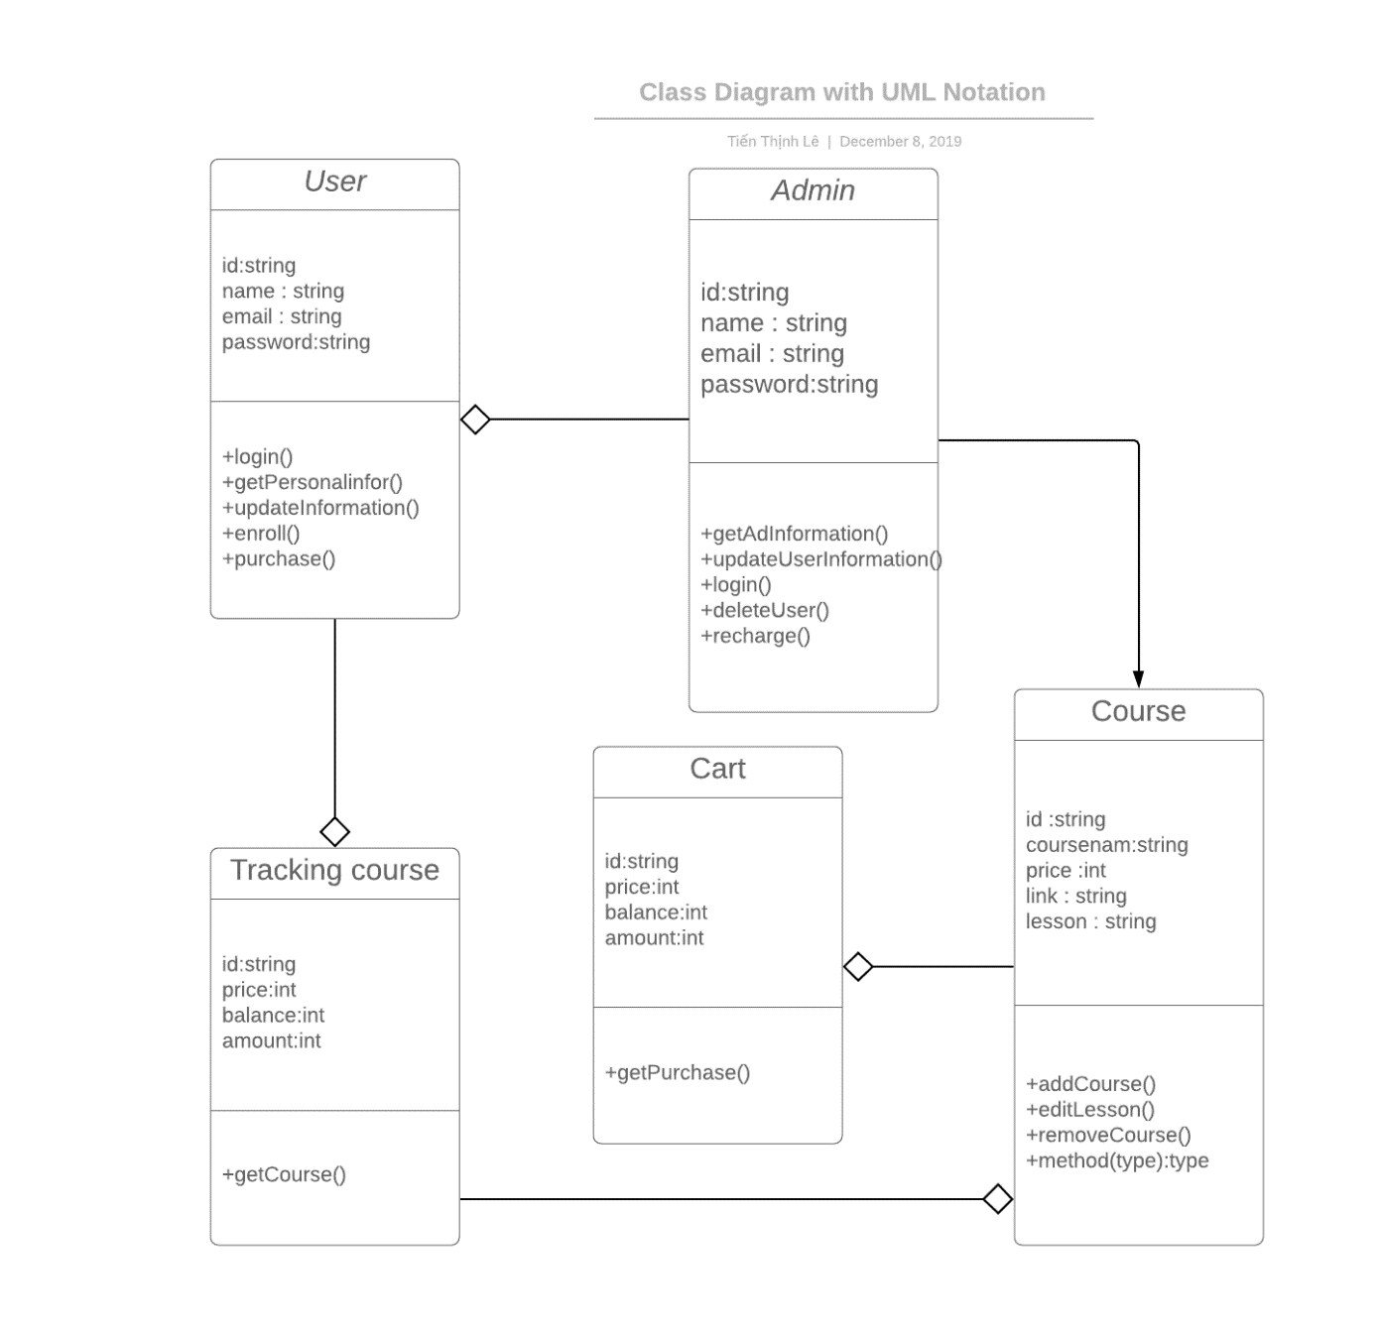

Figure 3:Class Diagram

***1.3 ERD***

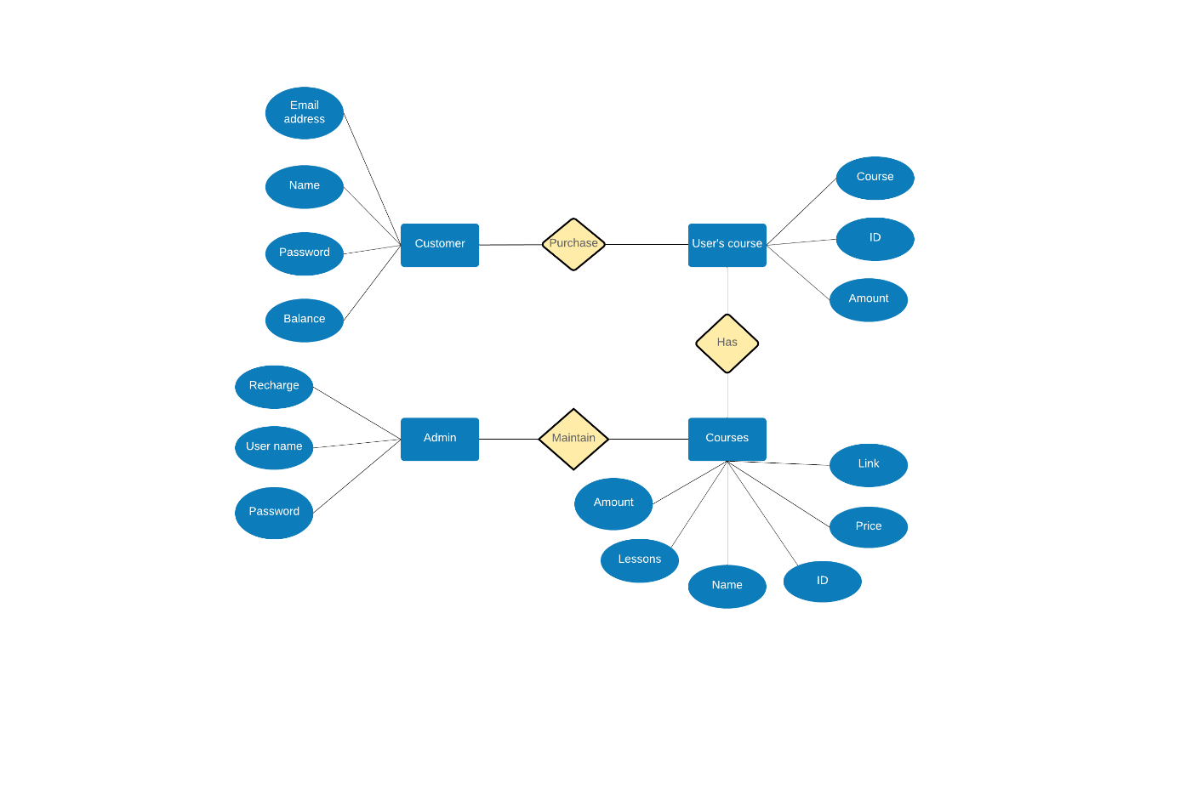

Figure 5: Sequence Diagram for bill handling

***1.4 Activty Diagram***

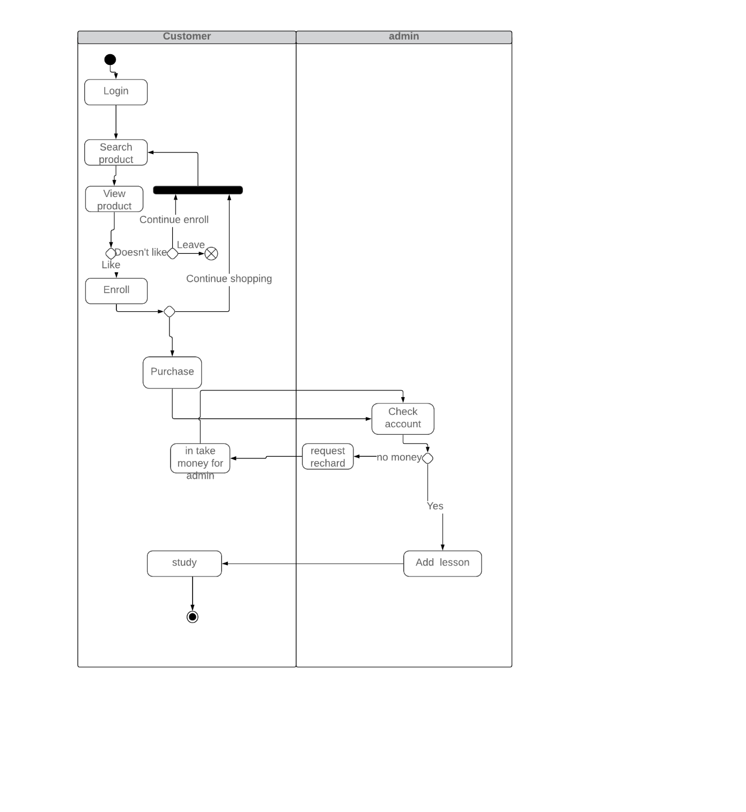

Figure 6: Activity Diagram