# Bài thực hành 1: Hướng dẫn tạo Project và Thiết kế giao diện người dùng

## HƯớng dẫn tạo Project

Clone Respository từ Github, ví dụ PTUDW

#### Bước này SV tự thực hiện việc tạo tài khoản github và tự clone về máy của mình thông qua Github Destop

### Tạo mới Project

Khởi động Visual Studio 2019 - New Project

Language: C#

Search: MVC

🞎 Place solution and Project in the same directory (***Tạo mới Folder trong Folder PTUDW***)

🗹 MVC

🗹 Configure for HTTPs

Ví dụ: Project name = **63CNTTX**

### Cấu hình file RouteConfig.cs

Controller = “Site”

Action = “Index”

### Tạo Controller

Controller – R_Click – Add

MVC

MVC 5 Controller Empty

Name: Site**Controller** (**Lưu ý** phải có Controller ở cuối)



### Chạy thử

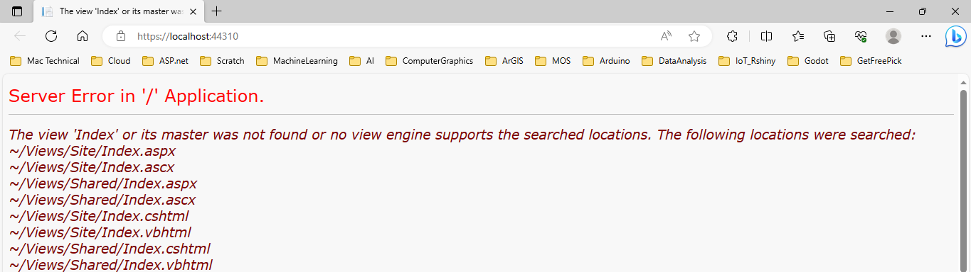

#### Nguyên nhân: chưa có tập tin Index (View)

### Tạo View: Layout View = những nội dung được lặp đi lặp lại ở các trang

R_Click View – Add Folder – Shared (Nếu chưa có)

R_click Shared – New Item

Installed – Visual C# - Web – Razor – Layout Page (Razor 3)

Name: _LayoutSite.cshtml (trang người dùng # trang admin)



<!DOCTYPE html>

<html>

<head>

<title>@Page.Title</title>

@RenderSection("head", required: false)

</head>

<body>

@RenderBody()

</body>

</html>

### Add Index.cshtml từ Site Controller

Quay lại Controller – R_Click Index – Add View

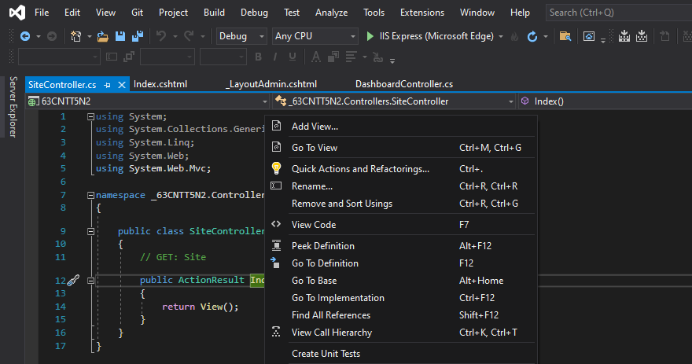

MVC 5 View

Name = Index

Template = Empty (without model)

🗹 Use layout view = View – Shared - _LayoutStie.cshtml

Add

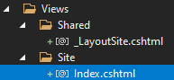

@{

ViewBag.Title = "Index";

Layout = "~/Views/Shared/_LayoutSite.cshtml";

}

<h2>Index</h2>

### Run Website

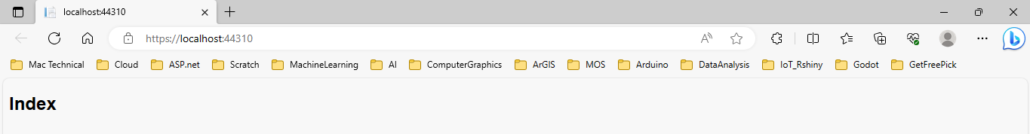

Sao chép nội dung Index.html trong aroma template cho Index.cshtml. Trong file index này có các đoạn css, script và hình ảnh nên chúng ta cần thiết lập đường dẫn cho chúng bằng cách chuyển tất cả các folder sang Public. Cụ thể:

## BOOTSTRAP

Tạo folder Public trong Project

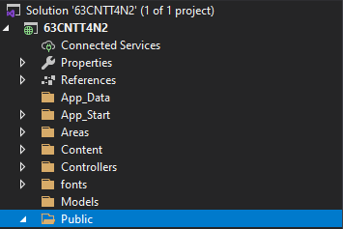

Lưu ý: không tạo folder publics bên trong folder Content có sẵn (mặc định của Bootstrap) nên khi gỡ Bootstrap thì đồng nghĩa với việc các css cũng bị mất.

Copy các folder trong sample_template_aroma\aroma cho Public (bao gồm css, js, …)

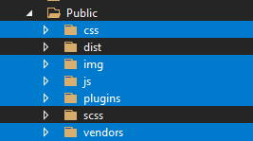

### Tạo StyleSheet

_LayoutSite.css trong folder css

Mục đích: để lưu trữ các css không có sẵn hoặc các thiết kế riêng của người dùng

## Thiết kế trang INDEX dựa vào Index của aroma template

Sao chép phần bootstrap của Index sang cho _Layoutsite, chỉnh sửa đường dẫn đến thư mục chứa Bootstrap

### Add bootstrap cho LayoutView (dành cho User là khách hàng)

Khai báo thư viện bootstrap

<head>

<title>@Page.Title</title>

<meta charset="UTF-8">

<meta name="viewport" content="width=device-width, initial-scale=1.0">

<meta http-equiv="X-UA-Compatible" content="ie=edge">

<title>Aroma Shop - Home</title>

<link rel="icon" href="~/Public/img/Fevicon.png" type="image/png">

<link rel="stylesheet" href="~/Public/vendors/bootstrap/bootstrap.min.css">

<link rel="stylesheet" href="~/Public/vendors/fontawesome/css/all.min.css">

<link rel="stylesheet" href="~/Public/vendors/themify-icons/themify-icons.css">

<link rel="stylesheet" href="~/Public/vendors/nice-select/nice-select.css">

<link rel="stylesheet" href="~/Public/vendors/owl-carousel/owl.theme.default.min.css">

<link rel="stylesheet" href="~/Public/vendors/owl-carousel/owl.carousel.min.css">

<link rel="stylesheet" href="~/Public/css/style.css">

@RenderSection("header", required: false)

</head>

<body>

@RenderBody()

<script src="Public/vendors/jquery/jquery-3.2.1.min.js"></script>

<script src="Public/vendors/bootstrap/bootstrap.bundle.min.js"></script>

<script src="Public/vendors/skrollr.min.js"></script>

<script src="Public/vendors/owl-carousel/owl.carousel.min.js"></script>

<script src="Public/vendors/nice-select/jquery.nice-select.min.js"></script>

<script src="Public/vendors/jquery.ajaxchimp.min.js"></script>

<script src="Public/vendors/mail-script.js"></script>

<script src="Public/js/main.js"></script>

</body>

</html>

## Thiết kế header



<!DOCTYPE html>

<html>

<head>

<title>@Page.Title</title>

<meta charset="UTF-8">

<meta name="viewport" content="width=device-width, initial-scale=1.0">

<meta http-equiv="X-UA-Compatible" content="ie=edge">

<title>Aroma Shop - Home</title>

<link rel="icon" href="Public/img/Fevicon.png" type="image/png">

<link rel="stylesheet" href="Public/vendors/bootstrap/bootstrap.min.css">

<link rel="stylesheet" href="Public/vendors/fontawesome/css/all.min.css">

<link rel="stylesheet" href="Public/vendors/themify-icons/themify-icons.css">

<link rel="stylesheet" href="Public/vendors/nice-select/nice-select.css">

<link rel="stylesheet" href="Public/vendors/owl-carousel/owl.theme.default.min.css">

<link rel="stylesheet" href="Public/vendors/owl-carousel/owl.carousel.min.css">

<link rel="stylesheet" href="Public/css/style.css">

@RenderSection("header", required: false)

</head>

<body>

<!--================ Start Header Menu Area =================-->

<header class="header_area">

<div class="main_menu">

<nav class="navbar navbar-expand-lg navbar-light">

<div class="container">

<a class="navbar-brand logo_h" href="index.html"><img src="~/Public/img/logo.png" alt=""></a>

<button class="navbar-toggler" type="button" data-toggle="collapse" data-target="#navbarSupportedContent" aria-controls="navbarSupportedContent" aria-expanded="false" aria-label="Toggle navigation">

<span class="icon-bar"></span>

<span class="icon-bar"></span>

<span class="icon-bar"></span>

</button>

<div class="collapse navbar-collapse offset" id="navbarSupportedContent">

<ul class="nav navbar-nav menu_nav ml-auto mr-auto">

<li class="nav-item active"><a class="nav-link" href="index.html">Home</a></li>

<li class="nav-item submenu dropdown">

<a href="#" class="nav-link dropdown-toggle" data-toggle="dropdown" role="button" aria-haspopup="true"aria-expanded="false">Shop</a>

<ul class="dropdown-menu">

<li class="nav-item"><a class="nav-link" href="category.html">Shop Category</a></li>

<li class="nav-item"><a class="nav-link" href="single-product.html">Product Details</a></li>

<li class="nav-item"><a class="nav-link" href="checkout.html">Product Checkout</a></li>

<li class="nav-item"><a class="nav-link" href="confirmation.html">Confirmation</a></li>

<li class="nav-item"><a class="nav-link" href="cart.html">Shopping Cart</a></li>

</ul>

</li>

<li class="nav-item submenu dropdown">

<a href="#" class="nav-link dropdown-toggle" data-toggle="dropdown" role="button" aria-haspopup="true"aria-expanded="false">Blog</a>

<ul class="dropdown-menu">

<li class="nav-item"><a class="nav-link" href="blog.html">Blog</a></li>

<li class="nav-item"><a class="nav-link" href="single-blog.html">Blog Details</a></li>

</ul>

</li>

<li class="nav-item submenu dropdown">

<a href="#" class="nav-link dropdown-toggle" data-toggle="dropdown" role="button" aria-haspopup="true"aria-expanded="false">Pages</a>

<ul class="dropdown-menu">

<li class="nav-item"><a class="nav-link" href="login.html">Login</a></li>

<li class="nav-item"><a class="nav-link" href="register.html">Register</a></li>

<li class="nav-item"><a class="nav-link" href="tracking-order.html">Tracking</a></li>

</ul>

</li>

<li class="nav-item"><a class="nav-link"href="contact.html">Contact</a></li>

</ul>

<ul class="nav-shop">

<li class="nav-item"><button><i class="ti-search"></i></button></li>

<li class="nav-item"><button><i class="ti-shopping-cart"></i><span class="nav-shop__circle">3</span></button> </li>

<li class="nav-item"><a class="button button-header" href="#">Buy Now</a></li>

</ul>

</div>

</div>

</nav>

</div>

</header>

<!--================ End Header Menu Area =================-->

@RenderBody()

<script src="Public/vendors/jquery/jquery-3.2.1.min.js"></script>

<script src="Public/vendors/bootstrap/bootstrap.bundle.min.js"></script>

<script src="Public/vendors/skrollr.min.js"></script>

<script src="Public/vendors/owl-carousel/owl.carousel.min.js"></script>

<script src="Public/vendors/nice-select/jquery.nice-select.min.js"></script>

<script src="Public/vendors/jquery.ajaxchimp.min.js"></script>

<script src="Public/vendors/mail-script.js"></script>

<script src="Public/js/main.js"></script>

</body>

</html>

## THIẾT KẾ FOOTER

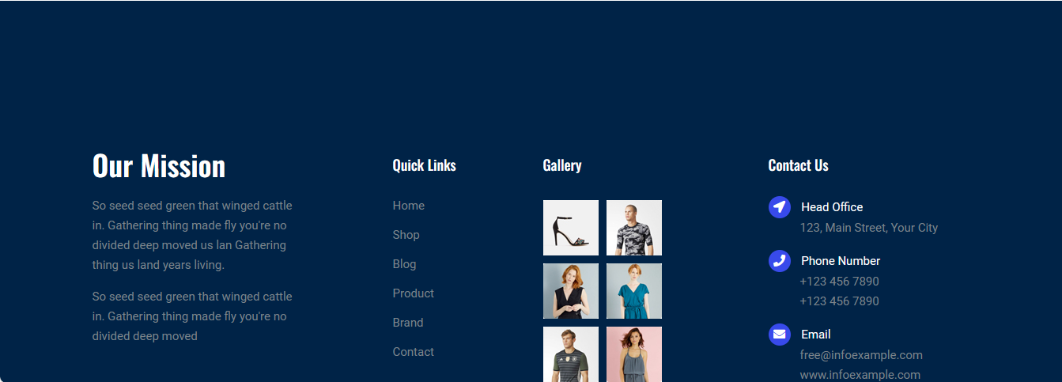

<!DOCTYPE html>

<html>

<head>

<title>@Page.Title</title>

<meta charset="UTF-8">

<meta name="viewport" content="width=device-width, initial-scale=1.0">

<meta http-equiv="X-UA-Compatible" content="ie=edge">

<title>Aroma Shop - Home</title>

<link rel="icon" href="Public/img/Fevicon.png" type="image/png">

<link rel="stylesheet" href="Public/vendors/bootstrap/bootstrap.min.css">

<link rel="stylesheet" href="Public/vendors/fontawesome/css/all.min.css">

<link rel="stylesheet" href="Public/vendors/themify-icons/themify-icons.css">

<link rel="stylesheet" href="Public/vendors/nice-select/nice-select.css">

<link rel="stylesheet" href="Public/vendors/owl-carousel/owl.theme.default.min.css">

<link rel="stylesheet" href="Public/vendors/owl-carousel/owl.carousel.min.css">

<link rel="stylesheet" href="Public/css/style.css">

@RenderSection("header", required: false)

</head>

<body>

<!--================ Start Header Menu Area =================-->

…

<!--================ End Header Menu Area =================-->

<!--================ Start footer Area =================-->

<footer class="footer">

<div class="footer-area">

<div class="container">

<div class="row section_gap">

<div class="col-lg-3 col-md-6 col-sm-6">

<div class="single-footer-widget tp_widgets">

<h4 class="footer_title large_title">Our Mission</h4>

<p> So seed seed green that winged cattle in. Gathering thing made fly you're no divided deep moved us lan Gathering thing us land years living.

</p>

<p> So seed seed green that winged cattle in. Gathering thing made fly you're no divided deep moved

</p>

</div>

</div>

<div class="offset-lg-1 col-lg-2 col-md-6 col-sm-6">

<div class="single-footer-widget tp_widgets">

<h4 class="footer_title">Quick Links</h4>

<ul class="list">

<li><a href="#">Home</a></li>

<li><a href="#">Shop</a></li>

<li><a href="#">Blog</a></li>

<li><a href="#">Product</a></li>

<li><a href="#">Brand</a></li>

<li><a href="#">Contact</a></li>

</ul>

</div>

</div>

<div class="col-lg-2 col-md-6 col-sm-6">

<div class="single-footer-widget instafeed">

<h4 class="footer_title">Gallery</h4>

<ul class="list instafeed d-flex flex-wrap">

<li><img src="~/Public/img/gallery/r1.jpg" alt=""></li>

<li><img src="~/Public/img/gallery/r2.jpg" alt=""></li>

<li><img src="~/Public/img/gallery/r3.jpg" alt=""></li>

<li><img src="~/Public/img/gallery/r5.jpg" alt=""></li>

<li><img src="~/Public/img/gallery/r7.jpg" alt=""></li>

<li><img src="~/Public/img/gallery/r8.jpg" alt=""></li>

</ul>

</div>

</div>

<div class="offset-lg-1 col-lg-3 col-md-6 col-sm-6">

<div class="single-footer-widget tp_widgets">

<h4 class="footer_title">Contact Us</h4>

<div class="ml-40">

<p class="sm-head"><span class="fa fa-location-arrow"></span>Head Office</p>

<p>123, Main Street, Your City</p>

<p class="sm-head"> <span class="fa fa-phone"></span>Phone Number</p>

<p>

+123 456 7890 <br>

+123 456 7890

</p>

<p class="sm-head"><span class="fa fa-envelope"></span>Email</p>

<p>

free@infoexample.com <br>

www.infoexample.com

</p>

</div>

</div>

</div>

</div>

</div>

</div>

<div class="footer-bottom">

<div class="container">

<div class="row d-flex">

<p class="col-lg-12 footer-text text-center">

<!-- Link back to Colorlib can't be removed. Template is licensed under CC BY 3.0. -->

Copyright &copy;

<script>document.write(new Date().getFullYear());</script> All rights reserved | This template is made with <i class="fa fa-heart" aria-hidden="true"></i> by <a href="https://colorlib.com" target="_blank">Colorlib</a>

<!-- Link back to Colorlib can't be removed. Template is licensed under CC BY 3.0. -->

</p>

</div>

</div>

</div>

</footer>

<!--================ End footer Area =================-->

<script src="Public/vendors/jquery/jquery-3.2.1.min.js"></script>

<script src="Public/vendors/bootstrap/bootstrap.bundle.min.js"></script>

<script src="Public/vendors/skrollr.min.js"></script>

<script src="Public/vendors/owl-carousel/owl.carousel.min.js"></script>

<script src="Public/vendors/nice-select/jquery.nice-select.min.js"></script>

<script src="Public/vendors/jquery.ajaxchimp.min.js"></script>

<script src="Public/vendors/mail-script.js"></script>

<script src="Public/js/main.js"></script>

</body>

</html>

# Bài thực hành 1+1: Hướng dẫn Thiết kế giao diện ADMIN

## Tạo vùng admin

### Tạo Areas

Add Folder: Areas

### Tạo Admin Area:

R_click Areas (folder) - Add - Areas

Common - MVC - Areas - MVC 5 Area - Add

Name: Admin

Một vùng MVC thu nhỏ bên trong Areas (Controller, Data, Views = Shared+ webconfig..)

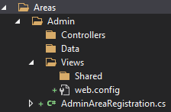

#### Mục đích: khi ra ngoài web gõ địa chỉ: /admin thì trang web hiển thị nội dung trang views admin tương ứng với controller admin.

Có thể thấy được điều này thông qua tập tin: AdminAreasRegistration.cs

using System.Web.Mvc;

namespace ThoiTrang.Areas.Admin

{

public class AdminAreaRegistration : AreaRegistration

{

public override string AreaName

{

get

{

return "Admin";

}

}

### 

### Khai báo Controller = “Dashboard” trong AdminAreasRegistration.cs

public override void RegisterArea(AreaRegistrationContext context)

{

context.MapRoute(

"Admin_default",

"Admin/{controller}/{action}/{id}",

new {Controller = "Dashboard"[1],action= "Index",id = UrlParameter.Optional }

);

}

}

}

### Tạo controller cho Admin = DashboardController.cs

R_Click Areas\Admin

Add: Controller

MVC 5 Controller - Empty

Add

Name: DashboardController.cs

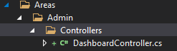

using System;

using System.Collections.Generic;

using System.Linq;

using System.Web;

using System.Web.Mvc;

namespace ThoiTrang.Areas.Admin.Controllers

{

public class DashboardController : Controller

{

// GET: Admin/Dashboard

public ActionResult Index()

{

return View();

}

}

}

Hiện nay chưa thể thực hiện trang admin: <https://localhost:44310/admin>.Vì còn thiếu trang Index

Trang Admin là Index (VIEW) chưa tồn tại cần tạo ra thì mới có thể thực thi được. Thay vì tạo trang Admin bằng tay thì ta dùng template admin sẵn có:

## Tạo _LayoutAdmin

R_click Areas\Admin\View\Shared - Add - New Item

Iinstalled - Visual C# - Web - Razor - Layout Page (Razor 3)

Name: _LayoutAdmin.cshtml

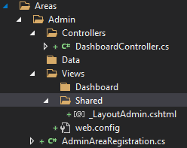

### Tải giao diện mẫu: adminlte.io

Tải source.zip

Unzip

Truy cập đến folder: Downloads\AdminLTE-3.1.0\AdminLTE-3.1.0\pages\examples

Mở file blank.html

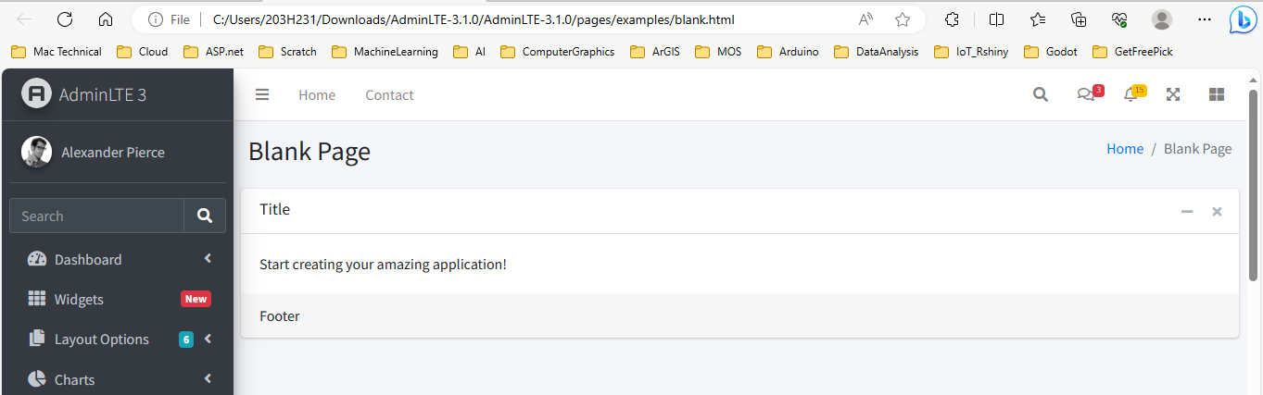

Open code blank.html

Nhìn sơ qua phần khai báo header của trang index, cần bổ sung các css, js như sau:

<head>

<meta charset="utf-8">

<meta name="viewport" content="width=device-width, initial-scale=1">

<title>AdminLTE 3 | Blank Page</title>

<!-- Google Font: Source Sans Pro -->

<link rel="stylesheet" href="https://fonts.googleapis.com/css?family=Source+Sans+Pro:300,400,400i,700&display=fallback">

<!-- Font Awesome -->

<link rel="stylesheet" href="../../plugins/fontawesome-free/css/all.min.css">

<!-- Theme style -->

<link rel="stylesheet" href="../../dist/css/adminlte.min.css">

</head>

### Sao chép folder dist và plugins của AdminLTE đến folder Publics

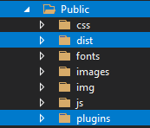





Sau đó chỉnh sửa đường dẫn đến các folder chứa thư mục **dist** và **plugin**

<!DOCTYPE html>

<html>

<head>

<title>@ViewBag.Title</title>

<meta name="viewport" content="width=device-width, initial-scale=1">

<!-- Google Font: Source Sans Pro -->

<link rel="stylesheet" href="https://fonts.googleapis.com/css?family=Source+Sans+Pro:300,400,400i,700&display=fallback">

<!-- Font Awesome -->

<link href="~/Public/plugins/fontawesome-free/css/all.min.css" rel="stylesheet" />

<!-- Theme style -->

<link href="~/Public/dist/css/adminlte.min.css" rel="stylesheet" />

<!-- Bootstrap tu dinh nghia-->

<link href="~/Public/css/LayoutAdmin.css" rel="stylesheet" />

@*Khu vuc header*@

@RenderSection("header", required: false)

</head>

@*Khu vuc body*@

<body class="hold-transition sidebar-mini">

<!-- Site wrapper -->

<div class="wrapper">

<!-- Navbar -->

<nav class="main-header navbar navbar-expand navbar-white navbar-light">

<!-- Left navbar links -->

<ul class="navbar-nav">

<li class="nav-item">

<a class="nav-link" data-widget="pushmenu" href="#" role="button"><i class="fas fa-bars"></i></a>

</li>

<li class="nav-item d-none d-sm-inline-block">

<a href#" class="nav-link">Home</a>

</li>

<li class="nav-item d-none d-sm-inline-block">

<a href="#" class="nav-link">Contact</a>

</li>

</ul>

<!-- Right navbar links -->

<ul class="navbar-nav ml-auto">

<li class="nav-item">

<a class="nav-link" data-widget="fullscreen" href="#" role="button">

<i class="fas fa-expand-arrows-alt"></i>

</a>

</li>

<li class="nav-item">

<a class="nav-link" data-widget="control-sidebar" data-slide="true" href="#" role="button">

<i class="fas fa-th-large"></i>

</a>

</li>

</ul>

</nav>

<!-- /.navbar -->

<!-- Main Sidebar Container -->

<aside class="main-sidebar sidebar-dark-primary elevation-4">

<!-- Brand Logo -->

<a href="@Url.Action("Index","Link")" class="brand-link">

<img src="~/Public/dist/img/AdminLTELogo.png" alt="AdminLTE Logo" class="brand-image img-circle elevation-3" style="opacity: .8">

<span class="brand-text font-weight-light">AdminLTE 3</span>

</a>

<!-- Sidebar -->

<div class="sidebar">

<!-- Sidebar user (optional) -->

<div class="user-panel mt-3 pb-3 mb-3 d-flex">

<div class="image">

<img src="~/Public/dist/img/user2-160x160.jpg" class="img-circle elevation-2" alt="User Image">

</div>

<div class="info">

<a href="#" class="d-block">Alexander Pierce</a>

</div>

</div>

<!-- Sidebar Menu -->

<nav class="mt-2">

<ul class="nav nav-pills nav-sidebar flex-column" data-widget="treeview" role="menu" data-accordion="false">

**<!-- Menu Sản phẩm: Loại SP, Sản phẩm, Nhà cung cấp -->**

<li class="nav-item">

<a href="#" class="nav-link">

<i class="nav-icon fas fa-tachometer-alt"></i>

<p>Sản phẩm <i class="right fas fa-angle-left"></i></p>

</a>

<ul class="nav nav-treeview">

<li class="nav-item">

<a href="@Url.Action("Index","Product")" class="nav-link">

<i class="far fa-circle nav-icon"></i>

<p>Sản phẩm</p>

</a>

</li>

<li class="nav-item">

<a href="@Url.Action("Index","Category")" class="nav-link">

<i class="far fa-circle nav-icon"></i>

<p>Loại sản phẩm</p>

</a>

</li>

<li class="nav-item">

<a href="@Url.Action("Index","Supplier")" class="nav-link">

<i class="far fa-circle nav-icon"></i>

<p>Nhà cung cấp</p>

</a>

</li>

</ul>

</li>

<!-- Menu danh mục bài viết-->

<li class="nav-item">

<a href="#" class="nav-link">

<i class="nav-icon fas fa-tachometer-alt"></i>

<p>Bài viết<i class="right fas fa-angle-left"></i></p>

</a>

<ul class="nav nav-treeview">

<li class="nav-item">

<a href="@Url.Action("Index","Post")" class="nav-link">

<i class="far fa-circle nav-icon"></i>

<p>Danh sách bài viết</p>

</a>

</li>

<li class="nav-item">

<a href="@Url.Action("Index","Topic")" class="nav-link">

<i class="far fa-circle nav-icon"></i>

<p>Chủ đề bài viết</p>

</a>

</li>

<li class="nav-item">

<a href="@Url.Action("Index","Page")" class="nav-link">

<i class="far fa-circle nav-icon"></i>

<p>Trang đơn</p>

</a>

</li>

</ul>

</li>

<!--Menu dành cho giao diện-->

<li class="nav-item">

<a href="#" class="nav-link">

<i class="nav-icon fas fa-tachometer-alt"></i>

<p>Giao diện<i class="right fas fa-angle-left"></i></p>

</a>

<ul class="nav nav-treeview">

<li class="nav-item">

<a href="@Url.Action("Index","Menu")" class="nav-link">

<i class="far fa-circle nav-icon"></i>

<p>Menu</p>

</a>

</li>

<li class="nav-item">

<a href="@Url.Action("Index","Slider")" class="nav-link">

<i class="far fa-circle nav-icon"></i>

<p>Slide Show</p>

</a>

</li>

</ul>

</li>

<!--Phàn còn lại của menu-->

<li class="nav-header">LABELS</li>

<li class="nav-item">

<a href="#" class="nav-link">

<i class="nav-icon far fa-circle text-danger"></i>

<p class="text">Important</p>

</a>

</li>

<li class="nav-item">

<a href="#" class="nav-link">

<i class="nav-icon far fa-circle text-warning"></i>

<p>Warning</p>

</a>

</li>

<li class="nav-item">

<a href="#" class="nav-link">

<i class="nav-icon far fa-circle text-info"></i>

<p>Informational</p>

</a>

</li>

</ul>

</nav>

</div><!-- /.sidebar-menu -->

</aside><!-- /.sidebar -->

**@RenderBody()[2]**

<footer class="main-footer">

<div class="float-right d-none d-sm-block">

<b>Version</b> 3.1.0

</div>

<strong>Copyright &copy; 2014-2021 <a href="https://adminlte.io">AdminLTE.io</a>.</strong> All rights reserved.

</footer>

<!-- Control Sidebar -->

<aside class="control-sidebar control-sidebar-dark">

<!-- Control sidebar content goes here -->

</aside>

<!-- /.control-sidebar -->

### </div>

<!-- ./wrapper -->

<!-- jQuery -->

<script src="~/Public/plugins/jquery/jquery.min.js"></script>

<!-- Bootstrap 4 -->

<script src="~/Public/plugins/bootstrap/js/bootstrap.bundle.min.js"></script>

<!-- AdminLTE App -->

<script src="~/Public/dist/js/adminlte.min.js"></script>

<!-- AdminLTE for demo purposes -->

<script src="~/Public/dist/js/demo.js"></script>

@*Khu vuc Footer*@

@RenderSection("footer", required: false)

</body>

</html>

### Tạo View Index cho DashboardController.cs

Từ tập tin DashboardController

public class DashboardController : Controller

{

// GET: Admin/Dashboard

public ActionResult Index()

{

return View();

}

}

R_Click Index - Add View

View \ MVC 5 View \

Name: Index

Template: Emty

🗹 Use layout page: ~Areas\Admin\View/Shared/_LayoutAdmin.cshtml

### Đây là nội dung trang INDEX

@{

ViewBag.Title = "Index";

Layout = "~/Areas/Admin/Views/Shared/_LayoutAdmin.cshtml";

}

<body class="hold-transition sidebar-mini">

<!-- Site wrapper -->

<div class="wrapper">

<!-- Main Sidebar Container -->

<!-- Content Wrapper. Contains page content -->

<div class="content-wrapper">

<!-- Main content -->

<section class="content">

<!-- Default box -->

<div class="card">

<div class="card-header">

<h3 class="card-title">Title</h3>

<div class="card-tools">

<button type="button" class="btn btn-tool" data-card-widget="collapse" title="Collapse">

<i class="fas fa-minus"></i>

</button>

<button type="button" class="btn btn-tool" data-card-widget="remove" title="Remove">

<i class="fas fa-times"></i>

</button>

</div>

</div>

<div class="card-body">

Start creating your amazing application!

</div> <!-- /.card-footer-->

</div><!-- /.card -->

</section><!-- /.content -->

</div> <!-- /.content-wrapper -->

</div><!-- ./wrapper -->

</body>

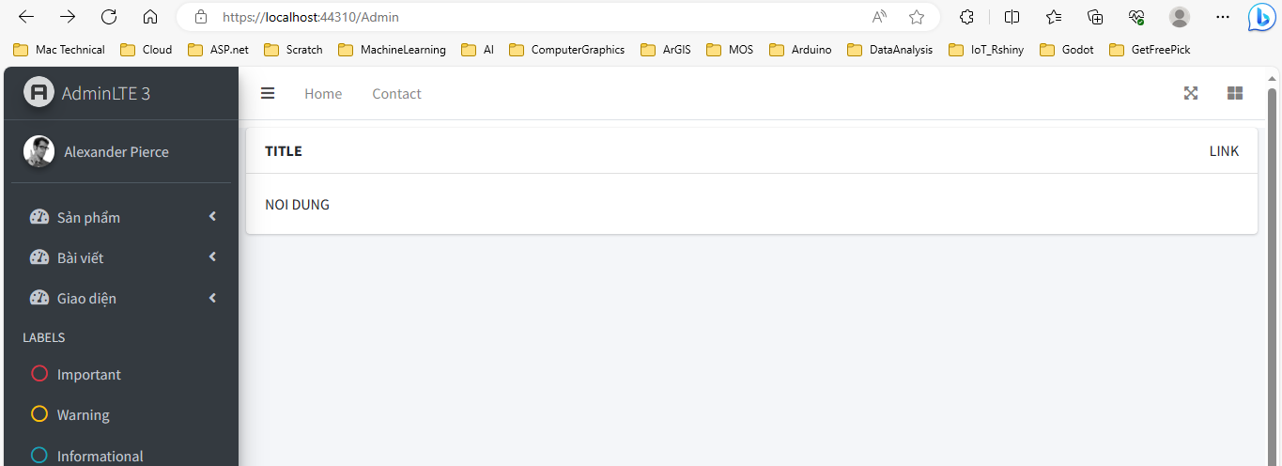

1. Đặt thêm tên cho controller
2. Đẩy nội dung trang INDEX hoặc bất kỳ trang nào khác qua đây (phần này mỗi trang khác nhau sẽ khác nhau)