# Bài thực hành 5: xây dựng trang quản trị cho suppliers

# Menu DETAILS

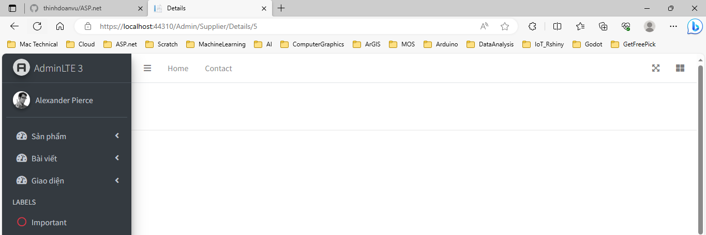

Khi click chuyển đổi trạng thái trên nhóm menu chức năng,

## supplier CONTROLLER

/////////////////////////////////////////////////////////////////////////////////////

// GET: Admin/Supplier/Details/5

public ActionResult Details(int? id)

{

if (id == null)

{

return new HttpStatusCodeResult(HttpStatusCode.BadRequest);

}

Suppliers suppliers = suppliersDAO.getRow(id);

if (suppliers == null)

{

return HttpNotFound();

}

return View(suppliers);

}

## DETAILS.cshmtl

### Tiêu đề

@model MyClass.Model.Suppliers

@{

ViewBag.Title = "Chi tiết Nhà cung cấp";

Layout = "~/Areas/Admin/Views/Shared/_LayoutAdmin.cshtml";

}



### Nội dung trang

<!-- Content Wrapper. Contains page content -->

<div class="content-wrapper">

<!-- Main content -->

<section class="content my-2">

<!-- Default box -->

<div class="card">

<div class="card-header">

<div class="row">

<div class="col-md-6">

<strong class="text-danger">CHI TIẾT NHÀ CUNG CẤP</strong>

</div>

<div class="col-md-6 text-right">

<a href="@Url.Action("Edit","Supplier", new { id = Model.Id })" class="btn-sm btn-success"> <i class="fa fa-edit"> Sửa</i></a>

<a href="@Url.Action("Index","Supplier")" class="btn-sm btn-info"> <i class="fa fa-long-arrow-alt-left"></i> Quay lại</a>

</div>

</div>

</div>

<div class="card-body">

<table class="table table-bordered table-striped">

<thead>

<tr>

<th>@Html.DisplayNameFor(model => model.Id)</th>

<th>@Html.DisplayNameFor(model => model.Name)</th>

<th>@Html.DisplayNameFor(model => model.Image)</th>

<th>@Html.DisplayNameFor(model => model.Order)</th>

<th>@Html.DisplayNameFor(model => model.Fullname)</th>

<th>@Html.DisplayNameFor(model => model.Phone)</th>

<th>@Html.DisplayNameFor(model => model.Email)</th>

<th>@Html.DisplayNameFor(model => model.Status)</th>

</tr>

</thead>

<tbody>

<tr>

<td>@Html.DisplayFor(model => model.Id)</td>

<td>@Html.DisplayFor(model => model.Name)</td>

<td><img src="~/Public/img/supplier/@Model.Image" alt="Image" class="img-fluid"/></td>[1]

<td>@Html.DisplayFor(model => model.Order)</td>

<td>@Html.DisplayFor(model => model.Fullname)</td>

<td>@Html.DisplayFor(model => model.Phone)</td>

<td>@Html.DisplayFor(model => model.Email)</td>

<td>@Html.DisplayFor(model => model.Status)</td>

</tr>

</tbody>

</table>

</div><!-- /.card-body -->

</div><!-- /.card -->

</section><!-- /.content -->

</div><!-- /.content-wrapper -->

# Thử nghiệm



1. Hiển thị nội dung của ảnh