# HIỂN THỊ TẤT CẢ SẢN PHẨM CHO DANH MỤC TRONG TRANG PRODUCTCATEGORY

## Site controller

/////////////////////////////////////////////////////////////////////////////

//Site/ProductCategory

public ActionResult ProductCategory(string slug)

{

//Lay categories dua vao Slug

CategoriesDAO categoriesDAO = new CategoriesDAO();

Categories categories = categoriesDAO.getRow(slug[1]);

return View("ProductCategory");

}

## CategoriesDAO

/////////////////////////////////////////////////////////////////////////////////////

//Hien thi danh sach 1 mau tin (ban ghi) voi kieu string = slug

public Categories getRow(string slug)

{

return db.Categories

.Where(m => m.Slug == slug && m.Status == 1)

.FirstOrDefault();

}

## Chỉnh sửa tiếp cho phần sitecontroller

Phần hiển thị nội dung cũng giống như HomeProduct

/////////////////////////////////////////////////////////////////////////////

//Site/ProductCategory

public ActionResult ProductCategory(string slug)

{

//Lay categories dua vao Slug

CategoriesDAO categoriesDAO = new CategoriesDAO();

Categories categories = categoriesDAO.getRow(slug);

//hien thi noi dung cua mau tin

ViewBag.Categories = categories;

//hien thi toan bo cac shan pham ung voi tung loai

//hien thi theo 3 cap: cha - con - con cua con

List<int> listcatid = new List<int>();

//cap 1

listcatid.Add(categories.Id);

//cap 2

List<Categories> listcategories2 = categoriesDAO.getListByPareantId(categories.Id);

if (listcategories2.Count() != 0)

{

foreach (var categories2 in listcategories2)

{

listcatid.Add(categories2.Id);

//cap 3

List<Categories> listcategories3 = categoriesDAO.getListByPareantId(categories2.Id);

if (listcategories3.Count() != 0)

{

foreach (var categories3 in listcategories3)

{

listcatid.Add(categories3.Id);

}

}

}

}

ProductsDAO productsDAO = new ProductsDAO();

List<ProductInfo> list = productsDAO.getListByListCatId(listcatid, 10);

return View("ProductCategory", **list**);

}

## Productcategorey.cshtml

### Tiêu đề trang[2]

@{

var item = ViewBag.Categories;

}

@{

ViewBag.Title = item.Name;

Layout = "~/Views/Shared/_LayoutSite.cshtml";

}

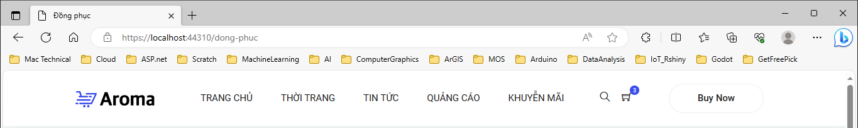

### Hiển thị các sản phẩm ứng với mỗi loại

@model IEnumerable<MyClass.Model.ProductInfo>

@{

var item = ViewBag.Categories;

}

@{

ViewBag.Title = item.Name;

Layout = "~/Views/Shared/_LayoutSite.cshtml";

}

<body>

<!-- ================ start banner area ================= -->

<section class="blog-banner-area" id="category">

<div class="container h-100">

<div class="blog-banner">

<div class="text-center">

<h1 class="text-uppercase">@item.Name</h1>

<nav aria-label="breadcrumb" class="banner-breadcrumb">

<ol class="breadcrumb">

<li class="breadcrumb-item"><a href="#">Home</a></li>

<li class="breadcrumb-item active" aria-current="page">@item.Name</li>

</ol>

</nav>

</div>

</div>

</div>

</section>

<!-- ================ end banner area ================= -->

<!-- ================ category section start ================= -->

<section class="section-margin--small mb-5">

<div class="container">

<div class="row">

<div class="col-xl-3 col-lg-4 col-md-5">

@* Category List Begin *@

@Html.Action("CategoriesList", "Module")

</div>

@* Category List End *@

<div class="col-xl-9 col-lg-8 col-md-7">

<!-- Start Best Seller -->

<section class="lattest-product-area pb-40 category-list">

<div class="row">

@foreach (var productItem in Model)

{

<div class="col-md-6 col-lg-4">

<div class="card text-center card-product">

<div class="card-product__img">

<img class="card-img" src="Public/img/product/@productItem.Image" alt="">

<ul class="card-product__imgOverlay">

<li><button><i class="ti-search"></i></button></li>

<li><button><i class="ti-shopping-cart"></i></button></li>

<li><button><i class="ti-heart"></i></button></li>

</ul>

</div>

<div class="card-body">

<p>Accessories</p>

<h4 class="card-product__title"><a href="#">@productItem.Name</a></h4>

<p strong class="card-product__price text-success">@string.Format("{0:0,0.00,00}", @productItem.Price)<sup>đ</sup></p>

<del><span class="danger card-product__price text-danger">@string.Format("{0:0,0.00,00}", @productItem.SalePrice)</span></del><sup>đ</sup>

</div>

</div>

</div>

}

</div>

</section><!-- End Best Seller -->

</div>

</div>

</div>

</section>

<!-- ================ category section end ================= -->

</body>

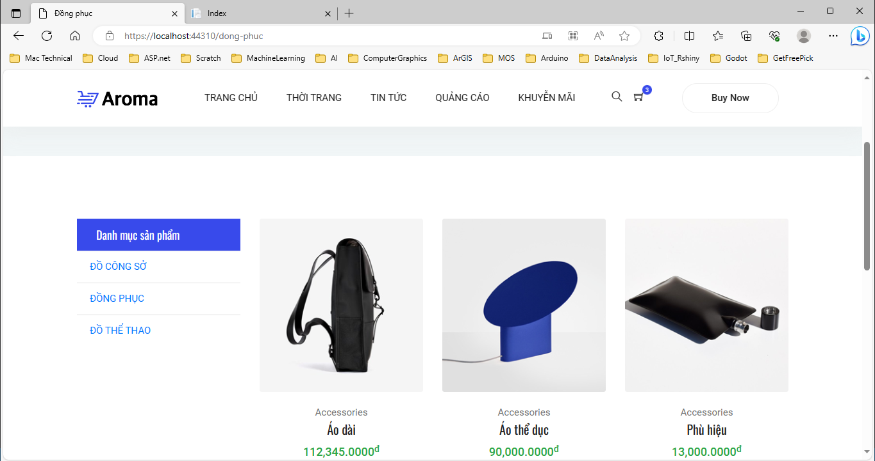

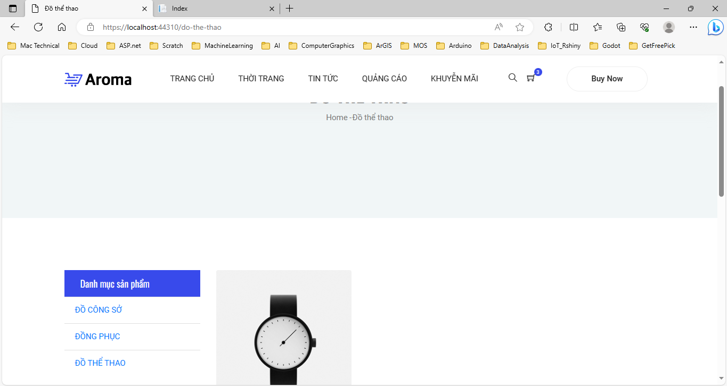

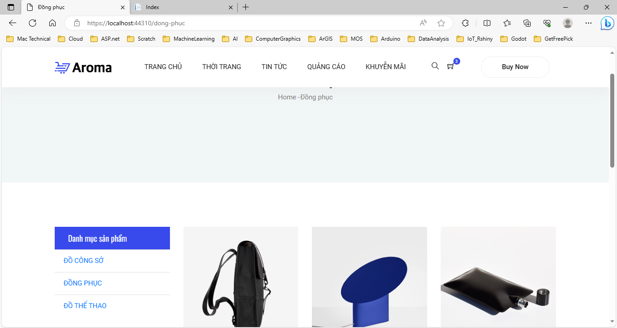

1. Trong categoriesDAO chỉ có hàm getrow với tham số kiểu int = id, chưa có hàm string slug
2. Kiểm tra trang _layoutSite.cshtml phải có <title>@ViewBag.Title</title> trong thẻ <head>