Lake Lodging

We make vacations easy and fun. You bring your own toys – like ATVs, powerboats, wave runners, or canoes – we’ll arrange for your lodging. As an option, we can also help you prepare for your excursion, advise you what to pack, and take care of all the little details so you and your guests can relax, have fun, and make memories.

# Types of Lodging

* Camping
* Hotels and Condos
* Houseboats

On a tight budget? Stay at one of our campgrounds. Camps ranging from simple tent sites with showers and flush toilets, to RV sites with full hook-ups.

On the other end of the spectrum, you can reserve a room at one of our many hotels or condo complexes. Prices range from economical to luxurious.

Are you adventurous and would you like to try something “in the middle”? Rent a houseboat! Where do you anchor your houseboat? The answer is “Anywhere you want.” The fun never ends when you explore our lake from a boat!

# Seasonal Pricing

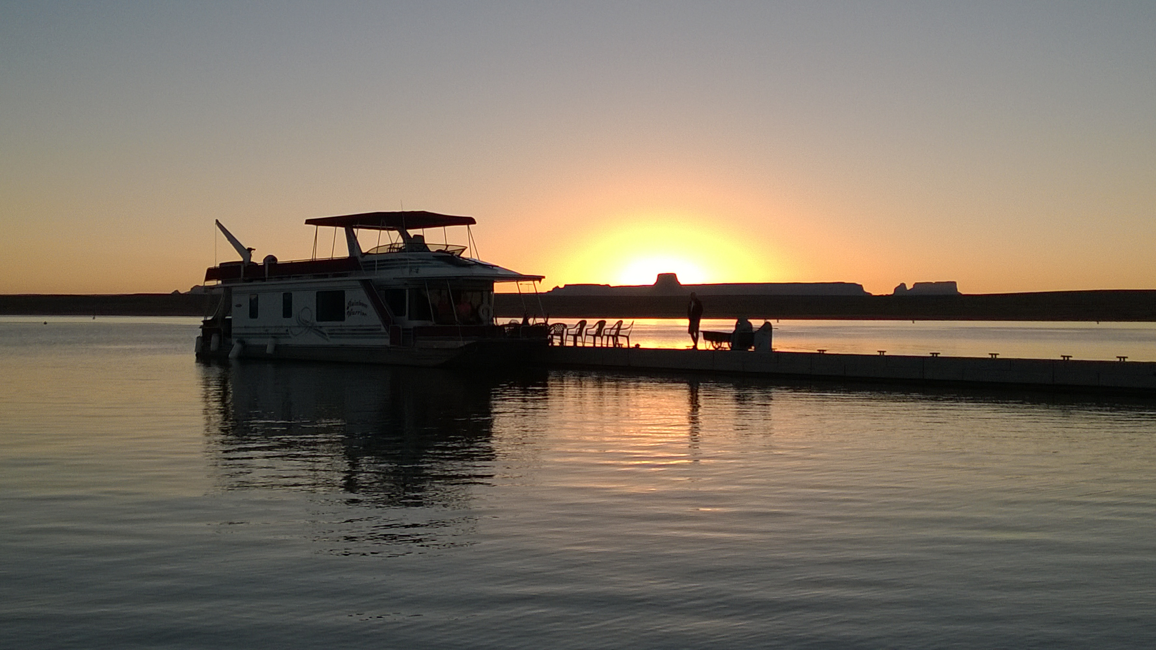The weather is beautiful throughout the year and the water at the lake is surprisingly warm most seasons. It can get very hot in July and August, so these months are most popular with water skiers, wakeboarders and wakesurfers. Our lowest prices are November through May

## Camping

* Tent Sites - $18/night all year.
* RV Sites (water, electrical, and sewer hookups) = $30/night all year.

## Hotels and Condos

We have many options for hotel and condominium accommodations. Prices vary depending on seasons, holidays, and demand. Budget hotels can run as low as $45/night. Luxury lakefront accommodations start at $250/night and up. We also have a limited number of houses available.

## Houseboats

# Contact Us

Lake Tourism Center

1234 Main St.

Page, AZ 86040