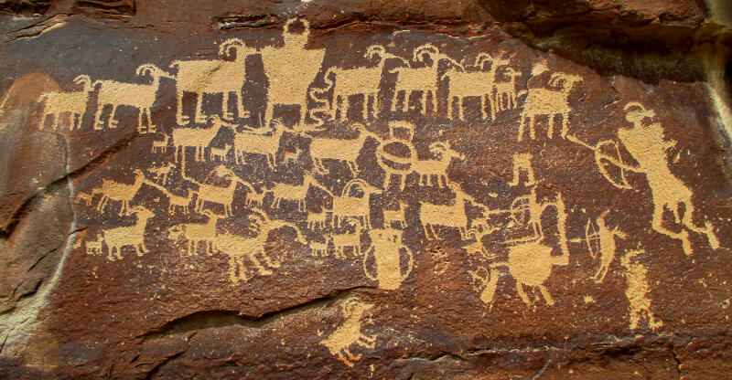

Report Date:

Ancient Utah Rock Art

**Contents**

Early Settlers of Utah 3

Rules for Visiting Ancient Sites 4

Table of Figures 4

Index 4

# Early Settlers of Utah

Utah has been the home of many people. The earliest cultures date back more than 2,000 years and include the Archaic, Anasazi, and Fremont. A thousand years ago, these cultures were replaced by numic-speaking hunter-gatherers such as the Shoshones, Utes, Southern Paiutes, and Goshutes. Each of these groups left evidence of their existence behind in the form of Rock Art.

## Archaic

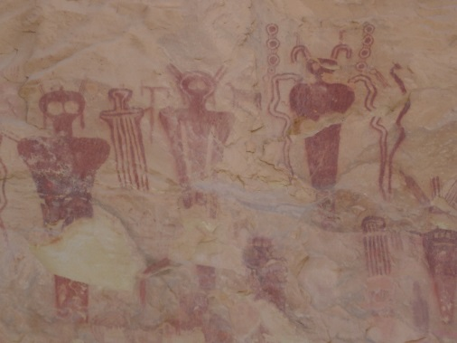

Figure 1: Barrier Style

Some of the most spectacular examples of rock art were left by the Archaic people. Archaic people were nomads, hunting game animals, and collecting wild plants. They did not build permanent dwellings, but lived in caves and small brush shelters. They occupied Utah from 8,000 years ago until 2,000 years ago.

Their rock art is called the Barrier Canyon Style and consists of larger than life size anthropomorphic forms with hollowed or missing eyes, the absence of arms and legs, antennae, earrings, and snakes in hand. These “ghost-like” forms may represent shaman art associated with ritual activities of the Archaic people.

## Anasazi

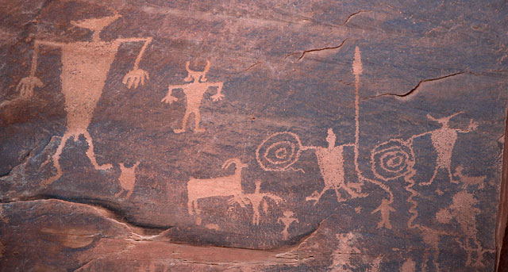

Figure 2: Earrings, bighorn sheep, and spirals typical of Anasazi

The Anasazi produced rock art, from 2,000 years ago until approximately A.D. 1,200. The Anasazi planted corn and lived in pithouses and surface stone structures. Their rock art consist of a variety of human forms with earrings, headdresses, handprints, paw prints, birds, spirals, bighorn sheep, shieldlike images, deer, Kokopellis, and some abstract designs.

## Fremont

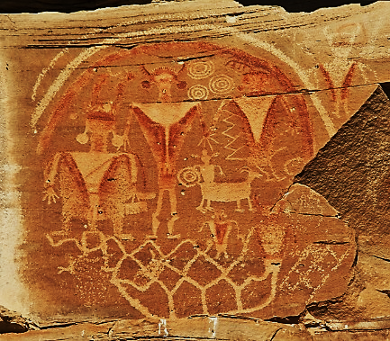

Figure 3: Fremont Trapezoids

The Fremont culture thrived from A.D. 600 to A.D.1250, contemporary with the Anasazi culture. Like the Anasazi, the Fremont planted corn and lived in pithouses and surface stone structures. They constructed distinctive basketry and made pottery. Their rock art designs are very similar to Anasazi and depict broad-shouldered human forms trapezoidal in shape with abstract interior body decorations, elaborate headdresses with ear bobs, facial decorations, bighorn sheep, and deer.

## Ute, Shoshone, Southern Paiute, and Goshute Tribes

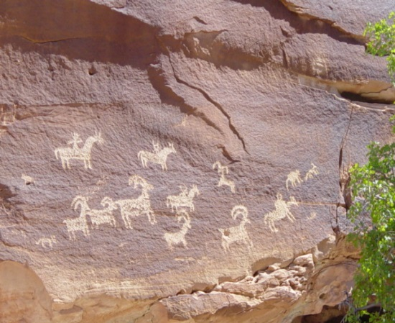

Figure 4: Ute Hunting Scene

The Ute, Paiute, Shoshone, and Goshute tribes replaced the Fremont Indians from A.D. 1200 to A.D. 1880 until they were forced to live on reservations. These cultures were hunters and gatherers. They used the bow and arrow, made baskets and brownware pottery, and lived in brush wickiups and tipis. They created rock art that frequently features human forms on foot and mounted on horseback, hunting and warfare scenes, sheep, deer, horses, and bison.

# Rules for Visiting Ancient Sites

Please help protect ancient cultural sites by observing these simple rules.

1. Don't touch rock art, artifacts, or dwellings. The oils in your skin causes damage. Don't apply water or any other fluids. Don't trace images with sticks, stones, or chalk.
2. Don't attempt to remove graffiti, chalking, lichen, bird droppings, or anything else from rock art. Don't remove soil to expose subsurface rock art or archaeology.
3. Don't disturb artifacts or features at an ancient site. It is acceptable to take photos as long as you leave the site undisturbed.
4. Report site vandalism to local authorities.

# Table of Figures

# Index

Anasazi, 3

Archaic, 3

Fremont, 3, 4

Goshutes, 3

Paiutes, 3

Shoshones, 3

Utes, 3