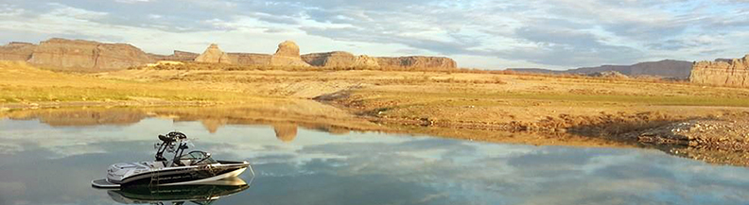Boating Vacations

We make boating vacations easy and fun. You bring your own powerboat, wave runners, or kayaks. We provide your lodging on one of our big houseboats! We help you prepare for your excursion, advise you what to pack, and take care of all the little details we have already thought out for you, so you and your guests can have the most fun while making the best memories.

The fun never ends when you explore the lake from a boat! There is fishing, wakeboarding, waterskiing, tubing, hiking, and nearly a hundred canyons to explore. Where do you live while on a boating vacation? When you rent a [houseboat](http://wikipedia.org/wiki/Houseboat), the answer is “Anywhere you want.”

# Living and Dining Areas

* Luxury lounge area with couches
* Modern dining setting that seats 12
* Plasma TV, DVD and CD player
* Dishwasher & Microwave
* Large Gourmet BBQ on rear deck
* All crockery, cutlery, glasses & cooking utensils
* Large fridge/freezer
* Washing machine & dryer

# Sleeping Areas

* 2 spacious bathrooms with full size shower
* 4 Queen size bedrooms (can be split)
* 2 quality innerspring sofa beds
* Quality pillows, sheets and towels all provided
* Air conditioning to all rooms
* TV/DVSs in all bedrooms
* Sliding doors to outside for privacy

# Outdoor Facilities

* Upstairs helm with seating
* Huge 8-10 person rooftop spa
* Sun lounge
* Outdoor dining table & chairs
* Hooded gas BBQ upstairs & downstairs
* Large undercover sundeck

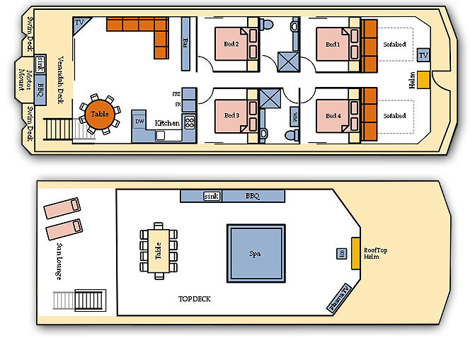

# Good Weather All Year

The weather is beautiful all year and the water at the lake is surprisingly warm for most of seasons. It can get very hot in July and August, so these months are popular with water skiers, wakeboaders and surfers. Average water temperatures fluctuate from a chilly 46 degrees F in February to an inviting 80 degrees F in August. Don't let cold water scare you away, because there's always fishing[1]!

|  |  |  |  |
| --- | --- | --- | --- |
| Month | High | Low | Water |
| January | 45 | 24 | 47 |
| February | 53 | 31 | 46 |
| March | 61 | 36 | 52 |
| April | 72 | 46 | 54 |
| May | 82 | 53 | 62 |
| June | 90 | 62 | 70 |
| July | 97 | 71 | 76 |
| August | 94 | 69 | 80 |
| September | 88 | 60 | 76 |
| October | 77 | 46 | 69 |
| November | 59 | 36 | 62 |
| December | 45 | 25 | 53 |

Table Average Temperatures

My family spent a week on a houseboat this past summer. It was so much fun! – Justin Campell, Salt lake City, UT

# Simple Planning

# Contact Us

Houseboat Lake Vacations, Inc.

1234 Main St.

Page, AZ 86040

1. Fishing license required