Use Cases

for

Hotel Management System, Release 1.0

**Version 1.0 approved**

**Prepared by Group 2**

**Process HMS**

**September 26, 2021**

**Revision History**

|  |  |  |  |
| --- | --- | --- | --- |
| **Name** | **Date** | **Reason For Changes** | **Version** |
| Đinh Phạm Hưng Thịnh | 26/9/2021 | Check-ins, Check-out | 1.0 draft 1 |
| Đức Cường | 26/9/2021 | View Available Room, Search Room | 1.0 draft 2 |
| Đinh Phạm Hưng Thịnh | 10/8/2021 | Major changes and format document | 1.0 draft 3 |
| Hiếu Trung | 10/8/2021 | Add Func Service use case fix | 1.0 draft 4 |
| Hiếu Trung | 10/8/2021 | Delete Func Service use case fix | 1.0 draft 4 |

The various user classes identified the following primary actors and use cases for the Hotel Management System:

|  |  |
| --- | --- |
| ***Primary Actor*** | ***Use Cases*** |
| Receptionist | 1. Check in (Thịnh) 2. Check out (Thịnh) 3. View Available Room (Cường) 4. Search Available Room (Cường) 5. View Available Service 6. Search Available Service (Ân) 7. Search Customer (Ân) 8. View Check-in information 9. Search Check-in information 10. Edit Check-in information 11. View Check-out information 12. Search Check-out information 13. Edit Check-out information 14. Add New Customer information 15. View Customer information 16. Edit Customer information 17. Delete Customer information |
| Room Manager | 1. Add New Room 2. Delete a Room 3. Edit a Room 4. View Room List |
| Service Manager | 1. Add New Service (Trung) 2. Delete a Service (Trung) 3. Edit a Service 4. View Service List |

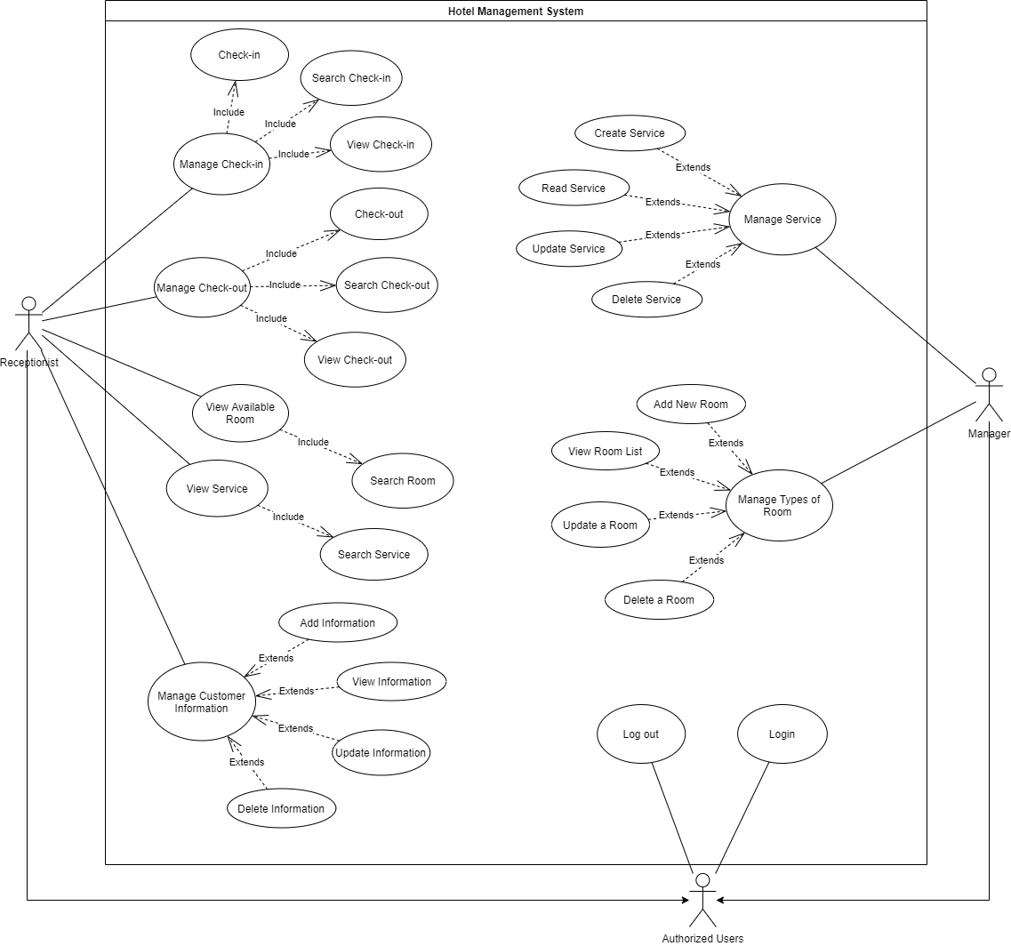

|  |  |  |  |
| --- | --- | --- | --- |
| ID and Name: | **UC-1 Check-in** | | |
| Created By: | Đinh Phạm Hưng Thịnh | Date Created: | 26/9/21 |
| Primary Actor: | Receptionist | Secondary Actors: | Room manager, Service Manager |
| Description: | A receptionist will greet customers directly, depending on whether the customer has booked or not, to arrange suitable rooms and services. Update customer information into the system and confirm registration The customer will have permission to access their room and use hotel services. | | |
| Trigger: | Receptionist make a check in for customer in the hotel | | |
| Preconditions: | PRE-1. Receptionist logged into HMS | | |
| Postconditions: | POST-1. Customer and check-ins information will be stored system  POST-2. Remaining available rooms and services in the system are updated. | | |
| Normal Flow: | **1.0 Check-in for single guest**   1. Notify the room manager to get information about available rooms and arrange for guests. 2. Ask if the customer wants to register to use any service. 3. Customer will select services and giving information to receptionist 4. Receptionist will confirm information about rooms, services, payment methods and check-out time for customers 5. Ask for customer information to complete registration 6. Receptionist updates customer, room and services information to the system. 7. HMS confirms acceptance of the check-in. | | |
| Alternative Flows: | **1.1 Check in for Group**   1. All guests will have to confirm their information and one person will act as a check-in representative. 2. Return to step-1 of Normal flow. | | |
| Exceptions: | **1.0.E1 The customer checks-in too early.**  1. Receptionist will tell the customer that it’s too early to check-in for today.  2a. If a customer wants to check-in early, then HMS will not allow the use case.  2b. Else if a customer comes back later, then HMS restarts use case.  **1.0.E2 Information incorrect**  1. This occurs if the customer’s information and registration are incorrect and need to be modified. The actor will correct any information that is deemed incorrect and the use case will continue.  2a. The customer will correct any changes that are deemed incorrect and the use case will continue at steps 5.  2b. Else if Customer cant correct information, terminate the use case. | | |
| Priority: | High | | |
| Frequency of Use: | Approximately 200 users, average of three usage per day. Peak usage load for this use case is between 7:00 A.M. and 9:00 A.M. or between 7:00 P.M and 9:00 P.M local time. | | |
| Business Rules: | BR-2 | | |
| Other Information: | 1. The customer shall be able to view all services and options 2. After gaining permission, the customer can make any change about their room and services if it is acceptable. 3. Only Receptionist can check-in | | |
| Assumptions: | . | | |

|  |  |  |  |
| --- | --- | --- | --- |
| ID and Name: | **UC-2 Check-out** | | |
| Created By: | Đinh Phạm Hưng Thịnh | Date Created: | 26/9/21 |
| Primary Actor: | Receptionist | Secondary Actors: | N/A |
| Description: | A receptionist will check out for customers when the time comes. Receptionist will calculate based on customer check-in information and the time customer check-out for the customer to pay the bill. | | |
| Trigger: | A Customer want to check-out when the time come | | |
| Preconditions: | PRE-1. Receptionist logged into HMS. | | |
| Postconditions: | POST-1. Customer and check-out information will be stored system  POST-2. Remaining available rooms and services in the system are updated. | | |
| Normal Flow: | **2.0 Check-out for single guest**   1. Receptionist will search for customer check-ins information to confirm with the check out date. 2. Receptionist will ask for payment methods and payment information to make payment. 3. Receptionist updates customer, room and services information to the system. 4. HMS confirms acceptance of the check-out.. | | |
| Alternative Flows: | **2.1 Check-out for Group**   1. Only the customer has its information in the system will have to confirm their information 2. Return to step-1 of Normal flow. | | |
| Exceptions: | **2.0.E1 Unable to Process Transaction.**  1. Receptionist will tell the customer that the payment has been canceled for some reason.  2a. Customers will have to use other methods or information for payment to continue the use case  2b. Else if a customer can’t finish the payment, then HMS terminates the use case.  **2.0.E2 Charges incorrect**  1. This occurs if there exists a charge or charges on the customer’s bill that are incorrect and need to be modified. The actor will correct any charges that are deemed incorrect and the use case will continue.  2a. The customer will correct any charges that are deemed incorrect and the use case will continue at steps 5.  2b. Else if Customer cant correct information, terminate the use case. | | |
| Priority: | High | | |
| Frequency of Use: | Approximately 150 users, average of three usage per day. Peak usage load for this use case is between 2:00 A.M. and 4:00 P.M. | | |
| Business Rules: | BR-1 | | |
| Other Information: | 1. The customer can extend the check-out time. 2. Only Receptionist can check-out | | |
| Assumptions: |  | | |

|  |  |  |  |
| --- | --- | --- | --- |
| ID and Name: | **UC-4 View Available Room** | | |
| Created By: | Trịnh Phan Đức Cường | Date Created: | 26/9/21 |
| Primary Actor: | Receptionist | Secondary Actors: | Room manager |
| Description: | Receptionist will check the hotel's availability room list. If that room is available, the staff will arrange guests in that room and match with the customer's request. | | |
| Trigger: | Receptionists check the availability of the room to arrange guests in the room according to the guest's request when check-ins. | | |
| Preconditions: | PRE-1. Receptionist logged into HMS.  PRE-2: Hotel staff is Authorized to request View Available Room. | | |
| Postconditions: | POST-2. Staff will save arranged room to customer information, if any. | | |
| Normal Flow: | **4.0 View available room for check in**   1. Receptionist will request to see the available room list in the hotel. 2. HMS will display the available room with a sign. 3. Receptionist selects rooms that match with the customer requirements. 4. HMS will send the room information to check-ins. 5. After confirming with the guest, HMS saves the room information in the customer check-ins. | | |
| Alternative Flows: | **None** | | |
| Exceptions: | **4.0.E1 Can’t find a suitable room.**  1. HMS notifies Staff that there is no room available.  2.a. If the user cancels the registration process, HMS will terminate the use case.  2.b. Conversely, if customer comes back when there is available room another date, HMS will restart the use case. | | |
| Priority: | High | | |
| Frequency of Use: | Approximately 200 users, average of five usage per day. Peak usage load for this use case is between 7:00 A.M. and 4:00 P.M. | | |
| Business Rules: | BR-3, BR-4 | | |
| Other Information: | N/A | | |
| Assumptions: |  | | |

|  |  |  |  |
| --- | --- | --- | --- |
| ID and Name: | **UC-5 Search Room** | | |
| Created By: | Trịnh Phan Đức Cường | Date Created: | 26/9/21 |
| Primary Actor: | Receptionist | Secondary Actors: | Room manager |
| Description: | When check-in the Receptionist wants to search for a specific room type suit for the customer request. | | |
| Trigger: | Receptionist want to search for a room type | | |
| Preconditions: | PRE-1. Hotel staff logged into HMS.  PRE-2: Hotel staff is Authorized to request search room | | |
| Postconditions: | N/A | | |
| Normal Flow: | **5.0 Search Room**  1. Receptionist providing room type information to the HMS..  2. HMS will return results of the desired room in the available room list with all necessary information and can be selected to arrange for customer check-in.  3. The system will save the request. | | |
| Alternative Flows: | None | | |
| Exceptions: | **5.0.E1 Not Found**  1. This error occurs because there is no matching room type with the request information.  2.a. If the user deletes requested information. HMS will terminate the use case.  2.b. Conversely, if customer provides another information. HMS will restart the use case. | | |
| Priority: | High | | |
| Frequency of use | Approximately 10 times per week by Searching Room | | |
| Business Rules: | BR-4, BR-3 | | |
| Other Information: | None | | |

|  |  |  |  |
| --- | --- | --- | --- |
| ID and Name: | **UC-13 Modify Service (add function)** | | |
| Created By: | Hiếu Trung | Date Created: | 27/09/2021 |
| Description: | The Hotel Management System may change the service for a specific date in the future, modify it to add or change services, create or change a special service, or change the price and save the modified service. | | |
| Exceptions: | No services are duplicated; show error messages and allow the Manager to enter a new service. | | |
| Priority: | High | | |
| Normal Flow | 1. Staff will base on the need of customer, then add the service is available 2. Staff will tell customer about the detail information about the services | | |
| Business Rules: | N/A | | |
| Other Information: | Only manager can modify service | | |

|  |  |  |  |
| --- | --- | --- | --- |
| ID and Name: | **UC-11 Modify Service (Delete function)** | | |
| Created By: | Hiếu Trung | Date Created: | 27/09/2021 |
| Description: | The Hotel Management Systemmay change the service for a specific date in the future, modify it to remove or change services,remove or change the price and save the modified service. | | |
| Exceptions: | No services are duplicated; show error messages and allow the Manager to enter a new service. | | |
| Normal Flow | 1. Staff will base on the need of customer, then delete the service is available 2. Staff will tell customer about the detail information about the services | | |
| Priority: | High | | |
| Business Rules: | N/A | | |
| Other Information: | Only manager can modify service | | |

|  |  |  |  |
| --- | --- | --- | --- |
| ID and Name: | **UC-7 Search Available Service** | | |
| Created By: | Phan Đình Thiên Ân | Date Created: | 29/9/21 |
| Primary Actor: | Receptionist | Secondary Actors: | Service manager |
| Description: | Receptionist will check the hotel's availability service list. If that service is available, the staff will arrange service to the customer and match with the customer's request. | | |
| Trigger: | Receptionists check the availability of the service to arrange service for customers according to the customer request when check-ins. | | |
| Preconditions: | PRE-1. Receptionist logged into HMS.  PRE-2: Hotel staff is Authorized to request View Available Service. | | |
| Postconditions: | POST-2. Staff will save arranged service to customer information, if any. | | |
| Normal Flow: | **7.0 View available service for check in**   1. Receptionist will request to see the available service list in the hotel. 2. HMS will display the available service with a sign. 3. Receptionist selects services that match with the customer requirements. 4. HMS will send the service information to check-ins. 5. After confirming with the guest, HMS saves the service information to the customer check-ins. | | |
| Alternative Flows: | **None** | | |
| Exceptions: | **7.0.E1 Can’t find a suitable service.**  1. HMS notifies Receptionist that there is no service suitable available.  2.a. If the user cancels the search process, HMS will terminate the use case.  2.b. Conversely, if customer wants to search for another service, HMS will restart the use case. | | |
| Priority: | High | | |
| Frequency of Use: | Approximately 200 users, average of six usage per day. Peak usage load for this use case is between 7:00 A.M. and 4:00 P.M. | | |
| Business Rules: | BR-5 | | |
| Other Information: | N/A | | |
| Assumptions: |  | | |

|  |  |  |  |
| --- | --- | --- | --- |
| ID and Name: | **UC-8 Search Customer** | | |
| Created By: | Phan Đình Thiên Ân | Date Created: | 29/9/21 |
| Primary Actor: | Receptionist | Secondary Actors | N/A |
| Description: | Receptionist log into the system and input the name/identity card of customers to check if they have a reservation or not .The system saved the information of customer so staff can take customer’s information | | |
| Trigger: | Receptionist input the name or identity card of a customer | | |
| Preconditions: | PRE-1. Receptionist logged into HMS. | | |
| Postconditions: | POST-1: Request is stored in HMS  POST-2: Request is sent to Room manager or to a customer. | | |
| Normal Flow: | **4.0 Search Customer**  1.Staff will input name/ID card of customers  2.System will display information of that customer | | |
| Alternative Flows: | N/A | | |
| Exceptions: | Can’t find customer information in the system because there is no customer information like requested information saved in the system befored | | |
| Priority: | High | | |
| Business Rules: | N/A | | |
| Other Information: | Only receptionist can search customer | | |