Virtual Reality And Augmented Reality

# Virtual Reality

## What is Virtual Reality?

[Virtual reality](https://en.wikipedia.org/wiki/Virtual_reality) (VR) is an artificial, computer-generated simulation or recreation of a real life environment or situation. It immerses the user by making them feel like they are experiencing the simulated reality firsthand, primarily by stimulating their vision and hearing.

The world of VR created by computers that allows you to experience and interact with a 3D world that isn't real by putting on a head-mounted display and some form of input tracking. The display will typically be split between your eyes, creating a stereoscopic 3D effect with stereo sound, and together with the technology and the input tracking, it will create an immersive, believable experience, allowing you to explore the virtual world being generated by the computer.

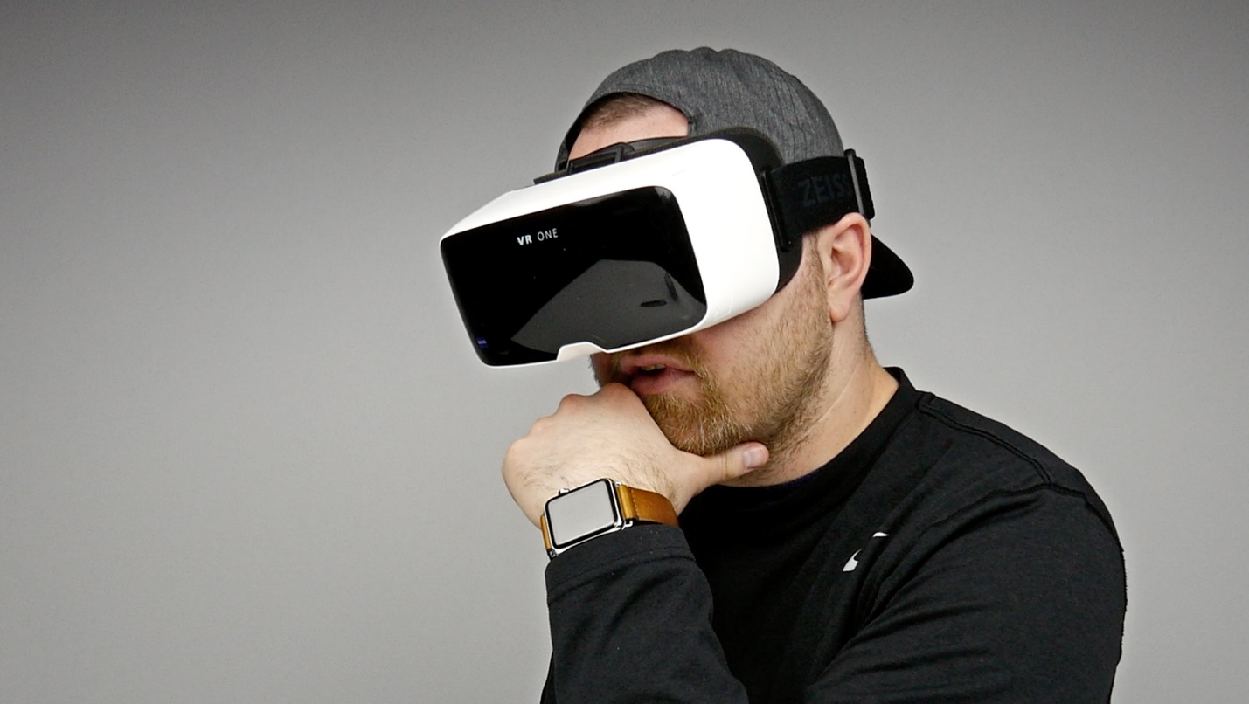

## How is work?

VR requires some form of head-mounted display, a computer, smartphone or console that creates the 3D world and some form of input tracking, which could be hand tracking, voice or head. There are currently a number of head-mounted displays all using this set-up including Oculus, HTC Vive, Sony PlayStation VR, Google Cardboard and Samsung Gear VR, and can be our smartphone.

# Augmented Reality

## What is Augmented Reality?

Augmented reality (AR) is a technology that layers computer-generated enhancements atop an existing reality in order to make it more meaningful through the ability to interact with it. AR is developed into apps and used on mobile devices to blends digital components into the real world in such a way that they enhance one another.

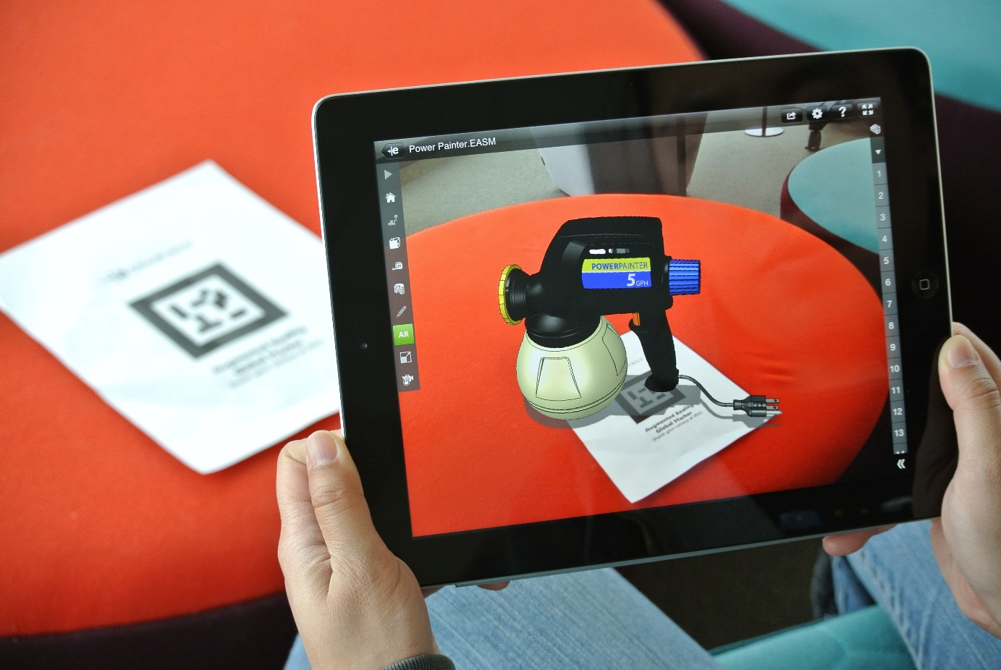

## How it work?

Using a mobile application, a mobile phone's camera identifies and interprets a marker, often a black and white barcode image. The software analyses the marker and creates a virtual image overlay on the mobile phone's screen, tied to the position of the camera. This means the app works with the camera to interpret the angles and distance the mobile phone is away from the marker. Due to the number of calculations a phone must do to render the image or model over the marker, often only smartphones are capable of supporting augmented reality.

# **Virtual Reality vs. Augmented Reality**

Virtual reality offers a digital recreation of a real life setting, while augmented reality delivers virtual elements as an overlay to the real world.

## Similar

Bring real interactive experiences and for users

## Different

Purpose

AR enhances experiences by adding virtual components such as digital images, graphics, or sensations as a new layer of interaction with the real world. VR creates its own reality that is completely computer generated and driven.

Delivery Method

VR is usually delivered to the user through a head-mounted, or hand-held controller. This equipment connects people to the virtual reality, and allows them to control and navigate their actions in an environment meant to simulate the real world.

AR is being used more and more in mobile devices such as laptops, smart phones, and tablets to change how the real world and digital images, graphics intersect and interact.