# DevOps Practical Assignment report

Name: Thinh Nguyen Nie Duc

StaffCode: SD5096

## I. Setting up CI/CD pipeline and deploying application to EKS

Source codes:  
Infra: https://github.com/thinhnnd/sd5096_aws_infrastructure   
MSA: <https://github.com/thinhnnd/sd5096_msa>

1.Provision AWS resource  
1.1 EKS cluster created from terraform  
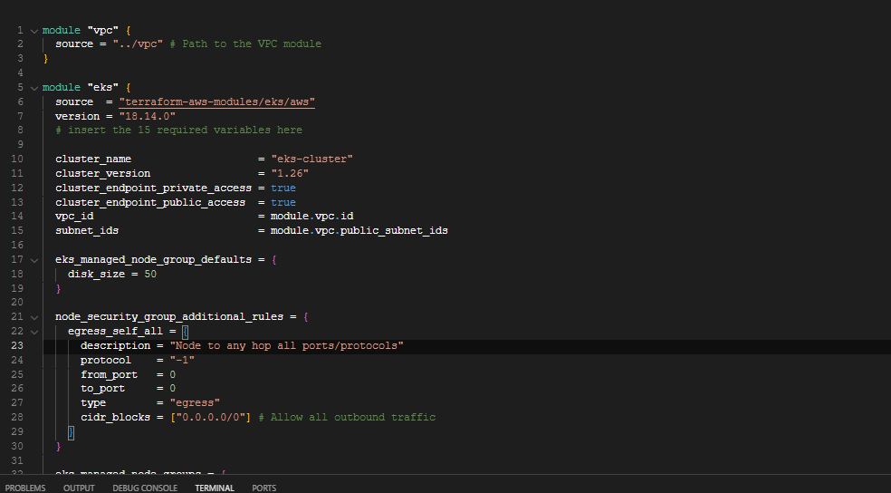   
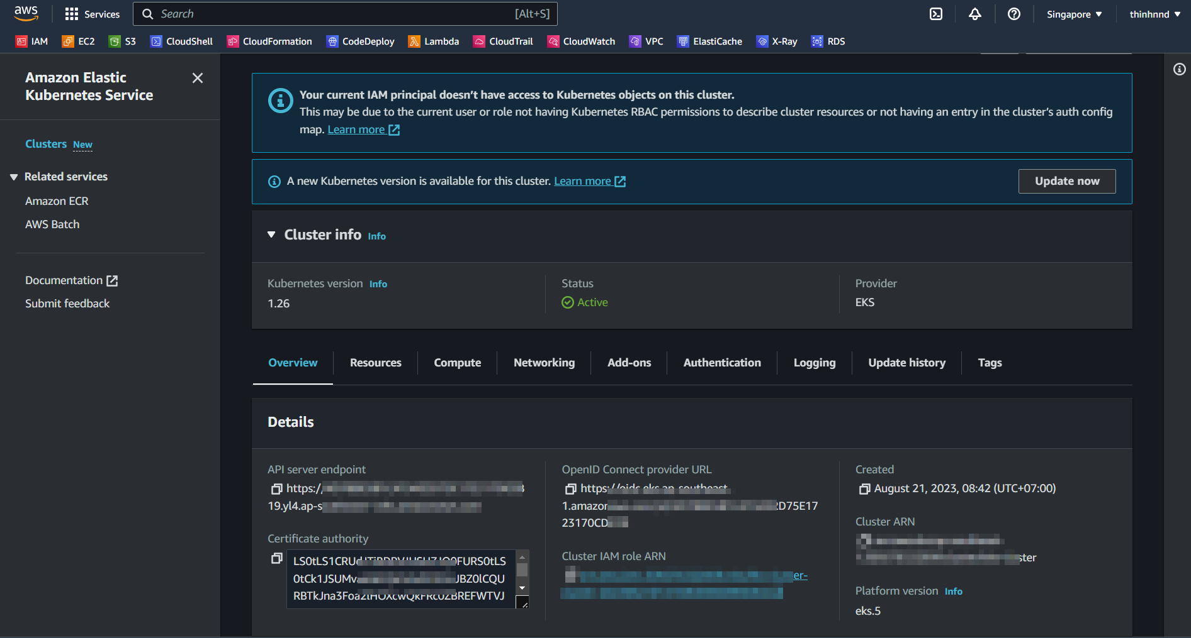  
1.2 EC2 created by using terraform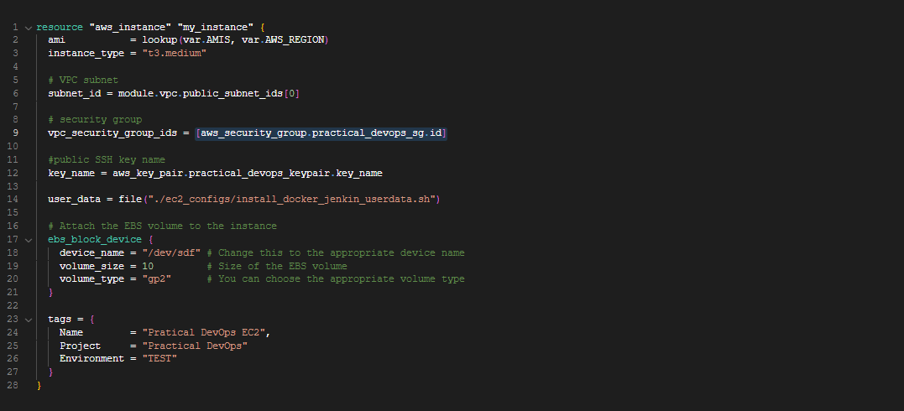  
  
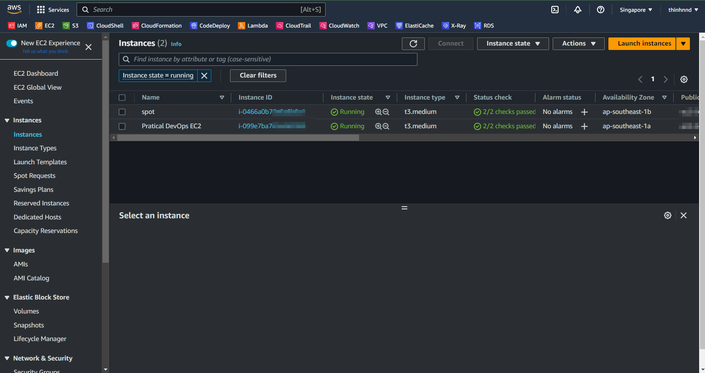   
1.3 ECR provision by terraform  
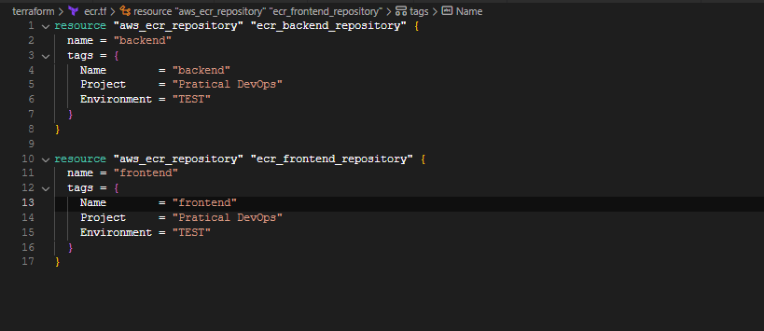

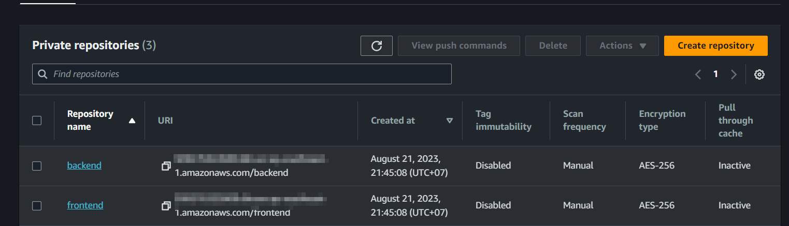

**2. Set up Jenkins for CI/CD**  
I create 4 stage: Clone Repositoy -> Build Backend Image -> Build Frontend Image -> Deploy to EKS  
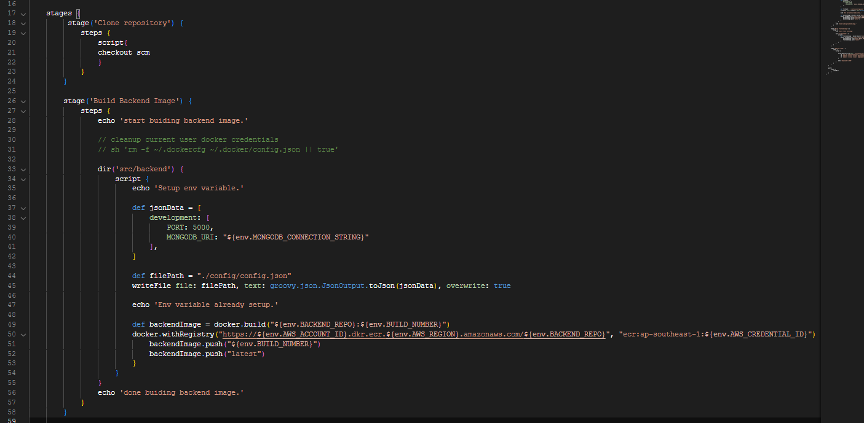

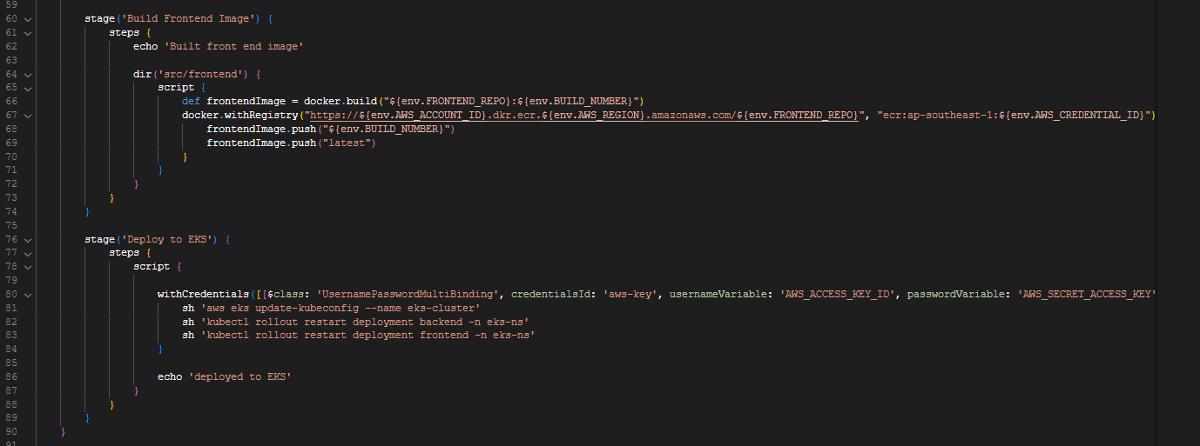  
Pipeline result:  
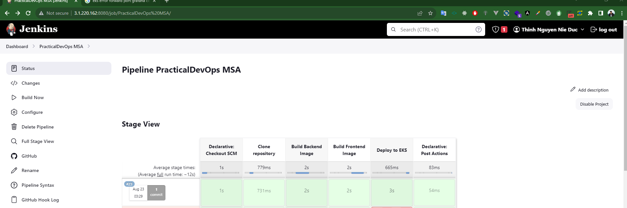  
Result when deploy success fully:  
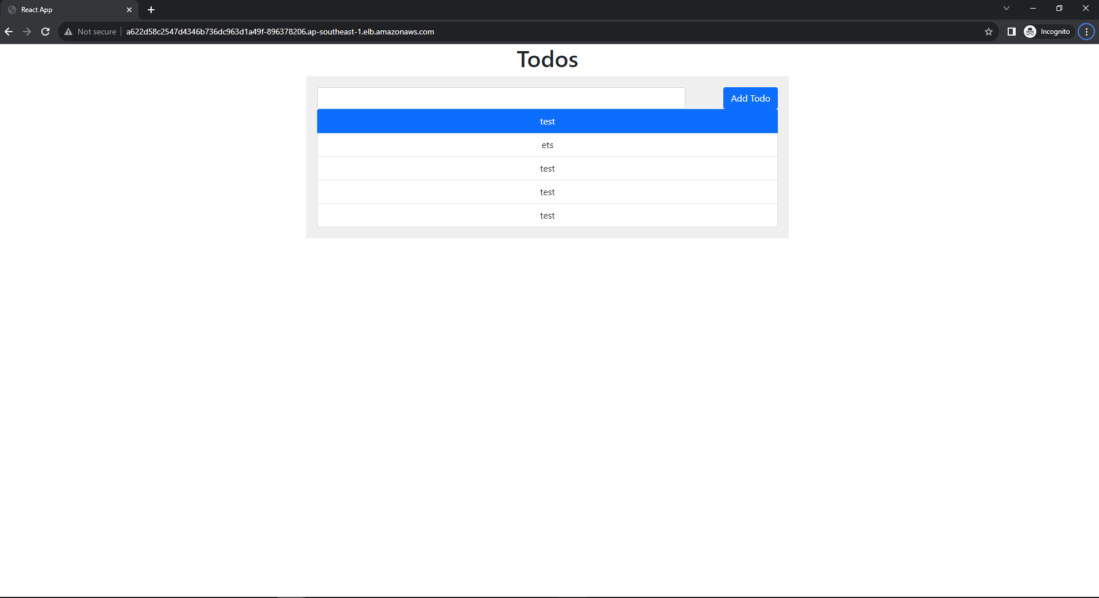  
  
If I change a code, and push to master branch, pipeline will automaticaly run   
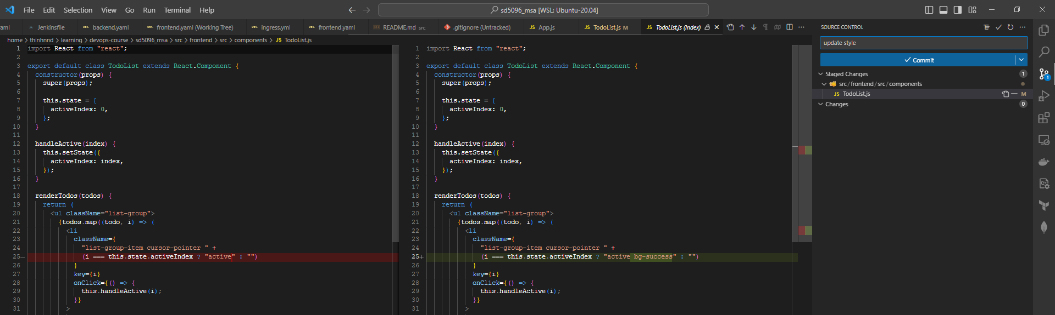  
Auto run by github push  
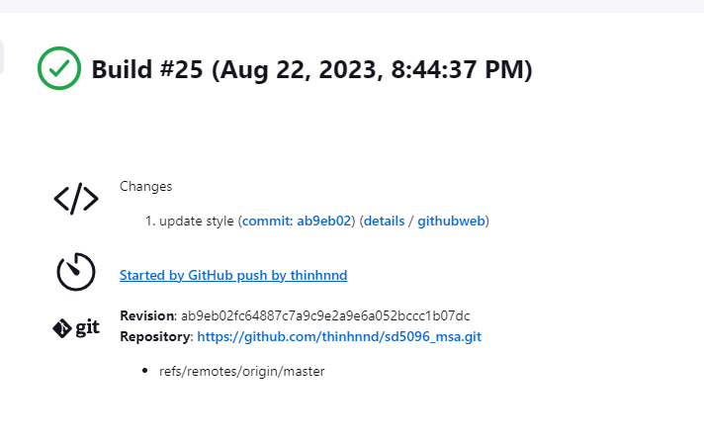Build success:  
  
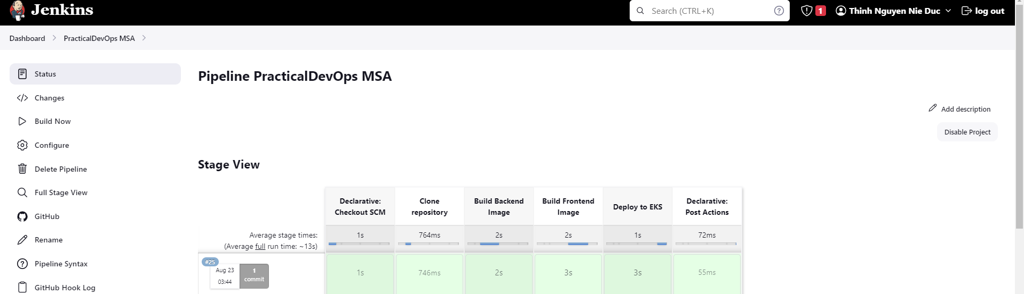  
App result:  
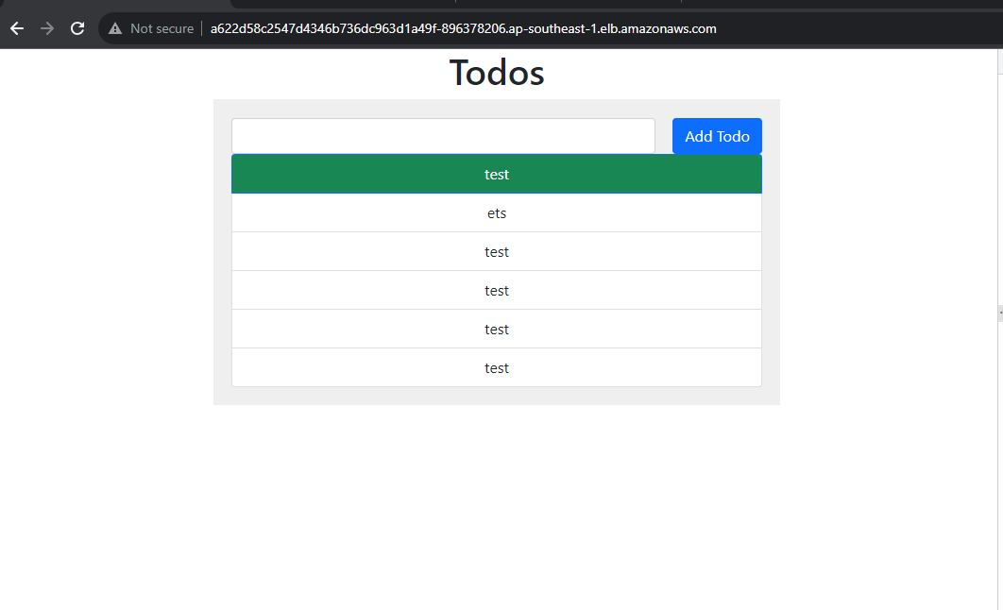

3. Monitor with Grafana  
3.1 Phometheus

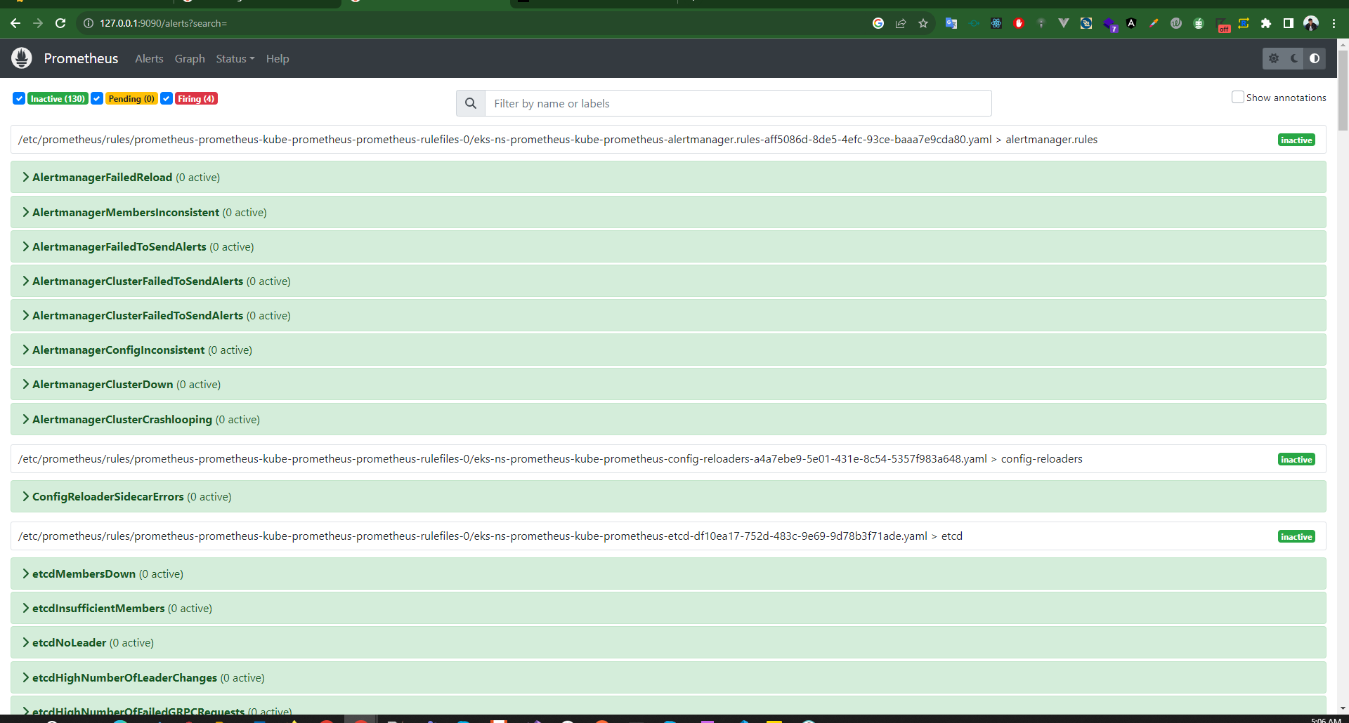

3.2 Alert Manager  
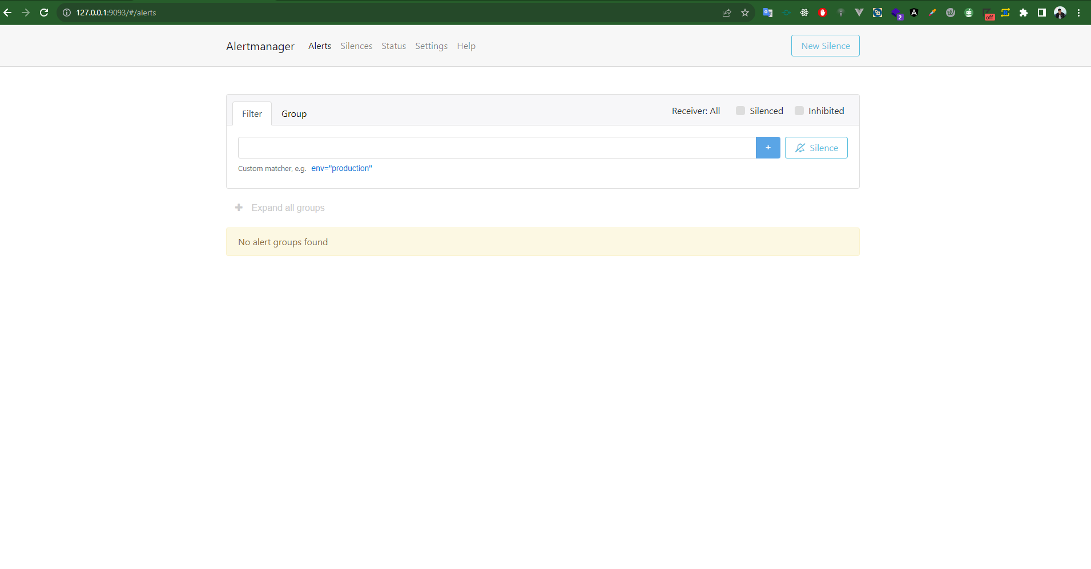  
Grafana

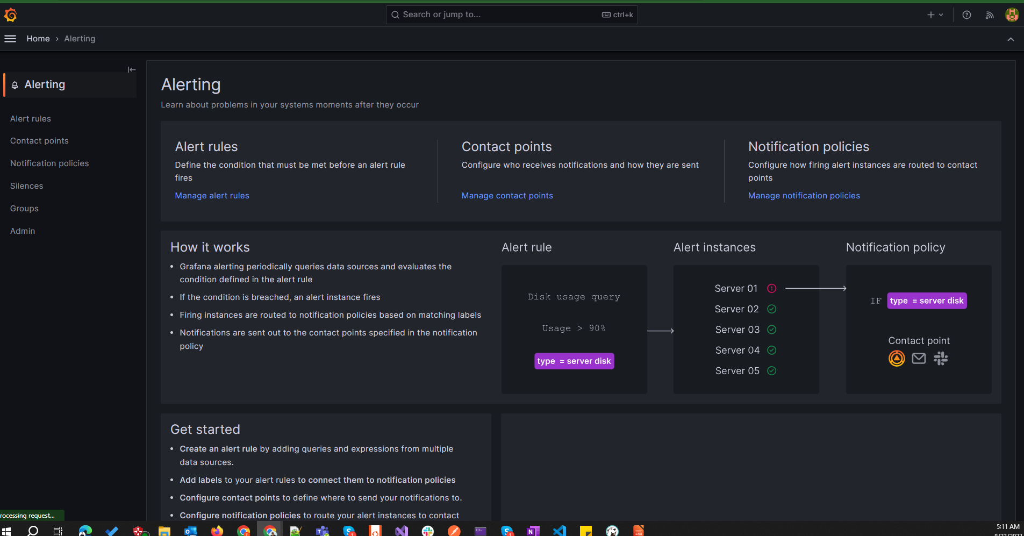

## II. Reuse Jenkin CI and use GitOps for CD pipeline

Repo: <https://github.com/thinhnnd/sd5096_deploy_argocd>

1.Install and login to Argo

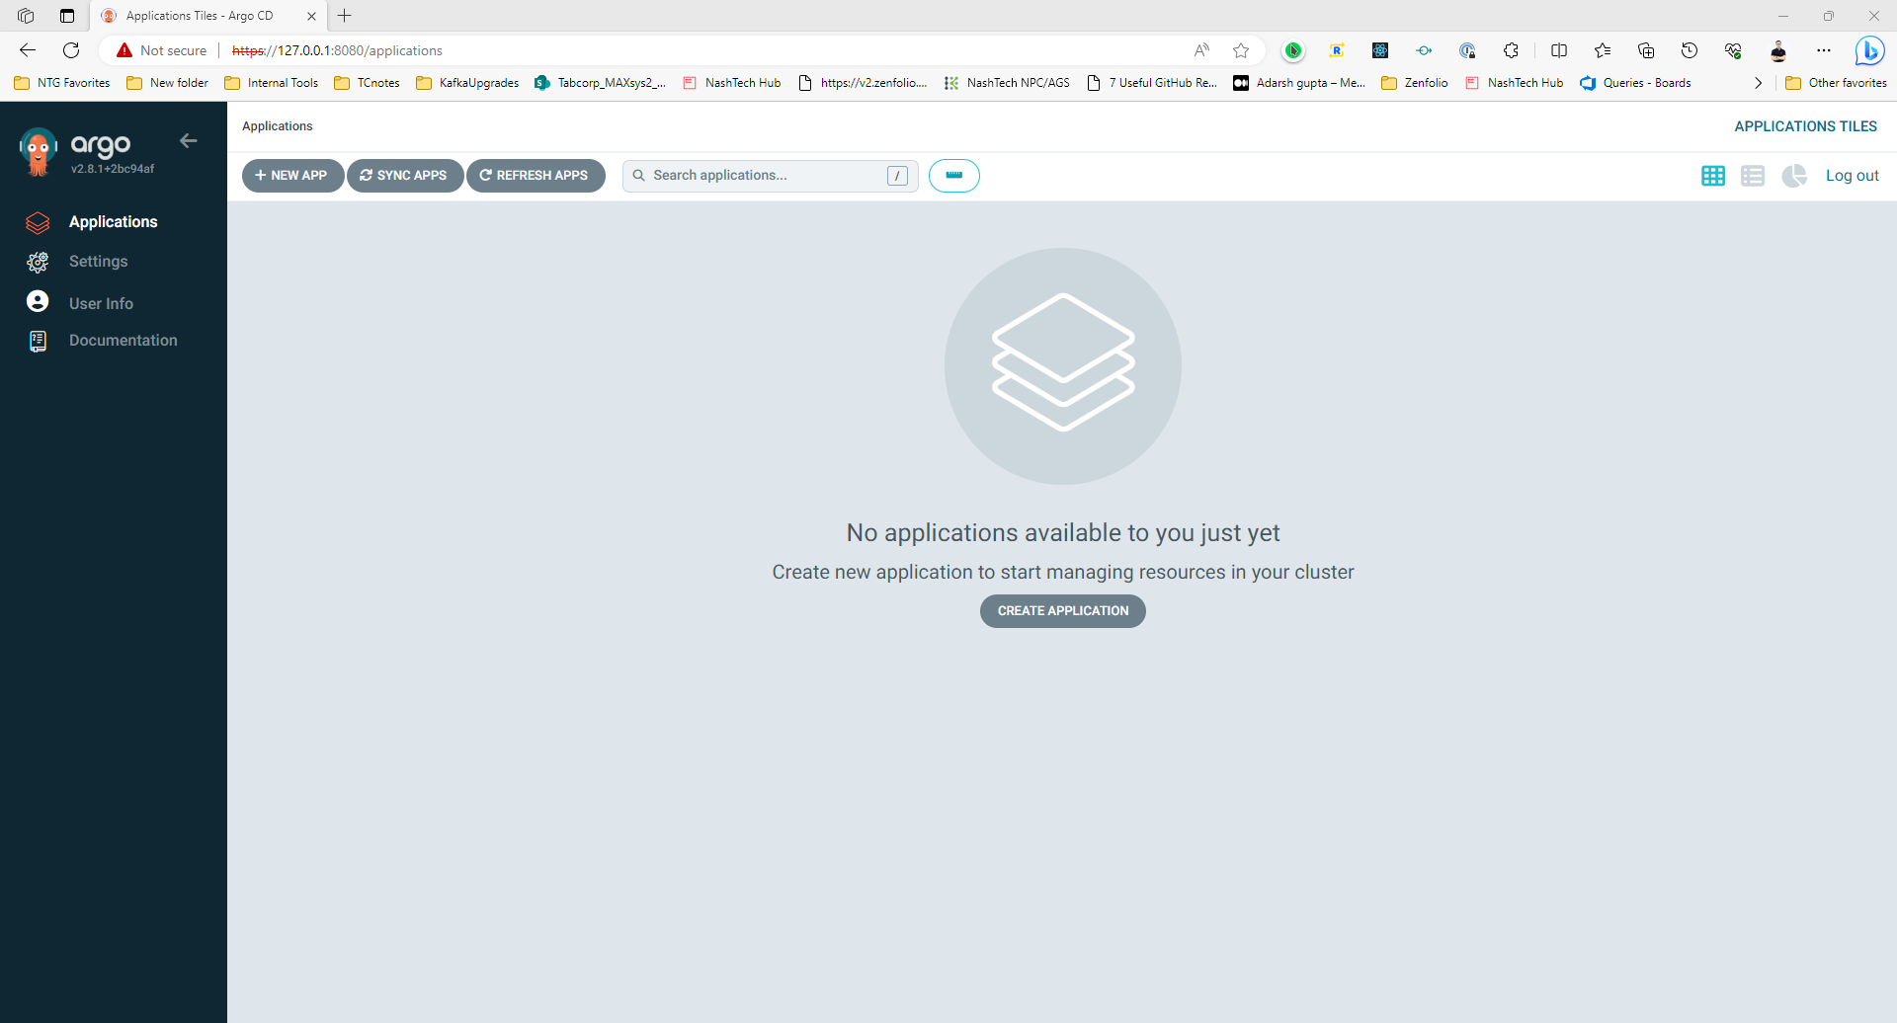

2. Deploy successfully by using argocd  
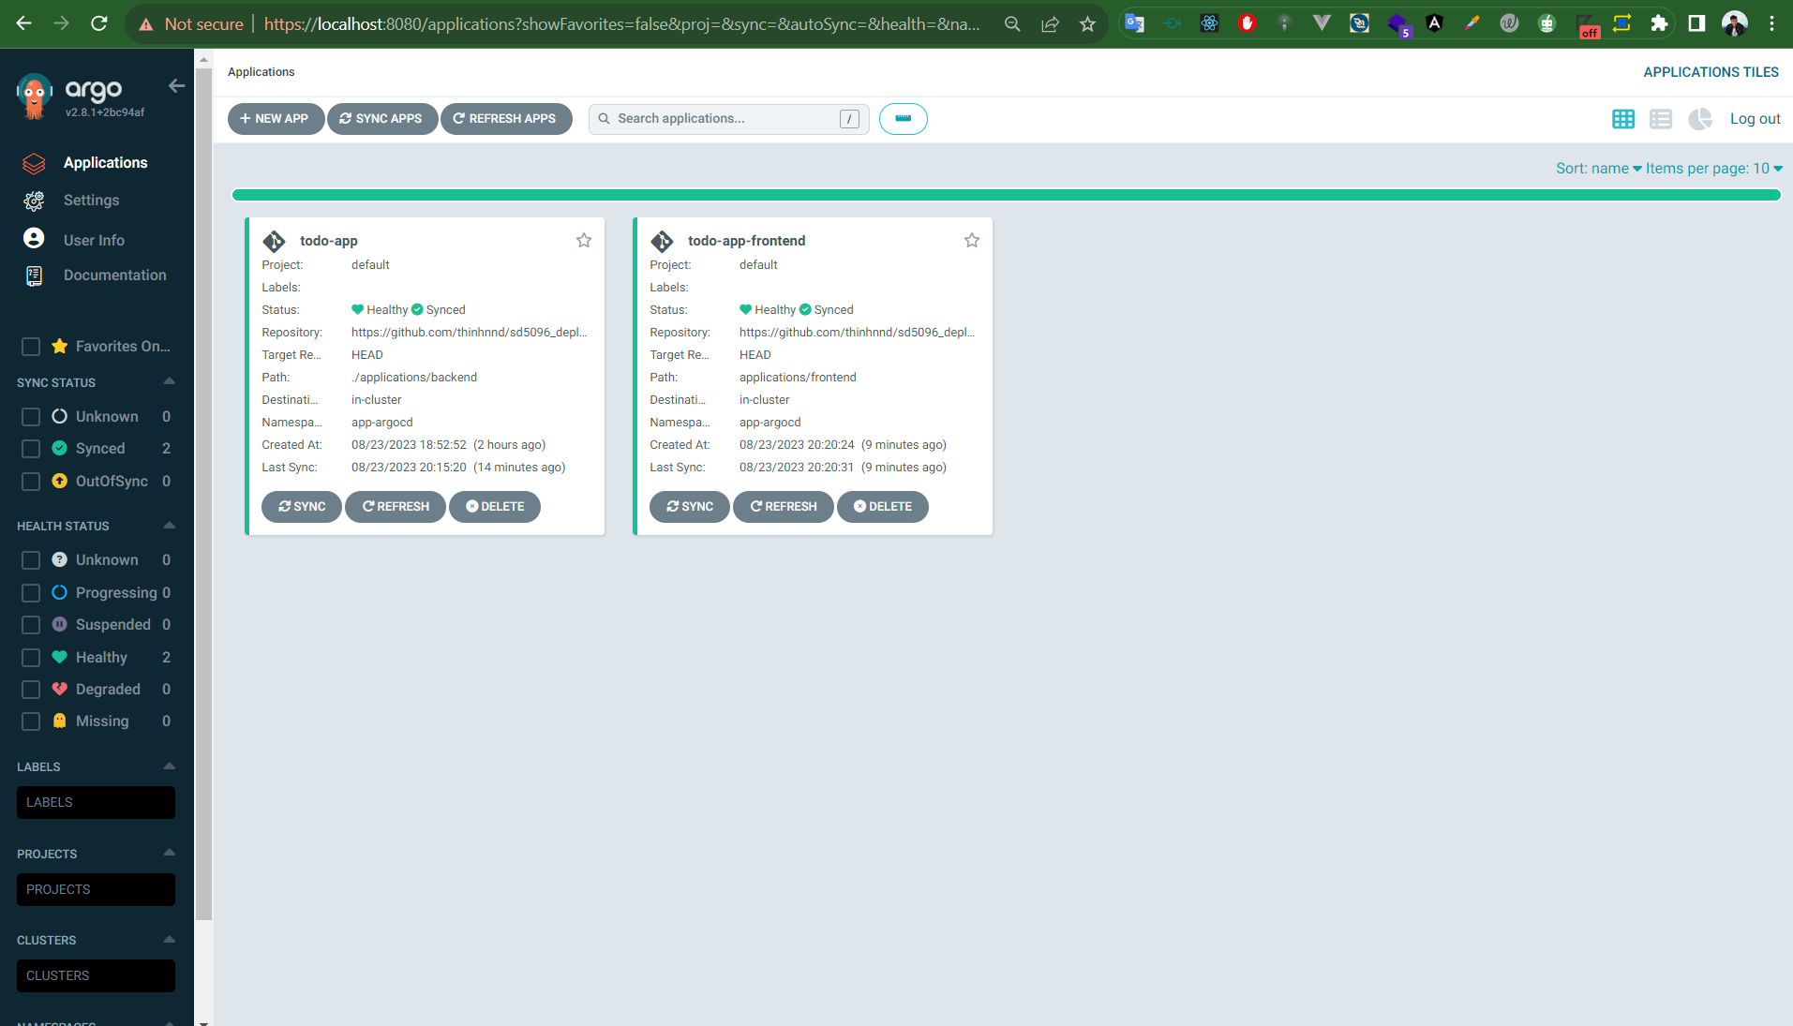

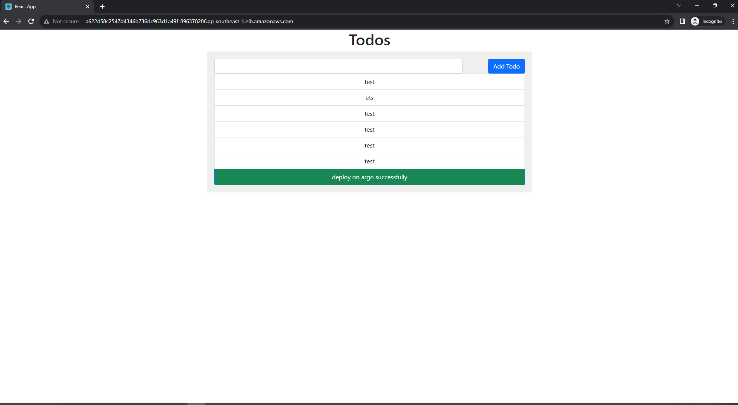

3. Setup argo image updater to make it listen change from ECR and auto update  
Notes: I will update for frontend app only to save times and easy to see  
3.1 Set up required credential  
  
3.2 Setup annotation of todo-frontend app like bellow

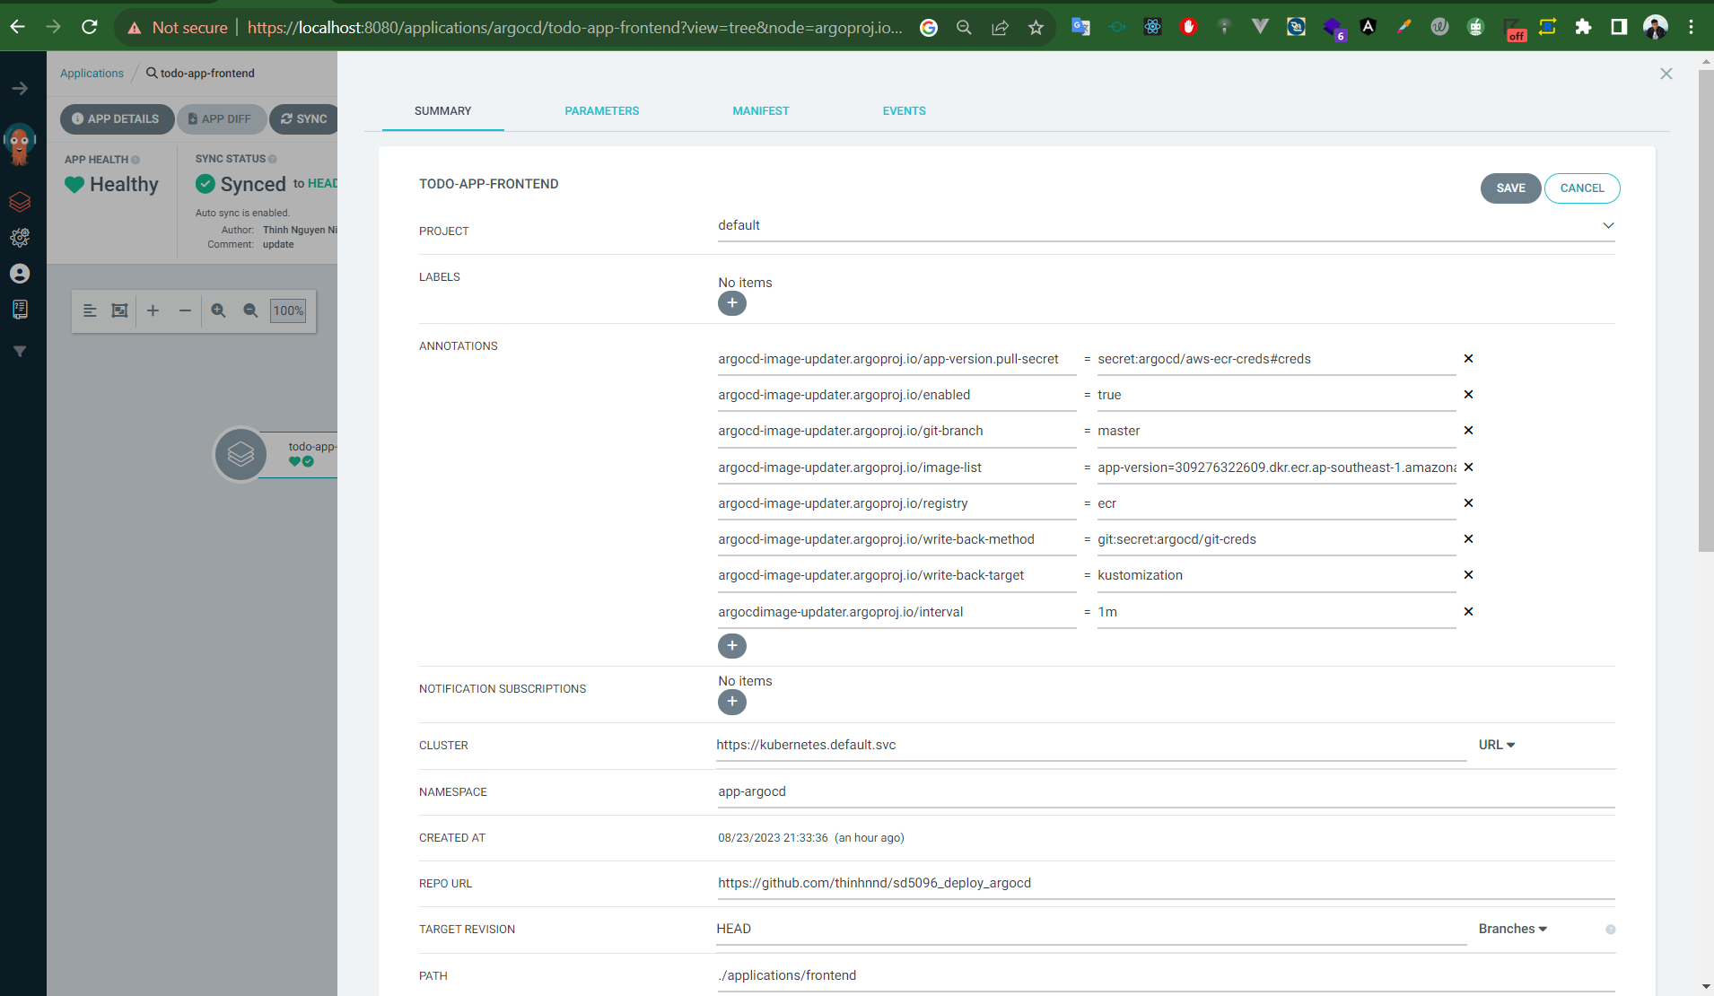  
3.3 On MSA source code, update new code and push to GitHub  
Change code then push to github, at this time I will change collor of button to red.

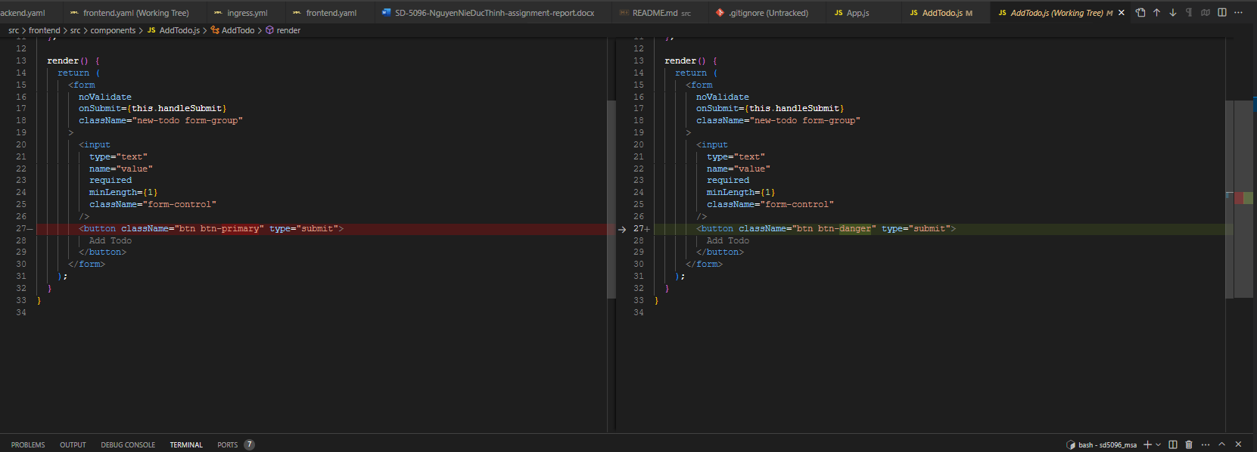

Jenkins will build new version of frontend image with tag 32  
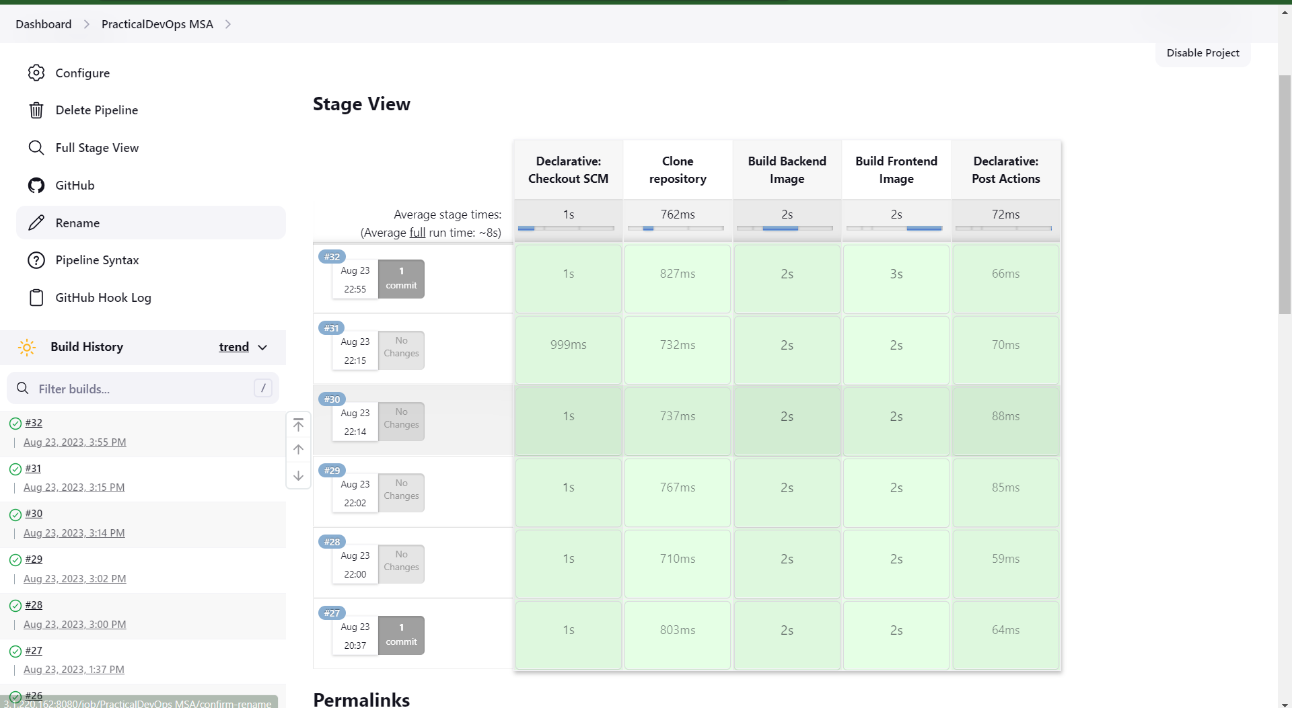  
  
3.4 Argo Image Updater will auto detect change  
we can check the log by type ping command bellow:  
kubectl --namespace argocd logs --selector app.kubernetes.io/name=argocd-image-updater --follow  
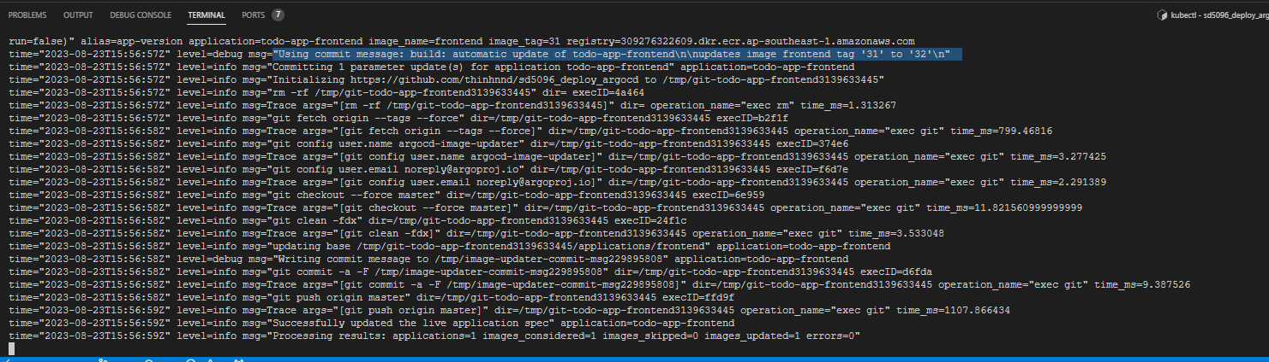

3.5 Check on GitHub, a new commit created by argo image updater

It shows that, our image now switched to version 32

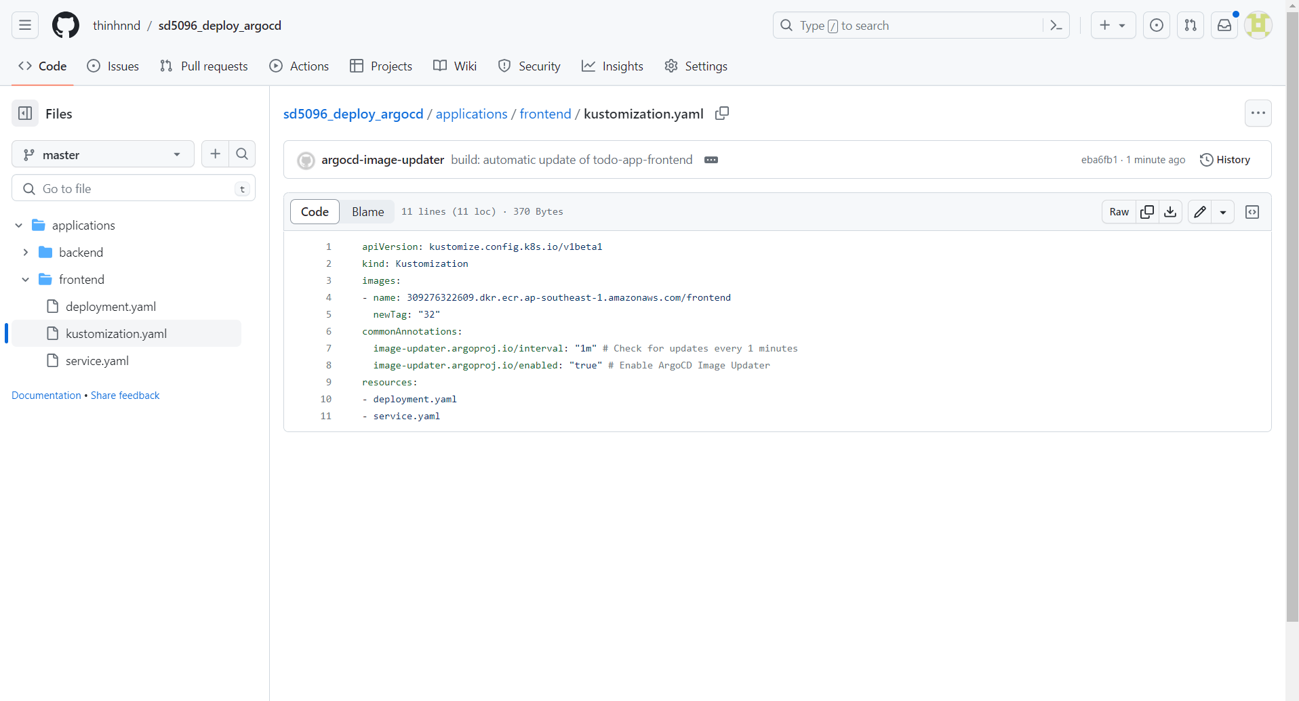

3.6 Check todo-frontend app on Argo CD UI  
We see that version 32 is pending to replace version 31  
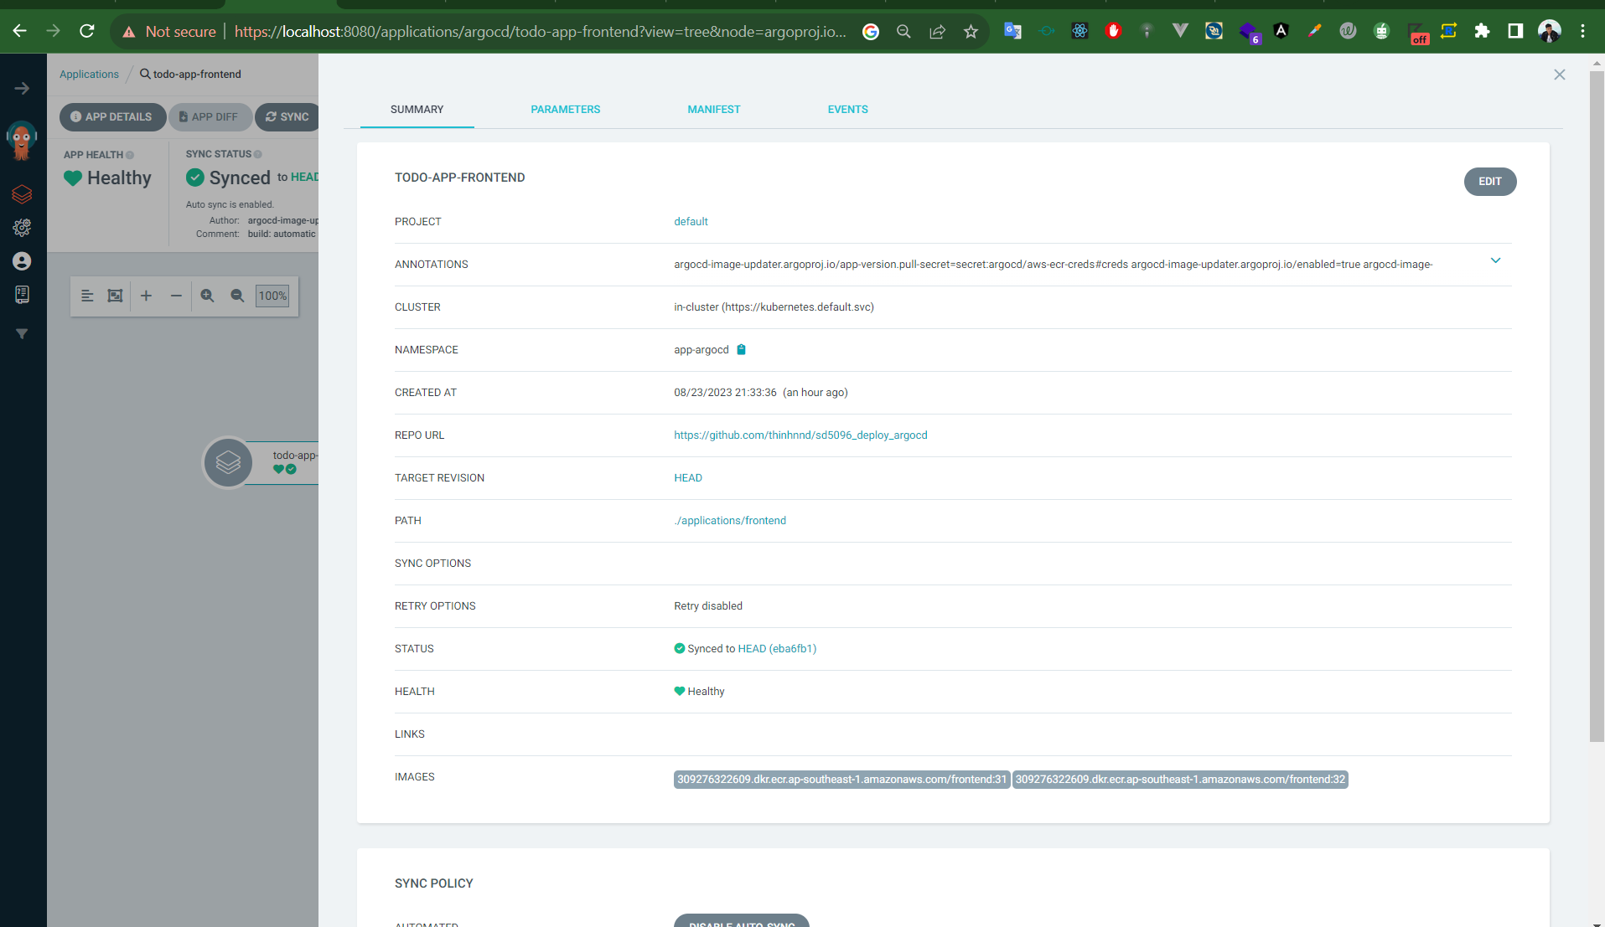

Result of the todo app, now it’s deployed the new version

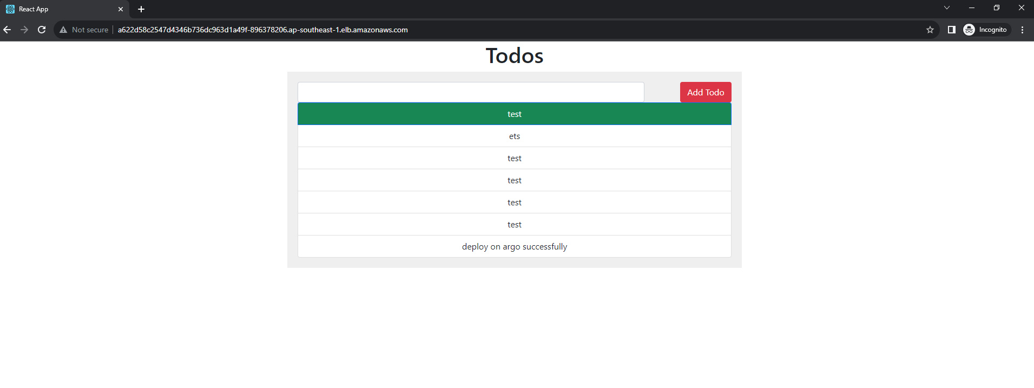

The End - Thanks for viewing