PE_PRN231_FA24_TrialTest
FALL 2024
Subject: PRN231
Duration: 90 minutes

INSTRUCTIONS
Please read the instructions carefully before doing the questions.
- You are NOT allowed to use any device to share data with others.
- You must use Visual Studio 2019 or above, MSSQL Server 2012 or above for your development tools.
IMPORTANT – before you start doing your solution, MUST do the following steps:
- Create Solution/Project in Visual Studio named PE_PRN231_FA24_TrialTest_StudentFullname_BE for API, and PE_PRN231_FA24_TrialTest_StudentCode_FE for Client Application. Set the default Client application for your project as Login page.
- Create your MS SQL database named EnglishPremierLeague2024DB by running code in script EnglishPremierLeague2024DB.sql.
- You are not allowed to connect directly to a database from ASP.NET Core Web API, every database connection must be used with Repository and Data Access Objects.
- The database connection string must get from the appsettings.json file. In the case your code connects direct to the database from ASP.NET Core Web API or hard coded the connection string, you will get 0 point.
- Please check before you submit your work, no syntax error(s) in the submitted PE. If there are syntax errors or compilation errors in your PE program, you will not pass the PE requirements, the point will be 0.
- Your work will be considered invalid (0 point) if your code inserts stuff that is unrelated to the test.

Implement a part of English Premier League Application. The below Figure is a part of EnglishPremierLeagueDB database.
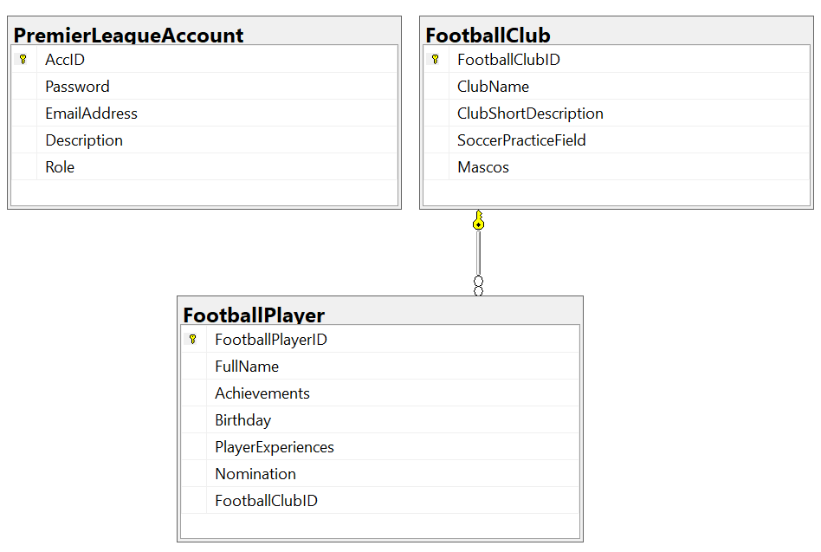
Note that: Member role: Administrator = 1; Staff = 2; Manager=3; Customer = 4. A club will have many football players, one football player will belong to only one football club.

Part 01 (7.0 points). Create an API using ASP.NET Core Web API with Entity Framework Core. A MS SQL Server database will be created to persist the data and it will be used for reading and managing data.

- Check authentication/authorization with the ASP.NET Core Web API with JSON Web Token (JWT)
- Administrator role will have a permission to all actions (CRUD and search).
- Staff role will have only permission to search information.
- Other roles do not have any permissions.
Note that the permission for Authentication feature is using UserEmail and UserPassword.

- You must use OData to implement the ASP.NET Core Web API. CORS is using in this case.
- Implement CRUD actions with FootballPlayer table. Add new item with the requirements:
  - All fields are required.
  - Value for Fullname includes a-z, A-Z, space, @, # and digit 0-9. Each word of the Fullname must begin with the capital letter.
  - Value for Birthday < 01-01-2007.
  - The value for Achievements and Nomination must be 9 – 100 characters.
- Get all items includes all FootballPlayer information and ClubName.
- Search all items in FootballPlayer table with 2 conditions: Achivements or Nomination (using relative search)

Part 02 (3.0 points).
Student can choose one of these options for client application
- ASP.NET Core Web App with MVC
- ASP.NET Core Razor Pages
- Windows Forms
- Windows Presentation Foundation
- Authentication function
If user with a Administrator role or Staff role logs in successfully, save this information to a temporary parameter.
- All CRUD actions are required with Administrator role
- Search information is required with Administrator role or Staff role.
- Other roles do not have any permissions.
In the case login unsuccessfully, display “You are not allowed to access this function!”

- Check if login successfully, search all items with 2 conditions: Achivements or Nominatio (using relative search)

- Check if login successfully, delete the selected item with the confirmation then update the list of items.

- Check if login successfully, add new item with the requirements:
  - The new item will display at the top of the list.
  - All fields are required.
  - Value for Fullname includes a-z, A-Z, space, @, # and digit 0-9. Each word of the Fullname must begin with the capital letter.
  - Value for Birthday < 01-01-2007.
  - The value for Achievements and Nomination must be 9 – 100 characters.

- Check if login successfully, update existing item with the same requirements with add function.

