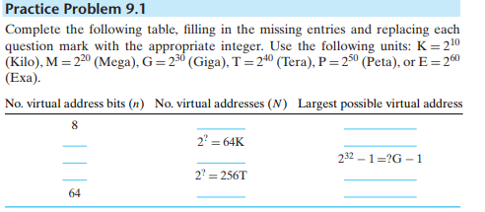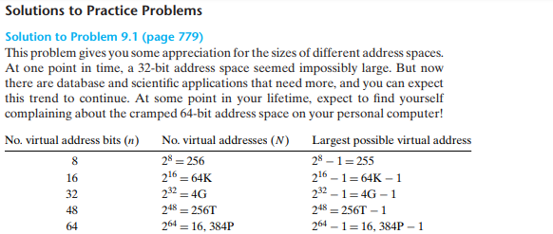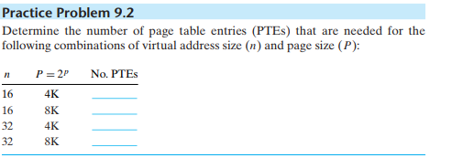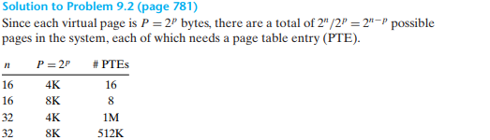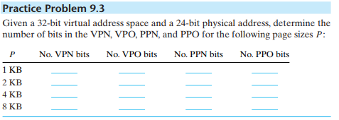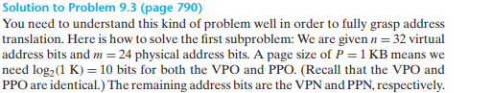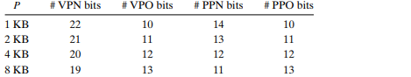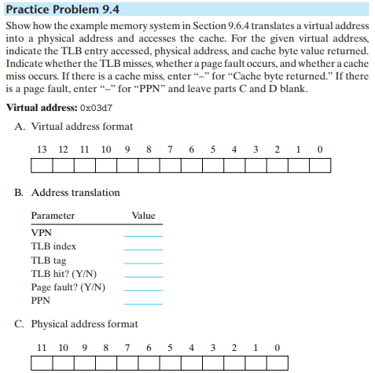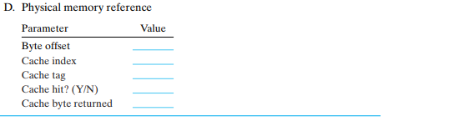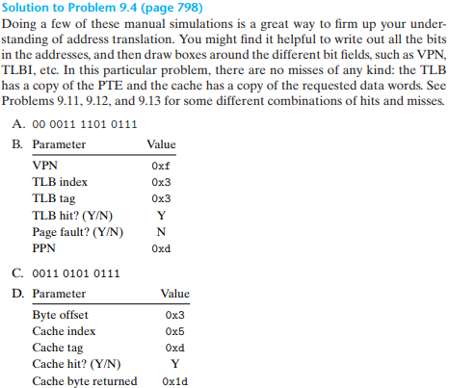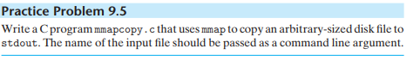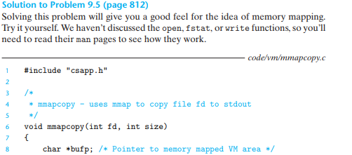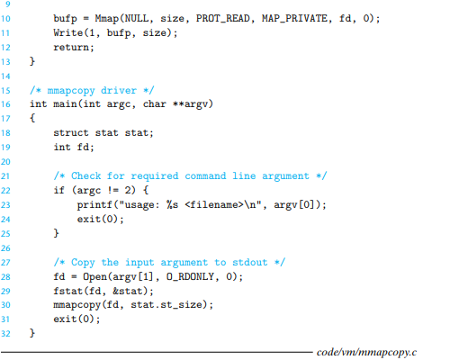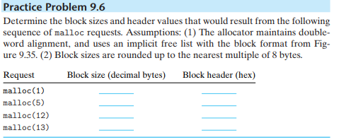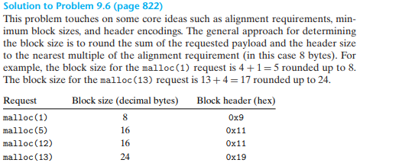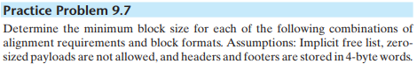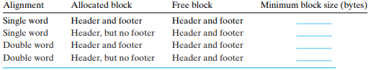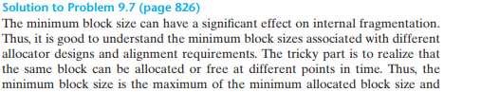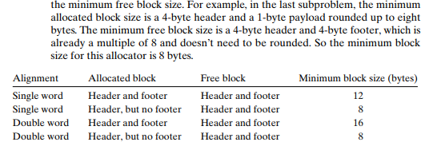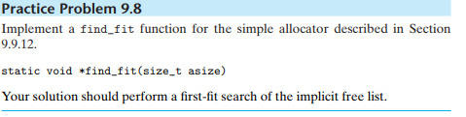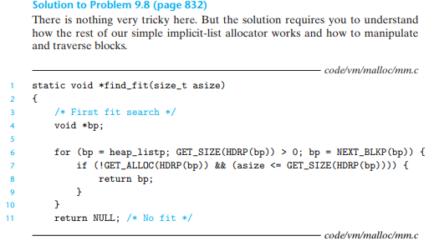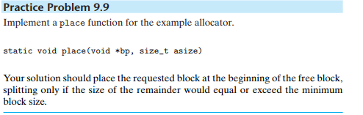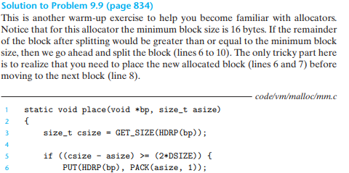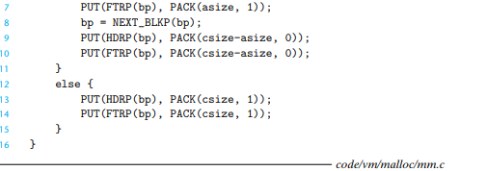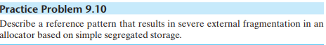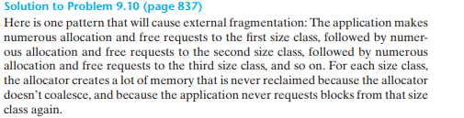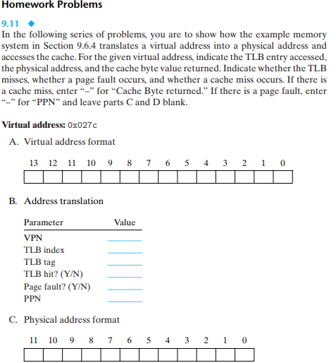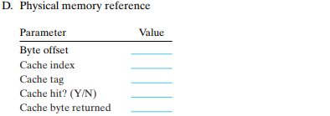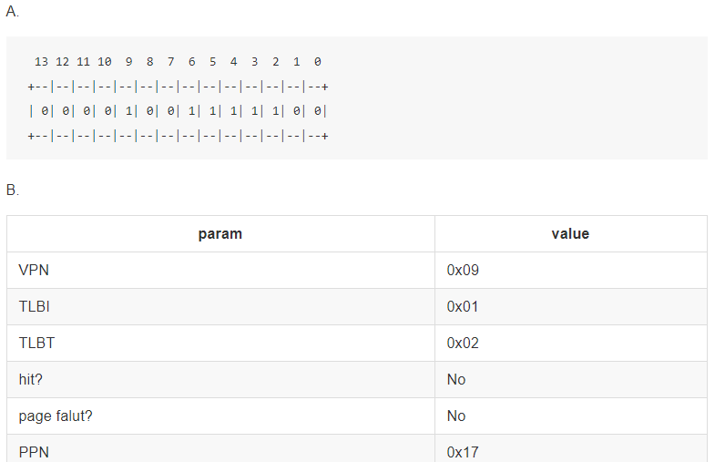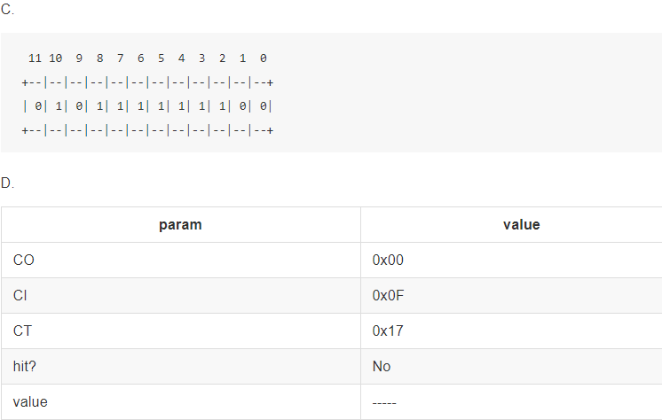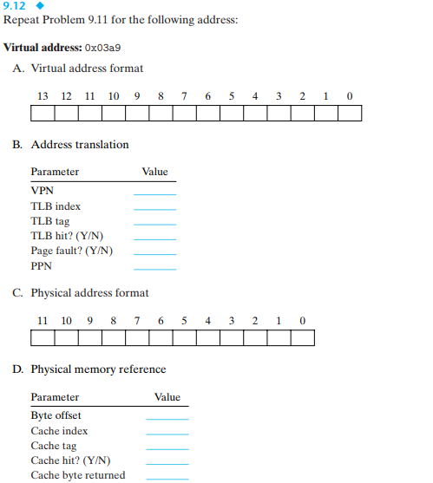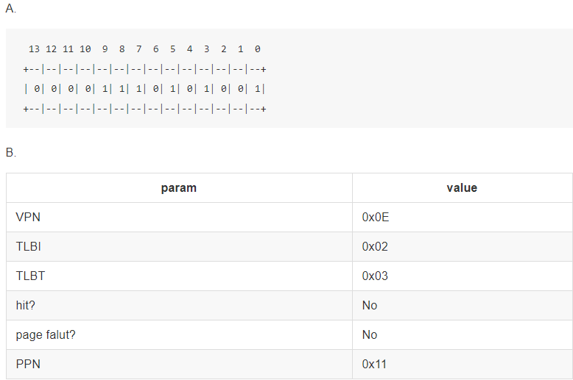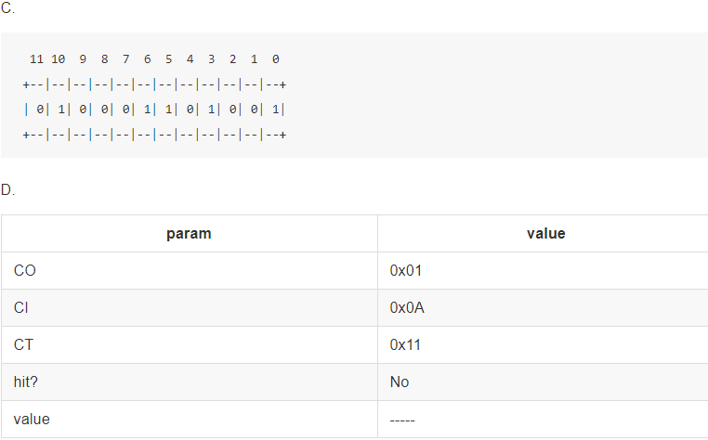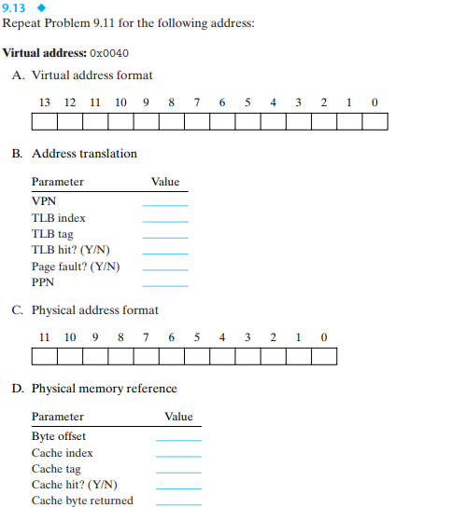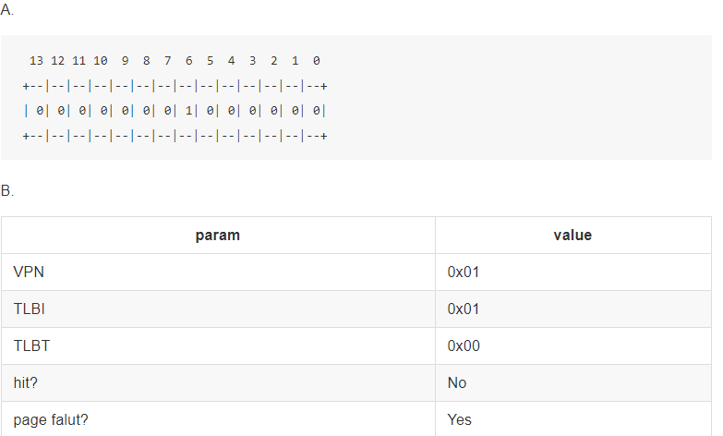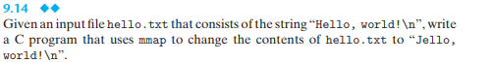/*

* 9.14.c

*/

#include <stdio.h>

#include <assert.h>

#include "vm/csapp.h"

void test(char* filename, char* content) {

int fd;

char buf[20];

fd = Open(filename, O_RDONLY, 0);

Read(fd, buf, strlen(content));

assert( !strncmp(buf, content, strlen(content)) );

}

int touch(char* filename, char* content) {

int fd;

umask(DEF_UMASK);

fd = Open(filename, O_WRONLY|O_CREAT|O_TRUNC, DEF_MODE);

Write(fd, content, strlen(content));

Close(fd);

}

int main(int argc, char* argv[]) {

touch("hello.txt", "Hello, world!");

test("hello.txt", "Hello, world!");

struct stat stat;

int fd;

char* bufp;

size_t size;

fd = Open("hello.txt", O_RDWR, 0);

fstat(fd, &stat);

size = stat.st_size;

bufp = Mmap(NULL, size, PROT_WRITE, MAP_SHARED, fd, 0);

*bufp = 'J';

Munmap(bufp, size);

test("hello.txt", "Jello, world!");

return 0;

}

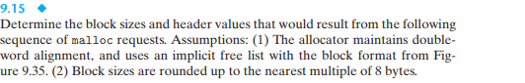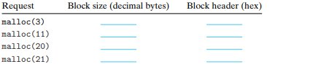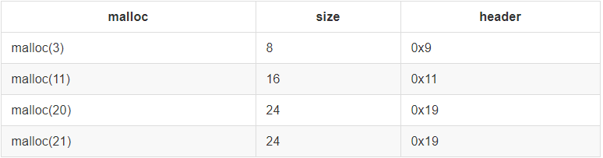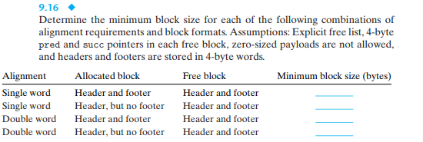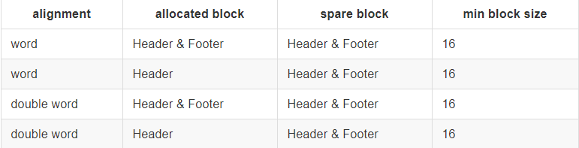

--- mm.c 2017-11-09 02:57:43.679935907 +0000

+++ mm.9.17.c 2017-11-09 02:57:43.679935907 +0000

@@ -41,6 +41,7 @@

/* Global variables */

static char *heap_listp = 0; /* Pointer to first block */

+static char *rover; /* Next fit rover */

/* Function prototypes for internal helper routines */

static void *extend_heap(size_t words);

@@ -69,6 +70,7 @@

heap_listp += (2*WSIZE); //line:vm:mm:endinit

/* $end mminit */

+ rover = heap_listp;

/* $begin mminit */

/* Extend the empty heap with a free block of CHUNKSIZE bytes */

@@ -177,6 +179,10 @@

bp = PREV_BLKP(bp);

}

/* $end mmfree */

+ /* Make sure the rover isn't pointing into the free block */

+ /* that we just coalesced */

+ if ((rover > (char *)bp) && (rover < NEXT_BLKP(bp)))

+ rover = bp;

/* $begin mmfree */

return bp;

}

@@ -290,16 +296,20 @@

{

/* $end mmfirstfit */

- /* $begin mmfirstfit */

- /* First-fit search */

- void *bp;

-

- for (bp = heap_listp; GET_SIZE(HDRP(bp)) > 0; bp = NEXT_BLKP(bp)) {

- if (!GET_ALLOC(HDRP(bp)) && (asize <= GET_SIZE(HDRP(bp)))) {

- return bp;

- }

- }

- return NULL; /* No fit */

+ /* Next fit search */

+ char *oldrover = rover;

+

+ /* Search from the rover to the end of list */

+ for ( ; GET_SIZE(HDRP(rover)) > 0; rover = NEXT_BLKP(rover))

+ if (!GET_ALLOC(HDRP(rover)) && (asize <= GET_SIZE(HDRP(rover))))

+ return rover;

+

+ /* search from start of list to old rover */

+ for (rover = heap_listp; rover < oldrover; rover = NEXT_BLKP(rover))

+ if (!GET_ALLOC(HDRP(rover)) && (asize <= GET_SIZE(HDRP(rover))))

+ return rover;

+

+ return NULL; /* no fit found */

}

/* $end mmfirstfit */

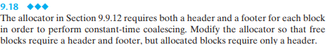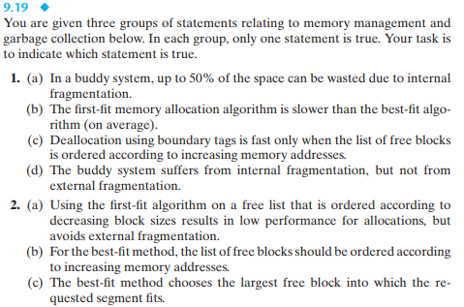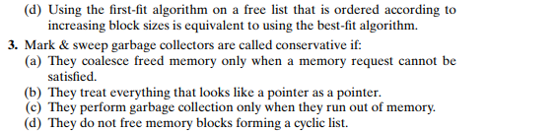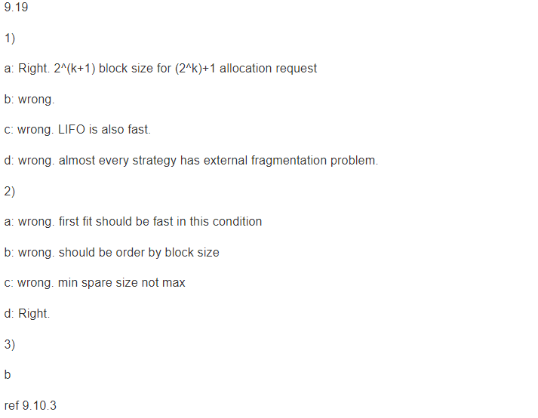

using malloc lib code from csapp site

* implicit idle list
* allocated block with header & footer
* idle block with header & footer
* no GC
* first fit strategy

another modification to malloc lib file

mm.h

--- ../vm/mm.h 2017-11-09 02:57:43.679935907 +0000

+++ mm.h 2017-11-09 02:57:43.679935907 +0000

@@ -5,6 +5,9 @@

extern void mm_free (void *ptr);

/* $end mallocinterface */

+#define malloc(size) mm_malloc(size)

+#define free(ptr) mm_free(ptr)

+

extern void *mm_realloc(void *ptr, size_t size);

extern void *mm_calloc (size_t nmemb, size_t size);

extern void mm_checkheap(int verbose);

memlib.c

--- ../vm/memlib.c 2017-11-09 02:57:43.679935907 +0000

+++ memlib.c 2017-11-09 02:57:43.675935936 +0000

@@ -15,23 +15,18 @@

#include "csapp.h"

#include "memlib.h"

-#define MAX_HEAP (20*(1<<20)) /* 20 MB */

-

-

/* $begin memlib */

/* Private global variables */

static char *mem_heap; /* Points to first byte of heap */

static char *mem_brk; /* Points to last byte of heap plus 1 */

-static char *mem_max_addr; /* Max legal heap addr plus 1*/

/*

* mem_init - Initialize the memory system model

*/

void mem_init(void)

{

- mem_heap = (char *)Malloc(MAX_HEAP);

+ mem_heap = (char *)sbrk(0);

mem_brk = (char *)mem_heap;

- mem_max_addr = (char *)(mem_heap + MAX_HEAP);

}

/*

@@ -43,7 +38,7 @@

{

char *old_brk = mem_brk;

- if ( (incr < 0) || ((mem_brk + incr) > mem_max_addr)) {

+ if ( (incr < 0) || ((mem_brk = sbrk(incr)) == (void *)-1)) {

errno = ENOMEM;

fprintf(stderr, "ERROR: mem_sbrk failed. Ran out of memory...\n");

return (void *)-1;

main.c file measure malloc performance

/*

* main.c

*/

#include <stdio.h>

#include "csapp.h"

#ifdef CUS_MALLOC

#include "mm.h"

#include "memlib.h"

#else

#include <stdlib.h>

#endif

#define LOOP 10000

int main(int argc, char* argv[]) {

void* m_start = sbrk(0);

size_t malloc_size = 0;

int i;

for (i = 0; i < LOOP; i+=2) {

void* ptr_f = malloc(i);

void* ptr = malloc(i+1);

free(ptr_f);

malloc_size += i+1;

}

void* m_end = sbrk(0);

size_t heap_size = (size_t)(m_end - m_start);

printf("malloc size: %ld, heap_size: %ld\n", malloc_size, heap_size);

return 0;

}

run make to generate both origin main executable file and custom version(using -DCUS_MALLOC)

CC = gcc

CFLAGS = -m64 -pthread -DCUS_MALLOC

SRCS = mm.c memlib.c csapp.c

all: origin custom diff

measure:

time ./origin.main

time ./custom.main

origin:

$(CC) -m64 main.c -o origin.main

custom:

$(CC) $(CFLAGS) $(SRCS) main.c -o custom.main

diff:

(diff -u ../vm/mm.h mm.h > mm.h.diff; cd .)

(diff -u ../vm/memlib.c memlib.c > memlib.c.diff; cd .)

test:

.PHONY: clean

clean:

find . -type f -executable -print0 | xargs -0 rm -f --

measurement

(cd chapter9/code/malloc; make measure)

time ./origin.main

malloc size: 25000000, heap_size: 28311552

0.00user 0.01system 0:00.01elapsed 100%CPU (0avgtext+0avgdata 19256maxresident)k

0inputs+0outputs (0major+4547minor)pagefaults 0swaps

time ./custom.main

malloc size: 25000000, heap_size: 31327104

0.58user 0.00system 0:00.58elapsed 99%CPU (0avgtext+0avgdata 30592maxresident)k

0inputs+0outputs (0major+7339minor)pagefaults 0swaps