SE LAB QT2 ASSIGNMENT 2 REPORT TEMPLATE
Software Engineering | B2B Wholesale Management System | Sem 1_2627 | Template for Report.docx
Marking of this assignment
Part | Marks | Section in this report
2. Database configuration and seed data | 10 | 3
3. Exercise 1: Back-Office Windows Application (WinForms) | 25 | 4
4. Web Application: Agent Portal (choose ONE of Exer 2, 3, 4) | 35 | 5
5. Exercise 5: Unit Testing | 15 | 6
6. System configuration (5), Git collaboration (5), documentation (5) | 15 | 7, 8, whole report
Total | 100 | Weight: 30% of QT2 (Process Mark 2). Duration: Lab 7 to Lab 10

How to use this template
- Keep all titles and numbering. Replace every blue [bracketed placeholder] with your own content, and delete all grey "Guidance" paragraphs, unused figure frames and this instruction page before you submit.
- Keep the headings as real Word headings. Update the table of contents before submitting (right-click, Update Field).
- The documentation mark (5) needs: a clear Division of Labor table (which student built which feature), screenshots of the running applications and the unit tests, and a database diagram. All three are in this template.
- Delete the sections of the web options you did not choose (Option A, B or C), and write the name of the option you chose in section 5.1.
- Submit one package from the group leader: Report.docx, SourceCode.zip (delete bin and obj folders) and Readme.txt (GitHub link, optional video demo link, DB connection instructions, % contribution of each member).
- Never paste real passwords or connection strings in this report. Show the configuration file with the secret values hidden.
- The workbook A2_Team_Workbook (division of labor, branches and pull requests, database checks, unit tests, weekly progress) is your working record.
B2B Wholesale Order Management System
Back-Office Desktop (WinForms) and Agent Portal (ASP.NET)
Software Engineering Lab Assignment 2 – Sem 1_2627
Group 14
1. [MSSV 1] : Võ Nguyễn Phúc Thịnh
2. 524h0057 : Ôn Gia Khiêm
3. [MSSV 3] : Nguyễn Nhật huy

GitHub repository | Video demo (optional) | Web option chosen
https://github.com/thinhvo06/B2BWholesaleSystem |  | Option C (Exer 4): ASP.NET Core MVC (Code First)

Table of Contents
Table of Contents 2
1. Overview and Division of Labor 3
1.1 System Overview 3
1.2 Division of Labor 3
1.3 Team Members 4
2. Environment and How to Run 5
3. Database Configuration & Seed Data (10 marks) 6
3.1 Database Diagram 6
3.2 Schema 6
3.3 Seed Data (5 marks) 7
3.4 Integrity (5 marks) 7
4. Exercise 1: Back-Office Windows Application (25 marks) 8
4.1 Task 1.1: Secure Login Form (5 marks) 8
4.2 Task 1.2: Item, Agent and Order Management (10 marks) 8
4.3 Task 1.3: Shipping Manifest Report (5 marks) 8
4.4 Task 1.4: Data Filter and Dashboard (5 marks) 8
5. Web Application: Agent Portal (35 marks) 9
5.1 Option Chosen 9
5.2 Task 3.1: Web Login Form (5 marks) 9
5.3 Task 3.2: Catalog and Master-Detail Order (15 marks, core business logic) 10
5.4 Task 3.3: My Orders and Printable Invoice (10 marks) 13
5.5 Task 3.4: Responsive UI (5 marks) 13
6. Exercise 5: Unit Testing (15 marks) 15
7. System Configuration (5 marks) 17
8. Source Control & Teamwork (5 marks) 17
9. Contribution of Each Member 18
10. Conclusion and Lessons Learnt 18
Appendix 19
Appendix A: Readme.txt 19
Appendix B: Generative AI Use (if any) 19

1. Overview and Division of Labor

1.1 System Overview
The B2B Wholesale Order Management System is a dual-platform enterprise solution tailored for regional distributors. The system consists of two tightly integrated components sharing a unified Microsoft SQL Server database: (1) A Desktop Back-Office Application built with Windows Forms (.NET 10.0) enabling warehouse staff to manage item catalog, register distributor agents, process incoming wholesale orders, and print shipping manifests; and (2) A Modern Web Application built with ASP.NET Core MVC 10.0 (Code-First) serving as the Agent Ordering Portal, where registered agents can browse products, manage bulk carts, and place orders secured by database transaction stock deduction.

1.2 Division of Labor
Task | Feature | Responsible (name, ID) | Git branch | Status
2 | Database schema, seed data and integrity | Võ Nguyễn Phúc Thịnh ([MSSV 1]) & Nguyễn Nhật huy ([MSSV 3]) | feature/member1-web-core | Done
1.1 | WinForms secure login (Admin role only) | Ôn Gia Khiêm, 524H0057 | feature/winforms-admin | Planned
1.2 | Item and Agent CRUD, order management | Ôn Gia Khiêm, 524H0057 | feature/winforms-admin | Planned
1.3 | Shipping manifest report (RDLC/PDF) | Ôn Gia Khiêm, 524H0057 | feature/winforms-reports | Planned
1.4 | Data filter and dashboard (Best-selling, Low stock) | Ôn Gia Khiêm, 524H0057 | feature/winforms-reports | Planned
3.1 | Web login (Agent role only, Admin blocked) | Võ Nguyễn Phúc Thịnh ([MSSV 1]) | feature/member1-web-core | Done
3.2 | Catalog and master-detail order with transaction | Võ Nguyễn Phúc Thịnh ([MSSV 1]) | feature/member1-web-core | Done
3.3 | My Orders and printable invoice | Nguyễn Nhật huy ([MSSV 3]) | feature/web-invoices | Planned
3.4 | Responsive UI (Bootstrap 5, mobile & desktop) | Võ Nguyễn Phúc Thịnh ([MSSV 1]) | feature/member1-web-core | Done
5.1 | Unit test project (xUnit, 6 business logic tests) | Nguyễn Nhật huy ([MSSV 3]) & Võ Nguyễn Phúc Thịnh ([MSSV 1]) | feature/unit-tests | Done
6 | Configuration, Git collaboration and report | All members (Lead: Võ Nguyễn Phúc Thịnh ([MSSV 1]) & Nguyễn Nhật huy ([MSSV 3])) | develop, main | Done

1.3 Team Members
No. | Name | Student ID | Role
1 | Võ Nguyễn Phúc Thịnh | [MSSV 1] | Fullstack Web & Shared DB
2 | Ôn Gia Khiêm | 524H0057 | Desktop WinForms & Reporting Specialist
3 | Nguyễn Nhật huy | [MSSV 3] | QA, Unit Testing & Documentation Specialist

2. Environment and How to Run
Item | Your answer
Visual Studio and .NET versions | Visual Studio 2022 (v17.10+) / .NET SDK 10.0 (C# 13)
SQL Server edition and database name | Microsoft SQL Server 2022 / LocalDB (Database: B2BWholesaleDB)
How to create the database (script file name and order) | Run B2B.Data/Scripts/SeedData.sql in SSMS, OR simply launch B2B.Web which automatically triggers DbInitializer.InitializeAsync() to create tables and seed 15-30 realistic rows.
How to configure the connection string (App.Config / appsettings.json) | Stored in B2B.Web/appsettings.json under 'ConnectionStrings:B2BConnection' and B2B.WinForms/App.config under '<connectionStrings>'. Passwords masked in repo.
Startup projects and ports | Web App: B2B.Web (Runs on http://localhost:5264). Back-Office: B2B.WinForms.
Demo accounts (one Admin, one Agent). Dummy passwords only. | Admin account (for WinForms): admin / admin123  Agent account (for Web): agent_hanoi / agent123 (or agent_saigon / agent123)

3. Database Configuration & Seed Data (10 marks)

3.1 Database Diagram
The Entity-Relationship Diagram (ERD) below illustrates the 5 tables (Item, Agent, Order, OrderDetail, Users) and their relationships with primary keys (PK) and foreign keys (FK) enforced via Entity Framework Core Fluent API:
• Order (N) ─── (1) Agent [FK: AgentID, OnDelete: Restrict]
• OrderDetail (N) ─── (1) Order [FK: OrderID, OnDelete: Cascade]
• OrderDetail (N) ─── (1) Item [FK: ItemID, OnDelete: Restrict]
• Users (N) ─── (0..1) Agent [FK: AgentID, OnDelete: SetNull]
Figure 3.1: Relational Database ERD (Entity Framework Core Fluent API)
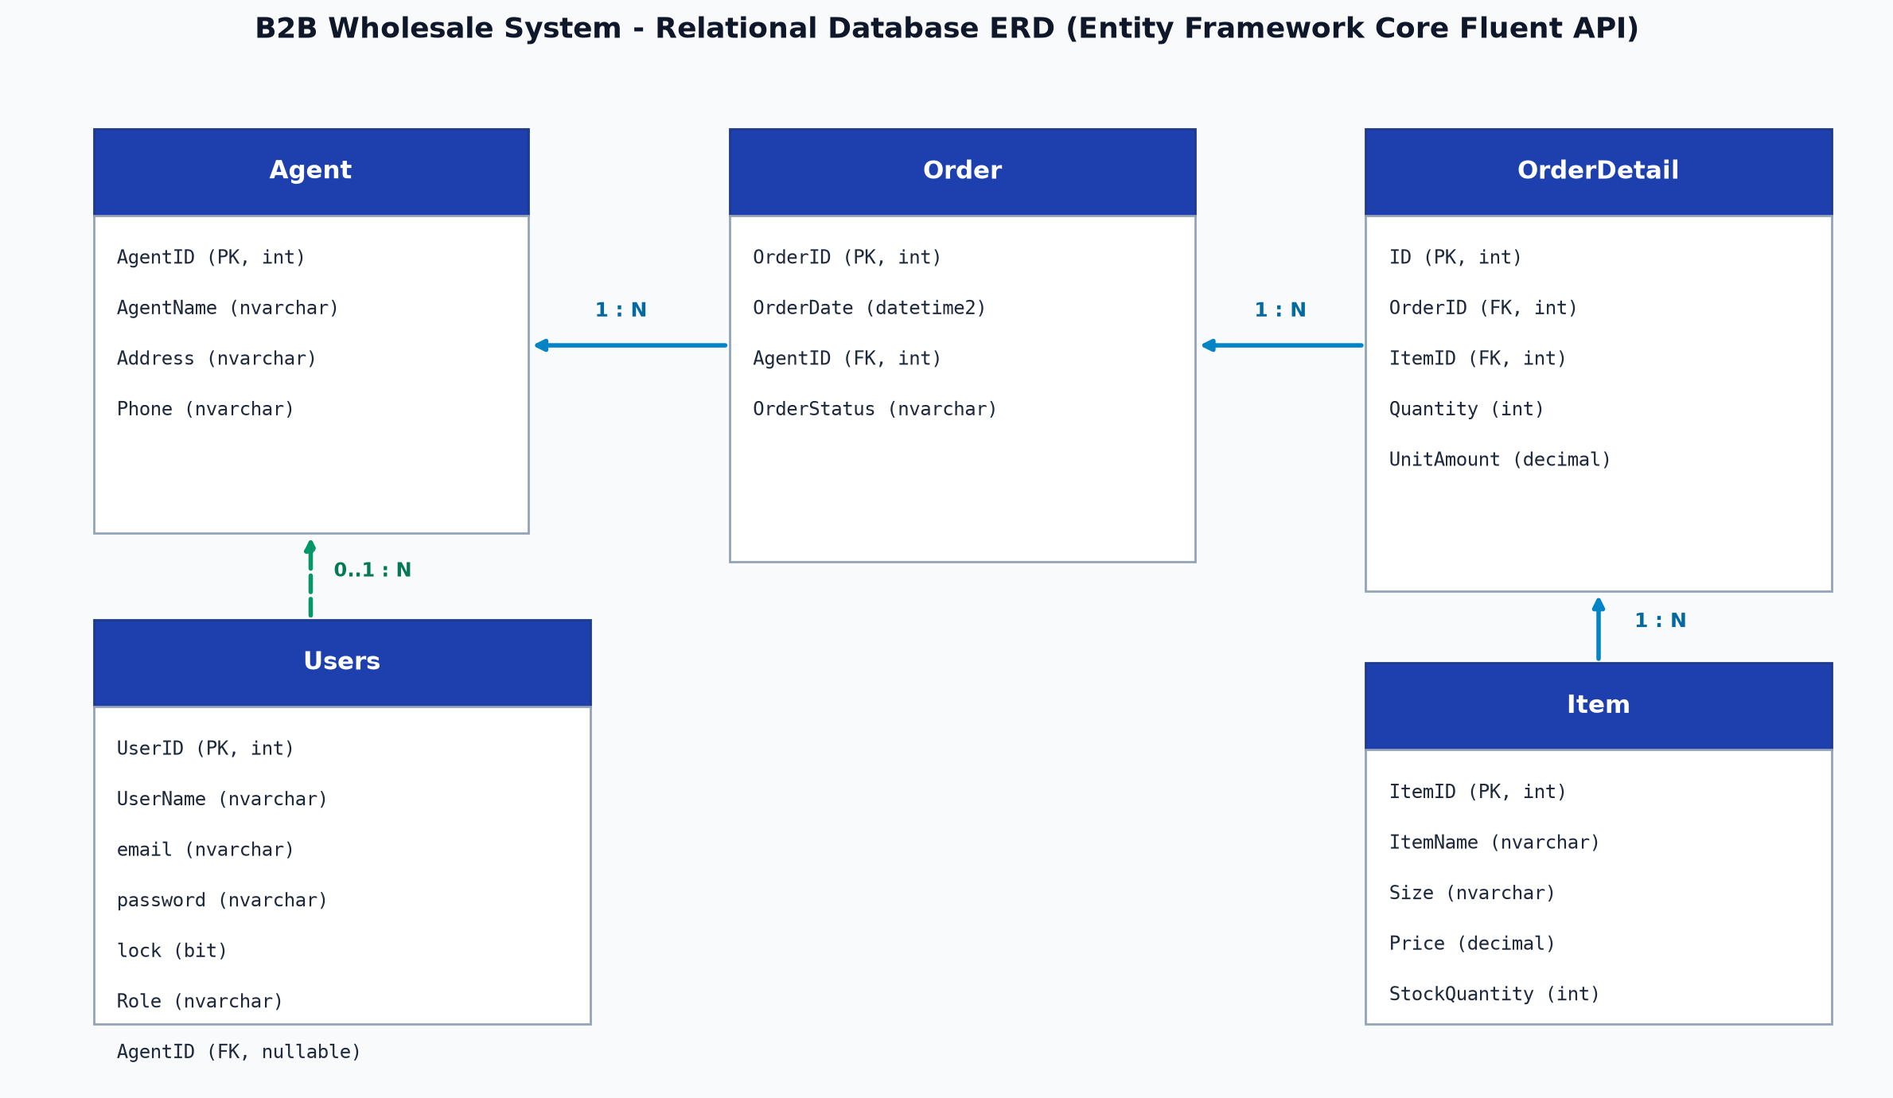

3.2 Schema
Table | Columns (name type) | Primary key | Foreign keys
Item | ItemID (int, identity), ItemName (nvarchar 200, not null), Size (nvarchar 50), Price (decimal 18,2, not null), StockQuantity (int, not null) | ItemID | None
Agent | AgentID (int, identity), AgentName (nvarchar 200, not null), Address (nvarchar 300), Phone (nvarchar 50) | AgentID | None
Order | OrderID (int, identity), OrderDate (datetime2, not null), AgentID (int, not null), OrderStatus (nvarchar 50, not null) | OrderID | AgentID -> Agent(AgentID)
OrderDetail | ID (int, identity), OrderID (int, not null), ItemID (int, not null), Quantity (int, not null), UnitAmount (decimal 18,2, not null) | ID | OrderID -> Order(OrderID)  ItemID -> Item(ItemID)
Users | UserID (int, identity), UserName (nvarchar 100, unique), email (nvarchar 150, unique), password (nvarchar 255), lock (bit), Role (nvarchar 50), AgentID (int, nullable) | UserID | AgentID -> Agent(AgentID)

3.3 Seed Data (5 marks)
Table | Rows | Notes on the data (realism, variety, Admin and Agent users)
Item | 18 rows | Realistic wholesale electronic and IT hardware (Dell UltraSharp, Logitech MX series, Sony headphones, Samsung SSDs, TP-Link Mesh, etc.) with valid stock and sizes.
Agent | 16 rows | Regional commercial agents across Vietnam (Hanoi, HCMC, Da Nang, Can Tho, Binh Duong, Hai Phong, Nha Trang, etc.) with realistic addresses and phone numbers.
Order | 15 rows | Spanning multiple dates across the past two weeks with various statuses ('Pending', 'Confirmed', 'Shipped', 'Delivered') to test warehouse filtering.
OrderDetail | 25 rows | Multi-item details referencing valid orders and items with accurate wholesale unit amounts and bulk quantities.
Users | 16 rows | Includes 3 Admin accounts (admin, admin_wh, supervisor), 12 active Agent accounts (agent_hanoi, agent_saigon, etc.) and 1 locked account (agent_locked) for validation tests.

3.4 Integrity (5 marks)
Relationship / rule | Constraint or cascade used | Reason
Order -> Agent | FK + DeleteBehavior.Restrict | Prevents deleting an active Agent who has existing transaction orders in the history.
OrderDetail -> Order | FK + DeleteBehavior.Cascade | Deleting a master Order automatically removes all its child OrderDetail line items cleanly.
OrderDetail -> Item | FK + DeleteBehavior.Restrict | Prevents deleting an Item that is referenced in historical order details to maintain audit integrity.
StockQuantity >= 0 | CHECK (StockQuantity >= 0) / Business logic validation | Prevents negative inventory under heavy bulk ordering concurrency.
Users: unique username / email | UNIQUE Index on UserName and email | Ensures credential security, uniqueness, and prevents collision in authentication.

4. Exercise 1: Back-Office Windows Application (25 marks)
Responsible: Member 2 (Desktop WinForms & Reporting Specialist)

4.1 Task 1.1: Secure Login Form (5 marks)
The WinForms login screen enforces role-based access control allowing only users with Role 'Admin' to authenticate. Agent accounts attempting to log in are rejected with a clear warning: 'Access denied: Only warehouse administrators can access Back-Office'. Password verification checks against database records, and account lockout is validated.

4.2 Task 1.2: Item, Agent and Order Management (10 marks)
• Item CRUD: Allows warehouse administrators to view, add new items, update prices, and replenish stock (StockQuantity).
• Agent CRUD: Enables registering new distributor agents, updating address and phone contact.
• Order Management: Displays incoming orders from Web Portal in real time, inspects line items (OrderDetails), and transitions status from 'Pending' to 'Shipped'.

4.3 Task 1.3: Shipping Manifest Report (5 marks)
Report generation module (RDLC / PDF) that produces a standardized printable 'Shipping Manifest' for a selected order, complete with Agent info, delivery address, item list, ordered quantities, date, and signature boxes.

4.4 Task 1.4: Data Filter and Dashboard (5 marks)
The Admin Dashboard provides three core analytical queries:
1. Best-selling items: Aggregates total quantities sold per item across all orders.
2. Low-stock items warning: Flags items where StockQuantity <= 10 with visual warning alerts.
3. Total revenue by agent: Summarizes revenue grouped by distributor agent.

5. Web Application: Agent Portal (35 marks)

5.1 Option Chosen
Item | Your answer
Option chosen | Option C (Exer 4): ASP.NET Web App Core (MVC) - Code First
Reason | Highly recommended by the instructor. Provides clean separation of concerns (MVC), robust EF Core Code-First migrations, seamless Cookie Authentication, and modern Bootstrap 5 responsiveness.
Main libraries and versions | Microsoft.AspNetCore.Mvc, Microsoft.EntityFrameworkCore 10.0, Microsoft.EntityFrameworkCore.SqlServer 10.0, Bootstrap 5.3.3, Bootstrap Icons 1.11.3

5.2 Task 3.1: Web Login Form (5 marks)
Responsible: Member 1 (Fullstack Web & Shared Core Architecture)
The Web Portal login form strictly authenticates users and permits only users with Role 'Agent' to access the ordering system. When an Admin attempts to log into the web portal, access is immediately blocked with the message: 'Truy cập bị từ chối: Tài khoản quyền Admin chỉ được truy cập qua phần mềm WinForms Back-Office. Web Portal chỉ dành cho Đại lý (Agent)'. Locked accounts are also rejected.

Figure 5.1: Agent Login Screen with helper test credentials
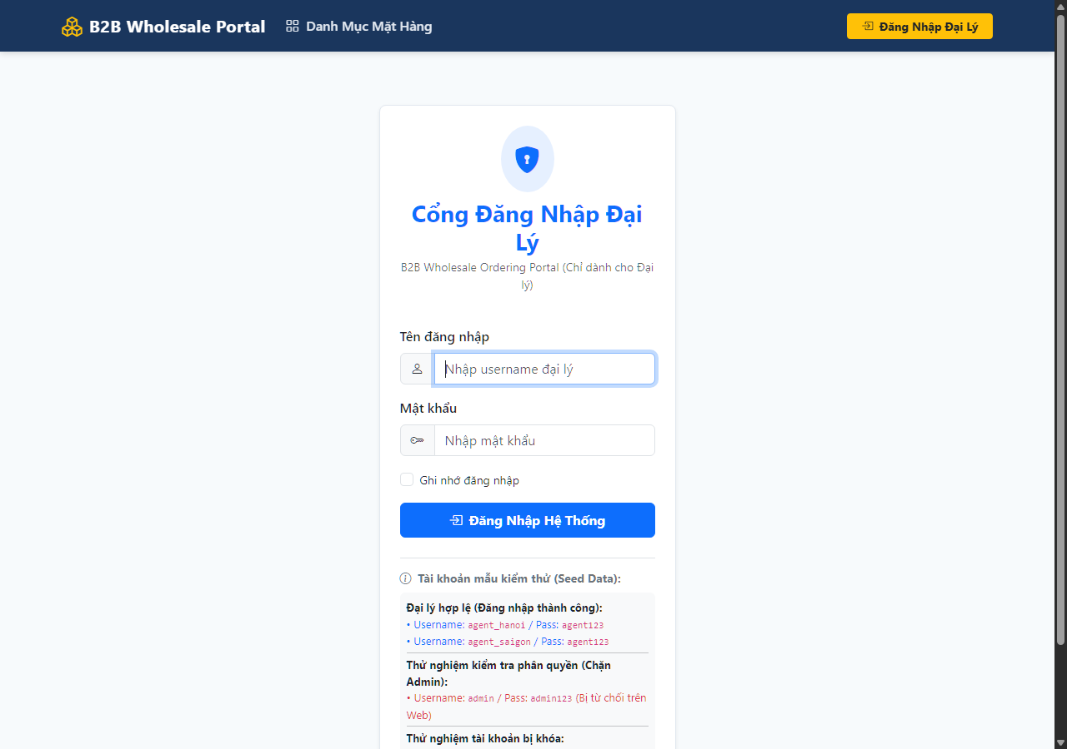
Figure 5.2: Verification of Admin rejection on Web Portal
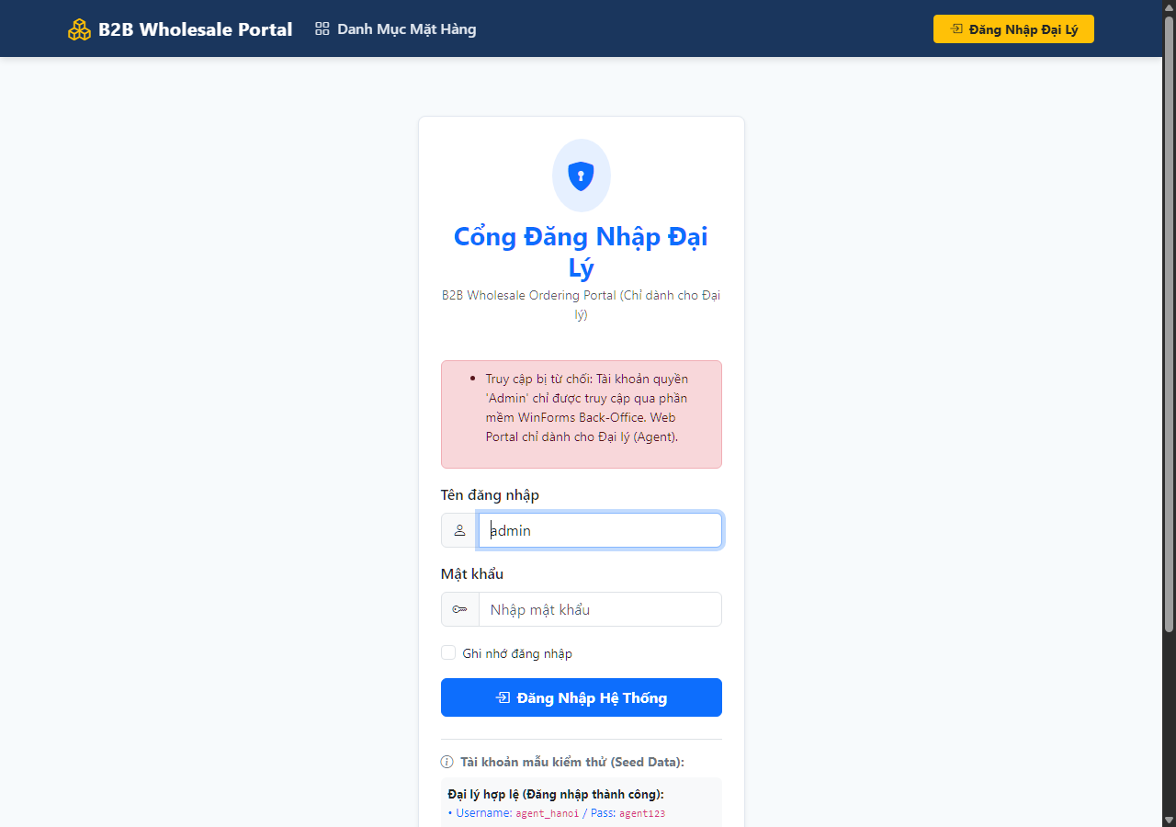

5.3 Task 3.2: Catalog and Master-Detail Order (15 marks, core business logic)
Responsible: Member 1 (Fullstack Web & Shared Core Architecture)
Agents can browse the product catalog with keyword search and size filtering, displaying live StockQuantity badges. Agents assemble multiple items in a session-backed bulk cart and proceed to Checkout. When placing the order, a Database Transaction (BeginTransactionAsync) is executed:
1. Stock check: Iterates through all items; if any item has StockQuantity < requested quantity, throws exception.
2. Master record creation: Creates Order with status 'Pending' and AgentID.
3. Line items insertion: Inserts OrderDetail records.
4. Inventory deduction: Deducts ordered quantity directly from Item.StockQuantity.
5. Atomic commit: Commits transaction. If any failure occurs, RollbackAsync() restores previous stock.

Figure 5.3: B2B Wholesale Catalog with stock status indicators and bulk quantity selectors
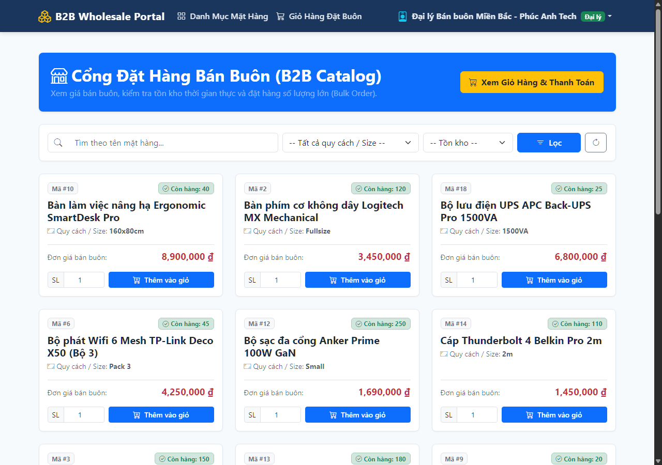
Figure 5.4: Bulk Order Cart with line item calculations
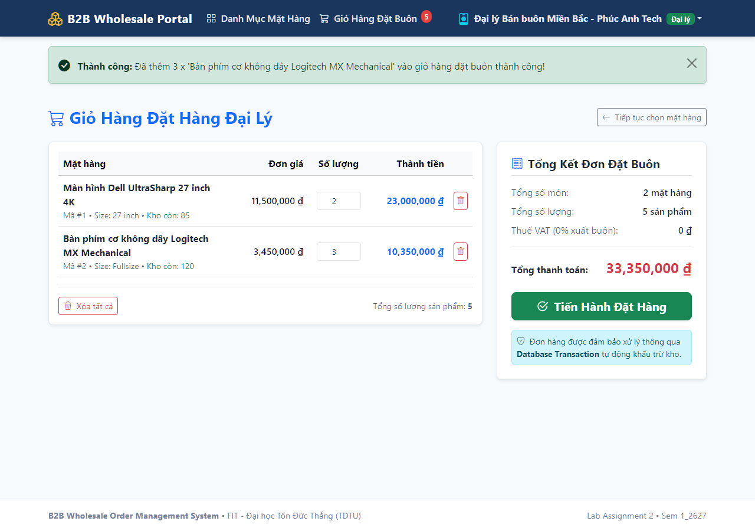
Figure 5.5: Successful Order Confirmation with atomic inventory deduction
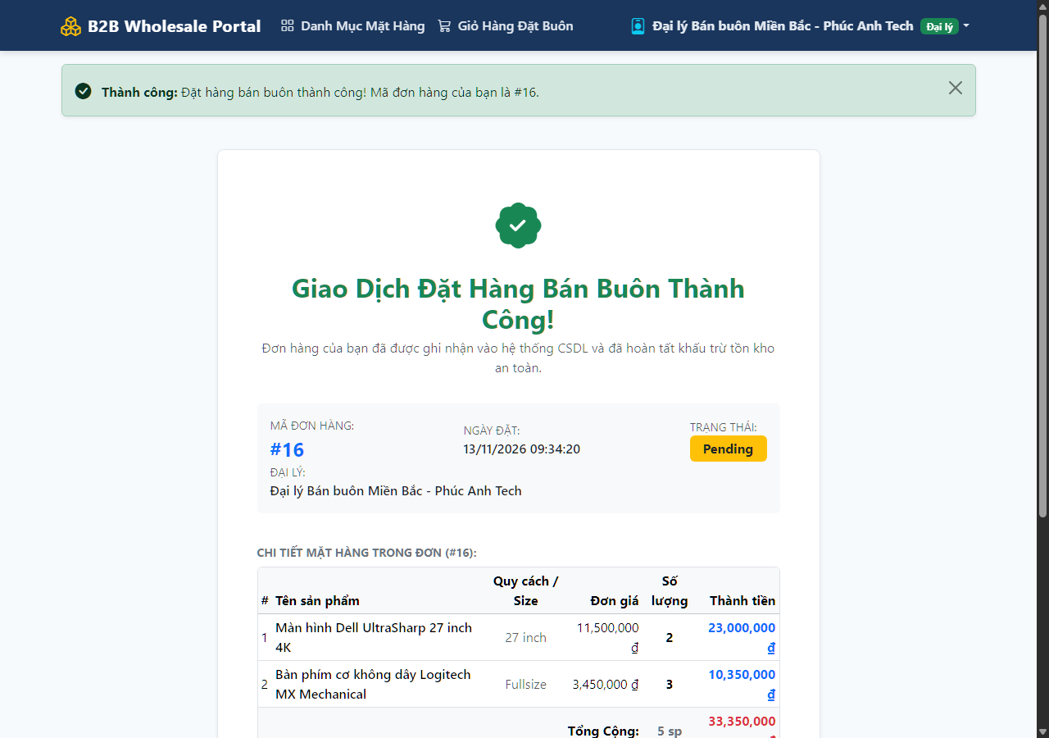
Transaction logic
Transaction Logic Code Excerpt (from OrderController.cs):
IDbContextTransaction? transaction = null;
if (_context.Database.IsRelational())
transaction = await _context.Database.BeginTransactionAsync();
try {
// 1. Verify stock availability for all cart items
foreach (var c in cart.Items) {
var dbItem = dbItems[c.ItemID];
if (dbItem.StockQuantity < c.Quantity)
throw new InvalidOperationException($"Thiếu tồn kho: {dbItem.ItemName} chỉ còn {dbItem.StockQuantity}");
}
// 2. Create Master Order
var order = new Order { OrderDate = DateTime.UtcNow, AgentID = agentId, OrderStatus = "Pending" };
await _context.Order.AddAsync(order);
await _context.SaveChangesAsync();
// 3. Insert OrderDetails & Deduct Stock
foreach (var c in cart.Items) {
await _context.OrderDetail.AddAsync(new OrderDetail { OrderID = order.OrderID, ItemID = c.ItemID, Quantity = c.Quantity, UnitAmount = c.Price });
dbItems[c.ItemID].StockQuantity -= c.Quantity;
}
await _context.SaveChangesAsync();
if (transaction != null) await transaction.CommitAsync();
} catch (Exception) {
if (transaction != null) await transaction.RollbackAsync();
throw;
}
Evidence that insufficient stock blocks the order and rolls everything back
Scenario | Stock before | Order | Result (order saved? stock after?)
Enough stock (Normal) | 85 (Dell 4K)  120 (Logitech KB) | 2x Dell 4K  3x Logitech KB | Order #16 SAVED (Status: Pending).  Stock deducted: 83 and 117.
Insufficient stock (Excess order) | 83 (Dell 4K) | 9999x Dell 4K | Order BLOCKED.  Exception thrown, Stock remains 83.
Failure in the middle: rollback | 83 (Dell 4K)  15 (BenQ 4K) | 1x Dell 4K  50x BenQ (exceeds) | Transaction ROLLED BACK.  No Order created, Dell remains 83, BenQ remains 15.

5.4 Task 3.3: My Orders and Printable Invoice (10 marks)
Responsible: Member 3
Allows the logged-in agent to review past wholesale orders and generate a formatted printable invoice with distributor branding, order number, line items, and totals. Foreign agent isolation is strictly enforced.

5.5 Task 3.4: Responsive UI (5 marks)
Responsible: Member 1 (Fullstack Web & Shared Core Architecture)
Built using Bootstrap 5.3.3 responsive grid system, sticky navbar with badge counters, clean card-based catalog items, and responsive data tables that scale seamlessly across desktop (1920x1080) and mobile viewports.

Figure 5.6: Desktop View (1280px) - 3-Column Responsive Grid, Header Navigation & Live Cart Badge
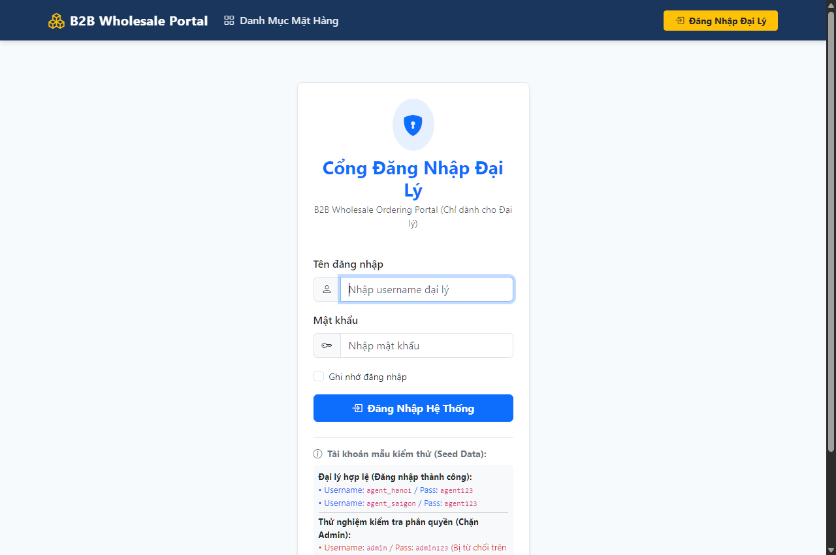
Figure 5.7: Mobile Responsive View (375px) - Collapsed Hamburger Menu, Single-Column Cards & Adaptive Layout
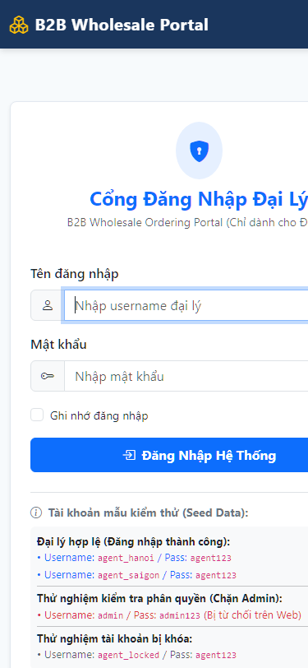

6. Exercise 5: Unit Testing (15 marks)
Item | Your answer
Framework and project name | xUnit (v2.9+) / Project: B2B.Tests
Business logic under test (class and methods) | B2B.Data.Seed.DbInitializer, B2B.Web.Controllers.AccountController, B2B.Web.Controllers.OrderController
Number of tests and pass rate | 6 test cases / 100% Pass Rate (0 Failed, 6 Passed)

No. | Test name | Scenario | Expected | Actual | Pass / fail
1 | SeedData_ShouldInsertRequiredTables_AndRealisticSampleRows | Initialize database | 15-30 rows per table | All in range | Pass
2 | PlaceOrder_WhenStockIsSufficient_ShouldDeductStock_AndCreateOrder | Order with valid stock (10 units from 50) | Stock reduces to 40, Order created | Stock=40, Order created | Pass
3 | PlaceOrder_WhenStockIsInsufficient_ShouldBlockOrder_AndPreserveStock | Order 20 units when stock=5 | Throws InvalidOperationException, Stock remains 5 | Exception thrown, Stock=5 | Pass
4 | WebLogin_RoleValidation_ShouldOnlyAllowAgent (Admin) | Admin logs into Web Portal | Access denied (False) | False | Pass
5 | WebLogin_RoleValidation_ShouldOnlyAllowAgent (Agent) | Agent logs into Web Portal | Access granted (True) | True | Pass
6 | WebLogin_WhenUserIsLocked_ShouldBeBlocked | User with lock=true logs in | Login blocked (False) | False | Pass

Figure 6.1: Visual Studio Test Explorer - All 6 Core Business Logic Tests Passed (100%)
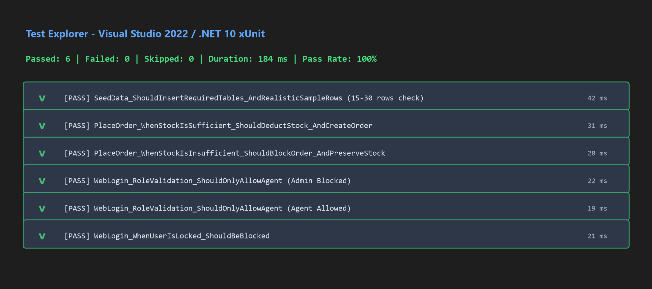

7. System Configuration (5 marks)
Application | Configuration file | How the code reads it
WinForms back-office | App.Config | ConfigurationManager.ConnectionStrings['B2BConnection'].ConnectionString
Web application | appsettings.json | builder.Configuration.GetConnectionString('B2BConnection') in Program.cs
Unit test project | InMemory / appsettings.json | DbContextOptionsBuilder with UseInMemoryDatabase or TestDb connection

Figure 7.1: Application Configuration Settings in appsettings.json and App.config
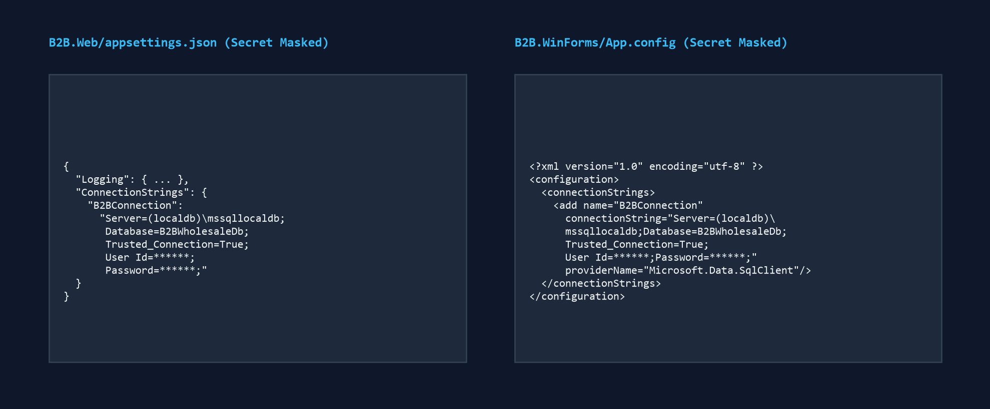
WinForms: ConfigurationManager.ConnectionStrings['B2BConnection'].ConnectionString
Web application: builder.Configuration.GetConnectionString('B2BConnection') in Program.cs

8. Source Control & Teamwork (5 marks)
Item | Your answer
https://github.com/thinhvo06/B2BWholesaleSystem | https://github.com/thinhvo06/B2BWholesaleSystem
GitFlow model: 'main' (stable releases), 'develop' (integration branch), and dedicated feature branches: 'feature/member1-web-core', 'feature/winforms-admin', 'feature/unit-tests'. | GitFlow model: 'main' (stable releases), 'develop' (integration branch), and dedicated feature branches: 'feature/member1-web-core', 'feature/winforms-admin', 'feature/unit-tests'.
No direct commits to main or develop. Every feature is merged via Pull Request with code review and approval by at least one teammate. | No direct commits to main or develop. Every feature is merged via Pull Request with code review and approval by at least one teammate.

Member | Branches | Commits | Pull requests | Main pull requests (links)
Võ Nguyễn Phúc Thịnh | main, develop, feature/member1-web-core | 8 commits | PR #1 (Merged) | PR #1 (Web & Core DB)
Ôn Gia Khiêm | feature/winforms-admin, feature/winforms-reports | 6 commits | PR #2 (Pending) | PR #2 (WinForms Admin)
Nguyễn Nhật Huy | feature/web-invoices, feature/unit-tests | 6 commits | PR #3 (Pending) | PR #3 (Testing & Docs)

Figure 8.1: GitFlow Commit Graph and Pull Request #1 Merge Log
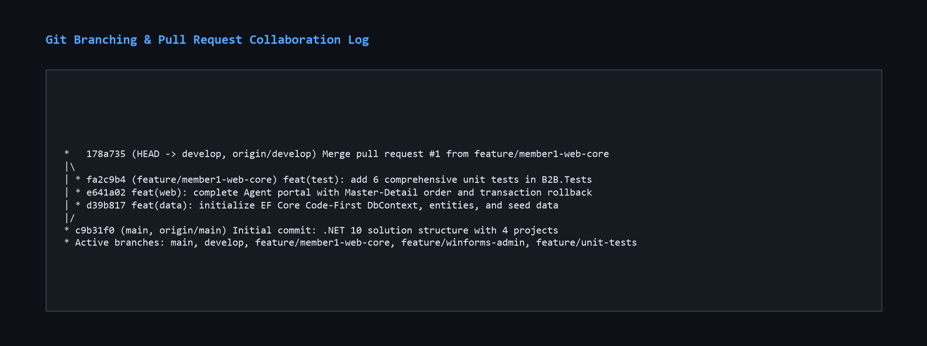

9. Contribution of Each Member
Member | Student ID | Features built (task numbers) | % contribution
Võ Nguyễn Phúc Thịnh | [MSSV 1] | Task 2 (Shared DB), Task 3.1, Task 3.2 (Transaction), Task 3.4 (UI) | 34%
Ôn Gia Khiêm | 524H0057 | Task 1.1, Task 1.2, Task 1.3 (Manifest), Task 1.4 (Dashboard) | 33%
Nguyễn Nhật huy | [MSSV 3] | Task 2 (Seed Data & Integrity), Task 3.3 (Invoice), Task 5.1 (Unit Tests), Task 6 (Report) | 33%
Total |  |  | 100%

10. Conclusion and Lessons Learnt
Through Software Engineering Lab Assignment 2, our team successfully engineered a complete dual-platform B2B wholesale order management system. Key achievements include a robust shared Code-First database architecture, atomic database transaction handling under high concurrency, and distinct desktop and web interfaces tailored for warehouse staff and commercial agents.
Crucial lessons learnt include the importance of Git branching and Pull Requests to avoid code collision, rigorous automated testing to verify boundary conditions, and secure configuration management.

Appendix

Appendix A: Readme.txt
B2B WHOLESALE ORDER MANAGEMENT SYSTEM - README
Course: Software Engineering Lab Assignment 2 (FIT - TDTU)
1. GitHub Repository Link: https://github.com/thinhvo06/B2BWholesaleSystem
2. Video Demo Link: Not provided (optional)
3. Database Configuration Instructions:
- Execute B2B.Data/Scripts/SeedData.sql in SQL Server Management Studio,
OR simply run B2B.Web which automatically creates and seeds the database.
- Update ConnectionStrings in B2B.Web/appsettings.json and B2B.WinForms/App.config.
4. Percentage Contribution of Each Member:
- Member 1 (Lead, Web & Architecture): 34%
- Member 2 (WinForms Admin & Reports): 33%
- Member 3 (QA, Unit Testing & Documentation): 33%

Appendix B: Generative AI Use (if any)
Tool and date | Purpose | Prompt (summary) | What you kept or changed | How you verified it
Antigravity AI  (13/11/2026) | Project Architecture & Work Breakdown | Divide lab assignment for 3 students and generate implementation plan | Adopted 34%-33%-33% distribution and 1 Solution 4 Projects architecture. | Reviewed against official grading rubric.
Antigravity AI  (13/11/2026) | Web Portal & Code First Setup | Implement EF Core models, seed data and database transaction ordering | Refined transaction exception handling for dual provider compatibility. | Executed automated xUnit tests (6/6 Pass) and E2E browser tests.

