THE ENEMIES AND FRIENDS WITHIN

The two photos below are from UK and recent ones. What UK Muslims of this kind want to express? They are doing harms to fellow peace loving Muslims by adopting a stance that they will overcome all adversities, obstacles and denials in a Muslim minority country like UK and establish Islamic hegemony there.

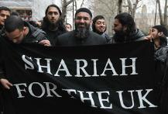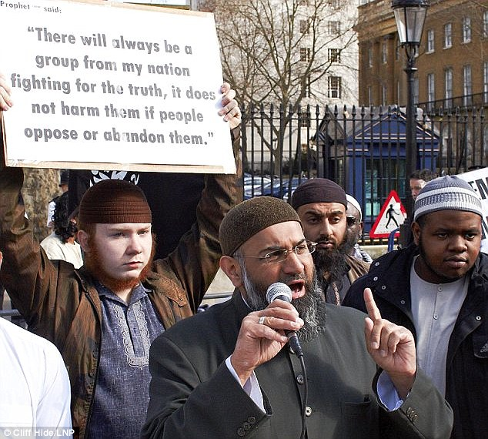

True, this blind faith (in Allah and paradise) or lure for booty, slaves and female flesh helped the early followers of Islam to expand an empire larger than Roman within one hundred years of Prophet’s death. But that was 1400 years back when both Roman and Persian empires were on downhill track.

The group of Muslims under present consideration takes the advantage of democracy, liberty and human rights in non-Muslim countries like UK, US and others to go and settle there first. Then they try to impose primitive and draconian *Shariah* (which was concocted by later Islamic Theologists) as a part of realization of their pan-Islamic dominance. But how many Muslim majority countries are following *Shariah* now? Most do not.

The clock for this group of Muslims is perpetually frozen in seventh century. They don’t want to accept that the world has changed and this is 21st century with its very different economics, scientific and social developments, as well as, geo-politics. This group of Muslims first behaves like parasite in the host countries and when their host countries accept them as minor nuisance, they start behaving like termite and try to nibble the host countries from within.

Muslims in non-Muslim countries should be treated as second class citizens. They should be paid back with their own coin of *Dhimmitude*. If non-Muslims are *Dhimmis* in Muslim countries then they are also *Dhimmis* in non-Muslim countries. For this no religious approval is required. It is simple logic.

One Indian Muslim youth from Kalyan (Mumbai) has recently come back from Iraq after participating in the Jihad of ISIS. Three of his friends are still there. Likewise hundreds of Muslims are going to Iraq from different countries to fight shoulder to shoulder with ISIS Jihadi*s*. This pattern is not unique as Islam teaches this. However, a certain proportion of Muslims around the world do not subscribe to Jihadi violence, *Shariah* and *Dhimmitude*. The world can count on them.