mu¹¡-mna Ÿsimnaerr sPl smaiÐ
pãTm Vela : 12 VgaîF, 2006|

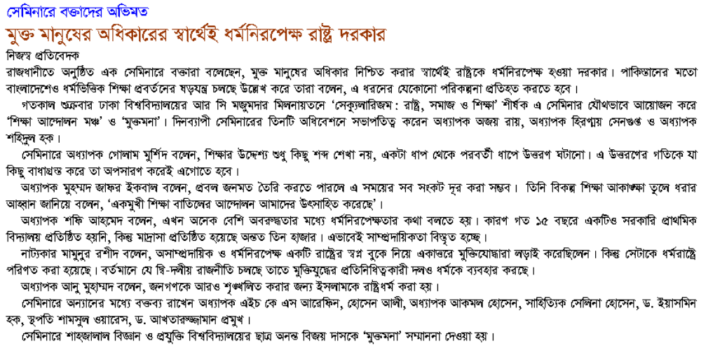

pãTm Vela : 12 VgaîF, 2006|

il«W
http://www.prothom-alo.net/v1/newhtmlnews1/category.php?CategoryID=5&Date=2006-08-12

