A symposium, a boost

Vishwajit Sur Chowdhury

The 5th Inter-congress Symposium of the Asia and Oceania Society for Comparative Endocrinology (AOSCE) was held at the Pathumwan Princess Hotel, Bangkok, Thailand from February 7-10, 2006. It was a gathering of a good number of excellent scientists and enthusiastic personnel of comparative endocrinology. First of all, I should clarify the purpose of comparative endocrinology. Comparative endocrinology is responsible to promote the scientific understanding of interdisciplinary knowledge in the fields of Biology and Medicine concerned with the morphological and functional aspects of endocrine physiology in order to facilitate improvement of the quality of life of animals and people.

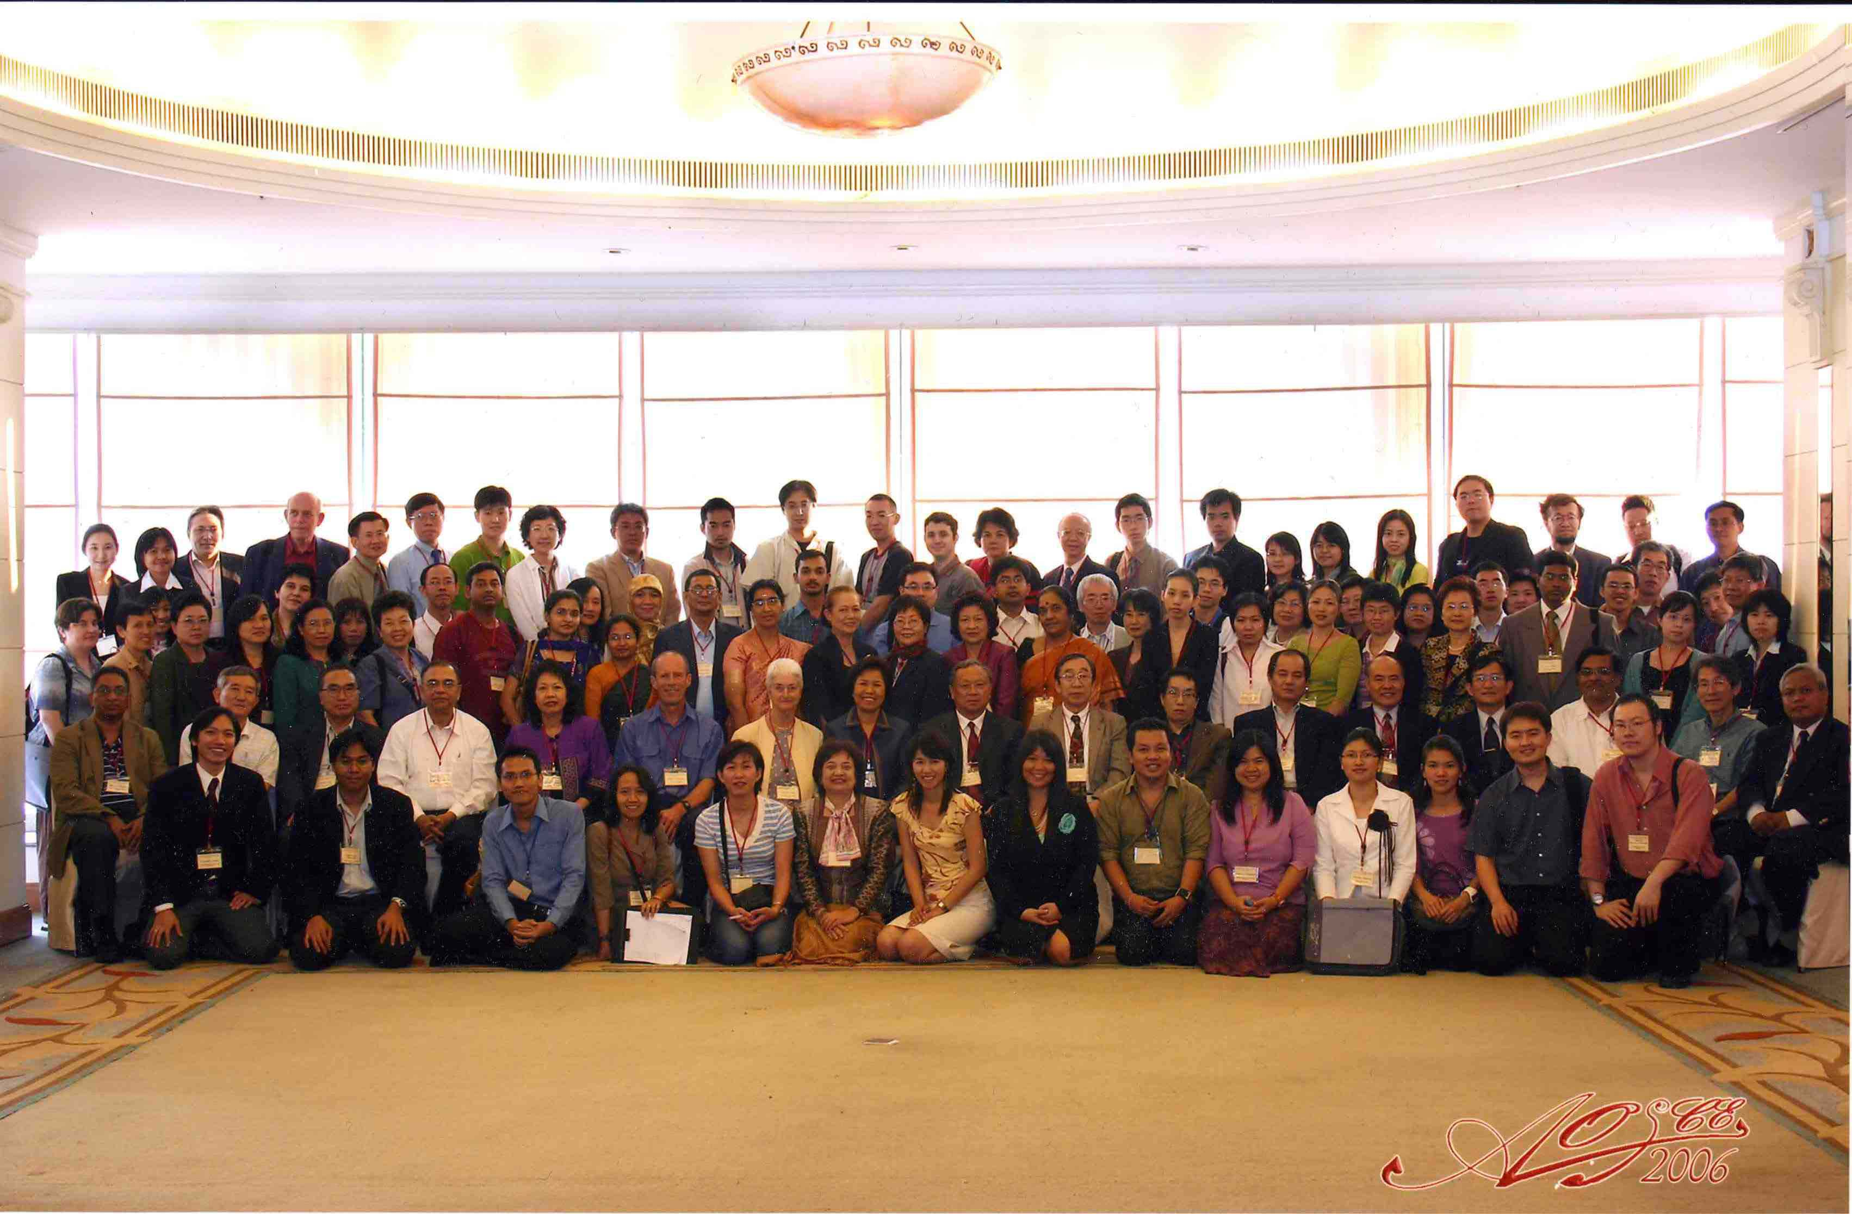
Group photo of the participants of AOSCE, 2006.

On Feb 7, Professor Charas Suwanwela, the Chairman of the University Council, Chulalongkorn University, Thailand emphasized on the role of biological scientists to discover the secret of our life during his presidential speech at the opening session. He added that the contributions of the scientists are very significant to progress the knowledge. Therefore, those who are working for biological science also have a great responsibility to continue the advancement of knowledge about living being. The AOSCE 2006 symposium was held in honor and commemoration of the late Professor Puttipongse Varavudhi, who was among the early founding members of the AOSCE from Thailand. In the first day of the symposium, therefore, Varavudhi memorial lecture was organized to remember late Professor Puttipongse Varavudhi by one and all participants. During this session emeritus Professor Susumu Ishii of Waseda University, Japan, Professor John Y. L. YU of Academic Sinica, Taiwan and Professor Jean M. P. Joss of Macquarie University, Australia delivered their excellent lectures. Prof. Ishii let the audience know that he had a promise to develop the knowledge on comparative endocrinology with Prof. Varavudhi long time ago. Accordingly, they worked with fruitful collaboration and stimulated each other via personal and conference communication. They also published a significant number of papers in the top graded international journals. Professor Issii highlighted the importance of comparative endocrinology to conserve the species. Prof. John Yu delivered his speech on evolution of pituitary gonadotropins in vertebrates. He predicted that since the evolution is still continuing, therefore, the physiology of living being and even creature as a whole in this world would possibly be changed in future. Prof. Jean Joss presented a talk on endocrinology and evolution of lungfish. She showed precisely that soft anatomy of living lungfish shares many similarities with that of living amphibians. After the Varavudhi memorial lectures, a group photo of the AOSCE conference participants was taken (see the photograph). In the evening, there was a “welcome reception” where plenty of delicious Thai dishes were served and a video show was displayed exclusively about Thailand. Bangkok, the capital city of Thailand, founded as a Thai capital in 1782 by the first monarch of the present Chakri Dynastry, is among Asia’s most cosmopolitan cities. At present, it is a national treasure house and Thailand’s spiritual, cultural, commercial, academic, and diplomatic center.

Next day, Professor S. Bhattacharya of Visva-Bharati Univ., India presented a plenary lecture on molecular mechanism in the regulation of oocyte maturation. He strongly suggested that cell division is the basis of biology. He showed in detail how a different regulatory mechanism exists in perch fish oocyte maturation. Scientific symposia were held followed by the plenary lecture. Professor Y. Koch of Weizmann Institute of Science, Rehovot, Israel, delivered a lecture on tissue specific regulation of Gonadotropin-Releasing Hormone (GnRH) under the session “Reproducton, Growth and Development”. GnRH is produced in the brain of all vertebrates, including human of course, and regulates the secretion of pituitary hormones which are essential for reproductive functions. It was interesting to note that circadian pattern exists for the expression of GnRH receptors. Professor K. Kubokawa from University of Tokyo, Japan delivered a nice talk on evolution form invertebrates to vertebrates. Two sessions of scientific symposia ran simultaneously in two different rooms in the same floor of the symposium venue. After the lunch break, Professor J. F. Cockrem of Massey University, New Zealand, offered a plenary lecture on stress endocrinology and behavior in Antarctic penguins. Prof. Cockrem showed how Antarctic penguins might respond to physical and emotional stress. Prof. Cockrem stated that stress was a condition to adopt our physiology with the environment. The poster session was held during 2:15-4:45 PM, where many excellent posters were presented by the participants from the countries of Asia and Oceania. I also presented a poster entitled “Melatonin action on the induction of gonadotropin-inhibitory hormone in the avian brain”. I have the plan to write about my research works for the learned readers of MM sometimes later. The poster session was the last academic session on Feb 8.

On Feb 9, Professor A. Urano of Hokkaido University offered a plenary lecture on expression of hormonal genes in the neuroendocrine system of salmon fish. Prof. Urano’s findings indicated the importance of GnRH neurons as the initiator of major neuroendocrine events during salmonid spawning migration. After that a scientific symposia sessions on “Reproduction, Growth and Development” and “Molecular Endocrinology and Gene Expression” were held. Professor H. B. Kwon of Chonnam National University, Korea explained the novel mechanism for ligand-receptor interaction and signal transduction of mammalian and nonmammalian GnRHs stimulated by either GnRH-I or GnRH-II. Prof. Kwon was optimistic that his research findings would be beneficial for the development of therapeutic drugs against central and reproductive disorders. In the afternoon, Professor Visut Baimai of Mahidol University, Thailand delivered his plenary lecture on biodiversity and conservation in Thailand. Professor Baimai nicely clarified the idea of biodiversity and showed how this biodiversity had long been essential for human survival in terms of food, medicine, clothing and housing. The last scientific symposium on “Frontiers in Reproductive Neuroscience” was held followed by the plenary lecture. Professor I. Parhar of Nippon Medical School, Japan was the first speaker of this session. Prof. Parhar described his novel single cell technique. By this technique his team discovered the G-protein coupled receptors in individual GnRH neurons and endocrine cells of the pituitary of tilapia. Their cloned novel nonmammalian G-protein coupled receptor (GPR54) stimulates GnRH secretion and is crucial for pubertal maturation. Associate Professor H. Ando of Kyushu University, Japan, then presented about molecular mechanisms of GnRH action in masu salmon pituitary cells. Prof. Ando adequately presented how the reproductive stages relate to GnRH action. Dr. T. Ikemoto, Dr. K. Okubo, Dr. B. Soonthornsumrith, Dr. G. Guerriero presented wonderful talks on different aspects of neuroendocrinology. Finally, Professor K. Tsutsui delivered a very interesting talk on a novel neurohormone, Gonadotropin-Inhibitory Hormone (GnIH). GnIH was discovered and reported by Prof. Tsutsui in 2000. Prof. Tsutsui showed about the isolation, localization and functions of GnIH. He also showed that melatonin acts directly on GnIH neurons via its receptor to induce GnIH expression. Many participants briskly participated on GnIH discussion as soon as Prof. Tsutsui’s finished his talk.

At the closing session, two of the the organizers Professors P. Tangpraprutgul and Prof. J. F. Cockrem delivered the concluding remarks. They gave an account to the audience about their full satisfaction of many excellent presentations on biodiversity, environmental endocrinology, molecular endocrinology and many others during the two and half day’s scientific sessions. Different themes of the AOSCE have been pointed out at this session. For example, the AOSCE recommended studying the animals from Asia and Oceania region to discover the biological phenomenon and to reveal the specific questions of biology of these regions. This society considered performing complete study from the whole animal up to its molecular level. The future directions of the AOSCE had also been pointed out in concluding remarks. For example, The AOSCE should give attention to develop dedicated and committed endocrinologists and comparative endocrinologists. The AOSCE should contribute to the enhancement of the international comparative endocrinology. In the evening on Feb 9, there was a Banquet at the Thai Pavillion in Chulalongkorn University. The participants of the conference enjoyed the fascinating environment of the Banquet along with Thai food and traditional Thai dance a lot.

On Feb 10, the last day of AOSCE2006 symposium, there was a very enjoyable excursion trip to Phra Nakhon Si Ayutthaya Province, Bangkok. The delegates got the opportunity to enjoy Thai places, timeless canals and rivers, which duly dubbed the city “Venice of the East” as well as the excitement of a dynamic metropolis.

To conclude, I should say that the AOSCE2006 intercongress was a wonderful symposium. The overall environment of the conference was truly favorable to enjoy the progress of comparative endocrinology. It was also a great opportunity to refresh old and build up new friendship. This symposium was really encouraging to be more ambitious to discover the endocrine nature of living being. It would be more pleasant for me if I could see more participants from Bangladesh. It is well known to everybody that the countries, which are progressing with sound policies, offer a great attention on research works. Because basic research findings prepare the platform on which development in all aspects is performed, both the basic and applied researches in all disciplines are very crucial for the development of any country. Therefore, it is expected to see that the policy makers and other related people of Bangladesh are actively playing their roles to develop a favorable environment for research works. I hope that my country will realize the necessity of research works within its own environment and provide the necessary facilities to perform it more actively and sincerely to make the living enjoyable with sound progress in all aspects.

Hiroshima, Japan
sur@hiroshima-u.ac.jp

