Requirements Analysis Document
eCPAT Park Search
CSCI 4711 Software Engineering
Fall 2016
Augusta University
Augusta, GA
Date: 2/10/2017
Version 1

Team Members

Connor Williams
Ryan Mahoney
Chris Gonsalves

Abstract

This document contains the requirements, analysis and design artifacts for the eCPAT Park Search. The eCPAT Park Search combines observational audit data about the presence/absence, usability, and condition of park facilities and amenities. Furthermore, information about the overall safety and quality of the park, pictures of the park, and GIS data to allow for mapping capabilities is also included within the system. Users will have the capability to search for park resources using an address or zip code. A basic search will generate a list of park resources within a pre- defined distance.
This document describes the requirements, analysis and design of the eCPAT Park Search. The rest of this document is structured as follows. Chapter 1 contains the introduction. This chapter presents a brief description of the system. Chapter 2 outlines the functional requirements of the system.
Table of Contents

1 | INTRODUCTION……………………………………………............. |  |  | 4
 | 1.1 | SCOPE OF SYSTEM………………………………………………… | 4
 | 1.2 | OVERVIEW OF DOCUMENT……………………………………… | 4
2 | REQUIREMENTS OF SYSTEM……………………………………. |  |  | 5
 | 2.1 | FUNCTIONAL REQUIREMENTS………………………………….. | 5
 | 2.2 | USE CASES………………………………………………………….. | 6
 | 2.3 | USE CASE DESCRIPTIONS………………………………………... | 7

Introduction

Scope of System
The eCPAT Park Search provides complete park information for all of Richmond and Columbia Counties to engage community members in utilizing community resources for physical activity and health benefits.
The eCPAT Park Search supports a generic User as an actor. The User actor interacts with eCPAT Park Search by accessing the park information stored in the eCPAT database through a park search.
Users will have a variety of options to help them select a park that best fits their needs. Users can select park filters such as Proximity (e.g., 1 mile, 5 miles), Activity Areas (e.g., playground, trails), and Amenities (e.g., picnic tables and shelters, restrooms) to tailor park search results to best suit their needs. Users will see a list of parks and park name and address within the vicinity of the user’s zip code, listed in order of proximity. Users can select Park Information to find out additional details about a specific park of interest

overview of document
The rest of this document is structured as follows. Chapter 2 outlines the functional requirements of eCPAT Park Search. Within this chapter is a list of functional requirements of eCPAT Park Search. It also includes a use case model of those functional requirements. A detailed description of each functional requirement then follows.

requirements of system

Functional Requirements
- ParkSearch – Users will have the capability to search for park resources using an address or zip code. A search will generate a list of park resources within a pre- defined radius. Users can select park filters such as proximity, activity areas, and amenities.
- ParkDirections – Once a User executes a park search they can click Get Directions to obtain navigation information.
- ParkInfo– User can access park info including park address, amenities and photos after performing a eCPAT Park Search.
- ParkComments – users can post comments with a link to the eCPAT site on their Facebook timeline, in groups, or to their friends via Facebook message allowing sharing park information via Facebook.

use cases

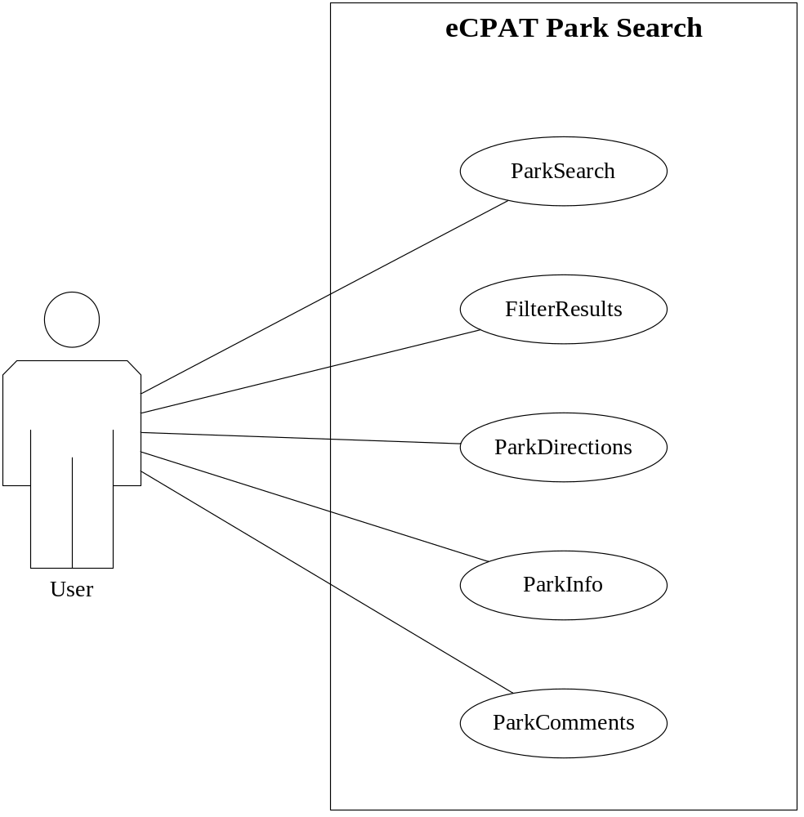
Figure 2.1: use case diagram for the eCPAT Park Search

use case descriptions

Use case name | ParkSearch
Participating  actors | Initiated by User
Flow of events | - The User fills out the form by entering an address or zip code inside the search box and clicking search located on the Park Search page.  - The eCPAT Park Search will find locations in our parks table that are within a certain radius of a given latitude/longitude with a SQL statement that will find the closest XX locations that are within a radius of XX miles to the search coordinate. Outputting the search results into an XML format that our map API can retrieve through asynchronous JavaScript calls that are displayed on the Park Search page in a list along with a map containing markers that represent the search results.  - The User filters results by proximity, activities, and amenities by selecting checkboxes located on the Park Search page.  - The eCPAT Park Search will execute a query based on filters outputting the search results into an XML format that our map API can retrieve through asynchronous JavaScript calls that are displayed on the Parks Search page in a list along with a map containing markers that represent the search results.
Entry condition | - The User is viewing the Park Search page.
Exit condition | - Display a list with a map containing markers that represent the park search results.
Quality  requirements | - Avoid SQL injection

Figure 2.2: Use case description for ParkSearch

Use case name | FilterResults
Participating  actors | Initiated by User
Flow of events | - The User selects any number of filtering options available to them in order to narrow their ParkSearch results.  - The eCPAT Park Search returns a new list of parks relevant to the filtering criteria supplied by the User.
Entry condition | - The User is viewing the Park Search page.
Exit condition | - Returns filtered results page.
Quality
requirements

Figure 2.3: Use case description for FilterResults

Use case name | ParkDirections
Participating  actors | Initiated by User
Flow of events | - User clicks Get Directions button located within a park result div on the Park Search page.  - The eCPAT Park Search passes the GPS coordinates from the database to the directions API opening Google Maps Directions in a new window.  - User will fill out directions form on the directions page.  - The Google Maps Directions site will display directions on the directions page.
Entry condition | - The User is viewing the Park Search page.
Exit condition | - Google Maps Directions site will display directions on the directions page.
Quality
requirements

Figure 2.4: Use case description for ParkDirections

Use case name | ParkInfo
Participating  actors | Initiated by User
Flow of events | - The eCPAT Park Search will query the database with a SQL statement for general park info including park address, amenities and photos, and display these additional details on the Park Info page.
Entry condition | - User has selected the more information button located in a park result div on the Park Search page.
Exit condition | - Additional details are displayed on the Park Info page.
Quality
requirements

Figure 2.5: Use case description for ParkInfo

Use case name | ParkComments
Participating  actors | Initiated by User
Flow of events | - The User enter their Facebook, Google or Twitter username and password in the user name and password input fields on the Park Info page.  - The Disqus application authenticates user’s identity and sends the user a verification email.  - After email verification, user submits a form by typing a comment in the textbox located in the comment section on the Park Info page.  - Disqus then displays the submitted comment on the page and stores the comment offsite to be retrieved on page-load. Disqus provides the user with the option of sharing a status update to their Facebook timeline or Twitter.
Entry condition | - The User is viewing the Park Info page and clicks the “Login” button generated by Disqus.
Exit condition | - The User’s comment is displayed in the comments section on the Park Info page.
Quality
requirements

Figure 2.6: Use case description for ParkComments

