**Change 12**

**Users**

**Manual**

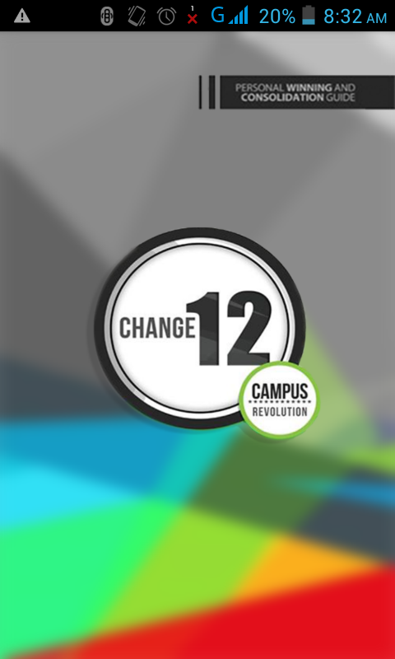

**Table of Contents**

1. General Information
   1. System Overview
   2. Organization of the Manual
2. **General Information**

The Change12 Android Mobile Application is

* 1. **System Overview**

Change12 Mobile App is an application, which allows the user to view the “appified” version of the Change12 Manual/tool, complete with 5 Lessons.

The user can add a consolidates (consolidates is the one the user currently sharing the Change12), keep track of the consolidate information, update the status of the consolidate (from change1 to change2 status). The user can also view his/her change12 activity per week in which can monitor the number of consolidates.

* 1. **Organization of the Manual**

The user’s manual consist of five sections: General Information, System Summary, Getting Started, using the System, and Reporting.

General System section explains in general the terms the system and the purpose for which it is intended.

System Summary section provides a general overview of the system. The summary outlines the uses of the system’s hardware and software requirements, system’s configurations, user access levels and system’s behavior in case of any contingencies.

Getting started section explains how to get Change12 Mobile App and install it on the device. The section presents briefly the system menu.

Using the System section provides a detailed description of the system functions.

Reporting section describes in what way information collected by the application are presented and how to access the information.

1. **System Summary**

System Summary section provides a general overview of the system. The summary outlines the uses of the system’s hardware and software requirements, system’s configuration, user access levels and system’s behavior in case of any contingencies

* 1. **System Configuration**

Change12 Mobile App operates on mobile devices with Android operating system. It is compatible with Android 4.2.2 API Level 17 and higher versions. The application might use the user’s load balance to use the “sms” feature.

* 1. **User Access Levels**

Everyone can use the application as authorized by their respected cell leaders.

**3.0 Getting Started**

Getting Started section explains how to get Change12 Mobile App and install it on the devices. The section presents briefly the Navigation Menu.

**3.1 Installation and Registration**

The Change12 Mobile App apk can be downloaded at <https://drive.google.com/folderview?id=0B4AwVawj_3xDem9WOXkxNldOTmM&usp=sharing>. The User must check the Android Settings to allow it to install apps from unknown sources. At first opening a password (given by cell leader) is needed before the user can proceed to the Registration Page. The use will input his/her information that is needed to be filled up on the form.

**3.2 System Menu**

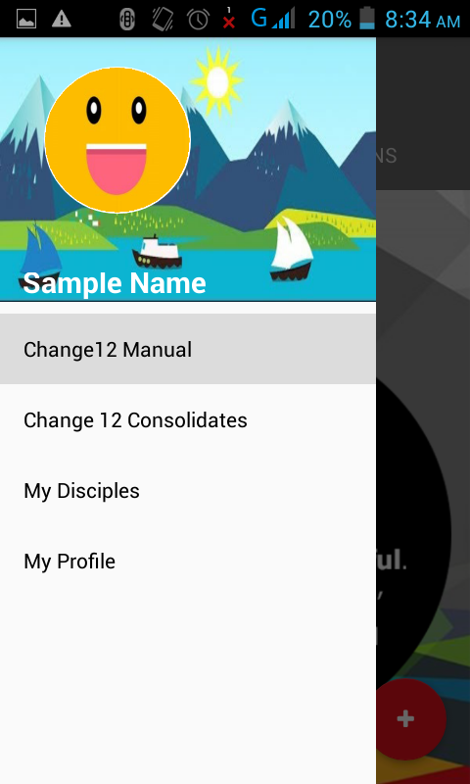 Change12 Mobile Application main modules is displayed on the navigation drawer, which consist of 4 menus. Each Menu represents each module of the system.

http://www.arbowebforest.com/android/ArboWebForestUserManual.pdf