MainBoss 4.2  
Getting Started  
  
  
(Read this first!)

Copyright © 2018, Thinkage Ltd.

Revision

Permission granted to reproduce and/or translate all or part of this document  
provided that Thinkage’s copyright notice is included in the result.  
No money may be charged for such documentation except  
to recover all or part of the cost of reproduction and/or translation.

Introduction

# Welcome to MainBoss

This guide provides a quick introduction to principles of using MainBoss. Once you have read this guide, you’ll be ready to read other MainBoss manuals for more specific information.

* For details of MainBoss set-up, see quickconfig.pdfConfiguration Quick-Start or the full config.pdfConfiguration guide
* For information about day-to-day use, see quickops.pdfOperations Quick-Start or the full operations.pdfOperations guide

This guide assumes that MainBoss has already been installed at your site. If you are the person who will install the software, see the install.pdfInstallation and Administration Guide.

## What You See

Here’s a typical picture of MainBoss’s main window:

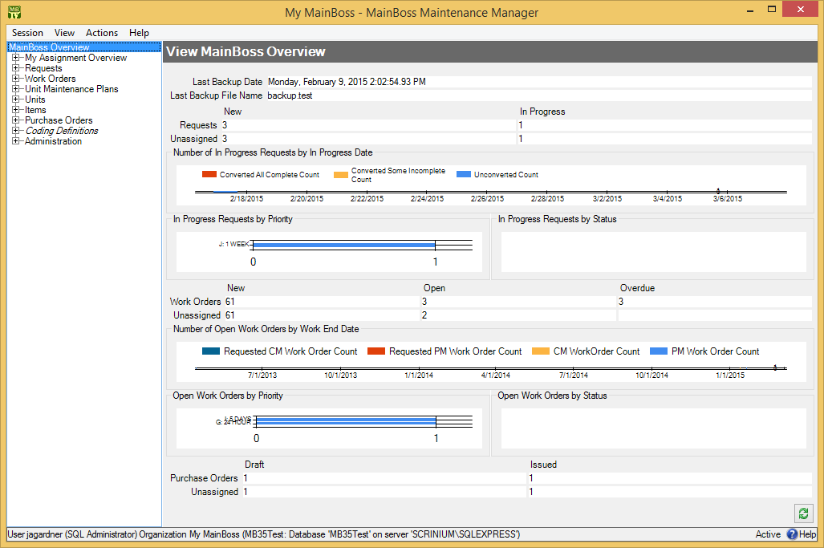

On the left is the control panel. This provides access to all standard actions and information. At the bottom right, the  (Refresh) button updates the information displayed (in case other users have recently made changes to your organization’s data).

General Principle: In MainBoss, you use the control panel (on the left) to go to a table, then you use the table’s buttons (on the right) to do work.

This manual uses the notation Entry | Subentry to refer to items in the control panel. For example, Work Orders | Reports refers to Reports under the Work Orders entry in the control panel.

Whenever you select an entry in the control panel, the rest of the window changes to show information about what you selected. For example, if you click Work Orders in the panel, the right-hand part of the window changes to show information on work orders.

We recommend that you maximize the MainBoss window so that MainBoss has the most possible screen-space to display information.

### Keyboard Shortcuts

MainBoss allows standard Windows keyboard shortcuts such as <Ctrl+C> for copy and <Ctrl+V> for paste.

You can also use <Tab> to move to the next field in a window. If you’re filling out a form, you can just tab from one field to another rather than using the mouse. <Shift+Tab> moves backward to the previous field.

In any table viewer, the shortcut sequence <Ctrl+F> opens the search window. The search will be applied to whatever list of records you clicked most recently. For example, if you most recently clicked a list of unit records, <Ctrl+F> will let you search through units. However, if you were looking at a unit record and your most recent click was on the unit’s list of service contracts, then <Ctrl+F> would search through service contracts. (<Ctrl+F> will not work if your most recent click was on the MainBoss control panel—it only works if your most recent click was in some sort of table viewer.)

If the search window is not open, the <F3> function key has the effect of Find Next, searching for whatever you searched for most recently. This means that pressing <F3> repeatedly will perform the same search over and over.

MainBoss buttons often allow keyboard shortcuts. To see the shortcuts in a window, press the <Alt> key. One letter of each button will be underlined, as in Save. Pressing <Alt> plus the underlined letter is equivalent to clicking the button, so that <Alt+S> is equivalent to clicking the Save button.

### View Menu Options

The View menu provides options that control how information is displayed:

* Zoom in on View: If you click this menu item, MainBoss will hide the control panel in this window. To bring back the control panel, click Zoom in on View again.
* Open in New Window: If you select this option, MainBoss opens a new window containing the same information as the current one. This is useful if you want to compare information between tables: you can have two windows open, one showing one table and one showing the other.
* Change Active Filter: This item lets you change the definition of “active” requests, work orders and purchase orders. For example, you can specify that work orders should only be displayed in table viewers if they’re less than three months old. Changes that you make through this menu item affect you but not other users.
* Show compact browsers: If this is checkmarked, table viewers will not show details from the currently selected record. This makes it possible for a table viewer to list many more records. If the entry is not checkmarked, table viewers will have an area showing the contents of the currectly selected record; this reduces the number of records that the window can show at any one time.
* Form Customization: Offers a submenu of actions related to customized table viewers, editors, and reports. The submenu contains:
* Enable: If this is checkmarked, you can customize table viewers, editors and report windows, as described in “Form Customization” later in this document. If you remove the checkmark, you will not be able to make such customizations. (Only users with the MainBoss Administration security role can change the setting for Enable.)
* Customize Main Menu: Lets you choose which entries appear in the control panel.
* Publish: This saves all your current form customizations as a single set of “preferred” customizations. You can make other customizations after publishing, but they will be forgotten when you quit MainBoss. Only published customizations are remembered from one session to the next.
* Restore from published: Gets rid of any customizations you have made since you last clicked Publish. You will return to the preferred customizations you have already saved.
* Clear all customization: Removes any and all form customizations you have created, restoring everything to MainBoss’s default forms. This does not delete your published customizations; therefore, you can use Restore from published to return to your published customizations.
* Export: This saves your current customizations in a file. (MainBoss will open a window so you can specify a file name and location.) Saving customizations in a file lets you pass your customizations along to someone else. It also keeps a record of your current customizations if you intend to publish a different set of customizations.
* Replace from file: Replaces all your current customizations with customizations from a file. The specified file should contain customizations previously saved with Export.
* Add from file: Adds customizations from a file to your current set of customizations. The customizations will be added to any customizations that already exist; however, if a customization in the file conflicts with one of your current customizations, the customization in the file will replace your current customization.
* Select View: Contains submenus that reproduce all the entries of the control panel. This is useful for people who would rather work with menus (especially menu shortcut keys) rather than using the mouse to click on the control panel.

## Getting Help

There are several ways to obtain online help while using MainBoss:

* Clicking the Help button at the bottom of the window displays information about the window currently on the screen.
* Pressing the <F1> function key provides the same information as the Help button.
* The MainBoss Help menu provides access to MainBoss’s help files.
* Help → Help gives you information about the screen you are currently looking at. For example, if you are looking at a table viewer, Help will provide information about the table and about what various buttons mean.
* Help → Table of Contents gives you the table of contents for the help files.
* Help → Help Index gives you an index of important terms.
* Help → Get Technical Support is useful if you currently have an Internet connection. It takes you to a web page that makes it easy to get help from MainBoss Support personnel.
* Help → Start Support Connection can be used when you are talking on the phone with MainBoss Support personnel. They will explain how the entry can be used to help deal with any problems you might be having.
* Help → About tells you which version of MainBoss you’re using.

### Tooltips

A tooltip is a small message that may appear if you point the cursor to something on your monitor screen. MainBoss uses tooltips to explain any situations that may be confusing.

For example, if you don’t have appropriate security permissions, you may not be allowed to click certain buttons or fill in certain information fields. In this case, pointing the cursor to the button or the field produces a tooltip message explaining the situation (and telling what security roles you’d need in order to use the field or button).

Similarly, if you’ve filled in a field with an unacceptable value, MainBoss will display an error marker. Pointing the cursor to the error marker will display a tooltip explaining why the value is unacceptable. For example, MainBoss may expect the field to contain a date rather than what you’ve typed in.

If you’re ever confused about MainBoss’s behavior, use the cursor to obtain tooltips. These should help you figure out what’s happening.

## Specifying Your MainBoss Database

The first time you start MainBoss, you must specify how to connect with your MainBoss database.

* To set up MainBoss so it can access an existing database:

1. Log in to the computer under your usual login name.
2. Start MainBoss on the new machine. It will display a window asking you to specify the maintenance organization (database):  
     
   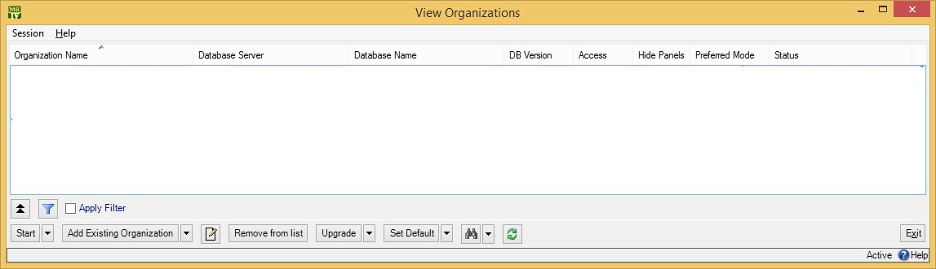
3. Click Add Existing Organization. This opens a window like this:  
     
   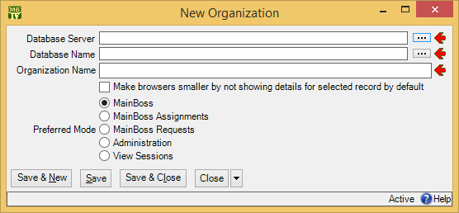
4. The person in charge of MainBoss at your site will tell you the values to specify for “Database Server” and “Database Name”. In most cases, you can click the “...” buttons associated with these fields and select the appropriate values from the resulting lists. However, for technical reasons related to firewalls and SQL Server configuration, you may not find the values you want in the lists. In that case, you’ll have to type in the values by hand.
5. Once you specify “Database Server” and “Database Name”, “Organization Name” will be filled in with a value from the database. Usually, you should simply keep this name; however, you have the option of changing “Organization Name” if you wish. What you enter will become your own private name for the organization—it will not affect other users.
6. Most users can ignore the rest of the window—just click Save & Close. MainBoss will add the database name to the list.
7. Click the Start button in the window to start using MainBoss.

Once you have set up this computer to access the maintenance organization, you don’t have to do it again. Every time you start MainBoss on this computer, it will automatically start working with the specified database.

## Table Viewers

A table is a list of entries, each of which contains information about something. For example, the Vendors table is a list of your suppliers.

Each entry in a table is called a record. For example, each entry in the Vendors table gives information about one of your suppliers.

A table viewer lists the records in a particular table. For example, the Vendors table viewer lists the entries in your Vendors table.

Table viewers usually have two sections:

View: A list of normal records—this can be anything from work orders to information about spare parts.

Defaults: Default values for creating new records. For example, the default values in the Vendors viewer will be used whenever you create a new vendor record.

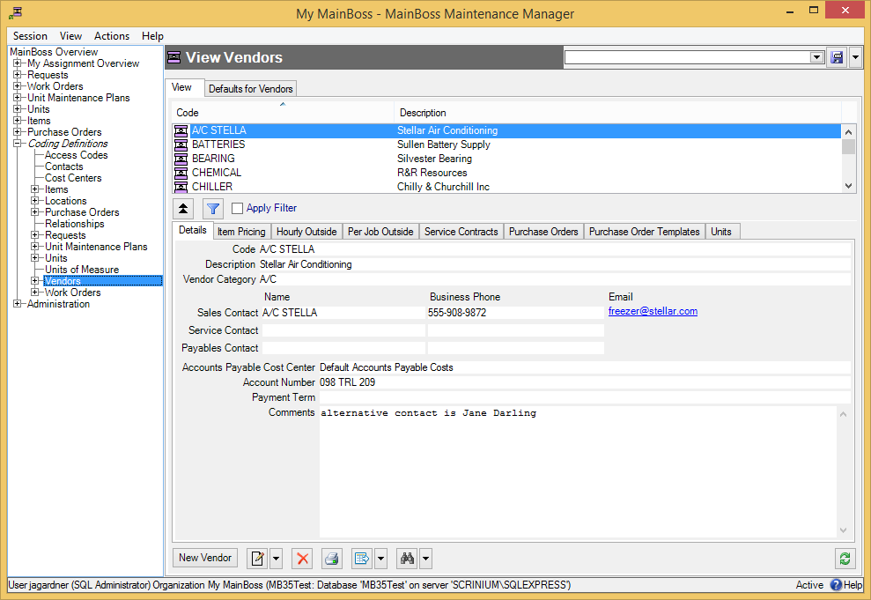

### Special Selection Actions

If you right-click on the records listed in a table viewer, MainBoss opens a menu of actions that can help you select entries in the table. For example, in most tables, the menu will include a Select all action; clicking this action in the menu selects all the entries in the table.

As another example, some right-click menus have an action named Select all editable. This selects all the entries that can be edited from this particular table viewer. For example, the Units table displays both units and the locations that contain the units. Records for the units can be edited from this table; locations cannot be. Therefore, Select all editable will select all the unit records in the table but will leave locations unselected.

Tables with entries that can be expanded or contracted have a menu item named Expand new entries. This lets you determine whether the entries are fully expanded or fully contracted when you start up MainBoss.

### Hiding the Details for a Selected Record

By default, when you select a record in a table, the table viewer displays information from that record. Typically, this is shown in a details panel beneath the list of records in the table.

If your computer has a small monitor screen, you may decide that the details panel takes up too much room on the screen. If so, you can tell MainBoss not to display the details panel; you do this by clicking the following button:



When you click this button, the details panel disappears. The list of records can then use the space that was previously occupied by the panel.

If you want to see the details panel again, click the same button.

### Active and All in Table Viewers

In the bottom right hand corner of most table viewers and editor windows, you’ll see either Active or All:

* If the word is Active, lists of records displayed in the window only include active records. This means that the window only shows records that haven’t been deleted. For requests, work orders, and purchase orders, it also means that it only shows records that are “recent”. By default, a record is “recent” if it’s less than 500 days old; your MainBoss administrator may change what counts as “recent.”  
    
  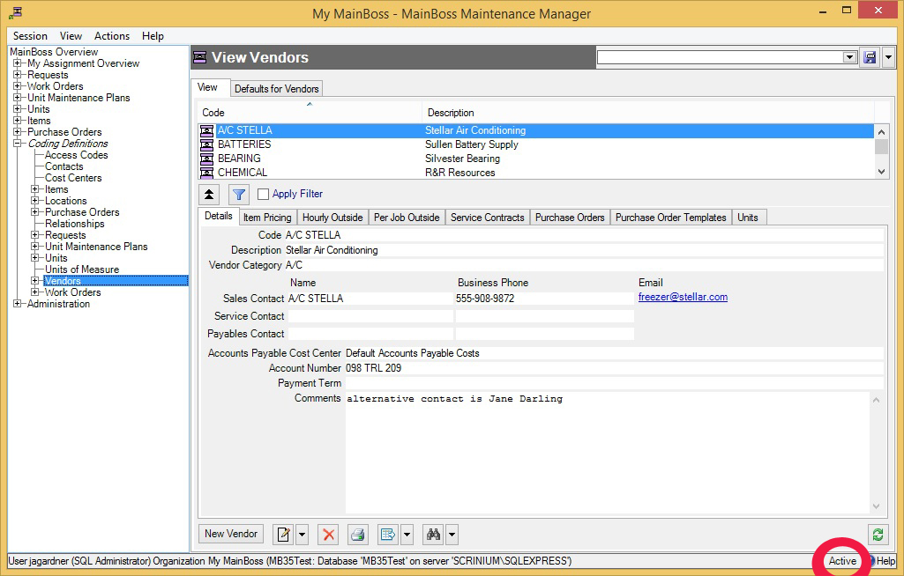
* If the word is All, the viewer is showing all records, no matter how old, including those that have been deleted. Deleted records are marked with a red X on the left. (Note that if you have many old records, MainBoss may take a considerable time to obtain them all from the database.)  
    
  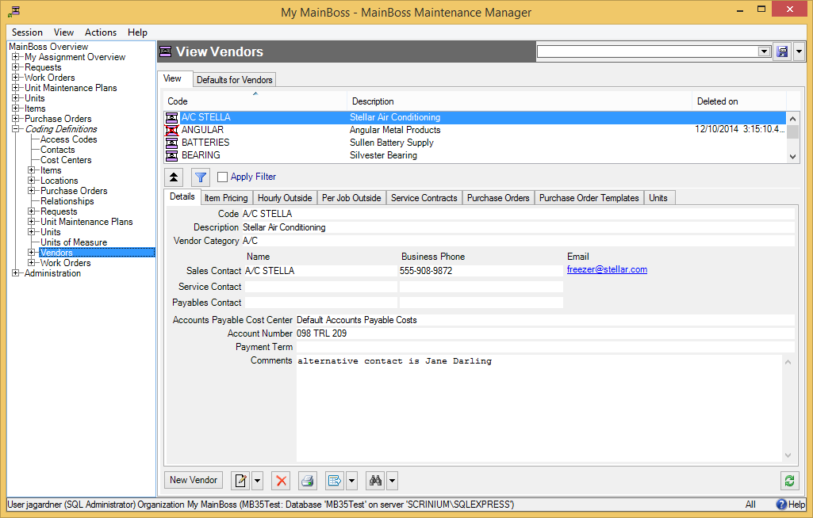

In most tables, MainBoss never completely erases deleted records. This makes it possible to maintain a complete audit trail of everything you do.

To switch from Active to All or vice versa, double-click the word. You’ll see old and deleted records appear or disappear.

The Restore button lets you bring back a record that was previously deleted. MainBoss opens a window where you can examine the record to be restored and make changes if necessary. When you save the record and close the window (typically by using Save & Close), the record will be restored to the active list.

Records That Refer to Deleted Information: When you delete a record, it’s possible that other records still refer to it. For example, suppose a worker leaves your organization so you delete that person from your Employees list. That worker’s name will still appear in old records (e.g. work orders that the person worked on).

MainBoss indicates that data comes from a deleted record by striking out the data. For example, if you delete Joe Smith’s employee record, all work orders that refer to that person will show the name as Joe Smith. This shows that the associated employee record has been deleted (and will reduce your confusion when you can’t find Joe Smith’s name in your list of Active employees).

Filter

### Table Filters

A table filter tells MainBoss to display a subset of all the records that are in a particular table. In other words, it “filters out” records that you don’t want to see.

For example, suppose you want to see which jobs are scheduled to begin today. You could set up a filter on the Work Orders table saying that you only want to see work orders whose “Work Start Date” is today. MainBoss would then filter out any work orders that started on some other day, so that the table viewer only displays work orders starting today.

As another example, suppose you only want to see information on units in your HVAC system. You could set up a filter on the Units table saying that you only want to see work orders whose “System” is HVAC. MainBoss would then filter out non-HVAC unit records, so that the table viewer only displays HVAC units.

You can specify a filter in any table viewer. To do so, click the filter set-up button beneath the table’s list of records:



This opens a window similar to the one used to search for individual records. Use this window to specify which records you want to see. For example, suppose you’re in the Items window and you specify

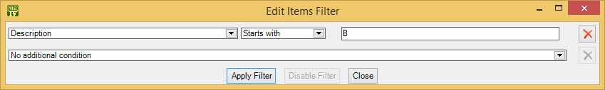

This indicates that you only want MainBoss to display item records whose “Description” field starts with the letter B. Once you enter this information, click the Apply Filter button. You’ll see that the table viewer changes so that it only shows records that match what you’ve specified. If you Close the filter window, the table remains filtered. To return to the table’s usual state, click the button associated with the filter.

When you specify one condition, MainBoss gives you a new line where you can specify an additional condition. Each time you specify a condition, MainBoss gives you a new line for more.

If you specify multiple conditions, MainBoss only shows records that satisfy *all* the specified conditions. For example, suppose you’re filtering the Requests table. One condition might specify that you only want to see requests on a particular unit. A second condition might specify that you only want to see requests with a particular priority code. MainBoss will then display all requests on that unit with the given priority code.

The filter set-up window contains the following:

Fields, filter conditions, values: Select the records to be displayed. You specify your selections in the same way that you specifying search conditions when searching for a particular record.

Apply Filter: If you click this button, MainBoss immediately filters the table using the given criteria. Note that the table does not get filtered until you click this button.

Disable Filter: If you click this button, MainBoss stops filtering the table—you see all the records you normally would.

Close: Closes the window where you specify filters. If you have not clicked Apply Filter, MainBoss will not filter the table. Furthermore, MainBoss will not record any filter conditions you’ve specified—the next time you open the filter window, you’ll start from scratch again.

On every table viewer, there is a checkbox labeled Apply Filter. If this box is blank, the table is unfiltered—you see everything you’d usually see. If you checkmark the box, the table will be filtered using the filter that is currently defined. By blanking or checkmarking the box, you can switch back and forth between filtered and unfiltered displays.

Some filters let you specify patterns rather than specific character strings. For example,

Description Matches Pattern .*furnace.*

corresponds to any Description which contains the string “furnace” anywhere. (The .* pattern is a particularly useful one which stands for any string of zero or more characters.) Patterns are often called regular expressions, and MainBoss supports any regular expression as defined in the Microsoft .NET environment. For more information, see

<http://www.codeproject.com/KB/dotnet/regextutorial.aspx>

### Customized Table Settings

Table viewers can be customized. The customization area is above the table, consisting of a drop-down list and a drop-down button:



A customized setting is name that stands for a particular set of table display options, especially filters (see Table Filters on page 11). For example, suppose your organization manages a lot of properties, but you yourself only work in Building A or Building B. You might create three customized settings for the Units table, named A, B, and A&B. If you choose the A setting, the Units table will only show you the units in Building A; similarly for the B and A&B settings. In this way, you only see the units that matter to you, not any units in other buildings.

Note: Settings that can be saved are indicated with blue lettering rather than black. For example, “Apply Filter” will appear in blue in table viewers, indicating that filter settings can be saved as a customized setting for the associated table.

To create a customized setting, you first set a filter that chooses only the records you want to see. For example, if you only want to see units in Building A, you could set a filter like

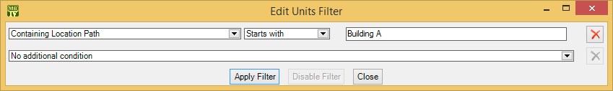

You then click Apply Filter and then Close. You’ll see that the table only shows the units whose containing location is Building A.

To give this table setting a name, click the drop-down arrow associated with the drop-down button in the customized setting area. In the resulting menu, click Save As. A window will appear letting you specify a name for the filter you’ve just set up:

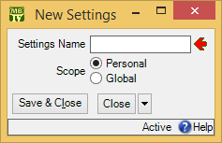

In “Settings Name”, enter a name for this setting (e.g. A to stand for Building A).

The scope of your settings may be Personal or Global. If you choose Global, then all people using your MainBoss database will see the name of this customization in the drop-down list of possible customizations. (Only people with the Administration security role may create Global customizations.) If you choose Personal, this name will appear in your own list of possible customizations, but not in anyone else’s.

Note: You may wish to create a number of standard global customizations that can be used by anyone in your organization. This is particularly helpful if some of your users aren’t knowledgeable enough about MainBoss to create customizations of their own.

Click Save & Close to save your setting and close the window. Once you’ve done this, you’ll see the name of the customization appear in the accompanying drop-down list. Anytime you come to this table, you can quickly apply the setting by selecting the name from the list. Once you’ve chosen a customization, MainBoss uses it every time you come back to this window until either you quit MainBoss or you choose a different customization or filter.

The drop-down button for customizations contains the following choices:

Save: Saves the current filter settings under an existing name. This is how you change the definition of an existing customization.

Save as: Saves the current filter settings under a new name.

Delete: Deletes the name that’s currently selected in the customization drop-down list.

Set as Default: Specifies that the selected customization should be treated as the default for this table. In this case, you don’t have to select the customization—whenever you start MainBoss, the customization is automatically applied. For example, if the default customization for your Units table only shows units in Building A, then the table is automatically filtered that way whenever you start MainBoss. You will never see units that are in other locations, unless you change the filter or choose a different customization.

Note: If you customize a form, it will no longer match the help files associated with the form. For example, if your customization leaves out certain fields, the help files will still describe those fields. This may confuse people who wonder why the help file doesn’t match what they see on the screen.

### Selecting Multiple Table Entries

A table viewer lets you select multiple records from the table. To do this, you use the standard Windows conventions:

* If you hold down the <Shift> key, click on one record, then click on another, you will select both records and all the records in between.
* If you hold down the <Ctrl> key and click on a record, you select that record. If you hold down <Ctrl> and click a different record, you select that record and the first record stays selected. In this way, you can use <Ctrl+Click> to select any number of separate records.

After you select multiple records, you can perform the following operations:

: Deletes the selected records. A window will open to ask if you really want to delete those records.

: Opens the first selected record in an editor window. This window offers you all the features available in a normal editor window for this type of record. In addition, it has a Next button; if you click Next, MainBoss closes the current window and opens one where you can edit the next record that you selected from the table viewer. By repeatedly clicking Next, you can move through the records that you’ve selected, editing each one as you wish.  
  
If you use the editor window to change the contents of a record, the Next button disappears until you click Save (to save your changes) or Cancel (to cancel the changes). You will not be able to go to the next record until you save or cancel your changes.  
  
Next is a drop-down button with the following entries:

Previous: Closes the current window and opens an editor window to edit the previous record from the list of selected records. By using Next and Previous, you can go forward and backward through the list of selected records.

Close: Closes the current window and goes back to the table viewer. This says that you are finished using Next and Previous to edit the selected records.

Cancel: Works like the usual Cancel button, canceling any changes you have made.

: Works exactly like  except that you can only look at the contents of the selected records, not make changes. You can use Next and Previous buttons to go forward and backward through the list of selected records.

Restore: Is only enabled if the records you have selected are all currently deleted. If so, MainBoss opens an editor window that works exactly like . If you Save the current record, it will be restored. You can use Next and Previous to move forward and backward through the list of selected records.

Right-Clicking: When looking at a multi-selection list, you can right-click on the list to get a menu of useful actions that can be performed. For example, the menu gives you the option of checkmarking all the entries in the list or blanking them out. With long lists, we recommend that you click the “...” button to get a selection window, then right-click on the list in the window to select the entries you want.

## Editors

An editor is a window where you can enter information. Most editor windows have a Details section where you can enter basic information; many editor windows have more sections for additional information.

* Mandatory fields are marked with a red arrow until they’re filled in. You can’t save the record until you specify values for those fields. (In the picture below, “Subject” and “Unit” are mandatory.)

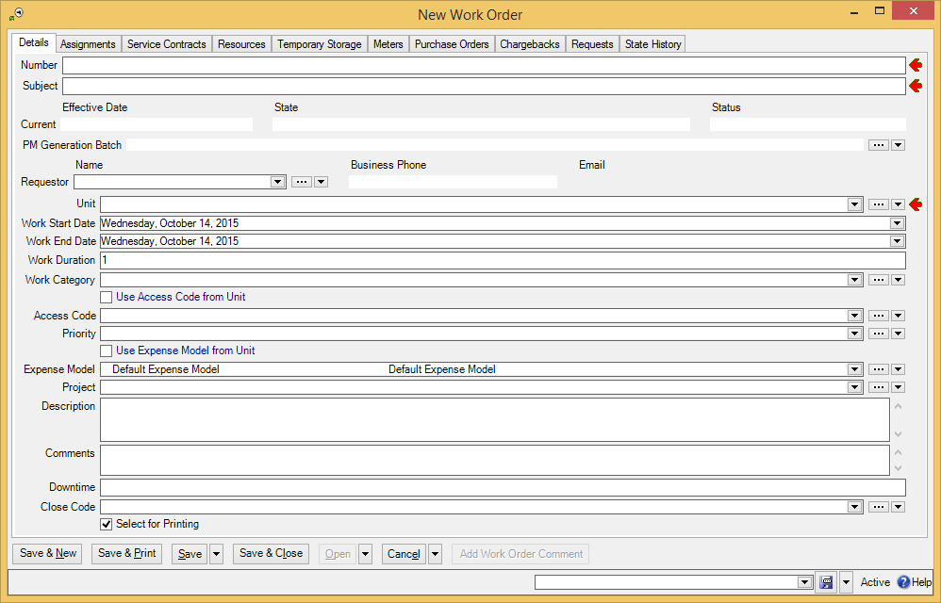

* Read-only fields can’t be changed. They can be recognized because they are not surrounded by a black border line. In the picture above, several fields are read-only. For example, the fields in the “Current” line and “Business Phone” are all read-only.
* Some fields can only be edited at certain times. For example, some fields on a purchase order can’t be changed once the purchase order is issued—issuing the purchase order implies that the purchase order is ready to be sent to the supplier, at which point, some information is considered “unchangeable”. (Actually, some information can be changed, but you have to withdraw the purchase order before you’re allowed to make the change.)  
    
  MainBoss also prevents you from changing information that has already generated accounting records—for the sake of security, accounting records can’t be changed or deleted. For example, when you record the use of materials in connection with a work order, MainBoss generates accounting records indicating the cost of those materials. You can’t directly edit this information once the accounting records have been written; if necessary, you must create a correction, which will generate a new accounting record to correct any mistakes in an old one.
* As shown above, editor windows have several buttons containing the word Save:

Save: Just saves information you’ve entered.

Save & Close: Saves the information and closes the window.

Save & New: Saves the information and starts a new record. This lets you create one record after another; for example, if you’re recording contact information for people, you can Save & New after each person, which saves what you’ve just entered and starts a record for someone else. (Fields in the new record are initialized with default values as set in the Defaults section of the appropriate table viewer.)

Save & Print: Saves the information and opens a window that will let you print the record you’ve just created.

General Tip: When you’re filling out a record, if you don’t know what value a field should have, leave it blank. Filling in dubious values will cause confusion; finding values that need to be changed can be difficult. If MainBoss really needs a field to be filled in, it uses the red arrow to mark the field as mandatory.

### Drop-Down Lists (Pickers)

Editor windows often specify information using drop-down lists, also known as pickers. For example, the “Requestor” field in a work request editor is a drop-down list:



As shown above, a drop-down list ends with three symbols:

* The left-most arrow displays a list of available values for the field. In the case of “Requestor” this will be a list of the people whom you’ve authorized to submit work requests.

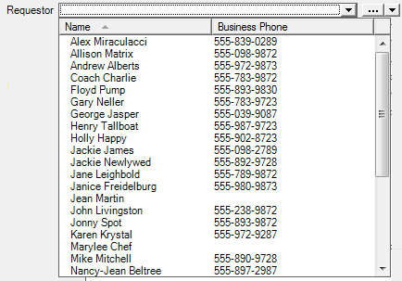

* The “...” opens a window showing the complete table. For example, if you click the “...” for “Requestor”, you get the Requestors table. Click an entry in the table, then click Select to fill in the original field.

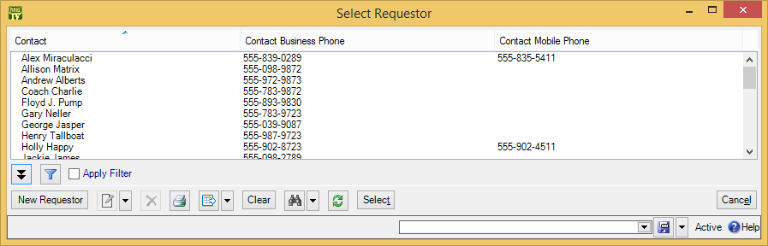

* The right-most arrow of the drop-down list opens a menu that gives you a number of options. For example, if you click this arrow for the “Requestor” field, you’ll see the following:  
    
  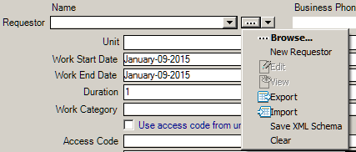  
  Browse lets you look at the existing Requestors table, just like the “...” button. New Requestor lets you create a new requestor record; if you do this, the requestor will be filled into the original “Requestor” field once you save and close the new record. This makes it easy to create new records as needed if you don’t already have an appropriate record. Edit lets you edit the selected requestor record, while View lets you look at the record (but not change it). Export, Import, and Save XML Schema are related to importing and exporting data; for more information, see the config.pdfMainBoss Configuration guide. Clear deletes the current contents of the field (if any).

### Multi-Select Features

A multi-select drop-down list lets you select more than one entry from the list. Such lists are designated with a “double-image” drop-down button:



When you click the button, MainBoss opens a window where you can select elements from the list. To select more than one list element, you use the standard Windows methods of selection:

* You can drag the cursor along a section of the list; this selects all the elements you drag the cursor across
* You can hold down the <Ctrl> key and click individual elements; this selects each of the elements you click
* You can hold down the <Shift> key and click any two elements; this selects the elements you clicked, plus all the elements between them

When you select multiple elements in a list, the result depends on the context. If, for example, you’re in the Assignees section of a work order and you select multiple assignees, all the people you select will be assigned to the work order. If you’re in the Security Roles section of a user record, the user will be given all the security roles that you select.

Right-Clicking: When looking at a multi-selection list, you can right-click on the list to get a menu of useful actions that can be performed. For example, the menu gives you the option of checkmarking all the entries in the list or blanking them out. With long lists, we recommend that you click the “...” button to get a selection window, then right-click on the list in the window to select the entries you want.

### Errors

MainBoss puts a marker beside data fields that contain invalid data. The error marker is a red circle containing a white exclamation point. This is shown below, where the “Effective Date” field should contain a date, but instead contains meaningless text:

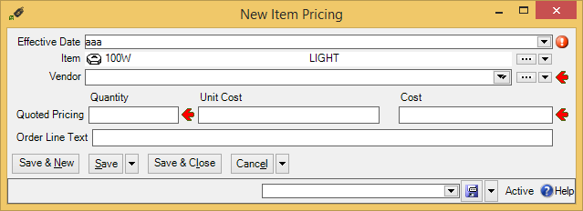

If you try to save a record when it contains an invalid field, MainBoss will display an error message and won’t save the record.

To find out why a data value is invalid, move your cursor to the error marker. MainBoss will display a tooltip with a message explaining why the current value can’t be accepted. This is shown below:

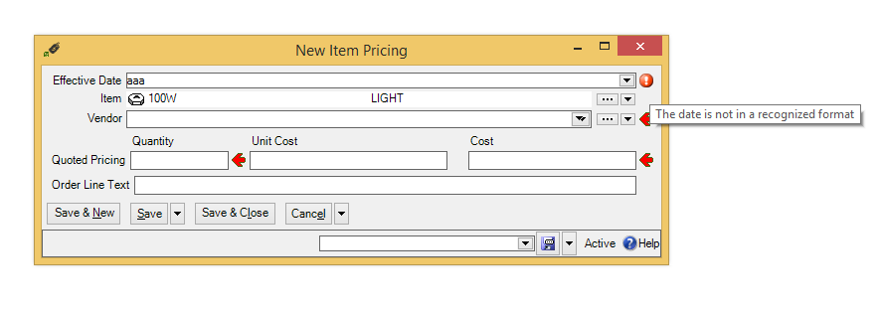

### Interrelated Records

MainBoss records are often linked to each other. For example, the unit record describing a furnace might have a link to a service contract record for that furnace. This link serves the same purpose as a link on a web page: it’s a pointer that MainBoss can follow in order to find related information.

If record A links to record B, record B often links back to record A. For example, just as a unit record can link to a service contract, each service contract record has links to all the units covered by the contract. This makes it possible for MainBoss to go from units to service contracts and vice versa.

Now suppose you’re creating a new unit record and you go to the Service Contracts section. If you haven’t yet saved the unit record, you’ll see that the New Service Contract button in the Service Contracts section is disabled. Why? Because the unit record doesn’t exist until you save it. If you tried to create a new service contract record before the unit record was saved, there’d be nothing to link the service contract back to.

For this reason, New Service Contract stays disabled until you save the unit record. After that, New Service Contract is enabled and you can use it to create a new service contract.

Note that if you hold the cursor on a disabled New button, a tooltip will explain the situation.

If this seems confusing, just remember this rule: If you’re in the middle of creating a new record, MainBoss may not let you create a connected record until you save the first record.

If you find that a New button is deactivated, saving the current record will usually activate the button.

### Corrections

Some editors have a Correct button. Correct is used to make corrections to information that has already generated accounting transactions (e.g. records of actual costs on work orders). To maintain an accurate audit trail, MainBoss doesn’t let you change or delete existing accounting records. Instead, you have to create correction records which add or subtract from previous monetary values.

On a similar principle, physical count records resulting from taking inventory can’t have their numbers altered once the record is saved. Instead, you have to void (cancel) a physical count, then record a new count. Again, the point is to prevent significant information from being completely discarded—you always leave an audit trail.

## Reports

Reports can display and analyze your maintenance information. Many sections in the control panel have subsections that offer reports; for example, Work Orders | Reports offers you a number of reports dealing with work orders.

When you choose the control panel entry for a report, you get a window that lets you specify options for the report:

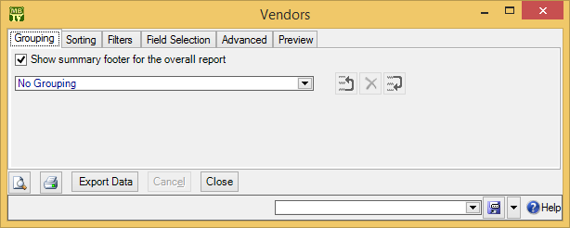

### Report Sections

The window associated with a report organizes options into sections.

Grouping and Sorting: Let you control how the report is organized. For example, suppose you’re printing information on work orders. The Grouping options will divide the report into sections. For example, you might group your work orders by the location where the work will take place. Inside each group, you can specify subgroups if you wish.  
  
The Sorting options tell how to sort records each each group and subgroup. For example, if you are grouping work orders by location, you might sort each group section by the date the work orders are supposed to begin. You can specify additional sorting options as well. For example, if you are sorting group sections by starting date, within each such date, you might choose to sort by expected duration; in this way, shorter jobs would be listed before longer ones.  
  
For both Grouping and Sorting, you can specify either ascending or descending order. For example, if you sort records by date, you can go from earliest to latest or vice versa.  
  
Each grouping/sorting option is followed by three buttons:  
   
   
  
These let you change the position of the option within the list of options or delete the option entirely.

Grouping options break a report into sections. Each section has headings to indicate the start of the section, and may have footers as well. If a section has more than five entries, the total number of entries will be shown in parentheses after the group heading. Sorting options sort information within each section; they do not result in headings.  
  
When appropriate, a group section may end with sums and averages. For example, in a report on work orders, a group may end with the total cost of the work orders in the group, plus the average cost per work order. A report on work order downtime might show total and average downtime.  
  
If a particular group has no elements, the group will not appear in the report. For example, suppose you’re printing information about inventory items, grouped by item category. If a particular category has no items in it, that category will be omitted from the report.

Filters: A report filter lets you select which records you do and don’t want in the report. For example, you might want to restrict a report about units to units in a particular category or range of unit IDs. Filter sections let you specify such restrictions.

Field Selection: Lets you specify what information should be included in the report. The section lists all the pieces of information that may be included in the report. Each possibility has a checkbox beside it; if you checkmark the checkbox, the information will appear in the report. Otherwise, it won’t.  
  
The first time you go to a print window during a MainBoss session, a default set of checkboxes will be checkmarked. If you change any of these, MainBoss will remember your changes throughout the rest of the session. However, when you quit MainBoss, everything gets set back to the defaults.  
  
For some reports, the Field Selection window may have special checkboxes. For example, some reports have a Suppress Costs checkbox; if you checkmark this checkbox, any money amounts that would otherwise be printed will be omitted from the report. (You will not be allowed to use Suppress Costs unless you have the Accounting security role.)  
  
Some print windows will have a number of checkboxes at the bottom of the page under the heading Show Child Records. These checkboxes let you choose extra optional information that may be included in the report.

The columns in a report are made wider or narrower, depending on how many pieces of information you’ve asked for. Asking for many different data fields will shrink the width of each column and may make the report difficult to read. Printing a report in landscape format rather than portrait may improve readability. Another option is to export the report to Microsoft Excel; if you do that, you can avoid the problems that arise from trying to cram a lot of information onto a limited piece of paper. One other solution is to use the “Report width in pages” option discussed below.

Advanced: Lets you specify a title for the report when it is printed, the fonts to be used, and additional information.  
  
In some reports, Advanced options let you obtain summaries. A summary typically gives totals and sub-totals of monetary amounts for the groups and sub-groups of the report. In some cases, the summary may also give you averages (e.g. the average lifespan of a particular kind of equipment). If you do not specify Grouping section options, summaries may not give you much information.

Report width in pages: By default, reports are one page wide (where the page width is dictated by your current printer settings). If a report contains many fields, you can set the value of this field to a number higher than 1; for example, if you set the field to 2, each line in the report will be two pages wide. This allows more space for the information you want to see.  
  
When a report is more than one page wide, the effects vary depending on whether you look at the report on your monitor screen or whether you actually print it out. In a screen preview, you can simply use the usual scroll bars to look at lines that are too wide to fit on the screen. In a printed report, each line of the report will be the given number of pages wide. For example, if the report width is 2 pages, each line will be two printed pages wide. You could then tape pages together to get a more readable report.  
  
In general, “Report width in pages” should be set to 1, unless you actually need wider lines. If you specify a large page-width when you don’t need it, the report will look worse than if you use the default width. In addition, a large page-width is likely inappropriate when you’re printing single work orders for workers or purchase orders for vendors—the results will probably be harder to read than the default format.

Preview: Displays a preview of the report—a version of what you’d see if you actually printed the report on paper. Preparing such a preview may take some time, since MainBoss may have to process a lot of data; therefore, you might have to wait while MainBoss creates the preview.  
  
The Preview section has buttons that let you specify which printer you want to use, the size of page margins, and other printing details. Another button lets you export data from the report (e.g. to Microsoft Excel). Finally, the Preview section has a button that will actually print the report.

Depending on the contents of your database, certain combinations of options in Grouping, Sorting, Filters, Field Selection and Advanced may result in a report with little or no useful information. You are encouraged to experiment with the options to find combinations that are particularly helpful to your work.

### A Report Example

Let’s say it’s 2016 and you want to know how many work orders are still open from the previous year. To get such a report, start by going to Work Orders | Print.

You want a report that only selects open work orders. So:

1. Go to the Filters section, and drop the arrow on the drop-down list where you specify conditions. This lists a lot of information you can filter by.
2. To specify open work orders, expand the “+” beside Current State History, and click State. You’ll see the screen change to specify “Work Order Current State History State” “is one of”.
3. In the box after “is one of”, drop the arrow and checkmark Open. This says that you only want the report to show open work orders.

Now you want to specify work orders from the previous year (in our example, 2015). You can either choose work orders that were created in 2015, or work orders that were actually opened in 2015. Let’s choose work orders that were actually opened.

1. Staying in the Filters section, drop the arrow on the drop-down list that currently reads “No additional condition” and choose Earliest Open Date. You’ll see that “Work Order Earliest Open Date” and “Is null” appear in the window.
2. Drop the arrow on “Is null” and choose Is in the range. This creates two more fields on the same line.
3. Drop the arrow on the first field. Use the resulting calendar to specify January 1, 2015.
4. Drop the arrow on the second field. Use the resulting calendar to specify December 31, 2015.

These two filters tell MainBoss that you want to see work orders that were opened in 2015, and that are still open now.

To expand on our example, suppose that you want a breakdown of these work orders by building. This means that you want to sort the output. You can do that by following these steps:

1. Go to the Sorting section of the work order printing window.
2. Drop the arrow on the drop-down list that currently reads “No Sorting”. Expand the “+” beside Unit and then click Containing Location. This sorts the output by the location that contains the units involved in the work orders. Typically, the report will then be according to the buildings that contain your units.

This example shows how you can shape the report you want by specifying one criterion at a time. You might also use the Field Selection section to specify which pieces of information you want to appear in the report.

### Report Controls

Every window for printing a report contains a number of buttons at the bottom:

: Goes to the Preview section of the window and creates a preview of the report. Preparing such a preview may take some time.

: Immediately prints the report, using whatever sorting and filtering options you have specified. You can use this button if you don’t want to preview it first. You can cancel printing with the Cancel button.

Export Data: Exports the report’s data in XML format. The result is primarily intended to serve as input for user-written programs which process the data in some way. This contrasts with the Preview export facilities (discussed below), which are most useful for embedding in Microsoft Word documents and other “unprocessed” contexts.

Clear Select for Printing: If you click this button, MainBoss removes the checkmark from all Select for Printing boxes on all requests, work orders and/or purchase orders being printed. Typically, you do this after printing ones that have been marked Select for Printing.

Cancel: Cancels the preparation and printing of a report. This button is enabled only when MainBoss is preparing a report, i.e. gathering the data and formatting it. Once the report is ready to print, MainBoss hands off the result to the Microsoft Windows printing facilities; after the report has been handed off to Windows, MainBoss has no more control over the print-out and the Cancel button won’t work. (If you want to cancel the print-out after that, you must use the standard Windows printer control facilities.)  
  
Depending on the configuration of Windows and the Microsoft Report Viewer, canceling a report may result in a diagnostic message. Typically, you can just ignore this message.

Close: Closes the window. (This button is only present if you opened a separate window to print the report.)

: Goes to the Preview section of the window and creates a preview of the report. Preparing such a preview may take some time.

### The Preview Window

The Preview section of a print window contains a control bar like this:



This bar contains the following (from left to right):

|  |  |
| --- | --- |
|  | First Page button: Goes to the start of the document. |

|  |  |
| --- | --- |
|  | Previous Page button: Goes to the previous page of the document. |

|  |  |
| --- | --- |
|  | Gives the number of the page that is currently being displayed and the total number of pages in the report. You can go to a specific page by typing the appropriate page number into the box. (The number of the last page is not finalized until the entire report has been generated. This means that the number may not appear when a preview begins, and the number may also change as report generation continues.) |

|  |  |
| --- | --- |
|  | Next Page button: Goes to the next page of the document. |

|  |  |
| --- | --- |
|  | Last Page button: Goes to the last page of the document. |

|  |  |
| --- | --- |
|  | Parent Report button: Only applies when a report contains sub-reports, and this feature is not currently used. |

|  |  |
| --- | --- |
|  | Stop button: Stops processing the report. You might click this you start preparing a lengthy report, then change your mind. |

|  |  |
| --- | --- |
|  | Print button: This is the button that actually prints the report. |

|  |  |
| --- | --- |
|  | Print Layout button: Switches the format of the preview display.  By default, the left side of the display contains an index of the information in the report. Clicking an entry in the index will move to the corresponding information. The mouse wheel can move forward or backward through the report but it doesn’t necessarily move backward or forward by a whole number of pages.  If you switch to the alternate format, you see a scaled-down version of the page as it will actually print. The mouse wheel will move from one page to the next. |

|  |  |
| --- | --- |
|  | Page Setup button: Opens a window where you can specify paper size, margin size, and other printing information.  Page Setup information specified within MainBoss always overrides any default options associated with your printer, even if you specify printer options at the time you print the report. For example, suppose you specify a page setup of Landscape orientation, but when you go to print the report, you specify Portrait. The Landscape overrides Portrait because the “page setup” in MainBoss overrides anything you specify directly with the printer.  Page Setup options specified for one MainBoss report do not affect options for different MainBoss reports. For example, if you set options when printing work orders, those options will not affect the Page Setup for printing any other MainBoss report. The options will also be forgotten when you quit MainBoss. |

|  |  |
| --- | --- |
|  | Export button: Exports information from the report into a file suitable for use with some other program. If you click the down-arrow associated with this button, you’ll see a list of available export formats. |

|  |  |
| --- | --- |
|  | Scale: Controls the scale of information displayed in the preview window. For example, if you set the scale to 200%, you’ll see the information at twice its normal size. If you set the scale to 50%, you’ll see it at half its normal size. |

|  |  |
| --- | --- |
|  | Searching: To search for information in the report, type what you want to find in the box, then click “Find”. For example, if you’re looking at a full Units report and want information on a particular unit, type the unit name in the box and click “Find”. Clicking the associated “Next” button goes to the next occurrence of the same text. |

### Customized Reports

You can create customized reports in exactly the same way that you create customized table settings (see Customized Table Settings on page 12). For example, if you regularly want a report of work orders performed in Plant #2, you could set up the options you want and then save them under a name like Plant #2 Work Orders. Any time you want the report, you can simply select the name from the list of available settings; MainBoss will then adjust all the options so that you’ll see the report when you click the report window’s preview button ().

Note: Generating reports can take a lot of time, especially if the report contains a lot of data. Therefore, when you select a name from the list of available settings, MainBoss doesn’t immediately generate the corresponding report. This may be a little confusing, but it’s actually practical—if you accidentally pick the wrong entry from the list of available settings, you don’t want MainBoss pausing for a long time while it generates a report that you don’t actually want. When you select a customized report from the list, MainBoss doesn’t generate the report until you click .

### Charts

A chart is special type of report that shows information in a graphical way. A chart report consists of one or more bar charts running either vertically or horizontally.

Some charts use different colors to distinguish different types of data on the same chart. For example, preventive and corrective work orders may be shown in different colors.

Often the Grouping section of a chart report window will determine how chart information is organized. For example, the Costs by Grouping chart shows work order costs organized by whatever option(s) you specify in the Grouping section. If you choose Work Category, costs are broken down by work category; if you choose Unit Location, costs are broken down by location; and so on.

Some data and option selections may produce charts that are difficult to read. In such cases, we recommend using the Filters section to reduce the amount of data you’re trying to show in a single chart. Breaking your data into multiple charts may make the final results easier to understand.