MainBoss 4.2.4
Day-to-Day Operations

Copyright © 2021, Thinkage Ltd.

Revision 13
Permission granted to reproduce and/or translate all or part of this document
provided that Thinkage’s copyright notice is included in the result.
No money may be charged for such documentation except
to recover all or part of the cost of reproduction and/or translation.

Table of Contents

Welcome to MainBoss 1
Documentation conventions 1
MainBoss Concepts 1
The MainBoss Control Panel 1
Identification Codes and Descriptions 1
Table Viewers 1
Special Selection Actions 1
Hiding the Details for a Selected Record 1
Active and All in Table Viewers 1
The Active Filter 1
Table Filters 1
Customized Table Settings 1
Form Customization 1
Selecting Multiple Table Entries 1
Editors 1
Drop-Down Lists (Pickers) 1
Errors 1
Reports 1
Report Sections 1
Report Buttons 1
The Preview Window 1
Select For Printing 1
Paper Size and Margins 1
Formatting in Columns 1
Charts 1
Interrelated Records 1
Accounting Facilities 1
Corrections 1
Security Roles 1
Cost-Related Security Roles 1
Bar Code Support 1
Assignments 1
My Assignment Overview 1
Online Help 1
MainBoss Sessions 1
Maintenance Organizations 1
Changing to a Different Maintenance Organization 1
Quitting MainBoss 1
Locations and Contacts 1
Locations 1
Postal Addresses 1
Sub Locations 1
Contacts 1
Requests 1
What is a Request? 1
Requestors 1
Codes Used in Requests 1
Request States 1
Creating a Request 1
Working with Requests 1
Typical Request Life Cycle 1
Request Status Codes 1
Printing Requests 1
Request Reports 1
Requests and MainBoss Service 1
Work Orders 1
Work Order States 1
Creating a Work Order 1
Starting a New Work Order 1
Basic Work Order Information 1
Work Order Resources 1
Scheduling Labor 1
Reserving Materials for a Work Order 1
Temporary Storage for a Job 1
Assigning People to a Work Order 1
Modifying Draft Work Orders 1
Opening a Work Order 1
Cancelling Draft Work Orders 1
Printing Open Work Orders 1
Closing a Work Order 1
Correcting Work Order Information 1
Actual Labor and Material Expenses 1
Chargebacks 1
Closing Information 1
Paying for Outside Labor with a Purchase Order 1
Other Work Order Sections 1
Multiple Work Orders, Multiple Requests 1
Units 1
Meters 1
Recording Meter Readings 1
Meter Offsets 1
Planned Maintenance 1
Generating Planned Maintenance Work Orders 1
Adjusting Planned Maintenance Work Orders 1
Standard (Boilerplate) Work Orders 1
Forecast Reports 1
General Inventory Control 1
Inventory Details 1
Inventory Operations 1
Finding Which Storeroom Contains a Particular Item 1
Recording Price Quotes 1
Taking Physical Inventory 1
Other Inventory Operations 1
Restocking 1
Purchasing and Receiving 1
The Purchasing/Receiving Process 1
Creating a New Purchase Order 1
Purchase Order Line Items 1
Printing One or More Purchase Orders 1
Issuing a Purchase Order 1
Recording Item Receipts 1
Recording the Receipt of Services 1
Closing a Purchase Order 1
Appendix A: MainBoss Support from Thinkage Ltd. 1

Introduction

Welcome to MainBoss

Thank you for licensing MainBoss. You’ll find it provides all the features you need for managing your organization’s maintenance work.

This guide concentrates on day-to-day operations with MainBoss. It assumes that MainBoss has already been installed and configured for use on your computer.

For information on installing MainBoss, see the Installation and Administration Guide. For information on configuring MainBoss, see the Configuration Guide.

Documentation conventions
This guide uses the following documentation conventions:

- Data-entry fields are shown in bold face, enclosed in double quotes:
Fill in the “Date” field...
- Buttons are shown in bold face and underlined:
Click the button.
- Keyboard keys are shown in bold face enclosed in <angle brackets>:
Press the <Tab> key.
Using the Mouse: Whenever this guide tells you to click on a button, a menu item, or some other object on the screen, click with the left button of the mouse. When the guide says to right-click an object, click with the right button of the mouse.
HelpBegin

MainBoss Concepts

This section explains a number of concepts that underlie MainBoss. It does not describe the fine details of using the software, but looks at how MainBoss is organized and how you can adapt that organization to the work you do.

Important: If you have not licensed a particular module, you will not see information related to that module. For example, if you have not licensed the MainBoss Requests module, you will not see various types of information related to requests.

Table: A table is a list of entries, each of which contains information about something.

For example, the Locations table is a list of locations relevant to your maintenance work. The Contacts table is a list of records giving contact information for anyone you may wish to contact.

Each entry in a table must be given an identifier code to distinguish it from other entries in the table. Identifier codes don’t have to be unique—for example, your Contacts table might have entries for different people with the same name (e.g. two John Smiths)—but it’s much less confusing if different records have different identifiers.

Unit: A unit is anything that might require maintenance.

This includes equipment, vehicles, and places. In a factory, for example, your units will mostly be pieces of manufacturing equipment. In a shopping mall, each store might be considered a separate unit, with additional units for washrooms, the parking lot, and so on.

Sub-Unit: A sub-unit is part of a unit.

For example, you might sub-divide complex equipment into smaller sub-units so that you can track the maintenance record of each piece. Similarly, in a shopping mall, you might subdivide large areas into smaller ones (e.g. “Department store, north section”, “Department store, east section”, and so on) so that workers have a clearer idea of where to go when they’re sent to fix a problem.

There’s no hard-and-fast dividing line between what is a sub-unit and what is simply a spare part. For example, if a piece of equipment has a self-contained motor, do you treat the motor as a sub-unit or simply a spare part? The answer depends on whether or not you want to track the motor’s maintenance independently from the containing equipment. If you’re likely to move such motors from one unit to another and if you care about the motor’s past maintenance history, then you should treat the motor as a sub-unit. Otherwise, there may be no point in treating the motor as a sub-unit.

Request: A request reports a problem or asks for work to be done (e.g. renovations).

Requests are often based on complaints from people outside the maintenance department. Requests provide preliminary information about the problem such as the location of the problem, the name of the person reporting it, the date/time the report was received, and a brief description of the problem itself.

Since problems may be reported by non-maintenance personnel, requests are designed to be simple enough that anybody can fill one out.

Work order: A work order is a detailed description of work to be done.

Work orders are designed to be filled out by maintenance personnel. In many organizations, work orders are written up by a supervisor or dispatcher, then issued to the people who’ll do the actual work.

Work orders are more detailed than work requests. For example, a work order may specify the amount of time the job is expected to take, the materials to be used, and so on. Such details are not present in a work request.

General Principle: Requests describe problems while work orders describe solutions.

Items: Items are materials used in your maintenance work.

Items include spare parts, tools, lubricants, and anything else whose use you wish to track. MainBoss can report on your materials inventory, including how much of an item you have on hand, where particular items are stored, and when you need to re-order more stock.

When setting up inventory records, start with the most important items in your inventory, such as expensive or vital spare parts. Tracking simple items like nails or 60-watt light bulbs is often more trouble than it’s worth...but if your operations depend on certain materials, those are the ones you should track.

Note that MainBoss’s records depend on physical inventory control. If anyone can go into a storeroom and take out materials without recording the fact in MainBoss, then you can’t expect MainBoss’s data to be accurate.

Task: A description of work to be done during planned maintenance or in some other standard maintenance job.

For example, you might have a task record describing a standard oil change and inspection on a vehicle. Task records often contain step-by-step instructions or check-lists of actions to be done during the work.

Unit Maintenance Plan: A complete description of a planned maintenance job. This includes the unit that should be serviced, the task that should be done, and the timing for doing that work.

For example, a unit maintenance plan might describe regular oil changes on a car. The unit is the car whose oil needs to be changed; the task might be a check-list of what should be done in each oil change; the timing might be “every three months or 3000 miles”.

MainBoss uses your unit maintenance plans to create actual work orders. For example, when the time comes for an oil change on a particular vehicle, MainBoss will create a work order for the job using information from the unit maintenance plan record.

Maintenance Organization: A collection of data describing the operations of a single maintenance organization. Each maintenance organization you have corresponds to a separate database.

While many MainBoss customers will only have one maintenance organization database, some may have more. For example, consider a property management company that maintains properties for several different clients. The company may choose to keep each client’s data separate from the others, or may decide to have a single database combining data from all clients.
You must have a separate set of license keys for each maintenance organization database you maintain.

Storeroom: A place where you store spare parts and other materials.

For each storeroom, you create storeroom assignments which specify what items the storeroom should contain and the maximum/minimum quantities for each item.

Note that a storeroom doesn’t have to be a normal room. For example, if you have service trucks that each are supposed to contain standard work materials, you can treat each truck as a storeroom and can track the contents to make sure each truck has everything it needs.

Expense Category: A way to label costs on a work order.

For example, you might have separate categories for inside labor (your own personnel), outside labor (done by hired contractors), electrical supplies, plumbing supplies, spare parts, and so on. You assign an expense category to each cost on a work order so that you can track and categorize your expenses.

Expense Model: A list of what expense categories are allowed on a particular work order.

For example, a property management company may have a separate expense model for each tenant. This makes it possible to associate different expense categories with different tenants.

Cost Center: A way of associating MainBoss costs with your organization’s actual accounting system.

Typically, each cost center corresponds to a single general ledger account in your accounting system. However, you can create multiple cost centers which are all associated with the same general ledger account, if you want to break down your costs in more detail than your ledger accounts allow.

Purchase Order: Information on materials or labor you wish to purchase from a specific supplier or contractor.

In addition to listing the materials or services you wish to purchase, a purchase order can specify where each item should be delivered, how goods should be shipped, when materials are needed, and much more. Purchase orders may contain miscellaneous items, which are expenses beyond goods and services (e.g. surcharges for quick delivery).

Receipt: A record that lists materials and labor received in response to a purchase order.

When all specified goods and services are received, the purchase order is closed.

Assignment: An indication that a work order, request or purchase order is of interest to a particular person.

You can assign work orders, requests or purchase orders to any number of people. If the assignees are MainBoss users, MainBoss makes it easy for them to find their assignments by listing them in the My Assignment Overview section of the control panel.

The workers who work on a job are automatically assigned to the work order. You might also assign a work order to whoever will supervise the work and anyone else with an interest in the work. You might assign a request to the requestor and to anyone else with an interest in seeing that the request is honored (e.g. the person at the help-desk who received the initial call). You might assign a purchase order to the person who created the purchase order, the person who authorized it, and the receiving clerk who’s expected to receive the purchased goods.

Notifications: Email messages that MainBoss can send to people under various circumstances. (In order for notifications to occur, you must have licensed the MainBoss Service module.)

Notifications may be sent in connection with requests, work orders, and/or purchase orders. In order to be notified, you must be assigned to the request/work order/purchase order; by default, all assignees receive any notifications sent out, but specific assignees can be set up so that they do not receive notifications.

Notifications are sent whenever a request, work order or purchase order changes state (e.g. when a work order goes from Draft to Open or from Open to Closed). They are also sent when someone adds a new comment to the request, work order or purchase order. This means that adding such a comment can be used to broadcast a message to all assignees.

Security Roles: Settings that determine what you can and can’t do with MainBoss.

Your MainBoss administrator assigns security roles to you. These determine what operations you can perform inside MainBoss.

Licensed Module: A collection of related operations in MainBoss.

The operations that are available in MainBoss are determined by which modules your organization has licensed. If you don’t have a particular license, you will not see various entries related to that module.

Important: Your licenses and your security roles determine what you can and can’t see in MainBoss. For example, if you haven’t licensed a particular module, information related to that module won’t be displayed in MainBoss windows. If you do not have a particular set of security permissions, some types of information may be hidden from you and some operations may be disabled. Therefore, what you see on your screen may differ from the pictures displayed in this guide.

The MainBoss Control Panel
Here’s a typical picture of MainBoss’s main window:

On the left is the control panel. This provides access to all standard actions and information. At the bottom right, the (Refresh) button updates the information displayed (in case other users have recently made changes to your organization’s data).

General Principle: In MainBoss, you use the control panel (on the left) to go to a table, then you use the table’s buttons (on the right) to do work.

This manual uses the notation Entry | Subentry to refer to items in the control panel. For example, Work Orders | Reports refers to Reports under the Work Orders entry in the control panel.

Whenever you select an entry in the control panel, the rest of the window changes to show information about what you selected. For example, if you click Work Orders in the panel, the right-hand part of the window changes to show information on work orders.

We recommend that you maximize the MainBoss window so that MainBoss has the most possible screen-space to display information.

Keyboard Shortcuts: MainBoss allows standard Windows keyboard shortcuts such as <Ctrl+C> for copy and <Ctrl+V> for paste.

You can also use <Tab> to move to the next field in a window. If you’re filling out a form, you can just tab from one field to another rather than using the mouse. <Shift+Tab> moves backward to the previous field.

In any table viewer, the shortcut sequence <Ctrl+F> opens the search window. The search will be applied to whatever list of records you clicked most recently. For example, if you most recently clicked a list of unit records, <Ctrl+F> will let you search through units. However, if you were looking at a unit record and your most recent click was on the unit’s list of service contracts, then <Ctrl+F> would search through service contracts. (<Ctrl+F> will not work if your most recent click was on the MainBoss control panel—it only works if your most recent click was in some sort of table viewer.)

If the search window is not open, the <F3> function key has the effect of Find Next, searching for whatever you searched for most recently. This means that pressing <F3> repeatedly will perform the same search over and over.

MainBoss buttons often allow keyboard shortcuts. To see the shortcuts in a window, press the <Alt> key. One letter of each button will be underlined, as in Save. Pressing <Alt> plus the underlined letter is equivalent to clicking the button, so that <Alt+S> is equivalent to clicking the Save button.

View Options: The View menu provides options that control how information is displayed:

- Zoom in on View: If you click this menu item, MainBoss will hide the control panel in this window. To bring back the control panel, click Zoom in on View again.
- Open in New Window: If you select this option, MainBoss opens a new window containing the same information as the current one. This is useful if you want to compare information between tables: you can have two windows open, one showing one table and one showing the other.
- Change Active Filter: This item lets you change the definition of “active” requests, work orders and purchase orders. For example, you can specify that work orders should only be displayed in table viewers if they’re less than three months old. Changes that you make through this menu item affect you but not other users.
- Show compact browsers: If this is checkmarked, table viewers will not show details from the currently selected record. This makes it possible for a table viewer to list many more records. If the entry is not checkmarked, table viewers will have an area showing the contents of the currectly selected record; this reduces the number of records that the window can show at any one time.
- Form Customization: Offers a submenu of actions related to customized table viewers, editors, and reports. The submenu contains:
- Enable: If this is checkmarked, you can customize table viewers, editors and report windows, as described in “Form Customization” later in this document. If you remove the checkmark, you will not be able to make such customizations.
- Customize Main Menu: Lets you choose which entries appear in the control panel.
- Publish: This saves all your current form customizations as a single set of “preferred” customizations. You can make other customizations after publishing, but they will be forgotten when you quit MainBoss. Only published customizations are remembered from one session to the next.
- Restore from published: Gets rid of any customizations you have made since you last clicked Publish. You will return to the preferred customizations you have already saved.
- Clear all customization: Removes any and all form customizations you have created, restoring everything to MainBoss’s default forms. This does not delete your published customizations; therefore, you can use Restore from published to return to your published customizations.
- Export: This saves your current customizations in a file. (MainBoss will open a window so you can specify a file name and location.) Saving customizations in a file lets you pass your customizations along to someone else. It also keeps a record of your current customizations if you intend to publish a different set of customizations.
- Replace from file: Replaces all your current customizations with customizations from a file. The specified file should contain customizations previously saved with Export.
- Add from file: Adds customizations from a file to your current set of customizations. The customizations will be added to any customizations that already exist; however, if a customization in the file conflicts with one of your current customizations, the customization in the file will replace your current customization.

- Select View: Contains submenus that reproduce all the entries of the control panel. This is useful for people who would rather work with menus (especially menu shortcut keys) rather than using the mouse to click on the control panel.
Coding Definitions: The Coding Definitions part of the control panel deals with information that doesn’t change very often. For example, MainBoss lets you assign a priority (urgency code) to every work order. Once you decide what priority codes your organization will use, you probably won’t change them. Therefore, MainBoss puts the codes under Coding Definitions.

The MainBoss Configuration guide explains how to set up your Coding Definitions. This Day-to-Day Operations Guide assumes that your basic coding definitions are already set up.

Identification Codes and Descriptions
Every record has an identification code. This code has different names in different types of records—for example, work orders are identified by a “Number” while inventory items are identified by a “Code”—but the purpose of the identifier is always the same: to provide a label that distinguishes one record from another.

Most records also have a “Description” field. This is often used to expand on the ID code. For example, in a unit record for a water boiler, the “Code” might be Boiler NorthEast while the “Description” might specify what type of boiler it is.

The Importance of Consistency: Before you begin entering any information, you must establish a coding policy that will be followed by everyone who uses MainBoss. Then you must stick to that policy with absolute consistency, unless everybody agrees that the naming conventions should be changed.

For example, consider the names by which you identify your equipment. You might decide on names like this:

Air conditioner 1
Air conditioner 2
Air conditioner 3

If someone then uses the name

AC 4

it will throw off the consistency of your records. In a list of equipment sorted in alphabetical order, the inconsistent one won’t be sorted with the other air conditioners. It will be harder to find the unit you want when you’re visually searching the list; the unit may also slip between the cracks when you’re printing off reports about your equipment.

The same applies to all other types of information in your database. Names must be consistent: similar things should have similar names. In particular, you should choose the format of names so that similar things appear together when sorted in alphabetical order.

You should decide on standard name formats before you start entering data. This decision affects how much benefit MainBoss can provide. A haphazard naming scheme reduces the software’s ability to organize and analyze data in effective ways.

Table Viewers
A table is a list of entries, each of which contains information about something. For example, the Vendors table is a list of your suppliers.

Each entry in a table is called a record. For example, each entry in the Vendors table gives information about one of your suppliers.

A table viewer lists the records in a particular table. For example, the Vendors table viewer lists the entries in your Vendors table.

Table viewers usually have two sections:

View: A list of normal records—this can be anything from work orders to information about spare parts.
Defaults: Default values for creating new records. For example, the default values in the Vendors viewer will be used whenever you create a new vendor record.

Special Selection Actions
If you right-click on the records listed in a table viewer, MainBoss opens a menu of actions that can help you select entries in the table. For example, in most tables, the menu will include a Select all action; clicking this action in the menu selects all the entries in the table.

As another example, some right-click menus have an action named Select all editable. This selects all the entries that can be edited from this particular table viewer. For example, the Units table displays both units and the locations that contain the units. Records for the units can be edited from this table; locations cannot be. Therefore, Select all editable will select all the unit records in the table but will leave locations unselected.

Tables with entries that can be expanded or contracted have a menu item named Expand new entries. This lets you determine whether the entries are fully expanded or fully contracted when you start up MainBoss.

Hiding the Details for a Selected Record
By default, when you select a record in a table, the table viewer displays information from that record. Typically, this is shown in a details panel beneath the list of records in the table.

If your computer has a small monitor screen, you may decide that the details panel takes up too much room on the screen. If so, you can tell MainBoss not to display the details panel; you do this by clicking the following button:

When you click this button, the details panel disappears. The list of records can then use the space that was previously occupied by the panel.

If you want to see the details panel again, click the same button.

Active and All in Table Viewers
In the bottom right hand corner of most table viewers and editor windows, you’ll see either Active or All:

- If the word is Active, lists of records displayed in the window only include active records. This means that the window only shows records that haven’t been deleted. For requests, work orders, and purchase orders, it also means that it only shows records that are “recent”. By default, a record is “recent” if it’s less than 500 days old; your MainBoss administrator may change what counts as “recent.”
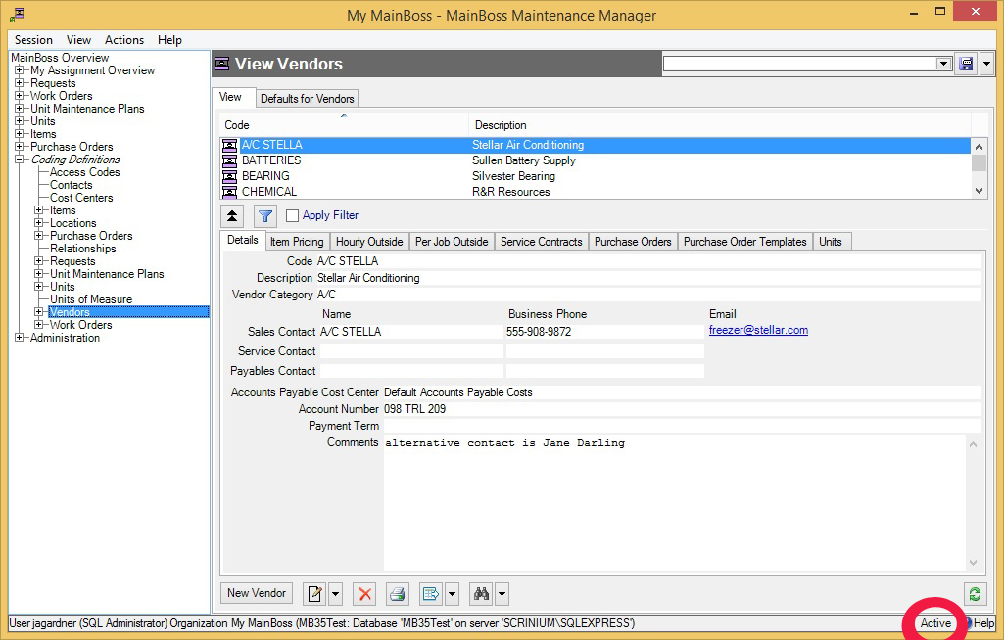
- If the word is All, the viewer is showing all records, no matter how old, including those that have been deleted. Deleted records are marked with a red X on the left. (Note that if you have many old records, MainBoss may take a considerable time to obtain them all from the database.)
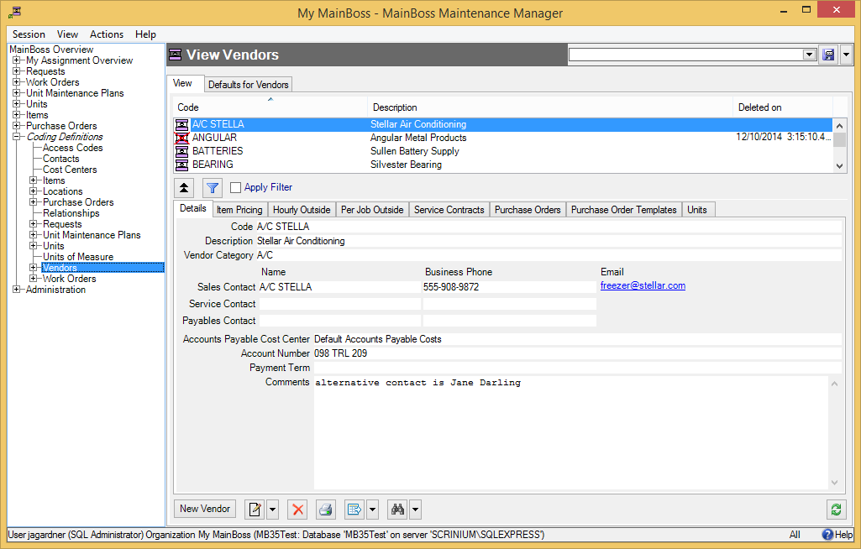
In most tables, MainBoss never completely erases deleted records. This makes it possible to maintain a complete audit trail of everything you do.

To switch from Active to All or vice versa, double-click the word. You’ll see old and deleted records appear or disappear.

The Restore button lets you bring back a record that was previously deleted. MainBoss opens a window where you can examine the record to be restored and make changes if necessary. When you save the record and close the window (typically by using Save & Close), the record will be restored to the active list.

Records That Refer to Deleted Information: When you delete a record, it’s possible that other records still refer to it. For example, suppose a worker leaves your organization so you delete that person from your Employees list. That worker’s name will still appear in old records (e.g. work orders that the person worked on).

MainBoss indicates that data comes from a deleted record by striking out the data. For example, if you delete Joe Smith’s employee record, all work orders that refer to that person will show the name as Joe Smith. This shows that the associated employee record has been deleted (and will reduce your confusion when you can’t find Joe Smith’s name in your list of Active employees).
Edit.Active Filter

The Active Filter
The active filter determines which work orders, requests, and purchase orders count as Active. In other words, it determines what a table will display when the word Active appears in the table’s bottom right-hand corner.

Work orders, requests and purchase orders are always considered active until they are closed or voided. For example, if a work order is open, its age doesn’t matter—it will be active until you close it.

To set your active filter, go to the View menu and click Change Active Filter. This opens a window that contains the following:

Show only records less than this many days old: You can set this field’s value to a number. If you do, work orders, requests, and purchase orders will only be considered Active if their most recent history record is less than the given number of days old. For example, if you set the value to 400, the only active work orders, requests and purchase orders will be ones whose histories have changed in the past 400 days. Typically, this means you won’t see any work orders, requests and purchase orders that were closed more than 400 days ago.
Show only records since: You can set this field’s value to a date. If you do, work orders, requests and purchase orders will only be considered Active if their most recent history record was created after the specified date. For example, if you set the value to January 1, 2009, the only active work orders, requests and purchase orders will be ones which have had some activity since that date.
The options you set through the View menu only affect your own MainBoss sessions. For example, if you only want to see very recent records, you might set “Show only records less than this many days old” to 30. MainBoss would only show you work orders, requests and purchase orders less than 30 days old. You can change this number at any time.

You can use Administration | Company Information to set active filter defaults for everyone who uses the MainBoss database.
Filter

Table Filters
A table filter tells MainBoss to display a subset of all the records that are in a particular table. In other words, it “filters out” records that you don’t want to see.

For example, suppose you want to see which jobs are scheduled to begin today. You could set up a filter on the Work Orders table saying that you only want to see work orders whose “Work Start Date” is today. MainBoss would then filter out any work orders that started on some other day, so that the table viewer only displays work orders starting today.

As another example, suppose you only want to see information on units in your HVAC system. You could set up a filter on the Units table saying that you only want to see work orders whose “System” is HVAC. MainBoss would then filter out non-HVAC unit records, so that the table viewer only displays HVAC units.

You can specify a filter in any table viewer. To do so, click the filter set-up button beneath the table’s list of records:

This opens a window similar to the one used to search for individual records. Use this window to specify which records you want to see. For example, suppose you’re in the Items window and you specify

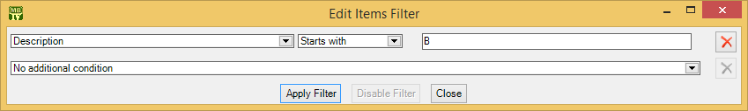

This indicates that you only want MainBoss to display item records whose “Description” field starts with the letter B. Once you enter this information, click the Apply Filter button. You’ll see that the table viewer changes so that it only shows records that match what you’ve specified. If you Close the filter window, the table remains filtered. To return to the table’s usual state, click the button associated with the filter.

When you specify one condition, MainBoss gives you a new line where you can specify an additional condition. Each time you specify a condition, MainBoss gives you a new line for more.

If you specify multiple conditions, MainBoss only shows records that satisfy all the specified conditions. For example, suppose you’re filtering the Requests table. One condition might specify that you only want to see requests on a particular unit. A second condition might specify that you only want to see requests with a particular priority code. MainBoss will then display all requests on that unit with the given priority code.

The filter set-up window contains the following:

Fields, filter conditions, values: Select the records to be displayed. You specify your selections in the same way that you specifying search conditions when searching for a particular record.
Apply Filter: If you click this button, MainBoss immediately filters the table using the given criteria. Note that the table does not get filtered until you click this button.
Disable Filter: If you click this button, MainBoss stops filtering the table—you see all the records you normally would.
Close: Closes the window where you specify filters. If you have not clicked Apply Filter, MainBoss will not filter the table. Furthermore, MainBoss will not record any filter conditions you’ve specified—the next time you open the filter window, you’ll start from scratch again.
On every table viewer, there is a checkbox labeled Apply Filter. If this box is blank, the table is unfiltered—you see everything you’d usually see. If you checkmark the box, the table will be filtered using the filter that is currently defined. By blanking or checkmarking the box, you can switch back and forth between filtered and unfiltered displays.

Some filters let you specify patterns rather than specific character strings. For example,

Description Matches Pattern .*furnace.*

corresponds to any Description which contains the string “furnace” anywhere. (The .* pattern is a particularly useful one which stands for any string of zero or more characters.) Patterns are often called regular expressions, and MainBoss supports any regular expression as defined in the Microsoft .NET environment. For more information, see

http://www.codeproject.com/KB/dotnet/regextutorial.aspx

Request, work order and purchase order tables are also affected by the active filter. For more, see The Active Filter on page 1.

Customized Table Settings
Table viewers can be customized. The customization area is above the table, consisting of a drop-down list and a drop-down button:

A customized setting is name that stands for a particular set of table display options, especially filters (see Table Filters on page 1). For example, suppose your organization manages a lot of properties, but you yourself only work in Building A or Building B. You might create three customized settings for the Units table, named A, B, and A&B. If you choose the A setting, the Units table will only show you the units in Building A; similarly for the B and A&B settings. In this way, you only see the units that matter to you, not any units in other buildings.

Note: Settings that can be saved are indicated with blue lettering rather than black. For example, “Apply Filter” will appear in blue in table viewers, indicating that filter settings can be saved as a customized setting for the associated table.

To create a customized setting, you first set a filter that chooses only the records you want to see. For example, if you only want to see units in Building A, you could set a filter like

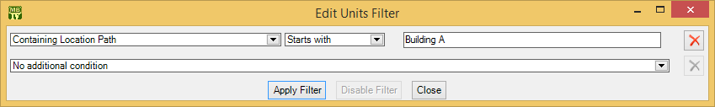

You then click Apply Filter and then Close. You’ll see that the table only shows the units whose containing location is Building A.

To give this table setting a name, click the drop-down arrow associated with the drop-down button in the customized setting area. In the resulting menu, click Save As. A window will appear letting you specify a name for the filter you’ve just set up:

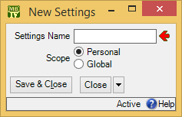

In “Settings Name”, enter a name for this setting (e.g. A to stand for Building A).

The scope of your settings may be Personal or Global. If you choose Global, then all people using your MainBoss database will see the name of this customization in the drop-down list of possible customizations. (Only people with the Administration security role may create Global customizations.) If you choose Personal, this name will appear in your own list of possible customizations, but not in anyone else’s.

Note: You may wish to create a number of standard global customizations that can be used by anyone in your organization. This is particularly helpful if some of your users aren’t knowledgeable enough about MainBoss to create customizations of their own.

Click Save & Close to save your setting and close the window. Once you’ve done this, you’ll see the name of the customization appear in the accompanying drop-down list. Anytime you come to this table, you can quickly apply the setting by selecting the name from the list. Once you’ve chosen a customization, MainBoss uses it every time you come back to this window until either you quit MainBoss or you choose a different customization or filter.

The drop-down button for customizations contains the following choices:

Save: Saves the current filter settings under an existing name. This is how you change the definition of an existing customization.
Save as: Saves the current filter settings under a new name.
: Deletes the name that’s currently selected in the customization drop-down list.
Set as Default: Specifies that the selected customization should be treated as the default for this table. In this case, you don’t have to select the customization—whenever you start MainBoss, the customization is automatically applied. For example, if the default customization for your Units table only shows units in Building A, then the table is automatically filtered that way whenever you start MainBoss. You will never see units that are in other locations, unless you change the filter or choose a different customization.

Form Customization
MainBoss lets users with the Administration security role control what information is displayed in table viewers, editor windows, and report windows. This is done by means of form customization. Using form customization, you can reduce the amount of information being displayed; this may be useful if you don’t care about some of the usual information, or if you’re working on a small display screen. (Note that some information cannot be removed from a window, e.g. compulsory fields.)

It is possible to disable form customization. To do so, go to the View menu and click Form Customization. In the resulting menu, remove the checkmark on Enable.
If you are attempting to customize a window and it doesn’t work, make sure that form customization is enabled (i.e. make sure that Enable has a checkmark beside it).

To customize a particular table viewer, editor window or report window, click the drop-down arrow beside the customization button:

(This button appears in the top right corner of table viewers and report windows, but the bottom right corner of editor windows.) After clicking the drop-down arrow, click Customize Form in the resulting menu.

MainBoss will display a window where you can use checkboxes to determine which information will appear in the associated form. Each table viewer, editor window and report window has its own customization form. For example, here’s the form for customizing the Work Orders table viewer:

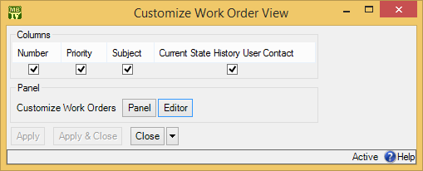

There is a checkbox for each column that usually appears at the top of the table viewer. If you blank out a checkbox, the corresponding column will no longer appear in the table viewer.

The Panel button in the customization form lets you customize the panel that appears at the bottom of the table viewer (under the list of work orders). The Editor button lets you customize the standard work order editor. If you click either button, MainBoss will open another window where you can use checkboxes to specify which information will and won’t appear in the corresponding location.

The customization form also has a button labeled Customize Work Order Report Form. This lets you customize the standard report for printing work orders (Work Orders | Print). It is included here so that the same window lets you customize the work orders table viewer, the work orders editor, and the work order report.

After you have specified any changes you want to make to a form, click Apply to save those changes. Click Apply & Close to save the changes and close the customization window, or click Close just to close the customization window.

Note: If you customize a form, it will no longer match the help files associated with the form. For example, if your customization leaves out certain fields, the help files will still describe those fields. This may confuse people who wonder why the help file doesn’t match what they see on the screen.

Publishing Your Customizations: By default, any customizations you have made will be discarded when you quit MainBoss. If you want to keep your customizations from one MainBoss session to the next, you have to publish them.

To publish your customizations, go to the View menu, click Form Customization, and then click Publish. This saves all your current customizations. From this point onward, those customizations will be used every time MainBoss starts. If you make a new customization, then want to go back to your old customizations, you can click Restore from published in the same menu.

You can use Clear all customization from the same menu to get rid of all the customizations you have made. However, you’ll go back to your published customizations the next time you start MainBoss, unless you Clear all customization and then Publish (so that the “cleared” customizations are your “official” ones).

Exporting Customizations: You can save your current customizations in a file. This makes it easy to restore the customizations later if you wish, or to switch between different sets of customizations.

To save your current customizations, go to the View menu, click Form Customization, and then click Export. MainBoss will ask you to specify the name of a file to hold your customizations.

At a later date, you can use Replace from file in the same menu to get rid of any current customizations and instead use the ones you exported to the file. You can use Add from file in the same menu to add the saved customizations to any other customizations that are currently in effect. With Add from file, if a saved customization conflicts with one of your current customizations, the saved customization replaces your current one.

Selecting Multiple Table Entries
A table viewer lets you select multiple records from the table. To do this, you use the standard Windows conventions:

- If you hold down the <Shift> key, click on one record, then click on another, you will select both records and all the records in between.
- If you hold down the <Ctrl> key and click on a record, you select that record. If you hold down <Ctrl> and click a different record, you select that record and the first record stays selected. In this way, you can use <Ctrl+Click> to select any number of separate records.
After you select multiple records, you can perform the following operations:

: Deletes the selected records. A window will open to ask if you really want to delete those records.
- : Opens the first selected record in an editor window. This window offers you all the features available in a normal editor window for this type of record. In addition, it has a Next button; if you click Next, MainBoss closes the current window and opens one where you can edit the next record that you selected from the table viewer. By repeatedly clicking Next, you can move through the records that you’ve selected, editing each one as you wish.
If you use the editor window to change the contents of a record, the Next button disappears until you click Save (to save your changes) or Cancel (to cancel the changes). You will not be able to go to the next record until you save or cancel your changes.
Next is a drop-down button with the following entries:
Previous: Closes the current window and opens an editor window to edit the previous record from the list of selected records. By using Next and Previous, you can go forward and backward through the list of selected records.
Close: Closes the current window and goes back to the table viewer. This says that you are finished using Next and Previous to edit the selected records.
Cancel: Works like the usual Cancel button, canceling any changes you have made.
- : Works exactly like except that you can only look at the contents of the selected records, not make changes. You can use Next and Previous buttons to go forward and backward through the list of selected records.
Restore: Is only enabled if the records you have selected are all currently deleted. If so, MainBoss opens an editor window that works exactly like . If you Save the current record, it will be restored. You can use Next and Previous to move forward and backward through the list of selected records.
Right-Clicking: When looking at a multi-selection list, you can right-click on the list to get a menu of useful actions that can be performed. For example, the menu gives you the option of checkmarking all the entries in the list or blanking them out. With long lists, we recommend that you click the “...” button to get a selection window, then right-click on the list in the window to select the entries you want.

Editors
An editor is a window where you can enter information. Most editor windows have a Details section where you can enter basic information; many editor windows have more sections for additional information.

- Mandatory fields are marked with a red arrow until they’re filled in. You can’t save the record until you specify values for those fields. (In the picture below, “Subject” and “Unit” are mandatory.)
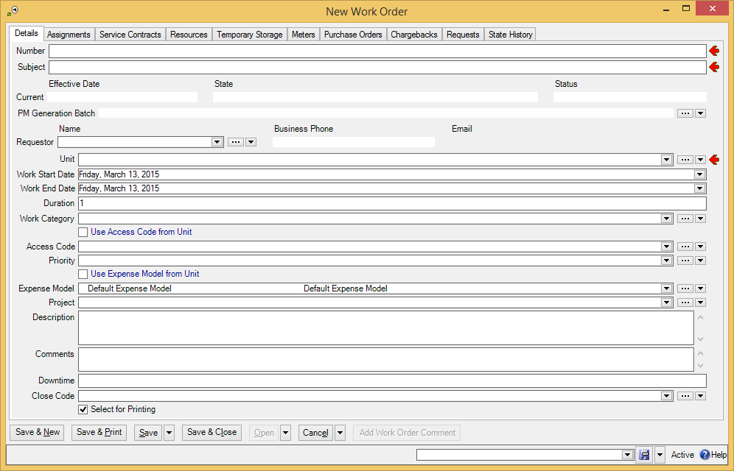

- Read-only fields can’t be changed. They can be recognized because they are not surrounded by a black border line. In the picture above, several fields are read-only. For example, the fields in the “Current” line and “Business Phone” are all read-only.
- Some fields can only be edited at certain times. For example, some fields on a purchase order can’t be changed once the purchase order is issued—issuing the purchase order implies that the purchase order is ready to be sent to the supplier, at which point, some information is considered “unchangeable”. (Actually, some information can be changed, but you have to withdraw the purchase order before you’re allowed to make the change.)
MainBoss also prevents you from changing information that has already generated accounting records—for the sake of security, accounting records can’t be changed or deleted. For example, when you record the use of materials in connection with a work order, MainBoss generates accounting records indicating the cost of those materials. You can’t directly edit this information once the accounting records have been written; if necessary, you must create a correction, which will generate a new accounting record to correct any mistakes in an old one.
- As shown above, editor windows have several buttons containing the word Save:
Save: Just saves information you’ve entered.
Save & Close: Saves the information and closes the window.
Save & New: Saves the information and starts a new record. This lets you create one record after another; for example, if you’re recording contact information for people, you can Save & New after each person, which saves what you’ve just entered and starts a record for someone else. (Fields in the new record are initialized with default values as set in the Defaults section of the appropriate table viewer.)
Save & Print: Saves the information and opens a window that will let you print the record you’ve just created.
General Tip: When you’re filling out a record, if you don’t know what value a field should have, leave it blank. Filling in dubious values will cause confusion; finding values that need to be changed can be difficult. If MainBoss really needs a field to be filled in, it uses the red arrow to mark the field as mandatory.

Drop-Down Lists (Pickers)
Editor windows often specify information using drop-down lists, also known as pickers. For example, the “Requestor” field in a work request editor is a drop-down list:

As shown above, a drop-down list ends with three symbols:

- The left-most arrow displays a list of available values for the field. In the case of “Requestor” this will be a list of the people whom you’ve authorized to submit work requests.
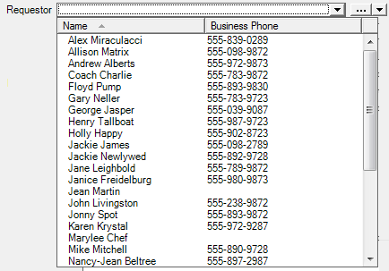

- The “...” opens a window showing the complete table. For example, if you click the “...” for “Requestor”, you get the Requestors table. Click an entry in the table, then click Select to fill in the original field.
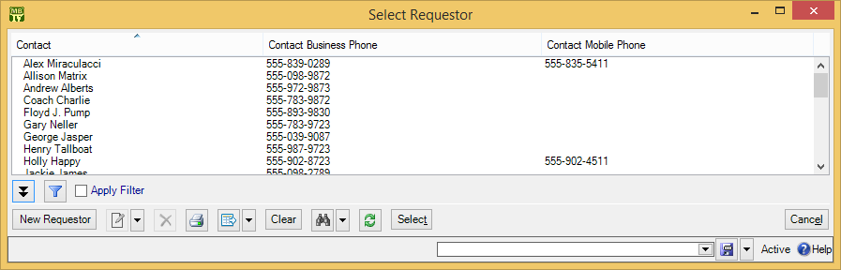

- The right-most arrow of the drop-down list opens a menu that gives you a number of options. For example, if you click this arrow for the “Requestor” field, you’ll see the following:
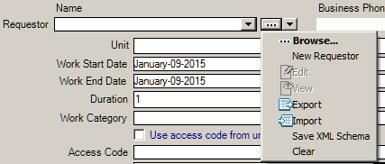
Browse lets you look at the existing Requestors table, just like the “...” button. New Requestor lets you create a new requestor record; if you do this, the requestor will be filled into the original “Requestor” field once you save and close the new record. This makes it easy to create new records as needed if you don’t already have an appropriate record. Edit lets you edit the selected requestor record, while View lets you look at the record (but not change it). Export, Import, and Save XML Schema are related to importing and exporting data; for more information, see the MainBoss Configuration Guide. Clear deletes the current contents of the field (if any).

Errors
MainBoss puts a marker beside data fields that contain invalid data. The error marker is a red circle containing a white exclamation point. This is shown below, where the “Effective Date” field should contain a date, but instead contains meaningless text:

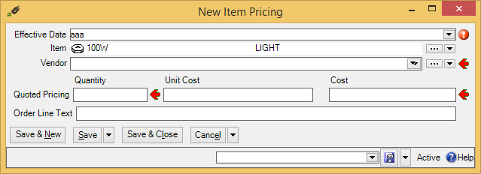

If you try to save a record when it contains an invalid field, MainBoss will display an error message and won’t save the record.

To find out why a data value is invalid, move your cursor to the error marker. MainBoss will display a tooltip with a message explaining why the current value can’t be accepted. This is shown below:

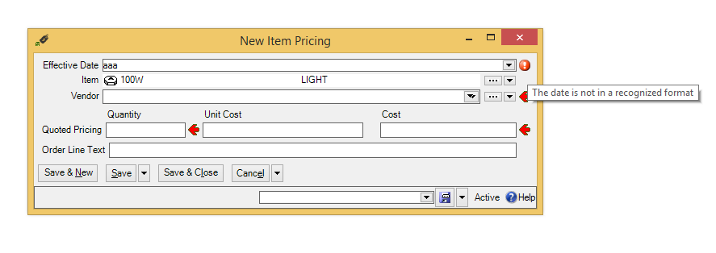

Concurrency Errors: In the rare case that two people try to edit the same record at the same time, MainBoss will report a concurrency error.

For example, suppose you start editing a Units table record and before you’re done, someone else tries to edit the same record. The first person to save the record will succeed. The second person to save the record will receive an error message indicating that the record has changed while you were making your changes:

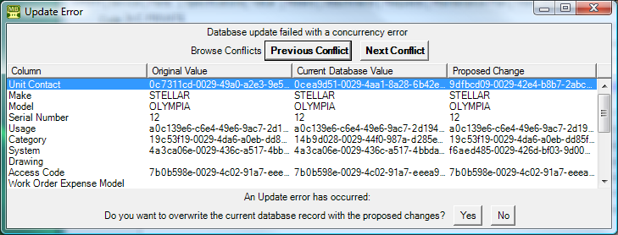

MainBoss is asking you to resolve conflicts between the changes that were just made. The error message lists the fields in the record. For each field, there are three columns:

- The first column shows the record’s values at the time you began editing
- The second column shows what the values are now (the ones that the other person saved)
- The third column shows the new values you’ve specified yourself
Where the values are different, you can see fields where your values differed from the other person’s. The Next Conflict and Previous Conflict buttons jump to fields where the values conflict.

In many records, some field values will look like nonsense strings of characters. These strings are actually links to other tables. For example, the “Category” field refers to an entry in the Unit Categories list. The field’s value is a meaningless string that serves as a pointer. You can see if two pointers have the same value, but you can’t tell anything about the record they point to.

When conflicts occur, it’s best to click the No button on every conflict; this basically says, “Ignore what I just did.” ) Then just go back and start editing the record again. This time you’ll see the values that the other person put in. You can then decide which of these you want to change.

Reports
Reports can display and analyze your maintenance information. Many sections in the control panel have subsections that offer reports; for example, Work Orders | Reports offers you a number of reports dealing with work orders.

When you choose the control panel entry for a report, you get a window that lets you specify options for the report:

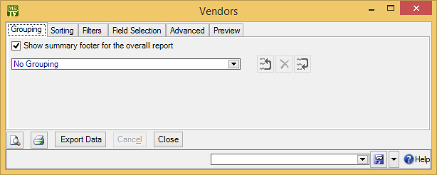

Report Sections
The window associated with a report organizes options into sections.

Grouping and Sorting: Let you control how the report is organized. For example, suppose you’re printing information on work orders. The Grouping options will divide the report into sections. For example, you might group your work orders by the location where the work will take place. Inside each group, you can specify subgroups if you wish.
The Sorting options tell how to sort records each each group and subgroup. For example, if you are grouping work orders by location, you might sort each group section by the date the work orders are supposed to begin. You can specify additional sorting options as well. For example, if you are sorting group sections by starting date, within each such date, you might choose to sort by expected duration; in this way, shorter jobs would be listed before longer ones.
For both Grouping and Sorting, you can specify either ascending or descending order. For example, if you sort records by date, you can go from earliest to latest or vice versa.
Each grouping/sorting option is followed by three buttons:
These let you change the position of the option within the list of options or delete the option entirely.
Grouping options break a report into sections. Each section has headings to indicate the start of the section, and may have footers as well. If a section has more than five entries, the total number of entries will be shown in parentheses after the group heading. Sorting options sort information within each section; they do not result in headings.
If a particular group has no elements, the group will not appear in the report. For example, suppose you’re printing information about inventory items, grouped by item category. If a particular category has no items in it, that category will be omitted from the report.

Filters: A report filter lets you select which records you do and don’t want in the report. For example, you might want to restrict a report about units to units in a particular category or range of unit IDs. Filter sections let you specify such restrictions.
Field Selection: Lets you specify what information should be included in the report. The section lists all the pieces of information that may be included in the report. Each possibility has a checkbox beside it; if you checkmark the checkbox, the information will appear in the report. Otherwise, it won’t.
The first time you go to a print window during a MainBoss session, a default set of checkboxes will be checkmarked. If you change any of these, MainBoss will remember your changes throughout the rest of the session. However, when you quit MainBoss, everything gets set back to the defaults.
For some reports, the Field Selection window may have special checkboxes. For example, some reports have a Suppress Costs checkbox; if you checkmark this checkbox, any money amounts that would otherwise be printed will be omitted from the report.
Some print windows will have a number of checkboxes at the bottom of the page under the heading Show Child Records. These checkboxes let you choose extra optional information that may be included in the report.
The columns in a report are made wider or narrower, depending on how many pieces of information you’ve asked for. Asking for many different data fields will shrink the width of each column and may make the report difficult to read. Printing a report in landscape format rather than portrait may improve readability. Another option is to export the report to Microsoft Excel; if you do that, you can avoid the problems that arise from trying to cram a lot of information onto a limited piece of paper. One other solution is to use the “Report width in pages” option discussed below.

Advanced: Lets you specify a title for the report when it is printed, the fonts to be used, and additional information.
In some reports, Advanced options let you obtain summaries. A summary typically gives totals and sub-totals of monetary amounts for the groups and sub-groups of the report. In some cases, the summary may also give you averages (e.g. the average lifespan of a particular kind of equipment). If you do not specify Grouping section options, summaries may not give you much information.
Report width in pages: By default, reports are one page wide (where the page width is dictated by your current printer settings). If a report contains many fields, you can set the value of this field to a number higher than 1; for example, if you set the field to 2, each line in the report will be two pages wide. This allows more space for the information you want to see.
When a report is more than one page wide, the effects vary depending on whether you look at the report on your monitor screen or whether you actually print it out. In a screen preview, you can simply use the usual scroll bars to look at lines that are too wide to fit on the screen. In a printed report, each line of the report will be the given number of pages wide. For example, if the report width is 2 pages, each line will be two printed pages wide. You could then tape pages together to get a more readable report.
In general, “Report width in pages” should be set to 1, unless you actually need wider lines. If you specify a large page-width when you don’t need it, the report will look worse than if you use the default width. In addition, a large page-width is likely inappropriate when you’re printing single work orders for workers or purchase orders for vendors—the results will probably be harder to read than the default format.
Preview: Displays a preview of the report—a version of what you’d see if you actually printed the report on paper. Preparing such a preview may take some time, since MainBoss may have to process a lot of data; therefore, you might have to wait while MainBoss creates the preview.
The Preview section has buttons that let you specify which printer you want to use, the size of page margins, and other printing details. Another button lets you export data from the report (e.g. to Microsoft Excel). Finally, the Preview section has a button that will actually print the report.
Depending on the contents of your database, certain combinations of options in Grouping, Sorting, Filters, Field Selection and Advanced may result in a report with little or no useful information. You are encouraged to experiment with the options to find combinations that are particularly helpful to your work.

Filtering on Locations and Units: Various reports let you filter by locations and/or units. In general, if you use a filter to select one or more locations, the report does not cover sublocations (unless you select the sublocations too). Similarly, if you use a filter to select one or more units, the report does not cover sub-units (unless you select the sub-units too).

However, when you filter on locations, the filter window offers you the option Location and all sublocations. If you select this option, MainBoss lets you specify a single location; the associated report will cover that location and all sublocations within the location. Similarly, when you filter on units, the filter window offers you the option Unit and all subunits. If you select this option, MainBoss lets you specify a single unit; the associated report will cover that unit and all subunits within the unit.

Report Buttons
Every window for printing a report contains a number of buttons at the bottom:

: Immediately prints the report, using whatever sorting and filtering options you have specified. You can use this button if you don’t want to preview it first. You can cancel printing with the Cancel button.
Export Data: Exports the report’s data in XML format. The result is primarily intended to serve as input for user-written programs which process the data in some way. This contrasts with the Preview export facilities (discussed below), which are most useful for embedding in Microsoft Word documents and other “unprocessed” contexts.
Clear Select for Printing: If you click this button, MainBoss removes the checkmark from all Select for Printing boxes on all work orders. Typically, you do this after printing work orders that have been marked Select for Printing.
Cancel: Cancels the preparation and printing of a report. This button is enabled only when MainBoss is preparing a report, i.e. gathering the data and formatting it. Once the report is ready to print, MainBoss hands off the result to the Microsoft Windows printing facilities; after the report has been handed off to Windows, MainBoss has no more control over the print-out and the Cancel button won’t work. (If you want to cancel the print-out after that, you must use the standard Windows printer control facilities.)
Depending on the configuration of Windows and the Microsoft Report Viewer, canceling a report may result in a diagnostic message. Typically, you can just ignore this message.
Close: Closes the window. (This button is only present if you opened a separate window to print the report.)
: Goes to the Preview section of the window and creates a preview of the report. Preparing such a preview may take some time.

The Preview Window
The Preview section of a print window contains a control bar like this:

This bar contains the following (from left to right):

If you click an entry in the left-hand panel of the preview, the preview changes to show you that entry.

First Page button: Goes to the start of the document.

Previous Page button: Goes to the previous page of the document.

Gives the number of the page that is currently being displayed and the total number of pages in the report. You can go to a specific page by typing the appropriate page number into the box. (The number of the last page is not finalized until the entire report has been generated. This means that the number may not appear when a preview begins, and the number may also change as report generation continues.)

Next Page button: Goes to the next page of the document.

Last Page button: Goes to the last page of the document.

Parent Report button: Only applies when a report contains sub-reports, and this feature is not currently used.

Stop button: Stops MainBoss processing the report. You might click this if MainBoss is preparing a lengthy report and you decide you don’t want to see the report after all.

Print button: This is the button that actually prints the report.

Print Layout button: Switches the format of the preview display.
By default, the left side of the display contains an index of the information in the report. Clicking an entry in the index will move to the corresponding information. The mouse wheel can move forward or backward through the report but it doesn’t necessarily move backward or forward by a whole number of pages.
If you switch to the alternate format, you see a scaled-down version of the page as it will actually print. The mouse wheel will move from one page to the next.

Page Setup button: Opens a window where you can specify paper size, margin size, and other printing information.
Page Setup information specified within MainBoss always overrides any default options associated with your printer, even if you specify printer options at the time you print the report. For example, suppose you specify a page setup of Landscape orientation, but when you go to print the report, you specify Portrait. The Landscape overrides Portrait because the “page setup” in MainBoss overrides anything you specify directly with the printer.
Page Setup options specified for one MainBoss report do not affect options for different MainBoss reports. For example, if you set options when printing work orders, those options will not affect the Page Setup for printing any other MainBoss report. The options will also be forgotten when you quit MainBoss.

Export button: Exports information from the report into a file. If you click the down-arrow associated with this button, you’ll see a list of available export formats. The formats currently supported include Microsoft Excel, Microsoft Word and Acrobat PDF.
Once you specify what type of output you want, MainBoss opens a window asking you to specify where the exported data should be stored. Loosely speaking, MainBoss exports the data in a format similar to what’s displayed in the preview. For example, if you export data in Excel format, the result can be read into Excel (or embedded in a Microsoft Word document) to produce something that looks like the original report. If, on the other hand, you want to export data for processing by some user-written program, it’s better to use the Export Data button (discussed previously).

Note: When you export data in PDF format, MainBoss uses the margin sizes and paper size as specified in the report’s current Page Setup settings.

Scale: Controls the scale of information displayed in the preview window. For example, if you set the scale to 200%, you’ll see the information at twice its normal size. If you set the scale to 50%, you’ll see it at half its normal size.

Searching: To search for information in the report, type the text you want to find in the box, then click “Find”. For example, if you’re looking at a full Units report and want information on a particular unit, type the unit name in the box and click “Find”. Clicking the associated “Next” button goes to the next occurrence of the same text.

Select For Printing
Work orders, requests, and purchase orders have a checkbox labeled Select for Printing. The purpose of this is to simplify the task of printing a number of newly created records in a single print run.

For example, suppose you create several work orders every day. By default, Select for Printing is checkmarked in every new work order. To print all the new ones, go to Work Orders | Print, go to the Filters section, and checkmark Select for Printing in the “Work Older Filters” options. (Click Enable Filter in the resulting window.)

This tells MainBoss that you want to print all work orders where Select for Printing is checkmarked. Once you’ve printed all those work orders, you can click the Clear Select for Printing button (at the bottom of the window for printing). This removes the checkmark from Select for Printing in all work orders. The next time you ask to print Select for Printing requests, you’ll only print work orders created after you clicked Clear Select for Printing.

You might decide to print off work orders at the end of each day. During the day, work orders are created, with Select for Printing checkmarked. At the end of the day, you print all work orders with Select for Printing checkmarked, then Clear Select for Printing on all work orders. In this way, you only have to make one print-run per day.

The same principle applies to requests and purchase orders. When a new one is created, Select for Printing is checkmarked. Once you’ve printed work orders or purchase orders, you can use Clear Select for Printing to remove the checkmarks and start over again with no records waiting to be printed.

Note: Suppose you use Work Orders | Print to prepare a report of all work orders that have Select for Printing turned on. Then suppose that you spend some time previewing the report before you print it out. Finally, you click Clear Select for Printing. This turns off Select for Printing on all work orders, including any that were created while you were previewing the report. The report won’t include those new work orders (because they were created after the report was prepared), but you’ll turn off Select for Printing anyway.

This demonstrates that you shouldn’t leave a long gap between the time you create a “select for printing” report and the time you Clear Select for Printing. The same principle applies for requests and purchase orders.

Paper Size and Margins
When you start MainBoss, it sets the margin sizes for any report to default values, and sets the paper size to the default size associated with your default printer. You can change both the margins and the paper size by clicking the Page Setup button in the Preview section of any window that prints reports.

Note: Any change in margin size or paper size only affects the current printing window. Different reports will still have the default margin size and paper size. Also, if you close a report window then open it again, the margin size and paper size for that report will be set back to the defaults.

When you export data in PDF format, MainBoss uses the margin sizes and paper size associated with your current Page Setup. This means that you might use Page Setup to specify a paper size and/or margin sizes that your printer can’t actually handle, if you intend to export the report in PDF format.

Formatting in Columns
Many reports have a Show Report in Columns option in the Advanced section. This organizes a report so that there is a single “line” for each record in the report, with the fields of each line broken up into separate columns. This format can be useful if you only want to see a few pieces of information from each record (as dictated by the Show checkboxes). However, it becomes unreadable if you try to cram too many pieces of information on a single line.

Note that if you print out the report in landscape format rather than portrait, you can put more on a line without losing readability. To change the format, use the "Page Setup" button near the top of the Preview section.

The column format is particularly useful if you intend to export the report’s data to Microsoft Excel. In this case, it doesn’t matter if the columns don’t fit well on a piece of paper—in Excel, you can expand the columns so that they’re readable on your computer screen.

Charts
A chart is special type of report that shows information in a graphical way. A chart report consists of one or more bar charts running either vertically or horizontally.

Some charts use different colors to distinguish different types of data on the same chart. For example, preventive maintenance work orders may be shown in a different color than corrective work orders.

Often the Grouping section of a chart report window will determine how chart information is organized. For example, the Costs by Grouping chart shows work order costs organized by whatever option(s) you specify in the Grouping section. If you choose Work Category, costs are broken down by work category; if you choose Unit Location, costs are broken down by location; and so on.

Some data and option selections may lead to charts that are difficult to read. In such cases, we recommend using the Filters section to reduce the amount of data you’re trying to show in a single chart. Breaking your data into multiple charts may make the final results easier to understand.

Interrelated Records
MainBoss records are often linked to each other. For example, a record describing a piece of equipment might have a link to a service contract record, indicating that the equipment is covered by the service contract. This link is roughly analogous to a link on a web page: it’s a pointer that MainBoss can follow in order to find related information.

If record A links to record B, record B often links back to record A. For example, just as an equipment record can link to a service contract, each service contract record has links to all the units covered by the contract. This makes it possible for MainBoss to go from equipment to service contracts or vice versa.

Now suppose you’re creating a new unit record and you go to the Service section. If you haven’t yet saved the unit record, you’ll see that the New Unit Service Contract button in the Service Contracts section is disabled. Why? Because the unit record doesn’t exist until you save it. If you tried to create a new service contract record before the unit record was saved, there’d be nothing to link the service contract back to.

For this reason, the New Unit Service Contract button for service contracts stays disabled until you save the unit record. After that, the New Unit Service Contract button is enabled and you can use it to create a new service contract.

Note that if you hold the cursor on a disabled New button, a tooltip will explain the situation.

If this seems confusing, just remember this rule: If you’re in the middle of creating a new record, MainBoss may not let you create a connected record until you save the first record.

If you find that a New button is deactivated, saving the current record will usually activate the button.

Accounting Facilities
MainBoss lets you keep track of various types of costs: the amount you pay for equipment, materials, outside contractors, etc., and the amount you charge for your maintenance department’s work.

Note: MainBoss is not a full-fledged accounting package. However, it does keep track of the transactions needed by such a package. This information can be exported for use with an accounting package.

MainBoss’s accounting facilities are intended to simplify day-to-day operations, so that workers using MainBoss don’t have to know which ledger account is used for which expenses. In order to make this possible, someone familiar with your organization’s accounting practices must set up a number of definitions that workers can then use.

For a complete description of how to set up MainBoss’s accounting facilities, see the Configuration Guide. The description here is only an overview of the basic concepts.

MainBoss’s accounting facilities generate a reliable audit trail of accounting records based on your general ledger accounts. However, there is currently no direct method for using these records in conjunction with any accounting software package. You will have to export the information from MainBoss and process it into a format acceptable to your accounting package.

The Accounting Module: If you have licensed the MainBoss Accounting module, you will have access to various special facilities for tracking accounting information:

- Cost Centers: If you have licensed the MainBoss Accounting module, you will be able to define cost centers. Most organizations will set up a single cost center for each general ledger account used by the maintenance department. However, it is possible to set up multiple cost centers all corresponding to a single general ledger account. This makes it possible to have detailed cost breakdowns for your department’s purposes, even if such detailed breakdowns aren’t required by your organization as a whole.
For example, suppose you only use a single ledger account for material expenses. You can create a single cost center named Materials for that ledger account. However, you might decide to create multiple cost centers like Electrical Materials, Plumbing Materials, Mechanical Materials, and so on, all corresponding to the same single ledger account. This lets MainBoss give you a more detailed breakdown of your materials expenses, even though your actual accounting system doesn’t subdivide expenses in this way.
If you have not licensed the MainBoss Accounting module, MainBoss hides all references to cost centers. Therefore, you won’t define any cost centers and you won’t see them used anywhere in the software.
- Expense Models: An expense model is a type of MainBoss record that describes how you’re going to “cost out” a particular work order. For example, on jobs that you do for Client X, you might be required to categorize expenses in one way; on jobs for Client Y, you may have to use a different system of classification. As another example, organizations that receive government grants may have to write up expenses in different ways on grant projects than on other types of work.
When you create a work order, you choose the appropriate expense model for the job. You should have a separate expense model for all the different expense-reporting formats that you may have to use.
- Expense Categories: Each expense model has a set of associated expense categories. These are the categories that must be used to classify expenses in this particular situation. You might have categories like
Spare parts
Work materials
Labor from outside contractors
When you prepare a work order, you look at each expense and ask, “What type of expense is this?” You choose the expense category from the list of available categories associated with the expense model.
If you have licensed the Accounting module, each expense category within an expense model has an associated cost center. This indicates the general ledger account that should be used for that expense category within that expense model. Linking an expense category to a cost center is called an expense mapping.
As an example, suppose that a property management company creates two separate general ledger accounts for each tenant: one for labor expenses and one for material expenses. This might lead you to set up the following cost centers:

Cost Centers Ledger Account
TenantA Labor 00001
TenantA Materials 00002
TenantB Labor 00003
TenantB Materials 00004
TenantC Labor 00005
TenantC Materials 00006

For each tenant, you create an expense model: TenantA Model, TenantB Model, TenantC Model. The TenantA Model would contain the following expense categories:

Category Associated Cost Center
Labor TenantA Labor
Materials TenantB Materials

TenantB Model and TenantC Model would be similar.

Whenever you create a work order, you have to assign it an expense model. Suppose you’re doing a job for Tenant A. You look at your list of expense models and see that there is one especially associated with Tenant A; you therefore assign that expense model to the work order.

Next you have to assign an expense category to each expense on the work order. When you look at the list of categories associated with TenantA Model, you see there are only two: Labor and Materials. Therefore, you just have to assign one of those two categories to each expense on the work order. If you have the Accounting module, this also associates a cost center with each expense, and therefore a general ledger account. Note, however, that when you fill out the work order, you only have to make two types of decisions:

- Which model do we use (what general approach will we use to “cost out” this job)?
- For each expense on the work order, which available expense category does it belong to?
Expense categories may be restricted to certain uses. For example, you might specify that an expense category can be used for labor expenses but not for inventory items or for miscellaneous expenses. This prevents expense categories being used for inappropriate entries.

Default Accounts: The MainBoss accounting facilities let you separate out expenses in a sophisticated way (e.g. if you keep separate accounts for each tenant). If your needs are more simple, MainBoss has default expense models and expense categories that you can use, with or without modification.

If you don’t need accounting at all, just use the default expense model for all work orders. Choose the default expense categories for every item on the work order.

Whenever you create a work order, you must specify an expense model. If you haven’t set up your own expense models, use the default model.
Similarly, whenever you add an item to a work order, you must specify an expense category. If you haven’t set up your own categories, use the default ones.

Displaying Accounting Records: To display the accounting records that MainBoss creates, you use Administration | Accounting.

Corrections
Some editors have a Correct button. Correct is used to make corrections to information that has already generated accounting transactions (e.g. records of actual costs on work orders). To maintain an accurate audit trail, MainBoss doesn’t let you change or delete existing accounting records. Instead, you have to create new correction records which add or subtract from previous monetary values.

On a similar principle, physical count records resulting from taking inventory can’t have their numbers altered once the record is saved. Instead, you have to void (cancel) a physical count, then record a new count. Again, the point is to prevent numbers from being fudged—you always leave an audit trail.

Security Roles
In order to use MainBoss, users need to be assigned one or more security roles. The available roles are listed in Administration | Security Role. The comments provided in each role record indicate what permissions that role provides.

Security roles affect what a user sees: if a user doesn’t have permission to see a particular type of information, that information will be blanked out or missing entirely from MainBoss windows. Security roles also affect what a user can do; for example, if a user has permission to view work orders (WorkOrderView) but not to close them, the Close Work Order button will be disabled for that user.

Important: When information is blank because you don’t have appropriate permissions, move the cursor to the blank; MainBoss will tell you what security roles will give you permission to see that information. Similarly, if a button is disabled, move the cursor to the button; MainBoss will tell you what security roles will allow you to use that button. Note, however, that in some cases, information will disappear entirely (e.g. sections of records just won’t be displayed); in this case, you may not even know that something is missing.

To assign security roles to a user, you use the Security Roles section of a user record (Administration | Users). In order to decide what roles an individual user should be granted, you must consider what that user is expected to do in his/her job. For example, consider someone working on a help-desk and receiving problem reports from clients outside the maintenance department. What does that person need to do?

- He or she will need to create work requests describing problems; that requires Request permission.
- Help-desk personnel also need a small amount of information on work orders (so that they can tell a client, “Your work has been scheduled for Thursday”). This suggests the WorkOrderSummary security role.
- The UnitSummary role might also be useful. It gives help-desk personnel enough information about units to make sure they understand which unit the client is talking about.
Other roles may also be appropriate, depending on what help-desk personnel are expected to do, and on your organization’s policies.

The Configuration guide offers suggestions on which security roles are appropriate for various duties within a maintenance organization.

Related Security Roles: Security roles tend to come in related groupings; for example, WorkOrder, WorkOrderView, WorkOrderFulfillment and WorkOrderSummary are all roles related to work orders.

In such a grouping, some roles automatically include others. For example:

- WorkOrder automatically includes all the other roles in the grouping.
- WorkOrderView automatically includes WorkOrderSummary.
For this reason, there’s no point in giving someone both WorkOrder and WorkOrderView (for example), because WorkOrder automatically includes all the permissions of WorkOrderView.

In general, a View role automatically includes the related Summary role and a role with a simple name automatically includes roles of the same name with extra words (e.g. PurchaseOrder automatically includes PurchaseOrderView, PurchaseOrderSummary, and PurchaseOrderReceive).

Cost-Related Security Roles
Only a few security roles allow users to see monetary values. For example, the AccountingWorkOrder role lets a user see the actual costs of materials (but not labor) on a work order.

Someone with the WorkOrder security role but not AccountingWorkOrder will be able to create work orders but will not be able to see or specify material costs on the work order. For example, you’ll be able to record that you used a particular spare part on a job but you won’t know how much the part cost. You’ll only be able to see material costs if you have the AccountingWorkOrder role (or some other accounting-related role). Furthermore, AccountingWorkOrder isn’t sufficient to see labor costs; for that, you need Accounting or AccountingView.

If you don’t have an appropriate accounting security role, you can’t directly enter monetary values. However, MainBoss can enter monetary values for you. Loosely speaking, if you record that Joe Smith worked five hours, MainBoss can calculate the cost of that work based on Joe’s salary, even if MainBoss doesn’t tell you what that cost is.

More specifically, when someone creates a demand for labor or materials on a work order, the person creating the demand has a choice of three options related to the actual cost of the labor or materials:

Current value calculation: If you choose this option, you tell MainBoss to calculate costs based on the current value of labor and materials.
For materials, MainBoss checks its inventory records and determines the historic cost of the materials used; it uses this cost as the actual cost of the materials. For example, if you specify that a particular job uses a quart of oil, MainBoss determines the cost of a quart of oil from its inventory records. That cost is then used as the actual cost of the oil used.
For labor, MainBoss checks its labor cost records (hourly inside, per job inside, hourly outside, per job outside) and uses the costs specified in those records. For example, if you specify that employee Joe Smith worked five hours, MainBoss checks its hourly inside records to determine Joe’s hourly wage. MainBoss then uses that hourly wage to determine the actual cost of five hours of Joe’s time.
Demanded: This is similar to Current value calculation except that it uses costs as they were at the time of the original demand rather than the time the actual materials and labor were recorded. This makes a difference, for example, if a worker’s hourly wage changes between the time of the demand and the time that actual hours are recorded.
Current value calculation and Demanded are useful in situations where costs can be specified by the person who creates the original demand, but not by the person who eventually records actual labor and material usage. This might happen when work orders are created by a dispatcher who has the roles WorkOrder and AccountingWorkOrder, but then the work orders are closed off by workers who only have the WorkOrderFulfillment role.

Manual entry: When this option is specified, the person who records actual costs must have AccountingWorkOrder or some other accounting role that allows costs to be entered directly. In this case, the “actualizer” may either choose the same calculations as Current value calculation or Demanded, or may manually enter some different cost.
Note that these options specify defaults to be used in situations where the person who records actual labor and material usage doesn’t have permission to specify costs. If the person recording actual usage has cost permissions, that person can override the defaults if and when desired.

Costs on Reports: In every report window, the Advanced section has a Suppress Costs option. This tells MainBoss not to print any costs that would normally appear in the report. This option is always in effect if you don’t have an appropriate accounting-related security role.

Bar Code Support
MainBoss can add bar codes to various printed reports including work orders, requests, purchase orders, storeroom assignments, and unit records. This provides a level of support for the use of bar codes in your operations.

To print bar codes on a report, go to the Advanced section of the report. On the line labeled Bar Code Symbology, choose the type of bar coding you wish to use. (There are numerous systems for representing data as bar codes, so you have to tell MainBoss which one you use.) Once you have specified a format, MainBoss will include a suitable bar code for each record in the print-out.

The bar code represents different information depending on the type of records being printed:

- For work orders, the bar code represents the work order’s number (e.g. WO 00000001)
- For requests, the bar code represents the request’s number (e.g. WR 00000001)
- For purchase orders, the bar code represents the purchase order’s number (e.g. PO 00000001)
- For storeroom and storeroom assignment records, the bar code represents the value of the record’s “External Tag” field; this field appears in the Details section of the associated record
- For unit, the bar code represents the value of the record’s “Unit Tag” field; this field appears in the Details section of the associated record
When you read a bar code into MainBoss, MainBoss will open an editor for the entity associated with that bar code. For example, suppose you want information about a unit. If you read the bar code on the unit, MainBoss will immediately open the appropriate unit record in an editor window; this lets you obtain all the usual information from the unit record.

Important: Make sure that a window containing MainBoss’s control panel is the active window at the time you read the bar code. If any other type of window is active (e.g. a window for editing a record or for printing a report), reading the bar code will not have an effect.

Default Bar Code Encoding: You can set your organization’s default bar coding by going to Administration | Company Information and clicking . This opens a window where you can specify which type of bar coding you most often use. From this point on, that type of bar coding will always be set as the default in any report that can print out bar codes.

As with all default values, you can specify a different value in any specific situation. For example, if you don’t want a particular report to include bar codes, you can set Bar Code Symbology to None when you print that particular report.

Drawbacks to Bar Codes: Many would-be bar code users think they can simply use the standard “universal” UPC bar codes that appear on most products (such as the codes that appear on grocery items in the supermarket). However, these usually aren’t satisfactory.

For example, consider standard D cell batteries. To most maintenance departments, these are all the same. However, each brand of battery comes with a different UPC code; also different packages from the same manufacturer have different codes, so a two-battery package is different from a four-battery package. You might like a single “D cell” code for all such batteries, but you can’t use the standard UPC code for that purpose.

A second problem is that manufacturers recycle UPC codes. Rubbermaid is well-known for this practice. When they discontinue a product, they re-use the old code for something new. They also use the same code for products with minor differences, e.g. similar products with different colors. This may or may not make a difference to your operations.

Similar problems apply if you use anyone else’s bar codes, e.g. bar codes linked to a particular supplier’s catalog numbers. If you use bar codes that come from anyone else, you may be caught by surprise changes or inconsistencies. For reasons like this, you will probably have to create your own bar codes for anything you want to identify. This can take a great deal of work, and must be planned carefully.

Note: MainBoss includes Barcode software developed by Neodynamic SRL (http://www.neodynamic.com/). All rights reserved.

Assignments
Requests, work orders, and purchase orders can be assigned to people. Someone assigned to a record is called an assignee.

Typically, you assign someone to a request if that person has some interest in the request. People who might be assigned to a request include:

- The requestor
- The person who received the request from the requestor (e.g. help-desk personnel)
- Whoever is responsible for seeing that the request is handled satisfactorily (e.g. a maintenance supervisor)
Similarly, you assign someone to a work order if that person has some interest in the job. People who might be assigned to a work order include:

- The requestor
- The dispatcher who created the work order
- Whoever is responsible for seeing that the work is done (e.g. a maintenance supervisor)
- A bookkeeper or accountant who has to keep track of work expenses
Any worker who appears in a labor demand (inside or outside, hourly or per job) is automatically an assignee for the associated work order (provided that the worker is on the list of recognized Work Order Assignees). You don’t have to create an assignment explicitly in the work order’s Assignees section.

You assign someone to a purchase order if that person has some interest in the purchase. People who might be assigned to a purchase order include:

- The vendor
- Whoever created the purchase order
- Whoever will receive materials specified on the purchase order
- A bookkeeper or accountant who has to keep track of purchase expenses
Different organizations will have different policies for who is and isn’t assigned to a record. For example, an organization might choose to assign requestors to requests but not to work orders. Similarly, help-desk personnel might be assigned to requests but not to work orders associated with those requests.

Your Assignments: When you run MainBoss, you’ll see that the control panel has an entry labeled My Assignment Overview. If you expand this entry, you’ll see

- In Progress Requests
- Open Work Orders
- Issued Purchase Orders
These tables list active requests, work orders, and purchase orders to which you’ve been assigned. In other words, My Assignment Overview lists the requests, work orders and purchase orders that you’re most likely to care about.

My Assignment Overview
The My Assignment Overview entry of the MainBoss control panel displays information on requests, work orders and purchase orders assigned to you.

- For requests, the window displays the number of new requests and the number of in-progress requests assigned to you.
- For work orders, the window displays the number of draft work orders and open work orders assigned to you.
- For purchase orders, the window displays the number of draft purchase orders and issued purchase orders assigned to you.

The button in this window updates the numbers to reflect any recent changes made by other people.

Online Help

While you are using MainBoss, you can obtain help in a number of ways:

- If you point the cursor to a data field and leave it there for a moment, MainBoss will display a tooltip (a small yellow box) explaining what the data field is for.
- If you click the Help button at the bottom of the MainBoss window, or you press the <F1> key, MainBoss provides full documentation about the window you’re looking at.
- The MainBoss Help menu provides access to MainBoss’s help files.
- Help → Help gives you information about the screen you are currently looking at. For example, if you are looking at a table viewer, Help will provide information about the table and about what various buttons mean.
- Help → Table of Contents gives you the table of contents for the help files.
- Help → Help Index gives you an index of important terms.
- Help → Get Technical Support is useful if you currently have an Internet connection. It takes you to a web page that makes it easy to get help from MainBoss Support personnel.
- Help → Start Support Connection can be used when you are talking on the phone with MainBoss Support personnel. They will explain how the entry can be used to help deal with any problems you might be having.
- Help → About tells you which version of MainBoss you’re using.

Online help is displayed using your web browser (for example, Internet Explorer or Firefox). If you want a print-out of any online help page, just use the print facilities of your browser.

MainBoss Sessions

A MainBoss session begins when you start the MainBoss program and ends when you quit the program. MainBoss sessions are controlled through the Session menu.

Maintenance Organizations
When you first begin using MainBoss, you may be asked to specify your maintenance organization:

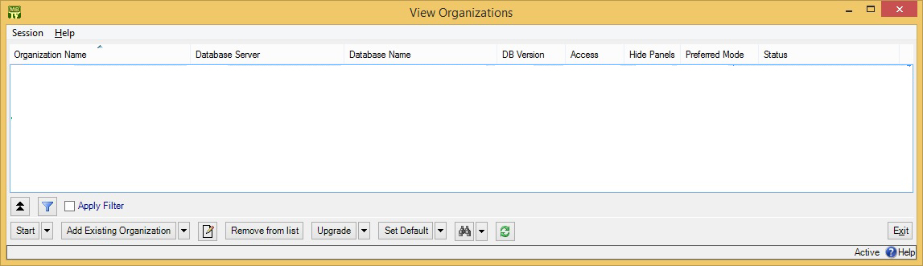

If you have no existing maintenance organizations (i.e. if you just installed MainBoss), see the Installation and Administration Guide for information on creating a maintenance organization. Otherwise, click Add Existing Organization. This opens a window where you can specify what organization you want to use:

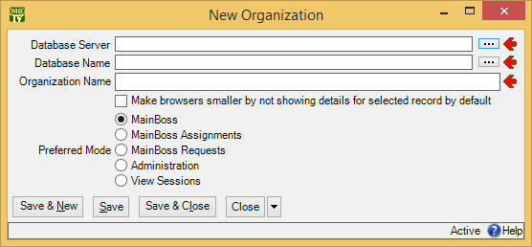

During the MainBoss installation process, your MainBoss administrator will have created an appropriate database on a server computer. Ask your administrator for the data you need to fill in the above window. Click OK when finished.

When you add an organization to your list, the new addition is automatically made your default organization. Whenever you start MainBoss in future, the program will automatically open this maintenance organization. Therefore, most users will never have to specify a maintenance organization in future.

Changing to a Different Maintenance Organization
Some companies may create multiple maintenance organizations. For example, a property management company with multiple clients may create a separate database for each client. As a result, workers in such a company may need to switch from one maintenance organization to another while using MainBoss.

To do this, open the Session menu and click Change Maintenance Organization. This opens a window that lists all the maintenance organizations known to you. Choose an organization from this list, then click Start. MainBoss will open the corresponding database and you can begin working with the associated data.

Quitting MainBoss
To quit MainBoss, simply close all the MainBoss windows that you have open.

Note that you can close a main MainBoss window and still have other windows open. MainBoss continues to run on your computer until you close the last window.

Locations and Contacts

This chapter discusses the most important tables in MainBoss: Locations table and Contacts. You use these tables in almost every aspect of your work with MainBoss.

The Configuration guide describes how to set up your Locations and Contacts when you first install MainBoss. After initial set-up, some organizations may not add new locations or contacts very often. However, other organizations may add locations and contacts frequently, so this guide provides full details about working with these tables.

Locations
The Locations table lists all locations that are of interest to your work. Examples include:

- The building sites where you perform maintenance operations
- Home addresses of your personnel
- Business addresses of your suppliers
- Any other addresses or places you want to record
In other words, the Locations table is like an address book, containing any geographical information you consider useful.

At a minimum, your Locations should list all the buildings covered by your maintenance operations. Almost everything you do with MainBoss requires an associated location. When someone submits a problem report, you have to specify where the problem is; when you create a work order, you have to tell workers where they should go; when you track spare parts, you have to tell where the parts are stored.

Here’s a simple Locations table:

This table has two types of locations:

- Postal addresses specifying a single building (or a set of buildings that all have the same postal address, as in a college campus). When you create a postal address record, you specify all the usual address information (street address, city, state or province, etc.).
- Sub Locations which are locations inside other locations. When you create a sub location record, you specify the location that contains the sub location. (The containing location must already have a record in your Locations table.)
Sub locations can have sub locations of their own. In the preceding picture, Room 100 is a sub location of Floor 1 which is a sub location of OurBuilding. You can organize your locations and sub locations in any way you like.

Notice that MainBoss depicts locations using a tree picture similar to the way that Windows Explorers shows folders, subfolders, and files. This makes it easy to see which locations contain which sub locations.

Postal Addresses
Here’s a typical example of a postal address record:

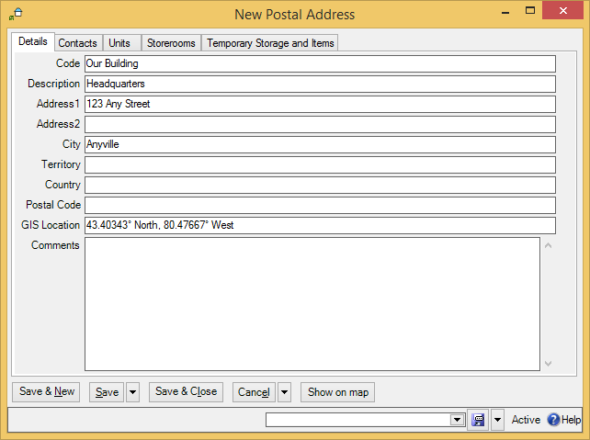

As shown, it contains a brief identifier code, a longer description of the location, and standard address information.

- To create a postal address record:
- In the control panel, click Locations. This opens the Locations table viewer.
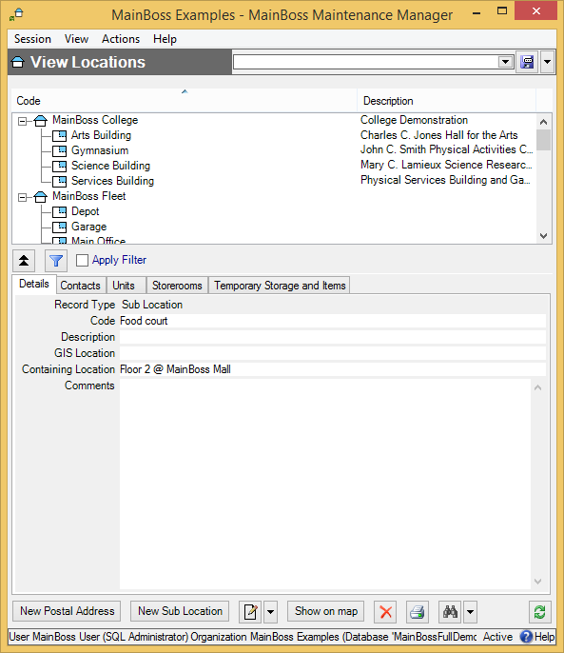

- In the View section of the table viewer, click New Postal Address . This opens a window where you can enter information about the location.
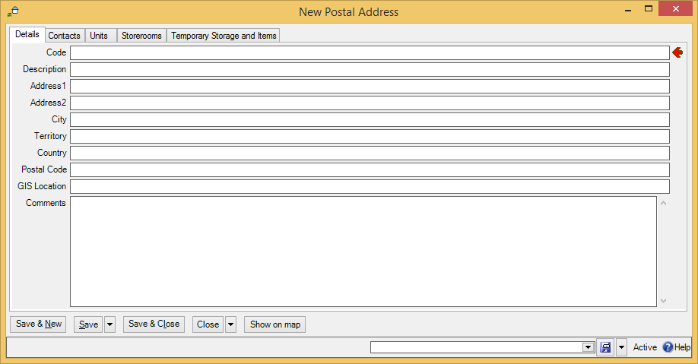

- In “Code” , enter a short identification code for this location.

- In “Description” , enter a longer description of the location.
- In the other fields of the record, enter address information for the location.
- Click Save & Close to save the information and close the window.

If you’re typing in a lot of postal addresses at once, you can use Save & New to save the information you’ve just typed, then set up a new empty record so you can record another address.

A postal address record contains a “Comments” field. You can use this field to record any information that isn’t covered by the other fields. For example, you might provide driving directions from your headquarters to the address if your personnel would find such information useful.

The Contacts area of the postal address record lists people you know at the given location. These are people from your Contacts list (discussed later in this chapter). When you first start setting up MainBoss, this area will be blank. It’s filled in automatically when you begin recording contact information.

As a special feature, MainBoss makes it easy for you to use Google Maps to specify “Map Coordinates”. First, use Google Maps to find the location’s geographic position. Then, right-click on the location in the Google Maps display and click Center map here in the resulting menu. Next, click the button in the left-hand panel with the link icon on it (a section of chain). Finally, copy the given URL (beginning with http:) and paste it into the “Map Coordinates” field in MainBoss. MainBoss will extract the longitude and latitude from the Google Maps URL.

Sub Locations
A sub location is contained in another location. Sub locations can contain their own sub locations.

- To create a new sub location record:
- In the View section of the Locations table viewer, click New Sub Location. This opens a window where you can enter information about the sub location:
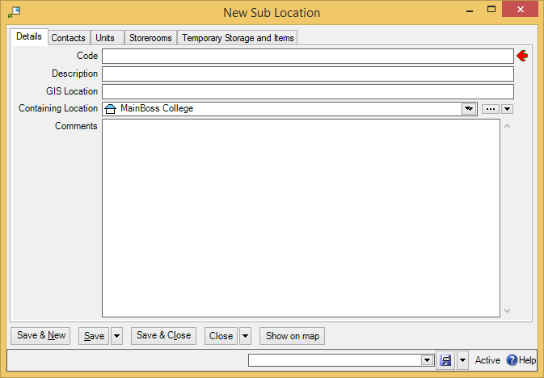

- In “Code” , enter a short identification code for this location.
- In “Description” , enter a longer description of the location.
- In “Containing Location” , specify the location that contains this sub location.
- Click Save & Close to save the information and close the window.

Note that “Contained Within” is a drop-down list. You usually fill in the value by clicking the first arrow, which displays your current locations. However, you can also click the “...” (which displays your full Locations table) or by clicking the last arrow (which offers you a menu of options for filling in the field).

Contacts
The Contacts table contains contact information for every person who’s relevant to your maintenance work. This includes maintenance workers, other personnel in the company, outside contractors, suppliers, clients, customers, and anyone else whom you may wish to contact.

When you record information about a contact, you may specify a location for that person. You do this by specifying a record in your Locations table. This is often a postal address: the contact person’s mailing address. However, for people inside your company, you might specify a sub location within one of your buildings. For example, in a shopping mall, you might have a contact person associated with each store; the location associated with each such contact is the store itself.

You can create an appropriate location record before you start creating a contact record. Alternatively, you can create a location record as needed in the middle of creating the contact record.

- To create contact records:
- In the control panel, go to Contacts. This opens the Contacts table viewer.
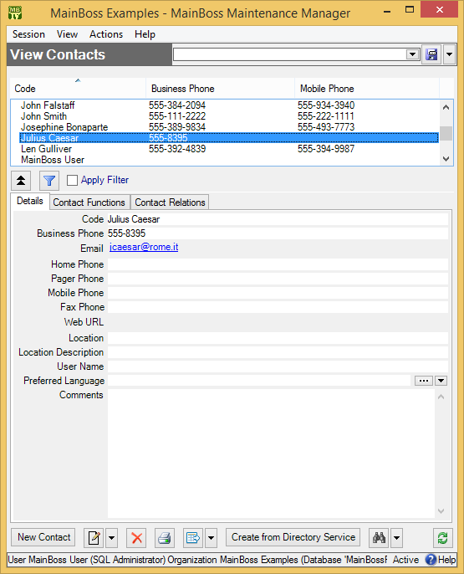

- In the View section of the Contacts table viewer, click New Contact . This opens a window where you can enter contact information:
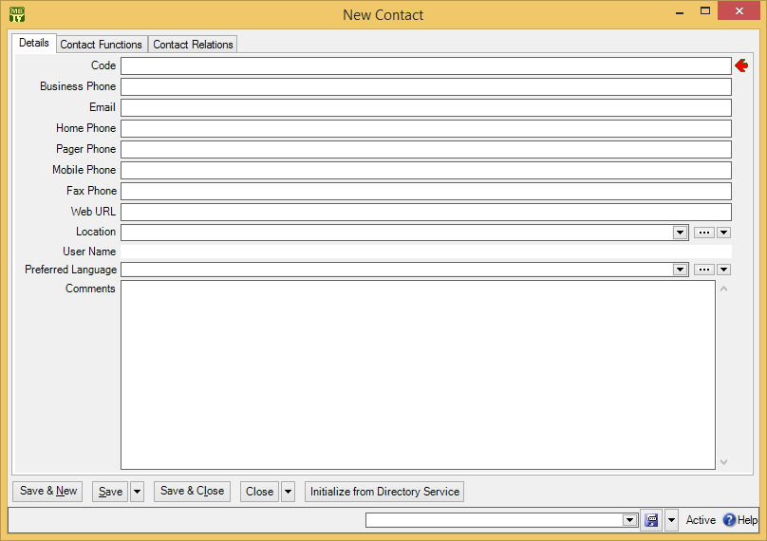

- In “Code” , enter the person’s name.

- In “Location” , specify the person’s location by selecting an entry in the Locations table. (If you don’t yet have a Locations record for this person, click the “...” button for “Location”. This opens a window where you can create a new location record.)
- Fill in any of the other fields for which you have appropriate information.
- Click Save & Close to save your data and close the window.

Requests

This chapter is only relevant if you have licensed the MainBoss Requests module. If you do not have a license key for this module, the control panel will not contain entries related to requests.

This chapter outlines the usual sequence of events in dealing with a problem report received from outside the maintenance department. Such a problem report is called a request or work request.

What is a Request?
A request is a description of a problem. Here are some situations that might initiate a request:

- An office is too hot
- A tap is dripping
- A piece of equipment has stopped working
- A piece of equipment is squeaking
- A parking lot has a pothole
Often, such problems are reported by someone outside the maintenance department. Problem reports usually come in by phone or email.

Requests vs. Work Orders: A request specifies a problem; a work order specifies a solution. Roughly speaking, a request might state, “The light has burned out in the atrium”, while a work order might state, “Chris, get a 1000-watt bulb from Storeroom 101 and replace the burnt-out bulb in the entrance atrium.”

Requestors
The person who submits a request is called the requestor. Some maintenance departments only accept requests from authorized requestors; others will accept requests from anybody.

If you only accept requests from authorized requestors, the names of such requestors should be listed in your Requestors table (Coding Definitions | Requests | Requestors). The Configuration guide explains how to set up this table. In day-to-day operations, you just have to select an existing requestor from the table whenever you create a request.

When Your Requestor Base is Huge: Your MainBoss license may limit the number of entries you may have in your Requestors table. In some cases, however, your maintenance department may accept requests from huge numbers of people; for example, a city’s road-maintenance department could conceivably receive complaints about potholes from anyone in the city. In this case, your best solution might be to create a requestor record in the name of Other, or General Citizen, or something like that. When a request comes in from someone who is unlikely to submit many requests, you can record their request using this general requestor record, possibly using the request’s “Comments” field to record the requestor’s actual name and contact information.

Codes Used in Requests
Requests use codes to provide information. For example, a request priority code can indicate how urgent a particular request is. The codes include:

Request priority codes
These can indicate how urgent the request is. Specifying a priority code is useful if a request is more urgent than usual (or if it’s considerably less urgent than usual).

Access codes
These indicate any restrictions on access to the work area or when the job can be performed. For example, if a location is only accessible during normal work hours or if a piece of equipment should only be serviced on weekends, the restriction may be specified using an access code.

These codes are set up using Coding Definitions | Requests | Request Priorities and Coding Definitions | Access Codes. For more information, see the Configuration Guide.

Request States
A request can be in one of the following states:

New: The request has been created and is waiting for attention.
In Progress: Maintenance personnel have marked the request as being in progress. This is often used when requests have been submitted by email using the MainBoss Service module (Requests and MainBoss Service on page 1). When you label a request as “in progress”, you send a message to the requestor saying that the request has been received and is being processed.
Closed: Typically, this means that the work is finished and the problem has been solved. However, requests are also marked as closed if they’re voided—if maintenance personnel have decided to reject or cancel the request.
Each of these states has its own table viewer. For example, Requests | New Request lists new requests—ones that are waiting for attention. This table is particularly useful if you’re running the MainBoss Service module, which automatically creates new requests based on incoming email. Requests | New Request shows you new requests created by this automatic process (as well as other requests created by hand).

Since the main Requests table shows all of your requests, it’s usually easier to find a specific request if you go to one of the single-state tables.

Creating a Request
To create a new request, you begin at the control panel entry for Requests.

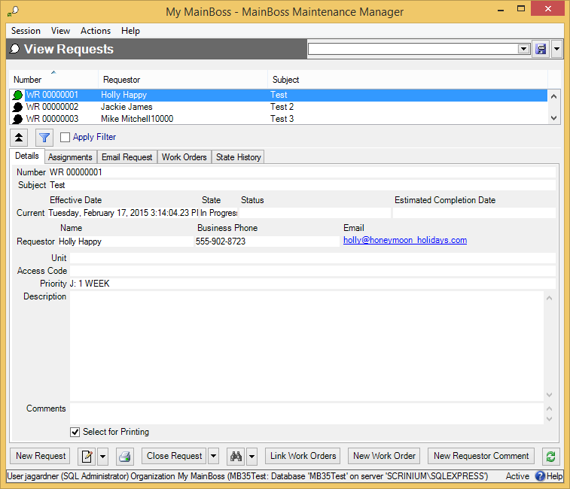

- To create a new work request:
- In the View section of the Requests table, click New Request . This opens a window where you can create a new request.
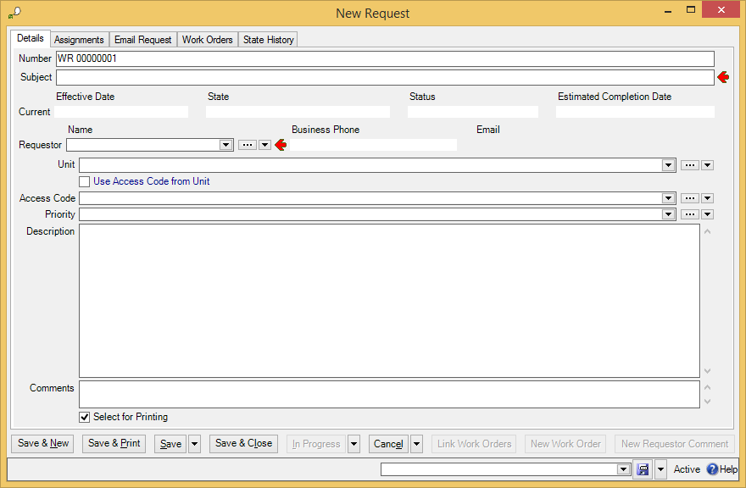

- In “Subject” type a brief description of the problem.
- Set “Requestor” to the name of the person who submitted the request. (“Requestor” comes from your Requestors table. If your company only accepts requests from authorized requestors, the submitter should already be in the list. Otherwise, you can create records for new requestors by clicking “...” .)
- Set “Unit” to the unit where the problem occurred.
- If there are restrictions on access to the unit, set “Access Code” to a code that describes those restrictions.
- If this job has a greater or lower priority than normal, see “Request Priority” to an appropriate priority code.
- In “Description” describe the problem in as much detail as you like.
- Click Save & Close to save the information you’ve entered. MainBoss will close the window when the information has been saved.

Working with Requests
The Requests table viewer has a number of buttons at the bottom of the View section. These include:

- : Opens a window where you can change information in the selected request.
: Lets you print one or more requests. See Printing Requests on page 1.
State change button: This is a drop-down button that offers a number of actions for changing the state of the selected request. The actions available for the drop-down button are determined by what kind of request is selected.
Operations that change the state of a request often open a window where you can record comments about your action. For example, if you Void (i.e. cancel) a request, MainBoss opens a window where you can record why you’re canceling the request. If you have the MainBoss Service module, any comments that you enter are automatically sent back to the person who submitted the request.
The state change buttons include:
Close Request: Closes an open request.
Close Request (With Comment): Closes the selected request, and also opens a window where you can record a comment about what you’re doing.
Reopen: Reopens a request that has been closed or voided. MainBoss will also open a window where you may record a comment explaining why you’re reopening the request.
In Progress (With Comment): Marks an open request as in progress. Using this button is particularly useful in connection with MainBoss Service: it’s a way to send the requestor an email update about the request.
For example, suppose a piece of equipment breaks down. You make a quick temporary repair but won’t be able to make a long-term fix until the weekend. By using In Progress, you can record what’s going on. This note gets saved in your records; if you have MainBoss Service, it also gets emailed to the requestor (unless you’ve set an option that says this requestor shouldn’t be sent such acknowledgements). You therefore keep the requestor informed, and also record useful information about exactly what happened on the job.
In Progress: Same as In Progress, but it doesn’t ask you to enter a comment. Requestors will still receive an email acknowledgement indicating that the request is now considered “in progress”, but the acknowledgement is basically just a form letter.
Void: Cancels an open request. You might do this when the request first comes in (effectively rejecting the request) or at any point before the request is closed.
New Requestor Comment: Sends a note to the requestor associated with the selected request, provided that you have the MainBoss Service module and that you haven’t set the option that prevents requestors from being sent acknowledgements. This is similar to In Progress (With Comment), but can be used any time—even if the request has been closed or voided.

Typical Request Life Cycle
To illustrate how requests are processed, here’s one possible life cycle for a request:

- Someone phones your service help-desk to report a problem. Help-desk personnel go to Requests in the MainBoss control panel and click New Request to create a new request.
- Help-desk personnel record information about the problem in the new request record. Then they click Save & Close to save the request and close the window.
- Sometime later, a maintenance department dispatcher goes to Requests | New Request in the MainBoss control panel. This lists all new requests, including the one that the help-desk just made.
- The dispatcher selects the new request in the table viewer list. Information from the request is displayed in the table viewer. The dispatcher examines the request and determines what ought to be done.
- If the request is acceptable, the dispatcher clicks In Progress, indicating that the request has been seen and accepted. MainBoss opens a window where the dispatcher can record any comments about the request.
- Otherwise, the dispatcher drops the arrow beside the In Progress button and clicks Void. This rejects the request. MainBoss opens a window where the dispatcher can enter a reason for rejecting the request.

The dispatcher typically repeats the above process for every request in the new request list.

- The dispatcher next goes to Requests | In Progress Requests to review the requests there. This table viewer shows requests that have been accepted and marked as in progress. The dispatcher goes through the list and decides which are ready to be turned into work orders. (If necessary, the dispatcher may phone the requestor to obtain more information about the problem.)
To turn a request into a work order, the dispatcher clicks on the request in the table viewer, then clicks New Work Order. (This is discussed in the next chapter.) Creating a work order from a request puts the request in Requests | In Progress Requests | In Progress Requests with linked Work Order, although the request also remains listed in Requests | In Progress Requests.
- The dispatcher assigns the work order to maintenance personnel who then do the work as specified.
- When the job is finished, the work order is closed. Once the work order is closed, the dispatcher must close the request too.
- The dispatcher goes to Requests | In Progress Requests | In Progress Requests with linked Work Order in the control panel. This lists open requests that have been used to make work orders.
- The dispatcher finds the appropriate request in the list. The dispatcher selects this request, then clicks Close Request.

Request Status Codes
A request may be assigned a status code. Typically, such a code indicates that the request requires attention from someone, or that it is unusual in some way.

For example, in some sectors it is common to put requests on hold until someone from the maintenance department has gone out to verify that a problem actually exists. In this case, you might give the request a status like Waiting for verification. This status indicates that the request requires personal action from someone (whoever is assigned to verify the problem). Once this action has been taken, the status code can be removed and the request can continue with normal processing.

Your organization can create any type of status codes that make sense for the way you work. To see what codes have been defined by your organization, see Coding Definitions | Requests | Request Statuses.

You assign status codes to a request by clicking New Requestor Comment in a request table viewer or in a request record. This opens a window where you can specify a status. You use the same process to remove an existing status.

Printing Requests
You can print requests from any of the Requests table viewers (Requests | New Request, Requests | In Progress Requests, etc.). However, the easiest way to print a request is from the request record.

- To print a specific request:
- In any Requests table viewer, select the request you want to print.
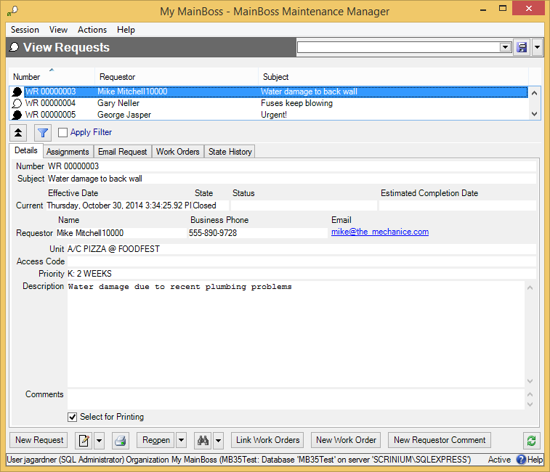

- Click . This opens the request record.
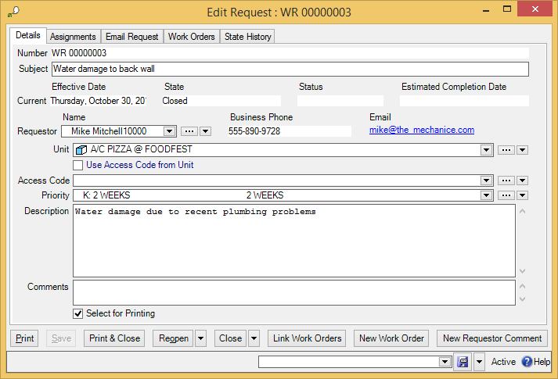

- Click Print . This opens a window where you can specify options for the print-out.
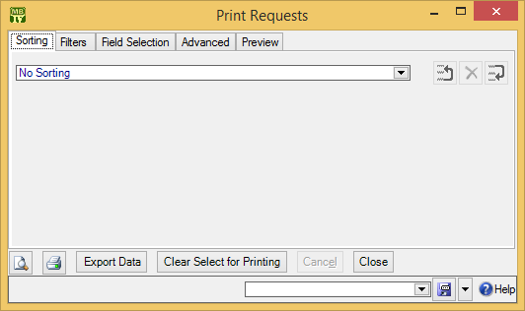

- Click . You’ll see a preview of the request print-out:
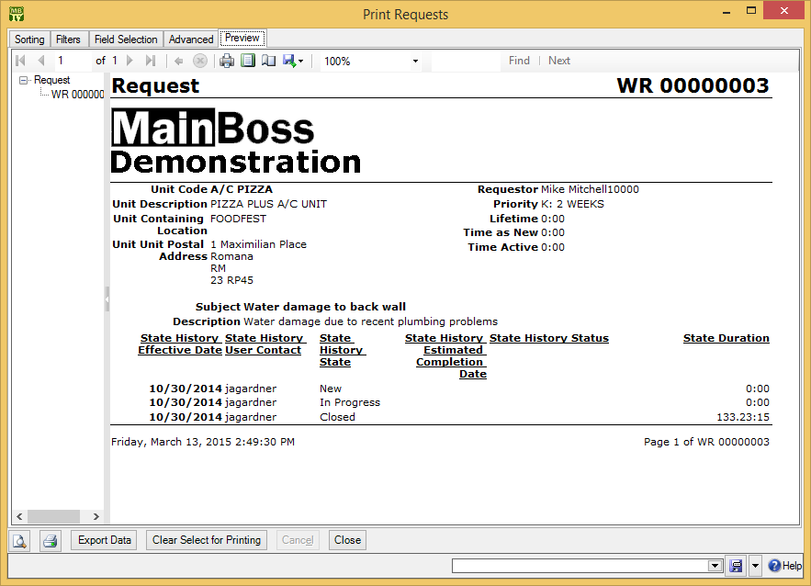

- Click the printer icon to print the request.

To print a batch of new requests, you can use the Select for Printing feature—for more details, see Select For Printing on page 1.

Request Reports
Request reports provide information about your requests:

- The Request History Report (Requests | Reports | Request History) prints out information about your requests. For example, suppose you want a building-by-building breakdown for your requests, to see which buildings have the most problems. In the Grouping section of the report window, you’d expand the Unit node then choose Containing Location. The resulting report would have a section for each location you maintain.
- The Request State History Summary (Requests | Reports | Request State History Summary) provides information about the state and status of requests. For example, suppose you want information on your open requests. In the Filters section, filter by State, then drop the arrow on the associated value field. This lets you specify which states should be included in the report:
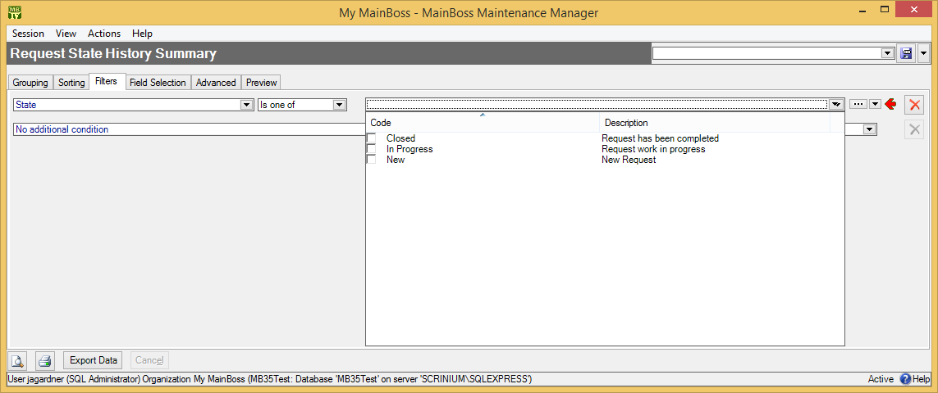
Once you checkmark which states you want to see, you can go to the Preview section to see the actual report.
- The Average Request Duration Per Grouping chart (Requests | Charts | Average Request Duration By Grouping) shows how long requests take from start to finish (on average). You use the Grouping section to organize the report. For example, if you group by priority, the chart will show the average duration of requests in each priority class.

Requests and MainBoss Service
If your organization has licensed the MainBoss Service module, users can submit requests by email to an automated processing system. This system offers several benefits:

- Requests from the web or email messages are automatically placed into your database files. Your personnel don’t have to enter the requests by hand.
Many organizations with MainBoss Service have found a dramatic decrease in phone calls to the maintenance department. When people can report problems by the web or email, they don’t use the phone. This frees up phone-answering personnel for other work.

- In order to keep the requestor informed, MainBoss Service sends email acknowledgements to the requestor at various points in the request process. This happens automatically when requests are created, when they’re marked “in progress”, when they’re closed, and whenever someone uses New Requestor Comment. Requestors are happy because they’re kept informed, and maintenance personnel are happy because they don’t have to deal with people phoning in to ask what’s happening with their request.
- MainBoss Service lets you specify whose email requests will be accepted. You list the email addresses from which the automatic processing program should accept requests. Requests sent from other addresses will not be accepted.
The Installation and Administration Guide explains how to set up MainBoss Service when you begin using MainBoss.

Keeping Requestors Informed: MainBoss Service automatically sends email acknowledgements to requestors when there’s a change in the state of their requests. This happens when the automatic processing program places the request in the database and whenever you change the state of the request.

For example, when you click the In Progress button to indicate that a new request has been accepted, MainBoss opens a window where you can enter comments. Any information you enter will be emailed to the requestor. The same happens if you use Void to cancel the request, New Work Order to turn the request into a work order, Close to close the request, or Reopen to reopen the request again.

If you don’t enter any specific comments at these points, the automatic request processor sends out email messages anyway. For example, when you create a work order from a request, the processor automatically creates an email message to tell the requestor about the work order. In many cases, the standard message is all that’s necessary—you only have to add extra details if something requires special comments.

Work Orders

As noted in the previous chapter, a request describes a problem while a work order describes a solution.

To use the features discussed in this chapter, your version of MainBoss must have the MainBoss module.

A work order may contain any or all of the following information:
- priority of the job
- date/time the job should be done
- personnel assigned to do the job (possibly including labor costs based on the workers’ wages)
- length of time the job is expected to take
- materials expected to be needed for the job
- a detailed description of the work to be performed

Work orders aren’t just useful for describing what should be done on a job—they also preserve a history of what got done. After a job is finished, it’s important to record the parts and labor used, as well as any other information that might be useful to remember.

Work Order States
A work order can be in one of the following states:

Draft: The work order has been created and saved, but is still considered easy to change. You may be waiting for additional information or some sort of approval before the work order can be finalized.
Open: The work order contains all the information you want and has received any approvals it might need. It’s ready to be issued to workers. The work order will remain in the open state until the job is actually finished.
Closed: The job is finished and all information about the work has been recorded. A work order can’t be changed when it’s in the closed state. However, you can reopen a closed work order, make changes, then close it again.
Void: The work order was created but it was canceled before it became Open.
Each of these states has its own table viewer. For example, Work Orders | Open Work Orders lists open work orders. In addition, there is a combined Work Orders table that lists all work orders in all states. (Since this can be a lengthy list, it’s usually easier to find work orders in one of the other work order lists.)

MainBoss has various buttons for changing the state of work orders. These are summarized below:

- Void: Changes Draft to Void, and also opens a window where you may record a comment about why you decided to cancel the work order
- Re-Draft: Changes Void to Draft, and also opens a window where you may record a comment about why you decided to reactivate the canceled work
- Open: Changes Draft to Open
- Open Work Order (With Comment): Changes Draft to Open, and also opens a window where you may record a comment about what you’re doing
- Suspend: Changes Open to Draft, and also opens a window where you may record a comment explaining why you suspended the work order
- Close Work Order: Changes Open to Closed
- Close Work Order (With Comment): Changes Open to Closed, and also opens a window where you can record a comment about what you’re doing
- Reopen: Changes Closed to Open, and also opens a window where you can record a comment explaining why you’re reopening the work order
An open work order can also be Overdue. When you create a work order, you can specify dates for when the work should start and end. A work order is considered overdue if it’s still open past its specified end date. Work Orders | Overdue Work Orders lists any work orders that are overdue.

If a work order has no specified end date, it will never be overdue. Therefore, you should usually specify an end date whenever you create a work order.

Work Order Status Codes: Work orders may be assigned status codes. Typically, a status code indicates that the work order needs someone’s personal attention. For example, your organization may have status codes like

Waiting for management approval
Waiting for parts
Waiting for customer sign-off

Once the issue has been resolved, the status code may be removed and the work order may resume normal processing.

You can create any type of status codes that make sense for the way you work. To see what codes have been defined by your organization, see Coding Definitions | Work Orders | Work Order Statuses.

Note that status codes can be a useful form of communication between users. For example, suppose that a worker has the WorkOrderFulfillment security role (meaning that the worker can record actual labor and material usage) but does not have the WorkOrderClose security role (which is needed to close a work order). The worker could give the work order a status like Ready to Close, indicating that all appropriate information has been recorded. A supervisor with WorkOrderClose permission could regularly check all open work orders to see if any are Ready to Close; if so, the supervisor can review those work orders and close them as appropriate (removing the status code in the process).

Remember that a status code is intended to bring a work order to someone’s attention. You can therefore use status codes as signals for other users.

You assign status codes to a work order by clicking Add Work Order Comment in a work order or in a work order table viewer. This opens a window where you can specify a status. You use the same process to remove an existing status. Any existing status code is also removed when you open or close the work order.

Creating a Work Order
The sections that follow describe how to create a complete work order. You may or may not decide to follow all the steps. For example, you may not be using MainBoss’s inventory facilities to keep track of work materials. If so, you can skip allocating materials for the job.

Before and After: When you first create a work order, you often supply estimates for various types of information. For example, you might specify when you expect the job to start and when you expect it to end. Once the job is finished, you can go back and put in the actual start and finish times.

The same applies to materials. Before a job, you can predict what materials you might need and record those materials in the work order. After a job, you can record what materials you actually used.

Emergencies: In emergencies, you may not have time to write up a work order before the job. However, you should write up the work order after the job, recording all relevant information. Work orders aren’t just instructions for what to do on the job, they’re a record of the work you do. This means it’s especially important to record what you did during an emergency, since such work is often more high profile than run-of-the-mill maintenance.

Starting a New Work Order
There are several ways to create a new work order. Two common ones are starting from an existing work request and making the work order from scratch.

- To turn a request into a work order:
- Open a Requests table viewer that shows the request. This might be Requests | New Request (if the request is brand new) or Requests | In Progress Requests (if the request has been marked as in progress).
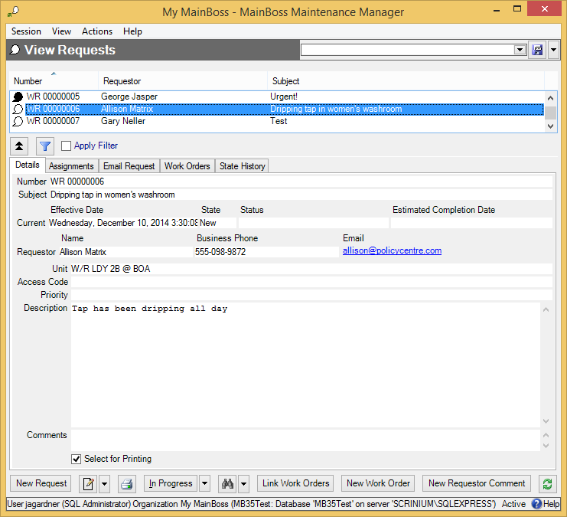

- Select the request in the table, then click New Work Order . MainBoss opens a window where you can begin creating the work order.

If you create a work order from a request, MainBoss fills in some of the fields of the work order, using information from the request.

- To create a new work order without starting from a request:
- In the control panel, open the Work Orders viewer.
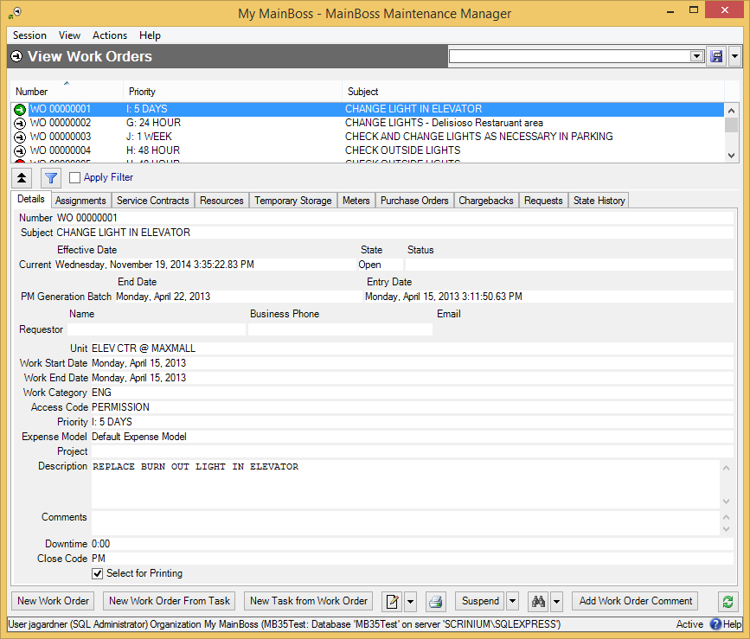

- Click New Work Order . MainBoss opens a window where you can begin creating the work order.

Saving the Work Order: As you will see, work orders can contain a lot of information. As you enter this information, you should save the work order from time to time by clicking the work order’s Save button. This ensures that information isn’t lost if something goes wrong (e.g. the power goes out). The sections that follow don’t explicitly tell you to Save your information while you’re writing up the work order, but you should make a point of doing so once in a while.

Basic Work Order Information
Once you’ve opened a window for editing work order information, you can start filling it in.

If you created the work order from a work request, some fields of the work order will be filled in with information from the original request. You can change this information, if necessary.

The instructions that follow assume that you have already opened a work order window (as discussed in the previous section).

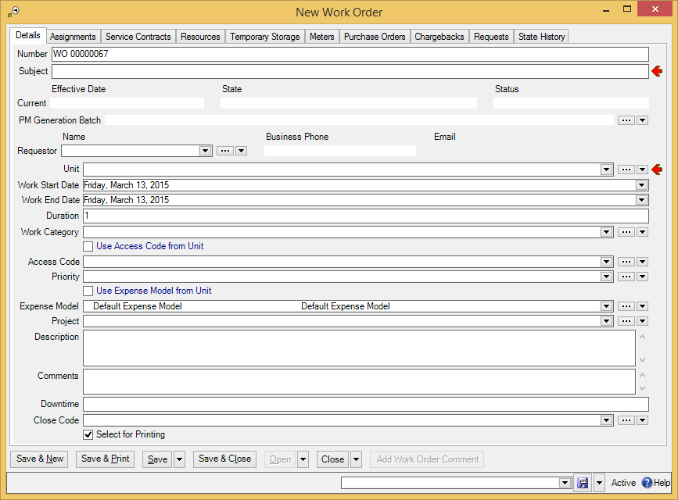

- To fill in basic work order information:
- In “Subject” , enter a description of the work to be done.
- In “Requestor” , specify the Contacts table record for the person who requested the work (if any). (Once you’ve specified the requestor, the person’s phone number and email address will be displayed in “Phone” and “Email”. This information is obtained from the person’s Contacts record.)
- In “Unit” , specify the unit where the work should be performed.
- In “Work Description” , enter a complete description of the work that should be done. This can take any form, but check-lists and/or step-by-step instructions are often the best approach.

The remaining fields in the Details section aren’t mandatory, but they can provide useful information about the job. You can fill them out in any order, but most people start at the top and work down:

Work Start Date: When you first create a work order, you can fill this in with the date and time when you want the work to start. After the job is done, you should change this (if necessary) to the actual date/time when the work began.
Work End Date: When you first create a work order, you can fill this in with the date and time you expect the work to be completed. After the job is done, you should change this (if necessary) to the actual date/time when the work was finished.
Duration: This is the expected duration of the job, in days. Every fraction of a day is rounded up to the next full day. For example, if a job is expected to take an hour, “Duration” becomes 1 day. If a job is expected to take 25 hours, “Duration” becomes 2 days.
Typically, you don’t fill in “Duration”. Instead, you fill in “Work Start Date” and “Work End Date”. MainBoss then calculates “Duration” automatically. By default, “Work Start Date” and “Work End Date” are set to the current date.

Work Category: The type of work involved. Look at your list of categories and select the appropriate one.
Use Access Code from Unit and Access Code: An access code specifies any restrictions on when a job can be done (e.g. only on weekends or after hours). Every unit may have its own default access code. If you checkmark Use Access Code from Unit, MainBoss will set “Access Code” to the unit’s normal access code; otherwise, you can set “Access Code” to any appropriate code. (You might override the unit’s normal access code in case of an emergency.)
Priority: May indicate how urgent the job is.
Use Expense Model from Unit and Expense Model: An expense model specifies the set of expense categories that will be allowed for materials and labor expenses on a work order. Every unit may have its own default expense model. If you checkmark Use Expense Model from Unit, MainBoss will set “Expense Model” to the unit’s normal expense model; otherwise, you can set “Expense Model” to any appropriate model. (For more about expense models, see Accounting Facilities on page 1.)
Project: May be used to indicate that this job is part of a larger project. For example, suppose your maintenance department is taking part in a series of jobs that are all part of one big renovation. You can create a project code that you attach to every job in the renovation. This makes it easy to track the costs of the renovation separately from the costs of other work.
Select for Printing: Makes it easy to print a number of new work orders in a single batch. For details, see Select For Printing on page 1.
MainBoss automatically fills in some of these fields when the work order is first created. For example, “Work Start Date” and “Work End Date” are both set to the current date and time. “Expense Model” is set to the default expense model. Other fields may also be set to default values if your organization has set up customized defaults.

You don’t have to fill in every field. For example, we recommend that you leave “Work Order Priority” blank unless the job really does have an unusually high or low priority. If you get used to using a blank to mean an ordinary job, then a non-blank value has more impact when you need to emphasize a point.

Work Order Resources
The Resources section of work order lets you record labor and materials for a job. This section uses the following terminology:

Demand
A demand is made before the job begins.
- A demand for labor means assigning someone to do the job. This could include inside workers (your own personnel) and/or outside workers (hired contractors).
- A demand for materials means reserving materials for the job, so that the items will be available when they’re needed.

There must be a demand for every labor and material expense associated with the work order.

Actual
An “actual” record is made after a resource is used. It records what labor and materials were actually used.
Actual records are created by actualizing an existing demand: indicating the labor or materials that were actually used in response to a demand. (Remember, there must be a demand for every labor and material expense...even ones you didn’t expect in advance.)

Scheduling Labor
The Resources section of a work order can record the following types of labor expenses:

Hourly Inside: Work done by your own personnel and charged for by the hour.
Per Job Inside: Work done by your own personnel and charged for on a flat fee basis (e.g. a vehicle oil change which has a fixed price no matter how long it actually takes).
Hourly Outside: Work done by an outside contractor and charged for by the hour.
Per Job Outside: Work done by an outside contractor and charged for on a flat fee basis.
During MainBoss set-up, you create records for each type of expense. For example, an Hourly Inside record specifies a worker and that worker’s cost per hour. It might say that Chris Smith gets paid $20 an hour.

The Configuration guide explains how to set up Hourly Inside, Per Job Inside, Hourly Outside, and Per Job Outside records.

To assign an inside worker to a job, you select an Hourly Inside or Per Job Inside record that names the worker and how much the worker is paid for such work. Similarly, to record that an outside contractor is going to do a job, you select an Hourly Outside or Per Job Outside record that names the contractor and how much the contractor will be paid.

Same Person, Different Charges: It’s possible to have several records for the same worker, inside or outside. For example, if Chris Smith gets paid extra for overtime, you might have one Hourly Inside record for Chris’s normal rate and another Hourly Inside record for overtime. When assigning personnel to a job or recording labor expenses, you should make sure to choose the correct record.

When recording the cost of a specific job, you can always write in a different cost than the one in your records. Therefore, it’s easy to handle one-time-only variations from standard labor charges.

- To assign your own personnel to a work order (Hourly Inside):
- In the Resources section of the work order, go to the Inside subsection.
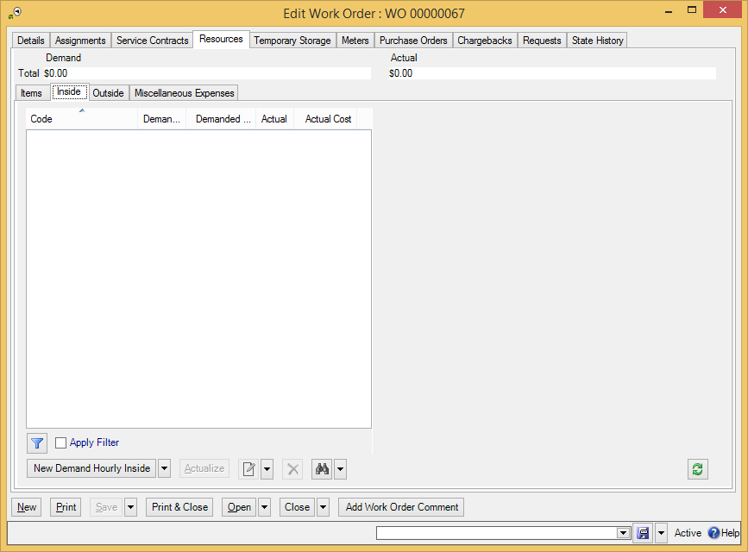

- Click New Demand Hourly Inside . MainBoss opens a window where you can assign a worker to the job.
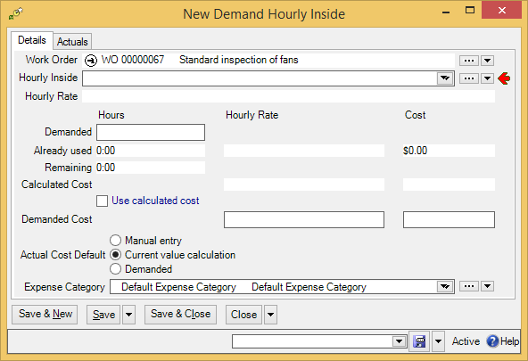
- In “Hourly Inside” , select an Hourly Inside record that names the person you want to assign and the hourly cost of that person.

- In “Demanded” , enter the number of hours and minutes that the person is expected to work. The format is hh:mm. For example, an hour and a half is 1:30. The value that you enter should be the total time expected on the job; for example, if the person is expected to work three eight-hour days, you should enter the value 24:00.
- If you wish, you can fill in “Demanded Cost” with an estimated cost of the worker’s time, or click Use Calculated Cost to have MainBoss calculate the cost based on the worker’s hourly rate and the time given in “Demanded”.
- Click Save & Close to save the information and close the window.

The options for “Actual Default” (shown above) let you tell MainBoss how to calculate the actual cost of this work later on. This is useful if the work order may eventually be closed by someone who doesn’t have appropriate security permissions to enter labor costs. The options are:

- Manual entry: You expect that the person who closes the work order will enter the actual cost, whatever it is.
- Current value calculation: You expect that the actual cost will be calculated from the hourly rate given in the “Labor Inside” record, as of the time that the actual time is recorded. The actual hours spent on this job may be greater or less than the time specified in “Demanded” but the hourly cost will be the rate expected.
- Demanded: This is similar to Current value calculation, except that MainBoss uses the hourly rate that applied at the time of the demand rather than the time of the actualization.
In all cases, someone with appropriate permissions may override the “Actual Cost Default” you specify. However, if the person closing the work order does not have sufficient permissions, the actual cost of the work will be calculated using “Actual Cost Default”.

After Filling Out the Hourly Inside Demand: When you return to the work order window, you’ll see that an estimate has been added to the Resources list.

Note that the “Demanded Cost” line has two columns: “Hourly Rate” for the cost per hour and “Cost” for the total cost. If you fill in one, MainBoss automatically fills in the other one with a value calculated from “Demanded”.

“Demanded Cost” lets you enter a special hourly rate for the worker, instead of the rate given in the Hourly Inside record. For example, suppose that the job has to be done on a holiday, when the worker is paid double the usual wage; you could enter this special wage into the “Hourly Rate” column of “Demanded Cost” so that the work order records the correct expense.

If you want to assign more than one person to a job, repeat the above process for each person. If a worker is expected to spend more than a day on the job, you can create a separate demand for each day or a single demand for the entire demand (e.g. a single demand for 24 hours might mean three 8-hour workdays).

Per Job Inside: You use a similar process to add demands for Per Job Inside labor expenses, with these exceptions:

- Click New Demand Per Job Inside.
- Select a Per Job Inside record specifying the person and cost of the job.
- For “Demanded”, specify the number of jobs involved. For example, suppose the work order is for piecework like cleaning windows and the worker is paid by the window. The “Demanded” would be the number of windows to be washed.
- If this job is charged at a special rate, you can enter the rate in “Demanded Cost”.
Outside Contractors: You use a similar process to add demands for Hourly Outside and Per Job Outside expenses. You begin this process in the Outside subsection of the Resources section. Just choose an appropriate Hourly Outside or Per Job Outside record that specifies the contractor and the expense rate. (If you don’t know the expense rate in advance, you can leave it blank when you fill out the demand. You can record the rate after the job is done when you record Actual information.)

In order to pay for outside labor, you can create a purchase order that is “linked” to the work order. For more details, see Paying for Outside Labor with a Purchase Order on page 1.

Miscellaneous Expenses: Work orders may have expenses that aren’t directly related to labor or inventoried materials. For example, a worker might have to pay for parking at a job site. For this kind of expense, you use the Miscellaneous subsection of the Resources section. Click New Demand Miscellaneous Cost to record details of the expense.

Any worker who appears in a labor demand (inside or outside, hourly or per job) is automatically an assignee for the associated work order (provided that the worker is on the list of recognized Work Order Assignees). You don’t have to create an assignment explicitly. The worker will therefore appear in the work order’s Assignees section.

Reserving Materials for a Work Order
When you assign materials to a work order before the work is done, you estimate what materials you believe the work is likely to require. MainBoss then puts these materials on reserve. For example, if a job on a forklift truck will replace two tires, you can put an appropriate number of tires on reserve when you make up the work order.

When materials are put on reserve, MainBoss removes them from counts of stock available. For example, if you currently have six tires in a storeroom but two of those tires have already been put on reserve, MainBoss says you have four tires available.

When you reserve an item, you tell MainBoss the storeroom where you’ll obtain that item. For example, if a particular item is found in three different storerooms, you tell MainBoss which storeroom you’ll go to. (MainBoss makes it easy to find out which storerooms contain a particular item and how much each storeroom contains.) By reserving items from a particular storeroom, you make sure that the items will be there when you want them.

You only need to reserve items if you track their use. For example, if you don’t track the use of common items like tape, glue, etc., then you don’t need to reserve them on work orders—you probably have plenty in stock, and you can easily buy more if you run out. On the other hand, the work order should list any items whose use you do track.

You reserve materials by creating demands in the Items subsection of a work order’s Resources section. You do so by specifying a demand item record. This record specifies the materials you want and the storeroom where you’ll get them.

- To reserve materials for a work order:
- In the Items subsection of the Resources section of the work order, click New Demand Item .
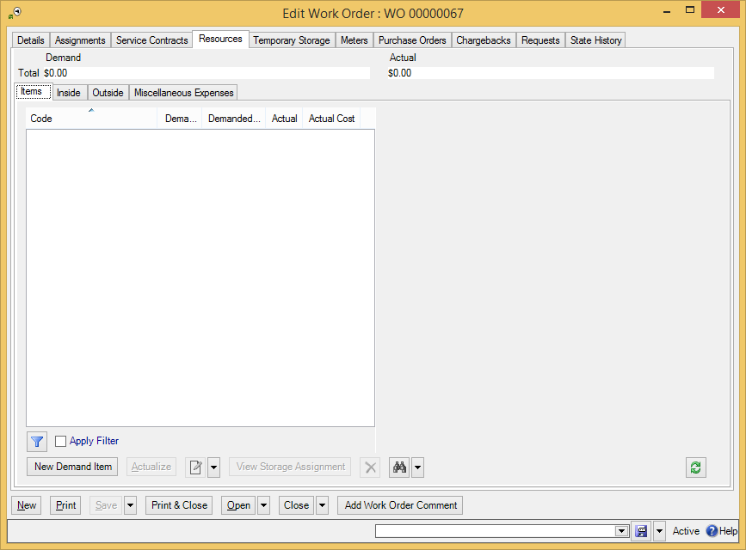

- MainBoss opens a window where you can reserve an item.
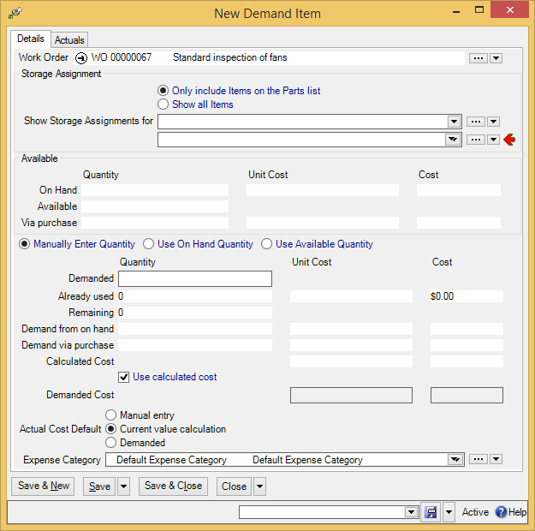

- In “Show Storage Assignments for” , specify the item for which you are creating a demand. (If the item is on the unit’s spare parts list, you can click Only include Items on the Parts list; this will shorten the length of the drop-down list. Otherwise, click Show all Items, and the drop-down list will show everything in your Items table.)
- Once you select an item, drop-down the arrow on the next line to select a storage assignment for the selected item. A storage assignment specifies a storeroom that contains the item you want.
Once you select a storage assignment, MainBoss will fill in the “Quantity” column of “Available” with the quantity of the item in the selected storeroom. (Note that “On Hand” shows the quantity that’s currently in the storeroom, but “Available” shows the quantity that’s available for use. The difference is the quantity that’s been put on reserve for other jobs.)
If the storeroom doesn’t contain the quantity you want, you can go back to the storage assignment drop-down list and select another entry. By checking all your storeroom assignments, you can see if any storeroom contains the quantity you want to reserve.
If no single storeroom contains enough of the item, you can create multiple reservations: reserve quantities from several different storerooms until you have enough to do the job. You’ll have to do this in several stages. Make one reservation according to these instructions, then make another reservation, and so on.
Another approach is to transfer items from various storerooms to a temporary storage location associated with the job. For more on temporary storage, see the next section.

- In “Demanded” , enter the quantity of the item that you want to reserve in the selected storeroom.
- Click Save & Close to save the information and close the window.

Temporary Storage for a Job
You may designate a temporary storage area for the job’s materials. For example, if you’re doing a large renovation, you may set aside one or more rooms where you can store lumber, paint, etc. for the job. To avoid confusion, it’s useful to record which materials are stored in this temporary storage and which are stored in your regular storerooms—otherwise, you may waste time searching for materials in the wrong place.

We recommend the following approach to reserving and using items:

- Before a job, you create demands for any important items you expect you’ll need. This puts the items on reserve. (There’s no need to reserve simple items that you always have lots of, e.g. masking tape.)
- When you’re ready to do a job, you remove reserved items from your storerooms and record that they’ve been transferred to temporary storage. Typically, you use the unit being repaired as the temporary storage location; this says, “I’ve taken the parts to the site of the unit.”
- After you’ve actually used an item, you create an “actual” record for the usage. We recommend that you don’t create this “actual” record until you’ve actually used the item. Creating an “actual” record generates an accounting transaction that can’t simply be deleted if you find out you didn’t need the item after all. (If you want to undo an accounting transaction, you have to create a formal correction record. MainBoss demands this formality in order to preserve an accurate audit trail.)
- If you use an item and you don’t already have an existing demand for that item, you have to create a demand record first, then create a corresponding “actual” record.
If you use temporary storage for a job, you record this on the job’s work order. Using the temporary storage is a two-stage process:

- Specify the location(s) you’re using for temporary storage (e.g. “We’ll be using Room 101 to hold materials for this job”).
- Record which materials have been transferred from your regular storerooms to the temporary storage location (or which materials have been delivered direct from the supplier to the temporary storage)
Although MainBoss lets you specify a regular storeroom as a temporary storage location, we recommend against this practice—distinguishing between what’s in a storeroom temporarily and what’s there permanently is bound to be confusing. If materials will be stored in a storeroom, just write it up as if they can always be stored in that storeroom.

As noted above, you can use the unit itself as a temporary storage location. This is often the best approach, especially if you just intend to keep materials close at hand while you work on the unit. The only time you’d use someplace else as a temporary storage location would be if you have a lengthy job and a lot of materials that will be stored in a special place over the course of the work.

- To designate a location as temporary storage:
- In a work order, go to the Temporary Storage section.
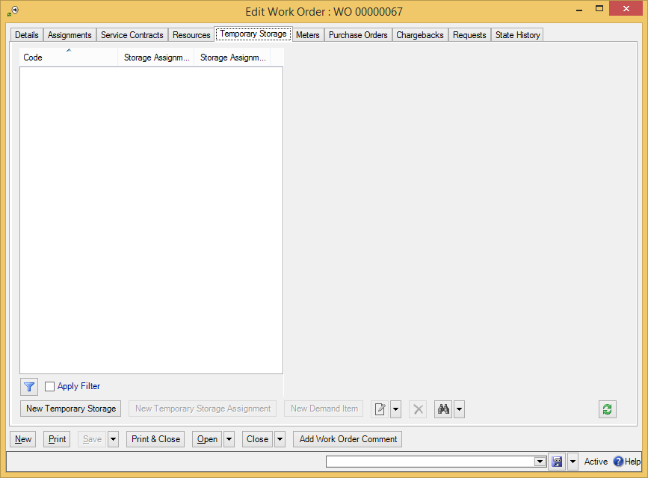

- Click New Temporary Storage . MainBoss opens a window where you can designate a new temporary storage location for this work order.
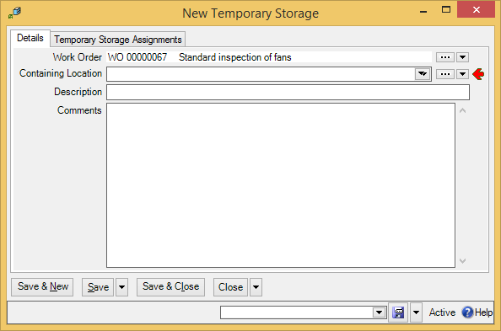
- In “Location” , specify the location you intend to use for temporary storage.

- In “Description” , specify an identification code for this temporary storage location.
- Click Save & Close to save the information and close the window.

Once you return to the work order, you’ll see that the temporary storage location now appears in the list. Underneath the location, you’ll see the identification number of the work order that’s using the location for temporary storage.

Temporary Storage Assignments: Once you have designated temporary storage for work order materials, you can specify temporary storage assignments. Temporary storage assignment records tell what kind of items may be stored in a temporary storage location.

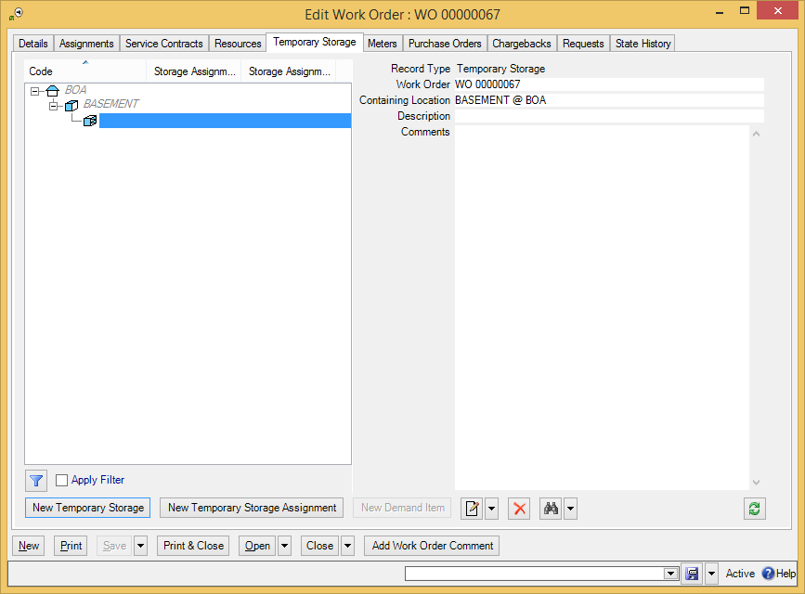

- To create a temporary storage assignment:
- In a work order’s Temporary Storage section, click New Temporary Storage Assignment . MainBoss opens a window where you can create a temporary storage assignment:
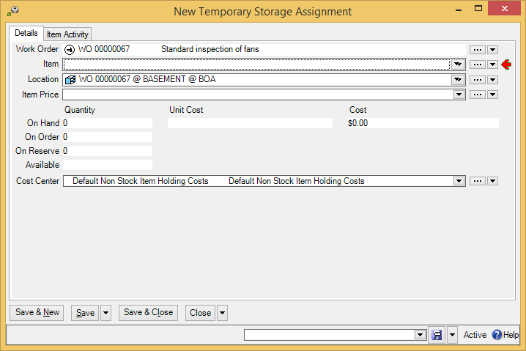
- In “Item” , specify an item that you intend to keep in the temporary storage location.

- Click Save & Close to save the information and close the window.

Once you’ve specified temporary storage assignments for a work order, you can record the transfer of materials from a regular storeroom to temporary storage. Note that you must choose a temporary storage assignment for the type of materials you’ll be transferring. For example, if a temporary storage assignment describes light bulbs in a temporary storage location, you cannot use that assignment for transferring paint. You must have a temporary storage assignment for each type of item that will be kept in the temporary storage location.

- To transfer materials to temporary storage:
- In a work order’s Temporary Storage section, select a temporary storage assignment entry for the materials and location you wish to transfer.
- Click to edit the temporary storage assignment record.
- In the Item Activity section of the temporary storage assignment record, drop the arrow on New Item Issue and click New Item Transfer From. MainBoss opens a window where you can record the transfer of items from a normal storeroom to the temporary storage location:
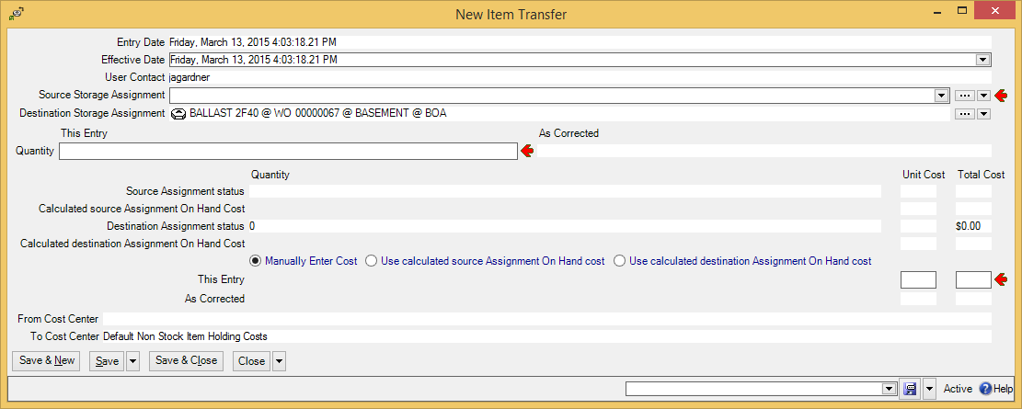

- In “Source Storage Assignment” , specify an existing storeroom assignment record that gives an item of the correct type and a storeroom that contains items of that type.
- In “Quantity” , enter the quantity being transferred.
- You must now specify the value of the item(s) being transferred. You can tell MainBoss to calculate from the value associated with the “from” storeroom (by clicking Use calculated source Assignment On Hand cost) or to calculate it from the value associated with the “to” storeroom (by clicking Use calculated destination Assignment On Hand cost). Alternatively, you can click Manually Enter Cost and enter the value directly in “This Entry” .
- Click Save & Close to save the information and close the window.

If you want to transfer items to a regular storeroom from a temporary storage location, you use a similar process and the button Item Transfer To.

Assigning People to a Work Order
Assigning someone to a work order indicates that the person has some interest in the work order. For example, you might assign the work order’s requestor or the workers who will eventually do the job. You might also assign some supervisor who’s responsible for seeing that the work gets done, or an inventory clerk who’s responsible for seeing that needed inventory items are ready by the time the job begins.

In order for someone to be assigned to a work order, the person must be on the list of authorized work order assignees: Coding Definitions | Work Orders | Work Order Assignees.

In MainBoss terminology, assigning someone to a work order is different than scheduling someone to work on the job:

- You assign someone to a work order when you want to draw that work order to the person’s attention. You make this assignment in the work order’s Assignees section.
- You schedule a worker to work on a job in the work order’s Resources section.
If you schedule a worker to work on a job, the worker is automatically considered assigned to the job (provided the worker is properly authorized in Coding Definitions | Work Orders | Work Order Assignees). All such workers will automatically appear in the work order’s Assignments section.

If a MainBoss user is assigned to a work order, the work order will be displayed in My Assignment Overview | Open Work Orders whenever that person uses MainBoss. Since this table only shows open work orders, the work order will not displayed when it’s just in the draft stage, nor will it be shown after the work order is closed.

- To assign someone to a work order:
- Open the work order window and go to the Assignments section:
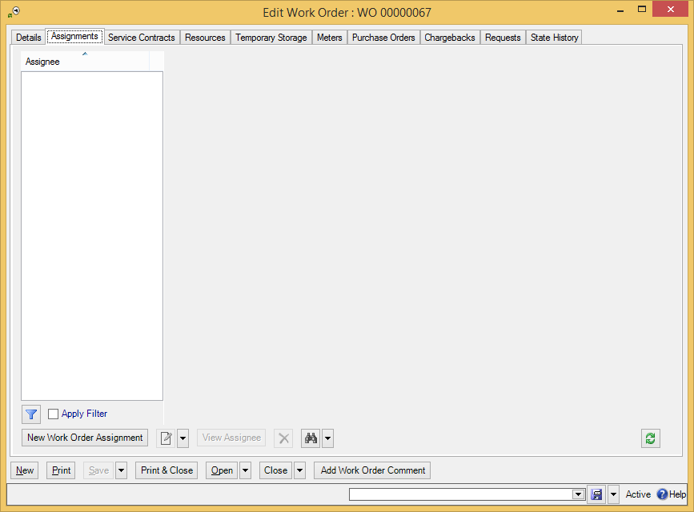

- Click New Work Order Assignment . MainBoss opens the following window:
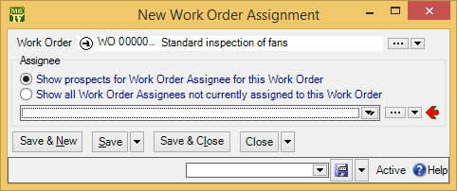

- If the person is already associated with this work order in some way (e.g. the person is the requestor or the person is a worker who’s been assigned to the job), click Show prospects for Work Order Assignee for this Work Order . Otherwise, click Show all Work Order Assignees not currently assigned to this Work Order .
- In the drop-down list , select the person whom you want to assign to this work order.
- Click Save & Close to save this assignment and close the window.

Modifying Draft Work Orders
After you have created a work order, you may need to make changes. For example, you may schedule the job for a particular day but then you’re forced to reschedule.

Work orders are easy to modify when they’re in the draft state. Once you’ve opened a work order, much of the information is “locked in” and can’t easily be changed.

- To modify a draft work order:
- Select Work Orders | Draft Work Orders from the control panel. MainBoss displays all draft work orders:
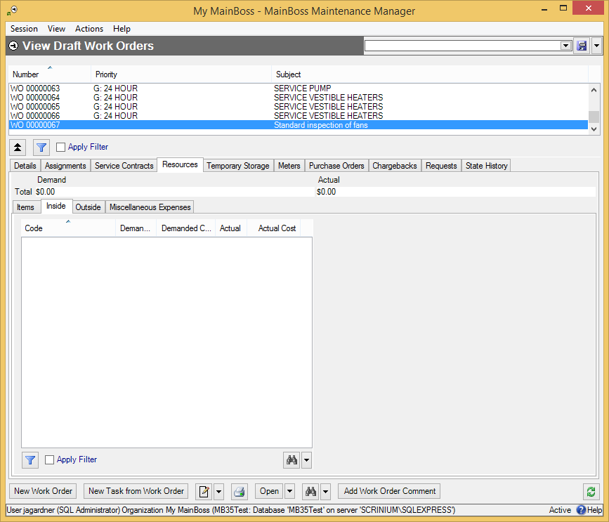

- In the list of work orders , find the work order you want to change. Click that work order to select it.
- Either double-click the work order where it appears in the list, or click .
- MainBoss will open a window showing all the information you have previously recorded about the work order. Make any changes you want, then click Save & Close. This saves the new information and then closes the work order window.

Opening a Work Order
Once you’ve filled in all necessary information on a draft work order (and once you’ve received any necessary approvals from management), you can open the work order. When you open a work order, you’re saying it’s ready to be printed off and handed to workers.

- To open a draft work order:
- Select Work Orders | Draft Work Orders from the control panel. MainBoss displays all draft work orders:
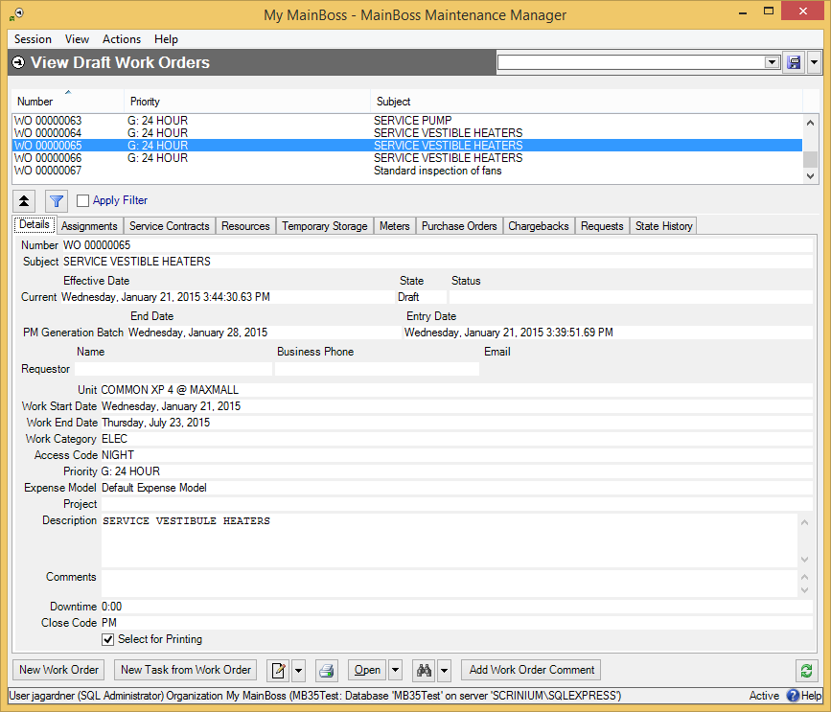

- Click Open .

As an alternative, you can drop-down the arrow on Open and use Open Work Order (With Comment) to open the work order and also record a comment.

Cancelling Draft Work Orders
You can cancel a draft work order. To do so, go to Work Orders | Draft Work Orders in the control panel. This opens the work order table viewer.

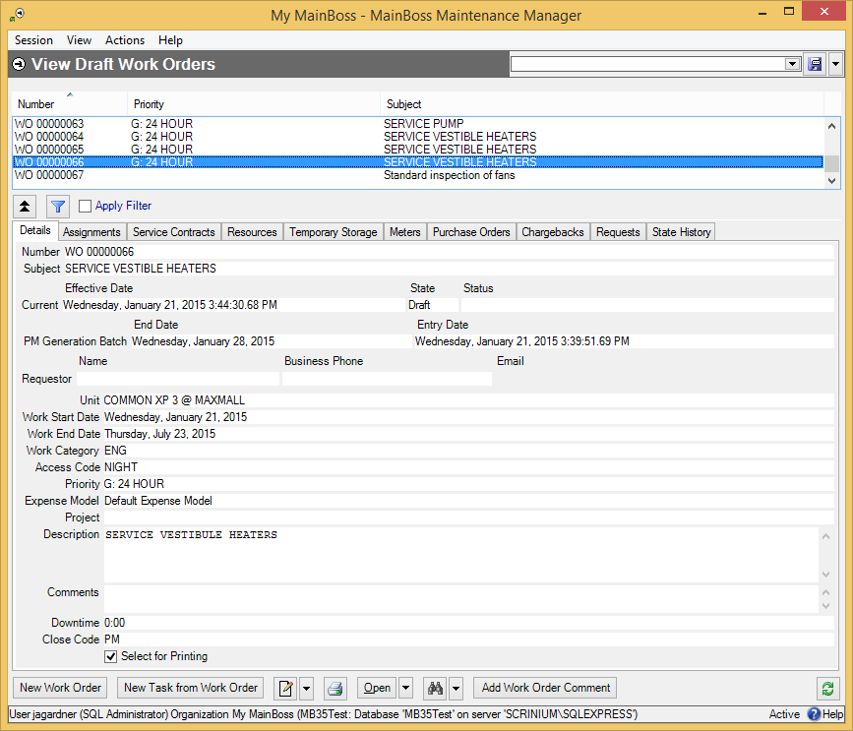

In the list of work orders, click the work order you want to cancel, click the arrow beside Open , then click Void. When you void (cancel) a work order, the work order disappears from Work Orders | Draft Work Orders and appears in Work Orders | Void Work Orders.

Important: You cannot use Void on an open work order. You must first Suspend the work order (changing it from open back to draft), and then you can use Void. Suspend is on the same drop-down button as Void.

MainBoss only lets you void work orders if they have no expenses associated with them (i.e. if all the actuals have a value of zero). If a work order already has actual expenses associated with it, you can’t void it until you Correct all the expenses to zero.

Voiding a work order gets rid of any demands associated with it.

Printing Open Work Orders
Once you have opened a work order, you typically print it and give it to the people who will actually do the job.

You can print a single work order as soon as you open it. You can also print a batch of work orders at once; for example, you might open a number of work orders, then print them all off together.

As explained in Select For Printing on page 1, new work orders are typically created with the Select for Printing box checkmarked. This simplifies the job of printing a batch of work orders that haven’t been printed yet.

- To print work orders which are marked “Select for Printing”:
- In Work Orders | Open Work Orders, click .
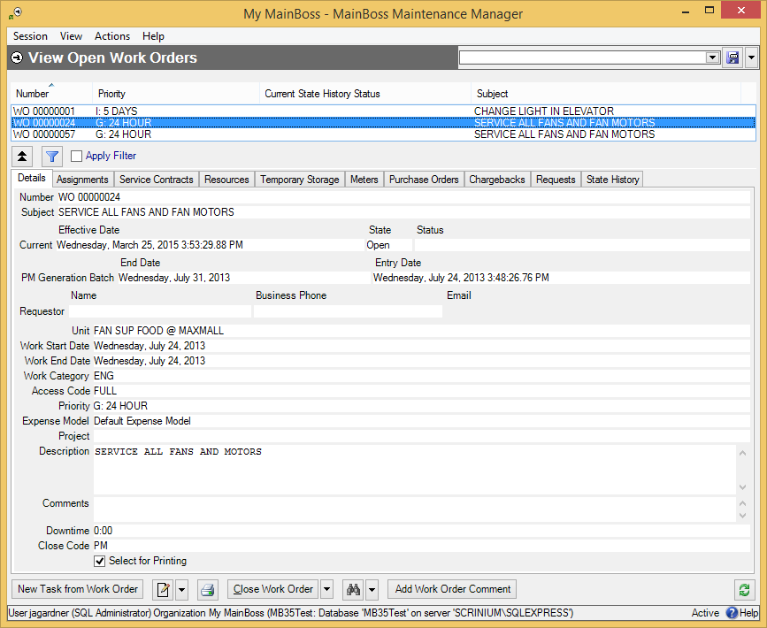

- MainBoss opens the following window for specifying which work order(s) you want to print:
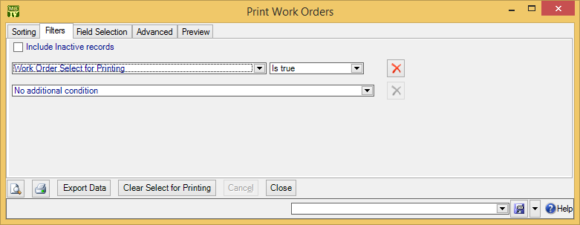

- In the Filters section, choose to see all work orders where Select for Printing is true (as shown in ).
- Click the preview button . MainBoss displays a preview of the work orders to be printed:
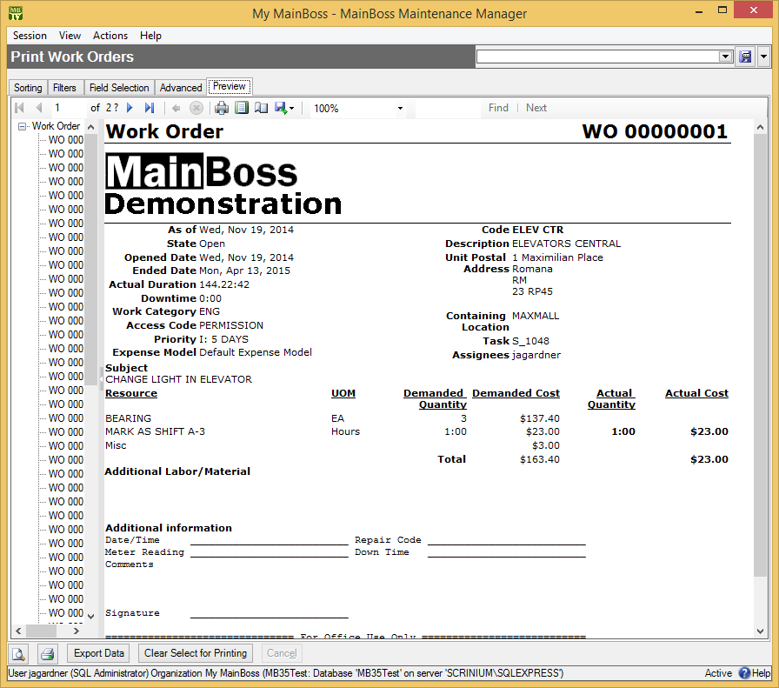
- Click to print the work orders.
- Once the work orders have been printed, click Clear Select for Printing . This blanks out the Select for Printing checkbox on all the work orders, because they have now been printed.

Using Select for Printing is the easiest way to print any work orders that haven’t been printed before. However, you can also select one or more work orders to be printed, whether they have or haven’t been printed before.

- To print one or more selected work orders:
- In Work Orders | Open Work Orders, click .
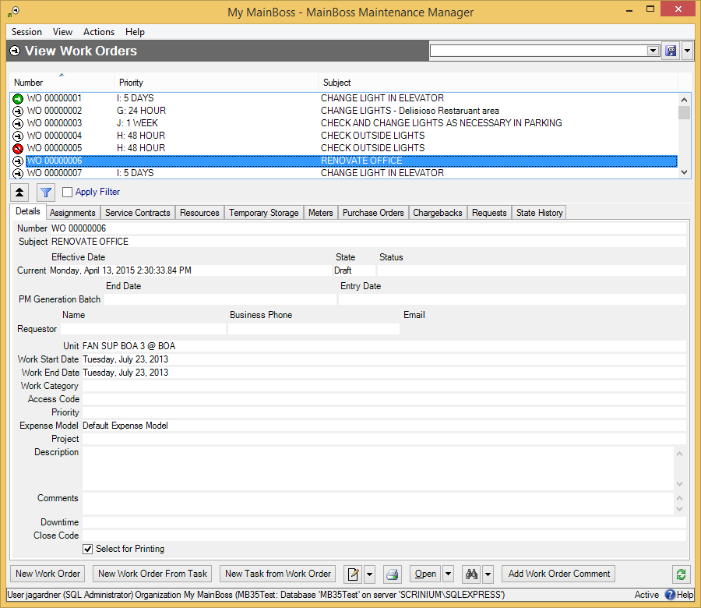

- MainBoss opens the following window for specifying which work order(s) you want to print.
- Go the Filters section of the “Print Work Orders” window. Choose “Work Order” for the first field and “is one of” for the second field.
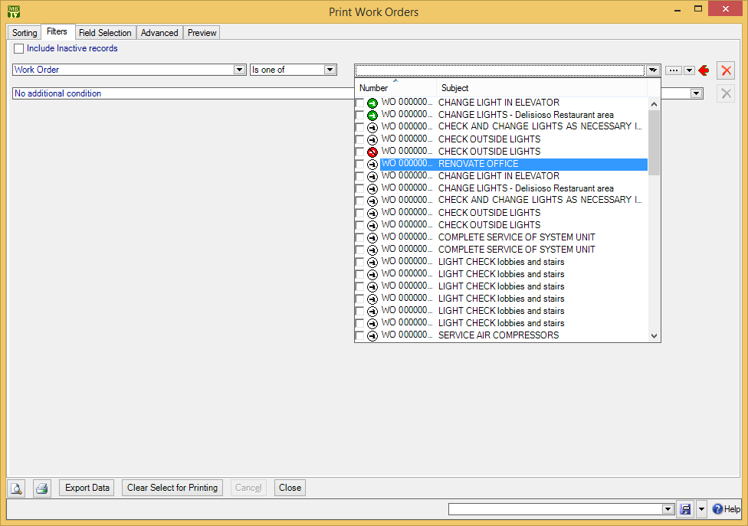
As shown, you can use the checkboxes to select the work orders you want to print.

The print window also lets you print work orders according to a number of criteria. For example, you can print all work orders (past and present) on a particular unit or in a specified location. You can print all overdue work orders that have a given priority. You can print all work orders that were closed in the past month. By combining options, you can get detailed reports or summaries about the state of work orders, open or closed.

Closing a Work Order
After a job is finished, you should close the associated work order. This means that you record final information about the job; for example, you record the actual labor and material costs (as opposed to any estimates you made when creating the original work order).

You begin to close the work order in the same way that you begin editing a work order (as described in Modifying Draft Work Orders on page 1). Select the work order in Work Orders | Open Work Orders, then click . After you’ve done this, go through the steps described in the next sections of this chapter.

Correcting Work Order Information
The first step in closing a work order is to review the work order’s information and make any corrections that might be necessary. For example, when you create a work order, you specify dates when the job is supposed to start and end. When you close a work order, you should record when the job actually started and ended.

- To correct simple work order information:
- In the Details section of the work order, review the details to make sure the job started and ended on the dates originally scheduled.
- In the Resources section of the work order, create demands for labor or materials that were used on the job but aren’t already on the work order.

Actual Labor and Material Expenses
The Resources section of a work order should state all the labor and materials expenses associated with the job. Before the work is done, you set up demands that reserve materials and assign workers to the job; after the work is done, you record what you actually spent on labor and materials.

If a job used labor or materials that weren’t expected before the job began, you must create demands for them after the fact. Every expense must have a demand.

Once you have demands for all your expenses, you can record the actual labor and materials used:

- To make Actual expense records from demands:
- In the Resources section of a work order, click on a demand . This can be a demand for labor or materials.
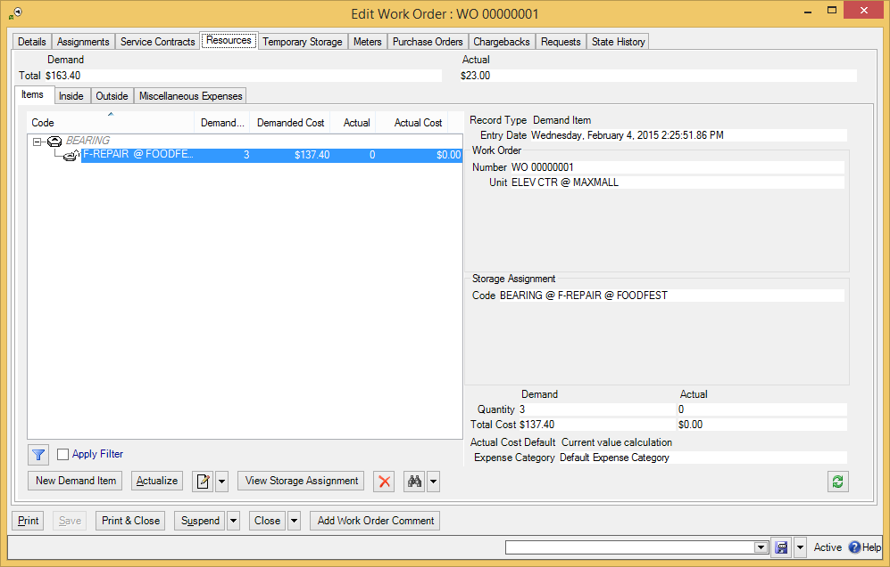

- Click Actualize . MainBoss opens a window where you can enter actual details about the labor or material expense.

There is a separate window for each type of expense: Item, Hourly Inside, Per Job Inside, Hourly Outside, and Per Job Outside. Each of these windows displays information from the original demand and has fields letting you specify any differences. For example, if an original Hourly Inside record specified that a job was expected to take an hour but it actually took an hour and a half, you can fill in the “Quantity” field with the time that the job actually took.

Each window also has a checkbox which use can use if your original estimate was correct. For example, the Actual Hourly Inside window has a checkbox labeled “Use all remaining demand”. If you checkmark this box, you’re saying the original time demanded was correct.

Cumulative Records: On lengthy jobs, it’s useful to record actual expenses as you go along rather than waiting until the job is finished. For example, if a renovation takes several weeks, you might record labor and materials used at the end of each workday; that way, you have a more accurate picture of your day-to-day expenses. It’s also easier to remember what you did during a single day than to recall all the materials and labor you used over a number of weeks.

To record expenses cumulatively, you use the same process described earlier in this section. For example, suppose that worker X is scheduled to spend three 8-hour days on a job, for a total of 24 hours. You’ve created a demand stating this expectation.

- At the end of the first day, select that demand and click Actualize.
- MainBoss opens a window where you can record the actual time that worker spent on the job during the day. You enter this time in the “Quantity” field (e.g. 8 hours).
- At the end of the second day, do the same thing. When MainBoss opens the Actual Hourly Inside window, you’ll see that it says you’ve already recorded 8 hours for this worker. Record another 8 hours.
- Repeat this process as often as necessary.
The same applies to material costs. If, for example, you have a demand for 100 gallons of paint over the course of a renovation, you can start with the demand and use Actualize to record how many gallons you used on a particular day. (On the other hand, you may decide you don’t need to track materials on this level of detail. It’s up to you whether you record materials day-by-day or just at the end of the job.)

Chargebacks
Chargebacks on a work order indicate that all or part of the costs should be charged to another party. For example, a rental management facility might charge tenants for all or part of the costs on some types of repairs.

One work order can include chargebacks to multiple parties. For example, if a job in a rental building affects several tenants, the work order could include a chargeback to each of the tenants involved.

Each chargeback record names a requestor: the person or organization who’ll be charged for the work. In addition, the chargeback record has one or more activity records: labor or materials that should be charged for the requestor. For example, you might make one activity record to state materials charges and another for labor charges. Alternatively, you might make more detailed activity records, such as individual labor expense records for each person who worked on the job.

Chargeback amounts do not have to match actual expenses. This gives you the flexibility to deal with situations where you only charge customers a percentage of actual expenses, or where you charge customers a fixed amount regardless of actual expenses.

- To record a chargeback on a work order:
- Go to the Chargebacks section of the work order.
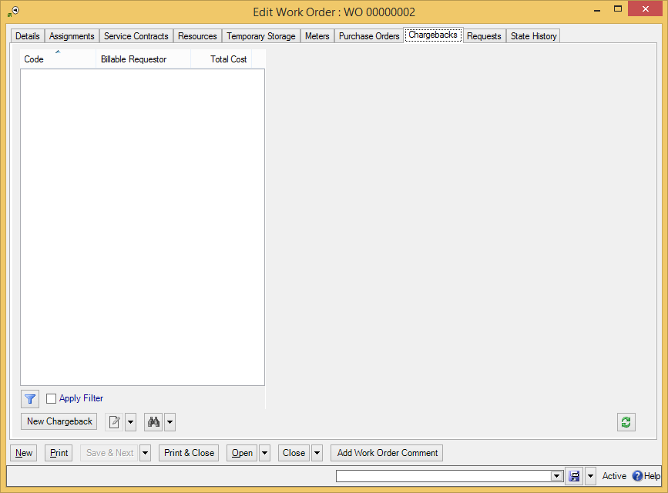

- Click New Chargeback . This opens a window where you can specify information about the chargeback.
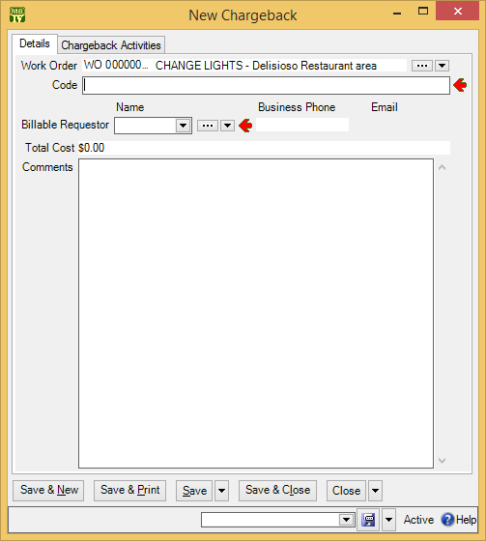

- In “Code” , enter an identification code for this record (e.g. the invoice number that will be used when billing the client).
- In “Billable Requestor” , specify the requestor to whom the charges will be billed.
- Click Save to save the information.
- Go to the Chargeback Activities section:
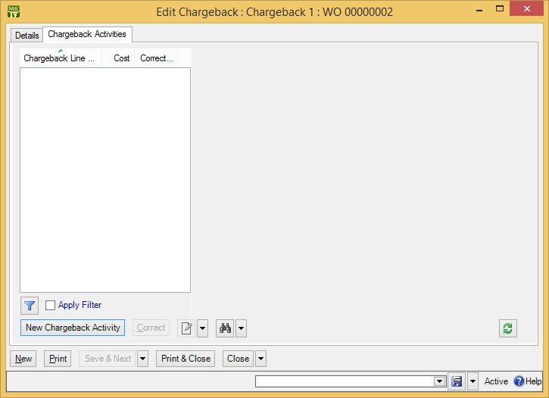

- Click New Chargeback Activity . This opens a window where you can enter information about one of the expenses being charged to the requestor.
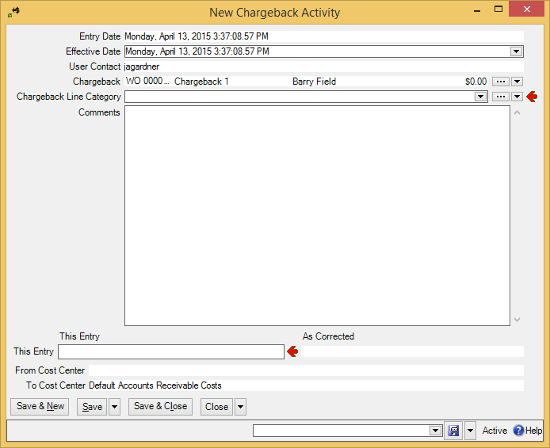
- In “Chargeback Line Category” , specify the type of expense that is being charged to the requestor.

- In “This Entry” , specify the cost of this particular expense.
- If there are other expenses to be charged, click Save & New to save your current information and start a new expense record. Otherwise, click Save & Close to save the information and close the window.
- When you return to the original chargeback record, click Save & Close to save the information and close the window.
- When you return to the work order itself, click Save to save its current information.

Correcting Chargebacks: You cannot directly delete chargebacks—when you create a chargeback, MainBoss creates an accounting record which (for audit purposes) cannot be deleted. If you wish to negate a chargeback, use Correct on the chargeback lines and set the charges to the correct amount.

Closing Information
Once a job is finished and you’ve recorded all pertinent information on the work order, you can close the work order. You do this using the work order’s Close Work Order button.

Important: Don’t confuse Close Work Order with the Close button (which just closes the window) or Save & Close (which saves the work order and closes the window, but does not close the work order).

Before you close a work order, you should record a unit’s “Downtime”: how long the unit was inoperative before and/or during the job. Tracking this information can tell you how effective planned maintenance is: does it actually reduce equipment downtime? It can also let you fine-tune your planned maintenance schedule; by examining unit downtime, you can see where you need to increase planned work.

Before closing the work order, you should also record a “Closing Code”. Different organizations use this code for different purposes. For example, some organizations might choose to classify the type of work done (plumbing, electrical, renovation, etc.). Some might choose to classify the original cause of the problem (normal wear and tear, operator error, vandalism, etc.). Some might use these codes for other purposes. Whatever your organization does with the codes, an appropriate one must be specified when you close a work order.

Closing codes have no direct effect on a work order. However, they’re useful in producing targeted reports. For example, if you use a closing code to identify work done in response to vandalism, you can then prepare reports that tell how much vandalism costs you. If you don’t use closing codes to record such information, you can’t obtain such reports.

Closing Options: There are three slightly different ways to close a work order:

Close Work Order button (on Work Orders table viewer or a work order editor): This button closes the work order immediately.
Close Work Order (With Comment) (on the drop-down list for the Close Work Order button in a Work Orders table viewer): This prepares to close the selected work order, but first opens a window where you can record closing information including the “Downtime”, a “Closing Code”, and a comment about the job. When you Save & Close the comment window, the work order will be closed.
Close Work Order (With Comment) (in the work order editor): This is similar to Close Work Order (With Comment) in the table viewer, but does not prompt you to enter “Downtime” or “Closing Code”.
We recommend that you always record a downtime and closing code. The following instructions show one way to do this:

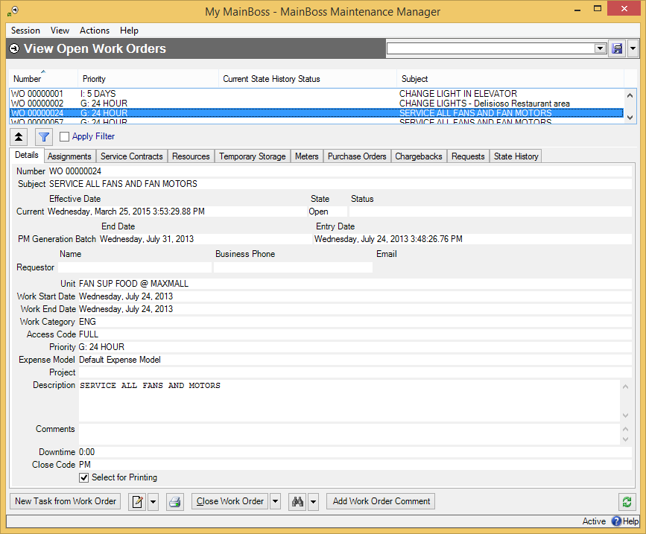

- To record downtime and closing code before closing a work order:
- Go to the open work order viewer (Work Orders | Open Work Orders), click on the work order you want to close, then click . MainBoss opens a window where you can edit the work order:
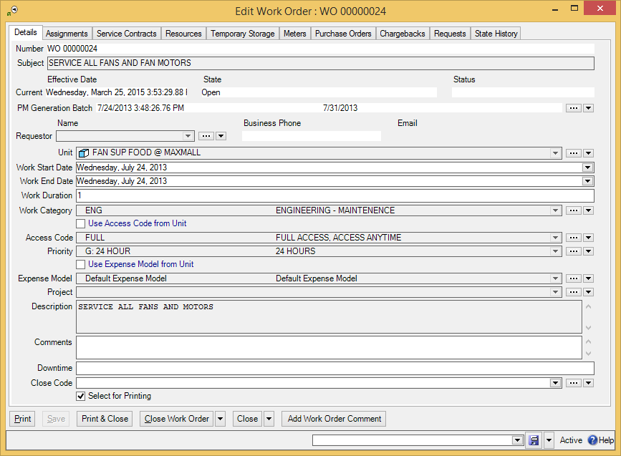
- In “Downtime” , record how long the associated unit was inoperative, if appropriate.

- In “Closing Code” , specify a closing code for the work order.
- Click Close Work Order .

As an alternative, you could select the work order in the table viewer, then click the drop-down button on Close Work Order and click Close Work Order (With Comment). This also gives you an opportunity to record the downtime and closing code.

Paying for Outside Labor with a Purchase Order
If you have licensed the Purchasing module, you can create purchase orders to deal with the cost of outside labor on work orders. MainBoss makes it easy to coordinate the labor demands on a work order with the corresponding costs appearing on a purchase order.

The first step in this process is to specify the work to be done. For example, suppose you need to hire a plumber to repair some faulty plumbing. You’d begin by creating a work order describing the job you want done. This would specify all the usual information (e.g. the unit that needs to be fixed, the description of the work to be done, the expected start and end dates, etc.).

Next, you would create a demand for the plumber’s labor. To do this, go to the work order’s Resources section, and then to the Outside subsection. This subsection deals with labor by outside contractors. Use New Demand Hourly Outside or New Demand Per Job Outside to create a demand for the plumber’s expected labor.

Note: MainBoss doesn’t “lock you in” to a specific outside contractor. For example, suppose you create an hourly outside demand saying that you intend to hire Plumber X. You can still hire some different plumber without changing the original demand; in other words, MainBoss lets you treat the demand as a suggestion rather than an absolute requirement.

Once you’ve created the demand for outside labor, click the New PO Line button. This opens a window where you can create a purchase order entry corresponding to the labor demand.

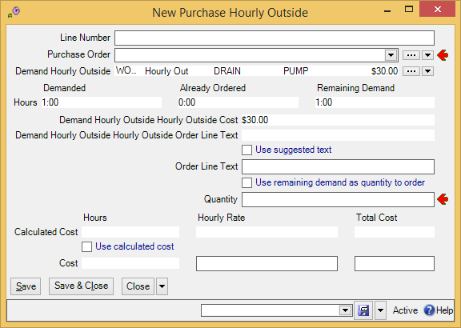

At this point, you can use the “...” button associated with “Purchase Order” to create a new purchase order for the plumber’s services. (For information on creating purchase orders, see Creating a New Purchase Order on page 1.) Alternatively, you can add this labor expense to an existing purchase order, if appropriate.

Once you’ve created or chosen the purchase order, use the above window to enter information about the labor. Often, you’ll just checkmark Use suggested text, Use remaining demand as quantity to order and Use calculated cost so that the purchase order reflects the same information as the demand.

After you’ve created the purchase order line item, the work order window will show the demand and the PO line:

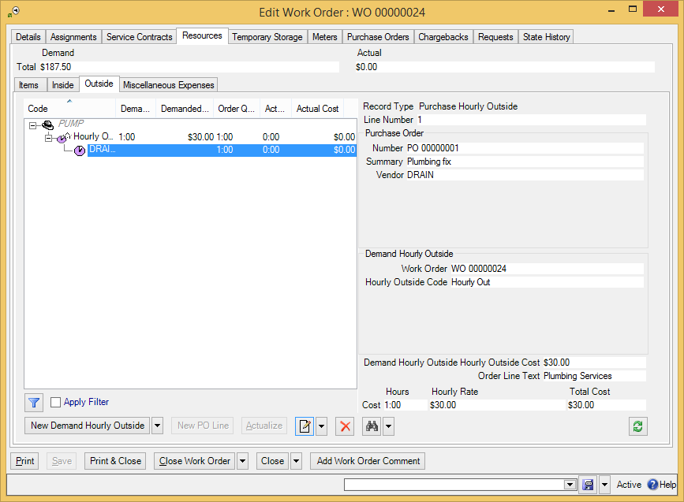

You’ll also notice that the Purchase Orders section of the work order lists the associated purchase order.

You should issue the purchase order once you’ve prepared it. For more information, see Issuing a Purchase Order on page 1.

After the job is done, you can actualize the contractor’s work. We recommend that you do this as follows:

- Go to the Resources section of the work order.
- Go to the Outside subsection.
- Click on the line for the purchase order entry (not the original demand).
- Click Actualize.
This opens a window where you can actualize the contractor’s work and also edit the associated purchase order to indicate that the labor was received. (For more on receiving labor on a purchase order, see Recording the Receipt of Services on page 1.)

Other Work Order Sections
In addition to the sections already discussed, a work order has the following:

- Meters section: Lists meter readings for the unit associated with the work order. You can use this section to record meter readings during or after the job. (To record a new meter reading, click New Work Order Meter Reading.)
- Requests section: Lists any requests associated with this work order. For example, if the work order was created from a request, this section will list the original request. The section can also be used to create new requests. For example, during an oil change, a worker might notice that the vehicle has some other problem; the worker could create a work request reporting the problem and asking that it be fixed.

Multiple Work Orders, Multiple Requests
Requests often lead to work orders. However, there doesn’t have to be a one-to-one correspondence.

For example, suppose that a toilet backs up and floods a washroom. Three different people send email to MainBoss Service reporting the problem. In response, the maintenance department creates four work orders: a short-term one (clean up the mess in the washroom and temporarily close off the toilet stall), a medium-term one (call a plumber), and two long-term ones (repair water damage to the washroom, and repair other damage caused by leaks into the floor below). This makes three requests and four work orders.

As a result of such possibilities, closing a work order doesn’t necessarily mean that you’ve satisfied related requests. More work may be needed before a request is satisfied. Therefore, when you close a work order, MainBoss does not close related requests. You must close all requests separately.

To close the requests related to a work order, we recommend the following:

- When a request is related to a work order, make sure you link the request to the work order (either through the Work Orders section of the request or in the Requests section of the work order).
- Once you close a work order, go to the work order’s Requests section. This will show you all the requests you have to close.
- Click the first request in the list, then click or View. This opens the record that links the request and the work order.
- In the “Number” field of the linking record, click the “...” button. This opens a requests viewer with the appropriate request selected.
- In this requests viewer, you can use Close Request to close the request.
- Repeat this process for each request linked to the work order.

If you turn on the Requests are automatically set In Progress when linked to a work order, and are closed when work order closes option, closing a work order automatically closes all linked requests, provided that the requests are only linked to this single work order. (If a request is linked to multiple work orders, you must close it manually—the request isn’t closed automatically, even if you close all its linked work orders.) To turn on this option, go to Requests in the control panel, go to the Defaults for Requests section, and click Edit Defaults. Turning on this option also means that when you create a work order from a new request, the request is automatically put into the “in progress” state.

The Edit Defaults window also has a field labeled Comment to requestor for requests that are automatically closed when their linked work order closes. This field lets you enter a message that will automatically be emailed to requestors whenever one of their requests closes because a linked work order closed. For example, you might use this message to direct requestors to a web page that contains a user satisfaction survey. (Note that the message is only emailed out if you have licensed the MainBoss Service module.)

Units

MainBoss records information about the places and equipment on which you perform maintenance. These are called units.

The Configuration guide describes how to set up initial information about your units. This Day-to-Day Operations guide describes actions that you might do on an ongoing basis, e.g. recording meter readings for your units.

To begin with, here is some basic terminology.

Meter: A device that is associated with a unit and that measures information relevant to maintenance work.

Examples include mileage meters on vehicles or clocks indicating hours of use for pieces of equipment.

It is helpful to take regular meter readings and record them in MainBoss. For example, this lets you schedule planned maintenance according to meter readers (e.g. inspecting a piece of equipment every 500 hours of use).

The readings given by a meter are assumed to increase over time. This is not true in some cases (for example with meters that roll over at 99999). To handle this situation, MainBoss uses meter offsets as described in Meter Offsets on page 1.

Specification: Information that may be helpful in performing maintenance on a unit.

With a vehicle, for example, it may be useful to record engine type, gas tank size, tools required for servicing, and so on.

Attachment: An online file that contains useful information about a unit.

For example, you might have schematic diagrams available on your computer, or documents recording information that isn’t in your MainBoss database.

Any kind of file can be specified as an attachment. For example, a rental management company might have online legal documents describing lease agreements with tenants. These documents could be attached to MainBoss records if they would be useful to personnel who want to know what kind of maintenance has been contractually guaranteed.

System: A collection of interrelated units.

For example, your equipment for heating and air-conditioning might be regarded as a single HVAC system.

Grouping your units into systems can make it easier for you to identify large-scale trends or to create more fine-tuned reports. For example, if you specify which units belong to the HVAC system, it becomes easy to provide management with a report listing all HVAC problems over a given period.

Relationship: A connection between units or between a unit and a person.

For example, a hot-water heater might supply hot water to several different bathrooms. If so, it’s useful to record this information in your MainBoss unit records; then, if a bathroom isn’t getting hot water, you can quickly identify the heater involved, even if it’s a long way from the bathroom where the problem was reported.

Similarly, it may be that a piece of manufacturing equipment is usually operated by a particular person. If something goes wrong with that equipment, workers might find that it’s helpful to talk to that person for more information about the problem.

Relationships are recorded in the Related section of unit records and contact records. This is worth checking whenever you work on a unit, in case it holds helpful information.

Units and locations may have associated map coordinates. If your database specifies map coordinates for a unit or location, you can use the Show on Map button to find out where the unit/location is. If you click Show on Map, MainBoss attempts to open Google Maps to a map that shows the geographic position of the unit/location. (In order for this to work, you need an active Internet connection and a suitable web browser.)

Meters
Meters can be used to schedule planned maintenance. For example, you might specify that a car needs an oil change every 3000 miles as measured by the car’s odometer.

In order for the scheduling process to work, you have to record meter readings on a regular basis. Suppose, for example, you record mileage readings for a car every week. After a few readings, MainBoss can figure out the average distance the car travels every day and can then predict when the next oil change should be scheduled. Obviously, this is just an approximation, but the more readings you record, the better predictions MainBoss can make.

When you generate planned maintenance work orders, MainBoss checks its meter predictions to see if any meter-scheduled jobs are expected to come due in the given period. If so, MainBoss creates an appropriate work order for the required task. Depending on the options you set, MainBoss can also create planned work orders if it finds that a meter reading has unexpectedly gone past the point when work was supposed to be scheduled (e.g. if you drive a car much farther than usual in a particular week so that you unexpectedly go past the mileage reading where an oil change is due).

Recording Meter Readings
It is helpful to record meter readings on a regular basis, especially if you base planned maintenance on those readings. For example, suppose a piece of equipment needs maintenance every 500 hours of use. Then you should record the hours of use regularly so MainBoss can tell you when 500 hours have passed since the last maintenance.

- To record a meter reading:
- Select Units from the control panel.
- In the list of units, select (click) the one that contains the meter whose reading you want to record.
- Click to open the unit record.
- In the Meters section of the unit, click the meter whose reading you want to record.
- Click New Meter Reading. MainBoss opens a window where you can record the new reading.
- In “Effective Date”, specify the date/time when the meter reading was taken. (By default, the field shows the current date/time.)
- In “Reading”, enter the reading from the meter.
- Click Save & Close to save the information and close the window.

Meter Offsets
Many meters wrap around when they reach a particular point. For example, a meter with only five digits will wrap around from 99999 to 00000. In this case, 00000 really means 100000 but the meter doesn’t have enough digits to show the true measurement.

For measurement accuracy—especially if you are scheduling planned maintenance based on meter readings—it’s important that MainBoss can interpret what a meter reading really means (e.g. that 00000 really means 100000). MainBoss solves this problem with meter offsets. A meter offset is a number that MainBoss adds to the reading you see on the meter in order to come up with the true value for the meter.

In our example of the five-digit meter, the meter offset is zero until the first time the meter wraps around. Then you should set the meter offset to 100000; this means that when the meter reads (for example) 00123, the real value is actually 100123. If and when the meter wraps around again, you should set the meter offset to 200000, and so on. In this way, workers can simply record the readings they see on the meter, but MainBoss can still calculate the true value associated with the meter.

Meter offsets may also be used when an old meter breaks and a new meter must be installed. For example, if the old meter breaks at 12345 and you install a new meter that starts at zero, you should specify a meter offset of 12345. This tells MainBoss to add 12345 to all readings from the new meter in order to determine the true value of what is being measured.

Important: You must change the meter offset every time a meter wraps around, every time you reset a meter to zero, and every time you replace an old meter with a new one. Otherwise, MainBoss will not be able to convert meter readings into true values and you will not be able to schedule planned maintenance by meter readings.

- To specify the meter offset for a meter:
- Go to Coding Definitions | Units | Meters. MainBoss displays a list of meters defined on your equipment.
- Select the desired meter from this list, then click . MainBoss opens a window where you can enter a new offset:
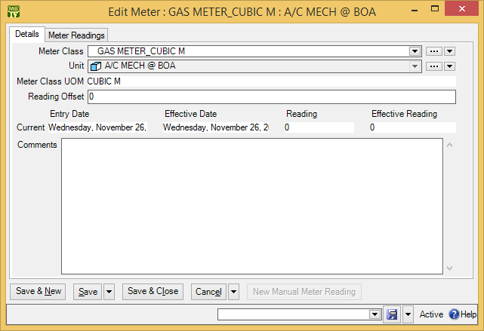

- In “Offset” , enter a new offset for the meter.

- Optionally, in “Comments” , enter a comment explaining why the new offset was necessary.
- Click Save & Close to save the information and close the window.

Defective Meter Readings: If you record a meter reading that is lower than the last reading, MainBoss issues a message saying that the reading is defective. Either you mistyped the reading, or it’s time to set the meter offset.

Planned Maintenance

This chapter is only relevant if you have licensed the Planned Maintenance module. If you do not have a license key for this module, the control panel will not contain entries related to planned maintenance.

This chapter introduces the basics of scheduling planned (preventive) maintenance (PM). Each PM job is represented by a work order, just as a repair job would be. However, PM work orders are created and scheduled by MainBoss itself; you do not make them up individually the way that you do with corrective jobs.

Here are some terms that MainBoss uses in connection with planned maintenance:

Task: A description of a particular planned maintenance operation.

For example, a task might describe everything that should be done during an oil change on a forklift truck. This could include inspecting engine belts, checking the filters, etc. in addition to the oil change itself.

Task descriptions are typically written up as checklists or step-by-step instructions for workers to follow.

Unit Maintenance Plan: A record giving a unit, a task, and timing for doing the task on the unit.

For example, the record might say that a particular vehicle (the unit) needs an oil change (the task) every three months (the timing).

The Configuration guide explains how to set up the plans for planned maintenance. This guide explains how to use your existing plans to create planned maintenance work orders.

Generating Planned Maintenance Work Orders
In order to schedule planned maintenance, you must explicitly tell MainBoss to generate appropriate work orders.

Important: PM work orders are not generated until you tell MainBoss to do so. You must explicitly tell MainBoss to generate the work orders.

PM work orders are always generated for a specific period. For example, every Friday you might generate work orders for the next week (up to and including the next Friday). MainBoss will then check all the PM schedules and see which jobs come due in the specified period. MainBoss will also check all the meter readings that have been recorded and will determine which jobs will come due based on those readings.

You specify a time period by giving the last day of the period. MainBoss will generate work orders for all jobs up to and including that day. For example, suppose that the last time, you generated all work orders up to March 30. The next time you generated work orders, you might tell MainBoss to generate work orders up to April 15; then MainBoss will generate work orders for all PM jobs that come due from March 31 to April 15 (inclusive).

- To generate PM work orders:
- Select Unit Maintenance Plans | Generate Planned Maintenance from the control panel. MainBoss displays list of records for all previous times that you generated planned maintenance jobs.
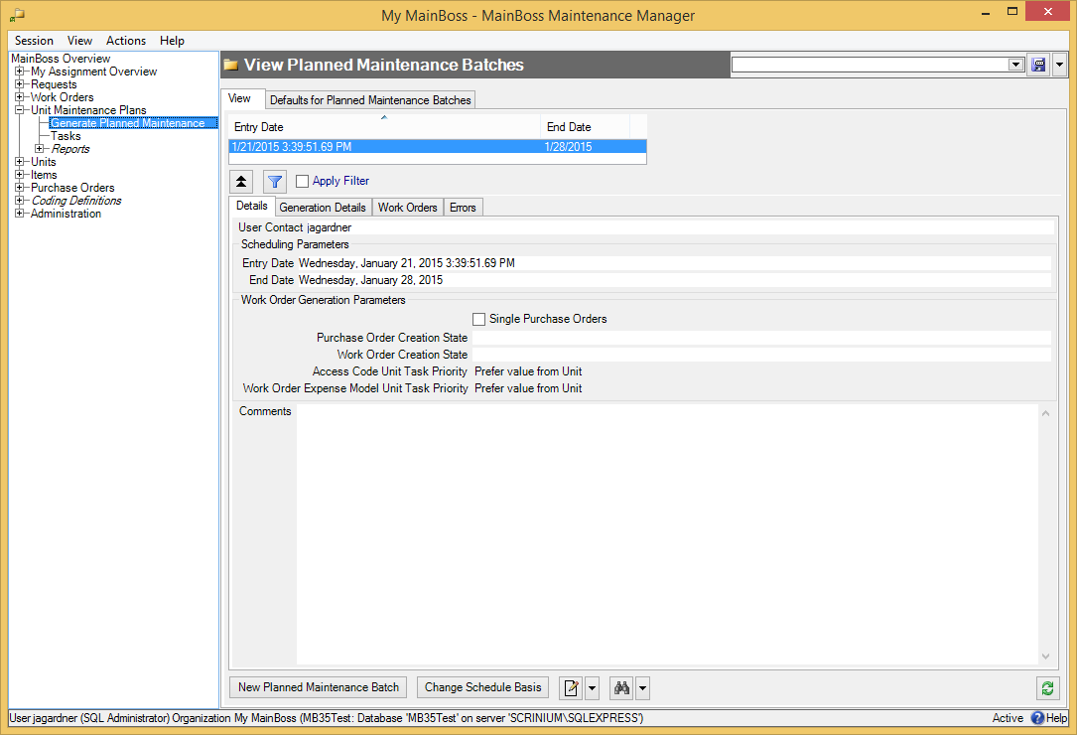

- Click New Planned Maintenance Batch . MainBoss opens a window where you can begin the generation process.
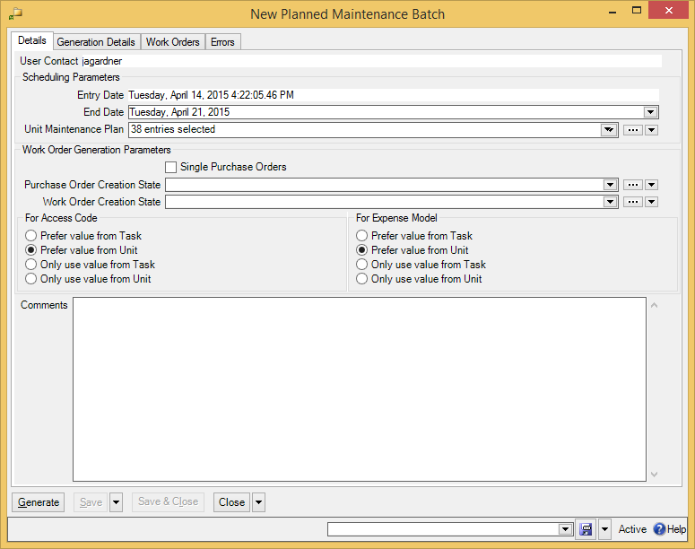
- Check the date in “End Date” and make sure it’s what you want. (MainBoss will generate all PM work orders up to and including the specified date.) Change the date if you want a different one.

- Click Generate . MainBoss will generate an initial list of work orders for the planned maintenance tasks that are due. This list is displayed in the Generation Details section.
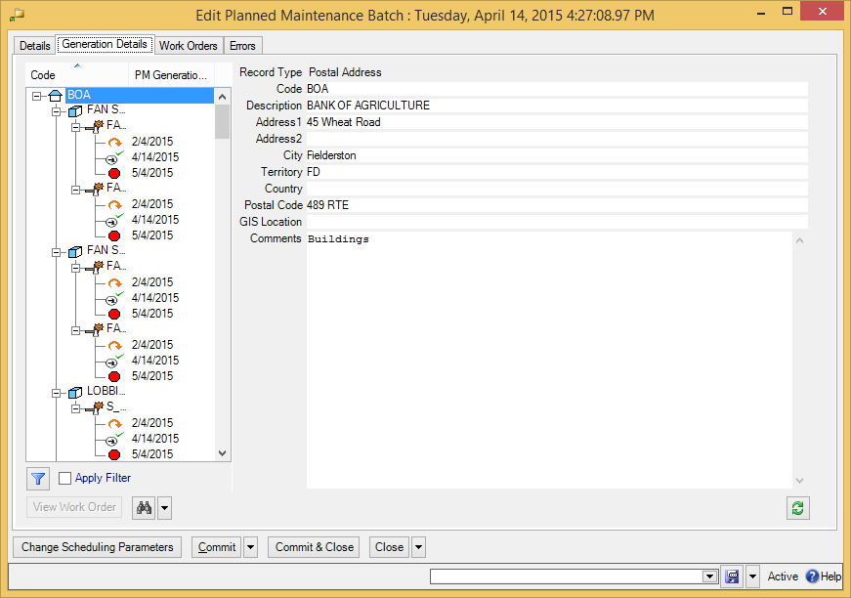
- Examine the list to make sure it’s what you expect. If it’s acceptable, click Commit to create the actual work orders.

Note: The Errors section of the record will report any errors that were found during the Commit process. For each entry in the Errors list, check the “Disposition details” field. This will tell you the source of the problem. Often, you’ll find out that there’s something that needs correcting in a task or a maintenance timing record.

You might be wondering why work order generation is a two-stage process: first Generate, then Commit. The answer is that the two-stage process gives you a chance to deal with mistakes.

For example, suppose that you mistype the year in “End Date”—you type January 1, 2009 rather than 2008. When you click Generate, you’ll see that you’ve got a lot more potential work orders than you expected; you can check to see what’s wrong and correct the error.

Similarly, if you made a mistake in setting up the maintenance schedule for a particular unit, you can see that something is wrong and fix the problem before making the actual work orders.

To fix any problems in planned maintenance generation, click Change Scheduling Parameters. This clears the Generation Details section and lets you edit previous fields in the record. Once you’ve made your correction, click Generate again.

Separating Generate and Commit gives you a chance to avoid the creation of incorrect work orders. You can check your work before actually committing to the final list of jobs. Once you Commit, however, you cannot uncommit—the work orders will be created and appear in your Work Orders table.

Adjusting Planned Maintenance Work Orders
After MainBoss has generated a set of PM work orders, you may adjust any of those work orders to reflect special circumstances. For example, suppose that a PM task description assigns a job to a particular worker, but that worker is sick or on vacation. In this case, you can adjust the generated work order to assign the job to someone else.

As another example, suppose a vehicle is scheduled for a routine oil change but you’ve also received a complaint about a slow leak in one of the vehicle’s tires. You may choose to modify the oil change work order to tell workers to deal with the slow leak too.

You can adjust a work order at any time, but many organizations find it convenient to review PM work orders immediately after the work orders have been generated.

After you Commit to a set of work orders, the Work Orders section of the planned maintenance generation record will list the work orders that were generated. To edit any of the work orders, select the work order in the list, then click .

Standard (Boilerplate) Work Orders
Your organization may define standard work orders (also called boilerplate work orders). These are pre-existing templates that can be used to create work orders quickly. For example, a property management company might have a standard procedure for what should be done after a tenant moves out or before a new tenant moves in. Similarly, a company with a number of vehicles to maintain might have standard procedures for what should be done when changing a muffler or brake pads.

MainBoss lets you write up templates for such procedures ahead of time. You can then create actual work orders based on the templates, and adjust the work orders in any way necessary (e.g. set specific times for the jobs to be done and assign the jobs to specific workers).

Using pre-existing templates can save you the effort of typing up instructions. Pre-existing templates also make sure that you don’t accidentally leave out important information (such as tools and materials that might be required or safety procedures that should be followed).

The Configuration guide explains how to create standard work order templates. In particular, it discusses the creation of unit maintenance plans designed specifically for direct use (as opposed to ones used to generate planned maintenance work orders). “Direct use” unit maintenance plans are “unscheduled” in the sense that they have special maintenance timing schedules that never come due on their own; such a plan only leads to a work order when you specifically ask to make a work order from the plan.

The instructions below show how to make a work order using a unit maintenance plan as a template, whether the plan has a normal schedule or not.

- To create a work order from an existing template:
- Select Unit Maintenance Plans from the control panel. MainBoss displays your existing maintenance plans:
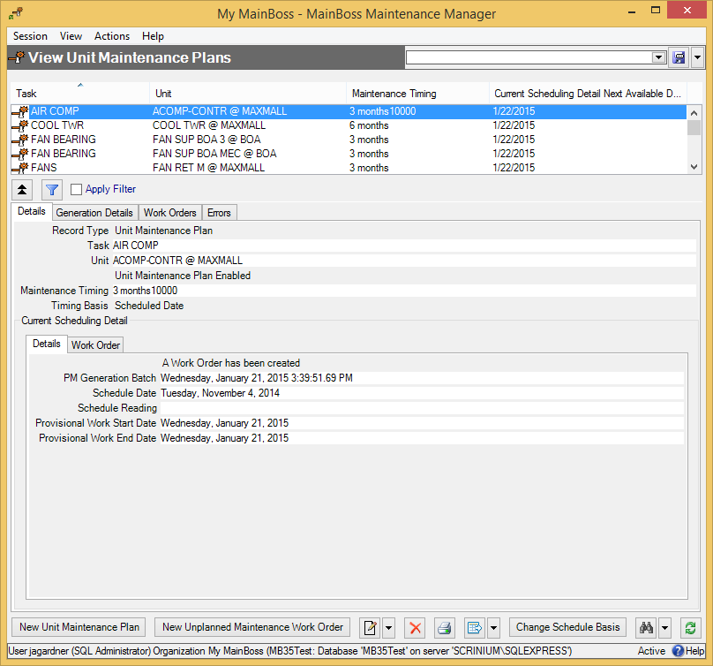
- In the list of unit maintenance plans , select the one that you want to use. (Make sure that it applies to the unit you want to service.)

- Click New Unplanned Maintenance Work Order . MainBoss opens a window where you can specify more information:
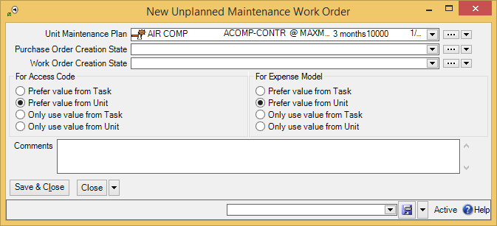
- Adjust any of the options as appropriate.

- Click Save & Close to create the work order and close the window.

You can also create boiler-plate work orders from tasks (Unit Maintenance Plans | Tasks). The process is similar: you go to the task list, select the one you want, and click New Work Order from Task. From that point, the procedure is straightforward.

Forecast Reports
MainBoss offers several reports that predict maintenance activities during an upcoming period:

Unit Maintenance Plans | Reports | Labor Forecast
Forecasts labor use over the specified period.

Unit Maintenance Plans | Reports | Material Forecast
Forecasts materials that will be used over the specified period.

Unit Maintenance Plans | Reports | Maintenance Forecast
Forecasts work orders that will be carried out during the specified period.

In all cases, the desired period is specified in the Filters section of the report window.

General Inventory Control

This chapter outlines how MainBoss helps you keep track of your materials inventory. In particular, the chapter examines how to record information about changes in your inventory, such as transfers from one storeroom to another or recording inventory numbers after a physical count.

As inventory materials are used, MainBoss automatically adjusts its database according to the information recorded when you close a work order. For example, if a particular work order states that you put a new tire on a forklift truck, MainBoss automatically reduces the count of tires in your inventory (as of the date of issue as stated on the work order).

You may also make manual adjustments to inventory totals. This lets you account for breakage, transfers from one storeroom to another, and other factors that influence your inventory.

The MainBoss module lets you track the inventory you use on work orders. This means you can create records describing inventory items, including price information and the quantities used on jobs.
The Inventory module adds the ability to keep track of where items are stored. In particular, you can describe which items each storeroom contains, as well as the maximum and minimum quantities of each item that you want to keep in each storeroom.

Inventory Details
This section discusses precise details of certain aspects of inventory control.

On Hand: When MainBoss tells you the quantity of an item that is currently on hand, that is the quantity that is expected to be present in a particular storeroom or in all storerooms combined.

On Reserve: When you create a work order, you can reserve inventory materials for use in the work order. These materials are said to be on reserve. You put materials on reserve when you use New Demand Item in the Resources section of an open work order. More precisely, the materials are put on reserve when you Save the demand.

Materials can be removed from reserve in several ways:

- You can Void (cancel) the work order. In this case, all materials that were on reserve become available for use again.
- You can use in the Resources section of the work order to delete demands from the list. Deleting a demand makes reserved materials available once more.
- You can use Actualize to state that reserved materials have actually been used. For example, suppose you use New Demand Item to reserve 10 quarts of oil for a job, then use Actualize to say that the job actually used 8 quarts. MainBoss will update its records to say that you now have only 2 quarts on reserve, since you used 8 of the original 10 quarts. (MainBoss will also update its records to say that you have 8 quarts less on hand.)
- When you close a work order, MainBoss removes all outstanding reservations for materials on that work order. For example, suppose you reserved 10 quarts of oil but only used 8 quarts. This leaves 2 quarts still on reserve. However, when you close the work order, MainBoss removes those 2 quarts from the reserve. Since the work order has been closed, the job is finished and the extra 2 quarts obviously weren’t needed. (If you reopen the work order after closing it, the extra 2 quarts will not be put back on reserve.)
The total quantity of an item on reserve is the sum of all on reserve quantities from open work orders. For example, if one work order calls for 10 quarts of oil and another calls for 20, you have a total of 30 quarts on reserve.

On Order: As soon as you add an item to a purchase order, the given quantity is considered on order. Note that the purchase order does not have to be issued; items are on order even if the purchase order is only in the draft state. For more on purchase orders, see Purchasing and Receiving on page 1.

Stock Available: When MainBoss tells you the total quantity of an item available (either in a single storeroom or in all storerooms combined), the quantity is calculated as

Stock Available = OnHand + OnOrder - OnReserve

When MainBoss needs to determine whether stock should be restocked, it looks at the available quantity, not at the quantity on hand.

Closed and Voided Work Orders: After a work order has been closed or voided, the use of New Demand Item does not put materials on reserve. Since the job is already finished or cancelled, there is no point in putting materials on reserve. (The only reason you would use New Demand Item would be to correct your records after the fact. MainBoss doesn’t put the item on order, but does reduce the quantity on hand.)

Inventory Operations
The purpose of MainBoss inventory control is to let you keep track of what materials you have on hand. If a particular job needs an item, you can use MainBoss to determine the storeroom locations where that item is currently available.

In order for MainBoss to be effective, you must make sure that your MainBoss records match what’s actually in your storeroom. This means that you must keep track of actions that affect your inventory. In most cases, MainBoss does this automatically; for example, when a work order records that an item was used in a job, MainBoss automatically updates the records about that item.

However, there are a few situations where you must tell MainBoss directly that your inventory has changed. For example, if you move items from one storeroom to another, you must tell MainBoss about the transfer. Similarly, if items are removed or added for some unusual reason (for example, something gets broken), you should tell MainBoss so that inventory records remain accurate. Finally, if you take a physical count of your inventory, you should modify MainBoss’s records whenever the actual count differs from what MainBoss expects.

The following sections describe some day-to-day situations related to inventory control and how you can handle them with MainBoss.

Finding Which Storeroom Contains a Particular Item
Suppose you need a particular item. You want to know which storerooms contain that item and how much each storeroom contains.

Go to Items in the control panel. Click on the item in the list. In the Storeroom Assignments area below the list, you’ll see locations where the item is stored. Clicking on any entry in the area will show you the quantity of the item in the selected location.

Recording Price Quotes
You can record price quotes on an item using the item record.

- To record a price quote on an item:
- In the control panel, select Items and click on the item for which you want to record a price quote.
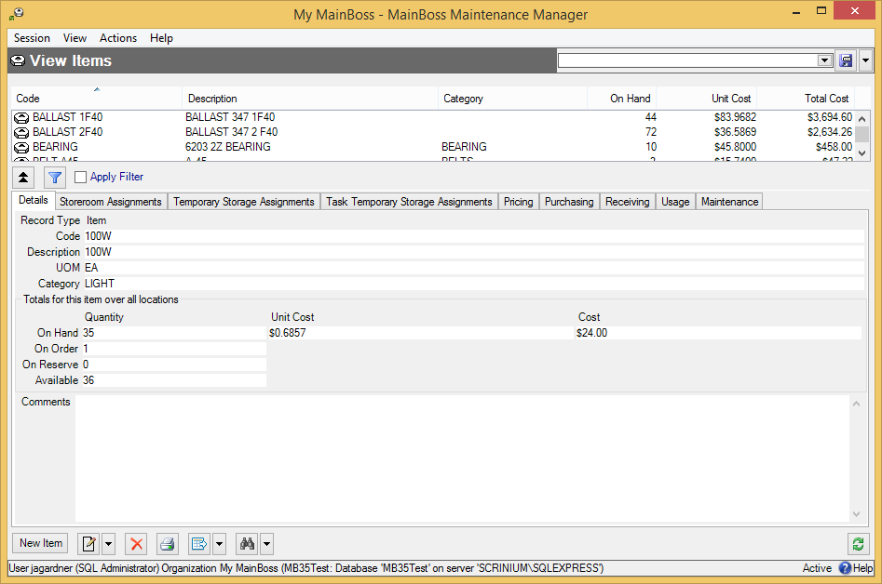

- Click . MainBoss opens a window showing the item record.
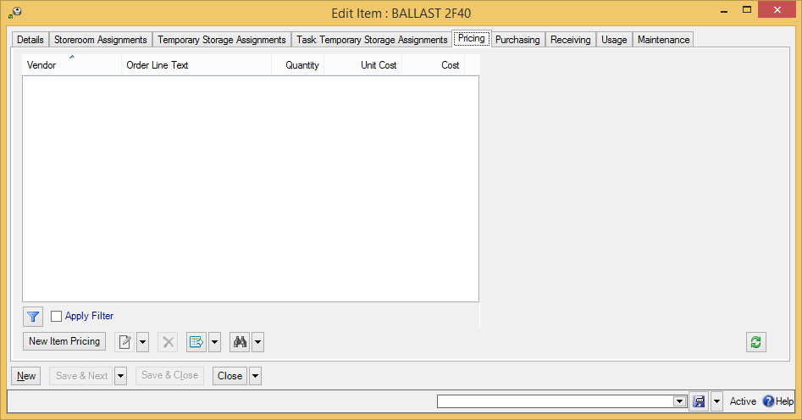

- In the Pricing section, click New Item Pricing . MainBoss opens a window where you can record the price quote.
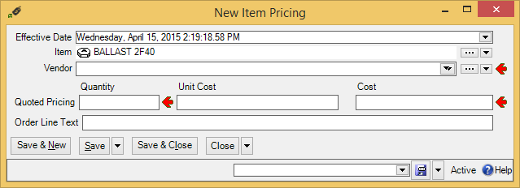

- In “Vendor” , select the supplier who provided the price quote.
- Under “Quantity” , specify the quantity given in the price quote.
- Specify the cost given in the price quote. (If you fill in “Unit Cost” with the price per unit, MainBoss will automatically fill in “Cost” with the total cost...and vice versa.)
- Click Save & Close to save the information and close the window.

You can record different price quotes for different vendors. The Pricing section of the item record lists all the price quotes you’ve recorded.

Taking Physical Inventory
Keeping an accurate inventory is notoriously difficult, even with computerized record-keeping. For this reason, most organizations periodically take a physical count of their stock.

There are several common approaches to taking a physical count of your stock:

- Periodic inventory: Closing down all your maintenance operations for a time and doing a complete count in all your storerooms
- Perpetual inventory: Every time you issue or receive a particular item, you take a count of the quantity of that item in the same location
- Cycle audit: Periodically selecting a type of inventory item and counting your complete stock of that item
- Cyclical inventory: Progressively counting parts of your stock until you have counted everything; for example, you might take inventory in one storeroom a month until you have covered all your storerooms. Once you have finished, you start the cycle again at the beginning.
After taking inventory by any of the above methods, you should compare the numbers from the physical count to the numbers in MainBoss’s records. If there is a disagreement, you should update MainBoss’s records to reflect the actual numbers.

In order to do a physical count, print off a report using Items | Reports | Location and Status. This displays which items are expected to be in which locations.

After you have taken inventory, you should adjust MainBoss’s records to reflect any differences between the real count and the expected quantities.

- To adjust MainBoss’s records after taking inventory:
- In the control panel, select Items | Storeroom Assignments. MainBoss displays a list of storeroom locations and what items they contain:
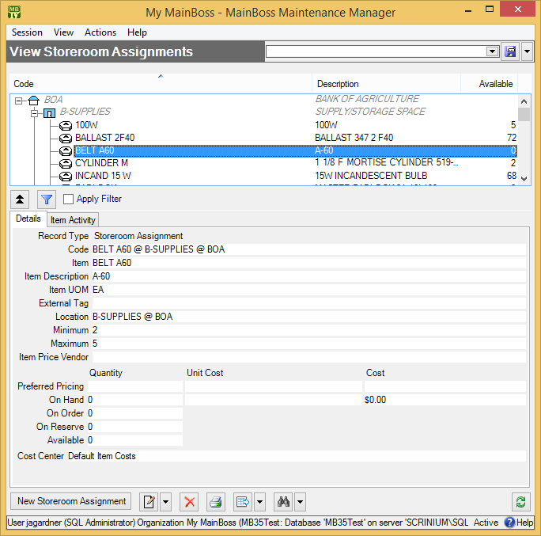
- In the list of records, find the storeroom that contains the item whose count should be changed, then click on the line for the item.

- Click . MainBoss opens a window that lets you edit the existing information.
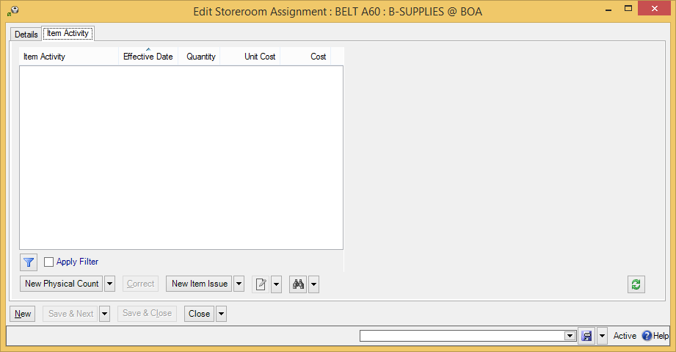

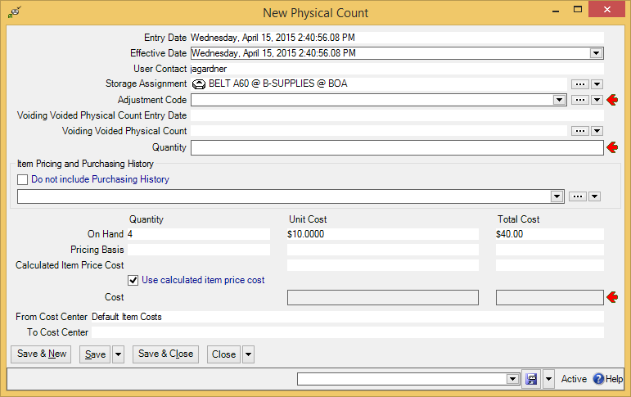
- In the Item Activity section of the record, click New Physical Count . MainBoss opens a window where you can specify the physical count for the item in this particular storeroom.

- In “Adjustment Code” , select a code indicating the reason for the change. (Typically, this will be your organization’s code for “physical count”.)
- In “Quantity” , enter the actual quantity of the item that was found in the storeroom.
- If the cost of the item is the same as the costs given in the “Calculated Item Price Cost” line, click Use calculated item price cost . Otherwise, enter the different cost in “Cost” . (If you fill in the “Unit Cost” column, MainBoss will automatically fill in “Total Cost” and vice versa.)
- Click Save & Close to save your information and return to the previous window.

Other Inventory Operations
A number of other inventory operations are available through storeroom assignment records (discussed in the previous sections):

New Item Adjustment (found on the drop-down list for New Physical Count):
May be used for any non-standard adjustment to item quantities recorded in your records. For example, if an item accidentally gets broken, you should record what happened by creating an adjustment record.
When you record an adjustment, you specify an adjustment code. Possible adjustment codes are set up by your MainBoss administrator. For more on such codes, see the MainBoss Configuration Guide.

New Item Issue:
Used in situations in which materials are issued from inventory, other than in connection with a work order. For example, a rental management company might issue a supply of light bulbs to tenants so that tenants can change their own bulbs rather than calling in maintenance personnel.
When you record an issue, you specify an issue code. Possible issue codes are set up by your MainBoss administrator. For more on such codes, see the MainBoss Configuration Guide.

Item Transfer To and Item Transfer From (found on the drop-down list for New Item Issue):
Lets you record when you move materials from one storeroom to another. Item Transfer From is used if you start with the record for the storeroom where the items were kept originally. Item Transfer To is used if you start with the record for the storeroom where the items are going.

Restocking
Items | Item Restocking lists all inventoried items that need to be re-ordered. To determine whether an item needs to be restocked, MainBoss looks at your current on-hand stock of that item, minus the quantity that has been put on reserve for work orders, plus the quantity that has already been put on order in issued purchase orders. In other words, MainBoss looks at the quantity

OnHand + OnOrder - OnReserve

If this is less than the minimum stock level for an item, MainBoss indicates that the item should be restocked. MainBoss suggests that you re-order a quantity that will put the above calculation up to the maximum stock level for the item.

Restocking is analyzed on a storeroom by storeroom basis. If an item is below its minimum level in a particular storeroom, the Restocking Report says the item should be re-ordered, even if other storerooms contain enough of the item to make up the difference.

Restocking Report: You can also get restocking information in report form by clicking the button in Items | Item Restocking. Either way, the restocking report lists all items that need to be restocked. Accompanying each item is a list of the storerooms where restocking is required.

Purchasing and Receiving

This chapter is only relevant if you have licensed the Purchasing module. If you do not have a license key for this module, the control panel will not contain entries related to purchase orders.

MainBoss has detailed facilities for reporting which inventory items need to be restocked, for creating purchase orders, and for tracking the shipments you receive. This chapter outlines the usual sequence of events for purchasing and receiving. For more detailed information, see the online help.

Draft Purchase Order: A draft purchase order is a preliminary version of a purchase order.

For example, if you need authorization before sending a purchase order to a supplier, you would usually create a draft purchase order and print it out, then submit that PO for management approval.

You can edit a drift purchase order whenever necessary. For example, if management does not approve some of the requested items, you can delete those items before issuing the purchase order to the vendor.

Issued Purchase Order: You issue a purchase order when the PO is ready to be submitted to the supplier. From that point on, the PO is an issued purchase order.

A purchase order becomes an issued purchase order when you have obtained all the required authorizations and have marked the PO as ready to submit. After you issue a PO, you print it off and send it to the supplier.

MainBoss won’t let you edit an issued purchase order, since you presumably want to preserve what the purchase order said at the time you sent it to the vendor. However, you can withdraw an issued purchase order, putting it back into the draft state. The purchase order can then be edited like any other purchase order.

Closed Purchase Order: You close a purchase order when you have received all the goods and services covered by the PO, or have canceled any goods and services that have not already been received.

In other words, you close a purchase order when it’s been filled or when you’ve canceled any unreceived portion of the order.

You can re-activate a closed purchase order. This puts it back into the issued state.

Waybill: A waybill number identifies a shipment received in response to a purchase order.

Each shipment has a unique waybill number, chosen by you. Many organizations use whatever identification number the vendor assigned to the shipment.

The Purchasing/Receiving Process
The following shows the usual steps of the purchasing/receiving cycle.

- Print a report of what materials need to be re-ordered (see Restocking on page 1).
- Decide which materials will be purchased from which suppliers.
- Create a purchase order for each supplier, listing the materials you want to purchase (see Creating a New Purchase Order on page 1).
- Obtain any authorizations needed for the purchase.
- Issue each purchase order and send it to the vendor (see Issuing a Purchase Order on page 1).
- Each time a shipment is received in response to the purchase order, assign the shipment a waybill number and record which items were received (see Recording Item Receipts on page 1).
- When all the ordered items have been received, close the PO (see Closing a Purchase Order on page 1).

Typical Purchasing/Receiving Cycle
The steps given above are only one approach to purchasing/receiving. A common alternative is to depend on a small number of suppliers and to prepare regular purchase orders for each. For example, you might ask, “What do we need to buy from Supplier X this week?” In this case, you might prepare your purchase orders for your regular suppliers first, then print a restocking report to see if there was anything else you needed to order.
Close
PO
Record
Receipts
Issue
PO
Get
Approvals
Create
PO
Choose Suppliers
Get Restocking
Report

Note: Purchase orders may be issued for services as well as for goods. For example, if you hire an outside contractor to do three weeks of work, you could issue a purchase order to cover the costs of that work. Labor costs would be regarded as “extras” on the purchase order.

Purchase Order Status Codes: Like requests and work orders, purchase orders may be assigned status codes. Typically, a status code indicates that the purchase order needs someone’s personal attention. For example, your organization may have a status code like Waiting for approval to indicate that a purchase order is waiting for management authorization. Once the issue has been resolved, the status code may be removed and the purchase order may resume normal processing.

Your organization can create any type of status codes that make sense for the way you purchase. To see what codes have been defined by your organization, see Coding Definitions | Purchase Orders | Purchase Order Statuses.

You assign status codes to a purchase order by clicking Add Purchase Order Comment in a purchase order or in a purchase order table viewer. This opens a window where you can specify a status. You use the same process to remove an existing status. Any existing status code is also removed when you issue or close the purchase order.

Note that status codes can be a useful form of communication between users. For example, suppose that a worker has the PurchaseOrderReceive security role (meaning that the worker can record the receipt of purchase order line items) but does not have the PurchaseOrderClose security role (which is needed to close a purchase order). The worker could give the purchase order a status like Ready to Close, indicating that all appropriate information has been recorded. A supervisor with PurchaseOrderClose permission could regularly check all open purchase orders to see if any are Ready to Close; if so, the supervisor can review those purchase orders and close them as appropriate (removing the status code in the process).

Remember that a status code is intended to bring a purchase order to someone’s attention. You can therefore use status codes as signals for other users.

Creating a New Purchase Order
In MainBoss, the purchase order window records information about the PO itself and the shipments received in response to the PO.

- To create a new purchase order:
- Go to Purchase Orders in the control panel and click New Purchase Order. MainBoss opens a purchase order form:
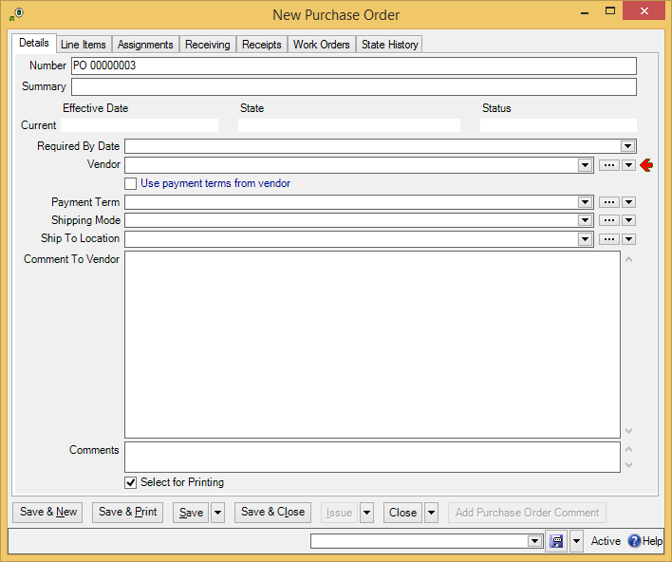

- In “Summary” enter a brief description of this purchase order.
- In “Required By Date” , specify the date by which you need this order to be filled.
- In “Vendor” , specify the vendor who will fill the order.
- Either checkmark Use payment terms from vendor (to use the vendor’s default payment terms), or else use “Payment Terms” to specify any payment terms for the order.
- In “Shipping Mode” , specify how the goods should be shipped.
- In “Deliver to Location” , specify the location where the goods should be delivered.
- In “Comments to Vendor” , enter any comments to the vendor that you want to put on the purchase order.
- Fill out the Line Items section as described in Purchase Order Line Items on page 1.
- Click Save & Close to save the information and close the window.

You can print the purchase order by following the instructions in Printing One or More Purchase Orders on page 1.

Purchase Order Line Items
The Line Items section of a purchase order specifies the items you want to purchase. It can also specify labor (e.g. if this purchase order is paying for the services of an outside contractor). Finally, the section can include miscellaneous items (e.g. paying surcharges for express delivery).

- To add a new item to a purchase order:
- Click New Purchase Item . This opens a window where you can add an item to the purchase order.
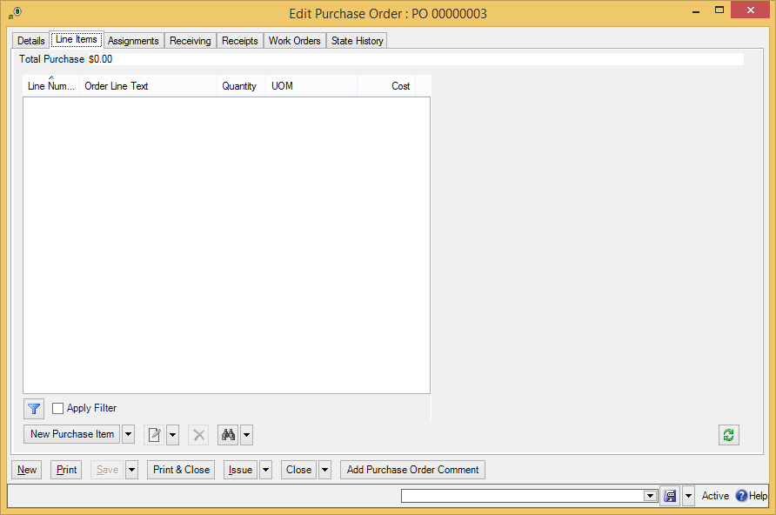

- Click New Purchase Item . This opens a window where you can add an item to the purchase order.

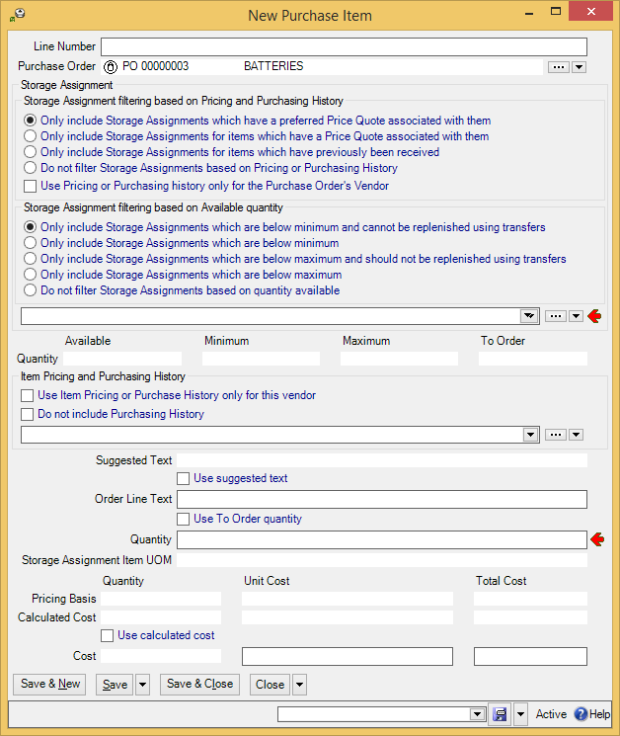

- In the drop-down list under “Storage Assignment” , specify an appropriate item location assignment, naming the item you want to order and the storeroom where the item will be stored once it’s delivered. (The options preceding the drop-down list can reduce the number of items in the list. For example, if you checkmark Use Pricing or Purchasing history only for the Purchase Order’s Vendor, the drop-down list will only show items you have previously purchased from the vendor, plus ones for which you have a price quote from the vendor.)
- In the drop-down list under “Item Pricing and Purchase History” , specify price information for this item from this vendor. (Once you specify a price, MainBoss will fill in “Suggested Text” with a description of the item from the price quote, if the quote contains such text.)
- If you checkmark Use suggested text , MainBoss will fill in “Order Line Text” with the contents of “Suggested Text”. Otherwise, fill in “Order Line Text” with whatever text you want to appear on the purchase order. This should be the vendor’s name for the item you want to purchase, possibly including the vendor’s catalog number for the item.
- The “Quantity” line contains a number of read-only fields stating the quantity of the given item in the chosen storeroom. The final field, “To Order”, gives the quantity required to restock the storeroom up to its specified “Maximum” stock level. If you wish to order this amount, checkmark Use To Order Quantity . Otherwise, fill in “Quantity” with the quantity you want to order.
- The “Calculated Cost” line contains read-only fields stating the cost of the quantity given in “Quantity”. If this cost is correct, checkmark Use Calculated Cost . Otherwise, enter the real cost in “Cost” . If you enter the unit cost, MainBoss automatically calculates the total cost, and vice versa.
- Click Save & Close to save the information and close the window. When you return to the previous screen, you’ll see the item entered in the purchase order’s Line Items list.

To add more items, you repeat the same process. If you want to order the same item for two different storerooms, you specify a separate line item record for each storeroom.

The process of adding an entry to pay for services is similar. The following example will use labor paid by the hour (“Hourly Outside” but a similar process can be used for labor paid by the job (“Per Job Outside”).

- To add labor services to a purchase order:
- In the Line Items section of a purchase order, drop the arrow on New Purchase Item and click New Purchase Hourly Outside. This opens a window where you can add labor costs to the purchase order.
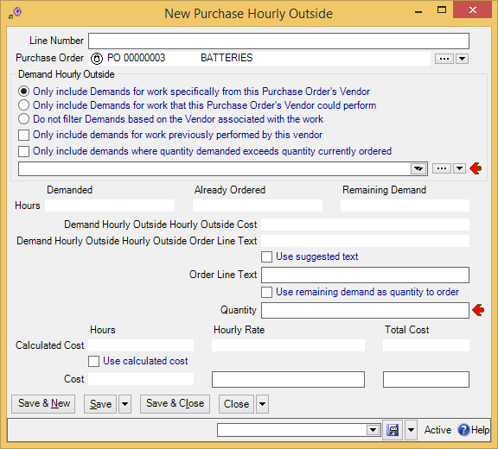

- In “Hourly Outside Demand” , specify an appropriate “hourly outside” record, naming the contractor you want to pay and the hourly rate for the contractor’s services. (The options preceding the drop-down list can reduce the number of items in the list. For example, if you checkmark Only include demands for work previously performed by this vendor, the drop-down list will only show hourly outside demands that have been used for previous work by this vendor.)
- Once you specify an “Hourly Outside Demand”, MainBoss fills in “Demand Hourly Outside Hourly Outside Order Line Text” with any “order line text” in the hourly outside record. If you wish this text to appear on the purchase order, checkmark Use suggested text . Otherwise, fill in “Order Line Text” with the text you want to appear on the purchase order.
- If you want the time specified on the purchase order to be the time given in “Remaining Demand”, checkmark Use remaining demand as quantity to order . Otherwise, fill in “Quantity” with the time that you expect the contractor to spend on the work.
- If you want the cost of the work to be the amount that appears in “Calculated Cost”, checkmark Use calculated cost . Otherwise, fill in “Cost” with the desired cost. (If you fill in “Hourly Cost”, MainBoss automatically fills in “Total Cost”, and vice versa.)
- Click Save & Close to save the information and close the window. When you return to the previous screen, you’ll see the work entered in the purchase order’s Line Items list.

You can also add “miscellaneous” items to a purchase order. For example, you can add sales tax or surcharges for special service. Such costs are represented by “Miscellaneous Items” records.

For some types of costs, you may already have an appropriate Miscellaneous Items record (e.g. if you frequently pay a particular vendor’s surcharge for express delivery). Often, however, you have to make up a new record; the cost of sales tax, for example, is likely to be different on every purchase order, so you have to create a new miscellaneous line item each time you add sales tax to a PO.

- To add miscellaneous costs to a purchase order:
- In the Line Items section of a purchase order, drop the arrow on New Purchase Item and click New Purchase Miscellaneous Item. This opens a window where you can add miscellaneous costs to the purchase order.
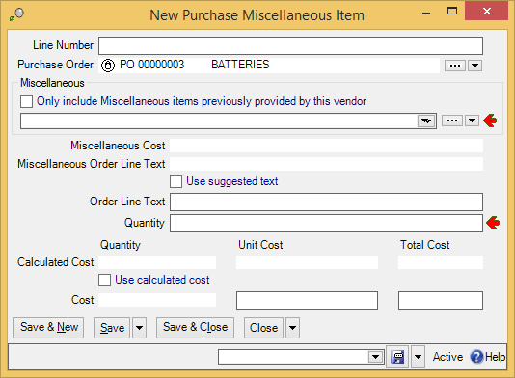

- In “Miscellaneous” , specify an appropriate “miscellaneous item” record that gives the appropriate charge. (If there isn’t an existing record for the charge, click the “...” button and create one.) “Miscellaneous Cost” and “Order Line Text” will be filled in with information from the selected miscellaneous item record.
- If you wish the text in “Order LineText” to appear on the purchase order, checkmark Use suggested text . Otherwise, fill in “Order Line Text” with the text you want to appear on the purchase order.
- In “Quantity” , enter the quantity of the miscellaneous item that should appear on the purchase order.
- If you want the cost of the work to be the amount that appears in “Calculated Cost”, checkmark Use calculated cost . Otherwise, fill in “Cost” with the desired cost. (If you fill in “Unit Cost”, MainBoss automatically fills in “Total Cost”, and vice versa.)
- Click Save & Close to save the information and close the window. When you return to the previous screen, you’ll see the charge entered in the purchase order’s Line Items list.

Printing One or More Purchase Orders
You may print a purchase order at any time. For example, you might print the PO when you complete an initial draft and wish to get authorization from management. You will also print the PO when you are ready to send it to the supplier.

Printing a purchase order is very much like printing a work order. In particular, you can use Select for Printing to print a batch of new purchase orders, or you can explicitly specify the numbers of the purchase orders you want to print.

Issuing a Purchase Order
When you are ready to send a purchase order to the supplier, you issue the PO. This “locks down” information on the purchase order, to indicate that the purchase order has been finalized and shouldn’t be changed anymore.

If you want to change a purchase order after it’s been issued, you must withdraw it first. In the Purchase Orders | Issued Purchase Orders viewer, click the purchase order you want to withdraw, click the drop-down arrow on Close Purchase Order, then click Withdraw Purchase Order.

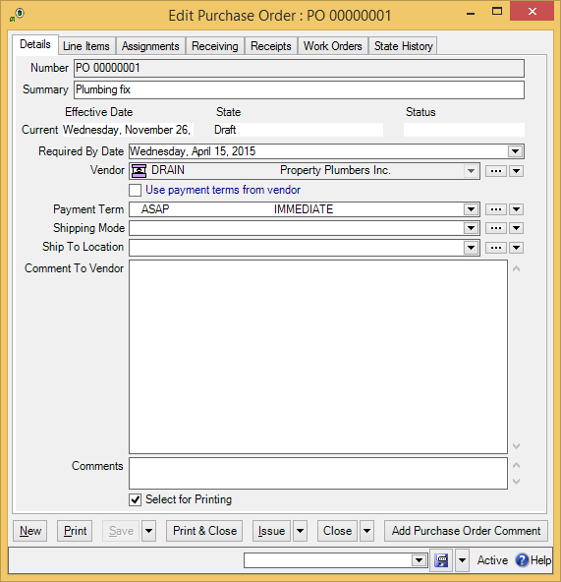

- To issue a purchase order:
- Open the purchase order (for example, by starting in the Purchase Orders | Draft Purchase Orders table viewer, then double-clicking on the entry for the PO).
- Click Issue .

Recording Item Receipts
When you receive items from a vendor, you should record what you have received. If the vendor’s shipment contains items in response to several purchase orders, you create a receipt record for each original purchase order.

- To record the items in a shipment:
- In the control panel, go to Purchase Orders | Receipts.
- Click New Receipt. MainBoss opens a window where you can record what goods were received:
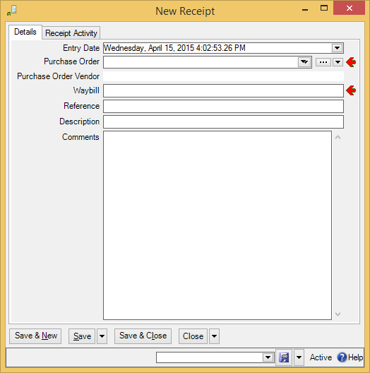

- In “Purchase Order” , specify the purchase order in which the items were originally ordered.
- In “Waybill” , specify an identifier for this receipt. (This is your own internal identifier. It should be unique from all other receipt identifiers.)
- In “Reference” , specify any reference code that might be associated with the shipment. (This is typically the identification code specified by the vendor. Different receipts may have the same reference code.)
- In “Description” , provide a description of the shipment.
- Click Save to save the record (without closing the window).
- Go to the Receipt Activity section of the record. It will show the items specified in the original purchase order:
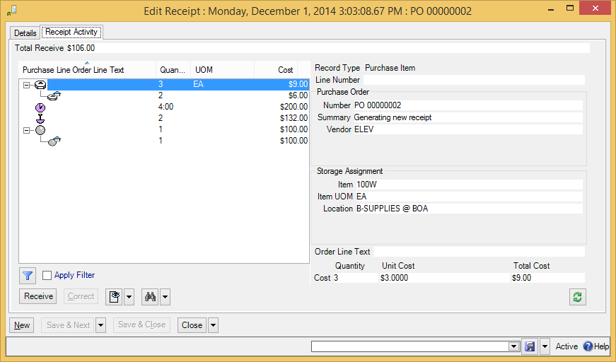

- Click one of the items that was on the original purchase order, then click Receive . MainBoss opens a window where you can record information about what was received:
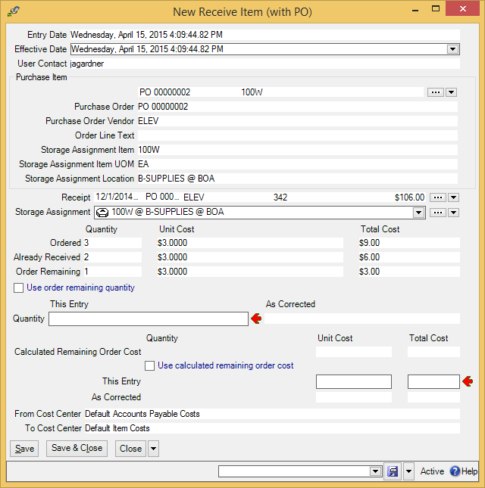
- Check “Storage Assignment” to make sure it specifies where you want the item to be stored. If it doesn’t, specify the storage location. (MainBoss initially sets “Storage Assignment” using the storage assignment specified in the original purchase order.)

- The center of the window contains a number of read-only fields which MainBoss fills with information. In particular, the “Order Remaining” line displays the quantity originally ordered, minus any quantity of the item that has already been received. If the value in the “Quantity” column is correct, checkmark Use order remaining quantity . Otherwise, fill in “Quantity” with the correct quantity.
- “Calculated Remaining Order Cost” contains the expected cost of the given quantity of items (based on previous price information). If this is correct, checkmark Use calculated remaining order cost . Otherwise, fill in “This Entry” with the correct cost. (If you fill in “Unit Cost”, MainBoss automatically fills in “Total Cost” and vice versa.)
- Click Save & Close to save the information.
- Repeat this process for every item received in the shipment.

Recording the Receipt of Services
Purchase orders can cover labor as well as materials. Whenever you hire an outside contractor to perform services, you should record the cost with a purchase order so that MainBoss retains accurate overall figures on your maintenance expenses.

You record the receipt of services in the same way as you record the receipt of items. Just follow the steps given previously. Some windows will be slightly different—for example, you may be asked to record the amount of time received rather than the quantity—but the processes are still quite similar.

Closing a Purchase Order
You close a purchase order once you have received all the goods originally ordered (or when you have given up on receiving some of the goods and have cancelled any outstanding part of the order). (Note that you can only close an issued purchase order; if the purchase order hasn’t been issued yet, you can’t close it.)

- To close an issued purchase order:
- Open the purchase order and review it, making sure all items have been received.
- Click Close Purchase Order.

Appendix A: MainBoss Support from Thinkage Ltd.

When you purchase MainBoss, you receive 30 days of free support, including toll-free phone calls and on-line support via the Internet. We also offer an Annual Support Plan that provides ongoing phone and on-line support. Support Plan Subscribers also receive free updates and one free upgrade per year containing enhancements and new features.

You can contact Thinkage Ltd. at:

Telephone:
1-800-563-0894 (U.S. and Canada)
1-519-895-1860 (outside Canada and the U.S.)

Address:
Thinkage Ltd.
85 McIntyre Drive
Kitchener, ON N2R 1H6, Canada

Email:
support@mainboss.com

World Wide Web:
http://www.mainboss.com

Support through the web site is available on the Services page. This page offers software updates and the most up-to-date list of answers to frequently asked questions, plus a form where you can request online support.

If you have suggestions for improvements to MainBoss, please email us at:
suggestions@mainboss.com

HelpEnd
INDEX

access codes, i
Acrobat PDF, i
active, i
active filter, i
actual expenses, i
actuals, i
adjusting work orders, i
adjustment codes, i
adjustments, i
physical count, i
administration
accounting, i
company information, i
security role, i
all, i
assignee, i
assignment overview, i
assignments, i
overview, i
work orders, i
attachments, i
available, i

bar charts, i
bar codes, i
border, i
buttons, i

change active filter, i
change scheduling parameters, i
chargebacks, i
activity, i
deleting, i
requestors, i
charts, i
clear select for printing, i
closed purchase orders, i
closed requests, i
closed work orders, i
codes, i
coding definitions, i
access codes, i
purchase orders
purchase order statuses, i
requests
request priorities, i
request statuses, i
requestors, i
units
meters, i
work orders
work order assignees, i
work order statuses, i
columns
reports, i
commit, i
concurrency errors, i
contacts, i
control panel, i
conventions, i
corrections, i
costs, i
customized table settings, i
cycle audit, i
cyclical inventory, i

database, i
defaults, i
defective meter readings, i
deleted records, i
demand item, i
demanded cost, i
demands, i
details panel, i
direct requestors, i
downtime, i
draft purchase orders, i
draft work orders, i
drop-down lists, i

editors, i
drop-down lists, i
errors, i
Excel, i
exiting MainBoss, i
expense categories, i
expense mappings, i
expense models, i
export, i
export data, i
exporting data, i
exporting form customizations, i

field selection, i
fields, i
filtering
location, i
units, i
filters
active, i
reports, i
tables, i
forecasts, i
form customization, i
form customizations
export, i
publish, i

generate, i
generating PM work orders, i

help, i
help menu, i
index, i
start support connection, i
table of contents, i
hourly inside, i
hourly outside, i
purchase orders, i

identifier codes, i
in progress requests, i
interrelated records, i
inventory
adjustments, i
cycle audit, i
cyclical inventory, i
operations, i
periodic, i
perpetual, i
price quotes, i
purchasing and receiving, i
taking inventory, i
transfers, i
inventory control, i
issue codes, i
issued purchase orders, i
issues, i
items, i
adjustments, i
issues, i
price quotes, i
purchase orders, i
reports
location and status, i
storeroom assignments, i
storerooms, i

keyboard keys, i

labor forecast, i
licensed modules, i
licenses, i
linked records, i
locations, i
filtering, i
sub locations, i

MainBoss Service, i
maintenance forecast, i
maintenance organizations, i
maintenance timing, i
margins, i
material forecast, i
materials, i
menus
help, i
session, i
meter offsets, i
meter readings, i
meters, i
defective readings, i
meter offsets, i
readings, i
Microsoft Excel, i
Microsoft Word, i
miscellaneous items, i
purchase orders, i
modules, i
mouse, i

new requests, i
notifications, i

offsets
meters, i
on hand, i
on order, i
on reserve, i
on-line support, i
open in new window, i
open work orders, i
outside labor, i
overdue work orders, i

page setup, i
paper-size, i
patterns, i
PDF, i
per job inside, i
per job outside, i
periodic inventory, i
perpetual inventory, i
physical counts, i
planned maintenance, i
adjusting work orders, i
generating work orders, i
postal addresses, i
preventive maintenance, i
preview, i
price quotes, i
print, i
work orders, i
print layout, i
printers, i
publish customizations, i
purchase orders, i
assignments, i
bar codes, i
closed, i
closing, i
creating, i
draft, i
hourly outside, i
issued, i
issuing, i
items, i
labor, i
line items, i
miscellaneous items, i
outside contractors, i
printing, i
receipts, i
status codes, i
withdrawal, i
work orders, i
purchasing, i

quitting MainBoss, i

re-activate purchase order, i
receipts, i
labor, i
receiving, i
records, i
re-draft, i
refresh, i
regular expressions, i
reopen, i
reports, i
advanced, i
columns, i
field selection, i
filters, i
item restocking, i
labor forecast, i
maintenance forecast, i
material forecast, i
planned maintenance, i
preview, i
requests, i
sections, i
request priorities, i
requestors, i
chargebacks, i
direct, i
requests, i
access codes, i
assignments, i
bar codes, i
charts
average request duration by grouping, i
close, i
closed, i
codes, i
creating, i
edit, i
in progress, i
life cycle, i
new, i
print, i
printing, i
priorities, i
reports, i
request history, i
request state history summary, i
states, i
status codes, i
void, i
voided, i
reserve materials, i
resources, i
actuals, i
demands, i
hourly inside, i
hourly outside, i
labor, i
per job inside, i
per job outside, i
restore, i

security roles, i
cost-related, i
select all editable, i
select for printing, i
select view, i
sessions, i
show compact browsers, i
show report in columns, i
specifications, i
status codes
purchase orders, i
requests, i
work orders, i
stock available, i
storeroom assignments, i
bar codes, i
storerooms, i
bar codes, i
sub locations, i
sub-units, i
summaries, i
support, i
suspend, i
systems, i

table viewers, i
sections, i
selection, i
tables, i
customization, i
filters, i
multi-select, i
tasks, i
temporary storage, i
temporary storage assignments, i
timing, i
tooltip, i
transfers, i

unit, i
unit maintenance plan, i
unit maintenance plans, i
generate planned maintenance, i
tasks, i
units, i
bar codes, i
filtering, i
meters, i

void requests, i
void work orders, i

W/R, i
waybills, i
withdraw purchase order, i
work orders, i
actual expenses, i
actuals, i
adjusting, i
assignments, i
bar codes, i
basic information, i
boilerplate, i
cancelling, i
chargebacks, i
closed, i
closing, i
closing code, i
demands, i
downtime, i
draft, i
hourly inside, i
hourly outside, i
labor, i
materials, i
modifying, i
open, i
outside labor, i
overdue work orders, i
per job inside, i
per job outside, i
personnel, i
printing, i
purchase orders, i
reopen, i
resources, i
standard, i
states, i
status codes, i
suspend, i
temporary storage, i
temporary storage assignments, i
transfer to, i
void, i
work requests, i

zoom in on view, i

