EA-PDF validation rules
  - Specification author review
229 rules · specification-page order · 31 October 2026
Purpose: help the specification authors review the accuracy, conditions and completeness of the rulebook against the published EA-PDF specification. Prepared by Thinkbox.DIGITAL.

How to read this document
Each numbered entry reproduces one current JSON rule. Numbers follow the first applicable specification page, with related predicates together. Operational diagnostics without a specification page appear last.
Starting requirement: the finished file must pass veraPDF for an EA-PDF-permitted PDF/A level. Adding EA-PDF data after a PDF/A check requires validation of the finished bytes. Applicable ISO/TS 32005 checks remain separate. This review does not duplicate the PDF/A rulebook.
Each entry contains the rule text, its source reference and original quotations. Specific interpretations are retained where needed; they are project decisions, not adopted errata. Detailed applicability and evidence mappings remain in the JSON review records.
All nineteen original source tables remain in Appendix A. Appendices B–E record coverage limits, source identities, interpretation questions and the project GitHub issues. Use the Word navigation pane to move between rule and appendix headings.
Source: PDF Association, EA-PDF 1.0 Specification, February 2025, 97 PDF pages. Copyright 2025 PDF Association, CC BY 4.0. Add seven to a printed page number to get the physical PDF page.

Rule 1 — SOURCE_IN_ISOLATED

Rule Text
Isolated status describes absent, modified or untrustworthy original email-source linkage. Do not turn this into a blanket prohibition on every Source associated file: object-level Source assets are allowed. Catalog original-email provenance and partial-source cases require their own reviewed applicability.
Source Reference: EA-PDF 3.1 printed p7; 7.4.2.1 printed p40; source presence does not establish complete preservation provenance

Relevant source quotations
EA-PDF 1.0, §3.1; printed p. 7; PDF p. 14
EA-PDF profiles without the “isolated” profile identifier i are suitable as verifiable preservation assets as these files contain the original raw source email assets as well as PDF/A compliant renderings of the emails and related context. EA-PDF profiles with the “isolated” profile identifier i may be unsuitable as preservation assets as these files do not contain all the original raw source email assets, or possibly contain modified or redacted versions of those original raw source email assets. However, “isolated” EA-PDF profiles may be smaller files as a result. Thus, the suitability of “isolated” EA-PDF profiles for preservation will depend on the precise archival and preservation strategies and policies that provide the context for the application of EA-PDF as shown in Figure 1: Context of EA-PDF.
EA-PDF 1.0, §7.4.2.1; printed p. 40; PDF p. 47
7.4.2.1 Referenced assets Subject to the policy environment, EA-PDF Creation Software may additionally decide to preserve assets referenced by the original raw source email (e.g., images, SVG, rich media, etc.), including fetching and preserving external assets from the internet. When such assets are not natively compatible with PDF, the raw asset may also be saved (preserved) in the EA-PDF file as an Associated File (in an AF array) to the most relevant PDF object (e.g., Image XObject, Form XObject, font, etc., but not the Document Catalog14) with an AFRelationship of Source. See [AssociatedFiles]. 14 Associated Files with AFRelationship Source in the Document Catalog AF array refer to the original raw source email assets for non-isolated PDF/mail-1{s, m, c} files.

Rule 2 — EAPDF_CONFORMANCE_VALUE

Rule Text
For all profiles: pdfmailid:conformance is lowercase text with value s si m mi c ci; i is last if present. The normal-string value is exact; URI/array values and surrounding whitespace cannot supply a listed Text value. Qualified simple strings remain permitted.
Source Reference: EA-PDF 1.0 section 9.8.1 Table 15 printed p84; EA-PDF 1.0 section 3.1 Table 1 printed p7

Relevant source quotations
EA-PDF 1.0, §9.8.1; printed p. 84; PDF p. 91
9.8.1 Conformance and identification The EA-PDF Identification schema SHALL use the namespace URI http://www.pdfa.org/eapdf/ns/id/ and SHALL use the schema namespace prefix pdfmailid as follows:
EA-PDF 1.0, §9.8.1, Table 15; printed p. 84; PDF p. 91
Editable source-table extract; original layout: Appendix A, Table 15
XMP Property | XMP Value Type | Value
pdfmailid:conformance | Open choice of text.  Always lowercase. | ‘s’, ‘si’, ‘m’, ‘mi’, ‘c’ or ‘ci’  The “i” designator SHALL always be  last if present.

EA-PDF 1.0, §3.1, Table 1; printed p. 7; PDF p. 14
Editable source-table extract; original layout: Appendix A, Table 1
EA-PDF Profile identifier  (lowercase letter) | Meaning
c | A structured container that can include  hierarchical folders of emails.
i | Isolated – this means that the faithful original  raw source email assets are missing, and the EA-  PDF file is not a verifiable preservation asset.
m | Multiple emails without folders
s | Single email message (without a folder)

EA-PDF 1.0, §9.8; printed p. 83; PDF p. 90
Like all PDF ISO subsets, EA-PDF files SHALL presumptively declare their full conformance using the document catalog XMP Metadata stream. This XMP metadata stream provides the definitive information about the email messages preserved in the EA-PDF file.

Rule 3 — PDFA_PART

Rule Text
Prerequisite: the finished PDF must pass veraPDF validation for an EA-PDF-permitted PDF/A level: PDF/A-3a, PDF/A-3u, PDF/A-4, PDF/A-4f or PDF/A-4e. This check identifies the declared PDF/A part; it does not repeat PDF/A validation. A declaration alone is not a passing result. Extra EA-PDF restrictions and applicable ISO/TS 32005 checks remain separate.
Source Reference: EA-PDF 1.0 section 9.1 printed p61; EA-PDF 1.0 section 3.2 Table 2 printed p8,9,10,11

Relevant source quotations
EA-PDF 1.0, §9.1; printed p. 61; PDF p. 68
All EA-PDF files SHALL conform to either PDF/A-3a, PDF/A-3u, PDF/A-4, PDF/A-4f, or PDF/A-4e. Note: the above requirements for PDF/A conformance incorporate a lot of technical requirements.
EA-PDF 1.0, §3; printed p. 4; PDF p. 11
This section provides a brief discussion on the background and context of the EA-PDF v1.0 file format as solicited via the EA-PDF Liaison Working Group (LWG). It does not contain the formal PDF technical requirements; however it needs to be read by all users of this document as it explains how EA-PDF achieves its goals and the agreed decisions made by the LWG. Note: this section is descriptive in nature and there are no “SHALL” or “SHOULD” statements. Use of the words “must” or “will” in this section implies something that is mandated without prescribing exactly how the mandate is technically achieved.
EA-PDF 1.0, §3.2, Table 2; printed p. 8, 9, 10, 11; PDF p. 15, 16, 17, 18 — full descriptive matrix and footnotes: Appendix A, Table 2

Rule 4 — PDFA_CONFORMANCE

Rule Text
After successful veraPDF validation of the finished PDF, verify that its declared PDF/A conformance level is one permitted by EA-PDF: 3a, 3u, 4, 4f or 4e. This is an allowed-level check, not independent proof of PDF/A conformance. The descriptive Table 2 profile matrix differs from section 9.1; the project follows the normative section 9.1 list.
Source Reference: EA-PDF 1.0 section 9.1 printed p61; EA-PDF 1.0 section 3.2 Table 2 printed p8,9,10,11

Relevant source quotations
EA-PDF 1.0, §9.1; printed p. 61; PDF p. 68
All EA-PDF files SHALL conform to either PDF/A-3a, PDF/A-3u, PDF/A-4, PDF/A-4f, or PDF/A-4e. Note: the above requirements for PDF/A conformance incorporate a lot of technical requirements.
EA-PDF 1.0, §3; printed p. 4; PDF p. 11
This section provides a brief discussion on the background and context of the EA-PDF v1.0 file format as solicited via the EA-PDF Liaison Working Group (LWG). It does not contain the formal PDF technical requirements; however it needs to be read by all users of this document as it explains how EA-PDF achieves its goals and the agreed decisions made by the LWG. Note: this section is descriptive in nature and there are no “SHALL” or “SHOULD” statements. Use of the words “must” or “will” in this section implies something that is mandated without prescribing exactly how the mandate is technically achieved.
EA-PDF 1.0, §3.2, Table 2; printed p. 8, 9, 10, 11; PDF p. 15, 16, 17, 18 — full descriptive matrix and footnotes: Appendix A, Table 2

Rule 5 — CONTENT_SET_COUNT

Rule Text
Every file must contain at least one Content Set. Each declared set must resolve to a consecutive, nonempty page range. Rule 51 checks blankness; rule 52 checks document page presence.
Source Reference: EA-PDF 1.0 section 9.2 printed p63; EA-PDF 1.0 section 5 printed p19
Interpretation: Local interpretation of section 9.2: every Content Set must contain at least one nonblank page. Other pages in the set may be blank. Visible page content or annotations establish nonblankness; declaring a page range alone does not.

Relevant source quotations
EA-PDF 1.0, §9.2; printed p. 63; PDF p. 70
For the purposes of EA-PDF validation, a blank PDF page is a page without any visible text, visible image, or visible vector as page content or annotations within the page CropBox that would result in one or more pixels being painted. Note: if CropBox is not present, it inherits the value from the MediaBox. Note: this technical definition for visible is not infallible – a page that marks a single pixel that is white passes this test but will not normally be visible in a viewing application. It is assumed that all EA-PDF Creation Software is well intentioned. Note: the requirements below are worded such that machine-validation can check consistency between XMP metadata, PDF content streams, navigation data, and other PDF data structures without referring to the original source email assets. This assumes EA-PDF validators can parse both PDF and XMP data, which is not unreasonable for PDF/A validators. It is not necessary for a human to perceive the page content to perform EA-PDF validation or to parse source email formats.
EA-PDF 1.0, §9.2; printed p. 63; PDF p. 70
All PDF/mail-1 files SHALL contain at least one Content Set of at least 1 page each that SHALL NOT be blank22. The first page in each Content Set in all PDF/mail-1 files SHALL be referenced from at least one Outline item referenced from the Document Catalog Outlines entry. Reason: this ensures a basic functional PDF with bookmark (outline) navigation even when the email is empty (e.g., an empty draft). Note: the form of the outline destination used is not further defined, while still allowing the page to be validated. This is also because logical structure is not mandated in EA-PDF.
EA-PDF 1.0, §9.2, footnote 22; printed p. 63; PDF p. 70
22 This requirement is intentionally not narrowed to be the rendering of email headers or of an email body as a zero-length source email asset or a source email asset with no valid emails may also need preserving.
EA-PDF 1.0, §5, Content Set definition; printed p. 19; PDF p. 26
Content Set EA-PDF specific term referring to a consecutive set of PDF page(s) associated with a common source (e.g., from the HTML body of an email, from the text body of an email, a list of email attachments, a conversion report, etc.). A content set will always be at least 1 page in an EA-PDF file, as page boundaries demarcate content sets.

Rule 6 — AF_RULE

Rule Text
When non-isolated s m c: Catalog AF is a nonempty array containing at least one Source file specification representing a primary original source email asset.
Source Reference: EA-PDF 1.0 section 9.1 printed p62; EA-PDF 1.0 section 9.4 printed p67; EA-PDF 1.0 section 7.2 printed p34

Relevant source quotations
EA-PDF 1.0, §9.1; printed p. 62; PDF p. 69
For non-isolated PDF/mail-1{s, m, c}, the Document Catalog dictionary SHALL have an AF entry as an array with at least one array element. At least one array element (file specification dictionary) in this array SHALL have an AFRelationship value of Source, representing the primary original source email asset(s). If the original email asset comprises a set of files21, then either:
EA-PDF 1.0, §9.4; printed p. 67; PDF p. 74
Non-isolated PDF/mail-1{s, m} files SHALL embed the original raw source email asset (e.g., EML, MSG, MBOX, OST/PST, etc.) in the Document Catalog Associated File (AF) array with array elements referring to an embedded file specification dictionary with an AFRelationship entry of Source. There SHALL only be at least one such entry in this AF array.
EA-PDF 1.0, §7.2; printed p. 34; PDF p. 41
When PDF/mail-1{s, m, c} files are directly created from an email source asset (e.g., EML, MSG, MBOX, NSF, OST/PST, etc.), that exact unmodified asset must also be embedded via the Document Catalog AF (Associated Files) array entry in order to create a verifiable preservation asset. This results in an Associated Files array element referring to a file specification dictionary with an AFRelationship entry of Source (see Table 43, [ISO 32000-2]) and with a Subtype value appropriate for Media Type of the original email file format. In non-isolated profiles, there must be at least one array element in the Document Catalog where AFRelationship is Source. Reason: This ensures that the original email file used at EA-PDF creation is always faithfully preserved and clearly identifiable. Note that AF is always an array (even if there is only a single associated file), even though several PDF producers currently generate malformed PDFs using a dictionary! Note: EA-PDF does not require that only the rendered emails are present in the source email assets. Thus, preserving an MBOX or PST file with multiple emails in PDF/mail-1s where only a single email is rendered is valid although potentially inefficient.

Rule 7 — SOURCE_AF

Rule Text
When non-isolated s m c: Catalog AF is a nonempty array containing at least one Source file specification representing a primary original source email asset.
Source Reference: EA-PDF 1.0 section 9.1 printed p62; EA-PDF 1.0 section 9.4 printed p67; EA-PDF 1.0 section 7.2 printed p34

Relevant source quotations
EA-PDF 1.0, §9.1; printed p. 62; PDF p. 69
For non-isolated PDF/mail-1{s, m, c}, the Document Catalog dictionary SHALL have an AF entry as an array with at least one array element. At least one array element (file specification dictionary) in this array SHALL have an AFRelationship value of Source, representing the primary original source email asset(s). If the original email asset comprises a set of files21, then either:
EA-PDF 1.0, §9.4; printed p. 67; PDF p. 74
Non-isolated PDF/mail-1{s, m} files SHALL embed the original raw source email asset (e.g., EML, MSG, MBOX, OST/PST, etc.) in the Document Catalog Associated File (AF) array with array elements referring to an embedded file specification dictionary with an AFRelationship entry of Source. There SHALL only be at least one such entry in this AF array.
EA-PDF 1.0, §7.2; printed p. 34; PDF p. 41
When PDF/mail-1{s, m, c} files are directly created from an email source asset (e.g., EML, MSG, MBOX, NSF, OST/PST, etc.), that exact unmodified asset must also be embedded via the Document Catalog AF (Associated Files) array entry in order to create a verifiable preservation asset. This results in an Associated Files array element referring to a file specification dictionary with an AFRelationship entry of Source (see Table 43, [ISO 32000-2]) and with a Subtype value appropriate for Media Type of the original email file format. In non-isolated profiles, there must be at least one array element in the Document Catalog where AFRelationship is Source. Reason: This ensures that the original email file used at EA-PDF creation is always faithfully preserved and clearly identifiable. Note that AF is always an array (even if there is only a single associated file), even though several PDF producers currently generate malformed PDFs using a dictionary! Note: EA-PDF does not require that only the rendered emails are present in the source email assets. Thus, preserving an MBOX or PST file with multiple emails in PDF/mail-1s where only a single email is rendered is valid although potentially inefficient.

Rule 8 — MESSAGE_SOURCE_COVERAGE

Rule Text
Retained original source data must cover every represented email; additional unrendered emails and non-email source data are allowed. A uniquely supported association is evidence, not a requirement that only one possible source candidate exist. PDF-only evidence does not prove the retained asset was the exact creator input.
Source Reference: EA-PDF 1.0 section 7.2 printed pp34-35

Relevant source quotations
EA-PDF 1.0, §7.2; printed p. 35; PDF p. 42
The preserved source email asset(s) in PDF/mail-1{s, m, c} files must reflect at least all emails that are represented in that EA-PDF file. If only a subset of emails in an MBOX, PST/OST, NSF, etc. are converted to EA-PDF, then the full original raw source email asset (with the additional information) can be embedded. However, it is not valid to store a source email assets with an AFRelationship of Source that do not contain all the source email content in a PDF/mail-1{s, m, c} file (i.e., every email represented in PDF/mail-1{s, m} files must be associated with data in the embedded source original email asset(s)) – otherwise the “isolated” profiles must be used (PDF/mail-1{si, mi}) to indicate that not all original source email assets are faithfully preserved.
EA-PDF 1.0, §7.2; printed p. 34; PDF p. 41
There is no requirement that only the email that is being preserved must be in the original raw email asset - additional data may also be present that is not represented by any pages in the EA-PDF file (e.g. calendar or contact entries in OST/PST, additional emails in MBOX).
EA-PDF 1.0, §7.3.1; printed p. 36; PDF p. 43
7.3.1 Core fields EA-PDF defines a set of common email header fields and related attributes of each email as Core Fields. Each email will have its Core Fields reflected in the document-level XMP of the PDF/mail file that contains the email. The values used in the XMP must be as equivalent as possible to the full value in the source email assets, subject to representation/encoding differences between the source email and UTF-8 based XMP. Reason: as discussed in the LWG, the document level XMP metadata is the primary and definitive source of email metadata used by document and archival management systems to manage email archives. Core Field names must be consistent to enable the most reliable searching across a diverse corpus of EA-PDF files and hence must not be localized or vary between EA-PDF Writers. EA-PDF Writers may however localize core fields when it renders this same information to PDF page content (e.g., “Subject:” might be rendered as “Objet:” for French emails, but in XMP it will always be “Subject” – the value of the field in both cases needs to be the same and not localized). Note: because the rendering of Core Fields in page content may be truncated, cropped, wrapped, localized, etc., the XMP Core Fields are to be considered the definitive “source of truth” for all EA-PDF aware software.

Rule 9 — MESSAGE_METADATA_MATCH_SOURCE

Rule Text
Supplied source-derived email metadata must preserve the full original value as equivalently as representation and encoding permit. Evaluate per email/property, including addresses, supplied Raw-* helpers, Subject, identifiers, Sent instant, SizeInBytes and NumberAttachments. Preserve normalization allowances and recorded source limits. Exclude generated GUIDs, source-asset and attachment metadata, and rendering media subtypes. Visible truncation or localization cannot excuse altering stored source values.
Source Reference: EA-PDF 1.0 section 7.3.1 printed pp36-37; section 9.8.3 Table 18 printed pp86-88

Relevant source quotations
EA-PDF 1.0, §7.2; printed p. 35; PDF p. 42
The preserved source email asset(s) in PDF/mail-1{s, m, c} files must reflect at least all emails that are represented in that EA-PDF file. If only a subset of emails in an MBOX, PST/OST, NSF, etc. are converted to EA-PDF, then the full original raw source email asset (with the additional information) can be embedded. However, it is not valid to store a source email assets with an AFRelationship of Source that do not contain all the source email content in a PDF/mail-1{s, m, c} file (i.e., every email represented in PDF/mail-1{s, m} files must be associated with data in the embedded source original email asset(s)) – otherwise the “isolated” profiles must be used (PDF/mail-1{si, mi}) to indicate that not all original source email assets are faithfully preserved.
EA-PDF 1.0, §7.2; printed p. 34; PDF p. 41
There is no requirement that only the email that is being preserved must be in the original raw email asset - additional data may also be present that is not represented by any pages in the EA-PDF file (e.g. calendar or contact entries in OST/PST, additional emails in MBOX).
EA-PDF 1.0, §7.3.1; printed p. 36; PDF p. 43
7.3.1 Core fields EA-PDF defines a set of common email header fields and related attributes of each email as Core Fields. Each email will have its Core Fields reflected in the document-level XMP of the PDF/mail file that contains the email. The values used in the XMP must be as equivalent as possible to the full value in the source email assets, subject to representation/encoding differences between the source email and UTF-8 based XMP. Reason: as discussed in the LWG, the document level XMP metadata is the primary and definitive source of email metadata used by document and archival management systems to manage email archives. Core Field names must be consistent to enable the most reliable searching across a diverse corpus of EA-PDF files and hence must not be localized or vary between EA-PDF Writers. EA-PDF Writers may however localize core fields when it renders this same information to PDF page content (e.g., “Subject:” might be rendered as “Objet:” for French emails, but in XMP it will always be “Subject” – the value of the field in both cases needs to be the same and not localized). Note: because the rendering of Core Fields in page content may be truncated, cropped, wrapped, localized, etc., the XMP Core Fields are to be considered the definitive “source of truth” for all EA-PDF aware software.
EA-PDF 1.0, §9.8.3; printed p. 86; PDF p. 93
9.8.3 Email headers All non-empty Core Fields for each email in PDF/mail-1{s, si, m, mi} files SHALL be recorded as structured metadata in the document-level XMP Metadata stream using the namespace “http://www.pdfa.org/eapdf/ns/meta/” with the required schema namespace prefix pdfmailmeta as an unordered set of email containers as follows. EA-PDF Creation Software may add additional email header fields using the case-sensitive email header field name. EA-PDF Creation Software may also prefix header fields with “Raw-” to indicate a raw value from the email that would otherwise be an error when using a more rigid or structured XMP data type (e.g. an XMP dateTime). Note: these properties cannot be “SHALL” requirements as they cannot be validated without re-processing the original source email. They can however be validated for consistency with Content Sets, outlines, DPM, and logical structure (if present) in the EA-PDF file.
EA-PDF 1.0, §9.8.3, Table 18; printed p. 86; PDF p. 93
Editable source-table extract; original layout: Appendix A, Table 18
Core Field | Requirement | XMP Metadata description
To | Optional | Represented as an ordered sequence of FOAF Agents  containers (foaf:Agent entries), each with required  foaf:mbox email address and optional foaf:name or  other FOAF Agent fields.

Dependency boundary: the table fixes ordered FOAF Agent records, required mbox and permitted name/other FOAF fields. Accepted RDF forms and mailbox syntax additionally depend on XMP/FOAF/RFC definitions; no new mailbox grammar is quoted from EA-PDF.
EA-PDF 1.0, §9.8.3; printed p. 86; PDF p. 93
9.8.3 Email headers All non-empty Core Fields for each email in PDF/mail-1{s, si, m, mi} files SHALL be recorded as structured metadata in the document-level XMP Metadata stream using the namespace “http://www.pdfa.org/eapdf/ns/meta/” with the required schema namespace prefix pdfmailmeta as an unordered set of email containers as follows. EA-PDF Creation Software may add additional email header fields using the case-sensitive email header field name. EA-PDF Creation Software may also prefix header fields with “Raw-” to indicate a raw value from the email that would otherwise be an error when using a more rigid or structured XMP data type (e.g. an XMP dateTime). Note: these properties cannot be “SHALL” requirements as they cannot be validated without re-processing the original source email. They can however be validated for consistency with Content Sets, outlines, DPM, and logical structure (if present) in the EA-PDF file.
EA-PDF 1.0, §9.8.3, Table 18; printed p. 86; PDF p. 93
Editable source-table extract; original layout: Appendix A, Table 18
Core Field | Requirement | XMP Metadata description
Raw-To | Optional | Free text string, directly reflecting the email header To:  field value.
EA-PDF 1.0, §9.8.3; printed p. 86; PDF p. 93
9.8.3 Email headers All non-empty Core Fields for each email in PDF/mail-1{s, si, m, mi} files SHALL be recorded as structured metadata in the document-level XMP Metadata stream using the namespace “http://www.pdfa.org/eapdf/ns/meta/” with the required schema namespace prefix pdfmailmeta as an unordered set of email containers as follows. EA-PDF Creation Software may add additional email header fields using the case-sensitive email header field name. EA-PDF Creation Software may also prefix header fields with “Raw-” to indicate a raw value from the email that would otherwise be an error when using a more rigid or structured XMP data type (e.g. an XMP dateTime). Note: these properties cannot be “SHALL” requirements as they cannot be validated without re-processing the original source email. They can however be validated for consistency with Content Sets, outlines, DPM, and logical structure (if present) in the EA-PDF file.
EA-PDF 1.0, §9.8.3, Table 18; printed p. 87; PDF p. 94
Editable source-table extract; original layout: Appendix A, Table 18
Core Field | Requirement | XMP Metadata description
From | Optional | Represented as an ordered sequence of FOAF Agents  containers (foaf:Agent entries), each with required  foaf:mbox email address and optional foaf:name or  other FOAF Agent fields.

Dependency boundary: the table fixes ordered FOAF Agent records, required mbox and permitted name/other FOAF fields. Accepted RDF forms and mailbox syntax additionally depend on XMP/FOAF/RFC definitions; no new mailbox grammar is quoted from EA-PDF.
EA-PDF 1.0, §9.8.3; printed p. 86; PDF p. 93
9.8.3 Email headers All non-empty Core Fields for each email in PDF/mail-1{s, si, m, mi} files SHALL be recorded as structured metadata in the document-level XMP Metadata stream using the namespace “http://www.pdfa.org/eapdf/ns/meta/” with the required schema namespace prefix pdfmailmeta as an unordered set of email containers as follows. EA-PDF Creation Software may add additional email header fields using the case-sensitive email header field name. EA-PDF Creation Software may also prefix header fields with “Raw-” to indicate a raw value from the email that would otherwise be an error when using a more rigid or structured XMP data type (e.g. an XMP dateTime). Note: these properties cannot be “SHALL” requirements as they cannot be validated without re-processing the original source email. They can however be validated for consistency with Content Sets, outlines, DPM, and logical structure (if present) in the EA-PDF file.
EA-PDF 1.0, §9.8.3, Table 18; printed p. 87; PDF p. 94
Editable source-table extract; original layout: Appendix A, Table 18
Core Field | Requirement | XMP Metadata description
Raw-From | Optional | Free text string, directly reflecting the email header  From: field value.
EA-PDF 1.0, §9.8.3; printed p. 86; PDF p. 93
9.8.3 Email headers All non-empty Core Fields for each email in PDF/mail-1{s, si, m, mi} files SHALL be recorded as structured metadata in the document-level XMP Metadata stream using the namespace “http://www.pdfa.org/eapdf/ns/meta/” with the required schema namespace prefix pdfmailmeta as an unordered set of email containers as follows. EA-PDF Creation Software may add additional email header fields using the case-sensitive email header field name. EA-PDF Creation Software may also prefix header fields with “Raw-” to indicate a raw value from the email that would otherwise be an error when using a more rigid or structured XMP data type (e.g. an XMP dateTime). Note: these properties cannot be “SHALL” requirements as they cannot be validated without re-processing the original source email. They can however be validated for consistency with Content Sets, outlines, DPM, and logical structure (if present) in the EA-PDF file.
EA-PDF 1.0, §9.8.3, Table 18; printed p. 87; PDF p. 94
Editable source-table extract; original layout: Appendix A, Table 18
Core Field | Requirement | XMP Metadata description
Sent | Required | Represented as a xsd:dateTime.  Due to potential errors in email header Sent: fields,  this value may have been normalized to a valid XMP  date/time value by EA-PDF Creation Software.  Note: RFC 822 defines this field as “Date” which can be  ambiguous when out of context. EA-PDF uses the term  “Sent”.

EA-PDF 1.0, §7.3.1, Table 4; printed p. 37; PDF p. 44
Editable source-table extract; original layout: Appendix A, Table 4
Core Field Property | Source | Condition
Sent | Conversion from  email header | Required (even if blank/empty)  Note: RFC 822 defines this field as “Date” which  can be ambiguous when out of context. EA-  PDF uses the term “Sent”.
EA-PDF 1.0, §9.8.3; printed p. 86; PDF p. 93
9.8.3 Email headers All non-empty Core Fields for each email in PDF/mail-1{s, si, m, mi} files SHALL be recorded as structured metadata in the document-level XMP Metadata stream using the namespace “http://www.pdfa.org/eapdf/ns/meta/” with the required schema namespace prefix pdfmailmeta as an unordered set of email containers as follows. EA-PDF Creation Software may add additional email header fields using the case-sensitive email header field name. EA-PDF Creation Software may also prefix header fields with “Raw-” to indicate a raw value from the email that would otherwise be an error when using a more rigid or structured XMP data type (e.g. an XMP dateTime). Note: these properties cannot be “SHALL” requirements as they cannot be validated without re-processing the original source email. They can however be validated for consistency with Content Sets, outlines, DPM, and logical structure (if present) in the EA-PDF file.
EA-PDF 1.0, §9.8.3, Table 18; printed p. 87; PDF p. 94
Editable source-table extract; original layout: Appendix A, Table 18
Core Field | Requirement | XMP Metadata description
Raw-Sent | Sometimes  required | Required when the email header Sent: field value has  an error that would result in an invalid XMP dateTime.  Otherwise SHOULD not be present.  Represented as a free text string, directly reflecting the  email header Sent field value.  Note: RFC 822 defines this field as “Date” which can be  ambiguous when out of context. EA-PDF uses the term  “Sent”.

EA-PDF 1.0, §7.3.1, Table 4; printed p. 37; PDF p. 44
Editable source-table extract; original layout: Appendix A, Table 4
Core Field Property | Source | Condition
Raw-Sent | Email header | Conditionally Required if the email header  Sent field date value contains an error that  cannot be identically represented as a valid  XMP date/time. Optional otherwise.  Note: RFC 822 defines this field as “Date” which  can be ambiguous when out of context. EA-  PDF uses the term “Sent”.

EA-PDF 1.0, §9.8.3; printed p. 86; PDF p. 93
9.8.3 Email headers All non-empty Core Fields for each email in PDF/mail-1{s, si, m, mi} files SHALL be recorded as structured metadata in the document-level XMP Metadata stream using the namespace “http://www.pdfa.org/eapdf/ns/meta/” with the required schema namespace prefix pdfmailmeta as an unordered set of email containers as follows. EA-PDF Creation Software may add additional email header fields using the case-sensitive email header field name. EA-PDF Creation Software may also prefix header fields with “Raw-” to indicate a raw value from the email that would otherwise be an error when using a more rigid or structured XMP data type (e.g. an XMP dateTime). Note: these properties cannot be “SHALL” requirements as they cannot be validated without re-processing the original source email. They can however be validated for consistency with Content Sets, outlines, DPM, and logical structure (if present) in the EA-PDF file.
EA-PDF 1.0, §9.8.3, Table 18; printed p. 87; PDF p. 94
Editable source-table extract; original layout: Appendix A, Table 18
Core Field | Requirement | XMP Metadata description
Subject | Optional | Free text string.
EA-PDF 1.0, §9.8.3; printed p. 86; PDF p. 93
9.8.3 Email headers All non-empty Core Fields for each email in PDF/mail-1{s, si, m, mi} files SHALL be recorded as structured metadata in the document-level XMP Metadata stream using the namespace “http://www.pdfa.org/eapdf/ns/meta/” with the required schema namespace prefix pdfmailmeta as an unordered set of email containers as follows. EA-PDF Creation Software may add additional email header fields using the case-sensitive email header field name. EA-PDF Creation Software may also prefix header fields with “Raw-” to indicate a raw value from the email that would otherwise be an error when using a more rigid or structured XMP data type (e.g. an XMP dateTime). Note: these properties cannot be “SHALL” requirements as they cannot be validated without re-processing the original source email. They can however be validated for consistency with Content Sets, outlines, DPM, and logical structure (if present) in the EA-PDF file.
EA-PDF 1.0, §9.8.3, Table 18; printed p. 87; PDF p. 94
Editable source-table extract; original layout: Appendix A, Table 18
Core Field | Requirement | XMP Metadata description
Message-ID | Optional | Free text string.  Note: some Message IDs may include an “@” sign and  domain name and appear as an email address,  however Message-IDs are never FOAF Agents.
EA-PDF 1.0, §9.8.3; printed p. 86; PDF p. 93
9.8.3 Email headers All non-empty Core Fields for each email in PDF/mail-1{s, si, m, mi} files SHALL be recorded as structured metadata in the document-level XMP Metadata stream using the namespace “http://www.pdfa.org/eapdf/ns/meta/” with the required schema namespace prefix pdfmailmeta as an unordered set of email containers as follows. EA-PDF Creation Software may add additional email header fields using the case-sensitive email header field name. EA-PDF Creation Software may also prefix header fields with “Raw-” to indicate a raw value from the email that would otherwise be an error when using a more rigid or structured XMP data type (e.g. an XMP dateTime). Note: these properties cannot be “SHALL” requirements as they cannot be validated without re-processing the original source email. They can however be validated for consistency with Content Sets, outlines, DPM, and logical structure (if present) in the EA-PDF file.
EA-PDF 1.0, §9.8.3, Table 18; printed p. 88; PDF p. 95
Editable source-table extract; original layout: Appendix A, Table 18
Core Field | Requirement | XMP Metadata description
SizeInBytes | Optional | A non-negative integer representing the size (in bytes)  of the original source of only this email message.  Note: this property is only meaningful for certain email  formats such as EML, MSG and MBOX.  Note: this property includes all headers, all email  attachments that may be encoded as Base64, etc. in  the original email format.

EA-PDF 1.0, §7.3.1, Table 4; printed p. 37; PDF p. 44
Editable source-table extract; original layout: Appendix A, Table 4
Core Field Property | Source | Condition
Original email message  size (in bytes) | Directly from  email asset | Required.

EA-PDF 1.0, §9.8.3; printed p. 86; PDF p. 93
9.8.3 Email headers All non-empty Core Fields for each email in PDF/mail-1{s, si, m, mi} files SHALL be recorded as structured metadata in the document-level XMP Metadata stream using the namespace “http://www.pdfa.org/eapdf/ns/meta/” with the required schema namespace prefix pdfmailmeta as an unordered set of email containers as follows. EA-PDF Creation Software may add additional email header fields using the case-sensitive email header field name. EA-PDF Creation Software may also prefix header fields with “Raw-” to indicate a raw value from the email that would otherwise be an error when using a more rigid or structured XMP data type (e.g. an XMP dateTime). Note: these properties cannot be “SHALL” requirements as they cannot be validated without re-processing the original source email. They can however be validated for consistency with Content Sets, outlines, DPM, and logical structure (if present) in the EA-PDF file.
EA-PDF 1.0, §9.8.3, Table 18; printed p. 88; PDF p. 95
Editable source-table extract; original layout: Appendix A, Table 18
Core Field | Requirement | XMP Metadata description
NumberAttachments | Required if 1  or more  attachments | A non-negative integer representing the number of  email attachments in this email message. Default value  is 0.

EA-PDF 1.0, §7.3.1, Table 4; printed p. 37; PDF p. 44
Editable source-table extract; original layout: Appendix A, Table 4
Core Field Property | Source | Condition
Number of email  attachments | Calculated from  email | Required.

EA-PDF 1.0, §9.8.3; printed p. 86; PDF p. 93
9.8.3 Email headers All non-empty Core Fields for each email in PDF/mail-1{s, si, m, mi} files SHALL be recorded as structured metadata in the document-level XMP Metadata stream using the namespace “http://www.pdfa.org/eapdf/ns/meta/” with the required schema namespace prefix pdfmailmeta as an unordered set of email containers as follows. EA-PDF Creation Software may add additional email header fields using the case-sensitive email header field name. EA-PDF Creation Software may also prefix header fields with “Raw-” to indicate a raw value from the email that would otherwise be an error when using a more rigid or structured XMP data type (e.g. an XMP dateTime). Note: these properties cannot be “SHALL” requirements as they cannot be validated without re-processing the original source email. They can however be validated for consistency with Content Sets, outlines, DPM, and logical structure (if present) in the EA-PDF file.
EA-PDF 1.0, §9.8.3, Table 18; printed p. 88; PDF p. 95
Editable source-table extract; original layout: Appendix A, Table 18
Core Field | Requirement | XMP Metadata description
Cc | Optional | Represented as an ordered sequence of FOAF Agent  containers (foaf:Agent entries), each with required  foaf:mbox email address and optional foaf:name or  other FOAF Agent fields.

Dependency boundary: the table fixes ordered FOAF Agent records, required mbox and permitted name/other FOAF fields. Accepted RDF forms and mailbox syntax additionally depend on XMP/FOAF/RFC definitions; no new mailbox grammar is quoted from EA-PDF.
EA-PDF 1.0, §9.8.3; printed p. 86; PDF p. 93
9.8.3 Email headers All non-empty Core Fields for each email in PDF/mail-1{s, si, m, mi} files SHALL be recorded as structured metadata in the document-level XMP Metadata stream using the namespace “http://www.pdfa.org/eapdf/ns/meta/” with the required schema namespace prefix pdfmailmeta as an unordered set of email containers as follows. EA-PDF Creation Software may add additional email header fields using the case-sensitive email header field name. EA-PDF Creation Software may also prefix header fields with “Raw-” to indicate a raw value from the email that would otherwise be an error when using a more rigid or structured XMP data type (e.g. an XMP dateTime). Note: these properties cannot be “SHALL” requirements as they cannot be validated without re-processing the original source email. They can however be validated for consistency with Content Sets, outlines, DPM, and logical structure (if present) in the EA-PDF file.
EA-PDF 1.0, §9.8.3, Table 18; printed p. 88; PDF p. 95
Editable source-table extract; original layout: Appendix A, Table 18
Core Field | Requirement | XMP Metadata description
Raw-Cc | Optional | Free text string, directly reflecting the email header cc:  field value.
EA-PDF 1.0, §9.8.3; printed p. 86; PDF p. 93
9.8.3 Email headers All non-empty Core Fields for each email in PDF/mail-1{s, si, m, mi} files SHALL be recorded as structured metadata in the document-level XMP Metadata stream using the namespace “http://www.pdfa.org/eapdf/ns/meta/” with the required schema namespace prefix pdfmailmeta as an unordered set of email containers as follows. EA-PDF Creation Software may add additional email header fields using the case-sensitive email header field name. EA-PDF Creation Software may also prefix header fields with “Raw-” to indicate a raw value from the email that would otherwise be an error when using a more rigid or structured XMP data type (e.g. an XMP dateTime). Note: these properties cannot be “SHALL” requirements as they cannot be validated without re-processing the original source email. They can however be validated for consistency with Content Sets, outlines, DPM, and logical structure (if present) in the EA-PDF file.
EA-PDF 1.0, §9.8.3, Table 18; printed p. 88; PDF p. 95
Editable source-table extract; original layout: Appendix A, Table 18
Core Field | Requirement | XMP Metadata description
Bcc | Optional | Represented as an ordered sequence of FOAF Agent  containers (foaf:Agent entries), each with required  foaf:mbox email address and optional foaf:name or  other FOAF Agent fields.

Dependency boundary: the table fixes ordered FOAF Agent records, required mbox and permitted name/other FOAF fields. Accepted RDF forms and mailbox syntax additionally depend on XMP/FOAF/RFC definitions; no new mailbox grammar is quoted from EA-PDF.
EA-PDF 1.0, §9.8.3; printed p. 86; PDF p. 93
9.8.3 Email headers All non-empty Core Fields for each email in PDF/mail-1{s, si, m, mi} files SHALL be recorded as structured metadata in the document-level XMP Metadata stream using the namespace “http://www.pdfa.org/eapdf/ns/meta/” with the required schema namespace prefix pdfmailmeta as an unordered set of email containers as follows. EA-PDF Creation Software may add additional email header fields using the case-sensitive email header field name. EA-PDF Creation Software may also prefix header fields with “Raw-” to indicate a raw value from the email that would otherwise be an error when using a more rigid or structured XMP data type (e.g. an XMP dateTime). Note: these properties cannot be “SHALL” requirements as they cannot be validated without re-processing the original source email. They can however be validated for consistency with Content Sets, outlines, DPM, and logical structure (if present) in the EA-PDF file.
EA-PDF 1.0, §9.8.3, Table 18; printed p. 88; PDF p. 95
Editable source-table extract; original layout: Appendix A, Table 18
Core Field | Requirement | XMP Metadata description
Raw-Bcc | Optional | Free text string, directly reflecting the email header  bcc: field value.
EA-PDF 1.0, §9.8.3; printed p. 86; PDF p. 93
9.8.3 Email headers All non-empty Core Fields for each email in PDF/mail-1{s, si, m, mi} files SHALL be recorded as structured metadata in the document-level XMP Metadata stream using the namespace “http://www.pdfa.org/eapdf/ns/meta/” with the required schema namespace prefix pdfmailmeta as an unordered set of email containers as follows. EA-PDF Creation Software may add additional email header fields using the case-sensitive email header field name. EA-PDF Creation Software may also prefix header fields with “Raw-” to indicate a raw value from the email that would otherwise be an error when using a more rigid or structured XMP data type (e.g. an XMP dateTime). Note: these properties cannot be “SHALL” requirements as they cannot be validated without re-processing the original source email. They can however be validated for consistency with Content Sets, outlines, DPM, and logical structure (if present) in the EA-PDF file.
EA-PDF 1.0, §9.8.3, Table 18; printed p. 88; PDF p. 95
Editable source-table extract; original layout: Appendix A, Table 18
Core Field | Requirement | XMP Metadata description
In-Reply-To | Optional | Unordered sequence of free text strings, directly  reflecting the email header In-Reply-To: field  value(s).  Note: some In-Reply-To message IDs may include an “@”  sign and domain name and appear as an email  address. In-Reply-To message IDs are not represented  as FOAF Agents in XMP metadata.  Note: although this email field can only occur once, it may  contain one or more message IDs separated by  whitespace.

Rule 10 — CORE_FIELDS_TEXT_OBJECTS

Rule Text
When Core Fields and values are represented in page content: Use PDF text objects; this does not make rendering every source field a mandatory PDF-only presence test.
Source Reference: EA-PDF 1.0 section 9.3 printed p64,65; EA-PDF 1.0 section 7.3.1 printed p37

Relevant source quotations
EA-PDF 1.0, §9.3; printed p. 64; PDF p. 71
All Core Fields and their values (when present) SHALL use text objects.
EA-PDF 1.0, §9.3; printed p. 65; PDF p. 72
Reason: this ensures that most legacy software will be to search for the basic email core field information relevant to humans. Text render mode 3 is acceptable. Due to the inclusion of required logical structure (see below) this can also be machine validated (a PDF text object is demarcated by the BT and ET operators).
EA-PDF 1.0, §7.3.1; printed p. 37; PDF p. 44
All non-blank Core Fields are strongly recommended to also be rendered into page content using PDF text objects.

Rule 11 — PAGE_CONTEXT_PRESENT_RECOMMENDED

Rule Text
Every page should include a unique page number or other identifying context as page content.
Source Reference: EA-PDF 1.0 section 9.3 printed p65; EA-PDF 1.0 section 7.4.1 printed p39,40

Relevant source quotations
EA-PDF 1.0, §9.3; printed p. 65; PDF p. 72
All pages in an EA-PDF file SHOULD have a unique page number or other identifying context as part of the page content. Such context SHOULD use PDF text objects. Reason: this tries to ensure that extracted pages retain some basic context information. It is not a requirement as it cannot be machine validated – however if additional logical structure requirements were mandated then PDF text object (BT/ET) validation might be possible, but this was viewed as onerous.
EA-PDF 1.0, §7.4.1; printed p. 39; PDF p. 46
All pages in PDF/mail-1 files ought to have a visible page number with equivalent page label (see §12.4.2 [ISO 32000-2]). If Tagged PDF is also used, then these page labels can be tagged as artifacts.

Rule 12 — LOGICAL_STRUCTURE_EQUIVALENCE_RECOMMENDED

Rule Text
Creators should preserve equivalent logical structure from source semantics. Tagged PDF 2.0 output must still satisfy ISO/TS 32005; repairing malformed source structure may be necessary.
Source Reference: EA-PDF 1.0 section 9.7 printed p74; EA-PDF 1.0 section 7.4.2 printed p40

Relevant source quotations
EA-PDF 1.0, §9.7; printed p. 74; PDF p. 81
EA-PDF Creation Software SHOULD create equivalent PDF logical structure to that already present in original source email content (such as encoded in HTML email bodies). Reason: many logical structure requirements cannot be validated without additionally parsing the original source (raw) email assets. This is viewed as onerous for validators and not possible for isolated EA-PDF files, so they are stated as recommendations and not requirements.
EA-PDF 1.0, §7.4.2; printed p. 40; PDF p. 47
For PDF/mail-1{s, si} and PDF/mail-1{m, mi} files that contain pages representing richly formatted email bodies with existing semantic information, PDF logical structure and Tagged PDF is strongly recommended. Reason: Richly formatted emails such as HTML and RTF contain their own semantics, so creation of equivalent PDF data is possible by EA-PDF Creation Software, but this is not mandated since it cannot be meaningfully validated without reference to the original source email data. Note: it is not mandated that EA-PDF files are also PDF/UA compliant (in addition to the requirement to be PDF/A compliant) as this imposes additional requirements. However, EA-PDF Creation Software ought to retain an equivalent level of semantics of the source email content (e.g., any semantics represented by the HTML tags of HTML email bodies ought to be retained when converted to PDF), however determining appropriate semantics from plain text emails is implementation dependent.

Rule 13 — ANNOTATION_CONTENTS_REQUIRED

Rule Text
Every FileAttachment annotation must include a PDF text-string Contents entry. Empty text is permitted. Filespec Desc remains a separate recommendation.
Source Reference: EA-PDF 1.0 section 7.5 printed p44

Relevant source quotations
EA-PDF 1.0, §7.5; printed p. 44; PDF p. 51
The PDF File Attachment annotation must contain a Contents entry and the file specification dictionary of the embedded attachment ought to have a meaningful Desc entry. For example, EA-PDF Creation Software may decide to use these entries to assist in disambiguating email attachments for situations where the filename is not unique in an EA-PDF file. Reason: The Contents key is often used by legacy viewers when navigating file attachment annotations on a PDF page (such as when hovering over the paperclip icon of the annotation). The embedded file stream dictionary Desc key (description) is often used when presenting the list of embedded files in a separate navigation pane. PDF standards do not define this level of user experience. Ensuring both are present provides a wider and hopefully more reliable legacy viewer experience.

Rule 14 — ASSOCIATED_FILE_MODDATE

Rule Text
Associated embedded-file streams require Params ModDate as a PDF date string. Check every EF stream at catalog, object and marked-content associations; unassociated embedded files do not acquire this requirement.
Source Reference: EA-PDF 1.0 section 7.5 printed p44; ISO 32000-2 Table 45

Relevant source quotations
EA-PDF 1.0, §7.5; printed p. 44; PDF p. 51
The embedded file parameter dictionary ([ISO 32000-2], Table 45) is required to have a ModDate entry for all associated files. EA-PDF Writers may also wish to record the MD5 checksum via the CheckSum and Size entries for all embedded file streams, which can assist correlating with XMP metadata and detecting any issues with file extraction.
ISO 32000-2:2020, local EC2 PDF, §7.11.4.1, Table 45; printed p. 139; PDF p. 154 [inherited dependency source]
Key | Type | Value
ModDate | date | (Optional, required in the case of an embedded file stream used as an  associated file) The date and time when the embedded file was last modified.  See "Table 155 — Entries in a collection field dictionary".

Rule 15 — ATTACHMENT_NATIVE_BYTES_SOURCE_FIDELITY_RECOMMENDED

Rule Text
Nonzero native attachment payloads should preserve the full decoded original attachment bytes. The specification explicitly does not mandate this source comparison. A failure of this recommendation alone is not a mandatory conformance failure. Zero-length policy placeholders and Alternative representations do not assert original-byte fidelity; stored size/checksum contradictions retain their separate mandatory rules.
Source Reference: EA-PDF 1.0 section 7.5 printed p44

Relevant source quotations
EA-PDF 1.0, §9.8.4; printed p. 89; PDF p. 96
9.8.4 Email attachments For EA-PDF files that include any emails with attachments (whether preserved as PDF file annotations or removed for policy reasons), additional metadata about all email attachments in the original source email assets SHOULD be recorded in the document-level (Document Catalog) XMP metadata. Note: this cannot be a “SHALL” requirement as it cannot be validated without re-processing the original source email. It can however be validated for consistency with embedded file streams in the EA-PDF file. The following structured metadata in the document-level XMP Metadata stream using the namespace http://www.pdfa.org/eapdf/ns/meta/ SHALL be included as an unordered set of zero or more source email attachment descriptions pdfmailmeta:attachments as follows:
EA-PDF 1.0, §7.5; printed p. 44; PDF p. 51
If an attachment exists in the source email but cannot be embedded in the EA-PDF file, then the file attachment annotation and embedded file stream representing that attachment ought to be created, with the stream Length set to zero bytes. Reason: this simulates the preserved representation of the email will still appear to have an attachment (via the File attachment annotation linked to a filename) even in legacy software, even if the bytes of the attachment are excluded from preservation (e.g., by a policy setting). However, this is not mandated as it cannot be machine validated without referencing the original source email asset. When the length of the stream data of the embedded file stream is non-zero, the decompressed PDF stream data needs to contain the full data of the decompressed email attachment as present in the original source email asset. Note: PDF embedded file streams can be losslessly compressed to reduce PDF file size. PDF does not support Base64 as is used by email. Reason: this ensures that the email attachment is faithfully preserved in EA-PDF by not being processed by the EA-PDF Creation Software which might result in a different bitstream (e.g. line ending changes). However, this is not mandated as it cannot be machine validated without referencing the original source email asset.
EA-PDF 1.0, §7.5; printed p. 44; PDF p. 51
The embedded file stream dictionary may also contain an AF array with a file specification dictionary having an AFRelationship key with a value of Alternative for an alternative representation of the attachment (e.g., conversion of the email attachment to PDF or PDF/A). See [AssociatedFiles].
EA-PDF 1.0, §9.8.4, Table 19; printed p. 89, 90; PDF p. 96, 97
Editable source-table extract; original layout: Appendix A, Table 19
Attachment property | Requirement | XMP Metadata
Filename | Required | A free text string representing the case-sensistive  filename of the email attachment as stored in the  original email asset.  Note: XMP in PDF is always UTF-8 so the filename can  contain Unicode characters.  Note: due to limitations with PDF filenames, the  corresponding PDF embedded file stream  filename may not be an exact match.  Note: the filename can come from either the Content-  Disposition header 'filename' parameter or the  Content-Type header 'name' parameter. Both are  optional, so it is possible that an email  attachment will not have a filename specified in  the email headers. In this case a suitable string  will need to be generated by the EA-PDF Creation  Software.
SizeInBytes | Required | A non-negative integer, reflecting the size (in bytes)  of this email attachment as stored in the EA-PDF as  an embedded file stream.  Note: email attachments that were removed for policy  or cybersecurity reasons may have zero length.  Note: this property is expected to match the  corresponding embedded file stream parameter  dictionary Size entry (if present).
Message-ID | Optional | Text string reflecting the Message-ID of the  original email containing this email attachment.
Mail_GUID | Required if  Message-ID is  not present | Text string reflecting the generated GUID of the  email containing this email attachment.  Note: this property name matches the DPM entry.
Content-Type | Required | A free text string, representing the IANA Media Type  (including any media type parameters) of this  email attachment as specified in the original email  asset.  Note: because of potential errors in the headers of  source emails, this string is not defined as an IANA  Media Type and must always reflect the raw field  in the original source email.  Note: this property is equivalent to the corresponding  embedded file stream dictionary Subtype and  Mail_MediaTypeParameters entries when  combined according to the algorithm above.
CheckSum | Optional | A 32 character ASCII text string, representing the  MD5 checksum (as hexadecimal, upper or lower  case alphanumerics) of this email attachment  when processed as its raw binary data.  Note: this property is equivalent to the corresponding  embedded file parameter dictionary CheckSum  entry (subject to encoding differences, if present).  Note: this is not security related.

Rule 16 — COLLECTION_CHILD_VALIDATION

Rule Text
When c ci contains embedded collection members: Apart from original source email assets, contained files are EA-PDF files; ordinary indexes, XML and PDF-only finding aids are not declared exceptions.
Source Reference: EA-PDF 1.0 section 7.6 printed p54; EA-PDF 1.0 section 7.6 printed p51,52

Relevant source quotations
EA-PDF 1.0, §7.6; printed p. 54; PDF p. 61
Besides the original raw source email asset(s), all the “contained” embedded files in a PDF/mail-1{c, ci} must be other EA-PDF files. Reason: this prohibits the addition of miscellaneous embedded files in the collection (such as Associated Files), alongside the EA-PDF files representing the emails in folders, which might cause confusion when using legacy non-EA-PDF aware software.
EA-PDF 1.0, §7.6; printed p. 51; PDF p. 58
• Any EA-PDF PDF/mail profile can be stored in a single container PDF/mail-1{c, ci} file. An embedded PDF/mail-1{c, ci} can thus contain other PDF/mail-1{c, ci} files, creating a nesting of files using PDF Collections. Although permitted, this nesting probably does not create
EA-PDF 1.0, §7.6; printed p. 52; PDF p. 59
a good end user experience as each PDF Collection needs to be individually opened to examine its contents.

Rule 17 — COLLECTION_SCHEMA_FIELD

Rule Text
When c ci: Collection Schema contains every Table 6 custom key with its prescribed PDF name Subtype; additional custom keys are allowed. Unresolved Table 5/6 conflict: Table 5 describes original-email bytes, while Table 6 prescribes the Size subtype used for embedded-file bytes. Keep the Table 6 schema keys and subtypes; the schema type alone does not settle which size value is intended.
Source Reference: EA-PDF 1.0 section 9.5 printed p68; EA-PDF 1.0 section 9.5 Table 6 printed p68; EA-PDF 1.0 section 7.6 Table 5 printed p53; ISO 32000-2:2020 Table 155 printed p451

Relevant source quotations
EA-PDF 1.0, §9.5; printed p. 68; PDF p. 75
All PDF/mail-1{c, ci} files SHALL have a Schema entry in the Collections dictionary. The following custom fields representing the Core Fields SHALL all exist in the collection schema dictionary – additional custom fields can also be present:
EA-PDF 1.0, §9.5, Table 6; printed p. 68; PDF p. 75
Editable source-table extract; original layout: Appendix A, Table 6
Key name in Collection Schema | CustomField Subtype
To | S (string)
From | S (string)
Sent | D (date)
Subject | S (string)
Message-ID ²³ | S (string)
Cc | S (string)
Bcc | S (string)
Size | Size
Attachments | N (number)

EA-PDF 1.0, §9.5, footnote 23; printed p. 68; PDF p. 75
23 Note that this is the email’s Message-ID (which may not exist) and is not the synthetically generated Mail_GUID used internally.
EA-PDF 1.0, §7.6, Table 5; printed p. 53; PDF p. 60
Editable source-table extract; original layout: Appendix A, Table 5
Core Field | Collection Schema key  (case sensitive)
To | To
From | From
Sent | Sent
Subject | Subject
Cc | Cc
Bcc | Bcc
Original message size (in bytes, ≥ 0) | Size
Number of email attachments (integer, ≥ 0) | Attachments

Rule 18 — COLLECTION_CONTENT_TYPES

Rule Text
When c ci contains embedded collection members: Apart from original source email assets, contained files are EA-PDF files; ordinary indexes, XML and PDF-only finding aids are not declared exceptions.
Source Reference: EA-PDF 1.0 section 7.6 printed p54

Relevant source quotations
EA-PDF 1.0, §7.6; printed p. 54; PDF p. 61
Besides the original raw source email asset(s), all the “contained” embedded files in a PDF/mail-1{c, ci} must be other EA-PDF files. Reason: this prohibits the addition of miscellaneous embedded files in the collection (such as Associated Files), alongside the EA-PDF files representing the emails in folders, which might cause confusion when using legacy non-EA-PDF aware software.

Rule 19 — DPM_KEY_PREFIX

Rule Text
When custom EA-PDF DPM keys: Use Mail_ developer prefix; do not prohibit unrelated valid extension keys merely because they are not EA-PDF keys.
Source Reference: EA-PDF 1.0 section 9.6 printed p69; EA-PDF 1.0 section 9 printed p61

Relevant source quotations
EA-PDF 1.0, §9.6; printed p. 69; PDF p. 76
All custom EA-PDF keys used in DPM SHALL use the registered prefix “Mail” followed by an underscore: “Mail_”. Note: some of the same key names introduced for DPM are also used for Logical Structure.
EA-PDF 1.0, §9; printed p. 61; PDF p. 68
Except for Collection Schema keys, all other PDF key names introduced by EA-PDF start with the registered developer prefix “Mail” and followed by an underscore to clearly identify them (i.e. “/Mail_…”). Note: technically this is unnecessary in certain situations (such as keys inside new dictionaries), however it can be helpful if non-EA-PDF aware software modifies an EA-PDF file, if pages or content are extracted, etc.

Rule 20 — EMBEDDED_STREAM

Rule Text
An embedded file specification must reference an embedded file stream of the required type. Listing AF streams in EmbeddedFiles is a separate EA-PDF 9.4 requirement.
Source Reference: ISO 32000-2, file specification / embedded file stream requirements; EA-PDF 9.4

Relevant source quotations
EA-PDF 1.0, §9; printed p. 61; PDF p. 68 [baseline context only; not a rule-specific predicate quotation]
This section provides a technical description of the EA-PDF v1 file format for readers familiar with the technical details of PDF and PDF/A. This section contains requirements that match those described in the previous sections. However, many aspects discussed above do not lead to formal requirements as they are either covered by existing PDF/A requirements or recommendations, or are explanations for EA-PDF developers or end-users. All “SHALL” mandatory requirements are worded to ensure that they are entirely machine-validatable. It is assumed that EA-PDF validators do not need to parse any original source raw email assets for validation but can parse only PDF data (including content streams) and XMP Metadata to perform all validation defined in this document. Not every PDF feature is listed: if a PDF feature is not mentioned and is not otherwise constrained by PDF/A, then it may occur in an EA-PDF file. This applies to many PDF features which do not impact the reliable rendering of pages in PDF/A. Boilerplate and common wording found in PDF ISO subset standards has been intentionally omitted from this section so that the focus can be on EA-PDF-specific requirements. Requirements from PDF/A are not duplicated here since all EA-PDF files are always conforming PDF/A-3 or PDF/A-4 files.
ISO 32000-2:2020, local EC2 PDF, §7.11.3, Table 43; printed p. 135; PDF p. 150 [inherited dependency source]
Key | Type | Value
EF | dictionary | (Required if RF is present; PDF 1.3; amended to include the UF key in PDF 1.7) A  dictionary containing a subset of the F and UF keys corresponding to the  entries by those names in the file specification dictionary. The value of each  such key shall be an embedded file stream (see 7.11.4, "Embedded file  streams") containing the corresponding file. If this entry is present, the Type  entry is required and the file specification dictionary shall be indirectly  referenced.  (PDF 2.0) For unencrypted wrapper documents for an encrypted payload  document (see 7.6.7, "Unencrypted wrapper document") the EF dictionary is  required for the file stream containing the encrypted payload.

ISO 32000-2:2020, local EC2 PDF, §7.11.4.1, Table 44; printed p. 138; PDF p. 153 [inherited dependency source]
Key | Type | Value
Type | name | (Optional) The type of PDF object that this dictionary describes; if present, shall  be EmbeddedFile for an embedded file stream.

Rule 21 — STRUCTURE_CORRESPONDENCE

Rule Text
When relevant underlying feature or diagnostic condition: Structure content references, marked content and parent lookup entries identify the same content and owning element.
Source Reference: EA-PDF 1.0 section 9 printed p61; applicable inherited PDF/PDF-A clauses require separate review

Relevant source quotations
EA-PDF 1.0, §9; printed p. 61; PDF p. 68 [baseline context only; not a rule-specific predicate quotation]
This section provides a technical description of the EA-PDF v1 file format for readers familiar with the technical details of PDF and PDF/A. This section contains requirements that match those described in the previous sections. However, many aspects discussed above do not lead to formal requirements as they are either covered by existing PDF/A requirements or recommendations, or are explanations for EA-PDF developers or end-users. All “SHALL” mandatory requirements are worded to ensure that they are entirely machine-validatable. It is assumed that EA-PDF validators do not need to parse any original source raw email assets for validation but can parse only PDF data (including content streams) and XMP Metadata to perform all validation defined in this document. Not every PDF feature is listed: if a PDF feature is not mentioned and is not otherwise constrained by PDF/A, then it may occur in an EA-PDF file. This applies to many PDF features which do not impact the reliable rendering of pages in PDF/A. Boilerplate and common wording found in PDF ISO subset standards has been intentionally omitted from this section so that the focus can be on EA-PDF-specific requirements. Requirements from PDF/A are not duplicated here since all EA-PDF files are always conforming PDF/A-3 or PDF/A-4 files.

Rule 22 — DOCINFO_PRESENT

Rule Text
When PDF/A-3 based EA-PDF: Trailer Info references a Document Information dictionary.
Source Reference: EA-PDF 1.0 section 9.1 printed p61

Relevant source quotations
EA-PDF 1.0, §9.1; printed p. 61; PDF p. 68
All EA-PDF files that also conform to PDF/A-3 SHALL have a Document Information dictionary referenced from the trailer Info entry. The information in this document information dictionary SHALL be consistent with the document catalog XMP Metadata entry as defined by Table 7 - Crosswalk between document information dictionary and XMP properties in [PDF/A-3]. Reason: because PDF 2.0 has deprecated document information dictionaries, it is an intentional EA-PDF design decision to not extend the document information dictionary with custom keys to express email-specific information.

Rule 23 — DOCINFO_TITLE_MATCH

Rule Text
When PDF/A-3 based EA-PDF: Document Information and document XMP are consistent under PDF/A-3 Table 7, including representation differences and conditional fields. Compare the explicitly qualified x-default Text item, including an empty value when present; localized alternatives cannot substitute for it. Supplied Info values must retain their PDF string type; coercing numbers, names or compound objects to text cannot establish synchronization.
Source Reference: EA-PDF 1.0 section 9.1 printed p61; ISO19005-3:2012 section6.6.3 Table7 printed p22

Relevant source quotations
EA-PDF 1.0, §9.1; printed p. 61; PDF p. 68
All EA-PDF files that also conform to PDF/A-3 SHALL have a Document Information dictionary referenced from the trailer Info entry. The information in this document information dictionary SHALL be consistent with the document catalog XMP Metadata entry as defined by Table 7 - Crosswalk between document information dictionary and XMP properties in [PDF/A-3]. Reason: because PDF 2.0 has deprecated document information dictionaries, it is an intentional EA-PDF design decision to not extend the document information dictionary with custom keys to express email-specific information.
Dependency boundary: EA-PDF requires consistency under PDF/A-3 Table 7. The full cited PDF/A-3 crosswalk is not reproduced from a local normative PDF here; this EA-PDF quotation alone does not establish every field-specific comparison rule.

Rule 24 — DOCINFO_PRODUCER_MATCH

Rule Text
When PDF/A-3 based EA-PDF: Document Information and document XMP are consistent under PDF/A-3 Table 7, including representation differences and conditional fields. Supplied Info values must retain their PDF string type; coercing numbers, names or compound objects to text cannot establish synchronization.
Source Reference: EA-PDF 1.0 section 9.1 printed p61

Relevant source quotations
EA-PDF 1.0, §9.1; printed p. 61; PDF p. 68
All EA-PDF files that also conform to PDF/A-3 SHALL have a Document Information dictionary referenced from the trailer Info entry. The information in this document information dictionary SHALL be consistent with the document catalog XMP Metadata entry as defined by Table 7 - Crosswalk between document information dictionary and XMP properties in [PDF/A-3]. Reason: because PDF 2.0 has deprecated document information dictionaries, it is an intentional EA-PDF design decision to not extend the document information dictionary with custom keys to express email-specific information.
Dependency boundary: EA-PDF requires consistency under PDF/A-3 Table 7. The full cited PDF/A-3 crosswalk is not reproduced from a local normative PDF here; this EA-PDF quotation alone does not establish every field-specific comparison rule.

Rule 25 — DOCINFO_AUTHOR_MATCH

Rule Text
When PDF/A-3 based EA-PDF: Document Information and document XMP are consistent under PDF/A-3 Table 7, including representation differences and conditional fields. Supplied Info values must retain their PDF string type; coercing numbers, names or compound objects to text cannot establish synchronization.
Source Reference: EA-PDF 1.0 section 9.1 printed p61

Relevant source quotations
EA-PDF 1.0, §9.1; printed p. 61; PDF p. 68
All EA-PDF files that also conform to PDF/A-3 SHALL have a Document Information dictionary referenced from the trailer Info entry. The information in this document information dictionary SHALL be consistent with the document catalog XMP Metadata entry as defined by Table 7 - Crosswalk between document information dictionary and XMP properties in [PDF/A-3]. Reason: because PDF 2.0 has deprecated document information dictionaries, it is an intentional EA-PDF design decision to not extend the document information dictionary with custom keys to express email-specific information.
Dependency boundary: EA-PDF requires consistency under PDF/A-3 Table 7. The full cited PDF/A-3 crosswalk is not reproduced from a local normative PDF here; this EA-PDF quotation alone does not establish every field-specific comparison rule.

Rule 26 — DOCINFO_SUBJECT_MATCH

Rule Text
When PDF/A-3 based EA-PDF: Document Information and document XMP are consistent under PDF/A-3 Table 7, including representation differences and conditional fields. Compare the explicitly qualified x-default Text item, including an empty value when present; localized alternatives cannot substitute for it. Supplied Info values must retain their PDF string type; coercing numbers, names or compound objects to text cannot establish synchronization.
Source Reference: EA-PDF 1.0 section 9.1 printed p61; ISO19005-3:2012 section6.6.3 Table7 printed p22

Relevant source quotations
EA-PDF 1.0, §9.1; printed p. 61; PDF p. 68
All EA-PDF files that also conform to PDF/A-3 SHALL have a Document Information dictionary referenced from the trailer Info entry. The information in this document information dictionary SHALL be consistent with the document catalog XMP Metadata entry as defined by Table 7 - Crosswalk between document information dictionary and XMP properties in [PDF/A-3]. Reason: because PDF 2.0 has deprecated document information dictionaries, it is an intentional EA-PDF design decision to not extend the document information dictionary with custom keys to express email-specific information.
Dependency boundary: EA-PDF requires consistency under PDF/A-3 Table 7. The full cited PDF/A-3 crosswalk is not reproduced from a local normative PDF here; this EA-PDF quotation alone does not establish every field-specific comparison rule.

Rule 27 — DOCINFO_CREATOR_MATCH

Rule Text
When PDF/A-3 based EA-PDF: Document Information and document XMP are consistent under PDF/A-3 Table 7, including representation differences and conditional fields. Supplied Info values must retain their PDF string type; coercing numbers, names or compound objects to text cannot establish synchronization.
Source Reference: EA-PDF 1.0 section 9.1 printed p61

Relevant source quotations
EA-PDF 1.0, §9.1; printed p. 61; PDF p. 68
All EA-PDF files that also conform to PDF/A-3 SHALL have a Document Information dictionary referenced from the trailer Info entry. The information in this document information dictionary SHALL be consistent with the document catalog XMP Metadata entry as defined by Table 7 - Crosswalk between document information dictionary and XMP properties in [PDF/A-3]. Reason: because PDF 2.0 has deprecated document information dictionaries, it is an intentional EA-PDF design decision to not extend the document information dictionary with custom keys to express email-specific information.
Dependency boundary: EA-PDF requires consistency under PDF/A-3 Table 7. The full cited PDF/A-3 crosswalk is not reproduced from a local normative PDF here; this EA-PDF quotation alone does not establish every field-specific comparison rule.

Rule 28 — DOCINFO_CREATIONDATE_MATCH

Rule Text
When PDF/A-3 based EA-PDF: Document Information and document XMP are consistent under PDF/A-3 Table 7, including representation differences and conditional fields. Supplied Info values must retain their PDF string type; coercing numbers, names or compound objects to text cannot establish synchronization.
Source Reference: EA-PDF 1.0 section 9.1 printed p61

Relevant source quotations
EA-PDF 1.0, §9.1; printed p. 61; PDF p. 68
All EA-PDF files that also conform to PDF/A-3 SHALL have a Document Information dictionary referenced from the trailer Info entry. The information in this document information dictionary SHALL be consistent with the document catalog XMP Metadata entry as defined by Table 7 - Crosswalk between document information dictionary and XMP properties in [PDF/A-3]. Reason: because PDF 2.0 has deprecated document information dictionaries, it is an intentional EA-PDF design decision to not extend the document information dictionary with custom keys to express email-specific information.
Dependency boundary: EA-PDF requires consistency under PDF/A-3 Table 7. The full cited PDF/A-3 crosswalk is not reproduced from a local normative PDF here; this EA-PDF quotation alone does not establish every field-specific comparison rule.

Rule 29 — DOCINFO_MODDATE_MATCH

Rule Text
When PDF/A-3 based EA-PDF: Document Information and document XMP are consistent under PDF/A-3 Table 7, including representation differences and conditional fields. Supplied Info values must retain their PDF string type; coercing numbers, names or compound objects to text cannot establish synchronization.
Source Reference: EA-PDF 1.0 section 9.1 printed p61

Relevant source quotations
EA-PDF 1.0, §9.1; printed p. 61; PDF p. 68
All EA-PDF files that also conform to PDF/A-3 SHALL have a Document Information dictionary referenced from the trailer Info entry. The information in this document information dictionary SHALL be consistent with the document catalog XMP Metadata entry as defined by Table 7 - Crosswalk between document information dictionary and XMP properties in [PDF/A-3]. Reason: because PDF 2.0 has deprecated document information dictionaries, it is an intentional EA-PDF design decision to not extend the document information dictionary with custom keys to express email-specific information.
Dependency boundary: EA-PDF requires consistency under PDF/A-3 Table 7. The full cited PDF/A-3 crosswalk is not reproduced from a local normative PDF here; this EA-PDF quotation alone does not establish every field-specific comparison rule.

Rule 30 — DOCINFO_KEYWORDS

Rule Text
When PDF/A-3 based EA-PDF: Info Keywords includes EA-PDF. Supplied Document Info Keywords must also match normal XMP pdf:Keywords Text under the EA-PDF mandatory Info/XMP crosswalk. Supplied Info values must retain their PDF string type; coercing numbers, names or compound objects to text cannot establish synchronization.
Source Reference: EA-PDF 1.0 section 9.1 printed p62; ISO19005-3:2012 section6.6.3 Table7 printed p22; EA-PDF1.0 section9.1 printed p61

Relevant source quotations
EA-PDF 1.0, §9.1; printed p. 61; PDF p. 68
All EA-PDF files that also conform to PDF/A-3 SHALL have a Document Information dictionary referenced from the trailer Info entry. The information in this document information dictionary SHALL be consistent with the document catalog XMP Metadata entry as defined by Table 7 - Crosswalk between document information dictionary and XMP properties in [PDF/A-3]. Reason: because PDF 2.0 has deprecated document information dictionaries, it is an intentional EA-PDF design decision to not extend the document information dictionary with custom keys to express email-specific information.
EA-PDF 1.0, §9.1; printed p. 62; PDF p. 69
The XMP pdf:Keywords property and, for all PDF-A/3-based EA-PDF files, the PDF document information dictionary Keywords entry SHALL each include “EA-PDF”. Reason: standardized inclusion of the term “EA-PDF” in both the Document Information dictionary and equivalent XMP ensures that EA-PDF users using non-EA-PDF aware legacy software have easy access to see if a PDF file is EA-PDF (since XMP data is not always presented). This is machine validatable.
Dependency boundary: EA-PDF requires consistency under PDF/A-3 Table 7. The full cited PDF/A-3 crosswalk is not reproduced from a local normative PDF here; this EA-PDF quotation alone does not establish every field-specific comparison rule.

Rule 31 — PDF_HEADER_VERSION_READ

Rule Text
For all profiles: The file header and effective PDF version must each be 1.7 or 2.0. A supplied Catalog Version must be a PDF version name; a lower catalog version does not override a later header.
Source Reference: EA-PDF 1.0 section 9.1 printed p61; ISO 32000-2:2020 Table 29 printed p99

Relevant source quotations
EA-PDF 1.0, §9.1; printed p. 61; PDF p. 68
The PDF header SHALL be either “%PDF-1.7” or “%PDF-2.0” and the declared PDF version number of an EA-PDF file SHALL be either PDF 1.7 or PDF 2.0. Note: the above PDF version requirement accounts for the Document catalog Version key (if present) and file header.

Rule 32 — PDF_CATALOG_VERSION

Rule Text
For all profiles: The file header and effective PDF version must each be 1.7 or 2.0. A supplied Catalog Version must be a PDF version name; a lower catalog version does not override a later header.
Source Reference: EA-PDF 1.0 section 9.1 printed p61; ISO 32000-2:2020 Table 29 printed p99

Relevant source quotations
EA-PDF 1.0, §9.1; printed p. 61; PDF p. 68
The PDF header SHALL be either “%PDF-1.7” or “%PDF-2.0” and the declared PDF version number of an EA-PDF file SHALL be either PDF 1.7 or PDF 2.0. Note: the above PDF version requirement accounts for the Document catalog Version key (if present) and file header.

Rule 33 — PDF_EFFECTIVE_VERSION

Rule Text
For all profiles: The file header and effective PDF version must each be 1.7 or 2.0. A supplied Catalog Version must be a PDF version name; a lower catalog version does not override a later header.
Source Reference: EA-PDF 1.0 section 9.1 printed p61; ISO 32000-2:2020 Table 29 printed p99

Relevant source quotations
EA-PDF 1.0, §9.1; printed p. 61; PDF p. 68
The PDF header SHALL be either “%PDF-1.7” or “%PDF-2.0” and the declared PDF version number of an EA-PDF file SHALL be either PDF 1.7 or PDF 2.0. Note: the above PDF version requirement accounts for the Document catalog Version key (if present) and file header.

Rule 34 — CATALOG_PIECEINFO

Rule Text
For all profiles: Catalog PieceInfo is prohibited; this does not prohibit page PieceInfo.
Source Reference: EA-PDF 1.0 section 9.1 printed p62

Relevant source quotations
EA-PDF 1.0, §9.1; printed p. 62; PDF p. 69
All EA-PDF files SHALL NOT contain a PieceInfo entry in the document catalog dictionary. Note: excluding the use of document catalog PieceInfo private data is not viewed as an issue, since Associated Files, 2nd class keys, or page-based PieceInfo private data can all be used as alternatives for storing private data. This exclusion ensures that a partial document information dictionary (i.e. only containing a ModDate) is then never present in PDF/A-4 based EA-PDF files, which may otherwise be confusing in legacy viewers that do not understand XMP.

Rule 35 — XMP_KEYWORDS

Rule Text
For all profiles: XMP pdf:Keywords includes EA-PDF.
Source Reference: EA-PDF 1.0 section 9.1 printed p62

Relevant source quotations
EA-PDF 1.0, §9.1; printed p. 62; PDF p. 69
The XMP pdf:Keywords property and, for all PDF-A/3-based EA-PDF files, the PDF document information dictionary Keywords entry SHALL each include “EA-PDF”. Reason: standardized inclusion of the term “EA-PDF” in both the Document Information dictionary and equivalent XMP ensures that EA-PDF users using non-EA-PDF aware legacy software have easy access to see if a PDF file is EA-PDF (since XMP data is not always presented). This is machine validatable.

Rule 36 — PAGEMODE_PRESENT

Rule Text
Every profile must supply a catalog PageMode entry. The profile-specific rules check its PDF name type and allowed value.
Source Reference: EA-PDF 1.0 section 9.1 printed p62
Interpretation: For c/ci, NonFullScreenPageMode must be UseAttachments in PDF 2.0. Local interpretation: use UseOutlines in PDF 1.7 because UseAttachments is a PDF 2.0 value. PageMode remains UseAttachments in both versions.

Relevant source quotations
EA-PDF 1.0, §9.1; printed p. 62; PDF p. 69
For PDF/mail-1{s, si} with no email attachments, the Document Catalog dictionary’s PageMode entry SHALL be UseOutlines and the Viewer Preferences NonFullScreenPageMode entry SHALL be UseOutlines.
EA-PDF 1.0, §9.1; printed p. 62; PDF p. 69
For PDF/mail-1{s, si} with email attachments, the Document Catalog PageMode entry SHALL be UseAttachments and the Viewer Preferences NonFullScreenPageMode entry SHALL be UseAttachments for PDF 2.0 or UseOutlines for PDF 1.7 files.
EA-PDF 1.0, §9.1; printed p. 62; PDF p. 69
For PDF/mail-1{m, mi}, the Document Catalog PageMode entry SHALL be UseOutlines and the Viewer Preferences NonFullScreenPageMode entry SHALL be UseOutlines.
EA-PDF 1.0, §9.1; printed p. 62; PDF p. 69
For PDF/mail-1{c, ci}, the Document Catalog PageMode entry SHALL be UseAttachments and the Viewer Preferences NonFullScreenPageMode entry SHALL be UseAttachments.

Rule 37 — NONFULLSCREENPAGEMODE_PRESENT

Rule Text
Every profile must supply ViewerPreferences NonFullScreenPageMode. The profile-specific rules check its PDF name type and allowed value.
Source Reference: EA-PDF 1.0 section 9.1 printed p62
Interpretation: For c/ci, NonFullScreenPageMode must be UseAttachments in PDF 2.0. Local interpretation: use UseOutlines in PDF 1.7 because UseAttachments is a PDF 2.0 value. PageMode remains UseAttachments in both versions.

Relevant source quotations
EA-PDF 1.0, §9.1; printed p. 62; PDF p. 69
For PDF/mail-1{s, si} with no email attachments, the Document Catalog dictionary’s PageMode entry SHALL be UseOutlines and the Viewer Preferences NonFullScreenPageMode entry SHALL be UseOutlines.
EA-PDF 1.0, §9.1; printed p. 62; PDF p. 69
For PDF/mail-1{s, si} with email attachments, the Document Catalog PageMode entry SHALL be UseAttachments and the Viewer Preferences NonFullScreenPageMode entry SHALL be UseAttachments for PDF 2.0 or UseOutlines for PDF 1.7 files.
EA-PDF 1.0, §9.1; printed p. 62; PDF p. 69
For PDF/mail-1{m, mi}, the Document Catalog PageMode entry SHALL be UseOutlines and the Viewer Preferences NonFullScreenPageMode entry SHALL be UseOutlines.
EA-PDF 1.0, §9.1; printed p. 62; PDF p. 69
For PDF/mail-1{c, ci}, the Document Catalog PageMode entry SHALL be UseAttachments and the Viewer Preferences NonFullScreenPageMode entry SHALL be UseAttachments.

Rule 38 — PROFILE_PAGEMODE_CONTAINER

Rule Text
For c/ci, Catalog PageMode must be UseAttachments.
Source Reference: EA-PDF 9.1, printed p62
Interpretation: For c/ci, NonFullScreenPageMode must be UseAttachments in PDF 2.0. Local interpretation: use UseOutlines in PDF 1.7 because UseAttachments is a PDF 2.0 value. PageMode remains UseAttachments in both versions.

Relevant source quotations
EA-PDF 1.0, §9.1; printed p. 62; PDF p. 69
For PDF/mail-1{c, ci}, the Document Catalog PageMode entry SHALL be UseAttachments and the Viewer Preferences NonFullScreenPageMode entry SHALL be UseAttachments.

Rule 39 — PROFILE_NFSM_CONTAINER

Rule Text
For c/ci, NonFullScreenPageMode must be UseAttachments in PDF 2.0. Local interpretation: use UseOutlines in PDF 1.7 because UseAttachments is a PDF 2.0 value. PageMode remains UseAttachments in both versions.
Source Reference: EA-PDF 9.1, printed p62

Relevant source quotations
EA-PDF 1.0, §9.1; printed p. 62; PDF p. 69
For PDF/mail-1{c, ci}, the Document Catalog PageMode entry SHALL be UseAttachments and the Viewer Preferences NonFullScreenPageMode entry SHALL be UseAttachments.

Rule 40 — PROFILE_PAGEMODE_MULTI

Rule Text
When m or mi: PageMode and NonFullScreenPageMode are UseOutlines.
Source Reference: EA-PDF 1.0 section 9.1 printed p62

Relevant source quotations
EA-PDF 1.0, §9.1; printed p. 62; PDF p. 69
For PDF/mail-1{m, mi}, the Document Catalog PageMode entry SHALL be UseOutlines and the Viewer Preferences NonFullScreenPageMode entry SHALL be UseOutlines.

Rule 41 — PROFILE_NFSM_MULTI

Rule Text
When m or mi: PageMode and NonFullScreenPageMode are UseOutlines.
Source Reference: EA-PDF 1.0 section 9.1 printed p62

Relevant source quotations
EA-PDF 1.0, §9.1; printed p. 62; PDF p. 69
For PDF/mail-1{m, mi}, the Document Catalog PageMode entry SHALL be UseOutlines and the Viewer Preferences NonFullScreenPageMode entry SHALL be UseOutlines.

Rule 42 — PROFILE_PAGEMODE_SINGLE_WITH_ATTACHMENTS

Rule Text
When s or si with email attachments: PageMode is UseAttachments; NonFullScreenPageMode is UseAttachments for PDF 2.0 and UseOutlines for PDF 1.7.
Source Reference: EA-PDF 1.0 section 9.1 printed p62

Relevant source quotations
EA-PDF 1.0, §9.1; printed p. 62; PDF p. 69
For PDF/mail-1{s, si} with email attachments, the Document Catalog PageMode entry SHALL be UseAttachments and the Viewer Preferences NonFullScreenPageMode entry SHALL be UseAttachments for PDF 2.0 or UseOutlines for PDF 1.7 files.

Rule 43 — PROFILE_NFSM_SINGLE_WITH_ATTACHMENTS

Rule Text
When s or si with email attachments: PageMode is UseAttachments; NonFullScreenPageMode is UseAttachments for PDF 2.0 and UseOutlines for PDF 1.7.
Source Reference: EA-PDF 1.0 section 9.1 printed p62

Relevant source quotations
EA-PDF 1.0, §9.1; printed p. 62; PDF p. 69
For PDF/mail-1{s, si} with email attachments, the Document Catalog PageMode entry SHALL be UseAttachments and the Viewer Preferences NonFullScreenPageMode entry SHALL be UseAttachments for PDF 2.0 or UseOutlines for PDF 1.7 files.

Rule 44 — PROFILE_PAGEMODE_SINGLE_NO_ATTACHMENTS

Rule Text
When s or si without email attachments: Catalog PageMode and ViewerPreferences NonFullScreenPageMode are UseOutlines.
Source Reference: EA-PDF 1.0 section 9.1 printed p62

Relevant source quotations
EA-PDF 1.0, §9.1; printed p. 62; PDF p. 69
For PDF/mail-1{s, si} with no email attachments, the Document Catalog dictionary’s PageMode entry SHALL be UseOutlines and the Viewer Preferences NonFullScreenPageMode entry SHALL be UseOutlines.

Rule 45 — PROFILE_NFSM_SINGLE_NO_ATTACHMENTS

Rule Text
When s or si without email attachments: Catalog PageMode and ViewerPreferences NonFullScreenPageMode are UseOutlines.
Source Reference: EA-PDF 1.0 section 9.1 printed p62

Relevant source quotations
EA-PDF 1.0, §9.1; printed p. 62; PDF p. 69
For PDF/mail-1{s, si} with no email attachments, the Document Catalog dictionary’s PageMode entry SHALL be UseOutlines and the Viewer Preferences NonFullScreenPageMode entry SHALL be UseOutlines.

Rule 46 — VIEWER_PREFS

Rule Text
Every file must contain a ViewerPreferences dictionary. Rule 46 separately requires DisplayDocTitle to be the Boolean true.
Source Reference: EA-PDF 1.0 section 9.1 printed p62

Relevant source quotations
EA-PDF 1.0, §9.1; printed p. 62; PDF p. 69
All PDF/mail-1 files SHALL set the Viewer Preferences DisplayDocTitle entry to true. Reason: this tries to ensure that the PDF title metadata is always used in window title bar of viewers.

Rule 47 — DISPLAY_DOCTITLE

Rule Text
For all profiles: ViewerPreferences DisplayDocTitle is the Boolean true.
Source Reference: EA-PDF 1.0 section 9.1 printed p62

Relevant source quotations
EA-PDF 1.0, §9.1; printed p. 62; PDF p. 69
All PDF/mail-1 files SHALL set the Viewer Preferences DisplayDocTitle entry to true. Reason: this tries to ensure that the PDF title metadata is always used in window title bar of viewers.

Rule 48 — SOURCE_FILE_SET

Rule Text
Required companion files use either the primary Source file specification RF dictionary, whose EF-compatible keys hold Related Files arrays, or catalog AF entries with relationship Supplement. Independent Source assets do not imply a file set.
Source Reference: EA-PDF 9.1 printed pp62-63 and 9.4 p67; ISO 32000-2 Table 43 p135 and 7.11.4.2 pp139-140

Relevant source quotations
EA-PDF 1.0, §9.1; printed p. 62; PDF p. 69
For non-isolated PDF/mail-1{s, m, c}, the Document Catalog dictionary SHALL have an AF entry as an array with at least one array element. At least one array element (file specification dictionary) in this array SHALL have an AFRelationship value of Source, representing the primary original source email asset(s). If the original email asset comprises a set of files21, then either: 1. a PDF Related Files (RF entry) SHALL be in the file specification dictionary of the primary original email asset; or 21 A “set of files” is differentiated from multiple original source email assets. A “set” is where several files are needed to function.
EA-PDF 1.0, §9.1; printed p. 63; PDF p. 70
2. additional Associated Files SHALL be listed in the Document Catalog AF entry, each with an AFRelationship value of Supplement.
EA-PDF 1.0, §9.4; printed p. 67; PDF p. 74
If additional source email assets are required as part of a source email asset file set, then those files can either be added to the Document Catalog Associated File (AF) array with array elements referring to file specification dictionaries with an AFRelationship value of Supplement, or added as a Related Files array (RF entry) of the primary original raw source email asset embedded file specification dictionary (which has an AFRelationship value of Source).
ISO 32000-2:2020, local EC2 PDF, §7.11.3, Table 43; printed p. 135; PDF p. 150 [inherited dependency source]
Key | Type | Value
RF | dictionary | (Optional; PDF 1.3) A dictionary with the same structure as the EF dictionary,  which shall be present. For each key in this dictionary, the same key shall  appear in the EF dictionary of this file specification dictionary. Each value  shall be a related files array (see 7.11.4.2, "Related files arrays") identifying  files that are related to the corresponding file in the EF dictionary. If this  entry is present, the Type entry is required and the file specification  dictionary shall be indirectly referenced.

Rule 49 — DPARTROOT_PRESENT

Rule Text
For all profiles: Catalog contains DPartRoot; all pages consequently have a DPart entry.
Source Reference: EA-PDF 1.0 section 9.1 printed p63

Relevant source quotations
EA-PDF 1.0, §9.1; printed p. 63; PDF p. 70
All PDF/mail-1 files SHALL have an Outlines and DPartRoot entries in the Document Catalog. As a consequence, all pages in all EA-PDF files will have a DPart entry. Reason: this ensures both PDF document navigation functionality and structured information, which can both be used in validating EA-PDF files.

Rule 50 — PAGE_DPART_PRESENT

Rule Text
Each PDF page links to the unique reachable leaf DPart dictionary whose valid page range includes it. DPart leaf ranges do not overlap, cover every page exactly once, and their depth-first traversal follows the page-tree order under ISO32000-2 sections14.12.2/3.
Source Reference: EA-PDF 1.0 section 9.1 printed p63; EA-PDF 1.0 section 9.2 printed p64; ISO32000-2:2020 14.12.2/3 and Tables408/409

Relevant source quotations
EA-PDF 1.0, §9.1; printed p. 63; PDF p. 70
All PDF/mail-1 files SHALL have an Outlines and DPartRoot entries in the Document Catalog. As a consequence, all pages in all EA-PDF files will have a DPart entry. Reason: this ensures both PDF document navigation functionality and structured information, which can both be used in validating EA-PDF files.
EA-PDF 1.0, §9.2; printed p. 64; PDF p. 71
All pages in all PDF/mail-1 files SHALL be included in the Document Part Metadata, referenced by the Document Catalog DPartRoot entry. Note: technically the above requirement is already covered by the previous requirement to have a DPartRoot entry in the Document Catalog and the existing ISO 32000-2 requirement to include all pages in DPM.
EA-PDF 1.0, §9.6; printed p. 69; PDF p. 76
All EA-PDF files SHALL define document part metadata for all pages via the Document Catalog DPartRoot dictionary entry. Note: consequently, this also requires every page in all EA-PDF files to always have a DPart entry. Reason: requiring DPM allows additional machine validation of EA-PDF files without needing to process original source email asset file formats, as well as offering richer presentation options in EA-PDF aware software.
ISO 32000-2:2020, local EC2 PDF, §14.12.2; printed p. 835; PDF p. 850 [inherited dependency source]
The pages of a sequence of independent document parts are defined in a PDF file using a hierarchy of DPart dictionaries referred to as document part dictionaries. The root node of this hierarchy of dictionaries is identified by the DPartRoot dictionary referenced from the catalog dictionary. The document part hierarchy is a data structure that defines the sequence of pages in the PDF file, including any documents and/or document parts of which it is composed. DPart dictionaries that are leaf nodes of this hierarchy may refer to a specific range of one or more PDF page objects as identified by their Start and End keys. The ranges of PDF page objects referenced from the various DPart dictionary leaf nodes shall not overlap and therefore shall not share the same PDF page objects. Each page object defined in the PDF file shall be included in the page range defined by one and only one DPart dictionary. The various DPart dictionary nodes of the hierarchy are fully connected by explicit references to the immediate descendant DPart nodes and to the parent node. NOTE 1 Although ISO 32000 also defines structured access to page objects via the pages tree, a PDF processor can also access page object entries indirectly from the DPart leaf nodes of the document part hierarchy for structured presentation of pages. The value of the optional DPartRoot key in the catalog dictionary shall be an indirect object reference to a DPartRootNode dictionary. A child DPart dictionary shall not be referenced by more than one parent DPart dictionary. NOTE 2 A DPart dictionary is not permitted to have more than one parent and can have any number of children because DPart dictionaries are part of a tree structure.
ISO 32000-2:2020, local EC2 PDF, §14.12.3; printed p. 835; PDF p. 850 [inherited dependency source]
A page object shall only be referenced in the range of pages specified by the Start and End keys of a single DPart dictionary entry. Each page object that is contained within the page range specified by the Start and End keys of a single DPart entry shall have a DPart key that has a value that is an indirect reference to the leaf node DPart dictionary whose range of pages includes this page object. NOTE 1 The DPart key in a page object allows a PDF processor to directly retrieve the section of the document part hierarchy that applies to this page object. For example, for certain implementation approaches to cut and stack imposition, this allows for efficient retrieval of DPM based on page indices. This also allows for ready access of DPM data in PDF processors. If more than one page object is included in the range of pages referenced by the Start and End keys of a DPart dictionary entry, the page number of each page object referenced within that range shall be monotonically increasing, as defined by the document’s page tree, beginning with the page object referenced by the Start key. The order of page objects as defined by the page tree shall be in the same
ISO 32000-2:2020, local EC2 PDF, §14.12.3; printed p. 836; PDF p. 851 [inherited dependency source]
order in which page objects are referenced from leaf node DPart dictionaries in a depth-first traversal of the document part hierarchy. NOTE 2 By ordering the PDF pages as referenced from the DPart tree structure to be respective of the order they are referenced from the normal page tree, the pages will be enumerated the same using either mechanism.

Rule 51 — OUTLINES_PRESENT

Rule Text
For all profiles: Catalog contains Outlines.
Source Reference: EA-PDF 1.0 section 9.1 printed p63

Relevant source quotations
EA-PDF 1.0, §9.1; printed p. 63; PDF p. 70
All PDF/mail-1 files SHALL have an Outlines and DPartRoot entries in the Document Catalog. As a consequence, all pages in all EA-PDF files will have a DPart entry. Reason: this ensures both PDF document navigation functionality and structured information, which can both be used in validating EA-PDF files.

Rule 52 — CONTENT_SET_NONBLANK

Rule Text
Local interpretation of section 9.2: every Content Set must contain at least one nonblank page. Other pages in the set may be blank. Visible page content or annotations establish nonblankness; declaring a page range alone does not.
Source Reference: EA-PDF 1.0 section 9.2 printed p63

Relevant source quotations
EA-PDF 1.0, §9.2; printed p. 63; PDF p. 70
For the purposes of EA-PDF validation, a blank PDF page is a page without any visible text, visible image, or visible vector as page content or annotations within the page CropBox that would result in one or more pixels being painted. Note: if CropBox is not present, it inherits the value from the MediaBox. Note: this technical definition for visible is not infallible – a page that marks a single pixel that is white passes this test but will not normally be visible in a viewing application. It is assumed that all EA-PDF Creation Software is well intentioned. Note: the requirements below are worded such that machine-validation can check consistency between XMP metadata, PDF content streams, navigation data, and other PDF data structures without referring to the original source email assets. This assumes EA-PDF validators can parse both PDF and XMP data, which is not unreasonable for PDF/A validators. It is not necessary for a human to perceive the page content to perform EA-PDF validation or to parse source email formats.
EA-PDF 1.0, §9.2; printed p. 63; PDF p. 70
All PDF/mail-1 files SHALL contain at least one Content Set of at least 1 page each that SHALL NOT be blank22. The first page in each Content Set in all PDF/mail-1 files SHALL be referenced from at least one Outline item referenced from the Document Catalog Outlines entry. Reason: this ensures a basic functional PDF with bookmark (outline) navigation even when the email is empty (e.g., an empty draft). Note: the form of the outline destination used is not further defined, while still allowing the page to be validated. This is also because logical structure is not mandated in EA-PDF.
EA-PDF 1.0, §9.2, footnote 22; printed p. 63; PDF p. 70
22 This requirement is intentionally not narrowed to be the rendering of email headers or of an email body as a zero-length source email asset or a source email asset with no valid emails may also need preserving.

Rule 53 — PAGE_COUNT

Rule Text
Every file must contain at least one PDF page. This check alone does not establish a valid or nonblank Content Set.
Source Reference: EA-PDF 1.0 section 9.2 printed p63
Interpretation: Local interpretation of section 9.2: every Content Set must contain at least one nonblank page. Other pages in the set may be blank. Visible page content or annotations establish nonblankness; declaring a page range alone does not.

Relevant source quotations
EA-PDF 1.0, §9.2; printed p. 63; PDF p. 70
For the purposes of EA-PDF validation, a blank PDF page is a page without any visible text, visible image, or visible vector as page content or annotations within the page CropBox that would result in one or more pixels being painted. Note: if CropBox is not present, it inherits the value from the MediaBox. Note: this technical definition for visible is not infallible – a page that marks a single pixel that is white passes this test but will not normally be visible in a viewing application. It is assumed that all EA-PDF Creation Software is well intentioned. Note: the requirements below are worded such that machine-validation can check consistency between XMP metadata, PDF content streams, navigation data, and other PDF data structures without referring to the original source email assets. This assumes EA-PDF validators can parse both PDF and XMP data, which is not unreasonable for PDF/A validators. It is not necessary for a human to perceive the page content to perform EA-PDF validation or to parse source email formats.
EA-PDF 1.0, §9.2; printed p. 63; PDF p. 70
All PDF/mail-1 files SHALL contain at least one Content Set of at least 1 page each that SHALL NOT be blank22. The first page in each Content Set in all PDF/mail-1 files SHALL be referenced from at least one Outline item referenced from the Document Catalog Outlines entry. Reason: this ensures a basic functional PDF with bookmark (outline) navigation even when the email is empty (e.g., an empty draft). Note: the form of the outline destination used is not further defined, while still allowing the page to be validated. This is also because logical structure is not mandated in EA-PDF.
EA-PDF 1.0, §9.2, footnote 22; printed p. 63; PDF p. 70
22 This requirement is intentionally not narrowed to be the rendering of email headers or of an email body as a zero-length source email asset or a source email asset with no valid emails may also need preserving.

Rule 54 — CONTENT_SET_OUTLINE_REF

Rule Text
When each Content Set: At least one outline in the same PDF references the first page of the Content Set; extra outlines are allowed.
Source Reference: EA-PDF 1.0 section 9.2 printed p63,64

Relevant source quotations
EA-PDF 1.0, §9.2; printed p. 64; PDF p. 71
The first page of every Content Set SHALL be referenced by an outline item in the same PDF. Other outline items in the PDF to locations within Content Sets may also be present. As a result, all EA-PDF files will have at least one outline item, and the number of outline items will be greater than or equal to the number of Content Sets.

Rule 55 — OUTLINE_ITEMS_PRESENT

Rule Text
When each Content Set: At least one outline in the same PDF references the first page of the Content Set; extra outlines are allowed.
Source Reference: EA-PDF 1.0 section 9.2 printed p63,64

Relevant source quotations
EA-PDF 1.0, §9.2; printed p. 64; PDF p. 71
The first page of every Content Set SHALL be referenced by an outline item in the same PDF. Other outline items in the PDF to locations within Content Sets may also be present. As a result, all EA-PDF files will have at least one outline item, and the number of outline items will be greater than or equal to the number of Content Sets.

Rule 56 — PROFILE_EMAIL_COUNT_MULTI

Rule Text
When m mi: Two or more emails, each in document XMP and with a nonblank Content Set; at least two nonblank pages result.
Source Reference: EA-PDF 1.0 section 9.2 printed p63

Relevant source quotations
EA-PDF 1.0, §9.2; printed p. 63; PDF p. 70
PDF/mail-1{m, mi} files SHALL represent 2 or more emails and SHALL contain a Content Set for each email that SHALL NOT be blank. As a result, a PDF/mail-1{m, mi} file SHALL contain at least 2 pages that are not blank. Each email SHALL be included in the document-level (document catalog) XMP metadata stream.

Rule 57 — EMAIL_XMP_CARDINALITY

Rule Text
Email XMP record count must be exactly one for s/si and at least two for m/mi. Count only actual email containers; unreadable container structure cannot establish cardinality.
Source Reference: EA-PDF 1.0 sections 9.2 printed pp62-64 and 9.8.3 printed p86

Relevant source quotations
EA-PDF 1.0, §9.8.3; printed p. 86; PDF p. 93
9.8.3 Email headers All non-empty Core Fields for each email in PDF/mail-1{s, si, m, mi} files SHALL be recorded as structured metadata in the document-level XMP Metadata stream using the namespace “http://www.pdfa.org/eapdf/ns/meta/” with the required schema namespace prefix pdfmailmeta as an unordered set of email containers as follows. EA-PDF Creation Software may add additional email header fields using the case-sensitive email header field name. EA-PDF Creation Software may also prefix header fields with “Raw-” to indicate a raw value from the email that would otherwise be an error when using a more rigid or structured XMP data type (e.g. an XMP dateTime). Note: these properties cannot be “SHALL” requirements as they cannot be validated without re-processing the original source email. They can however be validated for consistency with Content Sets, outlines, DPM, and logical structure (if present) in the EA-PDF file.
EA-PDF 1.0, §9.2; printed p. 63; PDF p. 70
PDF/mail-1{s, si} files SHALL represent only a single email that is the only email referenced in the document-level (document catalog) XMP metadata stream.
EA-PDF 1.0, §9.2; printed p. 63; PDF p. 70
PDF/mail-1{m, mi} files SHALL represent 2 or more emails and SHALL contain a Content Set for each email that SHALL NOT be blank. As a result, a PDF/mail-1{m, mi} file SHALL contain at least 2 pages that are not blank. Each email SHALL be included in the document-level (document catalog) XMP metadata stream.

Rule 58 — PROFILE_EMAIL_COUNT_SINGLE

Rule Text
When s si: Exactly one email is represented and it is the only email referenced in document-level XMP.
Source Reference: EA-PDF 1.0 section 9.2 printed p63

Relevant source quotations
EA-PDF 1.0, §9.2; printed p. 63; PDF p. 70
PDF/mail-1{s, si} files SHALL represent only a single email that is the only email referenced in the document-level (document catalog) XMP metadata stream.

Rule 59 — DPART_OBJECT_STRUCTURE

Rule Text
DPart hierarchy and page relationships follow ISO 32000-2. Optional Type, RecordLevel and NodeNameList retain prescribed types; a supplied RecordLevel identifies an actual zero-based level. The published Table409 correction prohibits DPart Metadata streams. DPM dictionaries and nested containers contain only permitted value classes, and dictionary keys satisfy the XML name-token constraint. Definite violations fail; unresolved spelling/decoding and bounded traversal remain unavailable. DPartRoot and every DPart node are PDF dictionary objects; a stream with matching entries cannot substitute for one. A leaf requires Start; omitted End defaults to Start for a single-page content set. Single-page leaves omit End.
Source Reference: EA-PDF 9.6 printed p69; ISO 32000-2 DPart structure; ISO32000-2:2020 Tables408/409; XML1.0 Fifth Edition productions4/4a/5/7; ISO32000-2:2020 14.12.4.2 and industry-approved clause14 corrections, accessed2026-10-20; ISO32000-2:2020 14.12.2/3 and Tables408/409

Relevant source quotations
EA-PDF 1.0, §9.2; printed p. 64; PDF p. 71
All pages in all PDF/mail-1 files SHALL be included in the Document Part Metadata, referenced by the Document Catalog DPartRoot entry. Note: technically the above requirement is already covered by the previous requirement to have a DPartRoot entry in the Document Catalog and the existing ISO 32000-2 requirement to include all pages in DPM.
EA-PDF 1.0, §9.6; printed p. 69; PDF p. 76
All EA-PDF files SHALL define document part metadata for all pages via the Document Catalog DPartRoot dictionary entry. Note: consequently, this also requires every page in all EA-PDF files to always have a DPart entry. Reason: requiring DPM allows additional machine validation of EA-PDF files without needing to process original source email asset file formats, as well as offering richer presentation options in EA-PDF aware software.
ISO 32000-2:2020, local EC2 PDF, §14.12.2; printed p. 835; PDF p. 850 [inherited dependency source]
The pages of a sequence of independent document parts are defined in a PDF file using a hierarchy of DPart dictionaries referred to as document part dictionaries. The root node of this hierarchy of dictionaries is identified by the DPartRoot dictionary referenced from the catalog dictionary. The document part hierarchy is a data structure that defines the sequence of pages in the PDF file, including any documents and/or document parts of which it is composed. DPart dictionaries that are leaf nodes of this hierarchy may refer to a specific range of one or more PDF page objects as identified by their Start and End keys. The ranges of PDF page objects referenced from the various DPart dictionary leaf nodes shall not overlap and therefore shall not share the same PDF page objects. Each page object defined in the PDF file shall be included in the page range defined by one and only one DPart dictionary. The various DPart dictionary nodes of the hierarchy are fully connected by explicit references to the immediate descendant DPart nodes and to the parent node. NOTE 1 Although ISO 32000 also defines structured access to page objects via the pages tree, a PDF processor can also access page object entries indirectly from the DPart leaf nodes of the document part hierarchy for structured presentation of pages. The value of the optional DPartRoot key in the catalog dictionary shall be an indirect object reference to a DPartRootNode dictionary. A child DPart dictionary shall not be referenced by more than one parent DPart dictionary. NOTE 2 A DPart dictionary is not permitted to have more than one parent and can have any number of children because DPart dictionaries are part of a tree structure.
ISO 32000-2:2020, local EC2 PDF, §14.12.3; printed p. 835; PDF p. 850 [inherited dependency source]
A page object shall only be referenced in the range of pages specified by the Start and End keys of a single DPart dictionary entry. Each page object that is contained within the page range specified by the Start and End keys of a single DPart entry shall have a DPart key that has a value that is an indirect reference to the leaf node DPart dictionary whose range of pages includes this page object. NOTE 1 The DPart key in a page object allows a PDF processor to directly retrieve the section of the document part hierarchy that applies to this page object. For example, for certain implementation approaches to cut and stack imposition, this allows for efficient retrieval of DPM based on page indices. This also allows for ready access of DPM data in PDF processors. If more than one page object is included in the range of pages referenced by the Start and End keys of a DPart dictionary entry, the page number of each page object referenced within that range shall be monotonically increasing, as defined by the document’s page tree, beginning with the page object referenced by the Start key. The order of page objects as defined by the page tree shall be in the same
ISO 32000-2:2020, local EC2 PDF, §14.12.3; printed p. 836; PDF p. 851 [inherited dependency source]
order in which page objects are referenced from leaf node DPart dictionaries in a depth-first traversal of the document part hierarchy. NOTE 2 By ordering the PDF pages as referenced from the DPart tree structure to be respective of the order they are referenced from the normal page tree, the pages will be enumerated the same using either mechanism.

Rule 60 — TEXT_CONTENT_PDF_TEXT_OBJECTS

Rule Text
Source text should use PDF text objects. Invisible render mode 3 is allowed; OCR of images of text is not required. Rendered Core Fields have a separate mandatory text-object requirement.
Source Reference: EA-PDF 1.0 section 9.3 printed p64

Relevant source quotations
EA-PDF 1.0, §9.3; printed p. 64; PDF p. 71
Content (including email bodies and all header fields) that is text in the source email assets SHOULD use PDF text objects. Reason: this recommends that email content (including headers) that is text is retained as text so that software can search the content of emails. Text render mode 3 is acceptable. Note that if an email contains an image of text, then there is no requirement for that text to be OCR-ed. Note: this cannot be validated without referencing the original source email asset(s) and is thus only a recommendation.

Rule 61 — ATTACHMENT_ANNOTATIONS_PRESENT

Rule Text
Each declared native attachment must have an associated FileAttachment annotation in every applicable BodyRendering Content Set of its owning email. Known absence of body sets is N/A; unresolved ownership or native-payload association is unavailable. Alternative representations do not substitute for native attachments. Annotation visibility and full CropBox containment are separate.
Source Reference: EA-PDF 1.0 section 9.3 printed p65

Relevant source quotations
EA-PDF 1.0, §9.8.4; printed p. 89; PDF p. 96
9.8.4 Email attachments For EA-PDF files that include any emails with attachments (whether preserved as PDF file annotations or removed for policy reasons), additional metadata about all email attachments in the original source email assets SHOULD be recorded in the document-level (Document Catalog) XMP metadata. Note: this cannot be a “SHALL” requirement as it cannot be validated without re-processing the original source email. It can however be validated for consistency with embedded file streams in the EA-PDF file. The following structured metadata in the document-level XMP Metadata stream using the namespace http://www.pdfa.org/eapdf/ns/meta/ SHALL be included as an unordered set of zero or more source email attachment descriptions pdfmailmeta:attachments as follows:
EA-PDF 1.0, §9.3; printed p. 65; PDF p. 72
Each email attachment (as indicated in the document-level XMP metadata) SHALL be visibly represented by a File Attachment annotation positioned entirely within the CropBox of a PDF page in each Content Set that represents an email body of the source email that contained that attachment (as determined by DPM – see below). Note: if CropBox is not present, it inherits the value from the MediaBox. Example: if an email has 1 attachment with 2 bodies (HTML and plain text) then there will be at least 2 file attachment annotations – at least one on a page (Content Set) associated with HTML rendering and a separate annotation on a different page (Content Set) associated with the plain text body. There is no requirement that the file attachment annotation is always on the first page of the Content Set, although this is conventional. Note that for efficiency both annotations could refer to the same file specification dictionary and thus the same embedded file stream. Furthermore, both annotations can also share the same appearance stream (e.g., XObject of a paperclip). Additional PDF file attachment annotations may also be added by the EA-PDF Creation Software. Note: this requirement does not constrain how email attachments in other Content Sets (such as an index of email attachments) might be represented.
EA-PDF 1.0, §9.8.4, Table 19; printed p. 89, 90; PDF p. 96, 97
Editable source-table extract; original layout: Appendix A, Table 19
Attachment property | Requirement | XMP Metadata
Message-ID | Optional | Text string reflecting the Message-ID of the  original email containing this email attachment.
Mail_GUID | Required if  Message-ID is  not present | Text string reflecting the generated GUID of the  email containing this email attachment.  Note: this property name matches the DPM entry.

Rule 62 — ATTACHMENT_ANNOTATIONS_VISIBLE_WITHIN_CROPBOX

Rule Text
At least one qualifying FileAttachment annotation for each attachment/body-set pair must be visible and positioned entirely within its page CropBox. Use MediaBox when CropBox is absent. Hidden, empty or clipped representations do not satisfy this duty. Use the same owned native-payload candidates; extra annotations elsewhere cannot substitute. Presence has its own rule.
Source Reference: EA-PDF 1.0 section 9.3 printed p65

Relevant source quotations
EA-PDF 1.0, §9.8.4; printed p. 89; PDF p. 96
9.8.4 Email attachments For EA-PDF files that include any emails with attachments (whether preserved as PDF file annotations or removed for policy reasons), additional metadata about all email attachments in the original source email assets SHOULD be recorded in the document-level (Document Catalog) XMP metadata. Note: this cannot be a “SHALL” requirement as it cannot be validated without re-processing the original source email. It can however be validated for consistency with embedded file streams in the EA-PDF file. The following structured metadata in the document-level XMP Metadata stream using the namespace http://www.pdfa.org/eapdf/ns/meta/ SHALL be included as an unordered set of zero or more source email attachment descriptions pdfmailmeta:attachments as follows:
EA-PDF 1.0, §9.3; printed p. 65; PDF p. 72
Each email attachment (as indicated in the document-level XMP metadata) SHALL be visibly represented by a File Attachment annotation positioned entirely within the CropBox of a PDF page in each Content Set that represents an email body of the source email that contained that attachment (as determined by DPM – see below). Note: if CropBox is not present, it inherits the value from the MediaBox. Example: if an email has 1 attachment with 2 bodies (HTML and plain text) then there will be at least 2 file attachment annotations – at least one on a page (Content Set) associated with HTML rendering and a separate annotation on a different page (Content Set) associated with the plain text body. There is no requirement that the file attachment annotation is always on the first page of the Content Set, although this is conventional. Note that for efficiency both annotations could refer to the same file specification dictionary and thus the same embedded file stream. Furthermore, both annotations can also share the same appearance stream (e.g., XObject of a paperclip). Additional PDF file attachment annotations may also be added by the EA-PDF Creation Software. Note: this requirement does not constrain how email attachments in other Content Sets (such as an index of email attachments) might be represented.
EA-PDF 1.0, §9.8.4, Table 19; printed p. 89, 90; PDF p. 96, 97
Editable source-table extract; original layout: Appendix A, Table 19
Attachment property | Requirement | XMP Metadata
Message-ID | Optional | Text string reflecting the Message-ID of the  original email containing this email attachment.
Mail_GUID | Required if  Message-ID is  not present | Text string reflecting the generated GUID of the  email containing this email attachment.  Note: this property name matches the DPM entry.

Rule 63 — UNSPECIFIED_COLOR_SRGB_ASSUMED

Rule Text
Unspecified email colors should be interpreted as sRGB. Explicit source color specifications remain authoritative.
Source Reference: EA-PDF 1.0 section 9.3 printed p65

Relevant source quotations
EA-PDF 1.0, §9.3; printed p. 65; PDF p. 72
PDF/A always requires the use of device-independent color such as via CIE-based color spaces ([ISO 32000-2], §8.6.5). For unspecified color content in email, sRGB SHOULD be assumed. Reason: sRGB is the de facto color space of the web, but modern HTML/CSS permits more advanced color spaces. It is unknown if these are (or will be) supported in emails, hence EA-PDF does not place any constraints. The preservation policy may also constrain email conversion to monochrome PDFs (for example).

Rule 64 — PAGE_CONTEXT_TEXT_OBJECTS_RECOMMENDED

Rule Text
Included identifying page context should use PDF text objects.
Source Reference: EA-PDF 1.0 section 9.3 printed p65

Relevant source quotations
EA-PDF 1.0, §9.3; printed p. 65; PDF p. 72
All pages in an EA-PDF file SHOULD have a unique page number or other identifying context as part of the page content. Such context SHOULD use PDF text objects. Reason: this tries to ensure that extracted pages retain some basic context information. It is not a requirement as it cannot be machine validated – however if additional logical structure requirements were mandated then PDF text object (BT/ET) validation might be possible, but this was viewed as onerous.

Rule 65 — REFERENCED_ASSETS_AS_ASSOCIATED_FILES

Rule Text
Individually preserved referenced rendering assets should use AFRelationship Source, separately from catalog original-email sources.
Source Reference: EA-PDF 1.0 section 9.3 printed p66

Relevant source quotations
EA-PDF 1.0, §9.3; printed p. 66; PDF p. 73
If referenced assets (e.g. file attachments; embedded images) from the source emails needed for page rendering are also being individually preserved (e.g., based on a policy setting), then those referenced assets SHOULD be embedded as Associated Files (AF array) with an AFRelationship of Source. They SHOULD be associated with the most appropriate PDF object (e.g., an Image XObject for images, a Form XObject for SVG vector art, a Font dictionary for font-related data, etc.) Refer to [AssociatedFiles]. Reason: these requirements cannot be validated without additionally parsing the original source (raw) email assets. This is viewed as onerous for validators and not possible for isolated EA-PDF files so they are stated as recommendations and not requirements. It is also not possible to enumerate every possibility and every object to make the above a requirement in all cases.

Rule 66 — REFERENCED_ASSETS_ASSOCIATED_TO_APPROPRIATE_OBJECT

Rule Text
Individually preserved referenced rendering assets should be associated with the most appropriate PDF object, such as their image, form or font.
Source Reference: EA-PDF 1.0 section 9.3 printed p66

Relevant source quotations
EA-PDF 1.0, §9.3; printed p. 66; PDF p. 73
If referenced assets (e.g. file attachments; embedded images) from the source emails needed for page rendering are also being individually preserved (e.g., based on a policy setting), then those referenced assets SHOULD be embedded as Associated Files (AF array) with an AFRelationship of Source. They SHOULD be associated with the most appropriate PDF object (e.g., an Image XObject for images, a Form XObject for SVG vector art, a Font dictionary for font-related data, etc.) Refer to [AssociatedFiles]. Reason: these requirements cannot be validated without additionally parsing the original source (raw) email assets. This is viewed as onerous for validators and not possible for isolated EA-PDF files so they are stated as recommendations and not requirements. It is also not possible to enumerate every possibility and every object to make the above a requirement in all cases.

Rule 67 — ACTIONABLE_URLS_LINK_ANNOTATIONS

Rule Text
URLs intended to be actionable under the conversion policy should use PDF Link annotations. Making every URL actionable is not mandatory.
Source Reference: EA-PDF 1.0 section 9.3 printed p66

Relevant source quotations
EA-PDF 1.0, §9.3; printed p. 66; PDF p. 73
Emails with URLs that are intended to be actionable by users or software SHOULD use PDF Link annotations. Reason: this link requirement cannot be validated without additionally parsing the original source (raw) email assets and understanding the policy environment. This is viewed as onerous for validators and not possible for PDF/mail-1{c, ci} so it is stated as a recommendation and not a requirement.

Rule 68 — EMBEDDEDFILES_PRESENT

Rule Text
When embedded streams referenced by any AF array or AF marked-content tag: List them in catalog Names EmbeddedFiles; scope includes arbitrary-object and marked-content associations.
Source Reference: EA-PDF 1.0 section 9.4 printed p66

Relevant source quotations
EA-PDF 1.0, §9.4; printed p. 66; PDF p. 73
All embedded file streams included as Associated Files (i.e. referenced from an AF array entry or AF tag in a marked content sequence) SHALL be listed in the Document Catalog Name name-tree EmbeddedFiles entry. Note: a lot of legacy software relies on the EmbeddedFiles name-tree to provide basic access to embedded files, while other legacy software may also additionally add file attachment annotations and remove duplicate embedded files. This legacy experience is further constrained as it provides a simple flat list of embedded files using their filename. This can be machine validated.

Rule 69 — AF_IN_NAME_TREE

Rule Text
When embedded streams referenced by any AF array or AF marked-content tag: List them in catalog Names EmbeddedFiles; scope includes arbitrary-object and marked-content associations.
Source Reference: EA-PDF 1.0 section 9.4 printed p66

Relevant source quotations
EA-PDF 1.0, §9.4; printed p. 66; PDF p. 73
All embedded file streams included as Associated Files (i.e. referenced from an AF array entry or AF tag in a marked content sequence) SHALL be listed in the Document Catalog Name name-tree EmbeddedFiles entry. Note: a lot of legacy software relies on the EmbeddedFiles name-tree to provide basic access to embedded files, while other legacy software may also additionally add file attachment annotations and remove duplicate embedded files. This legacy experience is further constrained as it provides a simple flat list of embedded files using their filename. This can be machine validated.

Rule 70 — EMBEDDED_MEDIATYPE_PARAMETERS_TYPE

Rule Text
A supplied embedded-stream Mail_MediaTypeParameters value must be a PDF string. Original-source availability does not waive this supplied-value type check. Conditional presence and original-value fidelity have separate rules.
Source Reference: EA-PDF 1.0 section 9.4 printed p66

Relevant source quotations
EA-PDF 1.0, §9.4; printed p. 66; PDF p. 73
All embedded file streams SHALL have a Subtype key in their embedded file stream dictionary which is the IANA Media (MIME) Type of the file and SHALL match the equivalent document-level (document catalog) XMP metadata. This SHALL NOT include any SEMI-COLONs or IANA Media Type parameters. Where the embedded file originates in a source email asset that also specifies IANA Media Type parameters, the same Media Type parameters SHALL be set as the value of the Mail_MediaTypeParameters key (PDF string object).

Rule 71 — EMBEDDED_MEDIATYPE_PARAMETERS_REQUIRED

Rule Text
An embedded stream originating from an email with media-type parameters must contain Mail_MediaTypeParameters. Known absence of original parameters does not activate this requirement. Supplied PDF-string type and original-value fidelity are separate.
Source Reference: EA-PDF 1.0 section 9.4 printed p66

Relevant source quotations
EA-PDF 1.0, §9.4; printed p. 66; PDF p. 73
All embedded file streams SHALL have a Subtype key in their embedded file stream dictionary which is the IANA Media (MIME) Type of the file and SHALL match the equivalent document-level (document catalog) XMP metadata. This SHALL NOT include any SEMI-COLONs or IANA Media Type parameters. Where the embedded file originates in a source email asset that also specifies IANA Media Type parameters, the same Media Type parameters SHALL be set as the value of the Mail_MediaTypeParameters key (PDF string object).

Rule 72 — SOURCE_MEDIATYPE_PARAMETERS_MATCH

Rule Text
Stored Mail_MediaTypeParameters must preserve the parameters of the independently associated originating email. Compare legal MIME equivalents and significant text under the recorded malformed-text policy. This rule does not compare XMP. Missing entry and wrong type are reported by their dedicated rules.
Source Reference: EA-PDF 1.0 section 9.4 printed p66

Relevant source quotations
EA-PDF 1.0, §9.4; printed p. 66; PDF p. 73
All embedded file streams SHALL have a Subtype key in their embedded file stream dictionary which is the IANA Media (MIME) Type of the file and SHALL match the equivalent document-level (document catalog) XMP metadata. This SHALL NOT include any SEMI-COLONs or IANA Media Type parameters. Where the embedded file originates in a source email asset that also specifies IANA Media Type parameters, the same Media Type parameters SHALL be set as the value of the Mail_MediaTypeParameters key (PDF string object).

Rule 73 — EMBEDDED_MEDIA_TYPE_MATCH_XMP

Rule Text
The complete reconstructed embedded media type, including supplied parameters, must agree with equivalent associated document-level XMP metadata. Compare legal MIME equivalents while preserving significant parameter text and the retained exact-malformed-text policy. This is internal consistency, not proof of original-source fidelity.
Source Reference: EA-PDF 1.0 section 9.4 printed pp66-67

Relevant source quotations
EA-PDF 1.0, §9.4; printed p. 66; PDF p. 73
All embedded file streams SHALL have a Subtype key in their embedded file stream dictionary which is the IANA Media (MIME) Type of the file and SHALL match the equivalent document-level (document catalog) XMP metadata. This SHALL NOT include any SEMI-COLONs or IANA Media Type parameters. Where the embedded file originates in a source email asset that also specifies IANA Media Type parameters, the same Media Type parameters SHALL be set as the value of the Mail_MediaTypeParameters key (PDF string object).

Rule 74 — EMBEDDED_FILESPEC_NO_PATH_COMPONENTS

Rule Text
When all file specification strings: Do not include absolute/relative path components, backslashes or two periods; XMP filenames are allowed to retain paths.
Source Reference: EA-PDF 1.0 section 9.4 printed p66

Relevant source quotations
EA-PDF 1.0, §9.4; printed p. 66; PDF p. 73
PDF file specification strings SHALL NOT include absolute or relative path components (i.e., REVERSE SOLIDUS and two PERIODs SHALL NOT be present).

Rule 75 — EMBEDDED_MEDIATYPE_RECONSTRUCTION

Rule Text
Decode the embedded Subtype name as UTF-8 after PDF name unescaping. Local interpretation: append a semicolon only when nonempty Mail_MediaTypeParameters text is supplied. This check establishes reconstruction; rules 68-69 separately compare associated XMP.
Source Reference: EA-PDF 1.0 section 9.4 printed p66,67

Relevant source quotations
EA-PDF 1.0, §9.4; printed p. 66; PDF p. 73
All embedded file streams SHALL have a Subtype key in their embedded file stream dictionary which is the IANA Media (MIME) Type of the file and SHALL match the equivalent document-level (document catalog) XMP metadata. This SHALL NOT include any SEMI-COLONs or IANA Media Type parameters. Where the embedded file originates in a source email asset that also specifies IANA Media Type parameters, the same Media Type parameters SHALL be set as the value of the Mail_MediaTypeParameters key (PDF string object).
EA-PDF 1.0, §9.4; printed p. 66; PDF p. 73
To reconstruct an email IANA Media Type including parameters the following algorithm SHALL be used:
EA-PDF 1.0, §9.4; printed p. 67; PDF p. 74
1. convert the Subtype entry (PDF name object) to a UTF-8 equivalent string value as defined in ISO 32000-2, Annex J.3.4; 2. append a SEMI-COLON; 3. append the Mail_MediaTypeParameters entry text string (if present) while accounting for any encoding differences (such as UTF-16BE).

Rule 76 — EMBEDDED_MD5_MATCH

Rule Text
A supplied embedded-file Params CheckSum must equal the MD5 digest of the actual decoded payload. Omission is handled only by EMBEDDED_MD5_RECOMMENDED. Binary representation remains separate from digest accuracy.
Source Reference: EA-PDF 1.0 section 9.4 printed p67

Relevant source quotations
EA-PDF 1.0, §9.4; printed p. 67; PDF p. 74
EA-PDF Writers SHOULD add the MD5 checksum and uncompressed size of all embedded files in the embedded file parameter dictionary CheckSum and Size entries (see [ISO 32000-2], Table 45).
ISO 32000-2:2020, local EC2 PDF, §7.11.4.1, Table 45; printed p. 139; PDF p. 154 [inherited dependency source]
Key | Type | Value
CheckSum | string | (Optional) A 16-byte string that is the checksum of the bytes of the  uncompressed embedded file. The checksum shall be calculated by applying  the standard MD5 message-digest algorithm (defined in Internet RFC 1321)  to the bytes of the embedded file stream.  NOTE This is strictly a checksum, and is not used for security purposes.

Rule 77 — EMBEDDED_MD5_BINARY_FORMAT

Rule Text
If the optional embedded-file Params CheckSum is supplied, it must be a 16-byte PDF string, not the 32-character hexadecimal text used in XMP. This rule describes supplied-value format only; adding a checksum is a SHOULD recommendation and byte-digest agreement is a separate check.
Source Reference: EA-PDF 1.0 section 9.4 printed p67

Relevant source quotations
EA-PDF 1.0, §9.4; printed p. 67; PDF p. 74
EA-PDF Writers SHOULD add the MD5 checksum and uncompressed size of all embedded files in the embedded file parameter dictionary CheckSum and Size entries (see [ISO 32000-2], Table 45).
ISO 32000-2:2020, local EC2 PDF, §7.11.4.1, Table 45; printed p. 139; PDF p. 154 [inherited dependency source]
Key | Type | Value
CheckSum | string | (Optional) A 16-byte string that is the checksum of the bytes of the  uncompressed embedded file. The checksum shall be calculated by applying  the standard MD5 message-digest algorithm (defined in Internet RFC 1321)  to the bytes of the embedded file stream.  NOTE This is strictly a checksum, and is not used for security purposes.

Rule 78 — EMBEDDED_MD5_RECOMMENDED

Rule Text
Writers should supply the MD5 digest in embedded-file Params CheckSum. Omission produces a recommendation warning, not a mandatory failure. Supplied representation and actual digest accuracy have separate rules.
Source Reference: EA-PDF 1.0 section 9.4 printed p67

Relevant source quotations
EA-PDF 1.0, §9.4; printed p. 67; PDF p. 74
EA-PDF Writers SHOULD add the MD5 checksum and uncompressed size of all embedded files in the embedded file parameter dictionary CheckSum and Size entries (see [ISO 32000-2], Table 45).
ISO 32000-2:2020, local EC2 PDF, §7.11.4.1, Table 45; printed p. 139; PDF p. 154 [inherited dependency source]
Key | Type | Value
CheckSum | string | (Optional) A 16-byte string that is the checksum of the bytes of the  uncompressed embedded file. The checksum shall be calculated by applying  the standard MD5 message-digest algorithm (defined in Internet RFC 1321)  to the bytes of the embedded file stream.  NOTE This is strictly a checksum, and is not used for security purposes.

Rule 79 — EMBEDDED_SIZE_MATCH

Rule Text
A supplied embedded-file Params Size value must equal the actual decoded payload byte length. Omission is handled only by EMBEDDED_SIZE_RECOMMENDED. Baseline PDF object/type conditions remain delegated to veraPDF.
Source Reference: EA-PDF 1.0 section 9.4 printed p67

Relevant source quotations
EA-PDF 1.0, §9.4; printed p. 67; PDF p. 74
EA-PDF Writers SHOULD add the MD5 checksum and uncompressed size of all embedded files in the embedded file parameter dictionary CheckSum and Size entries (see [ISO 32000-2], Table 45).
ISO 32000-2:2020, local EC2 PDF, §7.11.4.1, Table 45; printed p. 138; PDF p. 153 [inherited dependency source]
Key | Type | Value
Size | integer | (Optional) The size of the uncompressed embedded file, in bytes. See "Table  155 — Entries in a collection field dictionary".

Rule 80 — EMBEDDED_SIZE_RECOMMENDED

Rule Text
Writers should supply the uncompressed payload byte size in embedded-file Params Size. Omission produces a recommendation warning, not a mandatory failure. Supplied byte accuracy is EMBEDDED_SIZE_MATCH.
Source Reference: EA-PDF 1.0 section 9.4 printed p67

Relevant source quotations
EA-PDF 1.0, §9.4; printed p. 67; PDF p. 74
EA-PDF Writers SHOULD add the MD5 checksum and uncompressed size of all embedded files in the embedded file parameter dictionary CheckSum and Size entries (see [ISO 32000-2], Table 45).
ISO 32000-2:2020, local EC2 PDF, §7.11.4.1, Table 45; printed p. 138; PDF p. 153 [inherited dependency source]
Key | Type | Value
Size | integer | (Optional) The size of the uncompressed embedded file, in bytes. See "Table  155 — Entries in a collection field dictionary".

Rule 81 — SOURCE_MIME_GENERIC

Rule Text
When embedded files: Avoid generic media types; do not promote this recommendation into a mandatory failure.
Source Reference: EA-PDF 1.0 section 9.4 printed p67; EA-PDF 1.0 section 9.8.2 Table 16 printed p85

Relevant source quotations
EA-PDF 1.0, §9.8.2; printed p. 85; PDF p. 92
9.8.2 Source email assets For non-isolated EA-PDF files that include any source email assets (whether original raw (unmodified) source email asset(s) or modified), additional metadata about those source email asset(s) SHALL be recorded in the document-level (Document Catalog) XMP metadata. The following structured metadata in the document-level XMP Metadata stream using the namespace http://www.pdfa.org/eapdf/ns/meta/ SHALL be included as an unordered set of one or more source email asset container descriptions using pdfmailmeta:assets as follows:
EA-PDF 1.0, §9.4; printed p. 67; PDF p. 74
Use of generic Media Types (such as text/plain, application/octet-stream, or similar) SHOULD be avoided. Reason: these Media Type requirements cannot be validated without additionally parsing the original source (raw) email assets. This is viewed as onerous for validators and not possible for PDF/mail-1{c, ci} so they are stated as recommendations and not requirements.
EA-PDF 1.0, §9.8.2, Table 16; printed p. 85; PDF p. 92
Editable source-table extract; original layout: Appendix A, Table 16
Source email asset  property | Requirement | XMP Metadata description
ContentType | Required | Free text string representing the IANA Media Type  (including any required parameters) of this email asset.  Refer to Table 17: Common source email asset IANA Media  Types below for commonly used source email asset Media  Types. Other IANA Media Types are allowed, but non-  specific generic Media Types such as  application/octet-stream , application/zip, or  text/plain SHOULD NOT be used.

Rule 82 — ASSET_SIZE_MATCH

Rule Text
When source email asset containers: Document-level source metadata matches embedded file size and media type; XMP filenames may contain paths unlike file specification strings. A URI/container cannot be compared as a numeric size: retain its mandatory type failure and report the byte comparison as unavailable, without asserting a byte mismatch.
Source Reference: EA-PDF 1.0 section 9.4 printed p67; EA-PDF 1.0 section 9.8.2 Table 16 printed p85

Relevant source quotations
EA-PDF 1.0, §9.8.2; printed p. 85; PDF p. 92
9.8.2 Source email assets For non-isolated EA-PDF files that include any source email assets (whether original raw (unmodified) source email asset(s) or modified), additional metadata about those source email asset(s) SHALL be recorded in the document-level (Document Catalog) XMP metadata. The following structured metadata in the document-level XMP Metadata stream using the namespace http://www.pdfa.org/eapdf/ns/meta/ SHALL be included as an unordered set of one or more source email asset container descriptions using pdfmailmeta:assets as follows:
EA-PDF 1.0, §9.4; printed p. 67; PDF p. 74
The document-level (document catalog) XMP metadata for source email asset containers SHALL match for file size and IANA Media Type. Note: the XMP Metadata for source email asset container filenames permits the use of absolute and relative paths as well as platform specific components, which is not supported by PDF file specification dictionaries and thus no requirement is specified.
EA-PDF 1.0, §9.8.2, Table 16; printed p. 85; PDF p. 92
Editable source-table extract; original layout: Appendix A, Table 16
Source email asset  property | Requirement | XMP Metadata description
SizeInBytes | Required | A non-negative integer that is the size (in bytes) of this  source email asset.

Rule 83 — ASSET_CONTENTTYPE_MATCH

Rule Text
When source email asset containers: Document-level source metadata matches embedded file size and media type; XMP filenames may contain paths unlike file specification strings. V20: MIME recovery must not fabricate parameter equality. Invalid parameter syntax uses preserved text comparison; malformed source values remain permitted. Source attachment/body summaries retain original Content-Type text and quoted spaces. Legal folding and encoded parameter equivalence remain supported; absent or empty body types retain MIME defaults.
Source Reference: EA-PDF 1.0 section 9.4 printed p67; EA-PDF 1.0 section 9.8.2 Table 16 printed p85

Relevant source quotations
EA-PDF 1.0, §9.8.2; printed p. 85; PDF p. 92
9.8.2 Source email assets For non-isolated EA-PDF files that include any source email assets (whether original raw (unmodified) source email asset(s) or modified), additional metadata about those source email asset(s) SHALL be recorded in the document-level (Document Catalog) XMP metadata. The following structured metadata in the document-level XMP Metadata stream using the namespace http://www.pdfa.org/eapdf/ns/meta/ SHALL be included as an unordered set of one or more source email asset container descriptions using pdfmailmeta:assets as follows:
EA-PDF 1.0, §9.4; printed p. 67; PDF p. 74
The document-level (document catalog) XMP metadata for source email asset containers SHALL match for file size and IANA Media Type. Note: the XMP Metadata for source email asset container filenames permits the use of absolute and relative paths as well as platform specific components, which is not supported by PDF file specification dictionaries and thus no requirement is specified.
EA-PDF 1.0, §9.8.2, Table 16; printed p. 85; PDF p. 92
Editable source-table extract; original layout: Appendix A, Table 16
Source email asset  property | Requirement | XMP Metadata description
ContentType | Required | Free text string representing the IANA Media Type  (including any required parameters) of this email asset.  Refer to Table 17: Common source email asset IANA Media  Types below for commonly used source email asset Media  Types. Other IANA Media Types are allowed, but non-  specific generic Media Types such as  application/octet-stream , application/zip, or  text/plain SHOULD NOT be used.

Rule 84 — PROFILE_COLLECTION

Rule Text
When c ci: Catalog contains the PDF Collection entry; the specification says Collections but ISO's actual key is Collection.
Source Reference: EA-PDF 1.0 section 9.5 printed p67

Relevant source quotations
EA-PDF 1.0, §9.5; printed p. 67; PDF p. 74
9.5 PDF Collections (PDF/mail-1{c,ci}) The Document Catalog dictionary of all PDF/mail-1{c, ci} files SHALL have a Collections entry. The Collections entry SHALL NOT be present in all other PDF/mail-1{s, si, m, mi} files.

Rule 85 — COLLECTION_FORBIDDEN

Rule Text
When s si m mi: Catalog has no Collection entry.
Source Reference: EA-PDF 1.0 section 9.5 printed p67

Relevant source quotations
EA-PDF 1.0, §9.5; printed p. 67; PDF p. 74
9.5 PDF Collections (PDF/mail-1{c,ci}) The Document Catalog dictionary of all PDF/mail-1{c, ci} files SHALL have a Collections entry. The Collections entry SHALL NOT be present in all other PDF/mail-1{s, si, m, mi} files.

Rule 86 — COLLECTION_REQUIRED

Rule Text
When c ci: Catalog contains the PDF Collection entry; the specification says Collections but ISO's actual key is Collection.
Source Reference: EA-PDF 1.0 section 9.5 printed p67

Relevant source quotations
EA-PDF 1.0, §9.5; printed p. 67; PDF p. 74
9.5 PDF Collections (PDF/mail-1{c,ci}) The Document Catalog dictionary of all PDF/mail-1{c, ci} files SHALL have a Collections entry. The Collections entry SHALL NOT be present in all other PDF/mail-1{s, si, m, mi} files.

Rule 87 — COLLECTION_EXTENSIONS

Rule Text
When c ci using PDF 1.7: Declare Adobe ADBE extension BaseVersion name 1.7 and integer ExtensionLevel 5.
Source Reference: EA-PDF 1.0 section 9.5 printed p68

Relevant source quotations
EA-PDF 1.0, §9.5; printed p. 68; PDF p. 75
PDF/mail-1{c, ci} files that are PDF version 1.7 SHALL have an Extensions Dictionary indicating Adobe (ADBE) Extension Level 5 with entries BaseVersion /1.7 (PDF name object) and ExtensionLevel 5, as specified in “Adobe® Supplement to ISO 32000-1 BaseVersion: 1.7 ExtensionLevel: 5 (Adobe® Acrobat® SDK, Version 9.1)”, dated June 2009 [ADBE-Extn-L5].

Rule 88 — COLLECTION_FILENAMES_VALID

Rule Text
When collection folder and filenames: Conform to ISO 32000-2 restrictions below Table 159 and case-normalized uniqueness in the applicable naming scope.
Source Reference: EA-PDF 1.0 section 9.5 printed p68

Relevant source quotations
EA-PDF 1.0, §9.5; printed p. 68; PDF p. 75
All folder and filenames used in PDF/mail-1{c,ci} files SHALL conform to the valid file name restrictions and SHALL be unique after case normalization, as described below Table 159 in [ISO 32000-2].

Rule 89 — COLLECTION_FILENAMES_UNIQUE_CASEFOLD

Rule Text
When collection folder and filenames: Conform to ISO 32000-2 restrictions below Table 159 and case-normalized uniqueness in the applicable naming scope.
Source Reference: EA-PDF 1.0 section 9.5 printed p68

Relevant source quotations
EA-PDF 1.0, §9.5; printed p. 68; PDF p. 75
All folder and filenames used in PDF/mail-1{c,ci} files SHALL conform to the valid file name restrictions and SHALL be unique after case normalization, as described below Table 159 in [ISO 32000-2].

Rule 90 — COLLECTION_NAVIGATOR_FORBIDDEN

Rule Text
When Navigator is present: Navigator has neither SWF nor APIVersion.
Source Reference: EA-PDF 1.0 section 9.5 printed p68

Relevant source quotations
EA-PDF 1.0, §9.5; printed p. 68; PDF p. 75
If the Collection dictionary contains a Navigator entry, it SHALL NOT have either SWF or APIVersion entries. Reason: this prohibits vendor-specific support that was not adopted by ISO.

Rule 91 — COLLECTION_D_FORBIDDEN

Rule Text
When c ci: Collection D is absent.
Source Reference: EA-PDF 1.0 section 9.5 printed p68

Relevant source quotations
EA-PDF 1.0, §9.5; printed p. 68; PDF p. 75
The Collection dictionary D entry SHALL NOT be present. The Collection dictionary View entry SHALL NOT have the value H. Reason: these requirements prohibit opening a specified file in the collection as the default view. EA-PDF relies on opening the container PDF which is what ISO 32000 specifies will happen if the D entry is not present.

Rule 92 — COLLECTION_SCHEMA_E_FALSE

Rule Text
When any Collection CustomField has E: E is the Boolean false, including extra custom fields.
Source Reference: EA-PDF 1.0 section 9.5 printed p68

Relevant source quotations
EA-PDF 1.0, §9.5; printed p. 68; PDF p. 75
If the E entry is present in any Collection CustomField dictionary it SHALL have the value false.

Rule 93 — COLLECTION_VIEW_FORBIDDEN

Rule Text
When c ci: Collection View is not H; omission or other legal values are not forbidden.
Source Reference: EA-PDF 1.0 section 9.5 printed p68

Relevant source quotations
EA-PDF 1.0, §9.5; printed p. 68; PDF p. 75
The Collection dictionary D entry SHALL NOT be present. The Collection dictionary View entry SHALL NOT have the value H. Reason: these requirements prohibit opening a specified file in the collection as the default view. EA-PDF relies on opening the container PDF which is what ISO 32000 specifies will happen if the D entry is not present.

Rule 94 — COLLECTION_SCHEMA_PRESENT

Rule Text
When c ci: Collection Schema contains every Table 6 custom key with its prescribed subtype; additional custom keys are allowed. Unresolved Table 5/6 conflict: Table 5 describes original-email bytes, while Table 6 prescribes the Size subtype used for embedded-file bytes. Keep the Table 6 schema keys and subtypes; the schema type alone does not settle which size value is intended.
Source Reference: EA-PDF 1.0 section 9.5 printed p68

Relevant source quotations
EA-PDF 1.0, §9.5; printed p. 68; PDF p. 75
All PDF/mail-1{c, ci} files SHALL have a Schema entry in the Collections dictionary. The following custom fields representing the Core Fields SHALL all exist in the collection schema dictionary – additional custom fields can also be present:
EA-PDF 1.0, §9.5, Table 6; printed p. 68; PDF p. 75
Editable source-table extract; original layout: Appendix A, Table 6
Key name in Collection Schema | CustomField Subtype
To | S (string)
From | S (string)
Sent | D (date)
Subject | S (string)
Message-ID ²³ | S (string)
Cc | S (string)
Bcc | S (string)
Size | Size
Attachments | N (number)

EA-PDF 1.0, §9.5, footnote 23; printed p. 68; PDF p. 75
23 Note that this is the email’s Message-ID (which may not exist) and is not the synthetically generated Mail_GUID used internally.

Rule 95 — DPM_MAIL_GUID_PRESENT

Rule Text
Every intermediate email DPart node must supply a nonempty Mail_GUID as a PDF text string. Its exact decoded Unicode value identifies the email; arbitrary value coercions cannot satisfy the type. The separate DPM ownership and XMP matching assertions remain required.
Source Reference: EA-PDF 1.0 section 9.6 printed p69; EA-PDF 1.0 section 9.6 Table 7 printed p70

Relevant source quotations
EA-PDF 1.0, §9.6; printed p. 69; PDF p. 76
Intermediate nodes of the Document Part Metadata tree SHALL be used to associate emails with all Content Sets associated with that email, as illustrated by the green nodes (middle column of cells) in Figure 8: Conceptual illustration of a simplified Document Part Metadata tree. These intermediate nodes SHALL contain a DPM dictionary as specified in Table 7: Entries in an EA-PDF DPM dictionary for an intermediate node associated with an email below.
EA-PDF 1.0, §9.6, Table 7; printed p. 70; PDF p. 77
Editable source-table extract; original layout: Appendix A, Table 7
Key | Type | Description
Mail_GUID | text string | Required. A GUID that SHALL match a  pdfmailmeta:Mail_GUID property in the EA-PDF  XMP metadata.  If Mail_MessageID is also present, then Mail_GUID  takes precedence in identifying the email. Matching  SHALL be performed according to Annex J.3.3 in [ISO  32000-2].

Rule 96 — DPM_MAIL_MESSAGEID_MATCH

Rule Text
Every supplied canonical DPM Mail_MessageID, including leaf-node values, must be a PDF text string matching the corresponding document XMP identifier.
Source Reference: EA-PDF 1.0 section 9.6 printed p69; EA-PDF 1.0 section 9.6 printed p70; EA-PDF 1.0 section 9.6 Table 7 printed p70

Relevant source quotations
EA-PDF 1.0, §9.8.3; printed p. 86; PDF p. 93
9.8.3 Email headers All non-empty Core Fields for each email in PDF/mail-1{s, si, m, mi} files SHALL be recorded as structured metadata in the document-level XMP Metadata stream using the namespace “http://www.pdfa.org/eapdf/ns/meta/” with the required schema namespace prefix pdfmailmeta as an unordered set of email containers as follows. EA-PDF Creation Software may add additional email header fields using the case-sensitive email header field name. EA-PDF Creation Software may also prefix header fields with “Raw-” to indicate a raw value from the email that would otherwise be an error when using a more rigid or structured XMP data type (e.g. an XMP dateTime). Note: these properties cannot be “SHALL” requirements as they cannot be validated without re-processing the original source email. They can however be validated for consistency with Content Sets, outlines, DPM, and logical structure (if present) in the EA-PDF file.
EA-PDF 1.0, §9.6; printed p. 69; PDF p. 76
Intermediate nodes of the Document Part Metadata tree SHALL be used to associate emails with all Content Sets associated with that email, as illustrated by the green nodes (middle column of cells) in Figure 8: Conceptual illustration of a simplified Document Part Metadata tree. These intermediate nodes SHALL contain a DPM dictionary as specified in Table 7: Entries in an EA-PDF DPM dictionary for an intermediate node associated with an email below.
EA-PDF 1.0, §9.6; printed p. 70; PDF p. 77
Every Mail_MessageID and Mail_GUID value SHALL match a corresponding property in the Document Catalog XMP metadata stream.
EA-PDF 1.0, §9.6, Table 7; printed p. 70; PDF p. 77
Editable source-table extract; original layout: Appendix A, Table 7
Key | Type | Description
Mail_MessageID | text string | Optional. The Message-ID from the header of the  email and that SHALL match a  pdfmailmeta:messageid in the document-level  XMP metadata.  Note: the Message-ID email header is optional according  to [RFC-822], but is extremely common and widely  supported with email aware software.

EA-PDF 1.0, §9.8.3, Table 18; printed p. 87; PDF p. 94
Editable source-table extract; original layout: Appendix A, Table 18
Core Field | Requirement | XMP Metadata description
Message-ID | Optional | Free text string.  Note: some Message IDs may include an “@” sign and  domain name and appear as an email address,  however Message-IDs are never FOAF Agents.

Rule 97 — DPM_EMAIL_CONTENT_SET_OWNERSHIP

Rule Text
Intermediate email DPart nodes must associate each email with all and only its independently identified Content Sets. Retain the recorded exception for genuine document-wide front matter and reports. Unknown ownership remains unavailable; matching a GUID somewhere in XMP is insufficient.
Source Reference: EA-PDF 1.0 section 9.6 printed pp69-70

Relevant source quotations
EA-PDF 1.0, §9.8.3; printed p. 86; PDF p. 93
9.8.3 Email headers All non-empty Core Fields for each email in PDF/mail-1{s, si, m, mi} files SHALL be recorded as structured metadata in the document-level XMP Metadata stream using the namespace “http://www.pdfa.org/eapdf/ns/meta/” with the required schema namespace prefix pdfmailmeta as an unordered set of email containers as follows. EA-PDF Creation Software may add additional email header fields using the case-sensitive email header field name. EA-PDF Creation Software may also prefix header fields with “Raw-” to indicate a raw value from the email that would otherwise be an error when using a more rigid or structured XMP data type (e.g. an XMP dateTime). Note: these properties cannot be “SHALL” requirements as they cannot be validated without re-processing the original source email. They can however be validated for consistency with Content Sets, outlines, DPM, and logical structure (if present) in the EA-PDF file.
EA-PDF 1.0, §9.6; printed p. 69; PDF p. 76
Intermediate nodes of the Document Part Metadata tree SHALL be used to associate emails with all Content Sets associated with that email, as illustrated by the green nodes (middle column of cells) in Figure 8: Conceptual illustration of a simplified Document Part Metadata tree. These intermediate nodes SHALL contain a DPM dictionary as specified in Table 7: Entries in an EA-PDF DPM dictionary for an intermediate node associated with an email below.
EA-PDF 1.0, §9.6; printed p. 70; PDF p. 77
Every Mail_MessageID and Mail_GUID value SHALL match a corresponding property in the Document Catalog XMP metadata stream.
EA-PDF 1.0, §9.6, Table 7; printed p. 70; PDF p. 77
Editable source-table extract; original layout: Appendix A, Table 7
Key | Type | Description
Mail_GUID | text string | Required. A GUID that SHALL match a  pdfmailmeta:Mail_GUID property in the EA-PDF  XMP metadata.  If Mail_MessageID is also present, then Mail_GUID  takes precedence in identifying the email. Matching  SHALL be performed according to Annex J.3.3 in [ISO  32000-2].

EA-PDF 1.0, §9.8.3, Table 18; printed p. 87; PDF p. 94
Editable source-table extract; original layout: Appendix A, Table 18
Core Field | Requirement | XMP Metadata description
Mail_GUID | Required | An XMP GUID (see ISO 16684-1:2019, §8.2.2.3) that  uniquely identifies an email represented as a single free  text string.  Note: according to RFC 822 the Message-ID: core field is  optional, so this required synthetic unique identifier  allows a mapping between XMP metadata and PDF  content.  Note: this property name matches the other uses in EA-  PDF, including PDF second-class keys.

Rule 98 — DPM_ROOTNODE_PRESENT

Rule Text
For all profiles: Define DPart metadata for every page; underlying DPart object structure follows ISO 32000-2.
Source Reference: EA-PDF 1.0 section 9.6 printed p69

Relevant source quotations
EA-PDF 1.0, §9.6; printed p. 69; PDF p. 76
All EA-PDF files SHALL define document part metadata for all pages via the Document Catalog DPartRoot dictionary entry. Note: consequently, this also requires every page in all EA-PDF files to always have a DPart entry. Reason: requiring DPM allows additional machine validation of EA-PDF files without needing to process original source email asset file formats, as well as offering richer presentation options in EA-PDF aware software.

Rule 99 — DPM_NAME_TYPES

Rule Text
Required Mail_ContentSetType and conditional Mail_Subtype values are PDF names. Every name value in DPM data, including nested arrays/dictionaries and extension fields, contains valid UTF-8 after PDF name-escape decoding under the published 14.12.4.2 correction. Name values need not be XML tokens. Content Set names remain an open set.
Source Reference: EA-PDF 9.6 Table 8, printed pp70-71; ISO32000-2:2020 14.12.4.2 and industry-approved clause14 corrections, accessed2026-10-20

Relevant source quotations
EA-PDF 1.0, §9.6, Table 8; printed p. 70, 71; PDF p. 77, 78
Editable source-table extract; original layout: Appendix A, Table 8
Key | Type | Description
Mail_ContentSetType | name | Required. The Content Set that all pages in the page range  defined between Start and End (inclusive) of the DPart  dictionary represent. Supported values are as follows  (other values may be present):  • AttachmentList – a full list of all email attachments in  the EA-PDF file. SHALL NOT occur in  PDF/mail-1{c, ci} files.  • AttachmentRendering – see also Subtype entry, which  SHALL be the Media Type of the original email  attachment. SHALL NOT occur in PDF/mail-1{c, ci}  files.  • BodyRendering – an email body. See also Subtype  entry which SHALL be the Media Type of the email  body. SHALL NOT occur in PDF/mail-1{c, ci} files.  • ConversionReport  • EmailHeaderRendering – a separate rendering of some  or all of the email headers. SHALL NOT occur in  PDF/mail-1{c, ci} files.  • FrontMatter - SHALL always occur in a PDF/mail-1{c,  ci} file, optional in other profiles.  • PolicySettings  • Provenance  • RawEmailRendering – the rendering of some or all of  the original source “raw” email. SHALL NOT occur in  PDF/mail-1{c, ci} files.  • Other – unspecified
Mail_Subtype | name | Required if ContentSetType is BodyRendering or  AttachmentRendering. Not required otherwise. Indicates  the source Media Type and any parameters of the  rendered Content Set.  The value of this entry SHALL conform to the Media Type  names defined in Internet RFC 2046, with the provision  that characters not permitted in names SHALL use the 2-  character hexadecimal code format described in §7.3.5,  "Name objects" in [ISO 32000-2].  Note: this is the same type and definition used by the  embedded file stream dictionary Subtype entry (see Table  44, ISO 32000-2).

EA-PDF 1.0, §9.6; printed p. 69; PDF p. 76
All EA-PDF files SHALL define document part metadata for all pages via the Document Catalog DPartRoot dictionary entry. Note: consequently, this also requires every page in all EA-PDF files to always have a DPart entry. Reason: requiring DPM allows additional machine validation of EA-PDF files without needing to process original source email asset file formats, as well as offering richer presentation options in EA-PDF aware software.

Rule 100 — DPM_INTERMEDIATE_COUNT_CONTAINER

Rule Text
When c ci: No node, not just intermediate nodes, contains Mail_MessageID or Mail_GUID.
Source Reference: EA-PDF 1.0 section 9.6 printed p70

Relevant source quotations
EA-PDF 1.0, §9.6; printed p. 70; PDF p. 77
PDF/mail-1{c, ci} files SHALL have no nodes in the Document Part Metadata tree with Mail_MessageID or Mail_GUID entries.

Rule 101 — DPM_MAIL_GUID_MATCH

Rule Text
Every supplied canonical DPM Mail_GUID must match the corresponding document XMP email identifier under the retained PDF text-string matching rules. Required presence/type and independently established Content Set ownership are separate rules; global identifier membership alone does not prove ownership.
Source Reference: EA-PDF 1.0 section 9.6 Table 7 printed p70

Relevant source quotations
EA-PDF 1.0, §9.8.3; printed p. 86; PDF p. 93
9.8.3 Email headers All non-empty Core Fields for each email in PDF/mail-1{s, si, m, mi} files SHALL be recorded as structured metadata in the document-level XMP Metadata stream using the namespace “http://www.pdfa.org/eapdf/ns/meta/” with the required schema namespace prefix pdfmailmeta as an unordered set of email containers as follows. EA-PDF Creation Software may add additional email header fields using the case-sensitive email header field name. EA-PDF Creation Software may also prefix header fields with “Raw-” to indicate a raw value from the email that would otherwise be an error when using a more rigid or structured XMP data type (e.g. an XMP dateTime). Note: these properties cannot be “SHALL” requirements as they cannot be validated without re-processing the original source email. They can however be validated for consistency with Content Sets, outlines, DPM, and logical structure (if present) in the EA-PDF file.
EA-PDF 1.0, §9.6; printed p. 69; PDF p. 76
Intermediate nodes of the Document Part Metadata tree SHALL be used to associate emails with all Content Sets associated with that email, as illustrated by the green nodes (middle column of cells) in Figure 8: Conceptual illustration of a simplified Document Part Metadata tree. These intermediate nodes SHALL contain a DPM dictionary as specified in Table 7: Entries in an EA-PDF DPM dictionary for an intermediate node associated with an email below.
EA-PDF 1.0, §9.6; printed p. 70; PDF p. 77
Every Mail_MessageID and Mail_GUID value SHALL match a corresponding property in the Document Catalog XMP metadata stream.
EA-PDF 1.0, §9.6, Table 7; printed p. 70; PDF p. 77
Editable source-table extract; original layout: Appendix A, Table 7
Key | Type | Description
Mail_GUID | text string | Required. A GUID that SHALL match a  pdfmailmeta:Mail_GUID property in the EA-PDF  XMP metadata.  If Mail_MessageID is also present, then Mail_GUID  takes precedence in identifying the email. Matching  SHALL be performed according to Annex J.3.3 in [ISO  32000-2].

EA-PDF 1.0, §9.8.3, Table 18; printed p. 87; PDF p. 94
Editable source-table extract; original layout: Appendix A, Table 18
Core Field | Requirement | XMP Metadata description
Mail_GUID | Required | An XMP GUID (see ISO 16684-1:2019, §8.2.2.3) that  uniquely identifies an email represented as a single free  text string.  Note: according to RFC 822 the Message-ID: core field is  optional, so this required synthetic unique identifier  allows a mapping between XMP metadata and PDF  content.  Note: this property name matches the other uses in EA-  PDF, including PDF second-class keys.

Rule 102 — DPM_LEAF_REQUIRED

Rule Text
Every leaf DPart requires DPM as an actual PDF dictionary; non-null scalar or array values do not satisfy dictionary presence.
Source Reference: EA-PDF 1.0 section 9.6 printed p70

Relevant source quotations
EA-PDF 1.0, §9.6; printed p. 70; PDF p. 77
All leaf nodes of the Document Part Metadata tree SHALL contain a DPM dictionary to associate pages derived from a single email message with Content Sets as illustrated by the blue nodes (right most column of boxes) in Figure 8: Conceptual illustration of a simplified Document Part Metadata tree as defined in Table 8: Entries in an EA-PDF DPM dictionary for a leaf node associated with pages.

Rule 103 — DPM_INTERMEDIATE_COUNT_MULTI

Rule Text
When m mi: At least two intermediate email nodes with Mail_GUID and optional Mail_MessageID.
Source Reference: EA-PDF 1.0 section 9.6 printed p70

Relevant source quotations
EA-PDF 1.0, §9.6; printed p. 70; PDF p. 77
PDF/mail-1{m, mi} files SHALL have at least 2 intermediate nodes in the Document Part Metadata tree with Mail_MessageID / Mail_GUID entries.

Rule 104 — DPM_INTERMEDIATE_COUNT_SINGLE

Rule Text
When s si: Exactly one intermediate email node with Mail_GUID and optional Mail_MessageID.
Source Reference: EA-PDF 1.0 section 9.6 printed p70

Relevant source quotations
EA-PDF 1.0, §9.6; printed p. 70; PDF p. 77
PDF/mail-1{s, si} files SHALL have exactly one intermediate node in the Document Part Metadata tree with Mail_MessageID / Mail_GUID entries.

Rule 105 — DPM_DESC_REQUIRED

Rule Text
Every DPart leaf DPM requires Mail_Desc as a human-readable PDF text string. Names, arrays, dictionaries and numeric or Boolean coercions cannot satisfy this field.
Source Reference: EA-PDF 1.0 section 9.6 Table 8 printed p70,71

Relevant source quotations
EA-PDF 1.0, §9.6, Table 8; printed p. 71; PDF p. 78
Editable source-table extract; original layout: Appendix A, Table 8
Key | Type | Description
Mail_Desc | text  string | Required. A human readable text string that describes this  Content Set that might be presented in the UI of EA-PDF  viewers when using DPM.

Rule 106 — DPM_FRONTMATTER_REQUIRED_CONTAINER

Rule Text
When DPart leaf with the stated condition: FrontMatter occurs in every c/ci container; it is optional for other profiles.
Source Reference: EA-PDF 1.0 section 9.6 Table 8 printed p70,71

Relevant source quotations
EA-PDF 1.0, §9.6, Table 8; printed p. 70, 71; PDF p. 77, 78
Editable source-table extract; original layout: Appendix A, Table 8
Key | Type | Description
Mail_ContentSetType | name | Required. The Content Set that all pages in the page range  defined between Start and End (inclusive) of the DPart  dictionary represent. Supported values are as follows  (other values may be present):  • AttachmentList – a full list of all email attachments in  the EA-PDF file. SHALL NOT occur in  PDF/mail-1{c, ci} files.  • AttachmentRendering – see also Subtype entry, which  SHALL be the Media Type of the original email  attachment. SHALL NOT occur in PDF/mail-1{c, ci}  files.  • BodyRendering – an email body. See also Subtype  entry which SHALL be the Media Type of the email  body. SHALL NOT occur in PDF/mail-1{c, ci} files.  • ConversionReport  • EmailHeaderRendering – a separate rendering of some  or all of the email headers. SHALL NOT occur in  PDF/mail-1{c, ci} files.  • FrontMatter - SHALL always occur in a PDF/mail-1{c,  ci} file, optional in other profiles.  • PolicySettings  • Provenance  • RawEmailRendering – the rendering of some or all of  the original source “raw” email. SHALL NOT occur in  PDF/mail-1{c, ci} files.  • Other – unspecified

Rule 107 — DPM_ATTACHMENTLIST_FORBIDDEN

Rule Text
When c ci: No DPart leaf Content Set has Mail_ContentSetType AttachmentList.
Source Reference: EA-PDF 1.0 section 9.6 Table 8 printed p70,71

Relevant source quotations
EA-PDF 1.0, §9.6, Table 8; printed p. 70, 71; PDF p. 77, 78
Editable source-table extract; original layout: Appendix A, Table 8
Key | Type | Description
Mail_ContentSetType | name | Required. The Content Set that all pages in the page range  defined between Start and End (inclusive) of the DPart  dictionary represent. Supported values are as follows  (other values may be present):  • AttachmentList – a full list of all email attachments in  the EA-PDF file. SHALL NOT occur in  PDF/mail-1{c, ci} files.  • AttachmentRendering – see also Subtype entry, which  SHALL be the Media Type of the original email  attachment. SHALL NOT occur in PDF/mail-1{c, ci}  files.  • BodyRendering – an email body. See also Subtype  entry which SHALL be the Media Type of the email  body. SHALL NOT occur in PDF/mail-1{c, ci} files.  • ConversionReport  • EmailHeaderRendering – a separate rendering of some  or all of the email headers. SHALL NOT occur in  PDF/mail-1{c, ci} files.  • FrontMatter - SHALL always occur in a PDF/mail-1{c,  ci} file, optional in other profiles.  • PolicySettings  • Provenance  • RawEmailRendering – the rendering of some or all of  the original source “raw” email. SHALL NOT occur in  PDF/mail-1{c, ci} files.  • Other – unspecified

Rule 108 — DPM_CONTAINER_CONTENTSET_TYPES

Rule Text
For c/ci, leaf DPM Content Sets SHALL NOT use AttachmentRendering, BodyRendering, EmailHeaderRendering or RawEmailRendering. Other extension values are permitted.
Source Reference: EA-PDF 1.0 section 9.6 Table 8 printed p70,71

Relevant source quotations
EA-PDF 1.0, §9.6, Table 8; printed p. 70, 71; PDF p. 77, 78
Editable source-table extract; original layout: Appendix A, Table 8
Key | Type | Description
Mail_ContentSetType | name | Required. The Content Set that all pages in the page range  defined between Start and End (inclusive) of the DPart  dictionary represent. Supported values are as follows  (other values may be present):  • AttachmentList – a full list of all email attachments in  the EA-PDF file. SHALL NOT occur in  PDF/mail-1{c, ci} files.  • AttachmentRendering – see also Subtype entry, which  SHALL be the Media Type of the original email  attachment. SHALL NOT occur in PDF/mail-1{c, ci}  files.  • BodyRendering – an email body. See also Subtype  entry which SHALL be the Media Type of the email  body. SHALL NOT occur in PDF/mail-1{c, ci} files.  • ConversionReport  • EmailHeaderRendering – a separate rendering of some  or all of the email headers. SHALL NOT occur in  PDF/mail-1{c, ci} files.  • FrontMatter - SHALL always occur in a PDF/mail-1{c,  ci} file, optional in other profiles.  • PolicySettings  • Provenance  • RawEmailRendering – the rendering of some or all of  the original source “raw” email. SHALL NOT occur in  PDF/mail-1{c, ci} files.  • Other – unspecified

Rule 109 — DPM_SUBTYPE_REQUIRED

Rule Text
Every BodyRendering or AttachmentRendering DPart leaf must contain Mail_Subtype. A supplied empty Name satisfies entry presence but fails the separate RFC2046 media type syntax requirement. Null dictionary values are absent; the separate DPM_NAME_TYPES check retains prescribed PDF types.
Source Reference: EA-PDF 1.0 section 9.6 Table 8 printed p70,71; ISO32000-2:2020 7.3.5; EA-PDF9.6 Table8

Relevant source quotations
EA-PDF 1.0, §9.6, Table 8; printed p. 71; PDF p. 78
Editable source-table extract; original layout: Appendix A, Table 8
Key | Type | Description
Mail_Subtype | name | Required if ContentSetType is BodyRendering or  AttachmentRendering. Not required otherwise. Indicates  the source Media Type and any parameters of the  rendered Content Set.  The value of this entry SHALL conform to the Media Type  names defined in Internet RFC 2046, with the provision  that characters not permitted in names SHALL use the 2-  character hexadecimal code format described in §7.3.5,  "Name objects" in [ISO 32000-2].  Note: this is the same type and definition used by the  embedded file stream dictionary Subtype entry (see Table  44, ISO 32000-2).

Rule 110 — DPM_SUBTYPE_MEDIA_TYPE_NAME

Rule Text
A supplied DPart leaf Mail_Subtype name, including an optional or empty Name, must conform to the referenced media type syntax and PDF Name encoding. An empty Name has valid PDF Name syntax but cannot be a media type. Missing optional subtype data does not invent a presence requirement.
Source Reference: EA-PDF 1.0 section 9.6 Table 8 printed p70,71; ISO32000-2:2020 7.3.5; EA-PDF9.6 Table8

Relevant source quotations
EA-PDF 1.0, §9.6, Table 8; printed p. 71; PDF p. 78
Editable source-table extract; original layout: Appendix A, Table 8
Key | Type | Description
Mail_Subtype | name | Required if ContentSetType is BodyRendering or  AttachmentRendering. Not required otherwise. Indicates  the source Media Type and any parameters of the  rendered Content Set.  The value of this entry SHALL conform to the Media Type  names defined in Internet RFC 2046, with the provision  that characters not permitted in names SHALL use the 2-  character hexadecimal code format described in §7.3.5,  "Name objects" in [ISO 32000-2].  Note: this is the same type and definition used by the  embedded file stream dictionary Subtype entry (see Table  44, ISO 32000-2).

Rule 111 — DPM_BODY_MEDIA_TYPE_MATCH_SOURCE

Rule Text
BodyRendering Mail_Subtype must identify the original body media type including parameters. Use independently established ownership; preserve legal MIME equivalents and exact malformed source text under the recorded policy. Presence and PDF-name/media-type syntax remain separate.
Source Reference: EA-PDF 1.0 section 9.6 Table 8 printed pp70-71

Relevant source quotations
EA-PDF 1.0, §9.6, Table 8; printed p. 71; PDF p. 78
Editable source-table extract; original layout: Appendix A, Table 8
Key | Type | Description
Mail_Subtype | name | Required if ContentSetType is BodyRendering or  AttachmentRendering. Not required otherwise. Indicates  the source Media Type and any parameters of the  rendered Content Set.  The value of this entry SHALL conform to the Media Type  names defined in Internet RFC 2046, with the provision  that characters not permitted in names SHALL use the 2-  character hexadecimal code format described in §7.3.5,  "Name objects" in [ISO 32000-2].  Note: this is the same type and definition used by the  embedded file stream dictionary Subtype entry (see Table  44, ISO 32000-2).

Rule 112 — DPM_ATTACHMENT_MEDIA_TYPE_MATCH_SOURCE

Rule Text
AttachmentRendering Mail_Subtype must identify the original attachment media type including parameters. Use independent attachment/content ownership. A body-source match does not prove this attachment-source duty; presence and syntax remain separate.
Source Reference: EA-PDF 1.0 section 9.6 Table 8 printed pp70-71

Relevant source quotations
EA-PDF 1.0, §9.6, Table 8; printed p. 71; PDF p. 78
Editable source-table extract; original layout: Appendix A, Table 8
Key | Type | Description
Mail_Subtype | name | Required if ContentSetType is BodyRendering or  AttachmentRendering. Not required otherwise. Indicates  the source Media Type and any parameters of the  rendered Content Set.  The value of this entry SHALL conform to the Media Type  names defined in Internet RFC 2046, with the provision  that characters not permitted in names SHALL use the 2-  character hexadecimal code format described in §7.3.5,  "Name objects" in [ISO 32000-2].  Note: this is the same type and definition used by the  embedded file stream dictionary Subtype entry (see Table  44, ISO 32000-2).

Rule 113 — DPM_CONTENTSETTYPE_PRESENT

Rule Text
Every DPart leaf must contain Mail_ContentSetType as a PDF name; its open value set does not add a nonempty-name restriction. ISO32000-2 7.3.5 explicitly permits the empty Name. Presence is tested independently of Name type and field syntax; null dictionary values are absent.
Source Reference: EA-PDF 1.0 section 9.6 Table 8 printed p70,71; ISO32000-2:2020 7.3.5; EA-PDF9.6 Table8

Relevant source quotations
EA-PDF 1.0, §9.6, Table 8; printed p. 70, 71; PDF p. 77, 78
Editable source-table extract; original layout: Appendix A, Table 8
Key | Type | Description
Mail_ContentSetType | name | Required. The Content Set that all pages in the page range  defined between Start and End (inclusive) of the DPart  dictionary represent. Supported values are as follows  (other values may be present):  • AttachmentList – a full list of all email attachments in  the EA-PDF file. SHALL NOT occur in  PDF/mail-1{c, ci} files.  • AttachmentRendering – see also Subtype entry, which  SHALL be the Media Type of the original email  attachment. SHALL NOT occur in PDF/mail-1{c, ci}  files.  • BodyRendering – an email body. See also Subtype  entry which SHALL be the Media Type of the email  body. SHALL NOT occur in PDF/mail-1{c, ci} files.  • ConversionReport  • EmailHeaderRendering – a separate rendering of some  or all of the email headers. SHALL NOT occur in  PDF/mail-1{c, ci} files.  • FrontMatter - SHALL always occur in a PDF/mail-1{c,  ci} file, optional in other profiles.  • PolicySettings  • Provenance  • RawEmailRendering – the rendering of some or all of  the original source “raw” email. SHALL NOT occur in  PDF/mail-1{c, ci} files.  • Other – unspecified

Rule 114 — LOGICAL_TS32005_DECLARATION

Rule Text
PDF 2.0 / PDF/A-4 files with logical structure must conform to ISO/TS 32005 and include its PDF Declaration in document-level XMP. This applies even without custom EA-PDF tags. Declaration presence alone does not establish ISO/TS 32005 conformance. The PDF Declarations namespace is http://pdfa.org/declarations/; declarations is a Bag of structures with a required conformsTo URI whose registered ISO identifier is https://pdfa.org/declarations#iso32005. Supplied optional claimData and fields retain the PDF Declarations/XMP schema types and date precision.
Source Reference: EA-PDF 9.7, printed p74

Relevant source quotations
EA-PDF 1.0, §9.7; printed p. 74; PDF p. 81
When PDF 2.0 (PDF/A-4) is used, PDF/mail-1 files with logical structure SHALL also conform to ISO TS 32005 and SHALL include the PDF Declaration for ISO TS 32005 in the document level XMP metadata (see https://pdfa.org/declarations/#ISO_TS_32005 and [PDF-Declarations]). Reason: ISO TS 32005 standardizes the set of inclusion rules for the PDF 1.7 tag set, ensuring improved consistent behavior for reuse and accessibility across processors.

Rule 115 — CUSTOM_CONTENTSETS_TAGGEDPDF_RECOMMENDED

Rule Text
When custom Content Sets are included, creation software SHOULD create logical structure and Tagged PDF for all their pages. Absence is a recommendation warning; mandatory structure requirements still apply to structure that is supplied.
Source Reference: EA-PDF 1.0 section 9.7 printed p74

Relevant source quotations
EA-PDF 1.0, §9.7; printed p. 74; PDF p. 81
EA-PDF Creation Software SHOULD create PDF logical structure and use Tagged PDF for the content of all pages in custom Content Sets that are included in EA-PDF files. Reason: use of logical structure and Tagged PDF ensures both reuse and accessibility of custom content.

Rule 116 — ROLEMAPNS_PRESENT

Rule Text
Bind used PDF 2.0 custom EA-PDF tags to the registered EA-PDF namespace and resolve RoleMapNS targets transitively. A name targets the default PDF 1.7 namespace; a two-item array contains a role name and an indirect target namespace dictionary. Resolve to a standard role: Mail_Message to Document, Mail_ContentGroup to Part, Mail_ContentSet to Art, and field tags to appropriate standard roles. Reject malformed targets, unregistered namespaces, cycles and unresolved roles. Reaching an inspection limit leaves the assessment unavailable. Namespace resolution does not replace the separate EA-PDF backward-compatible RoleMap requirements. Standard-only structures continue to omit an unused EA-PDF namespace under the existing local interpretation; section 9.7 does not explicitly state that exemption.
Source Reference: EA-PDF 1.0 section 9.7 printed p74; EA-PDF 1.0 section 9.7 Table 9 printed p74,75; ISO 32000-2:2020 Tables 354/356 and 14.8.6.2; GitHub eapdf issue 2

Relevant source quotations
EA-PDF 1.0, §9.7; printed p. 74; PDF p. 81
EA-PDF Creation Software may utilize PDF’s Logical Structure and Tagged PDF features to provide enhanced semantics with improved accessibility and reuse of extracted content. EA-PDF defines an optional custom EA-PDF tag-set with specific role mapping back to the PDF 1.7 standard structure tag set. Reason: very few PDF applications appear to process custom PDF tag sets or utilize tagging at all (although adoption is increasing). At the time of writing, the burden of creation for tagging and custom-tagging is left as a design choice for EA-PDF Creation Software. Future PDF/mail specifications may mandate the use of a custom EA-PDF tag set. Note: in this section the word “tag” is used as an informal term for “custom structure element” although it is somewhat ambiguous with the tag operand of certain marked content operators. Where the marked content operators are discussed, the italic term “tag” specifically refers to that operand.
EA-PDF 1.0, §9.7; printed p. 74; PDF p. 81
In all PDF/A-4 files with logical structure, the custom EA-PDF-defined semantics SHALL be included using a PDF 2.0 Namespace dictionary with an NS entry of https://pdfa.org/ns/ea-pdf/mail-1 and including a RoleMapNS entry, as shown in Example 2 above. The following role map SHALL also be included (additional role mappings may also be included).
EA-PDF 1.0, §9.7, Table 9; printed p. 74, 75; PDF p. 81, 82
Editable source-table extract; original layout: Appendix A, Table 9
PDF 2.0 unique tags | Compatible PDF 1.7 tag
Artifact | Private
Aside | Div
DocumentFragment | Div
Em | Span
FENote | Note
Hn when n ≥ 7 | P
Strong | Span
Sub | Div
Title | H1 or P

Rule 117 — STRUCTTREE_ROOT_DOCUMENT

Rule Text
When logical structure is present, StructTreeRoot K must identify exactly one structure element dictionary, directly or in a one-item array, whose resolved standard role is Document. Resolve transitive RoleMap mappings when no explicit namespace applies; in PDF 2.0 use the registered namespace RoleMapNS for elements with explicit NS. Literal tag spelling alone is insufficient. Reject malformed targets, unregistered namespaces, cycles and unresolved custom roles; an inspection limit is unavailable evidence, not a proven violation.
Source Reference: EA-PDF 9.7, printed p74; ISO 32000-2:2020 Tables 354/356 and 14.8.6.2; GitHub eapdf issue 2

Relevant source quotations
EA-PDF 1.0, §9.7; printed p. 74; PDF p. 81
For all PDF/mail-1 files that contain Logical Structure, the logical structure tree root structure element as defined by the K entry of the structure tree root SHALL be a single structure element dictionary of structure type Document. If an array type for the K entry of the structure tree root is used, it SHALL have a single array element which SHALL be the structure type Document.

Rule 118 — ROLEMAP_MAIL_TAGS

Rule Text
For PDF/A-4 with logical structure, include the Table 9 backward-compatible RoleMap for tags actually used (local interpretation): Artifact→Private, Aside→Div, DocumentFragment→Div, Em→Span, FENote→Note, Hn (n≥7)→P, Strong→Span, Sub→Div and Title→H1 or P. When custom EA-PDF tags occur, separately apply Table 10: Mail_Message→Document, Mail_ContentGroup→Part, Mail_ContentSet→Art, and appropriate PDF 1.7 field tags. This does not mandate using the optional custom vocabulary.
Source Reference: EA-PDF 1.0 section 9.7 Table 9 printed p74,75; EA-PDF 1.0 section 9.7 Table 10 printed p75
Interpretation: Section 9.7 introduces the full Table 10 map when any listed custom tag occurs. The project requires each mapping only for the corresponding tag actually used; this is a local interpretation, not an adopted erratum.

Relevant source quotations
EA-PDF 1.0, §9.7; printed p. 74; PDF p. 81
EA-PDF Creation Software may utilize PDF’s Logical Structure and Tagged PDF features to provide enhanced semantics with improved accessibility and reuse of extracted content. EA-PDF defines an optional custom EA-PDF tag-set with specific role mapping back to the PDF 1.7 standard structure tag set. Reason: very few PDF applications appear to process custom PDF tag sets or utilize tagging at all (although adoption is increasing). At the time of writing, the burden of creation for tagging and custom-tagging is left as a design choice for EA-PDF Creation Software. Future PDF/mail specifications may mandate the use of a custom EA-PDF tag set. Note: in this section the word “tag” is used as an informal term for “custom structure element” although it is somewhat ambiguous with the tag operand of certain marked content operators. Where the marked content operators are discussed, the italic term “tag” specifically refers to that operand.
EA-PDF 1.0, §9.7; printed p. 74; PDF p. 81
In all PDF/A-4 files with logical structure, the custom EA-PDF-defined semantics SHALL be included using a PDF 2.0 Namespace dictionary with an NS entry of https://pdfa.org/ns/ea-pdf/mail-1 and including a RoleMapNS entry, as shown in Example 2 above. The following role map SHALL also be included (additional role mappings may also be included).
EA-PDF 1.0, §9.7, Table 9; printed p. 74, 75; PDF p. 81, 82
Editable source-table extract; original layout: Appendix A, Table 9
PDF 2.0 unique tags | Compatible PDF 1.7 tag
Artifact | Private
Aside | Div
DocumentFragment | Div
Em | Span
FENote | Note
Hn when n ≥ 7 | P
Strong | Span
Sub | Div
Title | H1 or P

EA-PDF 1.0, §9.7; printed p. 75; PDF p. 82
If an EA-PDF file contains any of the following custom EA-PDF structure elements, then the following role map SHALL be included.
EA-PDF 1.0, §9.7, Table 10; printed p. 75; PDF p. 82
Editable source-table extract; original layout: Appendix A, Table 10
Merged-cell context: repeated values below expand the original merged cell; they are not additional source wording.
Custom EA-PDF structure element | Role mapped PDF 1.7 tag
Mail_Message | Document
Mail_ContentGroup | Part
Mail_ContentSet | Art
Mail_Field | The PDF Writer SHALL choose the most  appropriate PDF 1.7 structure element, such  as P (paragraph), Span, list, or table tags.
Mail_FieldName | The PDF Writer SHALL choose the most  appropriate PDF 1.7 structure element, such  as P (paragraph), Span, list, or table tags.
Mail_FieldValue | The PDF Writer SHALL choose the most  appropriate PDF 1.7 structure element, such  as P (paragraph), Span, list, or table tags.

Rule 119 — CUSTOM_TAG_OPERAND_MATCH

Rule Text
When custom marked-content sequences: Operand matches the corresponding custom structure element name.
Source Reference: EA-PDF 1.0 section 9.7 printed p75

Relevant source quotations
EA-PDF 1.0, §9.7; printed p. 75; PDF p. 82
Custom EA-PDF tags SHALL only occur on marked content sequences (i.e. they SHALL NOT occur as marked content points). The tag operand of marked content sequence operators SHALL match the corresponding custom EA-PDF structure element name. Reason: ISO 32000 only has a recommendation for matching operands to structure element names.

Rule 120 — CUSTOM_TAG_MARKED_SEQUENCE_ONLY

Rule Text
When custom tags are used: Use custom tags on marked-content sequences, not marked-content points.
Source Reference: EA-PDF 1.0 section 9.7 printed p75

Relevant source quotations
EA-PDF 1.0, §9.7; printed p. 75; PDF p. 82
Custom EA-PDF tags SHALL only occur on marked content sequences (i.e. they SHALL NOT occur as marked content points). The tag operand of marked content sequence operators SHALL match the corresponding custom EA-PDF structure element name. Reason: ISO 32000 only has a recommendation for matching operands to structure element names.

Rule 121 — MAIL_CONTENTGROUP_ROLEMAP_PART

Rule Text
When Mail_ContentGroup is used: Role-map Mail_ContentGroup to Part. Field mappings allow appropriate spans, paragraphs, lists or tables rather than a single mandated P. Local interpretation: require the mapping for each custom tag actually used. Table 10 introduces the full map when any listed tag occurs; this used-only application is a project interpretation, not an adopted erratum.
Source Reference: EA-PDF 1.0 section 9.7 Table 10 printed p75
Interpretation: Section 9.7 introduces the full Table 10 map when any listed custom tag occurs. The project requires each mapping only for the corresponding tag actually used; this is a local interpretation, not an adopted erratum.

Relevant source quotations
EA-PDF 1.0, §9.7; printed p. 74; PDF p. 81
EA-PDF Creation Software may utilize PDF’s Logical Structure and Tagged PDF features to provide enhanced semantics with improved accessibility and reuse of extracted content. EA-PDF defines an optional custom EA-PDF tag-set with specific role mapping back to the PDF 1.7 standard structure tag set. Reason: very few PDF applications appear to process custom PDF tag sets or utilize tagging at all (although adoption is increasing). At the time of writing, the burden of creation for tagging and custom-tagging is left as a design choice for EA-PDF Creation Software. Future PDF/mail specifications may mandate the use of a custom EA-PDF tag set. Note: in this section the word “tag” is used as an informal term for “custom structure element” although it is somewhat ambiguous with the tag operand of certain marked content operators. Where the marked content operators are discussed, the italic term “tag” specifically refers to that operand.
EA-PDF 1.0, §9.7; printed p. 75; PDF p. 82
If an EA-PDF file contains any of the following custom EA-PDF structure elements, then the following role map SHALL be included.
EA-PDF 1.0, §9.7, Table 10; printed p. 75; PDF p. 82
Editable source-table extract; original layout: Appendix A, Table 10
Custom EA-PDF structure element | Role mapped PDF 1.7 tag
Mail_ContentGroup | Part

Rule 122 — MAIL_CONTENTSET_ROLEMAP_ART

Rule Text
When Mail_ContentSet is used: Role-map Mail_ContentSet to Art. Field mappings allow appropriate spans, paragraphs, lists or tables rather than a single mandated P. Local interpretation: require the mapping for each custom tag actually used. Table 10 introduces the full map when any listed tag occurs; this used-only application is a project interpretation, not an adopted erratum.
Source Reference: EA-PDF 1.0 section 9.7 Table 10 printed p75
Interpretation: Section 9.7 introduces the full Table 10 map when any listed custom tag occurs. The project requires each mapping only for the corresponding tag actually used; this is a local interpretation, not an adopted erratum.

Relevant source quotations
EA-PDF 1.0, §9.7; printed p. 74; PDF p. 81
EA-PDF Creation Software may utilize PDF’s Logical Structure and Tagged PDF features to provide enhanced semantics with improved accessibility and reuse of extracted content. EA-PDF defines an optional custom EA-PDF tag-set with specific role mapping back to the PDF 1.7 standard structure tag set. Reason: very few PDF applications appear to process custom PDF tag sets or utilize tagging at all (although adoption is increasing). At the time of writing, the burden of creation for tagging and custom-tagging is left as a design choice for EA-PDF Creation Software. Future PDF/mail specifications may mandate the use of a custom EA-PDF tag set. Note: in this section the word “tag” is used as an informal term for “custom structure element” although it is somewhat ambiguous with the tag operand of certain marked content operators. Where the marked content operators are discussed, the italic term “tag” specifically refers to that operand.
EA-PDF 1.0, §9.7; printed p. 75; PDF p. 82
If an EA-PDF file contains any of the following custom EA-PDF structure elements, then the following role map SHALL be included.
EA-PDF 1.0, §9.7, Table 10; printed p. 75; PDF p. 82
Editable source-table extract; original layout: Appendix A, Table 10
Custom EA-PDF structure element | Role mapped PDF 1.7 tag
Mail_ContentSet | Art

Rule 123 — MAIL_FIELD_ROLEMAP_APPROPRIATE

Rule Text
When Mail_Field is used: Role-map Mail_Field to appropriate PDF 1.7 tag. Field mappings allow appropriate spans, paragraphs, lists or tables rather than a single mandated P. Resolve the compatibility RoleMap chain to a standard PDF 1.7 role; an arbitrary non-Mail_ name is insufficient. Reject cycles, invalid value types and unresolved names; bounded inspection remains unavailable. Local interpretation: require the mapping for each custom tag actually used. Table 10 introduces the full map when any listed tag occurs; this used-only application is a project interpretation, not an adopted erratum.
Source Reference: EA-PDF 1.0 section 9.7 Table 10 printed p75
Interpretation: Section 9.7 introduces the full Table 10 map when any listed custom tag occurs. The project requires each mapping only for the corresponding tag actually used; this is a local interpretation, not an adopted erratum.

Relevant source quotations
EA-PDF 1.0, §9.7; printed p. 74; PDF p. 81
EA-PDF Creation Software may utilize PDF’s Logical Structure and Tagged PDF features to provide enhanced semantics with improved accessibility and reuse of extracted content. EA-PDF defines an optional custom EA-PDF tag-set with specific role mapping back to the PDF 1.7 standard structure tag set. Reason: very few PDF applications appear to process custom PDF tag sets or utilize tagging at all (although adoption is increasing). At the time of writing, the burden of creation for tagging and custom-tagging is left as a design choice for EA-PDF Creation Software. Future PDF/mail specifications may mandate the use of a custom EA-PDF tag set. Note: in this section the word “tag” is used as an informal term for “custom structure element” although it is somewhat ambiguous with the tag operand of certain marked content operators. Where the marked content operators are discussed, the italic term “tag” specifically refers to that operand.
EA-PDF 1.0, §9.7; printed p. 75; PDF p. 82
If an EA-PDF file contains any of the following custom EA-PDF structure elements, then the following role map SHALL be included.
EA-PDF 1.0, §9.7, Table 10; printed p. 75; PDF p. 82
Editable source-table extract; original layout: Appendix A, Table 10
Custom EA-PDF structure element | Role mapped PDF 1.7 tag
Mail_Field | The PDF Writer SHALL choose the most  appropriate PDF 1.7 structure element, such  as P (paragraph), Span, list, or table tags.

Rule 124 — MAIL_FIELDNAME_ROLEMAP_APPROPRIATE

Rule Text
When Mail_FieldName is used: Role-map Mail_FieldName to appropriate PDF 1.7 tag. Field mappings allow appropriate spans, paragraphs, lists or tables rather than a single mandated P. Resolve the compatibility RoleMap chain to a standard PDF 1.7 role; an arbitrary non-Mail_ name is insufficient. Reject cycles, invalid value types and unresolved names; bounded inspection remains unavailable. Local interpretation: require the mapping for each custom tag actually used. Table 10 introduces the full map when any listed tag occurs; this used-only application is a project interpretation, not an adopted erratum.
Source Reference: EA-PDF 1.0 section 9.7 Table 10 printed p75
Interpretation: Section 9.7 introduces the full Table 10 map when any listed custom tag occurs. The project requires each mapping only for the corresponding tag actually used; this is a local interpretation, not an adopted erratum.

Relevant source quotations
EA-PDF 1.0, §9.7; printed p. 74; PDF p. 81
EA-PDF Creation Software may utilize PDF’s Logical Structure and Tagged PDF features to provide enhanced semantics with improved accessibility and reuse of extracted content. EA-PDF defines an optional custom EA-PDF tag-set with specific role mapping back to the PDF 1.7 standard structure tag set. Reason: very few PDF applications appear to process custom PDF tag sets or utilize tagging at all (although adoption is increasing). At the time of writing, the burden of creation for tagging and custom-tagging is left as a design choice for EA-PDF Creation Software. Future PDF/mail specifications may mandate the use of a custom EA-PDF tag set. Note: in this section the word “tag” is used as an informal term for “custom structure element” although it is somewhat ambiguous with the tag operand of certain marked content operators. Where the marked content operators are discussed, the italic term “tag” specifically refers to that operand.
EA-PDF 1.0, §9.7; printed p. 75; PDF p. 82
If an EA-PDF file contains any of the following custom EA-PDF structure elements, then the following role map SHALL be included.
EA-PDF 1.0, §9.7, Table 10; printed p. 75; PDF p. 82
Editable source-table extract; original layout: Appendix A, Table 10
Merged-cell context: repeated values below expand the original merged cell; they are not additional source wording.
Custom EA-PDF structure element | Role mapped PDF 1.7 tag
Mail_Field | The PDF Writer SHALL choose the most  appropriate PDF 1.7 structure element, such  as P (paragraph), Span, list, or table tags.
Mail_FieldName | The PDF Writer SHALL choose the most  appropriate PDF 1.7 structure element, such  as P (paragraph), Span, list, or table tags.
Mail_FieldValue | The PDF Writer SHALL choose the most  appropriate PDF 1.7 structure element, such  as P (paragraph), Span, list, or table tags.

Rule 125 — MAIL_FIELDVALUE_ROLEMAP_APPROPRIATE

Rule Text
When Mail_FieldValue is used: Role-map Mail_FieldValue to appropriate PDF 1.7 tag. Field mappings allow appropriate spans, paragraphs, lists or tables rather than a single mandated P. Resolve the compatibility RoleMap chain to a standard PDF 1.7 role; an arbitrary non-Mail_ name is insufficient. Reject cycles, invalid value types and unresolved names; bounded inspection remains unavailable. Local interpretation: require the mapping for each custom tag actually used. Table 10 introduces the full map when any listed tag occurs; this used-only application is a project interpretation, not an adopted erratum.
Source Reference: EA-PDF 1.0 section 9.7 Table 10 printed p75
Interpretation: Section 9.7 introduces the full Table 10 map when any listed custom tag occurs. The project requires each mapping only for the corresponding tag actually used; this is a local interpretation, not an adopted erratum.

Relevant source quotations
EA-PDF 1.0, §9.7; printed p. 74; PDF p. 81
EA-PDF Creation Software may utilize PDF’s Logical Structure and Tagged PDF features to provide enhanced semantics with improved accessibility and reuse of extracted content. EA-PDF defines an optional custom EA-PDF tag-set with specific role mapping back to the PDF 1.7 standard structure tag set. Reason: very few PDF applications appear to process custom PDF tag sets or utilize tagging at all (although adoption is increasing). At the time of writing, the burden of creation for tagging and custom-tagging is left as a design choice for EA-PDF Creation Software. Future PDF/mail specifications may mandate the use of a custom EA-PDF tag set. Note: in this section the word “tag” is used as an informal term for “custom structure element” although it is somewhat ambiguous with the tag operand of certain marked content operators. Where the marked content operators are discussed, the italic term “tag” specifically refers to that operand.
EA-PDF 1.0, §9.7; printed p. 75; PDF p. 82
If an EA-PDF file contains any of the following custom EA-PDF structure elements, then the following role map SHALL be included.
EA-PDF 1.0, §9.7, Table 10; printed p. 75; PDF p. 82
Editable source-table extract; original layout: Appendix A, Table 10
Merged-cell context: repeated values below expand the original merged cell; they are not additional source wording.
Custom EA-PDF structure element | Role mapped PDF 1.7 tag
Mail_Field | The PDF Writer SHALL choose the most  appropriate PDF 1.7 structure element, such  as P (paragraph), Span, list, or table tags.
Mail_FieldName | The PDF Writer SHALL choose the most  appropriate PDF 1.7 structure element, such  as P (paragraph), Span, list, or table tags.
Mail_FieldValue | The PDF Writer SHALL choose the most  appropriate PDF 1.7 structure element, such  as P (paragraph), Span, list, or table tags.

Rule 126 — MAIL_MESSAGE_ROLEMAP_DOCUMENT

Rule Text
When Mail_Message is used: Role-map Mail_Message to Document. Field mappings allow appropriate spans, paragraphs, lists or tables rather than a single mandated P. Local interpretation: require the mapping for each custom tag actually used. Table 10 introduces the full map when any listed tag occurs; this used-only application is a project interpretation, not an adopted erratum.
Source Reference: EA-PDF 1.0 section 9.7 Table 10 printed p75
Interpretation: Section 9.7 introduces the full Table 10 map when any listed custom tag occurs. The project requires each mapping only for the corresponding tag actually used; this is a local interpretation, not an adopted erratum.

Relevant source quotations
EA-PDF 1.0, §9.7; printed p. 74; PDF p. 81
EA-PDF Creation Software may utilize PDF’s Logical Structure and Tagged PDF features to provide enhanced semantics with improved accessibility and reuse of extracted content. EA-PDF defines an optional custom EA-PDF tag-set with specific role mapping back to the PDF 1.7 standard structure tag set. Reason: very few PDF applications appear to process custom PDF tag sets or utilize tagging at all (although adoption is increasing). At the time of writing, the burden of creation for tagging and custom-tagging is left as a design choice for EA-PDF Creation Software. Future PDF/mail specifications may mandate the use of a custom EA-PDF tag set. Note: in this section the word “tag” is used as an informal term for “custom structure element” although it is somewhat ambiguous with the tag operand of certain marked content operators. Where the marked content operators are discussed, the italic term “tag” specifically refers to that operand.
EA-PDF 1.0, §9.7; printed p. 75; PDF p. 82
If an EA-PDF file contains any of the following custom EA-PDF structure elements, then the following role map SHALL be included.
EA-PDF 1.0, §9.7, Table 10; printed p. 75; PDF p. 82
Editable source-table extract; original layout: Appendix A, Table 10
Custom EA-PDF structure element | Role mapped PDF 1.7 tag
Mail_Message | Document

Rule 127 — MAIL_CONTENTGROUP_CHILDREN

Rule Text
At least one immediate Mail_ContentSet; no other Table 10 custom child types.
Source Reference: EA-PDF 1.0 section 9.7 Table 11 printed p75,76

Relevant source quotations
EA-PDF 1.0, §9.7; printed p. 74; PDF p. 81
EA-PDF Creation Software may utilize PDF’s Logical Structure and Tagged PDF features to provide enhanced semantics with improved accessibility and reuse of extracted content. EA-PDF defines an optional custom EA-PDF tag-set with specific role mapping back to the PDF 1.7 standard structure tag set. Reason: very few PDF applications appear to process custom PDF tag sets or utilize tagging at all (although adoption is increasing). At the time of writing, the burden of creation for tagging and custom-tagging is left as a design choice for EA-PDF Creation Software. Future PDF/mail specifications may mandate the use of a custom EA-PDF tag set. Note: in this section the word “tag” is used as an informal term for “custom structure element” although it is somewhat ambiguous with the tag operand of certain marked content operators. Where the marked content operators are discussed, the italic term “tag” specifically refers to that operand.
EA-PDF 1.0, §9.7; printed p. 75; PDF p. 82
Parent and immediate child containment rules for custom EA-PDF tags SHALL be as follows.
EA-PDF 1.0, §9.7, Table 11; printed p. 76; PDF p. 83
Editable source-table extract; original layout: Appendix A, Table 11
Merged-cell context: repeated values below expand the original merged cell; they are not additional source wording.
Parent | Occurrence | Immediate Child ²⁴
Mail_ContentGroup | 1 .. n | Mail_ContentSet
Mail_ContentGroup | 0 | All other custom EA-PDF tags as defined in Table  10.

EA-PDF 1.0, §9.7, footnote 24; printed p. 75; PDF p. 82
24 Other nesting requirements are described below.

Rule 128 — MAIL_CONTENTSET_CHILDREN

Rule Text
Under the user-approved correction Mail_ContentField→Mail_Field, Mail_ContentSet allows zero or more immediate Mail_Field custom children. No other Table 10 custom tag is an immediate child. Standard structure tags and unrelated extension tags are not prohibited by this row.
Source Reference: EA-PDF 9.7 Table 11, printed pp75–76; Mail_ContentField→Mail_Field interpretation approved by user 2026-10-19

Relevant source quotations
EA-PDF 1.0, §9.7; printed p. 74; PDF p. 81
EA-PDF Creation Software may utilize PDF’s Logical Structure and Tagged PDF features to provide enhanced semantics with improved accessibility and reuse of extracted content. EA-PDF defines an optional custom EA-PDF tag-set with specific role mapping back to the PDF 1.7 standard structure tag set. Reason: very few PDF applications appear to process custom PDF tag sets or utilize tagging at all (although adoption is increasing). At the time of writing, the burden of creation for tagging and custom-tagging is left as a design choice for EA-PDF Creation Software. Future PDF/mail specifications may mandate the use of a custom EA-PDF tag set. Note: in this section the word “tag” is used as an informal term for “custom structure element” although it is somewhat ambiguous with the tag operand of certain marked content operators. Where the marked content operators are discussed, the italic term “tag” specifically refers to that operand.
EA-PDF 1.0, §9.7; printed p. 75; PDF p. 82
Parent and immediate child containment rules for custom EA-PDF tags SHALL be as follows.
EA-PDF 1.0, §9.7, Table 11; printed p. 76; PDF p. 83
Editable source-table extract; original layout: Appendix A, Table 11
Merged-cell context: repeated values below expand the original merged cell; they are not additional source wording.
Parent | Occurrence | Immediate Child ²⁴
Mail_ContentSet | 0 .. n | Mail_ContentField
Mail_ContentSet | 0 | All other custom EA-PDF tags as defined in Table  10.

EA-PDF 1.0, §9.7, footnote 24; printed p. 75; PDF p. 82
24 Other nesting requirements are described below.

Rule 129 — MAIL_FIELD_CHILDREN

Rule Text
At least one immediate Mail_FieldName and zero or more Mail_FieldValue; no other defined custom immediate children.
Source Reference: EA-PDF 1.0 section 9.7 Table 11 printed p75,76

Relevant source quotations
EA-PDF 1.0, §9.7; printed p. 74; PDF p. 81
EA-PDF Creation Software may utilize PDF’s Logical Structure and Tagged PDF features to provide enhanced semantics with improved accessibility and reuse of extracted content. EA-PDF defines an optional custom EA-PDF tag-set with specific role mapping back to the PDF 1.7 standard structure tag set. Reason: very few PDF applications appear to process custom PDF tag sets or utilize tagging at all (although adoption is increasing). At the time of writing, the burden of creation for tagging and custom-tagging is left as a design choice for EA-PDF Creation Software. Future PDF/mail specifications may mandate the use of a custom EA-PDF tag set. Note: in this section the word “tag” is used as an informal term for “custom structure element” although it is somewhat ambiguous with the tag operand of certain marked content operators. Where the marked content operators are discussed, the italic term “tag” specifically refers to that operand.
EA-PDF 1.0, §9.7; printed p. 75; PDF p. 82
Parent and immediate child containment rules for custom EA-PDF tags SHALL be as follows.
EA-PDF 1.0, §9.7, Table 11; printed p. 76; PDF p. 83
Editable source-table extract; original layout: Appendix A, Table 11
Merged-cell context: repeated values below expand the original merged cell; they are not additional source wording.
Parent | Occurrence | Immediate Child ²⁴
Mail_Field | 1 .. n | Mail_FieldName
Mail_Field | 0 .. n | Mail_FieldValue  Note: email field values may be blank and thus not  present.
Mail_Field | 0 | All other custom EA-PDF tags as defined in Table  10.

EA-PDF 1.0, §9.7, footnote 24; printed p. 75; PDF p. 82
24 Other nesting requirements are described below.

Rule 130 — MAIL_FIELDVALUE_WITH_NAME

Rule Text
When Mail_FieldValue occurs: It has no valid occurrence without a corresponding Mail_FieldName in the same immediate Mail_Field parent; field order is not prescribed.
Source Reference: EA-PDF 1.0 section 9.7 printed p76; EA-PDF 1.0 section 9.7 Table 11 printed p75,76

Relevant source quotations
EA-PDF 1.0, §9.7; printed p. 74; PDF p. 81
EA-PDF Creation Software may utilize PDF’s Logical Structure and Tagged PDF features to provide enhanced semantics with improved accessibility and reuse of extracted content. EA-PDF defines an optional custom EA-PDF tag-set with specific role mapping back to the PDF 1.7 standard structure tag set. Reason: very few PDF applications appear to process custom PDF tag sets or utilize tagging at all (although adoption is increasing). At the time of writing, the burden of creation for tagging and custom-tagging is left as a design choice for EA-PDF Creation Software. Future PDF/mail specifications may mandate the use of a custom EA-PDF tag set. Note: in this section the word “tag” is used as an informal term for “custom structure element” although it is somewhat ambiguous with the tag operand of certain marked content operators. Where the marked content operators are discussed, the italic term “tag” specifically refers to that operand.
EA-PDF 1.0, §9.7; printed p. 76; PDF p. 83
In addition, the following requirements also apply if custom EA-PDF tags are used.
EA-PDF 1.0, §9.7; printed p. 76; PDF p. 83
• A Mail_FieldValue custom EA-PDF tag SHALL NOT occur without a corresponding a Mail_FieldName tag inside the immediate containing parent Mail_Field tag. Note: the ordering of the Mail_FieldName and Mail_FieldValue custom EA-PDF tags is purposely not defined to support right-to-left languages and other layouts. The requirement reflects that an email field needs to be tagged with Mail_FieldName only.
EA-PDF 1.0, §9.7; printed p. 75; PDF p. 82
Parent and immediate child containment rules for custom EA-PDF tags SHALL be as follows.
EA-PDF 1.0, §9.7, Table 11; printed p. 76; PDF p. 83
Editable source-table extract; original layout: Appendix A, Table 11
Merged-cell context: repeated values below expand the original merged cell; they are not additional source wording.
Parent | Occurrence | Immediate Child ²⁴
Mail_Field | 1 .. n | Mail_FieldName
Mail_Field | 0 .. n | Mail_FieldValue  Note: email field values may be blank and thus not  present.
Mail_Field | 0 | All other custom EA-PDF tags as defined in Table  10.

EA-PDF 1.0, §9.7, footnote 24; printed p. 75; PDF p. 82
24 Other nesting requirements are described below.

Rule 131 — MAIL_MESSAGE_CHILDREN

Rule Text
Immediate custom children are zero or more Mail_ContentGroup and zero or more Mail_ContentSet, with at least one of these in total; other defined custom tags are not immediate children.
Source Reference: EA-PDF 1.0 section 9.7 printed p76; EA-PDF 1.0 section 9.7 Table 11 printed p75,76

Relevant source quotations
EA-PDF 1.0, §9.7; printed p. 74; PDF p. 81
EA-PDF Creation Software may utilize PDF’s Logical Structure and Tagged PDF features to provide enhanced semantics with improved accessibility and reuse of extracted content. EA-PDF defines an optional custom EA-PDF tag-set with specific role mapping back to the PDF 1.7 standard structure tag set. Reason: very few PDF applications appear to process custom PDF tag sets or utilize tagging at all (although adoption is increasing). At the time of writing, the burden of creation for tagging and custom-tagging is left as a design choice for EA-PDF Creation Software. Future PDF/mail specifications may mandate the use of a custom EA-PDF tag set. Note: in this section the word “tag” is used as an informal term for “custom structure element” although it is somewhat ambiguous with the tag operand of certain marked content operators. Where the marked content operators are discussed, the italic term “tag” specifically refers to that operand.
EA-PDF 1.0, §9.7; printed p. 76; PDF p. 83
In addition, the following requirements also apply if custom EA-PDF tags are used. • For each Mail_Message custom EA-PDF tag, there SHALL be at least 1 Mail_ContentGroup or Mail_ContentSet immediate child. Note: this requirement ensures there are no empty email messages in the logical structure without a related Content Set.
EA-PDF 1.0, §9.7; printed p. 75; PDF p. 82
Parent and immediate child containment rules for custom EA-PDF tags SHALL be as follows.
EA-PDF 1.0, §9.7, Table 11; printed p. 75, 76; PDF p. 82, 83
Editable source-table extract; original layout: Appendix A, Table 11
Merged-cell context: repeated values below expand the original merged cell; they are not additional source wording.
Parent | Occurrence | Immediate Child ²⁴
Mail_Message | 0 .. n | Mail_ContentGroup
Mail_Message | 0 .. n | Mail_ContentSet
Mail_Message | 0 | All other custom EA-PDF tags as defined in Table  10.

EA-PDF 1.0, §9.7, footnote 24; printed p. 75; PDF p. 82
24 Other nesting requirements are described below.

Rule 132 — CONTENT_SET_MAIL_CONTENTSET_TAGGED

Rule Text
When custom tags are used: Every Content Set has Mail_ContentSet tagging; this lower-case shall is within the conditional custom-tag block.
Source Reference: EA-PDF 1.0 section 9.7 printed p76

Relevant source quotations
EA-PDF 1.0, §9.7; printed p. 76; PDF p. 83
In addition, the following requirements also apply if custom EA-PDF tags are used.
EA-PDF 1.0, §9.7; printed p. 76; PDF p. 83
• Every Content Set shall be tagged with a Mail_ContentSet custom EA-PDF tag. • All header fields rendered into page content SHOULD be tagged with a Mail_FieldName and Mail_FieldValue custom EA-PDF tag (if present).

Rule 133 — HEADER_FIELDS_TAGGED_RECOMMENDED

Rule Text
When custom tags are used and header fields are rendered, creation software SHOULD tag field names and any supplied values with Mail_FieldName and Mail_FieldValue. This recommendation does not replace the separate mandatory immediate-child and field-value constraints.
Source Reference: EA-PDF 1.0 section 9.7 printed p76

Relevant source quotations
EA-PDF 1.0, §9.7; printed p. 76; PDF p. 83
In addition, the following requirements also apply if custom EA-PDF tags are used.
EA-PDF 1.0, §9.7; printed p. 76; PDF p. 83
• Every Content Set shall be tagged with a Mail_ContentSet custom EA-PDF tag. • All header fields rendered into page content SHOULD be tagged with a Mail_FieldName and Mail_FieldValue custom EA-PDF tag (if present).
EA-PDF 1.0, §9.7; printed p. 76; PDF p. 83
Note: there are no explicit requirements related to email header fields and the Mail_FieldName or Mail_FieldValue custom EA-PDF tags as validation requires processing of the original source email assets.

Rule 134 — USERPROPS_NAME_ASCII

Rule Text
When EA-PDF UserProperties are used, each N entry must be a PDF ASCII string. The stored bytes must contain only ASCII characters; decoding UTF16 or UTF8-BOM text to ASCII-looking characters does not satisfy the ASCII-string encoding. Unrelated ASCII extension names may contain spaces or ASCII control characters; no printable-only or closed-name policy is imposed.
Source Reference: EA-PDF 1.0 section 9.7 printed p76,77; EA-PDF 1.0 section 9.7 Table 12 printed p77; EA-PDF9.7 Tables12/13; ISO32000-2:2020 Table35 and7.9.2.1

Relevant source quotations
EA-PDF 1.0, §9.7; printed p. 74; PDF p. 81
EA-PDF Creation Software may utilize PDF’s Logical Structure and Tagged PDF features to provide enhanced semantics with improved accessibility and reuse of extracted content. EA-PDF defines an optional custom EA-PDF tag-set with specific role mapping back to the PDF 1.7 standard structure tag set. Reason: very few PDF applications appear to process custom PDF tag sets or utilize tagging at all (although adoption is increasing). At the time of writing, the burden of creation for tagging and custom-tagging is left as a design choice for EA-PDF Creation Software. Future PDF/mail specifications may mandate the use of a custom EA-PDF tag set. Note: in this section the word “tag” is used as an informal term for “custom structure element” although it is somewhat ambiguous with the tag operand of certain marked content operators. Where the marked content operators are discussed, the italic term “tag” specifically refers to that operand.
EA-PDF 1.0, §9.7; printed p. 76; PDF p. 83
Certain custom EA-PDF tags may optionally also contain specific custom user property structure attributes when the associated attribute object dictionary has a value of UserProperties for the owner (O) entry. In this situation, the user property dictionary N SHALL be PDF ASCII strings with V entries as defined in Table 12: EA-PDF UserProperties custom attributes N and V entries below.
EA-PDF 1.0, §9.7; printed p. 77; PDF p. 84
Note: the UserProperties N entries match the DPM data (see Table 7 and Table 8 above) and XMP metadata fields (see Table 18 below) when prefixed with “Mail_” to allow validation. ISO 32000-2 Table 362 recommends only to use strings, Booleans and numbers so name values are represented as strings for UserProperties V values.
EA-PDF 1.0, §9.7, Table 12; printed p. 77; PDF p. 84
Editable source-table extract; original layout: Appendix A, Table 12
N entry (PDF ASCII string) | V entry type | Only with custom EA-PDF tag(s)
Mail_MessageID | string | Mail_Message
Mail_GUID | string | Mail_Message
Mail_ContentSetType | string | Mail_ContentGroup,  Mail_ContentSet
Mail_Subtype | string | Mail_ContentSet
Mail_To | string | Mail_Message, Mail_FieldValue
Mail_Raw_To | string | Mail_Message, Mail_FieldValue
Mail_From | string | Mail_Message, Mail_FieldValue
Mail_Raw_From | string | Mail_Message, Mail_FieldValue
Mail_Sent | PDF date (string) | Mail_Message, Mail_FieldValue
Mail_Raw_Sent | string | Mail_Message, Mail_FieldValue
Mail_Subject | string | Mail_Message, Mail_FieldValue
Mail_SizeInBytes | integer (≥ 0) | Mail_Message, Mail_FieldValue
Mail_NumberAttachments | integer (≥ 0) | Mail_Message, Mail_FieldValue
Mail_Cc | string | Mail_Message, Mail_FieldValue
Mail_Raw_Cc | string | Mail_Message, Mail_FieldValue
Mail_Bcc | string | Mail_Message, Mail_FieldValue
Mail_Raw_Bcc | string | Mail_Message, Mail_FieldValue
Mail_InReplyTo | string | Mail_Message, Mail_FieldValue
Mail_... (other email header  fields) | string, number or  Boolean only | Mail_Message, Mail_FieldName,  Mail_FieldValue

ISO 32000-2:2020, local EC2 PDF, §14.7.6.4, Table 361; printed p. 740; PDF p. 755 [inherited dependency source]
Key | Type | Value
O | name | (Required) The attribute owner. Shall be UserProperties.
P | array | (Required) An array of dictionaries, each of which represents a user property (see  "Table 362 — Entries in a user property dictionary").

Rule 135 — USERPROPS_TYPE

Rule Text
Every UserProperties dictionary has a required V entry; dictionary null values are absent. Prescribed EA Table12 fields retain actual PDF object types, date grammar and integer bounds. Other Mail_* email header fields use string, number or Boolean values and their prescribed tag scope. Unrelated additional generic PDF UserProperties retain V(any) under ISO32000-2 Table362; no EA field-specific type is invented for them. N ASCII validation remains separate, and Unicode V strings remain allowed.
Source Reference: EA-PDF 1.0 section 9.7 printed p76,77; EA-PDF 1.0 section 9.7 Table 12 printed p77; ISO32000-2:2020 14.7.6.4 Tables361/362 and7.3.7

Relevant source quotations
EA-PDF 1.0, §9.7; printed p. 74; PDF p. 81
EA-PDF Creation Software may utilize PDF’s Logical Structure and Tagged PDF features to provide enhanced semantics with improved accessibility and reuse of extracted content. EA-PDF defines an optional custom EA-PDF tag-set with specific role mapping back to the PDF 1.7 standard structure tag set. Reason: very few PDF applications appear to process custom PDF tag sets or utilize tagging at all (although adoption is increasing). At the time of writing, the burden of creation for tagging and custom-tagging is left as a design choice for EA-PDF Creation Software. Future PDF/mail specifications may mandate the use of a custom EA-PDF tag set. Note: in this section the word “tag” is used as an informal term for “custom structure element” although it is somewhat ambiguous with the tag operand of certain marked content operators. Where the marked content operators are discussed, the italic term “tag” specifically refers to that operand.
EA-PDF 1.0, §9.7; printed p. 76; PDF p. 83
Certain custom EA-PDF tags may optionally also contain specific custom user property structure attributes when the associated attribute object dictionary has a value of UserProperties for the owner (O) entry. In this situation, the user property dictionary N SHALL be PDF ASCII strings with V entries as defined in Table 12: EA-PDF UserProperties custom attributes N and V entries below.
EA-PDF 1.0, §9.7; printed p. 77; PDF p. 84
Note: the UserProperties N entries match the DPM data (see Table 7 and Table 8 above) and XMP metadata fields (see Table 18 below) when prefixed with “Mail_” to allow validation. ISO 32000-2 Table 362 recommends only to use strings, Booleans and numbers so name values are represented as strings for UserProperties V values.
EA-PDF 1.0, §9.7, Table 12; printed p. 77; PDF p. 84
Editable source-table extract; original layout: Appendix A, Table 12
N entry (PDF ASCII string) | V entry type | Only with custom EA-PDF tag(s)
Mail_MessageID | string | Mail_Message
Mail_GUID | string | Mail_Message
Mail_ContentSetType | string | Mail_ContentGroup,  Mail_ContentSet
Mail_Subtype | string | Mail_ContentSet
Mail_To | string | Mail_Message, Mail_FieldValue
Mail_Raw_To | string | Mail_Message, Mail_FieldValue
Mail_From | string | Mail_Message, Mail_FieldValue
Mail_Raw_From | string | Mail_Message, Mail_FieldValue
Mail_Sent | PDF date (string) | Mail_Message, Mail_FieldValue
Mail_Raw_Sent | string | Mail_Message, Mail_FieldValue
Mail_Subject | string | Mail_Message, Mail_FieldValue
Mail_SizeInBytes | integer (≥ 0) | Mail_Message, Mail_FieldValue
Mail_NumberAttachments | integer (≥ 0) | Mail_Message, Mail_FieldValue
Mail_Cc | string | Mail_Message, Mail_FieldValue
Mail_Raw_Cc | string | Mail_Message, Mail_FieldValue
Mail_Bcc | string | Mail_Message, Mail_FieldValue
Mail_Raw_Bcc | string | Mail_Message, Mail_FieldValue
Mail_InReplyTo | string | Mail_Message, Mail_FieldValue
Mail_... (other email header  fields) | string, number or  Boolean only | Mail_Message, Mail_FieldName,  Mail_FieldValue

ISO 32000-2:2020, local EC2 PDF, §14.7.6.4, Table 362; printed p. 740; PDF p. 755 [inherited dependency source]
Key | Type | Value
N | text string | (Required) The name of the user property.
V | any | (Required) The value of the user property.  While the value of this entry shall be any type of PDF object, PDF writers should use  only text string, number, and boolean values. PDF processors should display text,  number and boolean values to users but need not display values of other types;  however, they should not treat other values as errors.

ISO 32000-2:2020, local EC2 PDF, §14.7.6.4, Table 361; printed p. 740; PDF p. 755 [inherited dependency source]
Key | Type | Value
O | name | (Required) The attribute owner. Shall be UserProperties.
P | array | (Required) An array of dictionaries, each of which represents a user property (see  "Table 362 — Entries in a user property dictionary").

Rule 136 — USERPROPS_TAG_SCOPE

Rule Text
When custom user attributes with O UserProperties are used: N is a PDF ASCII string; V type and permitted custom tags follow Table 12.
Source Reference: EA-PDF 1.0 section 9.7 printed p76,77; EA-PDF 1.0 section 9.7 Table 12 printed p77

Relevant source quotations
EA-PDF 1.0, §9.7; printed p. 74; PDF p. 81
EA-PDF Creation Software may utilize PDF’s Logical Structure and Tagged PDF features to provide enhanced semantics with improved accessibility and reuse of extracted content. EA-PDF defines an optional custom EA-PDF tag-set with specific role mapping back to the PDF 1.7 standard structure tag set. Reason: very few PDF applications appear to process custom PDF tag sets or utilize tagging at all (although adoption is increasing). At the time of writing, the burden of creation for tagging and custom-tagging is left as a design choice for EA-PDF Creation Software. Future PDF/mail specifications may mandate the use of a custom EA-PDF tag set. Note: in this section the word “tag” is used as an informal term for “custom structure element” although it is somewhat ambiguous with the tag operand of certain marked content operators. Where the marked content operators are discussed, the italic term “tag” specifically refers to that operand.
EA-PDF 1.0, §9.7; printed p. 76; PDF p. 83
Certain custom EA-PDF tags may optionally also contain specific custom user property structure attributes when the associated attribute object dictionary has a value of UserProperties for the owner (O) entry. In this situation, the user property dictionary N SHALL be PDF ASCII strings with V entries as defined in Table 12: EA-PDF UserProperties custom attributes N and V entries below.
EA-PDF 1.0, §9.7; printed p. 77; PDF p. 84
Note: the UserProperties N entries match the DPM data (see Table 7 and Table 8 above) and XMP metadata fields (see Table 18 below) when prefixed with “Mail_” to allow validation. ISO 32000-2 Table 362 recommends only to use strings, Booleans and numbers so name values are represented as strings for UserProperties V values.
EA-PDF 1.0, §9.7, Table 12; printed p. 77; PDF p. 84
Editable source-table extract; original layout: Appendix A, Table 12
N entry (PDF ASCII string) | V entry type | Only with custom EA-PDF tag(s)
Mail_MessageID | string | Mail_Message
Mail_GUID | string | Mail_Message
Mail_ContentSetType | string | Mail_ContentGroup,  Mail_ContentSet
Mail_Subtype | string | Mail_ContentSet
Mail_To | string | Mail_Message, Mail_FieldValue
Mail_Raw_To | string | Mail_Message, Mail_FieldValue
Mail_From | string | Mail_Message, Mail_FieldValue
Mail_Raw_From | string | Mail_Message, Mail_FieldValue
Mail_Sent | PDF date (string) | Mail_Message, Mail_FieldValue
Mail_Raw_Sent | string | Mail_Message, Mail_FieldValue
Mail_Subject | string | Mail_Message, Mail_FieldValue
Mail_SizeInBytes | integer (≥ 0) | Mail_Message, Mail_FieldValue
Mail_NumberAttachments | integer (≥ 0) | Mail_Message, Mail_FieldValue
Mail_Cc | string | Mail_Message, Mail_FieldValue
Mail_Raw_Cc | string | Mail_Message, Mail_FieldValue
Mail_Bcc | string | Mail_Message, Mail_FieldValue
Mail_Raw_Bcc | string | Mail_Message, Mail_FieldValue
Mail_InReplyTo | string | Mail_Message, Mail_FieldValue
Mail_... (other email header  fields) | string, number or  Boolean only | Mail_Message, Mail_FieldName,  Mail_FieldValue

ISO 32000-2:2020, local EC2 PDF, §14.7.6.4, Table 361; printed p. 740; PDF p. 755 [inherited dependency source]
Key | Type | Value
O | name | (Required) The attribute owner. Shall be UserProperties.
P | array | (Required) An array of dictionaries, each of which represents a user property (see  "Table 362 — Entries in a user property dictionary").

Rule 137 — MAIL_CONTENTSET_ART_ONLY

Rule Text
When logical structure is present: Implicit or explicit Art elements represent Content Sets only; compare the same content range with outlines and DPM.
Source Reference: EA-PDF 1.0 section 9.7 printed p77

Relevant source quotations
EA-PDF 1.0, §9.7; printed p. 77; PDF p. 84
Implicit or explicit Art (article, implicit via Mail_ContentSet) child structure elements SHALL only be used to represent each Content Set in all PDF/mail-1 files. Note: this can be validated for consistency using PDF outlines and the document part metadata.

Rule 138 — USERPROPS_VALUES_UNMODIFIED

Rule Text
Custom user-property values should preserve original email values without truncation, even when rendered fields are cropped or hidden.
Source Reference: EA-PDF 1.0 section 9.7 printed p77

Relevant source quotations
EA-PDF 1.0, §9.7; printed p. 77; PDF p. 84
When using custom user property structure attributes, the values (V entries) SHOULD NOT be truncated or modified from the original source email, even if the page rendering of the equivalent information is cropped, hidden, obscured, or truncated.

Rule 139 — MULTI_EMAIL_DOCUMENT_STRUCTURE

Rule Text
When m mi with logical structure: Represent each email with an implicit or explicit Document element, including Mail_Message role mapping.
Source Reference: EA-PDF 1.0 section 9.7 printed p78

Relevant source quotations
EA-PDF 1.0, §9.7; printed p. 78; PDF p. 85
For PDF/mail-1{m, mi} files, each email SHALL be represented by an implicit or explicit Document structure element (implicitly via Mail_Message). Note: this can be validated for consistency using PDF outlines and document part metadata.

Rule 140 — MAIL_CONTENTGROUP_NESTED_UNDER_MESSAGE

Rule Text
When Mail_ContentGroup occurs: It is nested below Mail_Message; group itself remains optional.
Source Reference: EA-PDF 1.0 section 9.7 Table 13 printed p79

Relevant source quotations
EA-PDF 1.0, §9.7; printed p. 74; PDF p. 81
EA-PDF Creation Software may utilize PDF’s Logical Structure and Tagged PDF features to provide enhanced semantics with improved accessibility and reuse of extracted content. EA-PDF defines an optional custom EA-PDF tag-set with specific role mapping back to the PDF 1.7 standard structure tag set. Reason: very few PDF applications appear to process custom PDF tag sets or utilize tagging at all (although adoption is increasing). At the time of writing, the burden of creation for tagging and custom-tagging is left as a design choice for EA-PDF Creation Software. Future PDF/mail specifications may mandate the use of a custom EA-PDF tag set. Note: in this section the word “tag” is used as an informal term for “custom structure element” although it is somewhat ambiguous with the tag operand of certain marked content operators. Where the marked content operators are discussed, the italic term “tag” specifically refers to that operand.
EA-PDF 1.0, §9.7, Table 13; printed p. 79; PDF p. 86
Editable source-table extract; original layout: Appendix A, Table 13
Custom EA-PDF tag | Summary
Mail_ContentGroup | SHALL be role mapped to Part.  Optional, but SHALL always be nested below Mail_Message.  SHALL contain at least one Mail_ContentSet child element.  SHOULD have an attribute Mail_ContentSetType that SHALL  match the DPM and XMP Metadata if present.

Rule 141 — MAIL_CONTENTGROUP_CONTENTSETTYPE_ATTRIBUTE_RECOMMENDED

Rule Text
Mail_ContentGroup SHOULD have a Mail_ContentSetType attribute. Assess presence by the exact supplied name, without treating an empty supplied value as absence. Missing recommended attributes WARN; when supplied, the separate conditional matching requirement and Table12 value type apply.
Source Reference: EA-PDF 1.0 section 9.7 Table 13 printed p79; EA-PDF9.7 Tables12/13, printed pp76-79

Relevant source quotations
EA-PDF 1.0, §9.7; printed p. 74; PDF p. 81
EA-PDF Creation Software may utilize PDF’s Logical Structure and Tagged PDF features to provide enhanced semantics with improved accessibility and reuse of extracted content. EA-PDF defines an optional custom EA-PDF tag-set with specific role mapping back to the PDF 1.7 standard structure tag set. Reason: very few PDF applications appear to process custom PDF tag sets or utilize tagging at all (although adoption is increasing). At the time of writing, the burden of creation for tagging and custom-tagging is left as a design choice for EA-PDF Creation Software. Future PDF/mail specifications may mandate the use of a custom EA-PDF tag set. Note: in this section the word “tag” is used as an informal term for “custom structure element” although it is somewhat ambiguous with the tag operand of certain marked content operators. Where the marked content operators are discussed, the italic term “tag” specifically refers to that operand.
EA-PDF 1.0, §9.7, Table 13; printed p. 79; PDF p. 86
Editable source-table extract; original layout: Appendix A, Table 13
Custom EA-PDF tag | Summary
Mail_ContentGroup | SHALL be role mapped to Part.  Optional, but SHALL always be nested below Mail_Message.  SHALL contain at least one Mail_ContentSet child element.  SHOULD have an attribute Mail_ContentSetType that SHALL  match the DPM and XMP Metadata if present.

Rule 142 — MAIL_CONTENTGROUP_CONTENTSETTYPE_MATCH_IF_PRESENT

Rule Text
Every supplied active Mail_ContentSetType property on a Mail_ContentGroup retains its conditional DPM matching constraint. Inspect individual occurrences, including empty strings, using exact characters and independently resolved content contexts. Later same-name values do not override earlier properties. Optional absence remains conditional N/A; unbound XMP fields and unavailable data retain their separate limits.
Source Reference: EA-PDF 1.0 section 9.7 Table 13 printed p79; EA-PDF9.7 Tables12/13, printed pp76-79; ISO32000-2:2020 14.7.6.4 Tables361/362; EA-PDF9.7 Tables12/13

Relevant source quotations
EA-PDF 1.0, §9.7; printed p. 74; PDF p. 81
EA-PDF Creation Software may utilize PDF’s Logical Structure and Tagged PDF features to provide enhanced semantics with improved accessibility and reuse of extracted content. EA-PDF defines an optional custom EA-PDF tag-set with specific role mapping back to the PDF 1.7 standard structure tag set. Reason: very few PDF applications appear to process custom PDF tag sets or utilize tagging at all (although adoption is increasing). At the time of writing, the burden of creation for tagging and custom-tagging is left as a design choice for EA-PDF Creation Software. Future PDF/mail specifications may mandate the use of a custom EA-PDF tag set. Note: in this section the word “tag” is used as an informal term for “custom structure element” although it is somewhat ambiguous with the tag operand of certain marked content operators. Where the marked content operators are discussed, the italic term “tag” specifically refers to that operand.
EA-PDF 1.0, §9.7, Table 13; printed p. 79; PDF p. 86
Editable source-table extract; original layout: Appendix A, Table 13
Custom EA-PDF tag | Summary
Mail_ContentGroup | SHALL be role mapped to Part.  Optional, but SHALL always be nested below Mail_Message.  SHALL contain at least one Mail_ContentSet child element.  SHOULD have an attribute Mail_ContentSetType that SHALL  match the DPM and XMP Metadata if present.

Rule 143 — MAIL_MESSAGE_COUNT_CONTAINER

Rule Text
When c ci: No Mail_Message elements.
Source Reference: EA-PDF 1.0 section 9.7 Table 13 printed p79

Relevant source quotations
EA-PDF 1.0, §9.7; printed p. 74; PDF p. 81
EA-PDF Creation Software may utilize PDF’s Logical Structure and Tagged PDF features to provide enhanced semantics with improved accessibility and reuse of extracted content. EA-PDF defines an optional custom EA-PDF tag-set with specific role mapping back to the PDF 1.7 standard structure tag set. Reason: very few PDF applications appear to process custom PDF tag sets or utilize tagging at all (although adoption is increasing). At the time of writing, the burden of creation for tagging and custom-tagging is left as a design choice for EA-PDF Creation Software. Future PDF/mail specifications may mandate the use of a custom EA-PDF tag set. Note: in this section the word “tag” is used as an informal term for “custom structure element” although it is somewhat ambiguous with the tag operand of certain marked content operators. Where the marked content operators are discussed, the italic term “tag” specifically refers to that operand.
EA-PDF 1.0, §9.7, Table 13; printed p. 79; PDF p. 86
Editable source-table extract; original layout: Appendix A, Table 13
Custom EA-PDF tag | Summary
Mail_Message | SHALL occur once in PDF/mail-1{s, si} files.  SHALL occur 2 or more times in PDF/mail-1{m, mi} files.  SHALL not occur in PDF/mail-1{c, ci} files.  SHALL contain at least one Mail_ContentGroup or  Mail_ContentSet child element.  SHALL be role mapped to Document.  SHALL have attribute Mail_GUID that SHALL match a Mail_GUID in  the DPM and XMP Metadata (if present).

Rule 144 — MAIL_MESSAGE_GUID_ATTRIBUTE

Rule Text
Mail_Message requires a Mail_GUID user property recognized by its exact N string under the actual UserProperties name owner. A later empty value does not erase an existing nonempty occurrence. Each individual supplied value retains separate type/matching constraints; whole-P replacement across attribute objects is preserved.
Source Reference: EA-PDF 1.0 section 9.7 Table 13 printed p79; EA-PDF9.7 Tables12/13; ISO32000-2:2020 Table35 and7.9.2.1; ISO32000-2:2020 14.7.6.4 Tables361/362; EA-PDF9.7 Tables12/13

Relevant source quotations
EA-PDF 1.0, §9.7; printed p. 74; PDF p. 81
EA-PDF Creation Software may utilize PDF’s Logical Structure and Tagged PDF features to provide enhanced semantics with improved accessibility and reuse of extracted content. EA-PDF defines an optional custom EA-PDF tag-set with specific role mapping back to the PDF 1.7 standard structure tag set. Reason: very few PDF applications appear to process custom PDF tag sets or utilize tagging at all (although adoption is increasing). At the time of writing, the burden of creation for tagging and custom-tagging is left as a design choice for EA-PDF Creation Software. Future PDF/mail specifications may mandate the use of a custom EA-PDF tag set. Note: in this section the word “tag” is used as an informal term for “custom structure element” although it is somewhat ambiguous with the tag operand of certain marked content operators. Where the marked content operators are discussed, the italic term “tag” specifically refers to that operand.
EA-PDF 1.0, §9.7; printed p. 76; PDF p. 83
Certain custom EA-PDF tags may optionally also contain specific custom user property structure attributes when the associated attribute object dictionary has a value of UserProperties for the owner (O) entry. In this situation, the user property dictionary N SHALL be PDF ASCII strings with V entries as defined in Table 12: EA-PDF UserProperties custom attributes N and V entries below.
EA-PDF 1.0, §9.7; printed p. 77; PDF p. 84
Note: the UserProperties N entries match the DPM data (see Table 7 and Table 8 above) and XMP metadata fields (see Table 18 below) when prefixed with “Mail_” to allow validation. ISO 32000-2 Table 362 recommends only to use strings, Booleans and numbers so name values are represented as strings for UserProperties V values.
EA-PDF 1.0, §9.7, Table 13; printed p. 79; PDF p. 86
Editable source-table extract; original layout: Appendix A, Table 13
Custom EA-PDF tag | Summary
Mail_Message | SHALL occur once in PDF/mail-1{s, si} files.  SHALL occur 2 or more times in PDF/mail-1{m, mi} files.  SHALL not occur in PDF/mail-1{c, ci} files.  SHALL contain at least one Mail_ContentGroup or  Mail_ContentSet child element.  SHALL be role mapped to Document.  SHALL have attribute Mail_GUID that SHALL match a Mail_GUID in  the DPM and XMP Metadata (if present).

EA-PDF 1.0, §9.7, Table 12; printed p. 77; PDF p. 84
Editable source-table extract; original layout: Appendix A, Table 12
N entry (PDF ASCII string) | V entry type | Only with custom EA-PDF tag(s)
Mail_GUID | string | Mail_Message

Rule 145 — MAIL_MESSAGE_GUID_MATCH_DPM_XMP

Rule Text
Every applicable Mail_GUID property in the active UserProperties P array must match DPM/XMP and its connected email identity. Each P dictionary is an individual property; a later same-name property does not discard earlier occurrences. Preserve uniform legal repetitions and established whole-P-array replacement across attribute objects. Known contradictions fail; unreadable or non-string values and ambiguous context remain unverified.
Source Reference: EA-PDF 1.0 section 9.7 Table 13 printed p79; EA-PDF9.6 printed pp69-70 and9.7 printed pp77-79; ISO32000-2:2020 14.7.6.4 Tables361/362; EA-PDF9.7 Tables12/13

Relevant source quotations
EA-PDF 1.0, §9.7; printed p. 74; PDF p. 81
EA-PDF Creation Software may utilize PDF’s Logical Structure and Tagged PDF features to provide enhanced semantics with improved accessibility and reuse of extracted content. EA-PDF defines an optional custom EA-PDF tag-set with specific role mapping back to the PDF 1.7 standard structure tag set. Reason: very few PDF applications appear to process custom PDF tag sets or utilize tagging at all (although adoption is increasing). At the time of writing, the burden of creation for tagging and custom-tagging is left as a design choice for EA-PDF Creation Software. Future PDF/mail specifications may mandate the use of a custom EA-PDF tag set. Note: in this section the word “tag” is used as an informal term for “custom structure element” although it is somewhat ambiguous with the tag operand of certain marked content operators. Where the marked content operators are discussed, the italic term “tag” specifically refers to that operand.
EA-PDF 1.0, §9.7; printed p. 76; PDF p. 83
Certain custom EA-PDF tags may optionally also contain specific custom user property structure attributes when the associated attribute object dictionary has a value of UserProperties for the owner (O) entry. In this situation, the user property dictionary N SHALL be PDF ASCII strings with V entries as defined in Table 12: EA-PDF UserProperties custom attributes N and V entries below.
EA-PDF 1.0, §9.7; printed p. 77; PDF p. 84
Note: the UserProperties N entries match the DPM data (see Table 7 and Table 8 above) and XMP metadata fields (see Table 18 below) when prefixed with “Mail_” to allow validation. ISO 32000-2 Table 362 recommends only to use strings, Booleans and numbers so name values are represented as strings for UserProperties V values.
EA-PDF 1.0, §9.7, Table 13; printed p. 79; PDF p. 86
Editable source-table extract; original layout: Appendix A, Table 13
Custom EA-PDF tag | Summary
Mail_Message | SHALL occur once in PDF/mail-1{s, si} files.  SHALL occur 2 or more times in PDF/mail-1{m, mi} files.  SHALL not occur in PDF/mail-1{c, ci} files.  SHALL contain at least one Mail_ContentGroup or  Mail_ContentSet child element.  SHALL be role mapped to Document.  SHALL have attribute Mail_GUID that SHALL match a Mail_GUID in  the DPM and XMP Metadata (if present).

EA-PDF 1.0, §9.7, Table 12; printed p. 77; PDF p. 84
Editable source-table extract; original layout: Appendix A, Table 12
N entry (PDF ASCII string) | V entry type | Only with custom EA-PDF tag(s)
Mail_GUID | string | Mail_Message

Rule 146 — MAIL_MESSAGE_COUNT_MULTI

Rule Text
When custom tagging in m mi: At least two Mail_Message elements.
Source Reference: EA-PDF 1.0 section 9.7 Table 13 printed p79

Relevant source quotations
EA-PDF 1.0, §9.7; printed p. 74; PDF p. 81
EA-PDF Creation Software may utilize PDF’s Logical Structure and Tagged PDF features to provide enhanced semantics with improved accessibility and reuse of extracted content. EA-PDF defines an optional custom EA-PDF tag-set with specific role mapping back to the PDF 1.7 standard structure tag set. Reason: very few PDF applications appear to process custom PDF tag sets or utilize tagging at all (although adoption is increasing). At the time of writing, the burden of creation for tagging and custom-tagging is left as a design choice for EA-PDF Creation Software. Future PDF/mail specifications may mandate the use of a custom EA-PDF tag set. Note: in this section the word “tag” is used as an informal term for “custom structure element” although it is somewhat ambiguous with the tag operand of certain marked content operators. Where the marked content operators are discussed, the italic term “tag” specifically refers to that operand.
EA-PDF 1.0, §9.7, Table 13; printed p. 79; PDF p. 86
Editable source-table extract; original layout: Appendix A, Table 13
Custom EA-PDF tag | Summary
Mail_Message | SHALL occur once in PDF/mail-1{s, si} files.  SHALL occur 2 or more times in PDF/mail-1{m, mi} files.  SHALL not occur in PDF/mail-1{c, ci} files.  SHALL contain at least one Mail_ContentGroup or  Mail_ContentSet child element.  SHALL be role mapped to Document.  SHALL have attribute Mail_GUID that SHALL match a Mail_GUID in  the DPM and XMP Metadata (if present).

Rule 147 — MAIL_MESSAGE_COUNT_SINGLE

Rule Text
When custom tagging in s si: Exactly one Mail_Message.
Source Reference: EA-PDF 1.0 section 9.7 Table 13 printed p79

Relevant source quotations
EA-PDF 1.0, §9.7; printed p. 74; PDF p. 81
EA-PDF Creation Software may utilize PDF’s Logical Structure and Tagged PDF features to provide enhanced semantics with improved accessibility and reuse of extracted content. EA-PDF defines an optional custom EA-PDF tag-set with specific role mapping back to the PDF 1.7 standard structure tag set. Reason: very few PDF applications appear to process custom PDF tag sets or utilize tagging at all (although adoption is increasing). At the time of writing, the burden of creation for tagging and custom-tagging is left as a design choice for EA-PDF Creation Software. Future PDF/mail specifications may mandate the use of a custom EA-PDF tag set. Note: in this section the word “tag” is used as an informal term for “custom structure element” although it is somewhat ambiguous with the tag operand of certain marked content operators. Where the marked content operators are discussed, the italic term “tag” specifically refers to that operand.
EA-PDF 1.0, §9.7, Table 13; printed p. 79; PDF p. 86
Editable source-table extract; original layout: Appendix A, Table 13
Custom EA-PDF tag | Summary
Mail_Message | SHALL occur once in PDF/mail-1{s, si} files.  SHALL occur 2 or more times in PDF/mail-1{m, mi} files.  SHALL not occur in PDF/mail-1{c, ci} files.  SHALL contain at least one Mail_ContentGroup or  Mail_ContentSet child element.  SHALL be role mapped to Document.  SHALL have attribute Mail_GUID that SHALL match a Mail_GUID in  the DPM and XMP Metadata (if present).

Rule 148 — MAIL_FIELD_NESTING_RECOMMENDED

Rule Text
When Mail_Field occurs: SHOULD be nested below Mail_ContentSet; distinguish recommended ancestry from mandatory immediate-child constraints.
Source Reference: EA-PDF 1.0 section 9.7 Table 13 printed p79

Relevant source quotations
EA-PDF 1.0, §9.7; printed p. 74; PDF p. 81
EA-PDF Creation Software may utilize PDF’s Logical Structure and Tagged PDF features to provide enhanced semantics with improved accessibility and reuse of extracted content. EA-PDF defines an optional custom EA-PDF tag-set with specific role mapping back to the PDF 1.7 standard structure tag set. Reason: very few PDF applications appear to process custom PDF tag sets or utilize tagging at all (although adoption is increasing). At the time of writing, the burden of creation for tagging and custom-tagging is left as a design choice for EA-PDF Creation Software. Future PDF/mail specifications may mandate the use of a custom EA-PDF tag set. Note: in this section the word “tag” is used as an informal term for “custom structure element” although it is somewhat ambiguous with the tag operand of certain marked content operators. Where the marked content operators are discussed, the italic term “tag” specifically refers to that operand.
EA-PDF 1.0, §9.7, Table 13; printed p. 79; PDF p. 86
Editable source-table extract; original layout: Appendix A, Table 13
Custom EA-PDF tag | Summary
Mail_Field | SHALL only occur in PDF/mail-1{s, si, m, mi} files.  SHOULD always be nested below Mail_ContentSet.  SHALL contain at least one Mail_FieldName child element.  SHALL be role mapped appropriately.

Rule 149 — MAIL_FIELDNAME_NESTING_RECOMMENDED

Rule Text
When Mail_FieldName occurs: SHOULD be nested below Mail_Field; distinguish recommended ancestry from mandatory immediate-child constraints.
Source Reference: EA-PDF 1.0 section 9.7 Table 13 printed p79

Relevant source quotations
EA-PDF 1.0, §9.7; printed p. 74; PDF p. 81
EA-PDF Creation Software may utilize PDF’s Logical Structure and Tagged PDF features to provide enhanced semantics with improved accessibility and reuse of extracted content. EA-PDF defines an optional custom EA-PDF tag-set with specific role mapping back to the PDF 1.7 standard structure tag set. Reason: very few PDF applications appear to process custom PDF tag sets or utilize tagging at all (although adoption is increasing). At the time of writing, the burden of creation for tagging and custom-tagging is left as a design choice for EA-PDF Creation Software. Future PDF/mail specifications may mandate the use of a custom EA-PDF tag set. Note: in this section the word “tag” is used as an informal term for “custom structure element” although it is somewhat ambiguous with the tag operand of certain marked content operators. Where the marked content operators are discussed, the italic term “tag” specifically refers to that operand.
EA-PDF 1.0, §9.7, Table 13; printed p. 79; PDF p. 86
Editable source-table extract; original layout: Appendix A, Table 13
Custom EA-PDF tag | Summary
Mail_FieldName | SHALL only occur in PDF/mail-1{s, si, m, mi} files.  SHOULD always be nested below Mail_Field.  SHALL be role mapped appropriately.

Rule 150 — MAIL_FIELDVALUE_NESTING_RECOMMENDED

Rule Text
When Mail_FieldValue occurs: SHOULD be nested below Mail_Field; distinguish recommended ancestry from mandatory immediate-child constraints.
Source Reference: EA-PDF 1.0 section 9.7 Table 13 printed p79

Relevant source quotations
EA-PDF 1.0, §9.7; printed p. 74; PDF p. 81
EA-PDF Creation Software may utilize PDF’s Logical Structure and Tagged PDF features to provide enhanced semantics with improved accessibility and reuse of extracted content. EA-PDF defines an optional custom EA-PDF tag-set with specific role mapping back to the PDF 1.7 standard structure tag set. Reason: very few PDF applications appear to process custom PDF tag sets or utilize tagging at all (although adoption is increasing). At the time of writing, the burden of creation for tagging and custom-tagging is left as a design choice for EA-PDF Creation Software. Future PDF/mail specifications may mandate the use of a custom EA-PDF tag set. Note: in this section the word “tag” is used as an informal term for “custom structure element” although it is somewhat ambiguous with the tag operand of certain marked content operators. Where the marked content operators are discussed, the italic term “tag” specifically refers to that operand.
EA-PDF 1.0, §9.7, Table 13; printed p. 79; PDF p. 86
Editable source-table extract; original layout: Appendix A, Table 13
Custom EA-PDF tag | Summary
Mail_FieldValue | SHALL only occur in PDF/mail-1{s, si, m, mi} files.  SHOULD always be nested below Mail_Field.  SHALL only occur if Mail_FieldName is also nested in the same  parent Mail_Field.  SHALL be role mapped appropriately.

Rule 151 — MAIL_FIELD_PROFILE_USE

Rule Text
When Mail_Field occurs: Only use in s si m mi.
Source Reference: EA-PDF 1.0 section 9.7 Table 13 printed p79

Relevant source quotations
EA-PDF 1.0, §9.7; printed p. 74; PDF p. 81
EA-PDF Creation Software may utilize PDF’s Logical Structure and Tagged PDF features to provide enhanced semantics with improved accessibility and reuse of extracted content. EA-PDF defines an optional custom EA-PDF tag-set with specific role mapping back to the PDF 1.7 standard structure tag set. Reason: very few PDF applications appear to process custom PDF tag sets or utilize tagging at all (although adoption is increasing). At the time of writing, the burden of creation for tagging and custom-tagging is left as a design choice for EA-PDF Creation Software. Future PDF/mail specifications may mandate the use of a custom EA-PDF tag set. Note: in this section the word “tag” is used as an informal term for “custom structure element” although it is somewhat ambiguous with the tag operand of certain marked content operators. Where the marked content operators are discussed, the italic term “tag” specifically refers to that operand.
EA-PDF 1.0, §9.7, Table 13; printed p. 79; PDF p. 86
Editable source-table extract; original layout: Appendix A, Table 13
Custom EA-PDF tag | Summary
Mail_Field | SHALL only occur in PDF/mail-1{s, si, m, mi} files.  SHOULD always be nested below Mail_ContentSet.  SHALL contain at least one Mail_FieldName child element.  SHALL be role mapped appropriately.

Rule 152 — MAIL_FIELDNAME_PROFILE_USE

Rule Text
When Mail_FieldName occurs: Only use in s si m mi.
Source Reference: EA-PDF 1.0 section 9.7 Table 13 printed p79

Relevant source quotations
EA-PDF 1.0, §9.7; printed p. 74; PDF p. 81
EA-PDF Creation Software may utilize PDF’s Logical Structure and Tagged PDF features to provide enhanced semantics with improved accessibility and reuse of extracted content. EA-PDF defines an optional custom EA-PDF tag-set with specific role mapping back to the PDF 1.7 standard structure tag set. Reason: very few PDF applications appear to process custom PDF tag sets or utilize tagging at all (although adoption is increasing). At the time of writing, the burden of creation for tagging and custom-tagging is left as a design choice for EA-PDF Creation Software. Future PDF/mail specifications may mandate the use of a custom EA-PDF tag set. Note: in this section the word “tag” is used as an informal term for “custom structure element” although it is somewhat ambiguous with the tag operand of certain marked content operators. Where the marked content operators are discussed, the italic term “tag” specifically refers to that operand.
EA-PDF 1.0, §9.7, Table 13; printed p. 79; PDF p. 86
Editable source-table extract; original layout: Appendix A, Table 13
Custom EA-PDF tag | Summary
Mail_FieldName | SHALL only occur in PDF/mail-1{s, si, m, mi} files.  SHOULD always be nested below Mail_Field.  SHALL be role mapped appropriately.

Rule 153 — MAIL_FIELDVALUE_PROFILE_USE

Rule Text
When Mail_FieldValue occurs: Only use in s si m mi.
Source Reference: EA-PDF 1.0 section 9.7 Table 13 printed p79

Relevant source quotations
EA-PDF 1.0, §9.7; printed p. 74; PDF p. 81
EA-PDF Creation Software may utilize PDF’s Logical Structure and Tagged PDF features to provide enhanced semantics with improved accessibility and reuse of extracted content. EA-PDF defines an optional custom EA-PDF tag-set with specific role mapping back to the PDF 1.7 standard structure tag set. Reason: very few PDF applications appear to process custom PDF tag sets or utilize tagging at all (although adoption is increasing). At the time of writing, the burden of creation for tagging and custom-tagging is left as a design choice for EA-PDF Creation Software. Future PDF/mail specifications may mandate the use of a custom EA-PDF tag set. Note: in this section the word “tag” is used as an informal term for “custom structure element” although it is somewhat ambiguous with the tag operand of certain marked content operators. Where the marked content operators are discussed, the italic term “tag” specifically refers to that operand.
EA-PDF 1.0, §9.7, Table 13; printed p. 79; PDF p. 86
Editable source-table extract; original layout: Appendix A, Table 13
Custom EA-PDF tag | Summary
Mail_FieldValue | SHALL only occur in PDF/mail-1{s, si, m, mi} files.  SHOULD always be nested below Mail_Field.  SHALL only occur if Mail_FieldName is also nested in the same  parent Mail_Field.  SHALL be role mapped appropriately.

Rule 154 — MAIL_CONTENTSET_COUNT

Rule Text
When custom tagging is used: At least one Mail_ContentSet.
Source Reference: EA-PDF 1.0 section 9.7 Table 13 printed p79

Relevant source quotations
EA-PDF 1.0, §9.7; printed p. 74; PDF p. 81
EA-PDF Creation Software may utilize PDF’s Logical Structure and Tagged PDF features to provide enhanced semantics with improved accessibility and reuse of extracted content. EA-PDF defines an optional custom EA-PDF tag-set with specific role mapping back to the PDF 1.7 standard structure tag set. Reason: very few PDF applications appear to process custom PDF tag sets or utilize tagging at all (although adoption is increasing). At the time of writing, the burden of creation for tagging and custom-tagging is left as a design choice for EA-PDF Creation Software. Future PDF/mail specifications may mandate the use of a custom EA-PDF tag set. Note: in this section the word “tag” is used as an informal term for “custom structure element” although it is somewhat ambiguous with the tag operand of certain marked content operators. Where the marked content operators are discussed, the italic term “tag” specifically refers to that operand.
EA-PDF 1.0, §9.7, Table 13; printed p. 79; PDF p. 86
Editable source-table extract; original layout: Appendix A, Table 13
Custom EA-PDF tag | Summary
Mail_ContentSet | SHALL be role mapped to Art.  SHALL always occur at least once in all PDF/mail-1 files.  SHALL always be nested below Mail_Message.  SHOULD have an attribute Mail_Subtype that SHALL match the DPM  if present.

Rule 155 — MAIL_CONTENTSET_NESTED_UNDER_MESSAGE

Rule Text
Email-owned Mail_ContentSet elements must descend from Mail_Message. Local interpretation: document-wide FrontMatter, ConversionReport and PolicySettings may descend from the Document root in any profile when actual content and DPart ancestry establish document-wide ownership. A type label alone does not establish the exception. Collections retain their document-level exception and prohibition on Mail_Message.
Source Reference: EA-PDF 1.0 section 9.7 Table 13 printed p79

Relevant source quotations
EA-PDF 1.0, §9.7; printed p. 74; PDF p. 81
EA-PDF Creation Software may utilize PDF’s Logical Structure and Tagged PDF features to provide enhanced semantics with improved accessibility and reuse of extracted content. EA-PDF defines an optional custom EA-PDF tag-set with specific role mapping back to the PDF 1.7 standard structure tag set. Reason: very few PDF applications appear to process custom PDF tag sets or utilize tagging at all (although adoption is increasing). At the time of writing, the burden of creation for tagging and custom-tagging is left as a design choice for EA-PDF Creation Software. Future PDF/mail specifications may mandate the use of a custom EA-PDF tag set. Note: in this section the word “tag” is used as an informal term for “custom structure element” although it is somewhat ambiguous with the tag operand of certain marked content operators. Where the marked content operators are discussed, the italic term “tag” specifically refers to that operand.
EA-PDF 1.0, §9.7, Table 13; printed p. 79; PDF p. 86
Editable source-table extract; original layout: Appendix A, Table 13
Custom EA-PDF tag | Summary
Mail_ContentSet | SHALL be role mapped to Art.  SHALL always occur at least once in all PDF/mail-1 files.  SHALL always be nested below Mail_Message.  SHOULD have an attribute Mail_Subtype that SHALL match the DPM  if present.

EA-PDF 1.0, §9.7; printed p. 78; PDF p. 85
In PDF/mail-1{c, ci} container files the explicit top-level Document structure element represents the container PDF and its related Content Sets (not emails, as these are in the embedded files in the collection).
EA-PDF 1.0, §7.6; printed p. 53; PDF p. 60
PDF/mail-1{c, ci} files will always contain one or more pages (in at least one Content Set) that are used as the initial document. These pages do not represent the content of email but are front matter or other content or context related to the entire collection of emails (rather than a single email in the collection). Reason: this ensures that non-EA-PDF aware legacy software does not accidentally present an email from a PDF/mail-1{c, ci} file in a way that might confuse a user to think that the EA-PDF only contained a single email. The front matter pages of the container PDF ought to contain content explaining the file is an EA-PDF structured container file. For this reason, the Collection dictionary D entry ([ISO 32000-2], Table 153) must not be present so that the page(s) of the PDF/mail-1{c, ci} will be initially shown. These pages may contain one or more Content Sets at the discretion of the EA-PDF Creation Software. Each Content Set will have outline entries (bookmarks) relevant to the content of the container PDF/mail-1{c, ci} file as described above. As noted in [ISO 32000-2], such pages ought to include information that “… helps the user understand what is contained in the collection, such as a title and an introductory paragraph”. Reason: Content Sets in PDF/mail-1{c, ci} files are left unconstrained and might include content to help users understand the context of the email collection, conversion reports, policy settings, etc.

Rule 156 — MAIL_CONTENTSET_SUBTYPE_ATTRIBUTE_RECOMMENDED

Rule Text
When Mail_ContentSet occurs, it should carry a Mail_Subtype attribute. The recommendation is not conditioned on a supplied self Mail_ContentSetType property or limited to rendering categories. Resolved missing names warn; unresolved attribute evidence cannot justify a recommendation PASS. Supplied empty/repeated properties retain name presence and separate type/matching assessment. This SHOULD guidance does not create a mandatory DPM field or a new conformance failure; absent optional custom vocabulary remains N/A.
Source Reference: EA-PDF 1.0 section 9.7 Table 13 printed p79; ISO32000-2:2020 14.7.6.4 Tables361/362; EA-PDF9.7 Tables12/13

Relevant source quotations
EA-PDF 1.0, §9.7; printed p. 74; PDF p. 81
EA-PDF Creation Software may utilize PDF’s Logical Structure and Tagged PDF features to provide enhanced semantics with improved accessibility and reuse of extracted content. EA-PDF defines an optional custom EA-PDF tag-set with specific role mapping back to the PDF 1.7 standard structure tag set. Reason: very few PDF applications appear to process custom PDF tag sets or utilize tagging at all (although adoption is increasing). At the time of writing, the burden of creation for tagging and custom-tagging is left as a design choice for EA-PDF Creation Software. Future PDF/mail specifications may mandate the use of a custom EA-PDF tag set. Note: in this section the word “tag” is used as an informal term for “custom structure element” although it is somewhat ambiguous with the tag operand of certain marked content operators. Where the marked content operators are discussed, the italic term “tag” specifically refers to that operand.
EA-PDF 1.0, §9.7, Table 13; printed p. 79; PDF p. 86
Editable source-table extract; original layout: Appendix A, Table 13
Custom EA-PDF tag | Summary
Mail_ContentSet | SHALL be role mapped to Art.  SHALL always occur at least once in all PDF/mail-1 files.  SHALL always be nested below Mail_Message.  SHOULD have an attribute Mail_Subtype that SHALL match the DPM  if present.

Rule 157 — MAIL_CONTENTSET_SUBTYPE_MATCH_IF_PRESENT

Rule Text
Every supplied active Mail_Subtype property must match its independently connected DPart media type and parameters where present. Use MIME matching: media type/subtype and parameter names ignore case; generic parameter values retain case, charset names ignore case, parameter order and delimiting quotes do not change values. Preserve meaningful quoted spaces and raw malformed values instead of repairing them into equality. Known contradictions fail; absent or ambiguous counterparts remain unverified.
Source Reference: EA-PDF 1.0 section 9.7 Table 13 printed p79; ISO32000-2:2020 14.7.6.4 Tables361/362; EA-PDF9.7 Tables12/13; RFC2045 sections2/5/5.1 and RFC2046 media types

Relevant source quotations
EA-PDF 1.0, §9.7; printed p. 74; PDF p. 81
EA-PDF Creation Software may utilize PDF’s Logical Structure and Tagged PDF features to provide enhanced semantics with improved accessibility and reuse of extracted content. EA-PDF defines an optional custom EA-PDF tag-set with specific role mapping back to the PDF 1.7 standard structure tag set. Reason: very few PDF applications appear to process custom PDF tag sets or utilize tagging at all (although adoption is increasing). At the time of writing, the burden of creation for tagging and custom-tagging is left as a design choice for EA-PDF Creation Software. Future PDF/mail specifications may mandate the use of a custom EA-PDF tag set. Note: in this section the word “tag” is used as an informal term for “custom structure element” although it is somewhat ambiguous with the tag operand of certain marked content operators. Where the marked content operators are discussed, the italic term “tag” specifically refers to that operand.
EA-PDF 1.0, §9.7, Table 13; printed p. 79; PDF p. 86
Editable source-table extract; original layout: Appendix A, Table 13
Custom EA-PDF tag | Summary
Mail_ContentSet | SHALL be role mapped to Art.  SHALL always occur at least once in all PDF/mail-1 files.  SHALL always be nested below Mail_Message.  SHOULD have an attribute Mail_Subtype that SHALL match the DPM  if present.

Rule 158 — XMP_NS_PREFIX

Rule Text
For all profiles: Include all three Table 14 custom namespace URIs with their exact required prefixes, in addition to PDF/A-required namespaces.
Source Reference: EA-PDF 1.0 section 9.8 printed p83,84; EA-PDF 1.0 section 9.8 Table 14 printed p84

Relevant source quotations
EA-PDF 1.0, §9.8; printed p. 83; PDF p. 90
All EA-PDF files SHALL contain a Document Catalog Metadata XMP stream including the following namespaces and required prefixes, in addition to those required for their appropriate PDF/A conformance:
EA-PDF 1.0, §9.8, Table 14; printed p. 84; PDF p. 91
Editable source-table extract; original layout: Appendix A, Table 14
URI | Required Prefix
http://www.pdfa.org/eapdf/ | pdfmail
http://www.pdfa.org/eapdf/ns/id/ | pdfmailid
http://www.pdfa.org/eapdf/ns/meta/ | pdfmailmeta

EA-PDF 1.0, §9.8; printed p. 83; PDF p. 90
Like all PDF ISO subsets, EA-PDF files SHALL presumptively declare their full conformance using the document catalog XMP Metadata stream. This XMP metadata stream provides the definitive information about the email messages preserved in the EA-PDF file.

Rule 159 — EAPDF_VERSION

Rule Text
For all profiles: pdfmailid:version is integer with value 1. This is the integer value 1, not a canonical spelling requirement: permitted signs, zero padding and XML whitespace retain that value. RDF URI and array/structure values cannot supply the simple integer.
Source Reference: EA-PDF 1.0 section 9.8.1 Table 15 printed p84

Relevant source quotations
EA-PDF 1.0, §9.8.1; printed p. 84; PDF p. 91
9.8.1 Conformance and identification The EA-PDF Identification schema SHALL use the namespace URI http://www.pdfa.org/eapdf/ns/id/ and SHALL use the schema namespace prefix pdfmailid as follows:
EA-PDF 1.0, §9.8.1, Table 15; printed p. 84; PDF p. 91
Editable source-table extract; original layout: Appendix A, Table 15
XMP Property | XMP Value Type | Value
pdfmailid:version ²⁵ | Open choice of integer | 1

EA-PDF 1.0, §9.8; printed p. 83; PDF p. 90
Like all PDF ISO subsets, EA-PDF files SHALL presumptively declare their full conformance using the document catalog XMP Metadata stream. This XMP metadata stream provides the definitive information about the email messages preserved in the EA-PDF file.

Rule 160 — EAPDF_REV

Rule Text
For all profiles: pdfmailid:rev is integer with value 2024. This is the integer value 2024, not a canonical spelling requirement: permitted signs, zero padding and XML whitespace retain that value. RDF URI and array/structure values cannot supply the simple integer.
Source Reference: EA-PDF 1.0 section 9.8.1 Table 15 printed p84

Relevant source quotations
EA-PDF 1.0, §9.8.1; printed p. 84; PDF p. 91
9.8.1 Conformance and identification The EA-PDF Identification schema SHALL use the namespace URI http://www.pdfa.org/eapdf/ns/id/ and SHALL use the schema namespace prefix pdfmailid as follows:
EA-PDF 1.0, §9.8.1, Table 15; printed p. 84; PDF p. 91
Editable source-table extract; original layout: Appendix A, Table 15
XMP Property | XMP Value Type | Value
pdfmailid:rev | Open choice of integer | 2024 (representing a year)

EA-PDF 1.0, §9.8; printed p. 83; PDF p. 90
Like all PDF ISO subsets, EA-PDF files SHALL presumptively declare their full conformance using the document catalog XMP Metadata stream. This XMP metadata stream provides the definitive information about the email messages preserved in the EA-PDF file.

Rule 161 — XMP_CREATEDATE

Rule Text
xmp:CreateDate must be a normal XMP Date for creation of this EA-PDF. Local interpretation: use the PDF creation event, not the source email date. Reduced precision and an unknown timezone are allowed by XMP; invalid dates and URI/array values are not. This rule checks the value type, not provenance.
Source Reference: EA-PDF 1.0 section 9.8 printed p84

Relevant source quotations
EA-PDF 1.0, §9.8; printed p. 84; PDF p. 91
EA-PDF Creation Software SHALL also record the dc:creator[0], pdf:Producer and the date of the EA-PDF file creation date (xmp:CreateDate) in the standard XMP metadata fields as defined in [PDF/A-3], Table 7. The dc:title[“x-default”] property SHOULD also be set. Reason: many PDF viewers display Title information at the top of viewing window.

Rule 162 — XMP_CREATEDATE_SEMANTICS

Rule Text
EA-PDF 1.0 section 9.8 identifies xmp:CreateDate as the EA-PDF file creation date. Actual attribution requires independent creation provenance: a valid timestamp, filesystem time, or equality, ordering or difference relative to source Sent cannot establish the creation event. Without such evidence report provenance unavailable; required field presence and XMP date validity remain separate checks.
Source Reference: EA-PDF 1.0 section 9.8 printed p84

Relevant source quotations
EA-PDF 1.0, §9.8; printed p. 84; PDF p. 91
EA-PDF Creation Software SHALL also record the dc:creator[0], pdf:Producer and the date of the EA-PDF file creation date (xmp:CreateDate) in the standard XMP metadata fields as defined in [PDF/A-3], Table 7. The dc:title[“x-default”] property SHOULD also be set. Reason: many PDF viewers display Title information at the top of viewing window.

Rule 163 — XMP_CREATOR

Rule Text
EA-PDF 9.8 requires the first dc:creator item to be recorded. dc:creator is an ordered array of creator names (person, organization or service), not a field reserved for a software product. Preserve its standard XMP type; do not infer invalidity from an email-like value. A later nonempty sequence member does not populate an empty or missing first creator item. The array must be rdf:Seq and every supplied member must be normal ProperName Text.
Source Reference: EA-PDF 1.0 section 9.8 printed p84

Relevant source quotations
EA-PDF 1.0, §9.8; printed p. 84; PDF p. 91
EA-PDF Creation Software SHALL also record the dc:creator[0], pdf:Producer and the date of the EA-PDF file creation date (xmp:CreateDate) in the standard XMP metadata fields as defined in [PDF/A-3], Table 7. The dc:title[“x-default”] property SHOULD also be set. Reason: many PDF viewers display Title information at the top of viewing window.

Rule 164 — XMP_CREATOR_SEMANTICS

Rule Text
dc:creator identifies the entity primarily responsible for the resource, as an ordered array of names. EA-PDF requires its first item; neither EA-PDF nor the reviewed XMP definition requires a software-name pattern. Actual incorrect attribution requires provenance evidence; punctuation, address-like text or equality to an email sender alone is insufficient. Mailbox-like spelling or equality with an email sender is not evidence of incorrect attribution. Without independent creation provenance, report attribution as unavailable rather than assert PASS or FAIL.
Source Reference: EA-PDF 1.0 section 9.8 printed p84

Relevant source quotations
EA-PDF 1.0, §9.8; printed p. 84; PDF p. 91
EA-PDF Creation Software SHALL also record the dc:creator[0], pdf:Producer and the date of the EA-PDF file creation date (xmp:CreateDate) in the standard XMP metadata fields as defined in [PDF/A-3], Table 7. The dc:title[“x-default”] property SHOULD also be set. Reason: many PDF viewers display Title information at the top of viewing window.

Rule 165 — XMP_PRODUCER

Rule Text
EA-PDF requires pdf:Producer to be recorded; the XMP PDF schema defines it as the name of the tool that created the PDF. No product-name grammar, version suffix or ban on address-like text is specified. The supplied field must be normal AgentName Text; URI, array and structured substitutions cannot satisfy it.
Source Reference: EA-PDF 1.0 section 9.8 printed p84

Relevant source quotations
EA-PDF 1.0, §9.8; printed p. 84; PDF p. 91
EA-PDF Creation Software SHALL also record the dc:creator[0], pdf:Producer and the date of the EA-PDF file creation date (xmp:CreateDate) in the standard XMP metadata fields as defined in [PDF/A-3], Table 7. The dc:title[“x-default”] property SHOULD also be set. Reason: many PDF viewers display Title information at the top of viewing window.
Dependency boundary: detailed XMP datatype/serialization and semantic definitions are inherited references; EA-PDF text reproduced here is not a quotation of the complete cited ISO 16684-1:2019 definition.

Rule 166 — XMP_PRODUCER_SEMANTICS

Rule Text
pdf:Producer denotes the PDF creation tool. Evaluate contradictions only with reliable provenance; a lexical heuristic alone cannot establish an incorrect tool identity. Mailbox-like spelling or equality with an email sender is not evidence of incorrect attribution. Without independent creation provenance, report attribution as unavailable rather than assert PASS or FAIL.
Source Reference: EA-PDF 1.0 section 9.8 printed p84

Relevant source quotations
EA-PDF 1.0, §9.8; printed p. 84; PDF p. 91
EA-PDF Creation Software SHALL also record the dc:creator[0], pdf:Producer and the date of the EA-PDF file creation date (xmp:CreateDate) in the standard XMP metadata fields as defined in [PDF/A-3], Table 7. The dc:title[“x-default”] property SHOULD also be set. Reason: many PDF viewers display Title information at the top of viewing window.

Rule 167 — XMP_TITLE

Rule Text
For all profiles: Set the dc:title x-default Text item. Localized items alone do not satisfy this recommendation; Text may be empty. Failure to follow this recommendation is not a mandatory violation.
Source Reference: EA-PDF 1.0 section 9.8 printed p84

Relevant source quotations
EA-PDF 1.0, §9.8; printed p. 84; PDF p. 91
EA-PDF Creation Software SHALL also record the dc:creator[0], pdf:Producer and the date of the EA-PDF file creation date (xmp:CreateDate) in the standard XMP metadata fields as defined in [PDF/A-3], Table 7. The dc:title[“x-default”] property SHOULD also be set. Reason: many PDF viewers display Title information at the top of viewing window.
Dependency boundary: detailed XMP datatype/serialization and semantic definitions are inherited references; EA-PDF text reproduced here is not a quotation of the complete cited ISO 16684-1:2019 definition.

Rule 168 — EAPDF_CONFORMANCE_I_LAST

Rule Text
For all profiles: pdfmailid:conformance is lowercase text with value s si m mi c ci; i is last if present.
Source Reference: EA-PDF 1.0 section 9.8.1 Table 15 printed p84

Relevant source quotations
EA-PDF 1.0, §9.8.1; printed p. 84; PDF p. 91
9.8.1 Conformance and identification The EA-PDF Identification schema SHALL use the namespace URI http://www.pdfa.org/eapdf/ns/id/ and SHALL use the schema namespace prefix pdfmailid as follows:
EA-PDF 1.0, §9.8.1, Table 15; printed p. 84; PDF p. 91
Editable source-table extract; original layout: Appendix A, Table 15
XMP Property | XMP Value Type | Value
pdfmailid:conformance | Open choice of text.  Always lowercase. | ‘s’, ‘si’, ‘m’, ‘mi’, ‘c’ or ‘ci’  The “i” designator SHALL always be  last if present.

Rule 169 — ASSET_MATCH

Rule Text
When source asset descriptions are supplied: Each description describes the corresponding source asset; path-bearing XMP names and sanitized PDF names need not be literally equal, and an ambiguous match does not prove correspondence.
Source Reference: EA-PDF 1.0 section 9.8.2 printed p85

Relevant source quotations
EA-PDF 1.0, §9.8.2; printed p. 85; PDF p. 92
9.8.2 Source email assets For non-isolated EA-PDF files that include any source email assets (whether original raw (unmodified) source email asset(s) or modified), additional metadata about those source email asset(s) SHALL be recorded in the document-level (Document Catalog) XMP metadata. The following structured metadata in the document-level XMP Metadata stream using the namespace http://www.pdfa.org/eapdf/ns/meta/ SHALL be included as an unordered set of one or more source email asset container descriptions using pdfmailmeta:assets as follows:

Rule 170 — SOURCE_WITHOUT_XMP

Rule Text
When non-isolated files including source email assets: Use pdfmailmeta:assets as an unordered set of one or more descriptions under Table 16; isolated retained modified assets need explicit interpretation.
Source Reference: EA-PDF 1.0 section 9.8.2 printed p85

Relevant source quotations
EA-PDF 1.0, §9.8.2; printed p. 85; PDF p. 92
9.8.2 Source email assets For non-isolated EA-PDF files that include any source email assets (whether original raw (unmodified) source email asset(s) or modified), additional metadata about those source email asset(s) SHALL be recorded in the document-level (Document Catalog) XMP metadata. The following structured metadata in the document-level XMP Metadata stream using the namespace http://www.pdfa.org/eapdf/ns/meta/ SHALL be included as an unordered set of one or more source email asset container descriptions using pdfmailmeta:assets as follows:

Rule 171 — ASSET_XMP

Rule Text
When non-isolated files including source email assets: Use pdfmailmeta:assets as an unordered set of one or more descriptions under Table 16; isolated retained modified assets need explicit interpretation.
Source Reference: EA-PDF 1.0 section 9.8.2 printed p85

Relevant source quotations
EA-PDF 1.0, §9.8.2; printed p. 85; PDF p. 92
9.8.2 Source email assets For non-isolated EA-PDF files that include any source email assets (whether original raw (unmodified) source email asset(s) or modified), additional metadata about those source email asset(s) SHALL be recorded in the document-level (Document Catalog) XMP metadata. The following structured metadata in the document-level XMP Metadata stream using the namespace http://www.pdfa.org/eapdf/ns/meta/ SHALL be included as an unordered set of one or more source email asset container descriptions using pdfmailmeta:assets as follows:

Rule 172 — ASSET_XMP_FIELDS

Rule Text
Source asset records require canonical Table 16 Filename, SizeInBytes, ContentType and Checksum fields. Text fields are normal XMP strings, not URI, array or structure values; aliases such as Format or CheckSum do not replace required properties.
Source Reference: EA-PDF 1.0 section 9.8.2 printed p85; EA-PDF 1.0 section 9.8.2 Table 16 printed p85

Relevant source quotations
EA-PDF 1.0, §9.8.2; printed p. 85; PDF p. 92
9.8.2 Source email assets For non-isolated EA-PDF files that include any source email assets (whether original raw (unmodified) source email asset(s) or modified), additional metadata about those source email asset(s) SHALL be recorded in the document-level (Document Catalog) XMP metadata. The following structured metadata in the document-level XMP Metadata stream using the namespace http://www.pdfa.org/eapdf/ns/meta/ SHALL be included as an unordered set of one or more source email asset container descriptions using pdfmailmeta:assets as follows:
EA-PDF 1.0, §9.8.2, Table 16; printed p. 85; PDF p. 92
Editable source-table extract; original layout: Appendix A, Table 16
Source email asset  property | Requirement | XMP Metadata description
Filename | Required | Text string of the case-sensistive filename of the original  email asset.  Note: XMP in PDF is always UTF-8 so the filename can contain  Unicode characters. It may also include absolute or  relative path components or platform-specific components  in the metadata.
SizeInBytes | Required | A non-negative integer that is the size (in bytes) of this  source email asset.
ContentType | Required | Free text string representing the IANA Media Type  (including any required parameters) of this email asset.  Refer to Table 17: Common source email asset IANA Media  Types below for commonly used source email asset Media  Types. Other IANA Media Types are allowed, but non-  specific generic Media Types such as  application/octet-stream , application/zip, or  text/plain SHOULD NOT be used.
NumberMessages | Optional | A non-negative integer representing the number of  individual email messages in this source email asset that  have been successfully rendered into this EA-PDF file.  Note: emails with fatal errors and that could not be converted  to EA-PDF are not included in this count.  Note: this value cannot be validated without re-processing the  original source email assets. However it can be checked for  consistency with the Content Sets, outlines, DPM, etc.
Checksum | Required | The MD5 checksum of the original email asset, stored as a  32 character long hexadecimal ASCII string (upper and  lowecase alphanumerics).  Note: this checksum is not used for security and is only  provided to help detect if the embedded data has been  modified or corrupted.

Rule 173 — ASSET_CHECKSUM_FORM

Rule Text
Each source asset record requires Checksum as normal text containing exactly 32 ASCII hexadecimal characters, either case. This check establishes representation only. Matching the actual source bytes is a separate MD5 comparison.
Source Reference: EA-PDF 1.0 section 9.8.2 Table 16 printed p85

Relevant source quotations
EA-PDF 1.0, §9.8.2; printed p. 85; PDF p. 92
9.8.2 Source email assets For non-isolated EA-PDF files that include any source email assets (whether original raw (unmodified) source email asset(s) or modified), additional metadata about those source email asset(s) SHALL be recorded in the document-level (Document Catalog) XMP metadata. The following structured metadata in the document-level XMP Metadata stream using the namespace http://www.pdfa.org/eapdf/ns/meta/ SHALL be included as an unordered set of one or more source email asset container descriptions using pdfmailmeta:assets as follows:
EA-PDF 1.0, §9.8.2, Table 16; printed p. 85; PDF p. 92
Editable source-table extract; original layout: Appendix A, Table 16
Source email asset  property | Requirement | XMP Metadata description
Checksum | Required | The MD5 checksum of the original email asset, stored as a  32 character long hexadecimal ASCII string (upper and  lowecase alphanumerics).  Note: this checksum is not used for security and is only  provided to help detect if the embedded data has been  modified or corrupted.

Rule 174 — ASSET_MD5_MATCH

Rule Text
The source asset Checksum must equal the MD5 digest of the independently associated stored source bytes. Valid hexadecimal syntax alone does not establish a match. Unavailable or ambiguous byte association leaves this comparison unverified.
Source Reference: EA-PDF 1.0 section 9.8.2 Table 16 printed p85

Relevant source quotations
EA-PDF 1.0, §9.8.2; printed p. 85; PDF p. 92
9.8.2 Source email assets For non-isolated EA-PDF files that include any source email assets (whether original raw (unmodified) source email asset(s) or modified), additional metadata about those source email asset(s) SHALL be recorded in the document-level (Document Catalog) XMP metadata. The following structured metadata in the document-level XMP Metadata stream using the namespace http://www.pdfa.org/eapdf/ns/meta/ SHALL be included as an unordered set of one or more source email asset container descriptions using pdfmailmeta:assets as follows:
EA-PDF 1.0, §9.8.2, Table 16; printed p. 85; PDF p. 92
Editable source-table extract; original layout: Appendix A, Table 16
Source email asset  property | Requirement | XMP Metadata description
Checksum | Required | The MD5 checksum of the original email asset, stored as a  32 character long hexadecimal ASCII string (upper and  lowecase alphanumerics).  Note: this checksum is not used for security and is only  provided to help detect if the embedded data has been  modified or corrupted.

Rule 175 — SOURCE_MIME_TYPE

Rule Text
Each embedded Source associated file must declare its media type. This check concerns the embedded Source declaration; source-asset XMP ContentType has its own check. Bare Subtype presence and syntax are covered by the veraPDF PDF/A prerequisite. Table 17 gives common examples, not a closed list; a filename extension does not prove the actual media type.
Source Reference: EA-PDF 1.0 section 9.8.2 Table 16 printed p85; EA-PDF 1.0 section 9.8.2 Table 17 printed p86

Relevant source quotations
EA-PDF 1.0, §9.8.2; printed p. 85; PDF p. 92
9.8.2 Source email assets For non-isolated EA-PDF files that include any source email assets (whether original raw (unmodified) source email asset(s) or modified), additional metadata about those source email asset(s) SHALL be recorded in the document-level (Document Catalog) XMP metadata. The following structured metadata in the document-level XMP Metadata stream using the namespace http://www.pdfa.org/eapdf/ns/meta/ SHALL be included as an unordered set of one or more source email asset container descriptions using pdfmailmeta:assets as follows:
EA-PDF 1.0, §9.8.2, Table 16; printed p. 85; PDF p. 92
Editable source-table extract; original layout: Appendix A, Table 16
Source email asset  property | Requirement | XMP Metadata description
ContentType | Required | Free text string representing the IANA Media Type  (including any required parameters) of this email asset.  Refer to Table 17: Common source email asset IANA Media  Types below for commonly used source email asset Media  Types. Other IANA Media Types are allowed, but non-  specific generic Media Types such as  application/octet-stream , application/zip, or  text/plain SHOULD NOT be used.

EA-PDF 1.0, §9.8.2, Table 17; printed p. 86; PDF p. 93
Editable source-table extract; original layout: Appendix A, Table 17
Email file format | IANA Media Type ²⁶ | Number of  emails
EML | message/rfc822 ²⁷ | 1
MSG | application/vnd.ms-outlook ²⁸ | 1
MBOX | application/mbox ²⁹ | 1…N
OST, PST | application/vnd.ms-outlook ³⁰ | 1…N
NSF | application/vnd.lotus-notes ³¹ | 1…N

Rule 176 — ASSET_CONTENTTYPE

Rule Text
Each applicable source-asset XMP record requires ContentType as normal text containing the IANA media type and required parameters. This check concerns the XMP field representation and presence. Comparison with the independently associated embedded Source and preservation of original parameters are separate checks. Table 17 gives common examples, not a closed list of permitted formats.
Source Reference: EA-PDF 1.0 section 9.8.2 Table 16 printed p85; EA-PDF 1.0 section 9.8.2 Table 17 printed p86

Relevant source quotations
EA-PDF 1.0, §9.8.2; printed p. 85; PDF p. 92
9.8.2 Source email assets For non-isolated EA-PDF files that include any source email assets (whether original raw (unmodified) source email asset(s) or modified), additional metadata about those source email asset(s) SHALL be recorded in the document-level (Document Catalog) XMP metadata. The following structured metadata in the document-level XMP Metadata stream using the namespace http://www.pdfa.org/eapdf/ns/meta/ SHALL be included as an unordered set of one or more source email asset container descriptions using pdfmailmeta:assets as follows:
EA-PDF 1.0, §9.8.2, Table 16; printed p. 85; PDF p. 92
Editable source-table extract; original layout: Appendix A, Table 16
Source email asset  property | Requirement | XMP Metadata description
ContentType | Required | Free text string representing the IANA Media Type  (including any required parameters) of this email asset.  Refer to Table 17: Common source email asset IANA Media  Types below for commonly used source email asset Media  Types. Other IANA Media Types are allowed, but non-  specific generic Media Types such as  application/octet-stream , application/zip, or  text/plain SHOULD NOT be used.

EA-PDF 1.0, §9.8.2, Table 17; printed p. 86; PDF p. 93
Editable source-table extract; original layout: Appendix A, Table 17
Email file format | IANA Media Type ²⁶ | Number of  emails
EML | message/rfc822 ²⁷ | 1
MSG | application/vnd.ms-outlook ²⁸ | 1
MBOX | application/mbox ²⁹ | 1…N
OST, PST | application/vnd.ms-outlook ³⁰ | 1…N
NSF | application/vnd.lotus-notes ³¹ | 1…N

Rule 177 — ASSET_CONTENTTYPE_GENERIC

Rule Text
When source asset ContentType: Avoid generic application/octet-stream, application/zip and text/plain; source media type absence and generic values are not the same condition.
Source Reference: EA-PDF 1.0 section 9.8.2 Table 16 printed p85

Relevant source quotations
EA-PDF 1.0, §9.8.2; printed p. 85; PDF p. 92
9.8.2 Source email assets For non-isolated EA-PDF files that include any source email assets (whether original raw (unmodified) source email asset(s) or modified), additional metadata about those source email asset(s) SHALL be recorded in the document-level (Document Catalog) XMP metadata. The following structured metadata in the document-level XMP Metadata stream using the namespace http://www.pdfa.org/eapdf/ns/meta/ SHALL be included as an unordered set of one or more source email asset container descriptions using pdfmailmeta:assets as follows:
EA-PDF 1.0, §9.8.2, Table 16; printed p. 85; PDF p. 92
Editable source-table extract; original layout: Appendix A, Table 16
Source email asset  property | Requirement | XMP Metadata description
ContentType | Required | Free text string representing the IANA Media Type  (including any required parameters) of this email asset.  Refer to Table 17: Common source email asset IANA Media  Types below for commonly used source email asset Media  Types. Other IANA Media Types are allowed, but non-  specific generic Media Types such as  application/octet-stream , application/zip, or  text/plain SHOULD NOT be used.

Rule 178 — ASSET_NUMBERMESSAGES_TYPE

Rule Text
A supplied source-asset NumberMessages value must be a normal nonnegative XMP integer. This checks representation only; successfully rendered message count accuracy has its own rule.
Source Reference: EA-PDF 1.0 section 9.8.2 Table 16 printed p85

Relevant source quotations
EA-PDF 1.0, §9.8.2; printed p. 85; PDF p. 92
9.8.2 Source email assets For non-isolated EA-PDF files that include any source email assets (whether original raw (unmodified) source email asset(s) or modified), additional metadata about those source email asset(s) SHALL be recorded in the document-level (Document Catalog) XMP metadata. The following structured metadata in the document-level XMP Metadata stream using the namespace http://www.pdfa.org/eapdf/ns/meta/ SHALL be included as an unordered set of one or more source email asset container descriptions using pdfmailmeta:assets as follows:
EA-PDF 1.0, §9.8.2, Table 16; printed p. 85; PDF p. 92
Editable source-table extract; original layout: Appendix A, Table 16
Source email asset  property | Requirement | XMP Metadata description
NumberMessages | Optional | A non-negative integer representing the number of  individual email messages in this source email asset that  have been successfully rendered into this EA-PDF file.  Note: emails with fatal errors and that could not be converted  to EA-PDF are not included in this count.  Note: this value cannot be validated without re-processing the  original source email assets. However it can be checked for  consistency with the Content Sets, outlines, DPM, etc.

Rule 179 — ASSET_NUMBERMESSAGES_MATCH_RENDERED

Rule Text
NumberMessages must equal the successfully rendered emails attributable to that particular source-asset occurrence. Do not count every message in the original asset. Unassignable duplicate source occurrences, unsupported companions or incomplete child evidence leave the comparison unavailable; do not invent zero or merge distinct occurrences.
Source Reference: EA-PDF 1.0 section 9.8.2 Table 16 printed p85

Relevant source quotations
EA-PDF 1.0, §9.8.2; printed p. 85; PDF p. 92
9.8.2 Source email assets For non-isolated EA-PDF files that include any source email assets (whether original raw (unmodified) source email asset(s) or modified), additional metadata about those source email asset(s) SHALL be recorded in the document-level (Document Catalog) XMP metadata. The following structured metadata in the document-level XMP Metadata stream using the namespace http://www.pdfa.org/eapdf/ns/meta/ SHALL be included as an unordered set of one or more source email asset container descriptions using pdfmailmeta:assets as follows:
EA-PDF 1.0, §9.8.2, Table 16; printed p. 85; PDF p. 92
Editable source-table extract; original layout: Appendix A, Table 16
Source email asset  property | Requirement | XMP Metadata description
NumberMessages | Optional | A non-negative integer representing the number of  individual email messages in this source email asset that  have been successfully rendered into this EA-PDF file.  Note: emails with fatal errors and that could not be converted  to EA-PDF are not included in this count.  Note: this value cannot be validated without re-processing the  original source email assets. However it can be checked for  consistency with the Content Sets, outlines, DPM, etc.

Rule 180 — ASSET_SIZE_TYPE

Rule Text
Source asset SizeInBytes is a non-negative decimal integer. Signed and zero-padded lexical values are allowed; negative values, URI/array values, non-ASCII digits and Python-only underscore syntax cannot satisfy this type.
Source Reference: EA-PDF 1.0 section 9.8.2 Table 16 printed p85

Relevant source quotations
EA-PDF 1.0, §9.8.2; printed p. 85; PDF p. 92
9.8.2 Source email assets For non-isolated EA-PDF files that include any source email assets (whether original raw (unmodified) source email asset(s) or modified), additional metadata about those source email asset(s) SHALL be recorded in the document-level (Document Catalog) XMP metadata. The following structured metadata in the document-level XMP Metadata stream using the namespace http://www.pdfa.org/eapdf/ns/meta/ SHALL be included as an unordered set of one or more source email asset container descriptions using pdfmailmeta:assets as follows:
EA-PDF 1.0, §9.8.2, Table 16; printed p. 85; PDF p. 92
Editable source-table extract; original layout: Appendix A, Table 16
Source email asset  property | Requirement | XMP Metadata description
SizeInBytes | Required | A non-negative integer that is the size (in bytes) of this  source email asset.

Rule 181 — EMAIL_XMP_CONTAINER

Rule Text
Email metadata must use structured document-level XMP email containers in an unordered set with the required metadata namespace and prefix. The recorded local serialization uses pdfmailmeta:email with rdf:Bag. Record cardinality, source-field inclusion and original-value fidelity are separate rules.
Source Reference: EA-PDF 1.0 section 9.8.3 printed p86 and Table 18 pp86-88

Relevant source quotations
EA-PDF 1.0, §9.8.3; printed p. 86; PDF p. 93
9.8.3 Email headers All non-empty Core Fields for each email in PDF/mail-1{s, si, m, mi} files SHALL be recorded as structured metadata in the document-level XMP Metadata stream using the namespace “http://www.pdfa.org/eapdf/ns/meta/” with the required schema namespace prefix pdfmailmeta as an unordered set of email containers as follows. EA-PDF Creation Software may add additional email header fields using the case-sensitive email header field name. EA-PDF Creation Software may also prefix header fields with “Raw-” to indicate a raw value from the email that would otherwise be an error when using a more rigid or structured XMP data type (e.g. an XMP dateTime). Note: these properties cannot be “SHALL” requirements as they cannot be validated without re-processing the original source email. They can however be validated for consistency with Content Sets, outlines, DPM, and logical structure (if present) in the EA-PDF file.

Rule 182 — MESSAGE_CORE_FIELDS_SOURCE_REQUIRED

Rule Text
Email XMP must include each applicable nonempty original Core Field and the attachment count when the original has attachments. Preserve Table 18 optional SizeInBytes and separate Raw-* conditions. Sent remains internally required. This checks conditional inclusion, not value accuracy.
Source Reference: EA-PDF 1.0 section 7.3.1 printed pp36-37; section 9.8.3 printed p86 and Table 18 pp86-88

Relevant source quotations
EA-PDF 1.0, §9.8.3; printed p. 86; PDF p. 93
9.8.3 Email headers All non-empty Core Fields for each email in PDF/mail-1{s, si, m, mi} files SHALL be recorded as structured metadata in the document-level XMP Metadata stream using the namespace “http://www.pdfa.org/eapdf/ns/meta/” with the required schema namespace prefix pdfmailmeta as an unordered set of email containers as follows. EA-PDF Creation Software may add additional email header fields using the case-sensitive email header field name. EA-PDF Creation Software may also prefix header fields with “Raw-” to indicate a raw value from the email that would otherwise be an error when using a more rigid or structured XMP data type (e.g. an XMP dateTime). Note: these properties cannot be “SHALL” requirements as they cannot be validated without re-processing the original source email. They can however be validated for consistency with Content Sets, outlines, DPM, and logical structure (if present) in the EA-PDF file.
EA-PDF 1.0, §9.8.3; printed p. 86; PDF p. 93
9.8.3 Email headers All non-empty Core Fields for each email in PDF/mail-1{s, si, m, mi} files SHALL be recorded as structured metadata in the document-level XMP Metadata stream using the namespace “http://www.pdfa.org/eapdf/ns/meta/” with the required schema namespace prefix pdfmailmeta as an unordered set of email containers as follows. EA-PDF Creation Software may add additional email header fields using the case-sensitive email header field name. EA-PDF Creation Software may also prefix header fields with “Raw-” to indicate a raw value from the email that would otherwise be an error when using a more rigid or structured XMP data type (e.g. an XMP dateTime). Note: these properties cannot be “SHALL” requirements as they cannot be validated without re-processing the original source email. They can however be validated for consistency with Content Sets, outlines, DPM, and logical structure (if present) in the EA-PDF file.
EA-PDF 1.0, §9.8.3, Table 18; printed p. 88; PDF p. 95
Editable source-table extract; original layout: Appendix A, Table 18
Core Field | Requirement | XMP Metadata description
NumberAttachments | Required if 1  or more  attachments | A non-negative integer representing the number of  email attachments in this email message. Default value  is 0.

EA-PDF 1.0, §7.3.1, Table 4; printed p. 37; PDF p. 44
Editable source-table extract; original layout: Appendix A, Table 4
Core Field Property | Source | Condition
Number of email  attachments | Calculated from  email | Required.

Rule 183 — MESSAGE_BCC_XMP

Rule Text
A supplied Bcc value must be an ordered sequence of FOAF Agent containers. Conditional original-field inclusion and source-value fidelity are separate rules; this check does not claim an original-source comparison.
Source Reference: EA-PDF 1.0 section 9.8.3 Table 18 printed p86,87,88

Relevant source quotations
EA-PDF 1.0, §9.8.3; printed p. 86; PDF p. 93
9.8.3 Email headers All non-empty Core Fields for each email in PDF/mail-1{s, si, m, mi} files SHALL be recorded as structured metadata in the document-level XMP Metadata stream using the namespace “http://www.pdfa.org/eapdf/ns/meta/” with the required schema namespace prefix pdfmailmeta as an unordered set of email containers as follows. EA-PDF Creation Software may add additional email header fields using the case-sensitive email header field name. EA-PDF Creation Software may also prefix header fields with “Raw-” to indicate a raw value from the email that would otherwise be an error when using a more rigid or structured XMP data type (e.g. an XMP dateTime). Note: these properties cannot be “SHALL” requirements as they cannot be validated without re-processing the original source email. They can however be validated for consistency with Content Sets, outlines, DPM, and logical structure (if present) in the EA-PDF file.
EA-PDF 1.0, §9.8.3, Table 18; printed p. 88; PDF p. 95
Editable source-table extract; original layout: Appendix A, Table 18
Core Field | Requirement | XMP Metadata description
Bcc | Optional | Represented as an ordered sequence of FOAF Agent  containers (foaf:Agent entries), each with required  foaf:mbox email address and optional foaf:name or  other FOAF Agent fields.

Dependency boundary: the table fixes ordered FOAF Agent records, required mbox and permitted name/other FOAF fields. Accepted RDF forms and mailbox syntax additionally depend on XMP/FOAF/RFC definitions; no new mailbox grammar is quoted from EA-PDF.

Rule 184 — MESSAGE_BCC_FOAF

Rule Text
A supplied Bcc value must contain an ordered sequence of FOAF Agent containers, each with required foaf:mbox and optional foaf:name or other permitted FOAF properties. Conditional original-field inclusion and source-value fidelity are separate rules; this check does not claim an original-source comparison.
Source Reference: EA-PDF 1.0 section 9.8.3 Table 18 printed p86,87,88

Relevant source quotations
EA-PDF 1.0, §9.8.3; printed p. 86; PDF p. 93
9.8.3 Email headers All non-empty Core Fields for each email in PDF/mail-1{s, si, m, mi} files SHALL be recorded as structured metadata in the document-level XMP Metadata stream using the namespace “http://www.pdfa.org/eapdf/ns/meta/” with the required schema namespace prefix pdfmailmeta as an unordered set of email containers as follows. EA-PDF Creation Software may add additional email header fields using the case-sensitive email header field name. EA-PDF Creation Software may also prefix header fields with “Raw-” to indicate a raw value from the email that would otherwise be an error when using a more rigid or structured XMP data type (e.g. an XMP dateTime). Note: these properties cannot be “SHALL” requirements as they cannot be validated without re-processing the original source email. They can however be validated for consistency with Content Sets, outlines, DPM, and logical structure (if present) in the EA-PDF file.
EA-PDF 1.0, §9.8.3, Table 18; printed p. 88; PDF p. 95
Editable source-table extract; original layout: Appendix A, Table 18
Core Field | Requirement | XMP Metadata description
Bcc | Optional | Represented as an ordered sequence of FOAF Agent  containers (foaf:Agent entries), each with required  foaf:mbox email address and optional foaf:name or  other FOAF Agent fields.

Dependency boundary: the table fixes ordered FOAF Agent records, required mbox and permitted name/other FOAF fields. Accepted RDF forms and mailbox syntax additionally depend on XMP/FOAF/RFC definitions; no new mailbox grammar is quoted from EA-PDF.

Rule 185 — MESSAGE_CC_XMP

Rule Text
A supplied Cc value must be an ordered sequence of FOAF Agent containers. Conditional original-field inclusion and source-value fidelity are separate rules; this check does not claim an original-source comparison.
Source Reference: EA-PDF 1.0 section 9.8.3 Table 18 printed p86,87,88

Relevant source quotations
EA-PDF 1.0, §9.8.3; printed p. 86; PDF p. 93
9.8.3 Email headers All non-empty Core Fields for each email in PDF/mail-1{s, si, m, mi} files SHALL be recorded as structured metadata in the document-level XMP Metadata stream using the namespace “http://www.pdfa.org/eapdf/ns/meta/” with the required schema namespace prefix pdfmailmeta as an unordered set of email containers as follows. EA-PDF Creation Software may add additional email header fields using the case-sensitive email header field name. EA-PDF Creation Software may also prefix header fields with “Raw-” to indicate a raw value from the email that would otherwise be an error when using a more rigid or structured XMP data type (e.g. an XMP dateTime). Note: these properties cannot be “SHALL” requirements as they cannot be validated without re-processing the original source email. They can however be validated for consistency with Content Sets, outlines, DPM, and logical structure (if present) in the EA-PDF file.
EA-PDF 1.0, §9.8.3, Table 18; printed p. 88; PDF p. 95
Editable source-table extract; original layout: Appendix A, Table 18
Core Field | Requirement | XMP Metadata description
Cc | Optional | Represented as an ordered sequence of FOAF Agent  containers (foaf:Agent entries), each with required  foaf:mbox email address and optional foaf:name or  other FOAF Agent fields.

Dependency boundary: the table fixes ordered FOAF Agent records, required mbox and permitted name/other FOAF fields. Accepted RDF forms and mailbox syntax additionally depend on XMP/FOAF/RFC definitions; no new mailbox grammar is quoted from EA-PDF.

Rule 186 — MESSAGE_CC_FOAF

Rule Text
A supplied Cc value must contain an ordered sequence of FOAF Agent containers, each with required foaf:mbox and optional foaf:name or other permitted FOAF properties. Conditional original-field inclusion and source-value fidelity are separate rules; this check does not claim an original-source comparison.
Source Reference: EA-PDF 1.0 section 9.8.3 Table 18 printed p86,87,88

Relevant source quotations
EA-PDF 1.0, §9.8.3; printed p. 86; PDF p. 93
9.8.3 Email headers All non-empty Core Fields for each email in PDF/mail-1{s, si, m, mi} files SHALL be recorded as structured metadata in the document-level XMP Metadata stream using the namespace “http://www.pdfa.org/eapdf/ns/meta/” with the required schema namespace prefix pdfmailmeta as an unordered set of email containers as follows. EA-PDF Creation Software may add additional email header fields using the case-sensitive email header field name. EA-PDF Creation Software may also prefix header fields with “Raw-” to indicate a raw value from the email that would otherwise be an error when using a more rigid or structured XMP data type (e.g. an XMP dateTime). Note: these properties cannot be “SHALL” requirements as they cannot be validated without re-processing the original source email. They can however be validated for consistency with Content Sets, outlines, DPM, and logical structure (if present) in the EA-PDF file.
EA-PDF 1.0, §9.8.3, Table 18; printed p. 88; PDF p. 95
Editable source-table extract; original layout: Appendix A, Table 18
Core Field | Requirement | XMP Metadata description
Cc | Optional | Represented as an ordered sequence of FOAF Agent  containers (foaf:Agent entries), each with required  foaf:mbox email address and optional foaf:name or  other FOAF Agent fields.

Dependency boundary: the table fixes ordered FOAF Agent records, required mbox and permitted name/other FOAF fields. Accepted RDF forms and mailbox syntax additionally depend on XMP/FOAF/RFC definitions; no new mailbox grammar is quoted from EA-PDF.

Rule 187 — MESSAGE_FROM_XMP

Rule Text
A supplied From value must be an ordered sequence of FOAF Agent containers. Conditional original-field inclusion and source-value fidelity are separate rules; this check does not claim an original-source comparison.
Source Reference: EA-PDF 1.0 section 9.8.3 Table 18 printed p86,87,88

Relevant source quotations
EA-PDF 1.0, §9.8.3; printed p. 86; PDF p. 93
9.8.3 Email headers All non-empty Core Fields for each email in PDF/mail-1{s, si, m, mi} files SHALL be recorded as structured metadata in the document-level XMP Metadata stream using the namespace “http://www.pdfa.org/eapdf/ns/meta/” with the required schema namespace prefix pdfmailmeta as an unordered set of email containers as follows. EA-PDF Creation Software may add additional email header fields using the case-sensitive email header field name. EA-PDF Creation Software may also prefix header fields with “Raw-” to indicate a raw value from the email that would otherwise be an error when using a more rigid or structured XMP data type (e.g. an XMP dateTime). Note: these properties cannot be “SHALL” requirements as they cannot be validated without re-processing the original source email. They can however be validated for consistency with Content Sets, outlines, DPM, and logical structure (if present) in the EA-PDF file.
EA-PDF 1.0, §9.8.3, Table 18; printed p. 87; PDF p. 94
Editable source-table extract; original layout: Appendix A, Table 18
Core Field | Requirement | XMP Metadata description
From | Optional | Represented as an ordered sequence of FOAF Agents  containers (foaf:Agent entries), each with required  foaf:mbox email address and optional foaf:name or  other FOAF Agent fields.

Dependency boundary: the table fixes ordered FOAF Agent records, required mbox and permitted name/other FOAF fields. Accepted RDF forms and mailbox syntax additionally depend on XMP/FOAF/RFC definitions; no new mailbox grammar is quoted from EA-PDF.

Rule 188 — MESSAGE_FROM_FOAF

Rule Text
A supplied From value must contain an ordered sequence of FOAF Agent containers, each with required foaf:mbox and optional foaf:name or other permitted FOAF properties. Conditional original-field inclusion and source-value fidelity are separate rules; this check does not claim an original-source comparison.
Source Reference: EA-PDF 1.0 section 9.8.3 Table 18 printed p86,87,88

Relevant source quotations
EA-PDF 1.0, §9.8.3; printed p. 86; PDF p. 93
9.8.3 Email headers All non-empty Core Fields for each email in PDF/mail-1{s, si, m, mi} files SHALL be recorded as structured metadata in the document-level XMP Metadata stream using the namespace “http://www.pdfa.org/eapdf/ns/meta/” with the required schema namespace prefix pdfmailmeta as an unordered set of email containers as follows. EA-PDF Creation Software may add additional email header fields using the case-sensitive email header field name. EA-PDF Creation Software may also prefix header fields with “Raw-” to indicate a raw value from the email that would otherwise be an error when using a more rigid or structured XMP data type (e.g. an XMP dateTime). Note: these properties cannot be “SHALL” requirements as they cannot be validated without re-processing the original source email. They can however be validated for consistency with Content Sets, outlines, DPM, and logical structure (if present) in the EA-PDF file.
EA-PDF 1.0, §9.8.3, Table 18; printed p. 87; PDF p. 94
Editable source-table extract; original layout: Appendix A, Table 18
Core Field | Requirement | XMP Metadata description
From | Optional | Represented as an ordered sequence of FOAF Agents  containers (foaf:Agent entries), each with required  foaf:mbox email address and optional foaf:name or  other FOAF Agent fields.

Dependency boundary: the table fixes ordered FOAF Agent records, required mbox and permitted name/other FOAF fields. Accepted RDF forms and mailbox syntax additionally depend on XMP/FOAF/RFC definitions; no new mailbox grammar is quoted from EA-PDF.

Rule 189 — MESSAGE_INREPLYTO_XMP

Rule Text
A supplied In-Reply-To must be an unordered rdf:Bag of normal free-text identifiers under the recorded local interpretation; Seq/Alt, scalar or URI members do not satisfy it. Conditional original-field inclusion and source-value fidelity are separate rules; this check does not claim an original-source comparison.
Source Reference: EA-PDF 9.8.3 Table 18, printed p88

Relevant source quotations
EA-PDF 1.0, §9.8.3; printed p. 86; PDF p. 93
9.8.3 Email headers All non-empty Core Fields for each email in PDF/mail-1{s, si, m, mi} files SHALL be recorded as structured metadata in the document-level XMP Metadata stream using the namespace “http://www.pdfa.org/eapdf/ns/meta/” with the required schema namespace prefix pdfmailmeta as an unordered set of email containers as follows. EA-PDF Creation Software may add additional email header fields using the case-sensitive email header field name. EA-PDF Creation Software may also prefix header fields with “Raw-” to indicate a raw value from the email that would otherwise be an error when using a more rigid or structured XMP data type (e.g. an XMP dateTime). Note: these properties cannot be “SHALL” requirements as they cannot be validated without re-processing the original source email. They can however be validated for consistency with Content Sets, outlines, DPM, and logical structure (if present) in the EA-PDF file.
EA-PDF 1.0, §9.8.3, Table 18; printed p. 88; PDF p. 95
Editable source-table extract; original layout: Appendix A, Table 18
Core Field | Requirement | XMP Metadata description
In-Reply-To | Optional | Unordered sequence of free text strings, directly  reflecting the email header In-Reply-To: field  value(s).  Note: some In-Reply-To message IDs may include an “@”  sign and domain name and appear as an email  address. In-Reply-To message IDs are not represented  as FOAF Agents in XMP metadata.  Note: although this email field can only occur once, it may  contain one or more message IDs separated by  whitespace.

Rule 190 — MAIL_GUID_XMP

Rule Text
Each represented email requires Mail_GUID as a normal non-URI XMP simple string. No canonical UUID lexical form is required. Preserve exact Unicode text without trimming, case-folding or normalization. This check establishes presence and representation; uniqueness is checked separately.
Source Reference: EA-PDF 1.0 section 9.8.3 Table 18 printed p86,87,88

Relevant source quotations
EA-PDF 1.0, §9.8.3; printed p. 86; PDF p. 93
9.8.3 Email headers All non-empty Core Fields for each email in PDF/mail-1{s, si, m, mi} files SHALL be recorded as structured metadata in the document-level XMP Metadata stream using the namespace “http://www.pdfa.org/eapdf/ns/meta/” with the required schema namespace prefix pdfmailmeta as an unordered set of email containers as follows. EA-PDF Creation Software may add additional email header fields using the case-sensitive email header field name. EA-PDF Creation Software may also prefix header fields with “Raw-” to indicate a raw value from the email that would otherwise be an error when using a more rigid or structured XMP data type (e.g. an XMP dateTime). Note: these properties cannot be “SHALL” requirements as they cannot be validated without re-processing the original source email. They can however be validated for consistency with Content Sets, outlines, DPM, and logical structure (if present) in the EA-PDF file.
EA-PDF 1.0, §9.8.3, Table 18; printed p. 87; PDF p. 94
Editable source-table extract; original layout: Appendix A, Table 18
Core Field | Requirement | XMP Metadata description
Mail_GUID | Required | An XMP GUID (see ISO 16684-1:2019, §8.2.2.3) that  uniquely identifies an email represented as a single free  text string.  Note: according to RFC 822 the Message-ID: core field is  optional, so this required synthetic unique identifier  allows a mapping between XMP metadata and PDF  content.  Note: this property name matches the other uses in EA-  PDF, including PDF second-class keys.

EA-PDF 1.0, §7.3.1, Table 4; printed p. 37; PDF p. 44
Editable source-table extract; original layout: Appendix A, Table 4
Core Field Property | Source | Condition
Mail_GUID¹² | Created by EA-  PDF software | Required. Unique for the email and that is  generated by the EA-PDF Creation Software.

EA-PDF 1.0, §7.3.1, footnotes 12–13; printed p. 37; PDF p. 44
12 GUID = Global Unique Identifier. EA-PDF does not prescribe how GUIDs are generated and does not distinguish between the terms GUID and UUID (Universally Unique Identifier, see also RFC 4122). 13 Note that some Core Fields in email, such as Message-ID and Subject, are optional according to [RFC-822].

Rule 191 — MAIL_GUID_UNIQUE

Rule Text
Mail_GUID must identify one email uniquely among the represented email records. Compare exact decoded Unicode strings without trimming, case-folding or normalization. Supplied-value presence and type are checked separately; an unreadable identity inventory cannot prove uniqueness.
Source Reference: EA-PDF 9.8.3 Table 18, printed p87; XMP GUID definition

Relevant source quotations
EA-PDF 1.0, §9.8.3; printed p. 86; PDF p. 93
9.8.3 Email headers All non-empty Core Fields for each email in PDF/mail-1{s, si, m, mi} files SHALL be recorded as structured metadata in the document-level XMP Metadata stream using the namespace “http://www.pdfa.org/eapdf/ns/meta/” with the required schema namespace prefix pdfmailmeta as an unordered set of email containers as follows. EA-PDF Creation Software may add additional email header fields using the case-sensitive email header field name. EA-PDF Creation Software may also prefix header fields with “Raw-” to indicate a raw value from the email that would otherwise be an error when using a more rigid or structured XMP data type (e.g. an XMP dateTime). Note: these properties cannot be “SHALL” requirements as they cannot be validated without re-processing the original source email. They can however be validated for consistency with Content Sets, outlines, DPM, and logical structure (if present) in the EA-PDF file.
EA-PDF 1.0, §9.8.3, Table 18; printed p. 87; PDF p. 94
Editable source-table extract; original layout: Appendix A, Table 18
Core Field | Requirement | XMP Metadata description
Mail_GUID | Required | An XMP GUID (see ISO 16684-1:2019, §8.2.2.3) that  uniquely identifies an email represented as a single free  text string.  Note: according to RFC 822 the Message-ID: core field is  optional, so this required synthetic unique identifier  allows a mapping between XMP metadata and PDF  content.  Note: this property name matches the other uses in EA-  PDF, including PDF second-class keys.

EA-PDF 1.0, §7.3.1, Table 4; printed p. 37; PDF p. 44
Editable source-table extract; original layout: Appendix A, Table 4
Core Field Property | Source | Condition
Mail_GUID¹² | Created by EA-  PDF software | Required. Unique for the email and that is  generated by the EA-PDF Creation Software.

EA-PDF 1.0, §7.3.1, footnotes 12–13; printed p. 37; PDF p. 44
12 GUID = Global Unique Identifier. EA-PDF does not prescribe how GUIDs are generated and does not distinguish between the terms GUID and UUID (Universally Unique Identifier, see also RFC 4122). 13 Note that some Core Fields in email, such as Message-ID and Subject, are optional according to [RFC-822].

Rule 192 — MESSAGE_ID_XMP

Rule Text
A supplied messageid must be a normal XMP free-text string; it is an identifier, not a FOAF mailbox. Conditional original-field inclusion and source-value fidelity are separate rules; this check does not claim an original-source comparison.
Source Reference: EA-PDF 1.0 section 9.8.3 Table 18 printed p86,87,88

Relevant source quotations
EA-PDF 1.0, §9.8.3; printed p. 86; PDF p. 93
9.8.3 Email headers All non-empty Core Fields for each email in PDF/mail-1{s, si, m, mi} files SHALL be recorded as structured metadata in the document-level XMP Metadata stream using the namespace “http://www.pdfa.org/eapdf/ns/meta/” with the required schema namespace prefix pdfmailmeta as an unordered set of email containers as follows. EA-PDF Creation Software may add additional email header fields using the case-sensitive email header field name. EA-PDF Creation Software may also prefix header fields with “Raw-” to indicate a raw value from the email that would otherwise be an error when using a more rigid or structured XMP data type (e.g. an XMP dateTime). Note: these properties cannot be “SHALL” requirements as they cannot be validated without re-processing the original source email. They can however be validated for consistency with Content Sets, outlines, DPM, and logical structure (if present) in the EA-PDF file.
EA-PDF 1.0, §9.8.3, Table 18; printed p. 87; PDF p. 94
Editable source-table extract; original layout: Appendix A, Table 18
Core Field | Requirement | XMP Metadata description
Message-ID | Optional | Free text string.  Note: some Message IDs may include an “@” sign and  domain name and appear as an email address,  however Message-IDs are never FOAF Agents.

Rule 193 — MESSAGE_ATTACHMENT_COUNT_XMP

Rule Text
A supplied NumberAttachments must be a normal nonnegative XMP integer. Independently owned attachment metadata requires its presence and a positive value, while establishing only a positive lower bound rather than the original total. Conditional original-field inclusion and source-value fidelity are separate rules; this check does not claim an original-source comparison.
Source Reference: EA-PDF 9.8.3 Table 18, printed p88

Relevant source quotations
EA-PDF 1.0, §9.8.3; printed p. 86; PDF p. 93
9.8.3 Email headers All non-empty Core Fields for each email in PDF/mail-1{s, si, m, mi} files SHALL be recorded as structured metadata in the document-level XMP Metadata stream using the namespace “http://www.pdfa.org/eapdf/ns/meta/” with the required schema namespace prefix pdfmailmeta as an unordered set of email containers as follows. EA-PDF Creation Software may add additional email header fields using the case-sensitive email header field name. EA-PDF Creation Software may also prefix header fields with “Raw-” to indicate a raw value from the email that would otherwise be an error when using a more rigid or structured XMP data type (e.g. an XMP dateTime). Note: these properties cannot be “SHALL” requirements as they cannot be validated without re-processing the original source email. They can however be validated for consistency with Content Sets, outlines, DPM, and logical structure (if present) in the EA-PDF file.
EA-PDF 1.0, §9.8.3, Table 18; printed p. 88; PDF p. 95
Editable source-table extract; original layout: Appendix A, Table 18
Core Field | Requirement | XMP Metadata description
NumberAttachments | Required if 1  or more  attachments | A non-negative integer representing the number of  email attachments in this email message. Default value  is 0.

EA-PDF 1.0, §7.3.1, Table 4; printed p. 37; PDF p. 44
Editable source-table extract; original layout: Appendix A, Table 4
Core Field Property | Source | Condition
Number of email  attachments | Calculated from  email | Required.

Rule 194 — MESSAGE_RAW_BCC_XMP

Rule Text
A supplied Raw-Bcc value must be a normal XMP free-text string rather than an RDF URI, array or structure. Empty text is permitted. Conditional original-field inclusion and source-value fidelity are separate rules; this check does not claim an original-source comparison.
Source Reference: EA-PDF 1.0 section 9.8.3 Table 18 printed p86,87,88

Relevant source quotations
EA-PDF 1.0, §9.8.3; printed p. 86; PDF p. 93
9.8.3 Email headers All non-empty Core Fields for each email in PDF/mail-1{s, si, m, mi} files SHALL be recorded as structured metadata in the document-level XMP Metadata stream using the namespace “http://www.pdfa.org/eapdf/ns/meta/” with the required schema namespace prefix pdfmailmeta as an unordered set of email containers as follows. EA-PDF Creation Software may add additional email header fields using the case-sensitive email header field name. EA-PDF Creation Software may also prefix header fields with “Raw-” to indicate a raw value from the email that would otherwise be an error when using a more rigid or structured XMP data type (e.g. an XMP dateTime). Note: these properties cannot be “SHALL” requirements as they cannot be validated without re-processing the original source email. They can however be validated for consistency with Content Sets, outlines, DPM, and logical structure (if present) in the EA-PDF file.
EA-PDF 1.0, §9.8.3, Table 18; printed p. 88; PDF p. 95
Editable source-table extract; original layout: Appendix A, Table 18
Core Field | Requirement | XMP Metadata description
Raw-Bcc | Optional | Free text string, directly reflecting the email header  bcc: field value.

Rule 195 — MESSAGE_RAW_CC_XMP

Rule Text
A supplied Raw-Cc value must be a normal XMP free-text string rather than an RDF URI, array or structure. Empty text is permitted. Conditional original-field inclusion and source-value fidelity are separate rules; this check does not claim an original-source comparison.
Source Reference: EA-PDF 1.0 section 9.8.3 Table 18 printed p86,87,88

Relevant source quotations
EA-PDF 1.0, §9.8.3; printed p. 86; PDF p. 93
9.8.3 Email headers All non-empty Core Fields for each email in PDF/mail-1{s, si, m, mi} files SHALL be recorded as structured metadata in the document-level XMP Metadata stream using the namespace “http://www.pdfa.org/eapdf/ns/meta/” with the required schema namespace prefix pdfmailmeta as an unordered set of email containers as follows. EA-PDF Creation Software may add additional email header fields using the case-sensitive email header field name. EA-PDF Creation Software may also prefix header fields with “Raw-” to indicate a raw value from the email that would otherwise be an error when using a more rigid or structured XMP data type (e.g. an XMP dateTime). Note: these properties cannot be “SHALL” requirements as they cannot be validated without re-processing the original source email. They can however be validated for consistency with Content Sets, outlines, DPM, and logical structure (if present) in the EA-PDF file.
EA-PDF 1.0, §9.8.3, Table 18; printed p. 88; PDF p. 95
Editable source-table extract; original layout: Appendix A, Table 18
Core Field | Requirement | XMP Metadata description
Raw-Cc | Optional | Free text string, directly reflecting the email header cc:  field value.

Rule 196 — MESSAGE_RAW_FROM_XMP

Rule Text
A supplied Raw-From value must be a normal XMP free-text string rather than an RDF URI, array or structure. Empty text is permitted. Conditional original-field inclusion and source-value fidelity are separate rules; this check does not claim an original-source comparison.
Source Reference: EA-PDF 1.0 section 9.8.3 Table 18 printed p86,87,88

Relevant source quotations
EA-PDF 1.0, §9.8.3; printed p. 86; PDF p. 93
9.8.3 Email headers All non-empty Core Fields for each email in PDF/mail-1{s, si, m, mi} files SHALL be recorded as structured metadata in the document-level XMP Metadata stream using the namespace “http://www.pdfa.org/eapdf/ns/meta/” with the required schema namespace prefix pdfmailmeta as an unordered set of email containers as follows. EA-PDF Creation Software may add additional email header fields using the case-sensitive email header field name. EA-PDF Creation Software may also prefix header fields with “Raw-” to indicate a raw value from the email that would otherwise be an error when using a more rigid or structured XMP data type (e.g. an XMP dateTime). Note: these properties cannot be “SHALL” requirements as they cannot be validated without re-processing the original source email. They can however be validated for consistency with Content Sets, outlines, DPM, and logical structure (if present) in the EA-PDF file.
EA-PDF 1.0, §9.8.3, Table 18; printed p. 87; PDF p. 94
Editable source-table extract; original layout: Appendix A, Table 18
Core Field | Requirement | XMP Metadata description
Raw-From | Optional | Free text string, directly reflecting the email header  From: field value.

Rule 197 — MESSAGE_RAW_SENT_REQUIRED_IF_INVALID

Rule Text
When s si m mi; conditional; nonempty source-field inclusion is a distinct source-dependent check: Raw-Sent: required if original date cannot be represented as valid XMP dateTime; otherwise SHOULD NOT be present; free text reflecting source date. Supplied free text must be a normal simple string, not an RDF URI or container, independently of source availability. Empty strings remain permitted by this type; conditional presence and original-source fidelity remain separate.
Source Reference: EA-PDF 1.0 section 9.8.3 Table 18 printed p86,87,88

Relevant source quotations
EA-PDF 1.0, §9.8.3; printed p. 86; PDF p. 93
9.8.3 Email headers All non-empty Core Fields for each email in PDF/mail-1{s, si, m, mi} files SHALL be recorded as structured metadata in the document-level XMP Metadata stream using the namespace “http://www.pdfa.org/eapdf/ns/meta/” with the required schema namespace prefix pdfmailmeta as an unordered set of email containers as follows. EA-PDF Creation Software may add additional email header fields using the case-sensitive email header field name. EA-PDF Creation Software may also prefix header fields with “Raw-” to indicate a raw value from the email that would otherwise be an error when using a more rigid or structured XMP data type (e.g. an XMP dateTime). Note: these properties cannot be “SHALL” requirements as they cannot be validated without re-processing the original source email. They can however be validated for consistency with Content Sets, outlines, DPM, and logical structure (if present) in the EA-PDF file.
EA-PDF 1.0, §9.8.3, Table 18; printed p. 87; PDF p. 94
Editable source-table extract; original layout: Appendix A, Table 18
Core Field | Requirement | XMP Metadata description
Raw-Sent | Sometimes  required | Required when the email header Sent: field value has  an error that would result in an invalid XMP dateTime.  Otherwise SHOULD not be present.  Represented as a free text string, directly reflecting the  email header Sent field value.  Note: RFC 822 defines this field as “Date” which can be  ambiguous when out of context. EA-PDF uses the term  “Sent”.

EA-PDF 1.0, §7.3.1, Table 4; printed p. 37; PDF p. 44
Editable source-table extract; original layout: Appendix A, Table 4
Core Field Property | Source | Condition
Raw-Sent | Email header | Conditionally Required if the email header  Sent field date value contains an error that  cannot be identically represented as a valid  XMP date/time. Optional otherwise.  Note: RFC 822 defines this field as “Date” which  can be ambiguous when out of context. EA-  PDF uses the term “Sent”.

Rule 198 — MESSAGE_RAW_SENT_OMIT_IF_VALID

Rule Text
When s si m mi; conditional; nonempty source-field inclusion is a distinct source-dependent check: Raw-Sent: required if original date cannot be represented as valid XMP dateTime; otherwise SHOULD NOT be present; free text reflecting source date.
Source Reference: EA-PDF 1.0 section 9.8.3 Table 18 printed p86,87,88

Relevant source quotations
EA-PDF 1.0, §9.8.3; printed p. 86; PDF p. 93
9.8.3 Email headers All non-empty Core Fields for each email in PDF/mail-1{s, si, m, mi} files SHALL be recorded as structured metadata in the document-level XMP Metadata stream using the namespace “http://www.pdfa.org/eapdf/ns/meta/” with the required schema namespace prefix pdfmailmeta as an unordered set of email containers as follows. EA-PDF Creation Software may add additional email header fields using the case-sensitive email header field name. EA-PDF Creation Software may also prefix header fields with “Raw-” to indicate a raw value from the email that would otherwise be an error when using a more rigid or structured XMP data type (e.g. an XMP dateTime). Note: these properties cannot be “SHALL” requirements as they cannot be validated without re-processing the original source email. They can however be validated for consistency with Content Sets, outlines, DPM, and logical structure (if present) in the EA-PDF file.
EA-PDF 1.0, §9.8.3, Table 18; printed p. 87; PDF p. 94
Editable source-table extract; original layout: Appendix A, Table 18
Core Field | Requirement | XMP Metadata description
Raw-Sent | Sometimes  required | Required when the email header Sent: field value has  an error that would result in an invalid XMP dateTime.  Otherwise SHOULD not be present.  Represented as a free text string, directly reflecting the  email header Sent field value.  Note: RFC 822 defines this field as “Date” which can be  ambiguous when out of context. EA-PDF uses the term  “Sent”.

EA-PDF 1.0, §7.3.1, Table 4; printed p. 37; PDF p. 44
Editable source-table extract; original layout: Appendix A, Table 4
Core Field Property | Source | Condition
Raw-Sent | Email header | Conditionally Required if the email header  Sent field date value contains an error that  cannot be identically represented as a valid  XMP date/time. Optional otherwise.  Note: RFC 822 defines this field as “Date” which  can be ambiguous when out of context. EA-  PDF uses the term “Sent”.

Rule 199 — MESSAGE_RAW_TO_XMP

Rule Text
A supplied Raw-To value must be a normal XMP free-text string rather than an RDF URI, array or structure. Empty text is permitted. Conditional original-field inclusion and source-value fidelity are separate rules; this check does not claim an original-source comparison.
Source Reference: EA-PDF 1.0 section 9.8.3 Table 18 printed p86,87,88

Relevant source quotations
EA-PDF 1.0, §9.8.3; printed p. 86; PDF p. 93
9.8.3 Email headers All non-empty Core Fields for each email in PDF/mail-1{s, si, m, mi} files SHALL be recorded as structured metadata in the document-level XMP Metadata stream using the namespace “http://www.pdfa.org/eapdf/ns/meta/” with the required schema namespace prefix pdfmailmeta as an unordered set of email containers as follows. EA-PDF Creation Software may add additional email header fields using the case-sensitive email header field name. EA-PDF Creation Software may also prefix header fields with “Raw-” to indicate a raw value from the email that would otherwise be an error when using a more rigid or structured XMP data type (e.g. an XMP dateTime). Note: these properties cannot be “SHALL” requirements as they cannot be validated without re-processing the original source email. They can however be validated for consistency with Content Sets, outlines, DPM, and logical structure (if present) in the EA-PDF file.
EA-PDF 1.0, §9.8.3, Table 18; printed p. 86; PDF p. 93
Editable source-table extract; original layout: Appendix A, Table 18
Core Field | Requirement | XMP Metadata description
Raw-To | Optional | Free text string, directly reflecting the email header To:  field value.

Rule 200 — MESSAGE_SENT_XMP

Rule Text
For each email in s/si/m/mi, Sent is required and has xsd:dateTime type. The creator may normalize an erroneous source date; mandatory internal presence does not depend on source availability.
Source Reference: EA-PDF 9.8.3 Table 18, printed p87

Relevant source quotations
EA-PDF 1.0, §9.8.3; printed p. 86; PDF p. 93
9.8.3 Email headers All non-empty Core Fields for each email in PDF/mail-1{s, si, m, mi} files SHALL be recorded as structured metadata in the document-level XMP Metadata stream using the namespace “http://www.pdfa.org/eapdf/ns/meta/” with the required schema namespace prefix pdfmailmeta as an unordered set of email containers as follows. EA-PDF Creation Software may add additional email header fields using the case-sensitive email header field name. EA-PDF Creation Software may also prefix header fields with “Raw-” to indicate a raw value from the email that would otherwise be an error when using a more rigid or structured XMP data type (e.g. an XMP dateTime). Note: these properties cannot be “SHALL” requirements as they cannot be validated without re-processing the original source email. They can however be validated for consistency with Content Sets, outlines, DPM, and logical structure (if present) in the EA-PDF file.
EA-PDF 1.0, §9.8.3, Table 18; printed p. 87; PDF p. 94
Editable source-table extract; original layout: Appendix A, Table 18
Core Field | Requirement | XMP Metadata description
Sent | Required | Represented as a xsd:dateTime.  Due to potential errors in email header Sent: fields,  this value may have been normalized to a valid XMP  date/time value by EA-PDF Creation Software.  Note: RFC 822 defines this field as “Date” which can be  ambiguous when out of context. EA-PDF uses the term  “Sent”.

EA-PDF 1.0, §7.3.1, Table 4; printed p. 37; PDF p. 44
Editable source-table extract; original layout: Appendix A, Table 4
Core Field Property | Source | Condition
Sent | Conversion from  email header | Required (even if blank/empty)  Note: RFC 822 defines this field as “Date” which  can be ambiguous when out of context. EA-  PDF uses the term “Sent”.

Rule 201 — MESSAGE_SENT_FORMAT

Rule Text
Sent is required for each applicable email and must be a valid xsd:dateTime; it is not an optional field. Sent is a normal simple value rather than an RDF URI/container. Use the XML Schema 1.0 dateTime lexical/value rules: timezone is optional, legal end-of-day and extended/negative years are permitted, and Python datetime limits are not schema limits. Instant comparison is separate from lexical validity.
Source Reference: EA-PDF 9.8.3 Table 18, printed p87

Relevant source quotations
EA-PDF 1.0, §9.8.3; printed p. 86; PDF p. 93
9.8.3 Email headers All non-empty Core Fields for each email in PDF/mail-1{s, si, m, mi} files SHALL be recorded as structured metadata in the document-level XMP Metadata stream using the namespace “http://www.pdfa.org/eapdf/ns/meta/” with the required schema namespace prefix pdfmailmeta as an unordered set of email containers as follows. EA-PDF Creation Software may add additional email header fields using the case-sensitive email header field name. EA-PDF Creation Software may also prefix header fields with “Raw-” to indicate a raw value from the email that would otherwise be an error when using a more rigid or structured XMP data type (e.g. an XMP dateTime). Note: these properties cannot be “SHALL” requirements as they cannot be validated without re-processing the original source email. They can however be validated for consistency with Content Sets, outlines, DPM, and logical structure (if present) in the EA-PDF file.
EA-PDF 1.0, §9.8.3, Table 18; printed p. 87; PDF p. 94
Editable source-table extract; original layout: Appendix A, Table 18
Core Field | Requirement | XMP Metadata description
Sent | Required | Represented as a xsd:dateTime.  Due to potential errors in email header Sent: fields,  this value may have been normalized to a valid XMP  date/time value by EA-PDF Creation Software.  Note: RFC 822 defines this field as “Date” which can be  ambiguous when out of context. EA-PDF uses the term  “Sent”.

EA-PDF 1.0, §7.3.1, Table 4; printed p. 37; PDF p. 44
Editable source-table extract; original layout: Appendix A, Table 4
Core Field Property | Source | Condition
Sent | Conversion from  email header | Required (even if blank/empty)  Note: RFC 822 defines this field as “Date” which  can be ambiguous when out of context. EA-  PDF uses the term “Sent”.

Rule 202 — MESSAGE_SIZE_XMP

Rule Text
A supplied email SizeInBytes must be a normal nonnegative XMP integer; omission remains permitted by Table 18. Conditional original-field inclusion and source-value fidelity are separate rules; this check does not claim an original-source comparison.
Source Reference: EA-PDF 1.0 section 9.8.3 Table 18 printed p86,87,88

Relevant source quotations
EA-PDF 1.0, §9.8.3; printed p. 86; PDF p. 93
9.8.3 Email headers All non-empty Core Fields for each email in PDF/mail-1{s, si, m, mi} files SHALL be recorded as structured metadata in the document-level XMP Metadata stream using the namespace “http://www.pdfa.org/eapdf/ns/meta/” with the required schema namespace prefix pdfmailmeta as an unordered set of email containers as follows. EA-PDF Creation Software may add additional email header fields using the case-sensitive email header field name. EA-PDF Creation Software may also prefix header fields with “Raw-” to indicate a raw value from the email that would otherwise be an error when using a more rigid or structured XMP data type (e.g. an XMP dateTime). Note: these properties cannot be “SHALL” requirements as they cannot be validated without re-processing the original source email. They can however be validated for consistency with Content Sets, outlines, DPM, and logical structure (if present) in the EA-PDF file.
EA-PDF 1.0, §9.8.3, Table 18; printed p. 88; PDF p. 95
Editable source-table extract; original layout: Appendix A, Table 18
Core Field | Requirement | XMP Metadata description
SizeInBytes | Optional | A non-negative integer representing the size (in bytes)  of the original source of only this email message.  Note: this property is only meaningful for certain email  formats such as EML, MSG and MBOX.  Note: this property includes all headers, all email  attachments that may be encoded as Base64, etc. in  the original email format.

EA-PDF 1.0, §7.3.1, Table 4; printed p. 37; PDF p. 44
Editable source-table extract; original layout: Appendix A, Table 4
Core Field Property | Source | Condition
Original email message  size (in bytes) | Directly from  email asset | Required.

Rule 203 — MESSAGE_SUBJECT_XMP

Rule Text
A supplied Subject must be a normal XMP free-text string; URI, array and structure values do not satisfy this representation. Conditional original-field inclusion and source-value fidelity are separate rules; this check does not claim an original-source comparison.
Source Reference: EA-PDF 1.0 section 9.8.3 Table 18 printed p86,87,88

Relevant source quotations
EA-PDF 1.0, §9.8.3; printed p. 86; PDF p. 93
9.8.3 Email headers All non-empty Core Fields for each email in PDF/mail-1{s, si, m, mi} files SHALL be recorded as structured metadata in the document-level XMP Metadata stream using the namespace “http://www.pdfa.org/eapdf/ns/meta/” with the required schema namespace prefix pdfmailmeta as an unordered set of email containers as follows. EA-PDF Creation Software may add additional email header fields using the case-sensitive email header field name. EA-PDF Creation Software may also prefix header fields with “Raw-” to indicate a raw value from the email that would otherwise be an error when using a more rigid or structured XMP data type (e.g. an XMP dateTime). Note: these properties cannot be “SHALL” requirements as they cannot be validated without re-processing the original source email. They can however be validated for consistency with Content Sets, outlines, DPM, and logical structure (if present) in the EA-PDF file.
EA-PDF 1.0, §9.8.3, Table 18; printed p. 87; PDF p. 94
Editable source-table extract; original layout: Appendix A, Table 18
Core Field | Requirement | XMP Metadata description
Subject | Optional | Free text string.

Rule 204 — MESSAGE_TO_XMP

Rule Text
A supplied To value must be an ordered sequence of FOAF Agent containers. Conditional original-field inclusion and source-value fidelity are separate rules; this check does not claim an original-source comparison.
Source Reference: EA-PDF 1.0 section 9.8.3 Table 18 printed p86,87,88

Relevant source quotations
EA-PDF 1.0, §9.8.3; printed p. 86; PDF p. 93
9.8.3 Email headers All non-empty Core Fields for each email in PDF/mail-1{s, si, m, mi} files SHALL be recorded as structured metadata in the document-level XMP Metadata stream using the namespace “http://www.pdfa.org/eapdf/ns/meta/” with the required schema namespace prefix pdfmailmeta as an unordered set of email containers as follows. EA-PDF Creation Software may add additional email header fields using the case-sensitive email header field name. EA-PDF Creation Software may also prefix header fields with “Raw-” to indicate a raw value from the email that would otherwise be an error when using a more rigid or structured XMP data type (e.g. an XMP dateTime). Note: these properties cannot be “SHALL” requirements as they cannot be validated without re-processing the original source email. They can however be validated for consistency with Content Sets, outlines, DPM, and logical structure (if present) in the EA-PDF file.
EA-PDF 1.0, §9.8.3, Table 18; printed p. 86; PDF p. 93
Editable source-table extract; original layout: Appendix A, Table 18
Core Field | Requirement | XMP Metadata description
To | Optional | Represented as an ordered sequence of FOAF Agents  containers (foaf:Agent entries), each with required  foaf:mbox email address and optional foaf:name or  other FOAF Agent fields.

Dependency boundary: the table fixes ordered FOAF Agent records, required mbox and permitted name/other FOAF fields. Accepted RDF forms and mailbox syntax additionally depend on XMP/FOAF/RFC definitions; no new mailbox grammar is quoted from EA-PDF.

Rule 205 — MESSAGE_TO_FOAF

Rule Text
A supplied To value must contain an ordered sequence of FOAF Agent containers, each with required foaf:mbox and optional foaf:name or other permitted FOAF properties. Conditional original-field inclusion and source-value fidelity are separate rules; this check does not claim an original-source comparison.
Source Reference: EA-PDF 1.0 section 9.8.3 Table 18 printed p86,87,88

Relevant source quotations
EA-PDF 1.0, §9.8.3; printed p. 86; PDF p. 93
9.8.3 Email headers All non-empty Core Fields for each email in PDF/mail-1{s, si, m, mi} files SHALL be recorded as structured metadata in the document-level XMP Metadata stream using the namespace “http://www.pdfa.org/eapdf/ns/meta/” with the required schema namespace prefix pdfmailmeta as an unordered set of email containers as follows. EA-PDF Creation Software may add additional email header fields using the case-sensitive email header field name. EA-PDF Creation Software may also prefix header fields with “Raw-” to indicate a raw value from the email that would otherwise be an error when using a more rigid or structured XMP data type (e.g. an XMP dateTime). Note: these properties cannot be “SHALL” requirements as they cannot be validated without re-processing the original source email. They can however be validated for consistency with Content Sets, outlines, DPM, and logical structure (if present) in the EA-PDF file.
EA-PDF 1.0, §9.8.3, Table 18; printed p. 86; PDF p. 93
Editable source-table extract; original layout: Appendix A, Table 18
Core Field | Requirement | XMP Metadata description
To | Optional | Represented as an ordered sequence of FOAF Agents  containers (foaf:Agent entries), each with required  foaf:mbox email address and optional foaf:name or  other FOAF Agent fields.

Dependency boundary: the table fixes ordered FOAF Agent records, required mbox and permitted name/other FOAF fields. Accepted RDF forms and mailbox syntax additionally depend on XMP/FOAF/RFC definitions; no new mailbox grammar is quoted from EA-PDF.

Rule 206 — ATTACHMENT_XMP_INVENTORY_RECOMMENDED

Rule Text
Document-level attachment metadata should describe all original email attachments, including those removed for policy reasons. Complete original inventory is a source-dependent recommendation, not a mandatory PDF-only requirement. Mandatory attachment-container structure is separate.
Source Reference: EA-PDF 1.0 section 9.8.4 printed p89

Relevant source quotations
EA-PDF 1.0, §9.8.4; printed p. 89; PDF p. 96
9.8.4 Email attachments For EA-PDF files that include any emails with attachments (whether preserved as PDF file annotations or removed for policy reasons), additional metadata about all email attachments in the original source email assets SHOULD be recorded in the document-level (Document Catalog) XMP metadata. Note: this cannot be a “SHALL” requirement as it cannot be validated without re-processing the original source email. It can however be validated for consistency with embedded file streams in the EA-PDF file. The following structured metadata in the document-level XMP Metadata stream using the namespace http://www.pdfa.org/eapdf/ns/meta/ SHALL be included as an unordered set of zero or more source email attachment descriptions pdfmailmeta:attachments as follows:

Rule 207 — ATTACHMENT_XMP_CONTAINER

Rule Text
Document-level XMP must include pdfmailmeta:attachments as an unordered set of zero or more Table 19 attachment descriptions. Recording the complete original attachment inventory is a separate recommendation; this rule checks the container/schema.
Source Reference: EA-PDF 1.0 section 9.8.4 printed p89

Relevant source quotations
EA-PDF 1.0, §9.8.4; printed p. 89; PDF p. 96
9.8.4 Email attachments For EA-PDF files that include any emails with attachments (whether preserved as PDF file annotations or removed for policy reasons), additional metadata about all email attachments in the original source email assets SHOULD be recorded in the document-level (Document Catalog) XMP metadata. Note: this cannot be a “SHALL” requirement as it cannot be validated without re-processing the original source email. It can however be validated for consistency with embedded file streams in the EA-PDF file. The following structured metadata in the document-level XMP Metadata stream using the namespace http://www.pdfa.org/eapdf/ns/meta/ SHALL be included as an unordered set of zero or more source email attachment descriptions pdfmailmeta:attachments as follows:

Rule 208 — ATTACHMENT_XMP_CHECKSUM_FORM

Rule Text
Table 19 CheckSum is optional. When present it must be a normal string of exactly 32 ASCII hexadecimal characters (either case). Empty, URI, array or malformed values fail; the property remains optional when absent.
Source Reference: EA-PDF 1.0 section 9.8.4 Table 19 printed p89,90

Relevant source quotations
EA-PDF 1.0, §9.8.4; printed p. 89; PDF p. 96
9.8.4 Email attachments For EA-PDF files that include any emails with attachments (whether preserved as PDF file annotations or removed for policy reasons), additional metadata about all email attachments in the original source email assets SHOULD be recorded in the document-level (Document Catalog) XMP metadata. Note: this cannot be a “SHALL” requirement as it cannot be validated without re-processing the original source email. It can however be validated for consistency with embedded file streams in the EA-PDF file. The following structured metadata in the document-level XMP Metadata stream using the namespace http://www.pdfa.org/eapdf/ns/meta/ SHALL be included as an unordered set of zero or more source email attachment descriptions pdfmailmeta:attachments as follows:
EA-PDF 1.0, §9.8.4, Table 19; printed p. 90; PDF p. 97
Editable source-table extract; original layout: Appendix A, Table 19
Attachment property | Requirement | XMP Metadata
CheckSum | Optional | A 32 character ASCII text string, representing the  MD5 checksum (as hexadecimal, upper or lower  case alphanumerics) of this email attachment  when processed as its raw binary data.  Note: this property is equivalent to the corresponding  embedded file parameter dictionary CheckSum  entry (subject to encoding differences, if present).  Note: this is not security related.

Rule 209 — ATTACHMENT_XMP_CHECKSUM_MATCH

Rule Text
A supplied attachment XMP CheckSum must equal the MD5 digest of its independently associated native bytes stored in the EA-PDF. Checksum presence remains optional. Representation and PDF Params binary encoding are separate; ambiguous byte association remains unavailable.
Source Reference: EA-PDF 1.0 section 9.8.4 Table 19 printed p90

Relevant source quotations
EA-PDF 1.0, §9.8.4; printed p. 89; PDF p. 96
9.8.4 Email attachments For EA-PDF files that include any emails with attachments (whether preserved as PDF file annotations or removed for policy reasons), additional metadata about all email attachments in the original source email assets SHOULD be recorded in the document-level (Document Catalog) XMP metadata. Note: this cannot be a “SHALL” requirement as it cannot be validated without re-processing the original source email. It can however be validated for consistency with embedded file streams in the EA-PDF file. The following structured metadata in the document-level XMP Metadata stream using the namespace http://www.pdfa.org/eapdf/ns/meta/ SHALL be included as an unordered set of zero or more source email attachment descriptions pdfmailmeta:attachments as follows:
EA-PDF 1.0, §7.5; printed p. 44; PDF p. 51
If an attachment exists in the source email but cannot be embedded in the EA-PDF file, then the file attachment annotation and embedded file stream representing that attachment ought to be created, with the stream Length set to zero bytes. Reason: this simulates the preserved representation of the email will still appear to have an attachment (via the File attachment annotation linked to a filename) even in legacy software, even if the bytes of the attachment are excluded from preservation (e.g., by a policy setting). However, this is not mandated as it cannot be machine validated without referencing the original source email asset. When the length of the stream data of the embedded file stream is non-zero, the decompressed PDF stream data needs to contain the full data of the decompressed email attachment as present in the original source email asset. Note: PDF embedded file streams can be losslessly compressed to reduce PDF file size. PDF does not support Base64 as is used by email. Reason: this ensures that the email attachment is faithfully preserved in EA-PDF by not being processed by the EA-PDF Creation Software which might result in a different bitstream (e.g. line ending changes). However, this is not mandated as it cannot be machine validated without referencing the original source email asset.
EA-PDF 1.0, §7.5; printed p. 44; PDF p. 51
The embedded file stream dictionary may also contain an AF array with a file specification dictionary having an AFRelationship key with a value of Alternative for an alternative representation of the attachment (e.g., conversion of the email attachment to PDF or PDF/A). See [AssociatedFiles].
EA-PDF 1.0, §9.8.4, Table 19; printed p. 89, 90; PDF p. 96, 97
Editable source-table extract; original layout: Appendix A, Table 19
Attachment property | Requirement | XMP Metadata
Filename | Required | A free text string representing the case-sensistive  filename of the email attachment as stored in the  original email asset.  Note: XMP in PDF is always UTF-8 so the filename can  contain Unicode characters.  Note: due to limitations with PDF filenames, the  corresponding PDF embedded file stream  filename may not be an exact match.  Note: the filename can come from either the Content-  Disposition header 'filename' parameter or the  Content-Type header 'name' parameter. Both are  optional, so it is possible that an email  attachment will not have a filename specified in  the email headers. In this case a suitable string  will need to be generated by the EA-PDF Creation  Software.
SizeInBytes | Required | A non-negative integer, reflecting the size (in bytes)  of this email attachment as stored in the EA-PDF as  an embedded file stream.  Note: email attachments that were removed for policy  or cybersecurity reasons may have zero length.  Note: this property is expected to match the  corresponding embedded file stream parameter  dictionary Size entry (if present).
Message-ID | Optional | Text string reflecting the Message-ID of the  original email containing this email attachment.
Mail_GUID | Required if  Message-ID is  not present | Text string reflecting the generated GUID of the  email containing this email attachment.  Note: this property name matches the DPM entry.
Content-Type | Required | A free text string, representing the IANA Media Type  (including any media type parameters) of this  email attachment as specified in the original email  asset.  Note: because of potential errors in the headers of  source emails, this string is not defined as an IANA  Media Type and must always reflect the raw field  in the original source email.  Note: this property is equivalent to the corresponding  embedded file stream dictionary Subtype and  Mail_MediaTypeParameters entries when  combined according to the algorithm above.
CheckSum | Optional | A 32 character ASCII text string, representing the  MD5 checksum (as hexadecimal, upper or lower  case alphanumerics) of this email attachment  when processed as its raw binary data.  Note: this property is equivalent to the corresponding  embedded file parameter dictionary CheckSum  entry (subject to encoding differences, if present).  Note: this is not security related.

Rule 210 — ATTACHMENT_XMP_CONTENTTYPE

Rule Text
Each attachment description must supply canonical Content-Type as normal XMP free text; ContentType or Format aliases cannot supply it. Malformed media-type text is permitted. Conditional original-field inclusion and source-value fidelity are separate rules; this check does not claim an original-source comparison.
Source Reference: EA-PDF 1.0 section 9.8.4 Table 19 printed p89,90

Relevant source quotations
EA-PDF 1.0, §9.8.4; printed p. 89; PDF p. 96
9.8.4 Email attachments For EA-PDF files that include any emails with attachments (whether preserved as PDF file annotations or removed for policy reasons), additional metadata about all email attachments in the original source email assets SHOULD be recorded in the document-level (Document Catalog) XMP metadata. Note: this cannot be a “SHALL” requirement as it cannot be validated without re-processing the original source email. It can however be validated for consistency with embedded file streams in the EA-PDF file. The following structured metadata in the document-level XMP Metadata stream using the namespace http://www.pdfa.org/eapdf/ns/meta/ SHALL be included as an unordered set of zero or more source email attachment descriptions pdfmailmeta:attachments as follows:
EA-PDF 1.0, §9.8.4, Table 19; printed p. 90; PDF p. 97
Editable source-table extract; original layout: Appendix A, Table 19
Attachment property | Requirement | XMP Metadata
Content-Type | Required | A free text string, representing the IANA Media Type  (including any media type parameters) of this  email attachment as specified in the original email  asset.  Note: because of potential errors in the headers of  source emails, this string is not defined as an IANA  Media Type and must always reflect the raw field  in the original source email.  Note: this property is equivalent to the corresponding  embedded file stream dictionary Subtype and  Mail_MediaTypeParameters entries when  combined according to the algorithm above.

Rule 211 — ATTACHMENT_XMP_CONTENTTYPE_MATCH

Rule Text
Attachment XMP Content-Type must faithfully preserve the original attachment media-type field, including parameters and potential original errors. Known absence of an original MSG media declaration is N/A. Malformed original text is not rejected merely for lacking MIME syntax. Reconstructed PDF/XMP agreement is checked by EMBEDDED_MEDIA_TYPE_MATCH_XMP.
Source Reference: EA-PDF 1.0 section 9.8.4 Table 19 printed p90

Relevant source quotations
EA-PDF 1.0, §9.8.4; printed p. 89; PDF p. 96
9.8.4 Email attachments For EA-PDF files that include any emails with attachments (whether preserved as PDF file annotations or removed for policy reasons), additional metadata about all email attachments in the original source email assets SHOULD be recorded in the document-level (Document Catalog) XMP metadata. Note: this cannot be a “SHALL” requirement as it cannot be validated without re-processing the original source email. It can however be validated for consistency with embedded file streams in the EA-PDF file. The following structured metadata in the document-level XMP Metadata stream using the namespace http://www.pdfa.org/eapdf/ns/meta/ SHALL be included as an unordered set of zero or more source email attachment descriptions pdfmailmeta:attachments as follows:
EA-PDF 1.0, §9.8.4, Table 19; printed p. 90; PDF p. 97
Editable source-table extract; original layout: Appendix A, Table 19
Attachment property | Requirement | XMP Metadata
Content-Type | Required | A free text string, representing the IANA Media Type  (including any media type parameters) of this  email attachment as specified in the original email  asset.  Note: because of potential errors in the headers of  source emails, this string is not defined as an IANA  Media Type and must always reflect the raw field  in the original source email.  Note: this property is equivalent to the corresponding  embedded file stream dictionary Subtype and  Mail_MediaTypeParameters entries when  combined according to the algorithm above.

Rule 212 — ATTACHMENT_XMP_FILENAME

Rule Text
Each attachment description must supply Filename as a nonempty normal XMP text string; RDF URI or array values cannot supply it. Conditional original-field inclusion and source-value fidelity are separate rules; this check does not claim an original-source comparison.
Source Reference: EA-PDF 1.0 section 9.8.4 Table 19 printed p89,90

Relevant source quotations
EA-PDF 1.0, §9.8.4; printed p. 89; PDF p. 96
9.8.4 Email attachments For EA-PDF files that include any emails with attachments (whether preserved as PDF file annotations or removed for policy reasons), additional metadata about all email attachments in the original source email assets SHOULD be recorded in the document-level (Document Catalog) XMP metadata. Note: this cannot be a “SHALL” requirement as it cannot be validated without re-processing the original source email. It can however be validated for consistency with embedded file streams in the EA-PDF file. The following structured metadata in the document-level XMP Metadata stream using the namespace http://www.pdfa.org/eapdf/ns/meta/ SHALL be included as an unordered set of zero or more source email attachment descriptions pdfmailmeta:attachments as follows:
EA-PDF 1.0, §9.8.4, Table 19; printed p. 89; PDF p. 96
Editable source-table extract; original layout: Appendix A, Table 19
Attachment property | Requirement | XMP Metadata
Filename | Required | A free text string representing the case-sensistive  filename of the email attachment as stored in the  original email asset.  Note: XMP in PDF is always UTF-8 so the filename can  contain Unicode characters.  Note: due to limitations with PDF filenames, the  corresponding PDF embedded file stream  filename may not be an exact match.  Note: the filename can come from either the Content-  Disposition header 'filename' parameter or the  Content-Type header 'name' parameter. Both are  optional, so it is possible that an email  attachment will not have a filename specified in  the email headers. In this case a suitable string  will need to be generated by the EA-PDF Creation  Software.

Rule 213 — ATTACHMENT_XMP_FILENAME_MATCH_SOURCE

Rule Text
Attachment XMP Filename must preserve the exact original case-sensitive filename when supplied; otherwise a suitable generated filename is permitted. The embedded PDF filename may differ. Internal text presence/type remain separate; filename cleanup does not independently prove source association.
Source Reference: EA-PDF 1.0 section 9.8.4 Table 19 printed p89

Relevant source quotations
EA-PDF 1.0, §9.8.4; printed p. 89; PDF p. 96
9.8.4 Email attachments For EA-PDF files that include any emails with attachments (whether preserved as PDF file annotations or removed for policy reasons), additional metadata about all email attachments in the original source email assets SHOULD be recorded in the document-level (Document Catalog) XMP metadata. Note: this cannot be a “SHALL” requirement as it cannot be validated without re-processing the original source email. It can however be validated for consistency with embedded file streams in the EA-PDF file. The following structured metadata in the document-level XMP Metadata stream using the namespace http://www.pdfa.org/eapdf/ns/meta/ SHALL be included as an unordered set of zero or more source email attachment descriptions pdfmailmeta:attachments as follows:
EA-PDF 1.0, §7.5; printed p. 44; PDF p. 51
If an attachment exists in the source email but cannot be embedded in the EA-PDF file, then the file attachment annotation and embedded file stream representing that attachment ought to be created, with the stream Length set to zero bytes. Reason: this simulates the preserved representation of the email will still appear to have an attachment (via the File attachment annotation linked to a filename) even in legacy software, even if the bytes of the attachment are excluded from preservation (e.g., by a policy setting). However, this is not mandated as it cannot be machine validated without referencing the original source email asset. When the length of the stream data of the embedded file stream is non-zero, the decompressed PDF stream data needs to contain the full data of the decompressed email attachment as present in the original source email asset. Note: PDF embedded file streams can be losslessly compressed to reduce PDF file size. PDF does not support Base64 as is used by email. Reason: this ensures that the email attachment is faithfully preserved in EA-PDF by not being processed by the EA-PDF Creation Software which might result in a different bitstream (e.g. line ending changes). However, this is not mandated as it cannot be machine validated without referencing the original source email asset.
EA-PDF 1.0, §7.5; printed p. 44; PDF p. 51
The embedded file stream dictionary may also contain an AF array with a file specification dictionary having an AFRelationship key with a value of Alternative for an alternative representation of the attachment (e.g., conversion of the email attachment to PDF or PDF/A). See [AssociatedFiles].
EA-PDF 1.0, §9.8.4, Table 19; printed p. 89, 90; PDF p. 96, 97
Editable source-table extract; original layout: Appendix A, Table 19
Attachment property | Requirement | XMP Metadata
Filename | Required | A free text string representing the case-sensistive  filename of the email attachment as stored in the  original email asset.  Note: XMP in PDF is always UTF-8 so the filename can  contain Unicode characters.  Note: due to limitations with PDF filenames, the  corresponding PDF embedded file stream  filename may not be an exact match.  Note: the filename can come from either the Content-  Disposition header 'filename' parameter or the  Content-Type header 'name' parameter. Both are  optional, so it is possible that an email  attachment will not have a filename specified in  the email headers. In this case a suitable string  will need to be generated by the EA-PDF Creation  Software.
SizeInBytes | Required | A non-negative integer, reflecting the size (in bytes)  of this email attachment as stored in the EA-PDF as  an embedded file stream.  Note: email attachments that were removed for policy  or cybersecurity reasons may have zero length.  Note: this property is expected to match the  corresponding embedded file stream parameter  dictionary Size entry (if present).
Message-ID | Optional | Text string reflecting the Message-ID of the  original email containing this email attachment.
Mail_GUID | Required if  Message-ID is  not present | Text string reflecting the generated GUID of the  email containing this email attachment.  Note: this property name matches the DPM entry.
Content-Type | Required | A free text string, representing the IANA Media Type  (including any media type parameters) of this  email attachment as specified in the original email  asset.  Note: because of potential errors in the headers of  source emails, this string is not defined as an IANA  Media Type and must always reflect the raw field  in the original source email.  Note: this property is equivalent to the corresponding  embedded file stream dictionary Subtype and  Mail_MediaTypeParameters entries when  combined according to the algorithm above.
CheckSum | Optional | A 32 character ASCII text string, representing the  MD5 checksum (as hexadecimal, upper or lower  case alphanumerics) of this email attachment  when processed as its raw binary data.  Note: this property is equivalent to the corresponding  embedded file parameter dictionary CheckSum  entry (subject to encoding differences, if present).  Note: this is not security related.

Rule 214 — ATTACHMENT_XMP_MAIL_GUID_IF_NO_MESSAGE_ID

Rule Text
Attachment Mail_GUID is normal text identifying the containing email and is required when Message-ID is absent. A supplied GUID must match an email GUID in document XMP; an incomplete email GUID inventory leaves correspondence unavailable.
Source Reference: EA-PDF 1.0 section 9.8.4 Table 19 printed p89,90

Relevant source quotations
EA-PDF 1.0, §9.8.3; printed p. 86; PDF p. 93
9.8.3 Email headers All non-empty Core Fields for each email in PDF/mail-1{s, si, m, mi} files SHALL be recorded as structured metadata in the document-level XMP Metadata stream using the namespace “http://www.pdfa.org/eapdf/ns/meta/” with the required schema namespace prefix pdfmailmeta as an unordered set of email containers as follows. EA-PDF Creation Software may add additional email header fields using the case-sensitive email header field name. EA-PDF Creation Software may also prefix header fields with “Raw-” to indicate a raw value from the email that would otherwise be an error when using a more rigid or structured XMP data type (e.g. an XMP dateTime). Note: these properties cannot be “SHALL” requirements as they cannot be validated without re-processing the original source email. They can however be validated for consistency with Content Sets, outlines, DPM, and logical structure (if present) in the EA-PDF file.
EA-PDF 1.0, §9.8.4; printed p. 89; PDF p. 96
9.8.4 Email attachments For EA-PDF files that include any emails with attachments (whether preserved as PDF file annotations or removed for policy reasons), additional metadata about all email attachments in the original source email assets SHOULD be recorded in the document-level (Document Catalog) XMP metadata. Note: this cannot be a “SHALL” requirement as it cannot be validated without re-processing the original source email. It can however be validated for consistency with embedded file streams in the EA-PDF file. The following structured metadata in the document-level XMP Metadata stream using the namespace http://www.pdfa.org/eapdf/ns/meta/ SHALL be included as an unordered set of zero or more source email attachment descriptions pdfmailmeta:attachments as follows:
EA-PDF 1.0, §9.8.4, Table 19; printed p. 89, 90; PDF p. 96, 97
Editable source-table extract; original layout: Appendix A, Table 19
Attachment property | Requirement | XMP Metadata
Message-ID | Optional | Text string reflecting the Message-ID of the  original email containing this email attachment.
Mail_GUID | Required if  Message-ID is  not present | Text string reflecting the generated GUID of the  email containing this email attachment.  Note: this property name matches the DPM entry.

EA-PDF 1.0, §9.8.3, Table 18; printed p. 87; PDF p. 94
Editable source-table extract; original layout: Appendix A, Table 18
Core Field | Requirement | XMP Metadata description
Mail_GUID | Required | An XMP GUID (see ISO 16684-1:2019, §8.2.2.3) that  uniquely identifies an email represented as a single free  text string.  Note: according to RFC 822 the Message-ID: core field is  optional, so this required synthetic unique identifier  allows a mapping between XMP metadata and PDF  content.  Note: this property name matches the other uses in EA-  PDF, including PDF second-class keys.

Rule 215 — ATTACHMENT_XMP_MESSAGE_ID_MATCH

Rule Text
A supplied attachment Message-ID must identify its containing original email. Preserve identifier case and punctuation. Ambiguous Message-ID-only owners remain unavailable; GUID presence and correspondence have their existing rule.
Source Reference: EA-PDF 1.0 section 9.8.4 Table 19 printed p89

Relevant source quotations
EA-PDF 1.0, §9.8.4; printed p. 89; PDF p. 96
9.8.4 Email attachments For EA-PDF files that include any emails with attachments (whether preserved as PDF file annotations or removed for policy reasons), additional metadata about all email attachments in the original source email assets SHOULD be recorded in the document-level (Document Catalog) XMP metadata. Note: this cannot be a “SHALL” requirement as it cannot be validated without re-processing the original source email. It can however be validated for consistency with embedded file streams in the EA-PDF file. The following structured metadata in the document-level XMP Metadata stream using the namespace http://www.pdfa.org/eapdf/ns/meta/ SHALL be included as an unordered set of zero or more source email attachment descriptions pdfmailmeta:attachments as follows:
EA-PDF 1.0, §7.5; printed p. 44; PDF p. 51
If an attachment exists in the source email but cannot be embedded in the EA-PDF file, then the file attachment annotation and embedded file stream representing that attachment ought to be created, with the stream Length set to zero bytes. Reason: this simulates the preserved representation of the email will still appear to have an attachment (via the File attachment annotation linked to a filename) even in legacy software, even if the bytes of the attachment are excluded from preservation (e.g., by a policy setting). However, this is not mandated as it cannot be machine validated without referencing the original source email asset. When the length of the stream data of the embedded file stream is non-zero, the decompressed PDF stream data needs to contain the full data of the decompressed email attachment as present in the original source email asset. Note: PDF embedded file streams can be losslessly compressed to reduce PDF file size. PDF does not support Base64 as is used by email. Reason: this ensures that the email attachment is faithfully preserved in EA-PDF by not being processed by the EA-PDF Creation Software which might result in a different bitstream (e.g. line ending changes). However, this is not mandated as it cannot be machine validated without referencing the original source email asset.
EA-PDF 1.0, §7.5; printed p. 44; PDF p. 51
The embedded file stream dictionary may also contain an AF array with a file specification dictionary having an AFRelationship key with a value of Alternative for an alternative representation of the attachment (e.g., conversion of the email attachment to PDF or PDF/A). See [AssociatedFiles].
EA-PDF 1.0, §9.8.4, Table 19; printed p. 89, 90; PDF p. 96, 97
Editable source-table extract; original layout: Appendix A, Table 19
Attachment property | Requirement | XMP Metadata
Filename | Required | A free text string representing the case-sensistive  filename of the email attachment as stored in the  original email asset.  Note: XMP in PDF is always UTF-8 so the filename can  contain Unicode characters.  Note: due to limitations with PDF filenames, the  corresponding PDF embedded file stream  filename may not be an exact match.  Note: the filename can come from either the Content-  Disposition header 'filename' parameter or the  Content-Type header 'name' parameter. Both are  optional, so it is possible that an email  attachment will not have a filename specified in  the email headers. In this case a suitable string  will need to be generated by the EA-PDF Creation  Software.
SizeInBytes | Required | A non-negative integer, reflecting the size (in bytes)  of this email attachment as stored in the EA-PDF as  an embedded file stream.  Note: email attachments that were removed for policy  or cybersecurity reasons may have zero length.  Note: this property is expected to match the  corresponding embedded file stream parameter  dictionary Size entry (if present).
Message-ID | Optional | Text string reflecting the Message-ID of the  original email containing this email attachment.
Mail_GUID | Required if  Message-ID is  not present | Text string reflecting the generated GUID of the  email containing this email attachment.  Note: this property name matches the DPM entry.
Content-Type | Required | A free text string, representing the IANA Media Type  (including any media type parameters) of this  email attachment as specified in the original email  asset.  Note: because of potential errors in the headers of  source emails, this string is not defined as an IANA  Media Type and must always reflect the raw field  in the original source email.  Note: this property is equivalent to the corresponding  embedded file stream dictionary Subtype and  Mail_MediaTypeParameters entries when  combined according to the algorithm above.
CheckSum | Optional | A 32 character ASCII text string, representing the  MD5 checksum (as hexadecimal, upper or lower  case alphanumerics) of this email attachment  when processed as its raw binary data.  Note: this property is equivalent to the corresponding  embedded file parameter dictionary CheckSum  entry (subject to encoding differences, if present).  Note: this is not security related.

Rule 216 — ATTACHMENT_XMP_SIZE_MATCH

Rule Text
Attachment XMP SizeInBytes must equal the decoded byte length of its independently associated native payload stored in the EA-PDF. Permitted zero-byte placeholders remain valid. Presence and integer representation are separate rules; ambiguous payload association leaves this comparison unavailable.
Source Reference: EA-PDF 1.0 section 9.8.4 Table 19 printed p89

Relevant source quotations
EA-PDF 1.0, §9.8.4; printed p. 89; PDF p. 96
9.8.4 Email attachments For EA-PDF files that include any emails with attachments (whether preserved as PDF file annotations or removed for policy reasons), additional metadata about all email attachments in the original source email assets SHOULD be recorded in the document-level (Document Catalog) XMP metadata. Note: this cannot be a “SHALL” requirement as it cannot be validated without re-processing the original source email. It can however be validated for consistency with embedded file streams in the EA-PDF file. The following structured metadata in the document-level XMP Metadata stream using the namespace http://www.pdfa.org/eapdf/ns/meta/ SHALL be included as an unordered set of zero or more source email attachment descriptions pdfmailmeta:attachments as follows:
EA-PDF 1.0, §7.5; printed p. 44; PDF p. 51
If an attachment exists in the source email but cannot be embedded in the EA-PDF file, then the file attachment annotation and embedded file stream representing that attachment ought to be created, with the stream Length set to zero bytes. Reason: this simulates the preserved representation of the email will still appear to have an attachment (via the File attachment annotation linked to a filename) even in legacy software, even if the bytes of the attachment are excluded from preservation (e.g., by a policy setting). However, this is not mandated as it cannot be machine validated without referencing the original source email asset. When the length of the stream data of the embedded file stream is non-zero, the decompressed PDF stream data needs to contain the full data of the decompressed email attachment as present in the original source email asset. Note: PDF embedded file streams can be losslessly compressed to reduce PDF file size. PDF does not support Base64 as is used by email. Reason: this ensures that the email attachment is faithfully preserved in EA-PDF by not being processed by the EA-PDF Creation Software which might result in a different bitstream (e.g. line ending changes). However, this is not mandated as it cannot be machine validated without referencing the original source email asset.
EA-PDF 1.0, §7.5; printed p. 44; PDF p. 51
The embedded file stream dictionary may also contain an AF array with a file specification dictionary having an AFRelationship key with a value of Alternative for an alternative representation of the attachment (e.g., conversion of the email attachment to PDF or PDF/A). See [AssociatedFiles].
EA-PDF 1.0, §9.8.4, Table 19; printed p. 89, 90; PDF p. 96, 97
Editable source-table extract; original layout: Appendix A, Table 19
Attachment property | Requirement | XMP Metadata
Filename | Required | A free text string representing the case-sensistive  filename of the email attachment as stored in the  original email asset.  Note: XMP in PDF is always UTF-8 so the filename can  contain Unicode characters.  Note: due to limitations with PDF filenames, the  corresponding PDF embedded file stream  filename may not be an exact match.  Note: the filename can come from either the Content-  Disposition header 'filename' parameter or the  Content-Type header 'name' parameter. Both are  optional, so it is possible that an email  attachment will not have a filename specified in  the email headers. In this case a suitable string  will need to be generated by the EA-PDF Creation  Software.
SizeInBytes | Required | A non-negative integer, reflecting the size (in bytes)  of this email attachment as stored in the EA-PDF as  an embedded file stream.  Note: email attachments that were removed for policy  or cybersecurity reasons may have zero length.  Note: this property is expected to match the  corresponding embedded file stream parameter  dictionary Size entry (if present).
Message-ID | Optional | Text string reflecting the Message-ID of the  original email containing this email attachment.
Mail_GUID | Required if  Message-ID is  not present | Text string reflecting the generated GUID of the  email containing this email attachment.  Note: this property name matches the DPM entry.
Content-Type | Required | A free text string, representing the IANA Media Type  (including any media type parameters) of this  email attachment as specified in the original email  asset.  Note: because of potential errors in the headers of  source emails, this string is not defined as an IANA  Media Type and must always reflect the raw field  in the original source email.  Note: this property is equivalent to the corresponding  embedded file stream dictionary Subtype and  Mail_MediaTypeParameters entries when  combined according to the algorithm above.
CheckSum | Optional | A 32 character ASCII text string, representing the  MD5 checksum (as hexadecimal, upper or lower  case alphanumerics) of this email attachment  when processed as its raw binary data.  Note: this property is equivalent to the corresponding  embedded file parameter dictionary CheckSum  entry (subject to encoding differences, if present).  Note: this is not security related.

Rule 217 — ATTACHMENT_XMP_SIZE_PRESENT

Rule Text
Each attachment description must supply the canonical SizeInBytes property. Conditional original-field inclusion and source-value fidelity are separate rules; this check does not claim an original-source comparison.
Source Reference: EA-PDF 1.0 section 9.8.4 Table 19 printed p89,90

Relevant source quotations
EA-PDF 1.0, §9.8.4; printed p. 89; PDF p. 96
9.8.4 Email attachments For EA-PDF files that include any emails with attachments (whether preserved as PDF file annotations or removed for policy reasons), additional metadata about all email attachments in the original source email assets SHOULD be recorded in the document-level (Document Catalog) XMP metadata. Note: this cannot be a “SHALL” requirement as it cannot be validated without re-processing the original source email. It can however be validated for consistency with embedded file streams in the EA-PDF file. The following structured metadata in the document-level XMP Metadata stream using the namespace http://www.pdfa.org/eapdf/ns/meta/ SHALL be included as an unordered set of zero or more source email attachment descriptions pdfmailmeta:attachments as follows:
EA-PDF 1.0, §9.8.4, Table 19; printed p. 89; PDF p. 96
Editable source-table extract; original layout: Appendix A, Table 19
Attachment property | Requirement | XMP Metadata
SizeInBytes | Required | A non-negative integer, reflecting the size (in bytes)  of this email attachment as stored in the EA-PDF as  an embedded file stream.  Note: email attachments that were removed for policy  or cybersecurity reasons may have zero length.  Note: this property is expected to match the  corresponding embedded file stream parameter  dictionary Size entry (if present).

Rule 218 — ATTACHMENT_XMP_SIZE_TYPE

Rule Text
Each supplied attachment SizeInBytes must be a normal nonnegative XMP integer; zero-byte placeholders are permitted. Conditional original-field inclusion and source-value fidelity are separate rules; this check does not claim an original-source comparison.
Source Reference: EA-PDF 9.8.4 Table 19, printed p89

Relevant source quotations
EA-PDF 1.0, §9.8.4; printed p. 89; PDF p. 96
9.8.4 Email attachments For EA-PDF files that include any emails with attachments (whether preserved as PDF file annotations or removed for policy reasons), additional metadata about all email attachments in the original source email assets SHOULD be recorded in the document-level (Document Catalog) XMP metadata. Note: this cannot be a “SHALL” requirement as it cannot be validated without re-processing the original source email. It can however be validated for consistency with embedded file streams in the EA-PDF file. The following structured metadata in the document-level XMP Metadata stream using the namespace http://www.pdfa.org/eapdf/ns/meta/ SHALL be included as an unordered set of zero or more source email attachment descriptions pdfmailmeta:attachments as follows:
EA-PDF 1.0, §9.8.4, Table 19; printed p. 89; PDF p. 96
Editable source-table extract; original layout: Appendix A, Table 19
Attachment property | Requirement | XMP Metadata
SizeInBytes | Required | A non-negative integer, reflecting the size (in bytes)  of this email attachment as stored in the EA-PDF as  an embedded file stream.  Note: email attachments that were removed for policy  or cybersecurity reasons may have zero length.  Note: this property is expected to match the  corresponding embedded file stream parameter  dictionary Size entry (if present).

Rule 219 — FONTS_NONE

Rule Text
No fonts discovered is an observation, not an EA-PDF requirement that every PDF contain fonts. Actual text/font use and the applicable PDF/A font rules determine conformance.
Source Reference: Operational font-discovery diagnostic; applicable PDF/A font clauses

Relevant source quotations
EA-PDF 1.0, §9; printed p. 61; PDF p. 68 [baseline context only; not a rule-specific predicate quotation]
This section provides a technical description of the EA-PDF v1 file format for readers familiar with the technical details of PDF and PDF/A. This section contains requirements that match those described in the previous sections. However, many aspects discussed above do not lead to formal requirements as they are either covered by existing PDF/A requirements or recommendations, or are explanations for EA-PDF developers or end-users. All “SHALL” mandatory requirements are worded to ensure that they are entirely machine-validatable. It is assumed that EA-PDF validators do not need to parse any original source raw email assets for validation but can parse only PDF data (including content streams) and XMP Metadata to perform all validation defined in this document. Not every PDF feature is listed: if a PDF feature is not mentioned and is not otherwise constrained by PDF/A, then it may occur in an EA-PDF file. This applies to many PDF features which do not impact the reliable rendering of pages in PDF/A. Boilerplate and common wording found in PDF ISO subset standards has been intentionally omitted from this section so that the focus can be on EA-PDF-specific requirements. Requirements from PDF/A are not duplicated here since all EA-PDF files are always conforming PDF/A-3 or PDF/A-4 files.

Rule 220 — XMP_KEYWORDS_UNCHECKED

Rule Text
For all profiles: XMP pdf:Keywords includes EA-PDF.
Source Reference: EA-PDF 1.0 section 9.1 printed p62

Relevant source quotations
EA-PDF 1.0, §9.1; printed p. 62; PDF p. 69
The XMP pdf:Keywords property and, for all PDF-A/3-based EA-PDF files, the PDF document information dictionary Keywords entry SHALL each include “EA-PDF”. Reason: standardized inclusion of the term “EA-PDF” in both the Document Information dictionary and equivalent XMP ensures that EA-PDF users using non-EA-PDF aware legacy software have easy access to see if a PDF file is EA-PDF (since XMP data is not always presented). This is machine validatable.

Rule 221 — STRUCTTREE_PRESENT

Rule Text
For all profiles: Logical structure and the custom EA-PDF tag set are optional; absence alone is not an EA-PDF failure.
Source Reference: EA-PDF 1.0 section 9.7 printed p74

Relevant source quotations
EA-PDF 1.0, §9.7; printed p. 74; PDF p. 81
EA-PDF Creation Software may utilize PDF’s Logical Structure and Tagged PDF features to provide enhanced semantics with improved accessibility and reuse of extracted content. EA-PDF defines an optional custom EA-PDF tag-set with specific role mapping back to the PDF 1.7 standard structure tag set. Reason: very few PDF applications appear to process custom PDF tag sets or utilize tagging at all (although adoption is increasing). At the time of writing, the burden of creation for tagging and custom-tagging is left as a design choice for EA-PDF Creation Software. Future PDF/mail specifications may mandate the use of a custom EA-PDF tag set. Note: in this section the word “tag” is used as an informal term for “custom structure element” although it is somewhat ambiguous with the tag operand of certain marked content operators. Where the marked content operators are discussed, the italic term “tag” specifically refers to that operand.

Rule 222 — PDFA_XMP_UNCHECKED

Rule Text
When relevant underlying feature or diagnostic condition: Missing or unreadable XMP prevents identification/asset checks; report dependency failure without calling it a legitimate N/A.
Source Reference: Application validation-result policy; no added EA-PDF document requirement

Relevant source quotations
No independent normative EA-PDF quotation: this entry defines validation reporting or evidence/applicability policy.

Rule 223 — EAPDF_XMP_UNCHECKED

Rule Text
When relevant underlying feature or diagnostic condition: Missing or unreadable XMP prevents identification/asset checks; report dependency failure without calling it a legitimate N/A.
Source Reference: Application validation-result policy; no added EA-PDF document requirement

Relevant source quotations
No independent normative EA-PDF quotation: this entry defines validation reporting or evidence/applicability policy.

Rule 224 — SOURCE_MIME_NONE

Rule Text
When relevant underlying feature or diagnostic condition: Missing source MIME evidence is a diagnostic dependency of the actual embedded Subtype and asset ContentType requirements, not an independent new source format rule.
Source Reference: Application validation-result policy; no added EA-PDF document requirement

Relevant source quotations
No independent normative EA-PDF quotation: this entry defines validation reporting or evidence/applicability policy.

Rule 225 — ASSET_XMP_SKIPPED

Rule Text
When relevant underlying feature or diagnostic condition: Missing or unreadable XMP prevents identification/asset checks; report dependency failure without calling it a legitimate N/A.
Source Reference: Application validation-result policy; no added EA-PDF document requirement

Relevant source quotations
No independent normative EA-PDF quotation: this entry defines validation reporting or evidence/applicability policy.

Rule 226 — MESSAGE_METADATA_SKIPPED

Rule Text
When relevant underlying feature or diagnostic condition: Unavailable source evidence prevents source comparisons, but does not waive mandatory PDF/XMP-internal checks.
Source Reference: Application validation-result policy; no added EA-PDF document requirement

Relevant source quotations
No independent normative EA-PDF quotation: this entry defines validation reporting or evidence/applicability policy.

Rule 227 — OPEN

Rule Text
When relevant underlying feature or diagnostic condition: File readability is a validation prerequisite rather than an additional EA-PDF file-format clause.
Source Reference: Application validation-result policy; no added EA-PDF document requirement

Relevant source quotations
No independent normative EA-PDF quotation: this entry defines validation reporting or evidence/applicability policy.

Rule 228 — PROFILE_RULES_SKIPPED

Rule Text
When relevant underlying feature or diagnostic condition: Profile-specific checks require an interpretable conformance declaration; unavailable profile prevents a complete result.
Source Reference: Application validation-result policy; no added EA-PDF document requirement

Relevant source quotations
No independent normative EA-PDF quotation: this entry defines validation reporting or evidence/applicability policy.

Rule 229 — VALIDATION_INCOMPLETE

Rule Text
When relevant underlying feature or diagnostic condition: An unevaluated applicable check cannot establish conformance; this is validation result policy, not a new document field.
Source Reference: Application validation-result policy; no added EA-PDF document requirement

Relevant source quotations
No independent normative EA-PDF quotation: this entry defines validation reporting or evidence/applicability policy.

Appendix A — Source Table 1
EA-PDF 1.0 §3.1. Original printed layout; all table segments reproduced. The labels and notes below are editorial navigation, not alterations to the source image.
Table 1, segment 1/1 — printed p. 7, PDF p. 14.
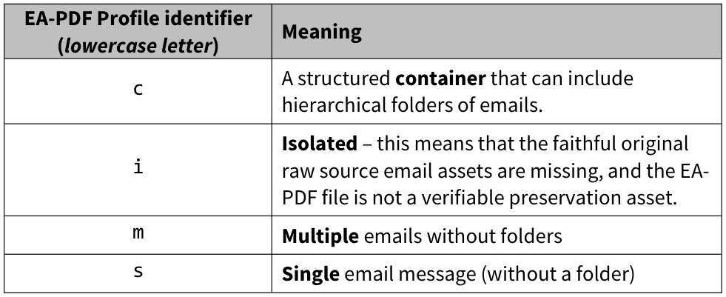

Appendix A — Source Table 2
EA-PDF 1.0 §3.2. Original printed layout; all table segments reproduced. The labels and notes below are editorial navigation, not alterations to the source image.
Descriptive profile matrix. The printed PDF/A-4fe spelling is preserved. Footnotes on each source page are included.
Table 2, segment 1/4 — printed p. 8, PDF p. 15.
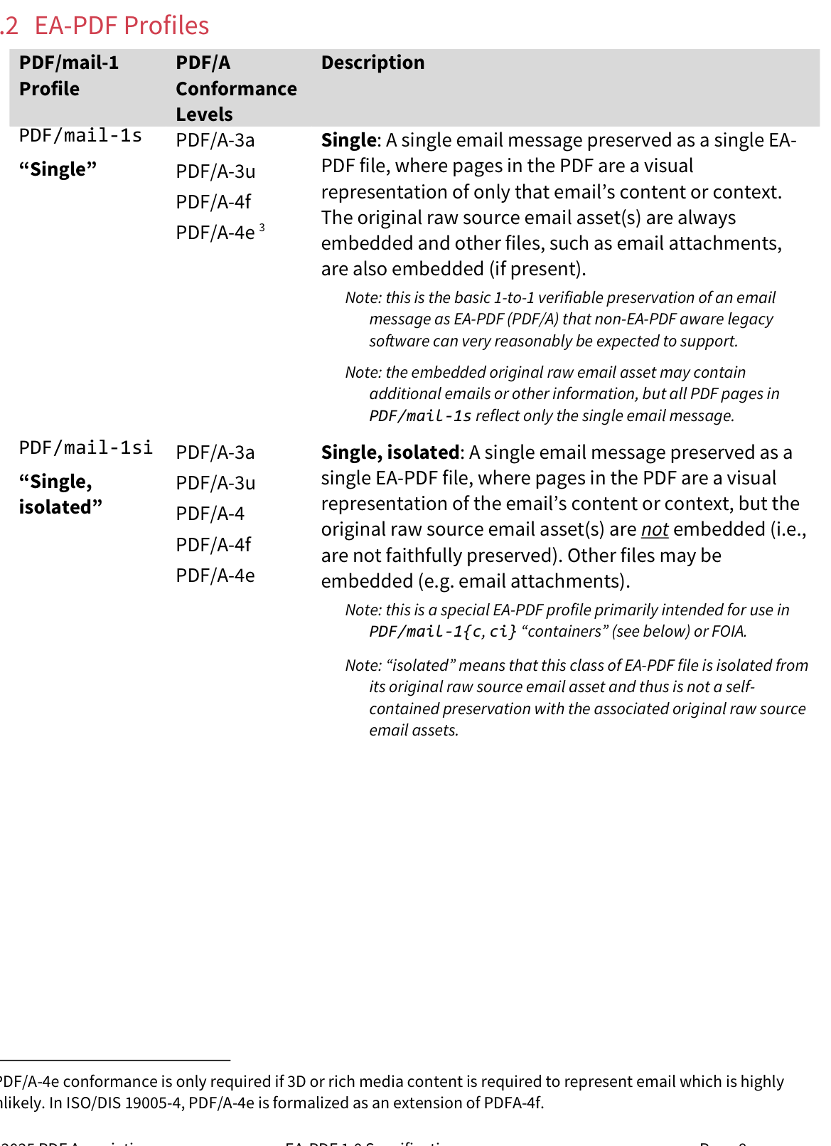
Table 2, segment 2/4 — printed p. 9, PDF p. 16.
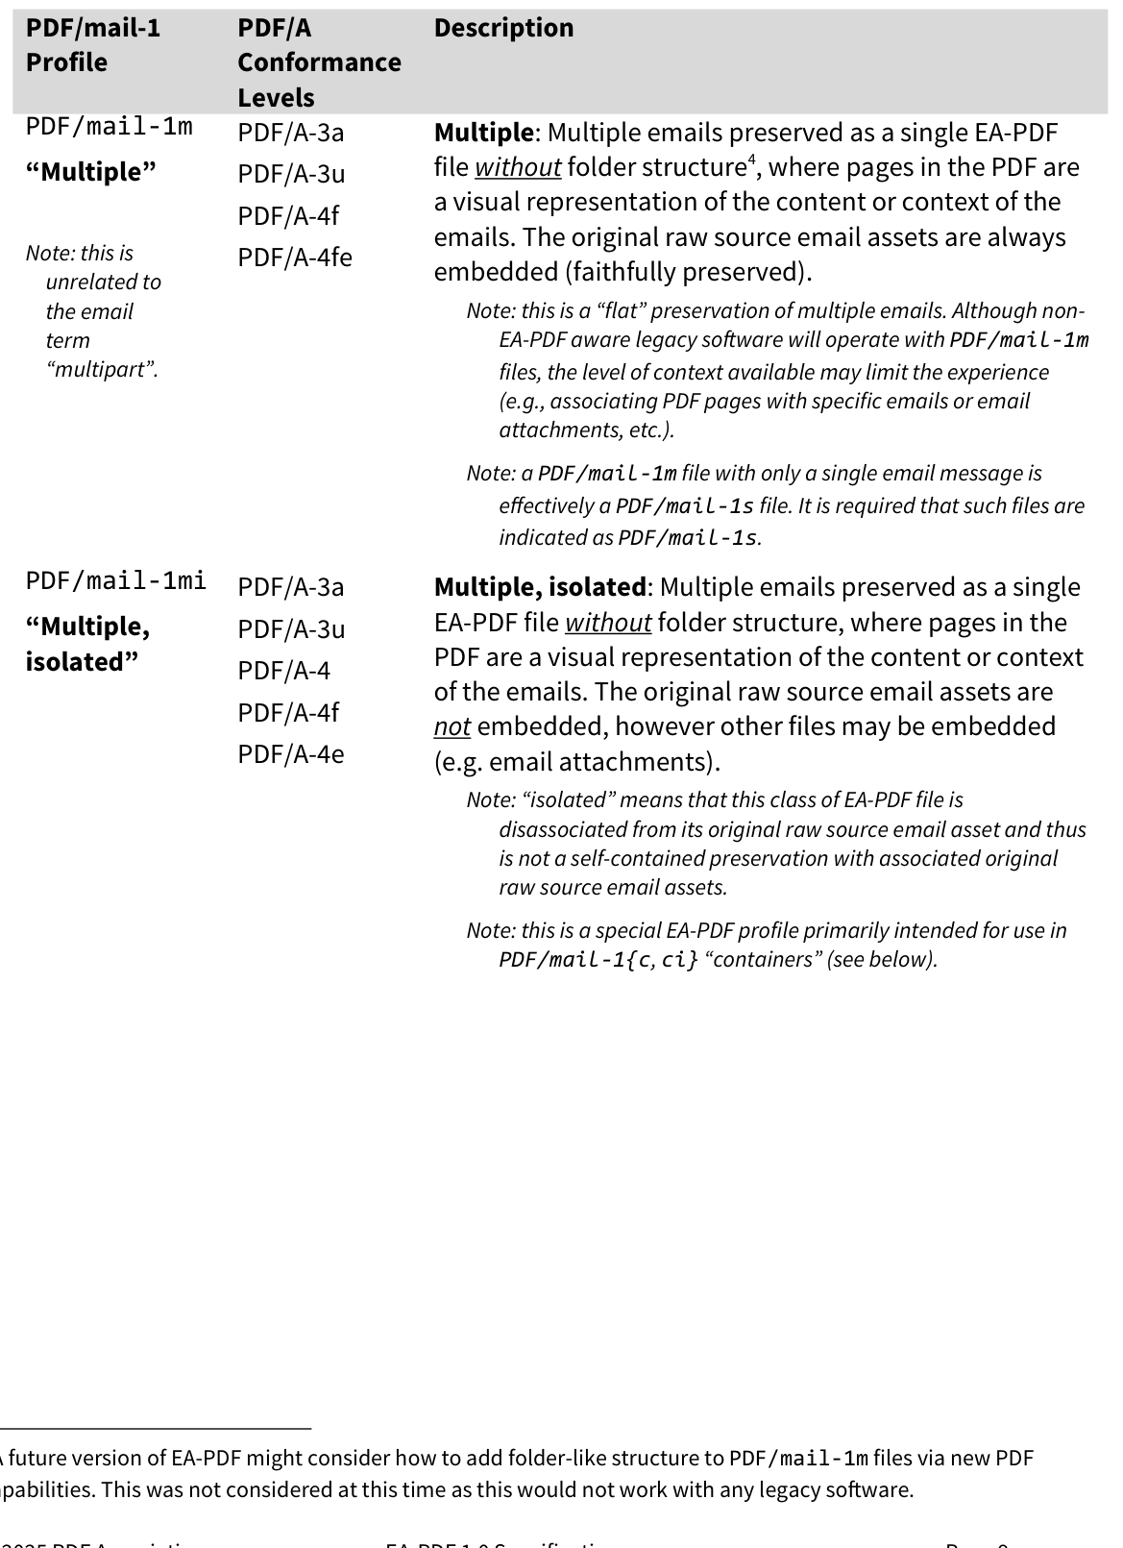
Table 2, segment 3/4 — printed p. 10, PDF p. 17.
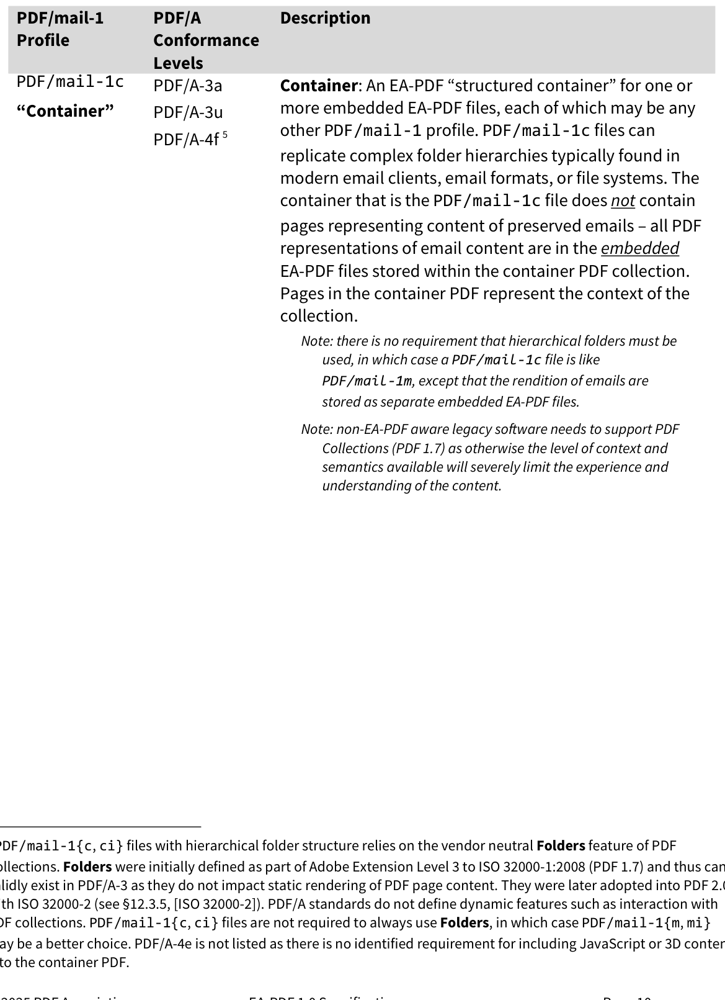
Table 2, segment 4/4 — printed p. 11, PDF p. 18.
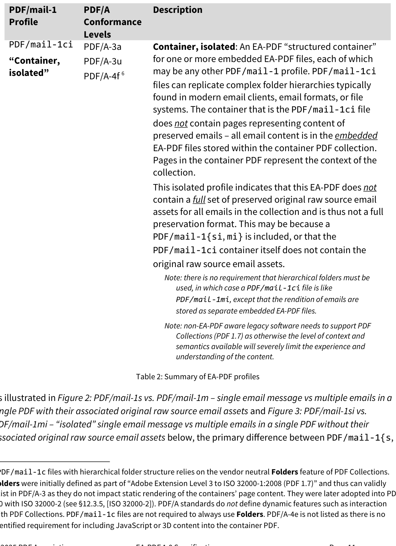

Appendix A — Source Table 3
EA-PDF 1.0 §7.1.2. Original printed layout; all table segments reproduced. The labels and notes below are editorial navigation, not alterations to the source image.
Informative example: this table does not impose all example structure nodes.
Table 3, segment 1/1 — printed p. 28, PDF p. 35.
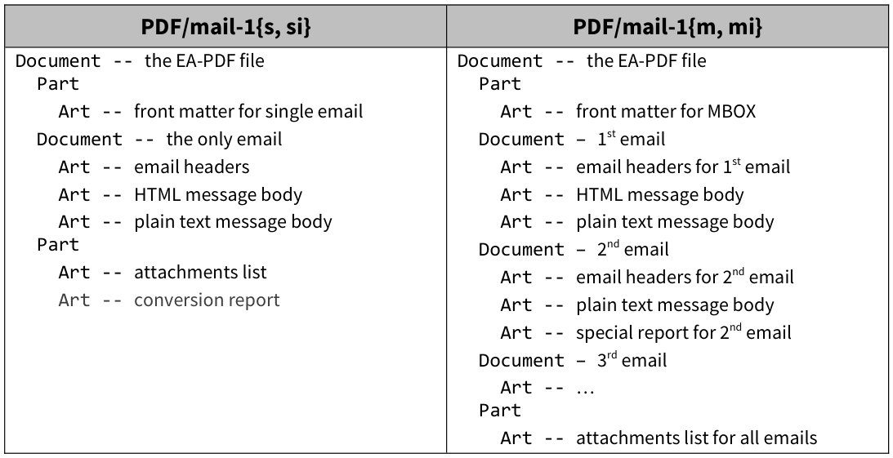

Appendix A — Source Table 4
EA-PDF 1.0 §7.3.1. Original printed layout; all table segments reproduced. The labels and notes below are editorial navigation, not alterations to the source image.
Table 4, segment 1/1 — printed p. 37, PDF p. 44.
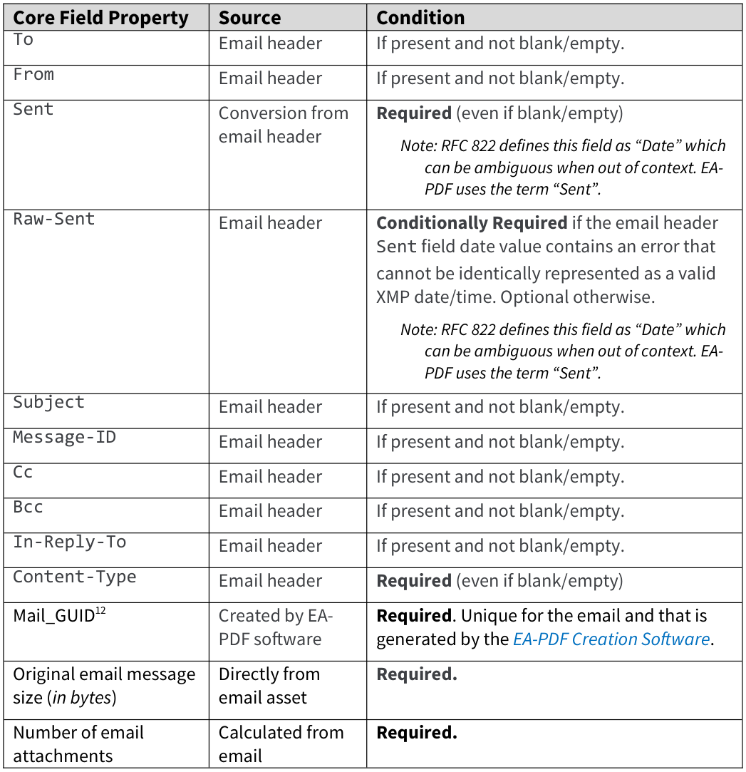
Associated source footnote — EA-PDF 1.0, §7.3.1, footnotes 12–13; printed p. 37; PDF p. 44
12 GUID = Global Unique Identifier. EA-PDF does not prescribe how GUIDs are generated and does not distinguish between the terms GUID and UUID (Universally Unique Identifier, see also RFC 4122). 13 Note that some Core Fields in email, such as Message-ID and Subject, are optional according to [RFC-822].

Appendix A — Source Table 5
EA-PDF 1.0 §7.6. Original printed layout; all table segments reproduced. The labels and notes below are editorial navigation, not alterations to the source image.
Table 5, segment 1/1 — printed p. 53, PDF p. 60.
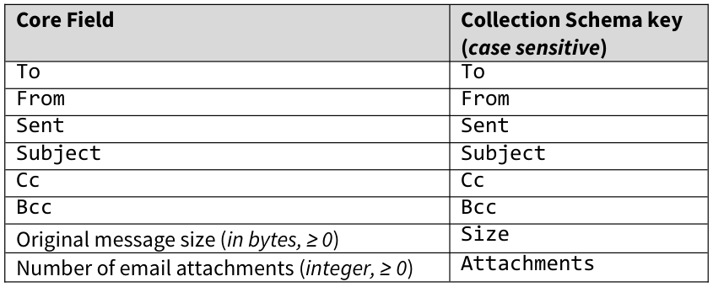

Appendix A — Source Table 6
EA-PDF 1.0 §9.5. Original printed layout; all table segments reproduced. The labels and notes below are editorial navigation, not alterations to the source image.
Table 6, segment 1/1 — printed p. 68, PDF p. 75.
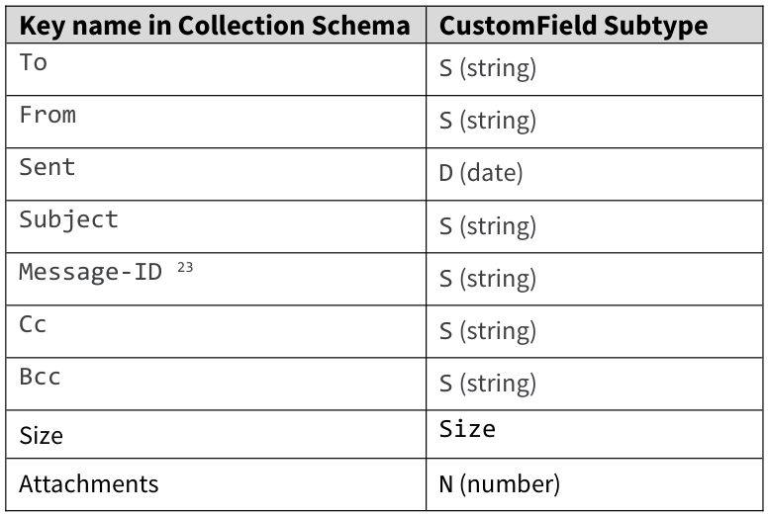
Associated source footnote — EA-PDF 1.0, §9.5, footnote 23; printed p. 68; PDF p. 75
23 Note that this is the email’s Message-ID (which may not exist) and is not the synthetically generated Mail_GUID used internally.

Appendix A — Source Table 7
EA-PDF 1.0 §9.6. Original printed layout; all table segments reproduced. The labels and notes below are editorial navigation, not alterations to the source image.
Table 7, segment 1/1 — printed p. 70, PDF p. 77.
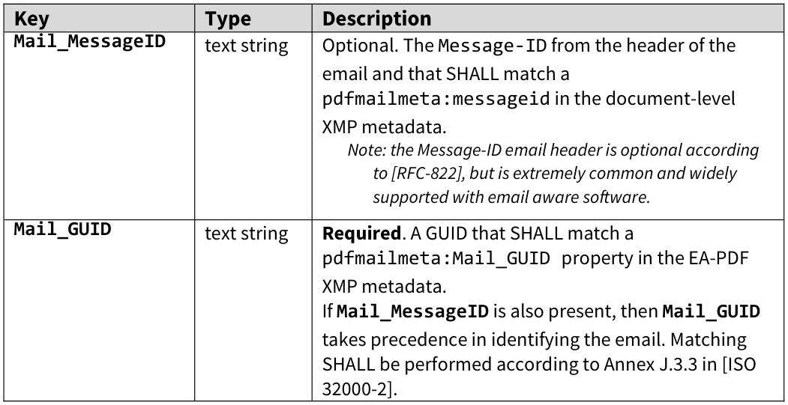

Appendix A — Source Table 8
EA-PDF 1.0 §9.6. Original printed layout; all table segments reproduced. The labels and notes below are editorial navigation, not alterations to the source image.
This table continues across source pages. Read all segments together; blank/merged parent cells continue earlier rows.
Table 8, segment 1/2 — printed p. 70, PDF p. 77.
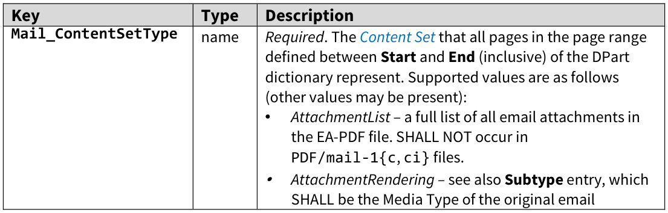
Table 8, segment 2/2 — printed p. 71, PDF p. 78.
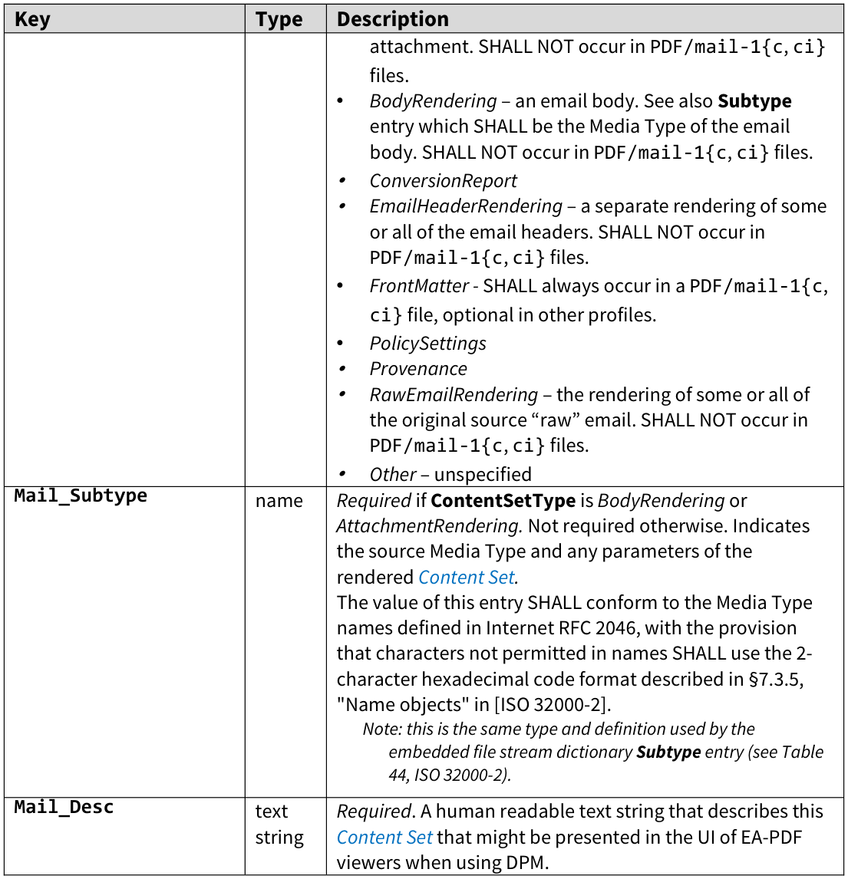

Appendix A — Source Table 9
EA-PDF 1.0 §9.7. Original printed layout; all table segments reproduced. The labels and notes below are editorial navigation, not alterations to the source image.
This table continues across source pages. Read all segments together; blank/merged parent cells continue earlier rows.
Table 9, segment 1/2 — printed p. 74, PDF p. 81.
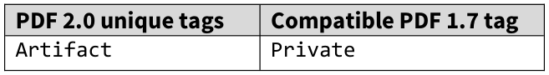
Table 9, segment 2/2 — printed p. 75, PDF p. 82.
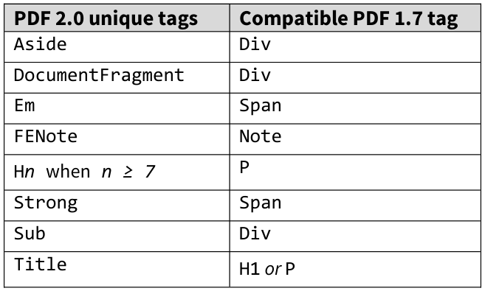

Appendix A — Source Table 10
EA-PDF 1.0 §9.7. Original printed layout; all table segments reproduced. The labels and notes below are editorial navigation, not alterations to the source image.
Table 10, segment 1/1 — printed p. 75, PDF p. 82.
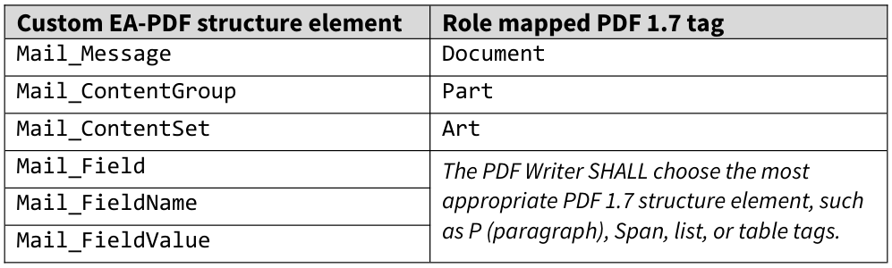

Appendix A — Source Table 11
EA-PDF 1.0 §9.7. Original printed layout; all table segments reproduced. The labels and notes below are editorial navigation, not alterations to the source image.
The source prints Mail_ContentField. The current JSON correction is shown separately in Rule 120.
This table continues across source pages. Read all segments together; blank/merged parent cells continue earlier rows.
Table 11, segment 1/2 — printed p. 75, PDF p. 82.
Table 11, segment 2/2 — printed p. 76, PDF p. 83.
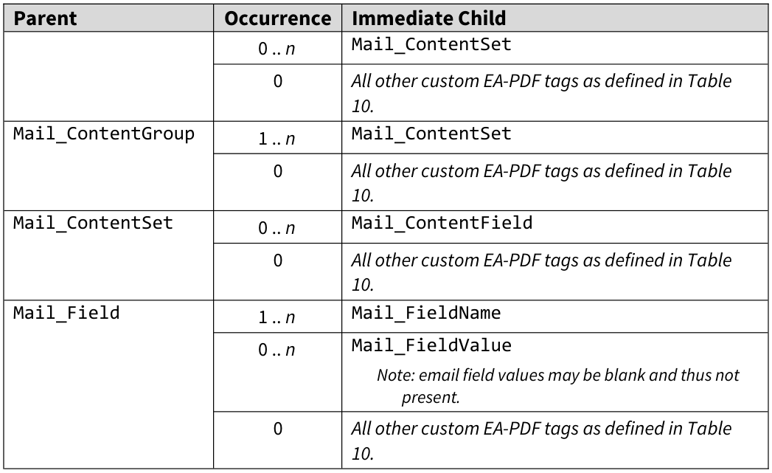
Associated source footnote — EA-PDF 1.0, §9.7, footnote 24; printed p. 75; PDF p. 82
24 Other nesting requirements are described below.

Appendix A — Source Table 12
EA-PDF 1.0 §9.7. Original printed layout; all table segments reproduced. The labels and notes below are editorial navigation, not alterations to the source image.
Table 12, segment 1/1 — printed p. 77, PDF p. 84.
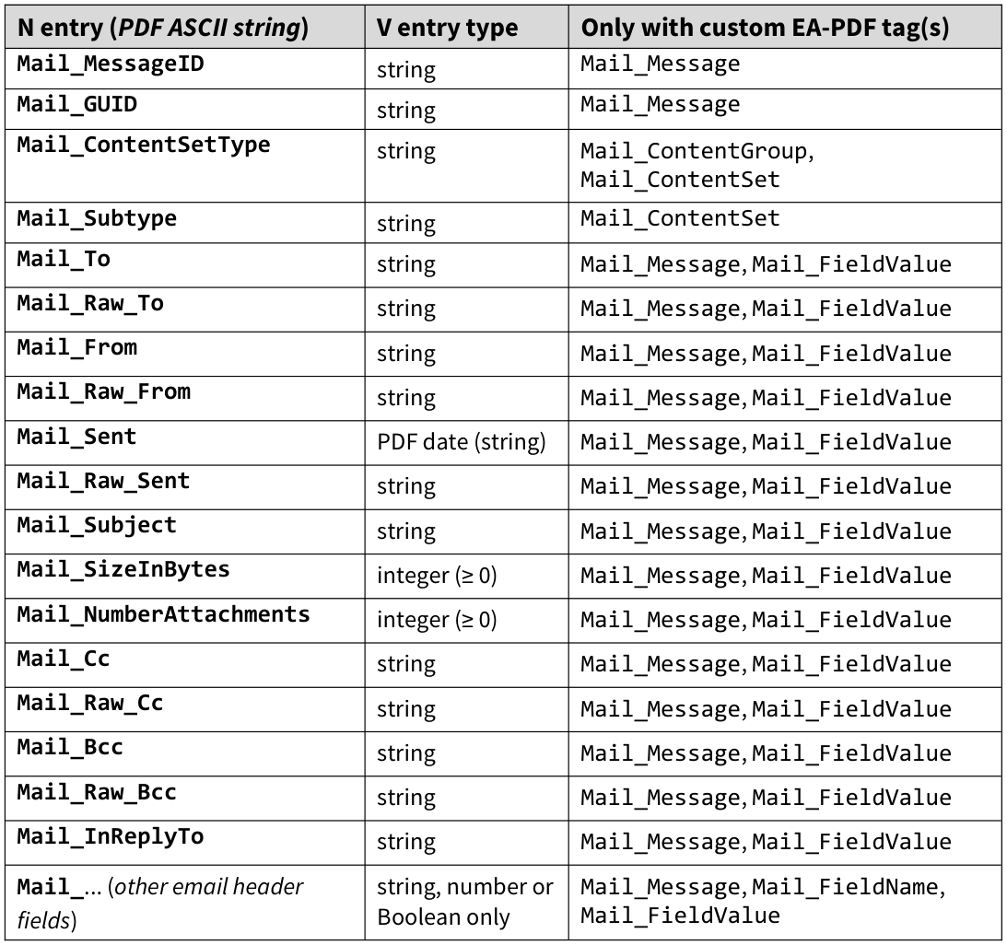

Appendix A — Source Table 13
EA-PDF 1.0 §9.7. Original printed layout; all table segments reproduced. The labels and notes below are editorial navigation, not alterations to the source image.
Table 13, segment 1/1 — printed p. 79, PDF p. 86.
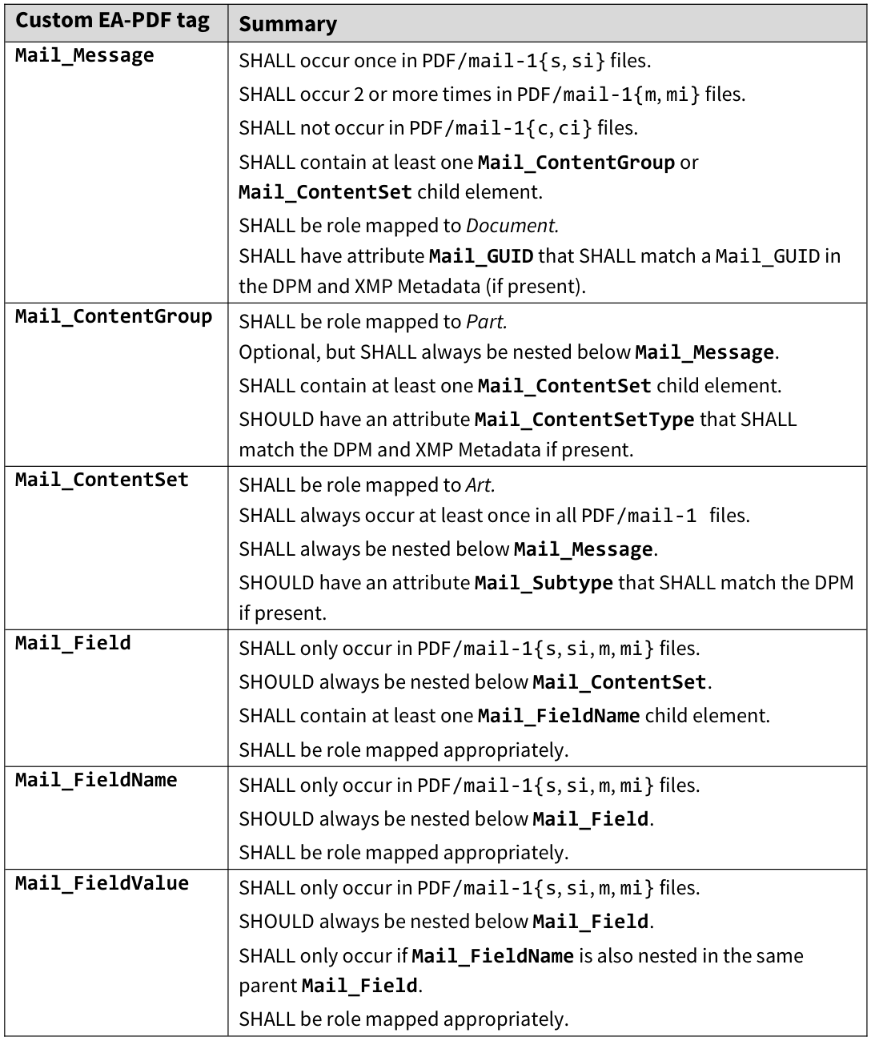

Appendix A — Source Table 14
EA-PDF 1.0 §9.8. Original printed layout; all table segments reproduced. The labels and notes below are editorial navigation, not alterations to the source image.
Table 14, segment 1/1 — printed p. 84, PDF p. 91.
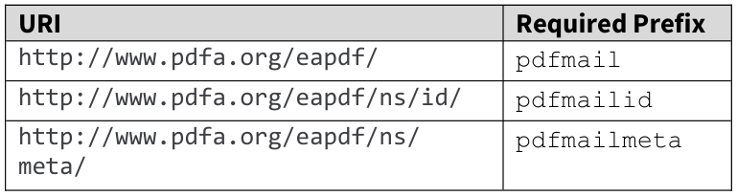

Appendix A — Source Table 15
EA-PDF 1.0 §9.8.1. Original printed layout; all table segments reproduced. The labels and notes below are editorial navigation, not alterations to the source image.
Table 15, segment 1/1 — printed p. 84, PDF p. 91.
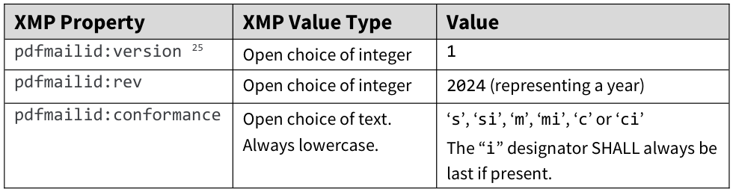
Associated source footnote — EA-PDF 1.0, §9.8.1, footnote 25; printed p. 84; PDF p. 91
25 pdfmailid:part is reserved for future ISO standardization.

Appendix A — Source Table 16
EA-PDF 1.0 §9.8.2. Original printed layout; all table segments reproduced. The labels and notes below are editorial navigation, not alterations to the source image.
Table 16, segment 1/1 — printed p. 85, PDF p. 92.
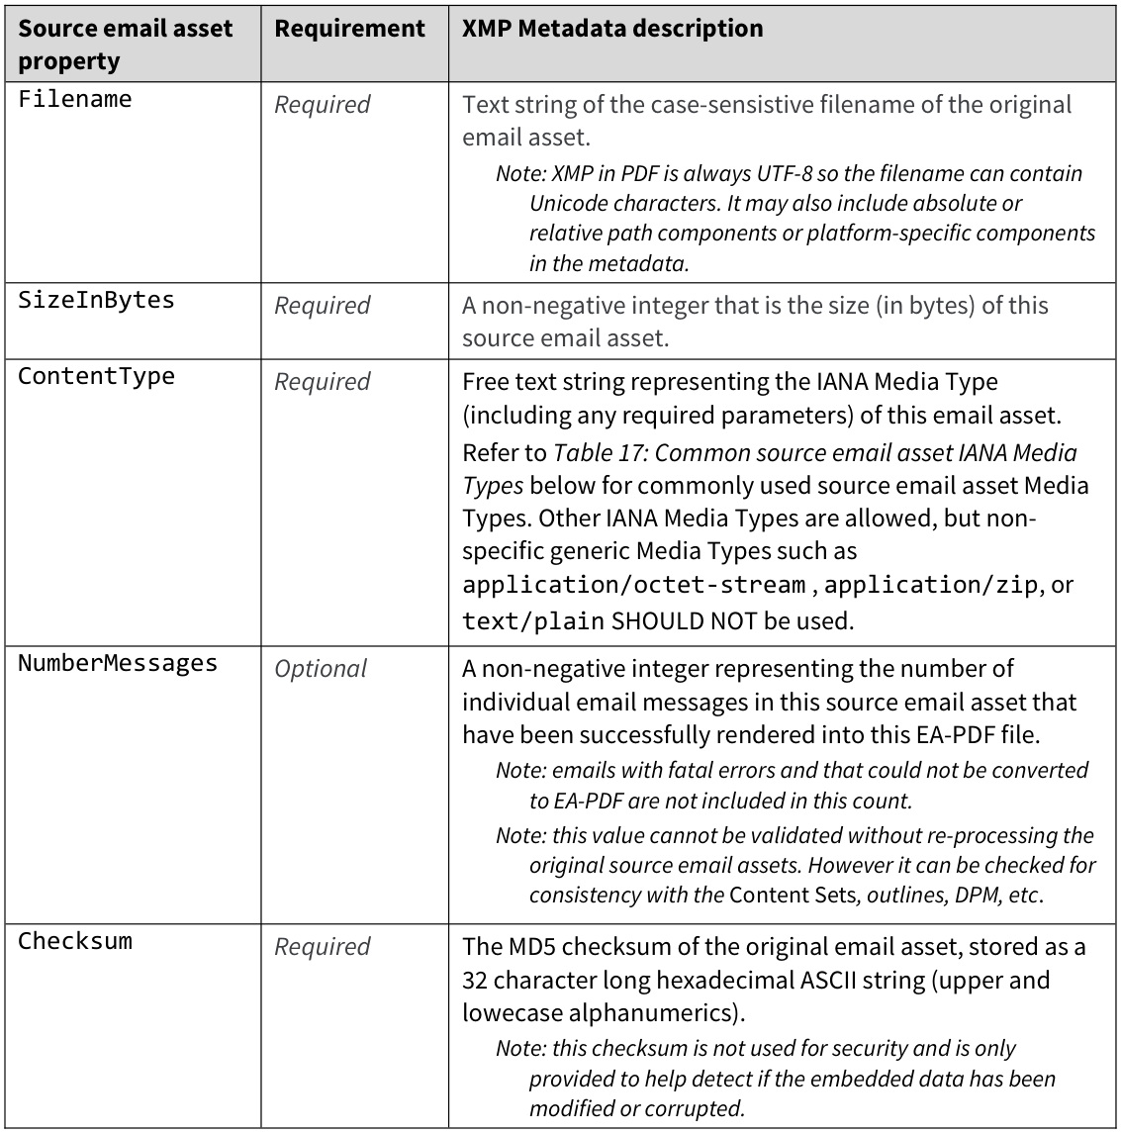

Appendix A — Source Table 17
EA-PDF 1.0 §9.8.2. Original printed layout; all table segments reproduced. The labels and notes below are editorial navigation, not alterations to the source image.
Table 17, segment 1/1 — printed p. 86, PDF p. 93.
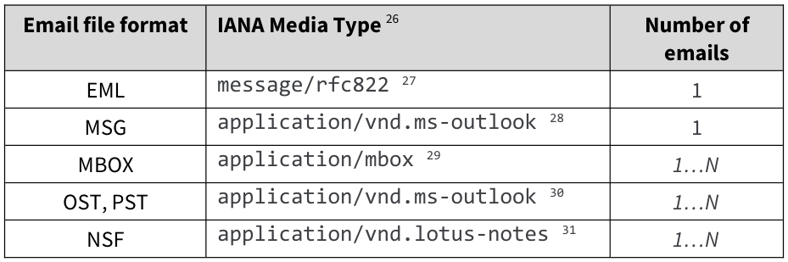
Associated source footnote — EA-PDF 1.0, §9.8.2, footnotes 26–31; printed p. 86; PDF p. 93
26 See https://www.iana.org/assignments/media-types/media-types.xhtml for registered Media Types. Not all media types for email formats are registered. 27 https://www.loc.gov/preservation/digital/formats/fdd/fdd000388.shtml 28 https://www.loc.gov/preservation/digital/formats/fdd/fdd000379.shtml 29 https://www.loc.gov/preservation/digital/formats/fdd/fdd000383.shtml 30 https://www.loc.gov/preservation/digital/formats/fdd/fdd000378.shtml 31 https://www.loc.gov/preservation/digital/formats/fdd/fdd000433.shtml

Appendix A — Source Table 18
EA-PDF 1.0 §9.8.3. Original printed layout; all table segments reproduced. The labels and notes below are editorial navigation, not alterations to the source image.
This table continues across source pages. Read all segments together; blank/merged parent cells continue earlier rows.
Table 18, segment 1/3 — printed p. 86, PDF p. 93.
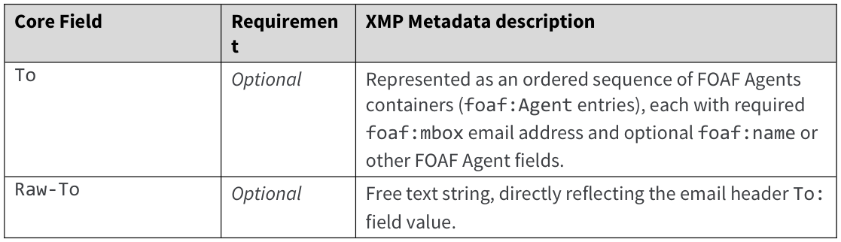
Table 18, segment 2/3 — printed p. 87, PDF p. 94.
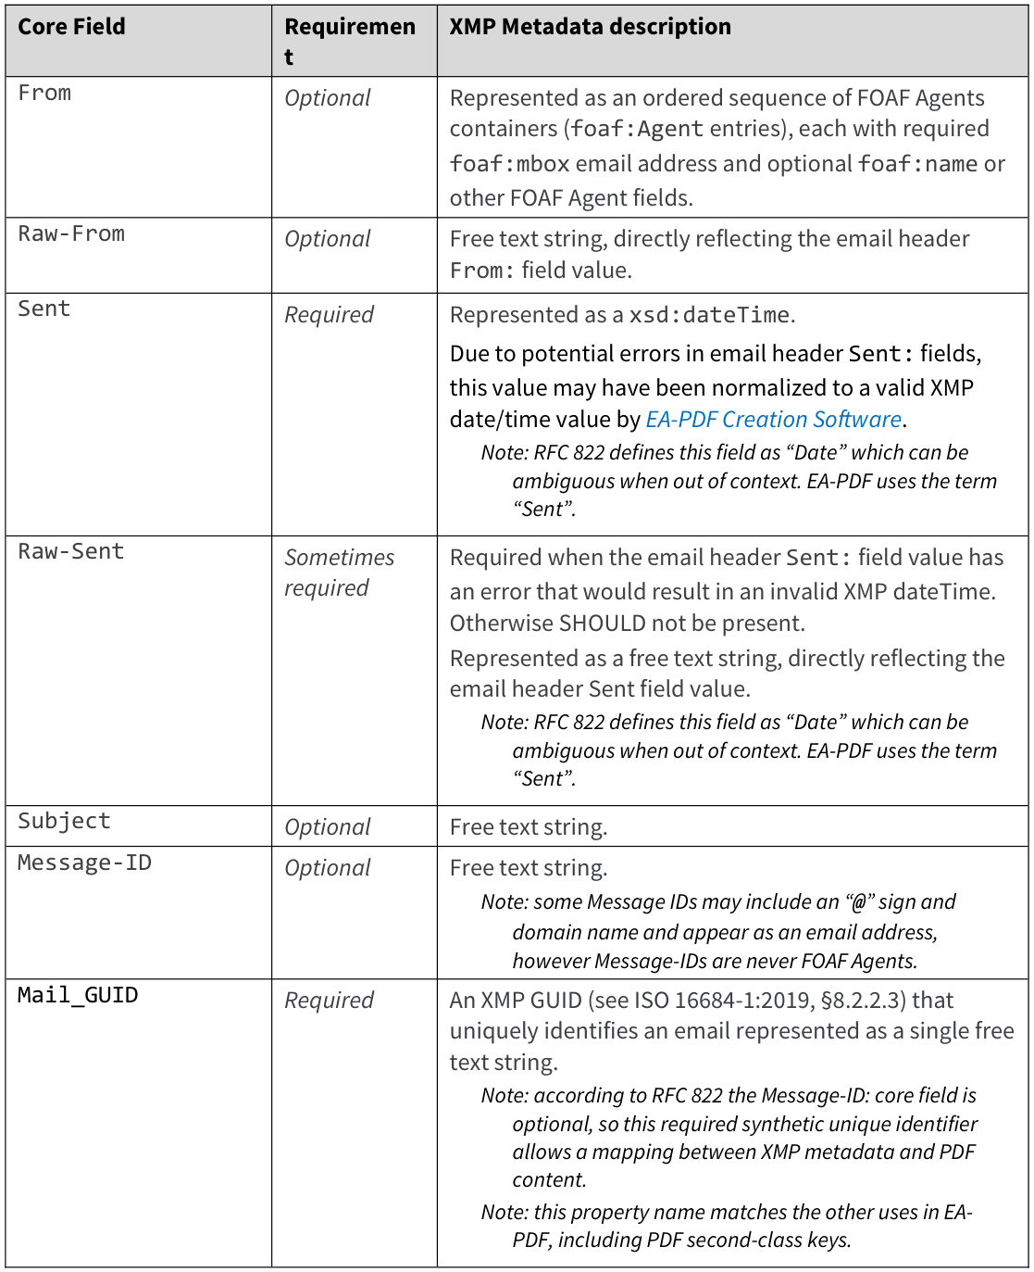
Table 18, segment 3/3 — printed p. 88, PDF p. 95.
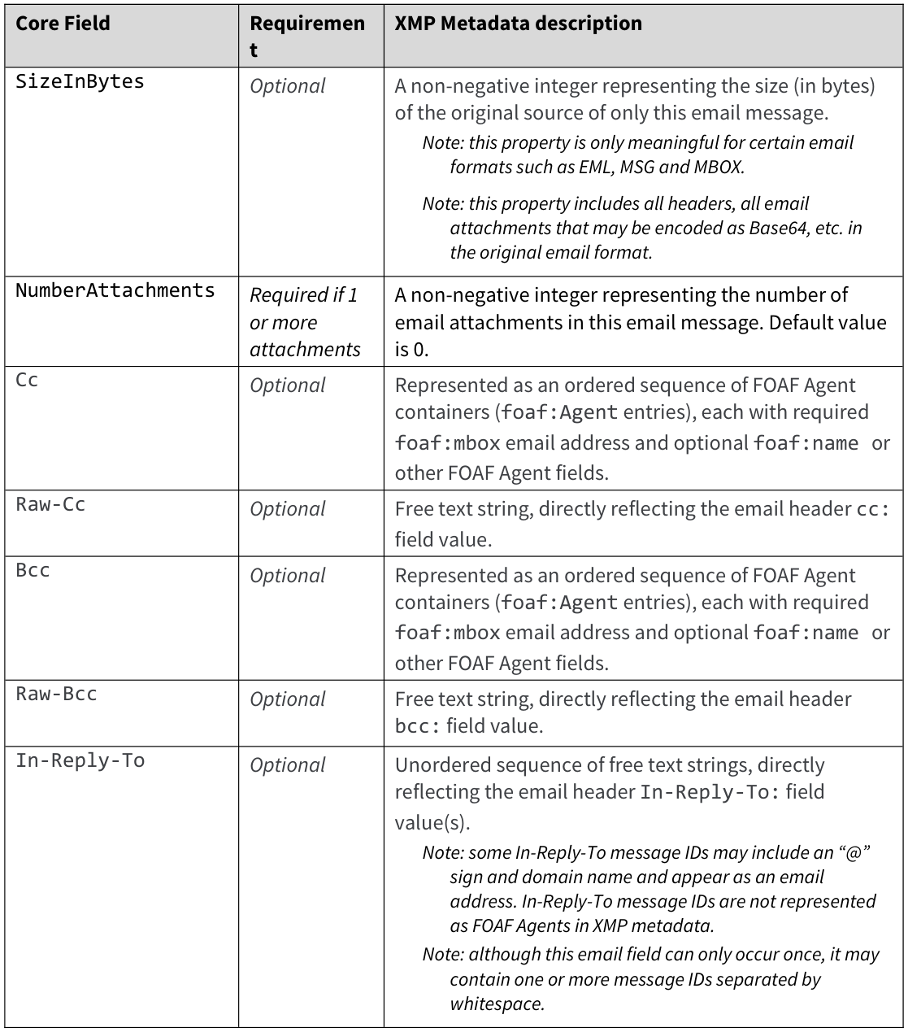
Associated source footnote — EA-PDF 1.0, §9.8.3, footnote 32; printed p. 88; PDF p. 95
32 Note that some Core Fields such as Message-ID and Subject are optional according to [RFC-822]. Other field values may also be empty/blank in draft emails.

Appendix A — Source Table 19
EA-PDF 1.0 §9.8.4. Original printed layout; all table segments reproduced. The labels and notes below are editorial navigation, not alterations to the source image.
This table continues across source pages. Read all segments together; blank/merged parent cells continue earlier rows.
Table 19, segment 1/2 — printed p. 89, PDF p. 96.
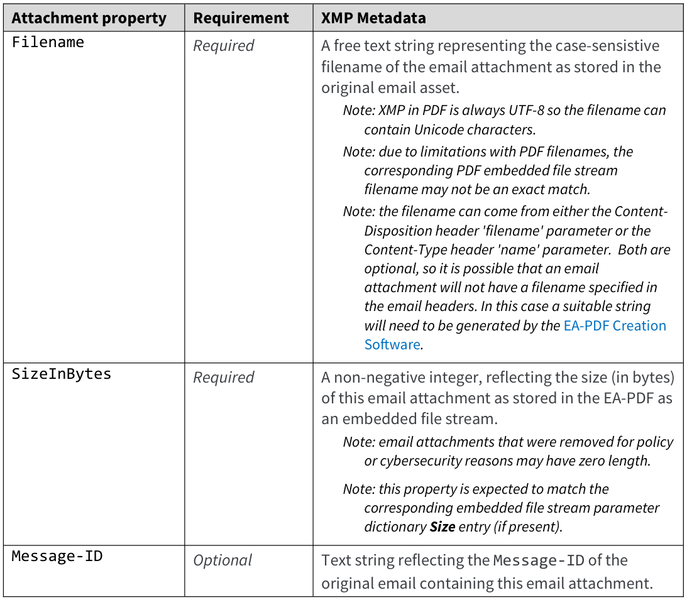
Table 19, segment 2/2 — printed p. 90, PDF p. 97.
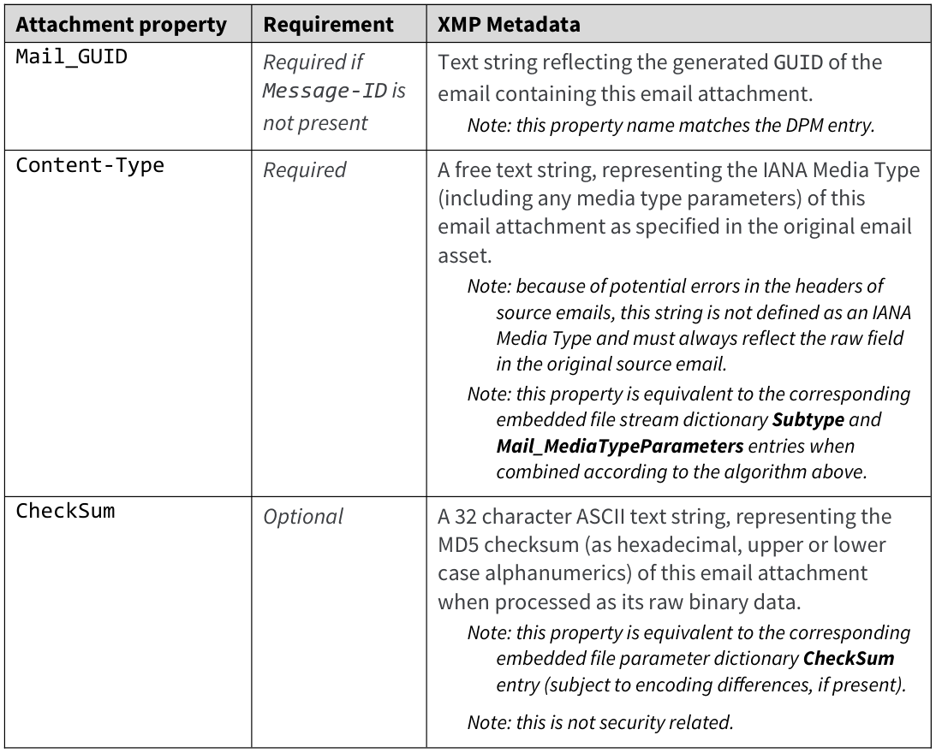

Appendix B — Completeness and coverage
The current rulebook has 229 numbered rules linked to 301 reviewed source records. Source records include recommendations, creator duties, software behaviour and definitions; they are not all mandatory PDF tests.
The registry audit verifies numbering, source identity, source-page order, conditional obligations and mappings. It does not prove every sentence was extracted perfectly or every permitted representation is implemented. PDF/A is delegated to veraPDF; applicable ISO/TS 32005 checks remain separate.
Original-input completeness and historical provenance cannot be inferred solely from consistent PDF metadata. Unknown association is not a proven mismatch or a successful comparison. Exact implementation results and skipped tests are recorded in docs/DEVELOPMENT_STATUS.md and docs/improvement/rule-refinement-2026-10-31/.

Source records outside the active custom rule list
CONTENTSET-ADDITIONAL — file; PERMITTED. Additional renderings, reports, raw dumps, attachment lists and other Content Sets are allowed subject to the other requirements.
EMBEDDED-SUBTYPE-PARAMS — file; SHALL_NOT. Subtype contains neither semicolons nor media-type parameters.
Delegated prerequisite: EMBEDDED_SUBTYPE_NO_PARAMETERS
COLLECTION-DISPLAY-FLEXIBILITY — file; PERMITTED. Schema display N, ordering O, default visibility V, Collection Sort and Folder layout are not further constrained.
XMP-PDFA3-EXTENSIONS — file; inherited_requirement. Include extension schemas as required by PDF/A-3 6.6.2.3.2; EA-PDF-only schema presence does not establish complete arbitrary custom-schema coverage.
Delegated prerequisite: PDFA3_EAPDF_XMP_EXTENSION_SCHEMA
XMP-ADDITIONAL-HEADERS — file; PERMITTED. Use case-sensitive header field names and optionally Raw- for otherwise nonrepresentable source data; do not ban unknown fields.
XMP-UTF8 — file; must_in_explanatory_section. Encode every XMP stream in UTF-8, including PDF/A-3; record this explicit statement despite section 7.1 saying it introduces no formal requirements.
Delegated prerequisite: XMP_UTF8
SOURCE-PREPROCESS-POLICY — file; PERMITTED. Export individual messages or combine assets before conversion, embed all originals, use collection members, or use isolated profiles; the format does not mandate universal reader enumeration.
SOURCE-PROVENANCE — file; ought_guidance. Record preprocessing in provenance metadata; no universal provenance schema or new SHALL is prescribed.
FILESPEC-DESCRIPTION — file; needs_in_explanatory_section. Supply appropriate Desc; reconcile the nearby ought guidance rather than silently assigning a new formal SHALL.
ATTACHMENT-ZERO — file; ought_guidance. Retain its annotation/file specification with a zero-length stream; this is explicitly not a mandatory source-parsing test.
ATTACHMENT-ALTERNATIVE — file; PERMITTED. An Alternative AF may carry a separate rendering; a zero-length original placeholder remains distinguishable from the alternate.
CONTAINER-FOLDERS — creation; conditional_creation_requirement. Use Collection Folders; hierarchical folders and a file in every folder are not unconditional EA-PDF requirements.
WORKFLOW-PROFILE — file; workflow_guidance. Retain valid PDF/A and accurately declare isolated status when original provenance is lost; redaction algorithms and archival workflows are out of scope.
SCOPE-POLICY — file; out_of_scope. Layout, wrapping, source-error recovery, URL policy, redaction, precise algorithms and user interface design are not new file-conformance rules.
SCOPE-PREMIS — file; not_required. PREMIS elements are not mandated by EA-PDF; optional schema checks must not be presented as a mandatory EA-PDF requirement.
EMBEDDED-DEDUP — creation; conditional_creation_requirement. Base deduplication on binary content rather than filename; multiple file specifications and names may share a stream.
DECLARATIONS-PUBLIC — file; strongly_recommended. Publicly record declarations at the PDF Association registry; this does not require EA-PDF files to use PREMIS or EAXS.
XMP-EXTRA — file; PERMITTED. Additional XMP may be associated with arbitrary dictionaries or streams subject to PDF/A and any applicable schema obligations.
HEADER-VISIBLE-DISTINCTION — file; ought_guidance. Make their layout distinguishable from message bodies; a visual recommendation is not an additional machine-only file validity predicate.
IMAGE-XOBJECTS — file; ought_guidance. Prefer Image XObjects rather than inline images for converted assets; inline images for other purposes are not prohibited.
FONT-REUSE — file; ought_guidance. Optimize reusable fonts/resources across emails; no mandatory file-size or exact resource-count limit is specified.
OUTLINE-HIERARCHY — file; ought_guidance. Use a useful hierarchy and collapse lower levels initially for large archives; outline title wording, formatting and destination mechanism remain flexible.
UNMENTIONED-PDF-FEATURES — file; PERMITTED. Do not reject a PDF feature solely because EA-PDF does not list it.
T8-OTHER-VALUES — file; PERMITTED. ConversionReport, PolicySettings, Provenance and Other are listed alongside rendering/front-matter types; unknown names are allowed and must not be rejected as an invented closed enum.
SOFTWARE-RENDER — software; SHALL. Render all pages according to the appropriate PDF/A requirements.
SOFTWARE-ANNOTATION-AP — software; SHALL. Display all annotations using their appearance streams; making an annotation visible may involve user action.
SOFTWARE-CONFORMANCE-INDICATION — software; SHALL. Indicate that the PDF claims EA-PDF conformance, in addition to PDF/A.
SOFTWARE-FUTURE-PROFILE — software; SHALL. Detect unsupported PDF/mail versions/profiles and inform the user of compatibility issues; detection is not limited to version 1.
SOFTWARE-INVALID-NAMES — software; SHALL. Software supporting c/ci does not support invalid Collection filenames.
SOFTWARE-READONLY — software; SHALL. Initially open read-only so modification requires additional explicit user action.
SOFTWARE-INITIAL-VIEW — software; SHALL. Use the initial viewing mode specified by the file.
SOFTWARE-OUTLINES — software; SHALL. Support outline navigation.
SOFTWARE-EXTRACT-EMBEDDED — software; SHALL. Allow extraction from EmbeddedFiles, page attachment annotations and AF on arbitrary objects.
SOFTWARE-DESCRIPTIONS — software; SHALL. Display file specification Desc entries as well as filenames.
SOFTWARE-ATTACHMENT-INTERACTION — software; SHALL. Display and permit access via file attachment annotations without modifying the EA-PDF.
SOFTWARE-CONTENTS — software; SHALL. Display file attachment Contents values.
SOFTWARE-EXPLICIT-LINKS — software; SHALL. Interact only with explicitly defined link annotations by default.
SOFTWARE-COLLECTIONS — software; SHALL. Support PDF Collections when c/ci is supported.
SOFTWARE-XMP — software; SHALL. Access and display all XMP Metadata streams.
SOFTWARE-EXTRACT-OBJECTS — software; SHALL. Allow extraction of all AF and XMP Metadata associated with arbitrary objects.
SOFTWARE-NO-AUTO-URL — software; SHALL_NOT. Do not auto-detect actionable/actioned URLs unless explicitly enabled by a user for each individual PDF; a persistent application setting is insufficient.
T3-EXAMPLE — guidance; informative_example. Examples illustrate nested Document/Part/Art and do not mandate every example node or require all optional tagging.
T4-To — creation; core_field_definition. To: present and nonblank. Distinguish source/creator guidance and Table 18 XMP schema; differences are recorded, not silently enforced as extra XMP fields.
T4-From — creation; core_field_definition. From: present and nonblank. Distinguish source/creator guidance and Table 18 XMP schema; differences are recorded, not silently enforced as extra XMP fields.
T4-Sent — creation; core_field_definition. Sent: required even if blank. Distinguish source/creator guidance and Table 18 XMP schema; differences are recorded, not silently enforced as extra XMP fields.
T4-Raw-Sent — creation; core_field_definition. Raw-Sent: required for an erroneous date, optional otherwise. Distinguish source/creator guidance and Table 18 XMP schema; differences are recorded, not silently enforced as extra XMP fields.
T4-Subject — creation; core_field_definition. Subject: present and nonblank. Distinguish source/creator guidance and Table 18 XMP schema; differences are recorded, not silently enforced as extra XMP fields.
T4-Message-ID — creation; core_field_definition. Message-ID: present and nonblank. Distinguish source/creator guidance and Table 18 XMP schema; differences are recorded, not silently enforced as extra XMP fields.
T4-Cc — creation; core_field_definition. Cc: present and nonblank. Distinguish source/creator guidance and Table 18 XMP schema; differences are recorded, not silently enforced as extra XMP fields.
T4-Bcc — creation; core_field_definition. Bcc: present and nonblank. Distinguish source/creator guidance and Table 18 XMP schema; differences are recorded, not silently enforced as extra XMP fields.
T4-In-Reply-To — creation; core_field_definition. In-Reply-To: present and nonblank. Distinguish source/creator guidance and Table 18 XMP schema; differences are recorded, not silently enforced as extra XMP fields.
T4-Content-Type — creation; core_field_definition. Content-Type: required even if blank. Distinguish source/creator guidance and Table 18 XMP schema; differences are recorded, not silently enforced as extra XMP fields.
T4-Mail_GUID — creation; core_field_definition. Mail_GUID: required and unique. Distinguish source/creator guidance and Table 18 XMP schema; differences are recorded, not silently enforced as extra XMP fields.
T4-Original-message-size — creation; core_field_definition. Original message size: required. Distinguish source/creator guidance and Table 18 XMP schema; differences are recorded, not silently enforced as extra XMP fields.
T4-Number-of-attachments — creation; core_field_definition. Number of attachments: required. Distinguish source/creator guidance and Table 18 XMP schema; differences are recorded, not silently enforced as extra XMP fields.
PDF-OUTPUTINTENT — inherited; inherited_requirement. Device-independent color obligations do not imply every PDF must have an OutputIntent; permitted CIE/default-color alternatives and the actual PDF/A clause govern.
Delegated prerequisite: OUTPUT_INTENT
PDF-XMP-WELLFORMED — inherited; inherited_requirement. Parseable XMP and RDF value/container serialization follow the underlying PDF/A/XMP model; parsing successfully alone does not prove schema conformance.
Delegated prerequisite: XMP_PARSE

Appendix C — Source and verification record
validator_rule_text.json
SHA-256: 5753d02350f1ff8262090c272bde6e760dfed20c5a5c97031871f8cbeebb1d21
docs/improvement/specification-audit/validator-rule-review.json
SHA-256: 639493a47527fa16edc6a139f4dc5bfa45e4891c19c2da166847fe8f00ed1eea
docs/reference/EA-PDF-v1.pdf
SHA-256: b89e7471afd3aabaa4e58bd6ca1f3241378c1596cf528023e740d9e79183dbae
docs/reference/ISO_32000-2_sponsored-ec2.pdf
SHA-256: 0958d3b076f4ad3bb32c1a1aa62011f52751b58bd2e3914bc714b74a1ccc517b
docs/improvement/rule-refinement-2026-10-31/top-level-rule-migration.json
SHA-256: 12e23a38afad73c2c323efe81ebe29fc959e44023e45bb78fbaba663099037d2
docs/improvement/rule-refinement-2026-10-31/project-issues.json
SHA-256: aca5aceb72a56f48f525aff62bb3ca5c1253d6545989ccfd608d8fa9144ff3ec
docs/improvement/rule-refinement-2026-10-31/project-issues-review.json
SHA-256: 4a47e0f257805399cad3917a82560fc6071f92e728676fca197b1f07738db3a6
Original quotations, editable source-table XML and image bytes were preserved. Reordering and splitting may repeat an exhibit. Linked source wording can support several independently reported rules.

Appendix D — Reexamination decisions
These project interpretations are retained for author review, not presented as published errata. The current rulebook and 31 October refinement take precedence over older runtime descriptions. Published inconsistencies still need authoritative clarification.

Finding 1: Which text controls conflicting requirements?
Use section 9 and its normative tables for file requirements, inherited PDF/PDF-A rules for valid representations, and published errata for corrections. Earlier explanations inform intent; they do not silently strengthen SHOULD into MUST.

Finding 2: Can a PDF prove that nothing was lost?
No. Separate observable internal consistency from source fidelity and creator evidence. Missing or ambiguous evidence must not be reported as a proved match.

Finding 3: Which PDF/A-4 edition can be checked now?
Keep the pinned 2020-edition veraPDF profiles as the operational baseline. Equivalence to the cited 2024 draft remains unverified; no duplicate PDF/A engine is invented.

Finding 4: Which conformance levels are allowed?
Use the section 9.1 list, including PDF/A-4e, subject to the actual PDF/A feature restrictions. Treat 4fe as the reported spelling error, not a new level.

Finding 5: What should a PDF 1.7 collection use for the full-screen exit mode?
Use UseOutlines for PDF 1.7 and UseAttachments for PDF 2.0. Keep the required preference and collection PageMode=UseAttachments. This newly authorized local version exception is not upstream errata.

Finding 6: Can sources retained only inside children satisfy the outer collection?
Keep the outer catalog Source requirement as well as independently preserved child sources. The creator retains both; changing preservation ownership needs an author decision.

Finding 7: What does an isolated file promise about retained originals?
Isolation does not prohibit retained source files or certify their completeness. Validate supplied asset records and observable links; do not require an invented complete-original inventory for isolated profiles.

Finding 8: How should email-to-asset ambiguity be handled?
Keep exact GUID priority and uniquely supported source associations. Report unavailable comparisons when records cannot identify one source; do not add an unstandardized mandatory link property.

Finding 9: How should attachment-to-stream ambiguity be handled?
Use independent filename, size, checksum and source evidence within the owning email. Equivalent candidates can prove a field value, not unique identity. Contradiction is proved only when all available candidates disagree.

Finding 10: What if Message-ID is duplicated or conflicts with GUID?
Use supplied GUID as the primary identity. Message-ID alone must identify one email. Ambiguity is unavailable evidence; never borrow another message's attachment evidence.

Finding 11: Should the missing email Content-Type field be invented?
Preserve the source header and rendered Core Fields where required. Do not invent a mandatory Table 18 property absent from that schema. DPM media-type and attachment Content-Type checks remain separate.

Finding 12: Which size/count presence conditions control?
Apply Table 18: SizeInBytes is optional, NumberAttachments is required when there are attachments. Keep source preservation and rendered Core Field obligations separate from XMP property presence.

Finding 13: What date should represent an absent or invalid Sent value?
Keep Sent required and correctly typed; retain Raw-Sent when normalization needs it. Never substitute conversion time for an unknown send time. Creation must surface missing required evidence rather than fabricate a valid history.

Finding 14: What profile represents an input with no valid messages?
Do not claim s or m conformance for zero messages. Reject an empty email conversion or leave diagnostics outside an EA-PDF claim. A new zero-message profile requires specification clarification.

Finding 15: What is the email-list property?
Continue using pdfmailmeta:email as an unordered Bag, as the existing schema interpretation and creator do. Do not introduce a competing property name.

Finding 16: Which Message-ID spelling is accepted?
Accept the recorded messageid and Message-ID forms with exact values. If both are supplied they must agree. Keep the creator's canonical output; do not normalize identifier case or punctuation.

Finding 17: Is In-Reply-To ordered?
Treat it as an unordered Bag of normal strings. Ordered Seq and Alt do not satisfy this local interpretation.

Finding 18: How should addresses and malformed originals be represented?
Use ordered FOAF Agent records and supported equivalent URI/text forms. Preserve non-SMTP or malformed originals in raw fields rather than fabricate mailboxes. Unhandled legal representations remain unavailable.

Finding 19: Must the attachments Bag always exist?
Yes, including an empty Bag. Complete original attachment inventory remains SHOULD. Required property presence and required supplied-record schema are distinct from recommended completeness.

Finding 20: Can malformed original media types be silently repaired?
No. Preserve original metadata text, use a valid embedded-stream media type, and report a real disagreement or unavailable comparison honestly. Where both printed demands cannot be met, do not fabricate conformance or invent a second mandatory raw-type property.

Finding 21: Should reconstruction add an empty trailing semicolon?
Append the separator only for nonempty parameters. Absent and empty parameter text add no semicolon; a supplied non-text value still fails its type check.

Finding 22: Must there be exactly one source?
Require at least one source for nonisolated preservation profiles; permit multiple independent sources. The contradictory word only does not impose a universal maximum.

Finding 23: Is the catalog key Collection or Collections?
Use the defined PDF Collection key. Retain the source spelling error as a question for the authors.

Finding 24: What does the collection Size column measure?
Keep the required Size subtype and interpret it as embedded PDF bytes. Original email bytes belong in email XMP; do not replace the required field with N.

Finding 25: Which minimum collection schema applies?
Use Table 6, including Message-ID, together with compatible Table 5 requirements. Keep Bcc; missing source identifiers or recipients must not be fabricated.

Finding 26: How should a collection summarize a child containing many emails?
Require the schema, not an invented first-message summary. The current creator emits single-message children. Validators permit absent item values where PDF allows them; aggregation semantics remain an author question.

Finding 27: Which tag replaces the undefined Mail_ContentField?
Retain the already approved Mail_Field interpretation and the immediate-child checks.

Finding 28: Where do collection content sets belong?
Under the outer Document, with no Mail_Message. Keep the collection exception and the separate prohibition on email content in collection front matter.

Finding 29: Where do archive-wide front matter and reports belong?
At document level in both DPart and logical structure. For noncollections, the ancestry exception requires verified content connections to document-wide FrontMatter, ConversionReport or PolicySettings with no email identity in their DPart ancestry. A tag attribute alone cannot select the exception.

Finding 30: When do custom-tag rules apply?
Apply custom vocabulary rules only when that vocabulary is used. Preserve inherited tagging requirements for the selected PDF/A level. Standard-only tagged PDF 2.0 still requires ISO/TS 32005.

Finding 31: Must unused tags be mapped and must standard tags use the EA namespace?
Require Table 9 mappings for tags actually used. Require the EA namespace for custom EA tags; keep RoleMap and RoleMapNS distinct and Artifact-to-Private direction. No guarantee of lossless PDF 1.7 interpretation of all PDF 2.0 namespaces is claimed.

Finding 32: What XMP field matches ContentGroup ContentSetType?
None is defined. Compare the supplied attribute with its actual DPart content; leave the unnamed XMP comparison explicitly unverified. Do not invent metadata to make the comparison appear complete.

Finding 33: Does blankness apply per page or per set?
Each declared set must contain at least one nonblank page. Other pages may be blank. Keep this existing runtime interpretation and correct the descriptions; page count, range validity and visible content are separate checks.

Finding 34: Where must attachments be exposed without a BodyRendering set?
The stated per-body annotation obligation is not applicable when absence of all body sets is known. The creator continues to provide attachment notices/lists. No universal fallback location is invented as a mandatory validator rule.

Finding 35: Is preservation of all original text mandatory?
Rendered Core Fields must use text objects; full source-text representation is SHOULD under section 9. Preserve that distinction in rule summaries and reports.

Finding 36: May Figure 6 identifiers replace the normative schema?
No. Keep the Table 14 namespaces and Table 15 version property. The faulty diagram remains source-maintenance work.

Finding 37: May example errors define media parameters or object syntax?
No. Use valid MIME parameter syntax and actual PDF object types. Keep example corrections as questions for the source authors; preserve the pinned publication unchanged.

Finding 38: Which collection ownership example controls?
Use the explicit ownership requirements and valid PDF object references, not the swapped left/right prose or duplicate sample object number.

Finding 39: Should the sample DPart tree be copied literally?
No. Keep valid parent/child/page relationships, prohibit DPart Metadata under the published correction, and retain source diagrams as evidence of the errors.

Finding 40: Should Example 7 override the tag tables?
No. Use Mail_ContentSet for sets, valid TJ array operands, permitted root array form and explicit namespace connections. Existing creator and validators enforce these independently of the faulty example.

Finding 41: Which attachment-set review answer is current?
The mandatory empty-or-populated Bag decision supersedes the old omission allowance. Update the active question, inventory and generated views while retaining dated history as superseded.

Finding 42: What does an individual rule PASS establish?
Only the check named in that rule: presence, type, allowed value, page range, visible content or a specific comparison. Update descriptions that previously claimed the entire combined requirement.

Finding 43: Should recommendations sound mandatory in standalone text?
No. Use should explicitly for recommendations and must for mandatory supplied-value conditions. Preserve the separate strength metadata.

Finding 44: Where should implementation history and local assumptions live?
Keep concise current requirements in runtime JSON. Retain previous detailed text in the separate review JSON and record current assumptions here; do not lose evidence by deleting the history.

Finding 45: Does mapping every requirement prove execution?
No. NumberMessages currently proves integer type, not the number rendered from each source. The body media comparator does not prove AttachmentRendering source fidelity. Keep these limits explicit; dependable source-to-rendering associations remain necessary and are not invented.

Finding 46: Which documents and counts are current?
Runtime JSON has 213 rules; separate review JSON holds 301 inventory records. Regenerate current views from both. Label older counts and acceptance results as historical.

Finding 47: How are creator-only preservation duties evidenced?
Link inventory duties to creator coverage review and relevant source-fidelity/creator tests. These links provide bounded evidence, not a new claim of exhaustive preservation for unsupported original formats.

Finding 48: Which creation event does CreateDate record?
The EA-PDF creation event. Preserve original dates separately. Both validators distinguish a valid date value from unavailable provenance, and cannot prove history merely by comparing Sent.

Finding 49: Should the malformed source PDF be repaired in place?
No. Preserve its pinned bytes and hash, document the invalid number trees, and request a corrected publication upstream when authorized. It is not a known-valid test PDF.

Finding 50: Can the two metadata schemas share normalized field names?
No. Preserve asset ContentType/Checksum and attachment Content-Type/CheckSum exactly. Do not introduce aliases based on the upstream complaint.

Finding 51: May preserved malformed HTML bypass ISO/TS 32005?
No. Repair structure where possible while preserving source bytes and recording conversion limits. Tagged PDF 2.0 must still meet the published requirement; optional PDF/UA is not imposed.

Finding 52: Which supporting guidance overrides old examples?
Apply published inherited corrections, including DPM names and MCAF. Keep known edition/schema guidance gaps visible; issue proposals and reported EC3 publication fixes do not silently replace pinned documents.

Appendix E — Project GitHub issues
All open and closed issues and comments returned by the repository API: 2 open issues, 1 comment; page 2 empty. Pull requests excluded.
Discussion is reviewed against the pinned published specification; no maintainer acceptance or adopted errata is inferred.
Issue references use an older numbering. The current rule numbers below follow specification pages. This review supersedes the implementation status in the 29 October issue review; it preserves the original discussions as evidence.

DPart child arrays and parent links
https://github.com/thinkbox-digital/eapdf/issues/1
Current rules: 50 PAGE_DPART_PRESENT, 59 DPART_OBJECT_STRUCTURE
Finding: Keep the array-of-arrays and correct Parent requirements. The historical sample defect is repaired in current creation code.
Specification: ISO 32000-2 document parts, as required by EA-PDF sections 9.2 and 9.6.
Verification boundary: Java DocumentPartChecks; Python check_dpart_object_structure; DPart parent, array and page-range regressions.

PDF/A-4 font CIDSet
https://github.com/thinkbox-digital/eapdf/issues/1
Current rules: Delegated prerequisite or interoperability evidence
Finding: Delegate the PDF/A determination to veraPDF on the finished file. Do not infer that a proposed future standards amendment is already effective.
Specification: PDF/A prerequisite; this is not a new custom EA-PDF rule.
Verification boundary: Current real outputs are independently checked by veraPDF. No blanket font stripping is introduced.

Embedded-file MD5 representation
https://github.com/thinkbox-digital/eapdf/issues/1
Current rules: 76 EMBEDDED_MD5_MATCH, 77 EMBEDDED_MD5_BINARY_FORMAT, 78 EMBEDDED_MD5_RECOMMENDED
Finding: Separate recommended presence, mandatory format when supplied, and actual digest agreement. PDF CheckSum is 16 binary bytes; XMP uses 32 hexadecimal characters.
Specification: EA-PDF section 9.4; ISO 32000-2 embedded-file parameters.
Verification boundary: PdfMailWriter.setEmbeddedChecksum; both validators check binary encoding and payload digest; malformed checksum regressions.

Tags must refer to actual content
https://github.com/thinkbox-digital/eapdf/issues/1
Current rules: 117 STRUCTTREE_ROOT_DOCUMENT, 145 MAIL_MESSAGE_GUID_MATCH_DPM_XMP
Finding: Retain content, MCID, ParentTree and ownership checks. Merely having a structure tree is insufficient. A few linked tags do not establish accessibility certification.
Specification: EA-PDF section 9.7 and applicable ISO/TS 32005 requirements.
Verification boundary: Creator PreservationRegressionTests and MarkedContentRepairTests; Python check_structure_correspondence; Java LogicalStructureChecks/PageContentChecks.

NonFullScreenPageMode
https://github.com/thinkbox-digital/eapdf/issues/2
Current rules: 37 NONFULLSCREENPAGEMODE_PRESENT, 39 PROFILE_NFSM_CONTAINER, 41 PROFILE_NFSM_MULTI, 43 PROFILE_NFSM_SINGLE_WITH_ATTACHMENTS, 45 PROFILE_NFSM_SINGLE_NO_ATTACHMENTS
Finding: Retain the published EA-PDF requirement. The concern that viewers ignore it is recorded; discussion is not an adopted deletion of the requirement. Preserve the separately labelled PDF 1.7 collection interpretation.
Specification: EA-PDF section 9.1, printed pages 62–63; linked pdf-association/report-an-issue#14.
Verification boundary: Both validators and creator retain profile-specific settings. Existing source-review decisions distinguish PDF behaviour from EA-PDF file requirements.

Single-page DPart may omit End
https://github.com/thinkbox-digital/eapdf/issues/2
Current rules: 59 DPART_OBJECT_STRUCTURE
Finding: Accept omitted End as Start. Reject invalid ranges and follow the prescribed single-page omission.
Specification: ISO 32000-2 document-part dictionary; EA-PDF section 9.6.
Verification boundary: Java DocumentPartChecks defaults End to Start; Python page_range_from_dpart does likewise; single-page and reversed-range tests pass.

Document root may be role-mapped
https://github.com/thinkbox-digital/eapdf/issues/2
Current rules: 117 STRUCTTREE_ROOT_DOCUMENT
Finding: Resolved: accept a single root whose resolved standard role is Document. Literal /S spelling alone must not decide the result.
Specification: EA-PDF section 9.7, printed 74; ISO 32000-2 section14.8.6.2.
Verification boundary: Java StructureRolesTests and Python test_role_mapping_review cover transitive mapping, invalid targets, cycles and bounds. This supersedes the open item in the 29 October issue review.

PDF 2 namespace mappings and legacy compatibility
https://github.com/thinkbox-digital/eapdf/issues/2
Current rules: 116 ROLEMAPNS_PRESENT, 118 ROLEMAP_MAIL_TAGS, 126 MAIL_MESSAGE_ROLEMAP_DOCUMENT
Finding: Resolve explicit NS through RoleMapNS and implicit namespace through the applicable RoleMap. Keep the separately required legacy compatibility map; PDF 2 ignoring it for an explicitly namespaced element does not remove EA-PDF compatibility requirements.
Specification: EA-PDF section 9.7 and Tables 9–10, printed 74–75; ISO 32000-2 section14.8.6.2.
Verification boundary: Both role resolvers test explicit NS overriding a conflicting root map. Full-map versus used-tag scope remains a labelled project interpretation, not adopted errata.

Whether pdfmail namespace is required
https://github.com/thinkbox-digital/eapdf/issues/2
Current rules: 158 XMP_NS_PREFIX
Finding: Retain all three namespace/prefix requirements. The issue claim that pdfmail is absent from the specification conflicts with the pinned document.
Specification: EA-PDF section 9.8 printed 83 explicitly requires the following namespaces; Table 14 printed 84 lists pdfmail, pdfmailid and pdfmailmeta.
Verification boundary: Re-read the complete preceding SHALL sentence and Table 14, not only the schema sections. Both validators retain the requirement.

Meaning and type of dc:creator
https://github.com/thinkbox-digital/eapdf/issues/2
Current rules: 163 XMP_CREATOR, 164 XMP_CREATOR_SEMANTICS
Finding: Accept creator names for people, organizations or services; do not demand a software product name or reject address-like spelling. Separate first-item/type checks from provenance.
Specification: EA-PDF section 9.8 printed 84; standard Dublin Core/XMP creator meaning.
Verification boundary: CreationProvenanceTests; both validators report unknown attribution as unavailable rather than infer it from punctuation or equality with the sender.

Meaning of xmp:CreateDate
https://github.com/thinkbox-digital/eapdf/issues/2
Current rules: 161 XMP_CREATEDATE, 162 XMP_CREATEDATE_SEMANTICS
Finding: The pinned specification expressly names the EA-PDF file creation date. Retain that meaning, but do not claim that timestamp syntax or a comparison with Sent proves the actual creation event.
Specification: EA-PDF section 9.8 printed 84: creation-software obligation for EA-PDF file creation date.
Verification boundary: Both validators separate XMP date format from independent provenance. The comment questioning whether the SHALL exists is contradicted by the published clause.

AttachmentList versus body annotations
https://github.com/thinkbox-digital/eapdf/issues/2
Current rules: 61 ATTACHMENT_ANNOTATIONS_PRESENT, 62 ATTACHMENT_ANNOTATIONS_VISIBLE_WITHIN_CROPBOX
Finding: Retain a qualifying attachment annotation in every relevant email-body content set. An AttachmentList can be additional navigation; it does not replace the body requirement. Presence and visibility/CropBox are now independently reported.
Specification: EA-PDF section 9.3 printed 65; last note explicitly leaves attachment indexes unconstrained by this requirement.
Verification boundary: Both validators bind annotations to the owning body set. The clipped-icon regression passes presence and fails visibility.

Revision, ISO 32005, GUID and tag nesting
https://github.com/thinkbox-digital/eapdf/issues/2
Current rules: 131 MAIL_MESSAGE_CHILDREN, 144 MAIL_MESSAGE_GUID_ATTRIBUTE, 145 MAIL_MESSAGE_GUID_MATCH_DPM_XMP, 160 EAPDF_REV
Finding: Keep revision 2024 and the applicable ISO 32005 assessment. Verify GUID on the actual owning message and correct structure ancestry, rather than accepting an identifier found somewhere else.
Specification: EA-PDF Table 15 printed 84 and section 9.7; linked pdf-association/report-an-issue#21.
Verification boundary: Current creator/validators retain these checks. Independent ISO 32005 assessment is separate from PDF/A and custom rule coverage.

Updated third-party sample
https://github.com/thinkbox-digital/eapdf/issues/2
Current rules: Delegated prerequisite or interoperability evidence
Finding: The attachment URL returns HTTP 404. Its bytes could not be retrieved, so the updated sample has not been tested. Existing compare/bfo.pdf has revision 2025 and is not treated as the updated revision 2024 sample.
Specification: https://github.com/user-attachments/files/26435040/out.pdf
Verification boundary: Historical compare/bfo.pdf and compare/uiuc.pdf were separately tested without changes. Both pass PDF/A and fail EA-PDF checks; both now pass resolved Document-root checks. Final reports retain their other failures. Neither file is represented as the unavailable updated attachment.

