EA-PDF: decisions needed from the specification experts
Plain-language decision brief • 2 November 2026 • Thinkbox.DIGITAL
This brief identifies 25 decisions needed to make EA-PDF 1.0 consistent and interoperable. Each question gives the source, the practical problem, current project handling and a proposed way forward. Proposals are for discussion; they are not approved corrections.
The highest-impact decisions concern truthful missing dates, Core Field requirements, source identity and what a validator can actually prove. Resolve those before tightening validation or requiring changes to existing archives.
The baseline is the PDF Association EA-PDF 1.0 Specification, February 2025: 97 PDF pages, with 90 printed content pages. Page references below are printed pages; add seven for the PDF page. PDF/A validation is delegated to veraPDF on the finished bytes. Separate applicable ISO/TS 32005 requirements remain in scope.
For each decision, the experts should record: agreed meaning; exact replacement wording and location; applicable edition/revision; treatment of existing files; and at least one passing and one failing example. Any schema change also needs exact property names, data types and a complete example packet.

Questions at a glance
Q01 — Which PDF/A editions and conformance levels apply?
Q02 — What does an isolated file promise about original material?
Q03 — Do Core Field presence requirements apply to XMP, rendered text, or both?
Q04 — How can missing or invalid Sent dates be represented honestly?
Q05 — When may Raw-Sent be retained if the date is valid?
Q06 — Must all original text be rendered as searchable PDF text?
Q07 — What does the collection Size column measure?
Q08 — Which collection fields are required, and what does blank mean?
Q09 — How should a collection describe a child containing multiple emails?
Q10 — Can validators establish conformance without opening original email sources?
Q11 — Should NonFullScreenPageMode remain required?
Q12 — Does the catalog permit one Source or several?
Q13 — How is an input with no valid email preserved?
Q14 — Does “not blank” apply to every page or to each content set?
Q15 — Where must attachments be accessible when no body set exists?
Q16 — How should MIME types be reconstructed, including malformed originals?
Q17 — Must PDF 1.7 collections declare exactly Adobe extension level 5?
Q18 — How are emails, original assets and attachment bytes linked unambiguously?
Q19 — Which tags require mappings, and in which dictionaries?
Q20 — Should preserved HTML structure always satisfy ISO/TS 32005?
Q21 — Where do document-wide content sets belong in the tag tree?
Q22 — What XMP value is a ContentGroup supposed to match?
Q23 — Which creation event and creator should document metadata describe?
Q24 — What is the exact XML structure of the email list and identifier fields?
Q25 — Which address representations and attachment inventories are valid?

Q01 — Which PDF/A editions and conformance levels apply?
Source: Table 2; section 4 references; section 9.1; printed pages 8, 9, 10, 11, 15, 61.
Table 2 describes narrower profile combinations than section 9.1. Table 2 also prints PDF/A-4fe. The references name ISO/DIS 19005-4:2024, while the operational PDF/A-4 baseline used here is the published 2020 edition.
Example: A document can satisfy the section 9.1 list yet appear excluded by Table 2. A validator also needs to know which edition to select.
Current handling: Use the section 9.1 list: PDF/A-3a, 3u, 4, 4f or 4e, subject to each level’s restrictions. Treat 4fe as a typo. Delegate finished-file PDF/A validation to veraPDF.
Decision needed: Publish one profile-by-PDF/A compatibility matrix. Is section 9.1 controlling? Correct 4fe to 4e and identify the exact normative PDF/A-4 edition, including how later amendments apply.
Suggested resolution: Reconcile Table 2 with section 9.1 and cite a published, available dependency edition. If a draft was intentional, provide its identity and explain differences.
Discussion: PDF Association issue #10

Q02 — What does an isolated file promise about original material?
Source: Section 7.2; isolated-profile definitions; sections 9.1 and 9.4; printed pages 34, 35, 61, 62, 63, 67.
The distinction between isolated and non-isolated files does not give an interoperable answer for partially retained originals, modified sources or sources retained only inside collection children.
Example: A PDF contains an extracted EML, but the original PST is not embedded. Another PDF retains some originals and omits others.
Current handling: Describe the actual conversion source and preservation boundary. Derivation alone does not automatically make a file isolated. Supplied sources are checked; omitted isolated originals do not create invented preservation evidence.
Decision needed: Define the claimed source for a derivative conversion; the threshold for selecting an isolated profile; allowed partial-source cases; and whether outer collections must duplicate sources retained by children.
Suggested resolution: Add examples for an EML exported from PST, partial source retention, and a collection with sources only in children. State exactly which file claims preservation of which original.

Q03 — Do Core Field presence requirements apply to XMP, rendered text, or both?
Source: Section 7.3.1/Table 4; section 9.3; section 9.8.3/Table 18; printed pages 36, 37, 64, 86, 88.
Table 4 requires original message size, attachment count and email Content-Type. Table 18 makes SizeInBytes optional, requires NumberAttachments only when attachments exist, and defines no email-level Content-Type property. “Optional” fields also sit under the requirement to record all nonempty Core Fields.
Example: A known nonempty Subject is omitted from XMP; a message has no attachments and no NumberAttachments property; a PST reader cannot supply an original per-message byte size.
Current handling: Require known nonempty original Core Fields where applicable, respect Table 18’s optional size and conditional count, and avoid inventing an XMP Content-Type property. Source-conditioned presence needs source evidence.
Decision needed: For each field, publish separate rules for XMP presence, rendered presence and unknown values. Define “optional” versus “present in the original.” Where must the top-level email Content-Type go?
Suggested resolution: Reconcile the tables in one field matrix with columns for original availability, XMP property/type, required presence and rendering. Do not confuse the email’s MIME type with body/attachment types.

Q04 — How can missing or invalid Sent dates be represented honestly?
Source: Table 4 Sent/Raw-Sent; Table 18 Sent/Raw-Sent; printed pages 37, 87.
Table 4 allows required Sent to be blank. Table 18 requires an xsd:dateTime, which cannot represent a blank or genuinely unknown date. Normalization cannot recover a date that is absent.
Example: Three real MBOX cases in the project lack usable send dates. Conversion time would be a false send date; Raw-Sent can preserve bad text but is not a typed date.
Current handling: Keep Sent’s required type and report failure when no truthful valid value is available. Preserve original bad text where available; do not fabricate dates.
Decision needed: For missing, malformed, partial or timezone-free dates, specify permitted representations separately. Is omission allowed, is an explicit unknown marker needed, or must such messages be rejected? What counts as permissible normalization?
Suggested resolution: Provide a truth-preserving unknown-date representation, clear presence rules, and examples covering absent Date, impossible date and unknown timezone. Specify whether this needs a new revision.

Q05 — When may Raw-Sent be retained if the date is valid?
Source: Table 4 and Table 18 Raw-Sent; printed pages 37, 87.
Table 4 calls Raw-Sent optional otherwise; Table 18 says it SHOULD not be present otherwise. These permit different recommendations even if they do not create a direct mandatory prohibition.
Example: A valid source Date contains unusual spacing that an archive wants to preserve alongside a normalized Sent value.
Current handling: Require Raw-Sent for an erroneous original date and treat other use as discouraged, not forbidden.
Decision needed: Confirm whether exact original date preservation is permitted or encouraged for valid dates, and which table states the intended recommendation.
Suggested resolution: Use matching wording in both tables and give one valid-date and one invalid-date example.

Q06 — Must all original text be rendered as searchable PDF text?
Source: Section 7.4.1; section 9.3; printed pages 38, 64, 65.
Section 7.4.1 says all textual email content must be represented with PDF text objects. Section 9.3 uses SHOULD for source text while requiring text objects for Core Fields.
Example: A complex HTML body is rendered as an image, with only the Core Fields represented as searchable text.
Current handling: Keep the mandatory Core Field text requirement distinct from the section 9 recommendation for other source text.
Decision needed: Is source body text preservation as PDF text mandatory or recommended? Are image-plus-invisible-text renderings acceptable, and what fidelity is required for the invisible text?
Suggested resolution: Use the same strength in both sections and distinguish searchability from exact source preservation. Include a raster body with and without a text layer.

Q07 — What does the collection Size column measure?
Source: Tables 5 and 6; ISO 32000-2 Table 155; printed pages 53, 68.
Table 5 describes original email bytes. Table 6 chooses the PDF collection Size subtype, whose value is the size of the embedded file, normally the child PDF.
Example: A 20 kB EML becomes a 150 kB PDF. The same Size column cannot truthfully mean both values.
Current handling: Keep the required PDF Size subtype and interpret it as embedded-file bytes; preserve original email size separately when known.
Decision needed: Choose original-message size or embedded-PDF size. If original size is intended, specify the numeric schema field and storage location. For children containing several emails, define aggregation.
Suggested resolution: Rename/document the existing Size column as embedded-file size, or change its subtype and define an original-size field. State how existing 1.0 files are handled.
Discussion: PDF Association issue #17

Q08 — Which collection fields are required, and what does blank mean?
Source: Tables 5 and 6; printed pages 53, 68.
Table 6 requires Message-ID but Table 5 omits it. Bcc is required in the schema although received mail may reveal no Bcc information. A schema field and a populated item value are different requirements.
Example: For received email, blank Bcc may mean unknown, absent, or intentionally omitted; it does not prove nobody received a blind copy.
Current handling: Use Table 6, including Message-ID and Bcc, without inventing missing values. The upstream Bcc comment explains a deliberate wish to distinguish unrecorded information.
Decision needed: Reconcile Message-ID and specify which item values must exist. How should absent, unknown and known-empty Bcc be distinguished in both collection metadata and XMP?
Suggested resolution: Publish one minimum-schema table plus item-value rules. Retain the preservation rationale while providing an explicit representation of unknown versus known-empty.
Discussion: PDF Association issue #17

Q09 — How should a collection describe a child containing multiple emails?
Source: Collection schema requirements; source NumberMessages; printed pages 53, 68, 85.
The schema assumes single-valued subject, sender, recipient, identifier and date. No clear aggregation rules describe a child PDF that contains several emails.
Example: One child contains a thread with three different subjects and senders. Choosing the first message misrepresents the other two.
Current handling: Do not invent a first-message summary. The current creator normally emits one email per collection child; validators distinguish required schema from optional item values.
Decision needed: Are multi-email child PDFs permitted? For every collection item field, define omission, aggregation or multi-value representation and any relationship to child profile/cardinality.
Suggested resolution: Provide a complete two-email child example, including the outer item dictionary, child metadata and expected validation outcome.

Q10 — Can validators establish conformance without opening original email sources?
Source: Section 9 introduction; section 9.2 note; section 9.8.3 preservation requirement and following note; printed pages 61, 63, 86.
The introduction says mandatory requirements are entirely machine-validatable from PDF/XMP without parsing originals. Later duties depend on whether original fields were nonempty and whether their full values were preserved; the note acknowledges original reprocessing is needed.
Example: Internally consistent XMP omits a known original Subject. A PDF-only validator cannot discover that loss.
Current handling: Separate internal format checks from source-conditioned preservation checks. Missing or ambiguous evidence remains unverified; an internal match does not prove complete preservation.
Decision needed: Define the conformance claim and report outcomes for PDF-only validation, source-aware validation and creator-only obligations. Does unavailable mandatory source evidence prevent a full claim?
Suggested resolution: Specify validation scopes and a distinct unverified outcome, with examples. Identify which duties need originals and which are verifiable entirely inside the PDF.

Q11 — Should NonFullScreenPageMode remain required?
Source: Section 9.1; ISO 32000-2 Table 147; printed pages 62, 63.
The value normally applies only when exiting FullScreen, yet EA-PDF does not allow that PageMode. Collection wording also gives both a version-dependent fallback and an unconditional UseAttachments requirement.
Example: A PDF 1.7 collection uses UseAttachments for PageMode, but needs a valid NonFullScreenPageMode value supported by PDF 1.7.
Current handling: Retain the published setting; use UseOutlines for PDF 1.7 collections and UseAttachments for PDF 2.0. This version exception is labelled local policy.
Decision needed: Remove the redundant preference, retain it for compatibility, or define a future purpose? Resolve the PDF 1.7 collection contradiction explicitly.
Suggested resolution: If retained, publish one version-specific table. Explain that the stored setting does not guarantee what a viewer will display.
Discussion: PDF Association issue #14

Q12 — Does the catalog permit one Source or several?
Source: Sections 9.1 and 9.4; printed pages 62, 63, 67.
The phrase “There SHALL only be at least one such entry” combines an apparent maximum with a minimum. Earlier text explicitly discusses several original assets and multi-file sources.
Example: A combined archive contains two independent EML sources; another source requires a primary file plus supplements.
Current handling: Require at least one catalog Source for non-isolated profiles and permit multiple independently supported sources. Distinguish supplemental files from independent sources.
Decision needed: Choose exactly one or at least one. Define treatment of multiple sources, multi-file sources and collection-child sources, and clarify whether RF and Supplement are alternatives or additional requirements.
Suggested resolution: Replace the contradictory sentence and add object-level examples for two independent sources and one multi-file source.
Discussion: PDF Association issue #14

Q13 — How is an input with no valid email preserved?
Source: Section 9.2 profile cardinalities and footnote 22; printed pages 63.
The footnote anticipates preserving a zero-length source or an asset containing no valid emails. Single-email and multi-email profiles still require one or multiple emails.
Example: An empty MBOX or unreadable source is retained with a conversion report but no actual email record.
Current handling: Do not invent a zero-message profile or fictitious message. Reject the email conversion or retain a diagnostic PDF without claiming an unsupported EA-PDF profile.
Decision needed: Which profile, metadata cardinality and content-set requirements apply to zero-message preservation? Distinguish an empty draft message from a file containing no messages.
Suggested resolution: Add an explicit zero-message policy and normative example, or state that such preservation is outside EA-PDF 1.0 conformance.

Q14 — Does “not blank” apply to every page or to each content set?
Source: Section 9.2; printed pages 63.
The sentence about a content set of at least one page “that SHALL NOT be blank” leaves the target of the condition unclear.
Example: A two-page message has one visible page and one intentionally blank separator page.
Current handling: Require at least one nonblank page per content set; do not prohibit every extra blank page. Use the specified visible-content/CropBox definition.
Decision needed: Confirm whether every page must be nonblank or whether one nonblank page per set is enough. Can a standalone blank separator be its own content set?
Suggested resolution: State the quantifier explicitly and include both a mixed blank/nonblank set and an entirely blank set.

Q15 — Where must attachments be accessible when no body set exists?
Source: Section 9.3 attachment annotations; Table 8 content sets; printed pages 65, 70, 71.
The annotation duty applies to every content set representing an email body. It gives no fallback when a message has attachments but no BodyRendering set.
Example: An attachment-only message has a header rendering and attachment list, but no body rendering.
Current handling: The per-body condition does not apply when no body set exists. The creator supplies notices/lists, but no universal fallback location is invented as a mandatory rule.
Decision needed: Must every attachment still have an annotation somewhere? If so, define the fallback set, its ownership and whether collection containers are exempt.
Suggested resolution: Add an attachment-only example and a fallback rule if discoverability is intended to be mandatory.

Q16 — How should MIME types be reconstructed, including malformed originals?
Source: Section 9.4 reconstruction algorithm; Table 19 Content-Type; printed pages 66, 67, 89, 90.
The algorithm always appends a semicolon even if parameters are absent. Table 19 also requires faithful original Content-Type text, including errors, while embedded-stream typing must remain valid.
Example: Without parameters, reconstruction produces text/plain; rather than text/plain. An original says text/pla in, while a valid embedded Subtype cannot simply preserve that invalid spelling.
Current handling: Append a separator only for nonempty parameters. Preserve original text in the defined metadata where possible, use valid PDF typing and avoid claiming a proved match when the requirements cannot be reconciled.
Decision needed: Confirm empty/absent parameter handling, whitespace/quoting equivalence and which value wins when valid PDF typing differs from erroneous original Content-Type. Is an explicit original/raw field needed?
Suggested resolution: Publish one valid parameter-free case, one quoted-parameter case and one malformed-original case, including exact PDF objects, XMP and expected results.

Q17 — Must PDF 1.7 collections declare exactly Adobe extension level 5?
Source: Section 9.5; printed pages 68.
The published requirement says level 5. The upstream proposal asks for at least 5, while a later comment argues that higher levels lack an acceptable public documentation basis.
Example: A PDF 1.7 collection declares ADBE ExtensionLevel 8 and otherwise has the required collection features.
Current handling: Require BaseVersion /1.7 and integer ExtensionLevel 5, following the published text.
Decision needed: Confirm exact equality or a minimum, identify permissible higher extension specifications, and state whether separate feature-level declarations can coexist.
Suggested resolution: Retain exactly 5 unless a publicly documented compatibility policy justifies widening it. Record any change as an explicit amendment.
Discussion: PDF Association issue #22

Q18 — How are emails, original assets and attachment bytes linked unambiguously?
Source: Section 9.6 ownership; Tables 16, 18 and 19; printed pages 69, 70, 85, 87, 89, 90.
GUIDs identify email records, but there is no uniformly mandatory independent link from every original message or attachment occurrence to its stored stream. Message-IDs, filenames and even checksums can repeat.
Example: Two distinct Source entries contain identical bytes; each declares one rendered email. A digest alone cannot assign two rendered occurrences to those source entries. Two attachments may also share a filename and size.
Current handling: Use independent evidence within the owning email; report ambiguous comparisons unavailable. Do not merge duplicate occurrences, borrow another email’s attachment, or invent a mandatory private link property.
Decision needed: Define occurrence identity and authoritative links, GUID scope across collection children, duplicate handling and NumberMessages attribution. Which ambiguities may a conforming file leave unresolved?
Suggested resolution: Provide duplicate-ID and byte-identical-occurrence examples with explicit source-to-message and attachment-to-stream links. If new identifiers are needed, specify their schema and revision.

Q19 — Which tags require mappings, and in which dictionaries?
Source: Section 9.7; Tables 9 and 10; printed pages 74, 75.
The text mixes PDF 2.0 namespace mappings with a legacy compatibility map, and introduces whole tables with broad triggers although some listed tags are unused. Table 10’s trigger can mean a complete map once any custom tag appears.
Example: A tagged PDF/A-4 file uses only standard tags. Another uses Mail_Message but none of the custom field tags.
Current handling: Resolve implicit namespaces through RoleMap and explicit namespaces through RoleMapNS. Retain required compatibility mappings but apply individual custom-tag mappings to tags actually used; the narrowed trigger is local policy.
Decision needed: Specify each map’s dictionary, direction and trigger; whether unused entries are required; and whether an unused EA namespace is required for standard-only tagging. Decide whether legacy compatibility remains a goal.
Suggested resolution: Give minimal standard-only and custom-tagged PDF 2.0 examples. Confirm that Table 9’s first published pair is Artifact to Private; the issue quotation reverses it.
Discussion: PDF Association issue #21

Q20 — Should preserved HTML structure always satisfy ISO/TS 32005?
Source: Section 9.7; printed pages 74.
Preserving existing source structure is recommended, but tagged PDF 2.0 must satisfy ISO/TS 32005. Malformed original HTML can force the creator to repair, discard or fail its tags.
Example: An email contains structurally invalid HTML tables. Preserving that structure verbatim would fail the required PDF inclusion rules.
Current handling: Keep ISO/TS 32005 mandatory for tagged PDF 2.0; repair structure where possible and record conversion limitations. Preserving original bytes is separate from preserving invalid rendered tags.
Decision needed: Retain SHALL, introduce a narrowly defined preservation exception, or change the recommendation? Explain whether invalid input should be repaired, left untagged or rejected, and how the decision is recorded.
Suggested resolution: Publish an invalid-HTML example with the required treatment. Any exception needs a machine-identifiable scope and declaration policy rather than a silent validation bypass.
Discussion: PDF Association issue #21

Q21 — Where do document-wide content sets belong in the tag tree?
Source: Tables 11–13; collection and document-wide content-set requirements; printed pages 75, 76, 79.
The ancestry requirements put content sets under Mail_Message, but a collection has no Mail_Message and archive-wide front matter or policy reports may belong to no single email. Table 11 also names an undefined Mail_ContentField.
Example: One conversion report describes the entire multi-email archive, rather than one message.
Current handling: Place proven document-wide sets under the outer Document and use Mail_Field for the undefined Mail_ContentField. Do not allow an arbitrary attribute to claim a document-wide exception.
Decision needed: Confirm the intended replacement tag and explicit ancestry exceptions for collections, front matter, conversion reports and policy settings. Define how their DPart ownership corresponds to logical structure.
Suggested resolution: Correct the undefined name and supply minimal trees for a collection and a multi-email file with shared front matter.

Q22 — What XMP value is a ContentGroup supposed to match?
Source: Table 13 Mail_ContentGroup / Mail_ContentSetType; printed pages 79.
The attribute is recommended, but if supplied it must match DPM and XMP. No corresponding ContentGroup XMP property is defined.
Example: A group contains an HTML body and an attachment rendering. The writer cannot locate a specified XMP group-type property against which to compare its attribute.
Current handling: Compare with independently connected DPart content where meaningful; leave the undefined XMP comparison unverified.
Decision needed: Name the exact XMP path, cardinality and group association, or remove the XMP comparison. Also define how a group containing several set types is represented.
Suggested resolution: Provide the missing schema and example, or limit the comparison to DPM and explain mixed groups.

Q23 — Which creation event and creator should document metadata describe?
Source: Section 9.8; standard XMP creator/CreateDate meanings; printed pages 84.
The source explicitly names the EA-PDF file creation date, but discussion reveals differing archival practices. Standard date syntax cannot prove which historical event a timestamp describes. dc:creator is also an entity name, not necessarily a software product.
Example: An email sent in 2010 is converted in 2026 and regenerated in 2027. The archive wants all three events preserved without assigning the wrong one to CreateDate.
Current handling: Interpret CreateDate as EA-PDF creation, preserve source Sent separately, accept people/organizations/services as creators, and avoid inferring provenance from matching timestamps or address-like names.
Decision needed: Confirm the creation event for first conversion, regeneration and metadata-only updates; prescribe where earlier events and tool identity go; distinguish file-format checks from provenance evidence.
Suggested resolution: Keep the explicit file-creation wording and add a dated conversion/regeneration example. Identify suitable existing history/provenance properties rather than repurposing Sent.
Discussion: PDF Association issue #22

Q24 — What is the exact XML structure of the email list and identifier fields?
Source: Section 9.8.3 and Table 18; other Message-ID/messageid uses; printed pages 86, 87, 88.
The text calls for an unordered set of email containers but does not explicitly name its outer property. It also uses inconsistent identifier spellings in different contexts. “Unordered sequence” for In-Reply-To mixes two RDF container conventions. Examples of identifier spelling that need an explicit crosswalk are Mail_MessageID in PDF document-part metadata, pdfmailmeta:messageid in Table 7, and Message-ID in Table 18.
Example: One implementation writes an rdf:Bag under pdfmailmeta:email; another writes a differently named property or an rdf:Seq for In-Reply-To. Both can appear consistent with prose alone.
Current handling: Use pdfmailmeta:email with rdf:Bag and an rdf:Bag for In-Reply-To. Preserve case-sensitive field names and reject conflicting duplicate identifier forms.
Decision needed: Publish the normative outer property, RDF container type, structured-record form and canonical identifier names in each context. Are alternative spellings legal aliases or errors? Is In-Reply-To ordered?
Suggested resolution: Provide a minimal complete XMP packet and schema covering two messages, multiple reply identifiers and all required namespace declarations. State backward compatibility for existing files.

Q25 — Which address representations and attachment inventories are valid?
Source: Tables 18 and 19; attachment-set introduction; printed pages 86, 87, 88, 89, 90.
FOAF Agent prose does not fully settle XML/URI representations, malformed addresses or non-SMTP identifiers. An attachment Bag may be required even when empty while complete attachment descriptions are only recommended; NumberAttachments counts original attachments rather than necessarily the available descriptions.
Example: A native MSG has an Exchange-only recipient with no known SMTP address. Another message declares two original attachments but has only one attachment description.
Current handling: Do not fabricate SMTP addresses. Preserve raw values, use supported FOAF forms, require the attachment container, and keep original inventory completeness separate from mandatory supplied-record validity.
Decision needed: Publish accepted foaf:mbox XML forms and URI normalization rules, handling of unsupported address systems, and the exact scope of an empty/missing attachments Bag. Confirm how partial descriptions relate to original attachment counts and isolated profiles.
Suggested resolution: Provide complete SMTP, non-SMTP, malformed-address, no-attachment and partial-inventory examples. Define which cases fail, warn or remain unverified.

Publication corrections to settle alongside the policy decisions
These repairs should be published as an itemized errata sheet and corrected examples. They do not justify changing valid underlying PDF syntax to match a faulty illustration.
Location | Requested correction
p9, Table 2 | Replace PDF/A-4fe with the intended published conformance level; see Q01.
pp24–25, Figure 6 | Align the diagram’s identification/schema names with Tables 14–15, including the version property.
pp46–48, Examples 3–4 | Correct MIME-parameter and PDF-object examples; provide a syntactically valid, machine-tested replacement.
pp51 and68, Collection/Collections | Use the PDF catalog key Collection consistently. A plural spelling is not a new PDF key.
pp53–55, collection example | Reconcile ownership descriptions and duplicate object numbering with the actual embedded child objects.
pp72–74, DPart example | Publish a valid nested child-array/Parent/page-range example; apply the published inherited correction concerning DPart Metadata streams.
p76, Table 11 | Confirm Mail_Field replaces the undefined Mail_ContentField; see the content-set ancestry question.
pp81–83, Example 7 | Use the intended content-set tag, valid TJ array operands, explicit namespace connections and the permitted root representation.
Tables 16 and19 | Correct case-sensistive. Preserve the current distinct ContentType/Checksum and Content-Type/CheckSum spellings until any deliberate schema change is specified.
Specification PDF itself | Repair the reported malformed number tree in a separately identified publication. Retain the original pinned source for traceability.

Points already explicit in the published text
The project issue discussions also raised points that the pinned source already answers: section 9.8/Table 14 requires pdfmail as well as pdfmailid and pdfmailmeta; section 9.3 requires attachment annotations in each applicable body rendering; and section 9.8 names the EA-PDF file creation date. A different policy would be an amendment, not merely a validator bug fix.
The single Document root may be role-mapped under the applicable PDF rules; a missing End in a single-page DPart defaults to Start. Embedded PDF CheckSum is a 16-byte binary MD5 value, unlike the 32-character hexadecimal XMP form. These implementation repairs should not be reopened as new EA-PDF ambiguities.
PDF/A font rules, including CIDSet, belong to the selected PDF/A edition and engine. Do not assume a proposed future amendment is already effective. Viewer behaviour, store approval and limitations in a particular source parser are separate from the meaning of EA-PDF.

Source extracts: the conflicting Core Field tables
The next three pages reproduce the published table pages for direct comparison. In particular compare Sent, Raw-Sent, original size, attachment count, Content-Type and In-Reply-To. Other source locations are given with each question. Copyright 2025 PDF Association, CC BY 4.0.

Published source — printed page 37 (PDF page 44)
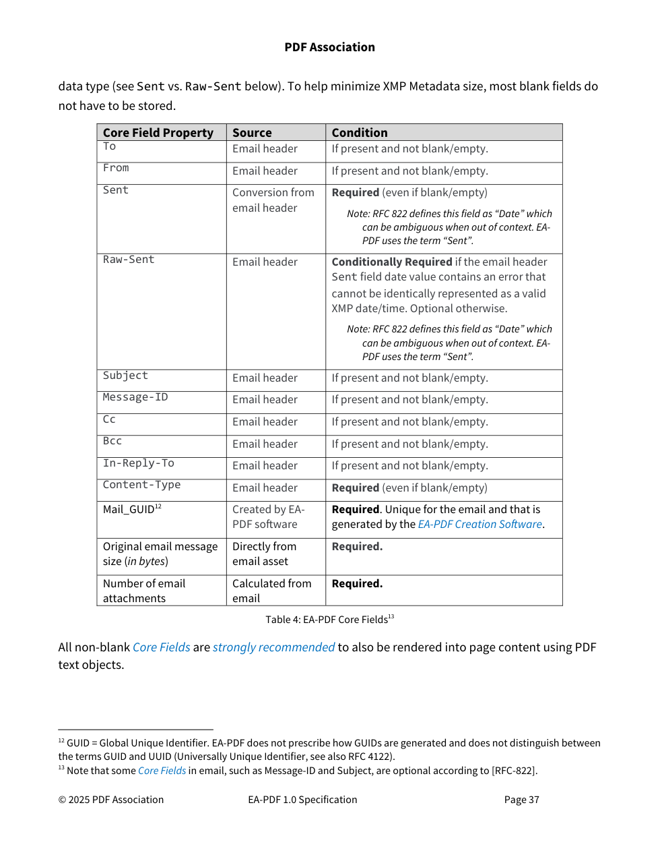

Published source — printed page 87 (PDF page 94)
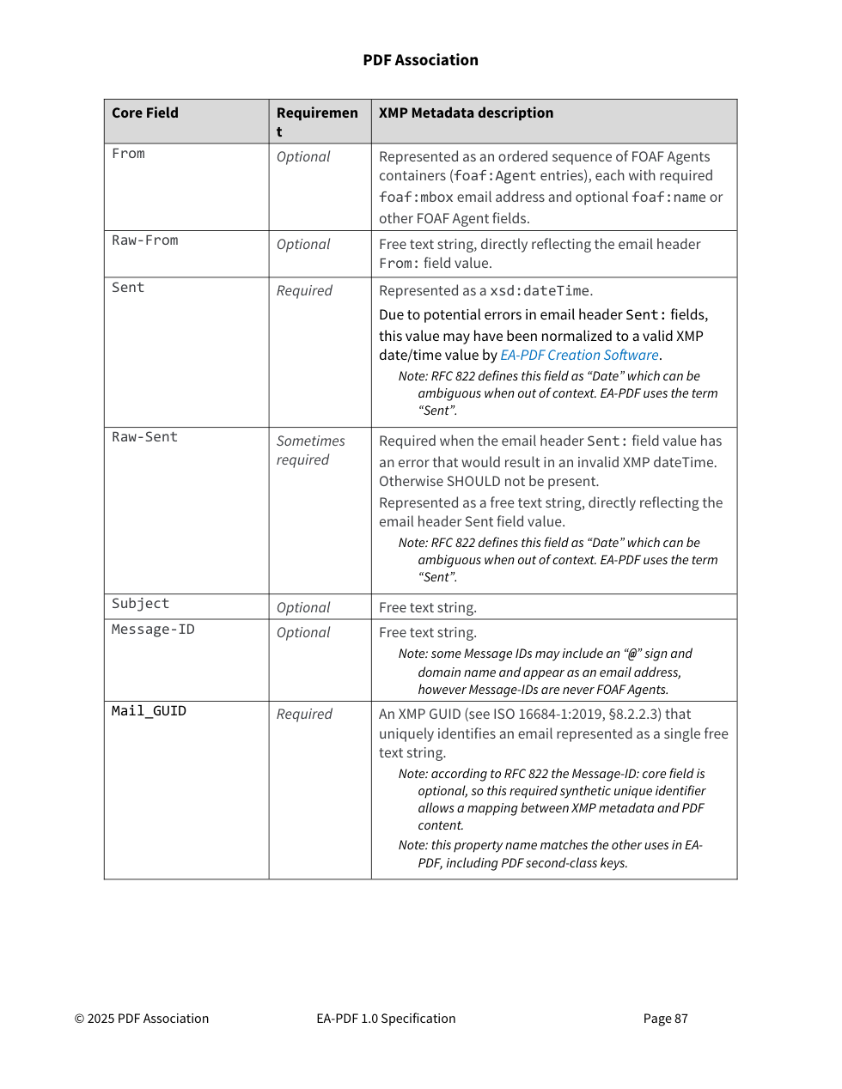

Published source — printed page 88 (PDF page 95)
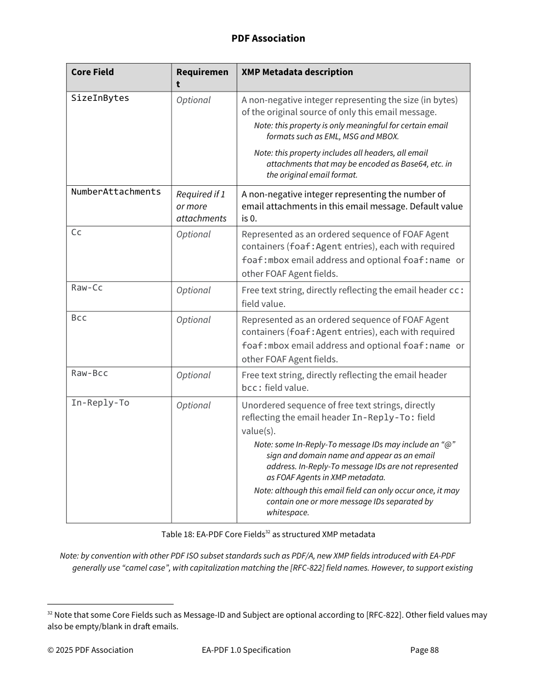

Sources and review status
Source PDF: docs/reference/EA-PDF-v1.pdf
SHA-256: b89e7471afd3aabaa4e58bd6ca1f3241378c1596cf528023e740d9e79183dbae
Current implementation reference: release 1.6.0-beta.5 and the 229-rule catalogue. Earlier audit decisions were checked for superseded implementation statements; repaired rule extraction or validator defects are not listed as outstanding policy questions.
Public discussions were reread on 2 November 2026. The PDF Association repository returned 26 issues, including broader publication/dependency matters; its EA-PDF issues 8, 10, 13, 14, 17, 21 and 22 remain open. The project repository returned two issues. An open issue or a comment is not adopted errata.
https://github.com/pdf-association/report-an-issue/issues
https://github.com/thinkbox-digital/eapdf/issues
Project issue #2 was closed on 2 November 2026: its final comment says most implementation issues are addressed in recent builds, while remaining matters need adjudication by the PDF Association and others. Closure does not adopt a specification amendment.
Supporting local review: docs/improvement/specification-audit/specification-reexamination-2026-10-31.txt; docs/improvement/rule-refinement-2026-10-31/project-issues-review.txt; EA_PDF_Rule_Review_for_Specification_Authors.docx. This decision brief is self-contained; those files provide the fuller extraction history and rule-by-rule exhibits.

