版权声明：本文为博主原创文章，未经博主允许不得转载。
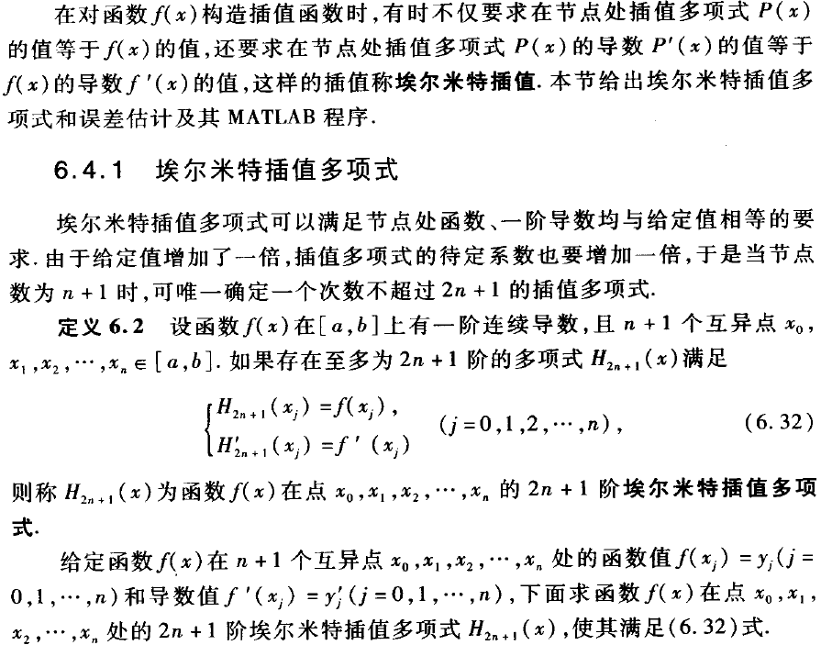
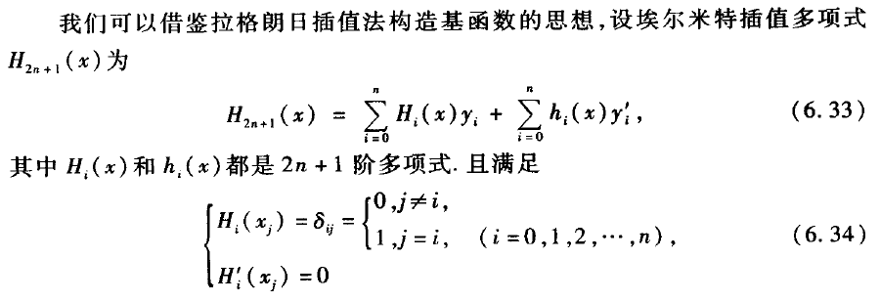
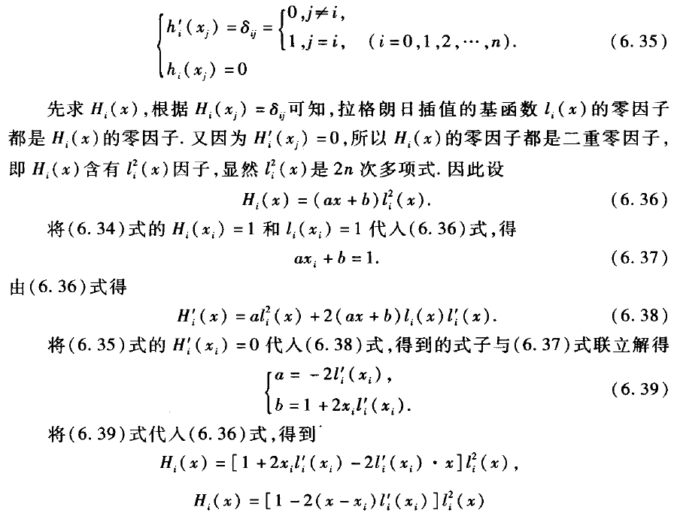
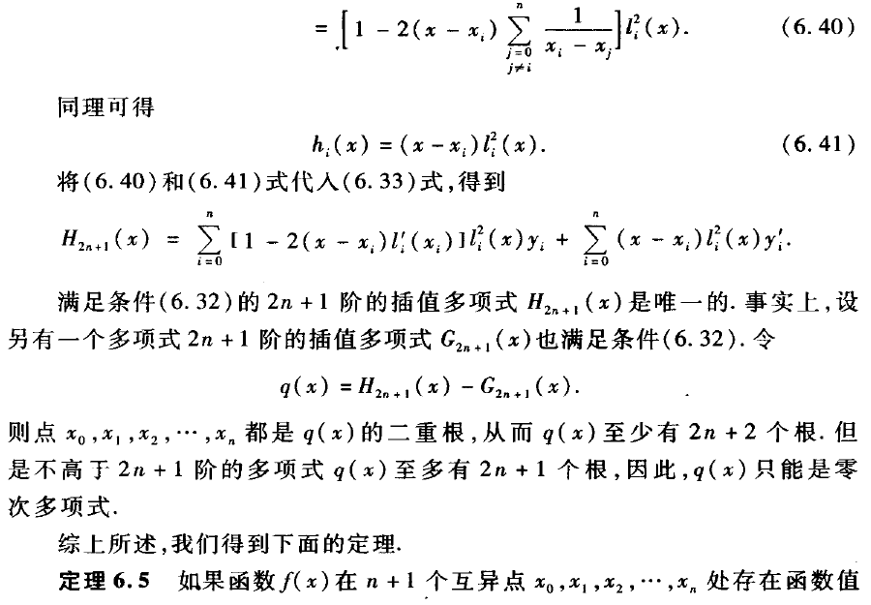
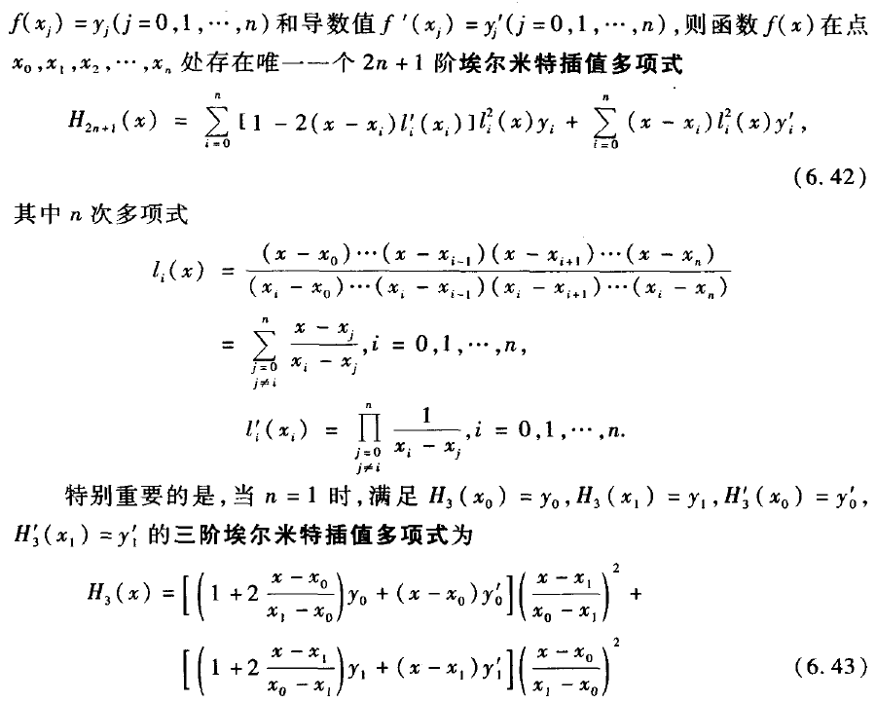
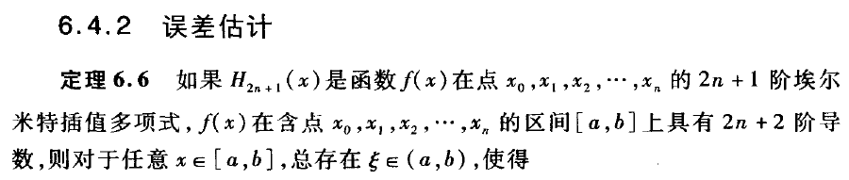
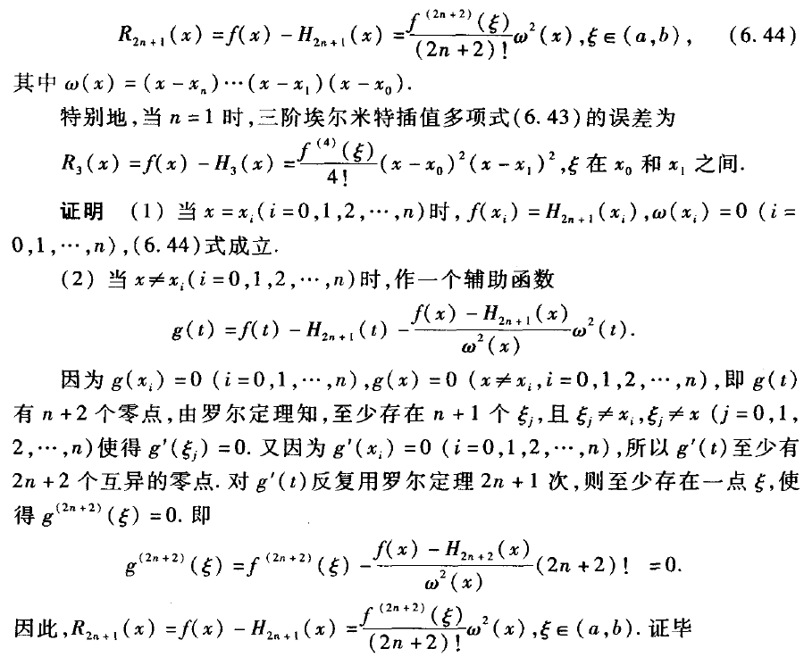
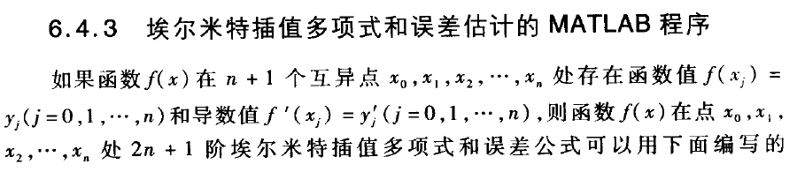
[plain] view plain copy
- %hermite.m
- %求埃尔米特多项式和误差估计的MATLAB主程序
- %输入的量:X是n+1个节点(x_i,y_i)(i = 1,2, ... , n+1)横坐标向量，Y是纵坐标向量，
- %以f'(x_i)=y'_i(i = 1,2,...,n+1)为元素的向量Y1;
- %x是以向量形式输入的m个插值点，M在[a,b]上满足｜f~(2n+2)(x)｜≤M
- %注：f~(2n+2)(x)表示f(x)的2n+2阶导数
- %输出的量：向量y是向量x处的插值，误差限R,2n+1阶埃尔米特插值多项式H_k及其系数向量
- %H_c,误差公式wcgs及其系数向量Cw.
- function[y,R,Hc,Hk,wcgs,Cw] = hermite(X,Y,Y1,x,M)
- n = length(X);
- m = length(x);

- for t = 1 : m
- z = x(t);
- H = 0;
- q = 1;
- c1 = 1;

- for k = 1 : n
- s = 0;
- V = 1;
- for i = 1 : n
- if k ~= i
- s = s + (1/(X(k)-X(i)));
- V = conv(V,poly(X(i)))/(X(k)-X(i));
- end
- end
- h = poly(X(k));
- g = ([0 1]-2 * h * s);%注意不要写成1-2*h*s，因为是多项式减法，低阶多项式前面必须用零填补，书上的错误，浪费我一晚上时间
- G = g * Y(k) + h * Y1(k);
- H = H + conv(G,conv(V,V));%hermite插值多项式
- b = poly(X(k));
- b2 = conv(b,b);
- q = conv(q,b2);
- end
- Hc = H;
- Hk = poly2sym(H);
- Q = poly2sym(q);
- for i = 1 : 2*n
- c1 = c1 * i;
- end
- wcgs = M * Q / c1;
- Cw = M * q / c1;
- y(t) = polyval(Hc,x(t));
- R(t) = polyval(Cw,x(t));
- end
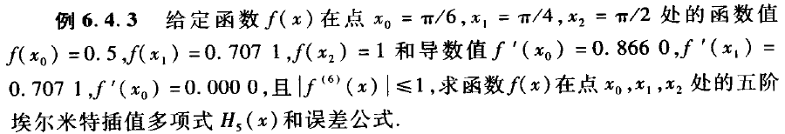
[plain] view plain copy
- %hermite.m
- %求埃尔米特多项式和误差估计的MATLAB主程序
- %输入的量:X是n+1个节点(x_i,y_i)(i = 1,2, ... , n+1)横坐标向量，Y是纵坐标向量，
- %以f'(x_i)=y'_i(i = 1,2,...,n+1)为元素的向量Y1;
- %x是以向量形式输入的m个插值点，M在[a,b]上满足｜f~(2n+2)(x)｜≤M
- %注：f~(2n+2)(x)表示f(x)的2n+2阶导数
- %输出的量：向量y是向量x处的插值，误差限R,2n+1阶埃尔米特插值多项式H_k及其系数向量
- %H_c,误差公式wcgs及其系数向量Cw.
- function[y,R,Hc,Hk,wcgs,Cw] = hermite(X,Y,Y1,x,M)
- n = length(X);
- m = length(x);

- for t = 1 : m
- z = x(t);
- H = 0;
- q = 1;
- c1 = 1;

- for k = 1 : n
- s = 0;
- V = 1;
- for i = 1 : n
- if k ~= i
- s = s + (1/(X(k)-X(i)));
- V = conv(V,poly(X(i)))/(X(k)-X(i));
- end
- end
- h = poly(X(k));
- g = ([0 1]-2 * h * s);%注意不要写成1-2*h*s，因为是多项式减法，低阶多项式前面必须用零填补，书上的错误，浪费我一晚上时间
- G = g * Y(k) + h * Y1(k);
- H = H + conv(G,conv(V,V));%hermite插值多项式
- b = poly(X(k));
- b2 = conv(b,b);
- q = conv(q,b2);
- end
- Hc = H;
- Hk = poly2sym(H);
- Q = poly2sym(q);
- for i = 1 : 2*n
- c1 = c1 * i;
- end
- wcgs = M * Q / c1;
- Cw = M * q / c1;
- y(t) = polyval(Hc,x(t));
- R(t) = polyval(Cw,x(t));
- end
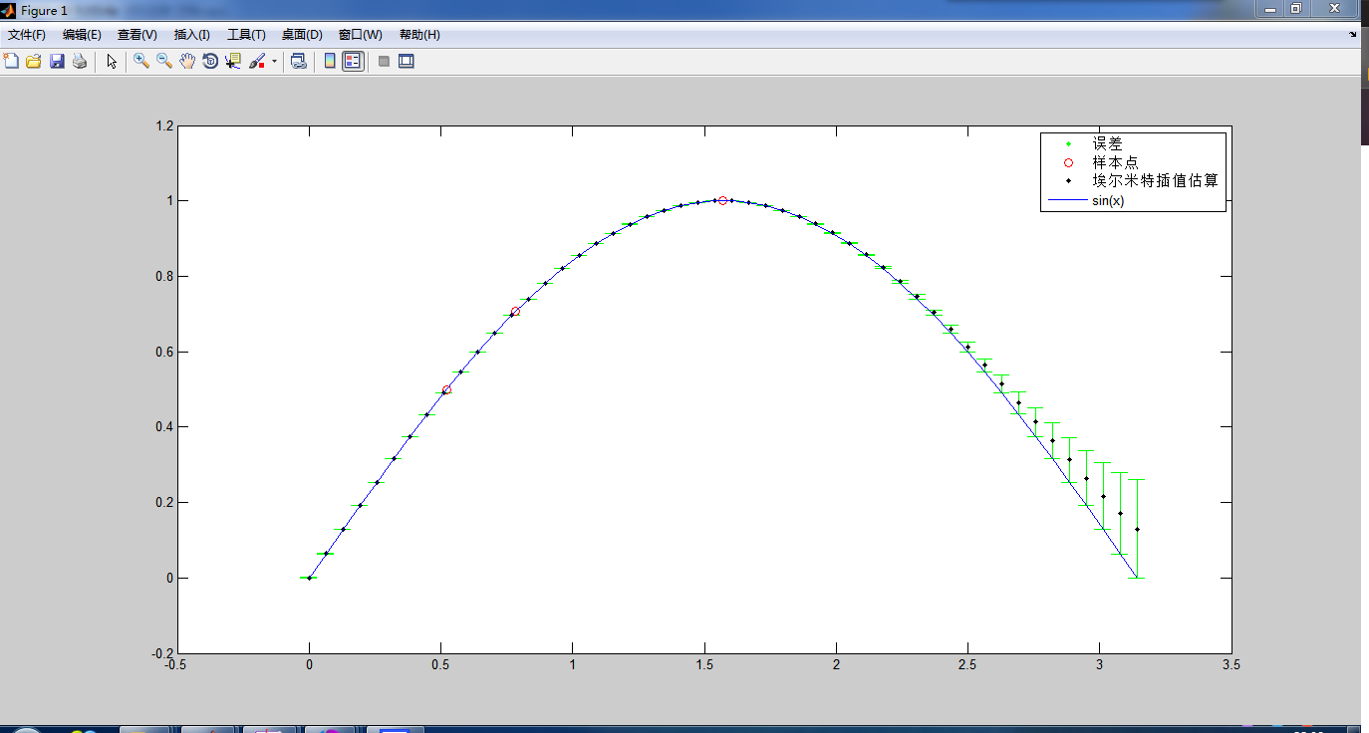

从这图片看要比拉格朗日和牛顿插值要好，不过当插值多了以后，也就是埃尔米特多项式的次数高了以后误差会变得很大的。不信我们来试试。
我们还是用sinx，不过这次我们用5个点。
X 0 pi/6 pi/4 pi/3 pi/2
Y 0 0.5 0.7071 0.8660 1
Y1 1 0.8660 0.7071 0.5 0
[plain] view plain copy
- >> X = [0 pi/6 pi/4 pi/3 pi/2];Y = [0 0.5 0.7071 0.8660 1];Y1 = [1 0.8660 0.7071 0.5 0];
- >> M = 1;
- >> x = linspace(0, pi, 50);
- >> [y,R,Hc,Hk,wcgs,Cw] = hermite(X,Y,Y1,x,M)
- >> y1 = sin(x);
- >> errorbar(x,y,R,'.g')
- >> hold on
- >> plot(X, Y, 'or', x, y, '.k', x, y1, '-b');
- >> legend('误差','样本点','埃尔米特插值估算','sin(x)');
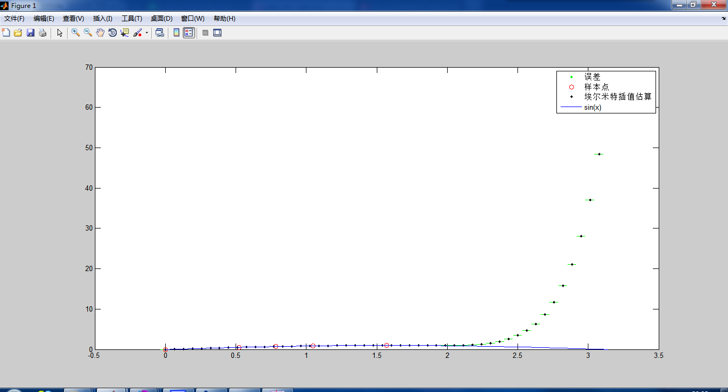
可以看到拟合的多项式从x=2.5开始远远偏离sinx，并且此时误差公式也失效了.这就是我们后面需要讲到的高次插值的振荡问题。

