一、n次拉格朗日插值
根据《插值多项式的性质》中的定理6.1可得
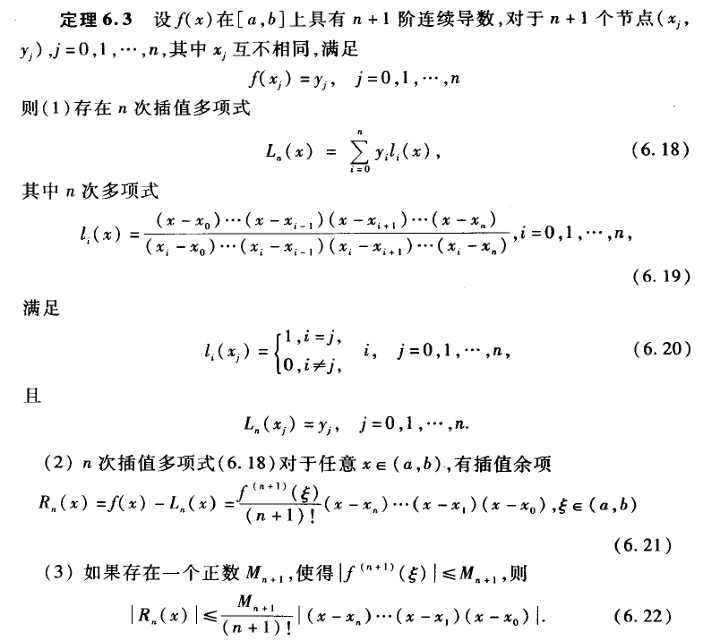
其中（6.19）称为基函数，（6.18）称为拉格朗日多项式，用（6.18）计算插值称为拉格朗日多项式插值。
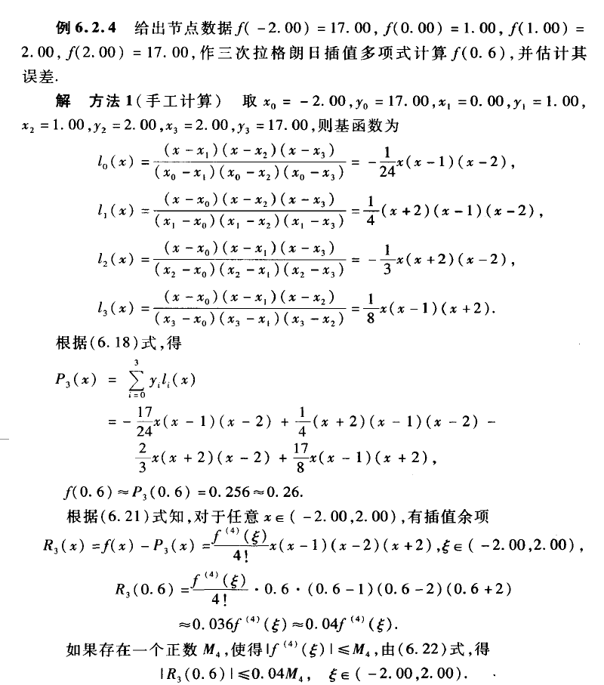
方法2：通过MATLAB程序计算
[plain] view plain copy
- >> X = [-2, 0, 1, 2]; Y = [17, 1, 2, 17];
- >> p1 = poly(X(1)); p2 = poly(X(2)); p3 = poly(X(3)); p4 = poly(X(4));
- >> l01 = conv(conv(p2, p3), p4)/((X(1) - X(2)) * (X(1) - X(3)) * (X(1) - X(4)));
- >> l11 = conv(conv(p1, p3), p4)/((X(2) - X(1)) * (X(2) - X(3)) * (X(2) - X(4)));
- >> l21 = conv(conv(p1, p2), p4)/((X(3) - X(1)) * (X(3) - X(2)) * (X(3) - X(4)));
- >> l31 = conv(conv(p1, p2), p3)/((X(4) - X(1)) * (X(4) - X(2)) * (X(4) - X(3)));
- >> l0 = poly2sym(l01), l1 = poly2sym(l11), l2 = poly2sym(l21), l3 = poly2sym(l31)

- l0 =

- - x^3/24 + x^2/8 - x/12

- l1 =

- x^3/4 - x^2/4 - x + 1

- l2 =

- - x^3/3 + (4*x)/3

- l3 =

- x^3/8 + x^2/8 - x/4

- >> P = l01 * Y(1) + l11 * Y(2) + l21 * Y(3) + l31 * Y(4)

- P =

- 1 4 -4 1

- >> L = poly2sym(P), x = 0.6; Y = polyval(P, x)

- L =

- x^3 + 4*x^2 - 4*x + 1

- Y =

- 0.2560

- >> syms M; x = 0.6;
- >> R3 = M * abs((x - X(1)) * (x - X(2)) * (x - X(3)) * (x - X(4))) / 24

- R3 =

- (91*M)/2500

- >>
即误差满足
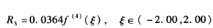
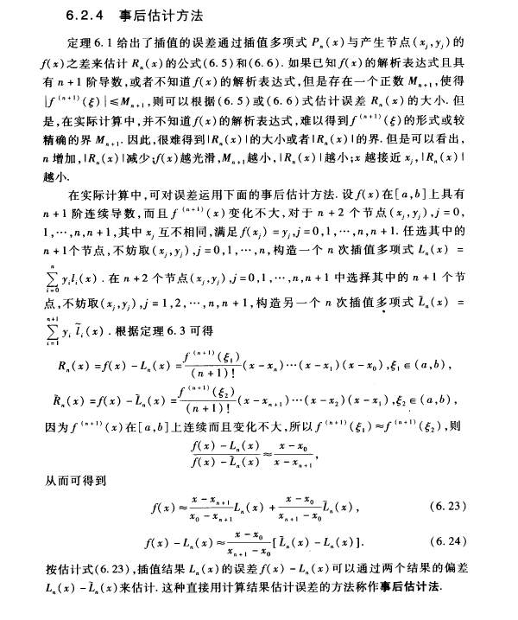
二、拉格朗日多项式和基函数的MATLAB程序
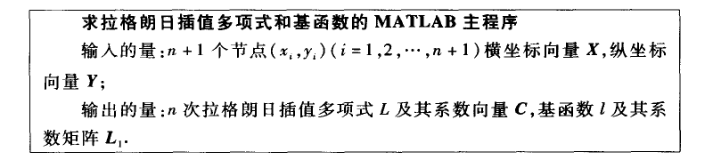
编辑M文件：
[plain] view plain copy
- %lagran1.m
- %求拉格朗日插值多项式和基函数
- %输入的量:n+1个节点(x_i,y_i)(i = 1,2, ... , n+1)横坐标向量X，纵坐标向量Y
- %输出的量：n次拉格朗日插值多项式L及其系数向量C，基函数l及其系数矩阵L
- function [C,L,L1,l] = lagran1(X,Y)
- m = length(X); L = ones(m,m);
- for k = 1 : m
- V = 1;
- for i = 1 : m
- if k ~= i
- V = conv(V,poly(X(i))) / (X(k) - X(i));
- end
- end
- L1(k, :) = V; l(k, :) = poly2sym(V);
- end
- C = Y * L1;
- L = Y * l;
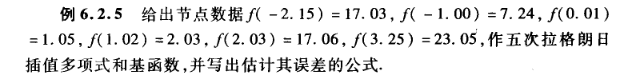
[plain] view plain copy
- >> X = [-2.15 -1.00 0.01 1.02 2.03 3.25];
- >> Y = [17.03 7.24 1.05 2.03 17.06 23.05];
- >> [C,L,L1,l] = lagran1(X,Y);
- >> C

- C =

- -0.2169 0.0648 2.1076 3.3960 -4.5745 1.0954

- >> vpa(L,5)

- ans =

- - 0.21686*x^5 + 0.06482*x^4 + 2.1076*x^3 + 3.396*x^2 - 4.5745*x + 1.0954

- >> L1

- L1 =

- -0.0056 0.0299 -0.0323 -0.0292 0.0382 -0.0004
- 0.0331 -0.1377 -0.0503 0.6305 -0.4852 0.0048
- -0.0693 0.2184 0.3961 -1.2116 -0.3166 1.0033
- 0.0687 -0.1469 -0.5398 0.6528 0.9673 -0.0097
- -0.0317 0.0358 0.2530 -0.0426 -0.2257 0.0023
- 0.0049 0.0004 -0.0266 0.0001 0.0220 -0.0002

- >> vpa(l,5)

- ans =

- - 0.0056263*x^5 + 0.029875*x^4 - 0.032273*x^3 - 0.029239*x^2 + 0.038157*x - 0.00037862
- 0.033098*x^5 - 0.13769*x^4 - 0.050322*x^3 + 0.63051*x^2 - 0.48517*x + 0.0047887
- - 0.069344*x^5 + 0.21843*x^4 + 0.39608*x^3 - 1.2116*x^2 - 0.31662*x + 1.0033
- 0.06865*x^5 - 0.14691*x^4 - 0.53981*x^3 + 0.65279*x^2 + 0.9673*x - 0.0097378
- - 0.031721*x^5 + 0.035845*x^4 + 0.25295*x^3 - 0.042557*x^2 - 0.22568*x + 0.0022608
- 0.0049432*x^5 + 0.00044489*x^4 - 0.026633*x^3 + 0.000092729*x^2 + 0.022008*x - 0.00022006
三、拉格朗日插值及其误差估计的MATLAB程序
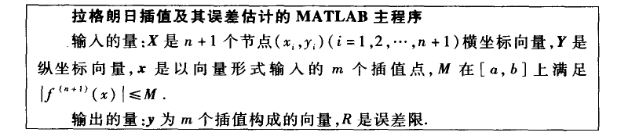
编写M文件
[plain] view plain copy
- %lagrane.m
- %拉格朗日插值及其误差估计
- %输入的量:X是n+1个节点(x_i,y_i)(i = 1,2, ... , n+1)横坐标向量，Y是纵坐标向量，
- %x是以向量形式输入的m个插值点，M在[a,b]上满足｜f~(n+1)(x)｜≤M
- %注：f~(n+1)(x)表示f(x)的n+1阶导数
- %输出的量：y为m个插值构成的向量，R是误差限
- function [y, R] = lagrange(X, Y, x, M)
- n = length(X);m = length(x);
- for i = 1:m
- z = x(i);
- s = 0.0;
- for k = 1:n
- p = 1.0; q1 = 1.0; c1 = 1.0;
- for j = 1:n
- if j~=k
- p = p * (z - X(j)) / (X(k) - X(j));
- end
- q1 = abs(q1 * (z - X(j)));
- c1 = c1 * j;
- end
- s = p * Y(k) + s;
- end
- y(i) = s;
- R(i) = M * q1 / c1;
- end

例：用Lagrange插值来求sinx在某点的值，并估计其误差，已知sin0° = 0, sin30° = 0.5, sin45° = 0.7071, sin60° = 0.8660, sin90° = 1.
X 0 pi/6 pi/4 pi/3 pi/2
Y 0 0.5 0.7071 0.8660 1

解：
[plain] view plain copy
- >> X = [0 pi/6 pi/4 pi/3 pi/2];
- >> Y = [0 0.5 0.7071 0.8660 1];
- >> x = linspace(0,pi,50);
- >> M = 1;
- >> [y, R] = lagrange(X, Y, x, M);
- >> y1 = sin(x);
- >> errorbar(x,y,R,'.g')
- >> hold on
- >> plot(X, Y, 'or', x, y, '.k', x, y1, '-b');
- >> legend('误差','样本点','拉格朗日插值估算','sin(x)');
