A New Approach to E-Prescribing: Semantic Medical Prescriptions

Bita Sedagati¹
Ali Khalili²
¹University of Leipzig, Institute of Pharmacy
bita.sedaghati@uni-leipzig.de
²University of Leipzig, Institute of Informatics
khalili@informatik.uni-leipzig.de

Abstract
Nowadays, the increasing need of data management in the field of pharmaceutical research encourages various software developments. Tunes of drugs information prescribed in different disease states produce huge datasets that are worth managing. Linked Open Data is defined as an approach for the integration of multiple disparate data sources. It brings into the spotlight a new generation of knowledge management applications. Particularly in the domain of pharmaceutical research and development, many efforts have been done to create a linked open drug data. In this paper we present the Pharmer as an approach to facilitate the creation of semantic prescriptions. Semantic prescriptions are intelligent e-prescription documents enriched by drug-related meta-data, thereby; know about their content and the possible interactions. In an e-health system, semantic prescriptions provide an interoperable interface which helps patients, physicians, pharmacists, researchers and companies to collaboratively take the advantages of the quality of pharmaceutical services. Pharmer provides different perspectives for the different personas involved in the process of e-prescribing. By employing the datasets such as DBpedia, DrugBank, DailyMed and RxNorm, Pharmer automatically detects the drugs in the prescription and collects multidimensional data on them. We evaluate the feasibility of the Pharmer by conducting a usability evaluation and report on the quantitative and qualitative results of our survey. The challenges and feasibility of implementation such a system in Iran has been also discussed in the paper.
Keywords: Semantic prescription; e-prescription; semantic annotation; e-health;
Introduction
Medical errors are a great concern among health care authorities and providers. As reported in MedicineNet medication errors are the most common type of medical errors in health care. Errors such as improper dose of medicine, adverse drug interactions, food interactions, etc. often stem from invalid prescriptions and unawareness of the patients. There are bodies of evidence exhibiting the IT based prescriptions are able to reduce medical errors to the great extend. Implying Electronic Health Record (EHR) system is another approach to pave the way toward fewer possible errors. By that, the patient profile is recorded and kept confidential. It is therefore transferable and interpretable (Peyman Rezaeehachesoo, Shafie Habibi, Shahla Fozonkhah, 2007).
Electronic prescriptions, which are recently gaining attention in the e-health domain, are one of the solutions proposed to solve these types of errors. While even nowadays, traditional paper prescriptions are commonly used, e-prescriptions offer several advantages. In an e-prescription system, prescriber electronically sends an accurate, error-free and understandable prescription directly to a pharmacy from the point-of-care. Reduction in medication error and decline in adverse drug events are more highlighted consequences of e-prescribing.
During the recent years, the adoption of e-prescriptions has been spreading rapidly. To illustrate, the Australian government started launching of e-prescription from March 2007. Using this system, the e-providers who effectively market themselves on the web will have a distinct advantage.
A system called epSOS which performs the use of e-prescriptions all around Europe, is currently passing the extensive practical testing phase. epSOS contains patient summary and an e-prescription service which allows access to the cross-border e-health services.This service allows people in participating epSOS pilot countries, as tourists, business travelers, commuters or exchange students to take advantage of e-health services.
The e-prescribing incentive program performed in US is another example in this area. As a reporting program it uses a combination of incentive payments and payment adjustments to encourage electronic prescribing by eligible professionals.
One of the main challenges of e-prescription systems is the heterogeneity of available information sources. There exist already different sources of information addressing different aspects of pharmaceutical research. Information about chemical, pharmacological and pharmaceutical drug data, clinical trials, approved prescription drugs, drugs activity against drug targets such as proteins, gene-disease-drug associations, adverse effects of marketed drugs, etc. are some examples of these diverse information. Handling this dynamic information within current e-prescription systems without blurring the border of the existing pharmaceutical information islands is a cumbersome task.
On the other hand, Linked Open Data as an effort to interlink and integrate these isolated sources of information is obtaining more attention in the domain of pharmaceutical, medical and life sciences. Combining the best practices from Linked Open Data together with e-prescription systems can provide an opportunity for patients, researchers as well as practitioners to collaborate together in a synergic way. A consequence of introducing linked data in health care sector is that it significantly changes the daily duties of the employees of the health care sector. Therefore the most challenging aspect will not be the technology but rather changing the mind-set of the employees and the training of the new technology (Puustjärvi & Puustjärvi, 2006).
Furthermore, the information generated via that approach can be employed as a data source for researchers. Drug companies are also able then to take the advantage of considering these informative statistical data. Semantic prescriptions as introduced in this paper are a proposed approach to utilize semantic web technologies in e-prescription systems.
As intelligent prescriptions, they can automatically handle the medical errors occurring in prescriptions and increase the awareness of the patients about the prescribed drugs and drug consumption in general.
Semantic prescriptions also enable the creation of more efficient and effective search approaches for drug discovery and consumption.
We created a tool called Pharmer as a showcase application to facilitate the process of semantic prescription generation. Pharmer adopts a bottom-up approach for enriching the normal e-prescriptions with semantic annotations using a set of predefined datasets from linked open data.
The remainder of this article is structured as follows:
Sections I, II, III provide a background on the basic concepts such as Linked Open Data, Semantic Content Authoring and E-prescriptions employed in this paper. In section IV, we describe the Pharmer as a solution to effectively create semantic prescription. Then we discuss the possible benefits of Pharmer. To better clarify the use cases of the Pharmer system, an example scenario is drawn in section V. In VI Pharmer usability evaluation results are reported. Furthermore, possible challenges for Pharmer implementation in Iran health system in section VII is discussed. Finally in section VIII conclusion with an outlook on future work are presented.

I. Linked Open Data
In computing, Linked Data describes a method of publishing structured data so that it can be interlinked and become more useful. It builds upon standard Web technologies such as HTTP and URIs, but rather than using them to serve web pages for human readers, it extends them to share information in a way that can be read automatically by computers. This enables data from different sources to be connected and queried (Bizer, Heath, & Berners-Lee, 2009).

Tim Berners-Lee, the inventor of the Web and Linked Data initiator, suggested a 5 star deployment scheme for Linked Open Data:

- Make your stuff available on the Web (whatever format) under an open license
- Make it available as structured data (e.g., Excel instead of image scan of a table)
- Use non-proprietary formats (e.g., CSV instead of Excel)
- Use URIs to identify things, so that people can point at your stuff
- Link your data to other data to provide context

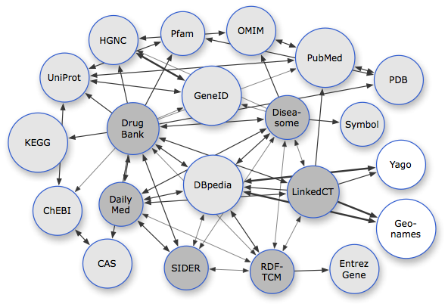
Figure 1 Available datasets related to pharmaceutical research

Particularly in the areas of health care and life sciences with the wealth of available data, large scale integration projects like Bio2RDF,Chem2Bio2RDF and the W3C HCLS’s (Health Care and Life Sciences) Linked Open Drug Data (LODD) have not only significantly contributed to the development of the Linked Open Data effort, but have also made social and technical contributions towards data integration, knowledge management, and knowledge discovery.
There are already many interesting information on pharmaceutical research available on the Web.
The sources of data range from drugs general information, interactions and impacts of the drugs on gene expression, through to the results of clinical trials (as shown in Figure 1)
LODD (Samwald et al., 2011) has surveyed publicly available data about drugs, created Linked Data representations of the data sets, and identified interesting scientific and business questions that can be answered once the data sets are connected. One of the use cases of LODD datasets is authoring of Semantic Prescriptions, which are prescriptions, enriched by linked open data.

II. Semantic Content Authoring
Semantic Document is an intelligent document (with explicit semantic structure), which “knows about” its own content so that it can be automatically processed in unforeseen ways.Semantic documents facilitate a number of important aspects of information management (Khalili, Auer, & Hladky, 2012):
- For search and retrieval enriching documents with semantic representations helps to create more efficient and effective search interfaces, such as faceted search (Tunkelang, 2009) or question answering (Lopez, Uren, Sabou, & Motta, 2011). Ultimately, users are empowered to counter the increasing information overload and gain better access to relevant documents and answers related to their information needs.
- Information presentation semantically enriched documents can be used to create more sophisticated ways of flexibly visualizing information, such as by means of semantic overlays as described in (Burel, Cano1, & Lanfranchi, 2009).
- Information integration semantically enriched documents can be used to provide unified views on heterogeneous data stored in different applications by creating composite applications such as semantic mashups (Ankolekar, Krötzsch, Tran, & Vrandecic, 2007).
- To realize personalization, semantic documents provide customized and context-specific information which better fits user needs and willresult in delivering customized applications such as personalized semantic portals (Sah, Hall, Gibbins, & Roure, 2007).
- For reusability and interoperability enriching documents with semantic representations (e.g. using the SKOS and Dublin Core vocabularies) facilitates exchanging content between disparate systems and enables building applications such as executable papers (Müller, Rojas, Eberhart, Haase, & Schmidt, 2011).
These benefits, however, come at the cost of increased authoring effort (Hasida, 2007) (Uren et al., 2006).
Semantic Content Authoring (SCA) is a tool-supported manual composition process aiming at the creation of semantic documents which are either:
- Fully semantic in the sense that their original data model uses a semantic knowledge representation formalism (such as RDF, RDF-Schema or OWL) or
- Based on a non-semantic representation form (e.g. text or hypertext), which is enriched with semantic representations during the authoring process.
With an ontology and a user interface appropriate for the type of content, semantic authoring can be easier than traditional composition of content and the resulting content can be of higher quality (Hasida, 2007).A Semantic Authoring User Interface (SAUI) is a human accessible interface with capabilities for modifying and writing semantic documents.
Medical prescriptions are a good candidate to be enriched by semantic annotations.Semantic prescriptions enable the traditionally written prescriptions to be utilized in novel ways as discussed above.In the following sections, we first describe the e-prescriptions and then discuss how they can be enriched as semantic documents.

III. e-prescriptions
E-health has evolved and emerged recently in many forms.E-prescription is one of those forms and defined as a computer-generated prescription utilized by health-care providers.E-prescribing as it is commonly called, is the use of an automated data entry system to generate a prescription that is then transmitted through a special network to a pharmacy in such a way that the data goes directly into the pharmacy’s computer system.It plays an important role in improving the quality of patient care.For the prescriber, e-prescribing happens when a physician uses a computer or handheld device with a software that allows him or her to (with the patient’s consent) electronically access information regarding a patient’s drug benefit coverage and medication history; electronically transmit the prescription to the patient’s pharmacy of choice; and, when the patient runs out of refills, his or her pharmacist can also electronically send a renewal request to the physician’s office for approval.
In order to see an increase in both quality and efficiency that can be attributed to e-prescribing, the system must be capable of performing key functions related to:
- Medication selection/decision support capabilities (e.g., diagnosis-based medication menus, evidence based information, drug interaction checking, safety-alerts, formulary checking, prescription renewal, and dosage calculation).
- Patient-specific information capabilities (e.g., current patient medication list, access to patient historical data, patient identification).
- System integration capabilities (e.g., connection with various databases, connection with pharmacy and pharmacy benefit manager systems).
- Educational capabilities (e.g., patient education, provider feedback).
One of the main challenges of the current e-prescription systems is the heterogeneity and evolving nature of available information sources.There exist already different sources of information addressing different aspects of pharmaceutical research.Handling these dynamic information within current e-prescription systems without blurring the border of the existing pharmaceutical information islands is a cumbersome task.

IV. Pharmer: Semantic Authoring of Medical Prescriptions
Pharmer is an application created as a proof of concept for the authoring of semantic prescriptions.The Pharmer implementation is open-source and available for download together with an explanatory video and online demo at http://code.google.com/p/pharmer/. Pharmer adopts a bottom-up approach (i.e. semantic markup (Araujo, Houben, & Schwabe, 2010) for enriching the normal e-prescriptions with semantic annotations using a set of predefined ontologies.

The basic ingredients of a semantic annotation system are ontologies, the documents and the annotations that link ontologies to documents (Khalili & Auer, 2012).Here, we need two kinds of ontologies:Annotation ontologies (i.e. metadata schemata), which define what kind of properties and value types, should be used for describing a resource. Domain ontologies which are used to define vocabularies providing possible values for metadata properties.We use Schema.org MedicalTherapy vocabulary as our annotation ontology and utilize the existing pharmaceutical linked datasets such as DBpedia, DrugBank, DailyMed and RxNorm as our domain ontology.

IV. I. Features
The main features of Pharmer can be summarized as:
- Providing Different Semantic Views. Semantic views allow the generation of different views on the same metadata schema and aggregations of the knowledge base based on the roles, personal preferences, and local policies of the intended users.Pharmer suggests two types of views: generic and domain specific views.Generic views provide visual representations of drug information (e.g. as information view depicted in Figure 2 or graph view. Domain specific views address the requirements of a particular domain user (e.g. a researcher need specific views for visualizing the atomic structure of chemical compounds).
- Real-time Drug Tagging: Real-time tagging means creating drug annotations while the user is typing. This will significantly increase the annotation speed (O’Donoghue et al., 2010).Users are not distracted since they do not have to interrupt their current authoring task. Pharmer has a client-side component which interacts with the server asynchronously to make real-time tagging possible.
- Drug Suggestion. When searching for a drug, Pharmer suggests the similar drugs by taking into account the history of search terms.
- Automatic Drug Annotation. Automatic annotation means the provision of facilities for automatic mark-up of prescriptions. The automatic process of annotating in Pharmer is composed basically of finding drug terms in prescription using an NLP service, mapping them against an ontology, and disambiguating common terms.

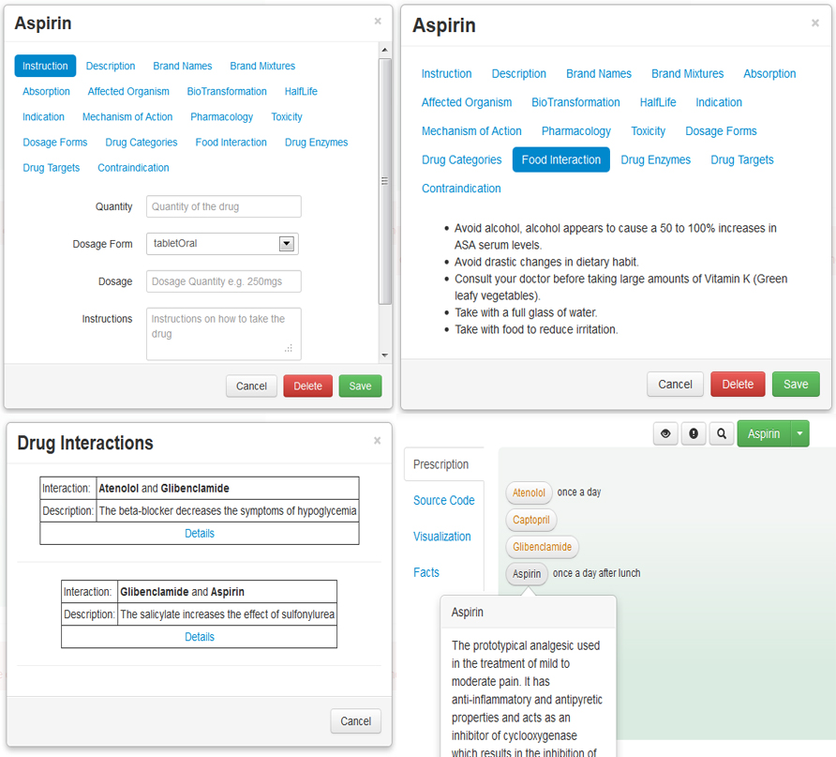
Figure 2 A screenshot of Pharmer information view

IV. II. Pharmer Stakeholders

As depicted in Figure 3, Pharmer approach is very versatile and can be applied in a vast number of use cases by different stakeholders. The arrows in the figure can be summarized as the following:
- After patient contacts physician, the physician diagnoses the disease and writes the corresponding semantic prescription using Pharmer. It is then immediately passed to pharmacy. By that, patient profile is automatically stored into the Pharmer system. The patient's medication history is also available to the physician.
- Pharmer utilizes the Linked Open Data as its integrated information source.
- On the other side, researcher can analyze the stored semantic prescriptions data.
- Drug companies as Pharmer stakeholders utilize it in order to balance their production and distribution according to the market taste and demand.
- Semantic prescription is immediately sent to the pharmacy chosen by patient from the point of care. Pharmacist verifies the prescription and hands in the medication to the patient.
- Patient already is in the system, therefore he inquires about drug information. He can also contact the related physician and pharmacist via the Pharmer.

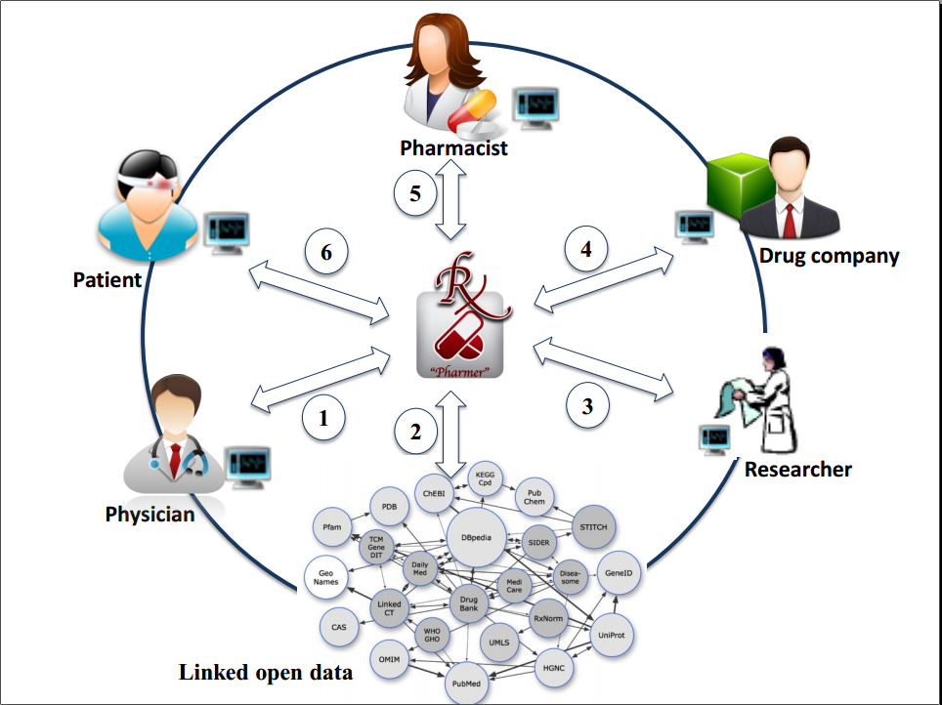
Figure 3 Pharmer ecosystem.

The main benefit of using semantic prescriptions is the persistent connection to up-to-date drug information coming from multiple dynamic data sources.So, when a change occurs to a drug (e.g. change in its effects or interactions) the semantic prescription automatically adopts to this new change.Once writing a prescription it is very critical to consider drug interactions.Drug interactions are divided to three categories namely food-drug, drug-drug and drug-plant interactions.Coadministration can either be synergistic or antagonistic which respectively increase or decrease the drugs effect.The interactions may sometimes lead to change in the drug effect.By applying semantic prescriptions, all types of drug interactions are prevented and the probability of errors in prescriptions are reduced to a great extend.
A semantic prescription is a self-contained document which is aware of its content and is connected to the linked open data.In contrast to database-oriented e-prescriptions, semantic prescriptions can easily be exchanged among other e-health systems without need to changing their related infrastructure.
Furthermore, semantic prescriptions increase the awareness of patients.They provide patients with all the related information of the prescribed drugs thereby mitigating the possible misuse of drugs.
Another important advantage of semantic prescribing is the connection of physicians, pharmacists, patients, pharmaceutical researchers and drug companies.It brings the following benefits for its stakeholders:
- Physicians: increased efficiency, improved care, patient satisfaction and potential short and long-term incentives.
- Patients: increased information, safety, efficiency and compliance.
- Pharmacists: increased efficiency, improved service quality, improved patient satisfaction, prevention of adverse drug reactions and speeding up the whole process.
- Researchers: easy accessed abundant information source and statistical data availability.
- Drug companies: production efficacy, patient compliance and rate of the consumption of each medicine.
V. Example scenario
As a scenario; A 63 year old man with the history of MI (Myocardial Infarction) and type 2 diabetes visits a heart and coronary specialist complaining about frequent headaches and heavy head feeling. The specialist, after general inspection and monitoring vital signs, asks for a blood test. The specialist considers symptoms including high blood pressure (sys/dias:158/95 mmHg) and high Fasting Blood Sugar (150 mg/dl). He diagnoses high blood pressure plus sever type 2 diabetes.Thereby, Patient profile is defined in Pharmer by patient's information besides diagnosis.Considering the medication that the patient took before (Metformin only), The specialist dispenses the new semantic prescription by entering the following drugs:
- Metformin 500 mg Oral Tablet bid
- Glibenclamide 5 mg Oral Tablet bid
- Atenolol 50 mg Oral Tablet once daily
He then checks for the possible drug interactions by clicking the attributed button in Pharmer software.As Pharmer is connected to linked open data it is capable of recognizing the most recent updated drug interactions.He finds out that Sulfunyl Urea class drugs (here Glibenclamide) are not compatible to be coadministrated with beta-blockers (here Atenolol).So, he needs to replace it with another drug.Using Pharmer and its connection to linked open data, the physician can find the possible alternatives.Then he decides to choose Captopril as replacement.Therefore the new semantic prescription is corrected as the following:
- Metformin 500 mg Oral Tablet bid
- Glibenclamide 5 mg Oral Tablet bid
- Captopril 25 mg Oral Tablet once daily
The semantic prescription is then sent to the patient's pharmacy of choice.There, pharmacist is able to review the semantic prescription and comments on that directly in the system so that the physician is also aware of the corresponding changes.Pharmacist comments may cause minor or major modifications in the semantic prescription.For instance, using the Pharmer she is able to check the appropriate dose of each medicine or suggest cheaper alternatives (if possible).Thereafter, patient who was referred to the pharmacy takes the prescribed drugs.Before he starts taking the tablets, he enters in Pharmer system with his ID as patient.There he is able to observe drug information embedded in the semantic prescription besides the preferred time and drug intake instructions.He is also informed about the possible food interactions.The patient's profile completes as he visits physicians or ask for refills.Furthermore the physician and the pharmacist follow him up via the Pharmer.After 2 months the patient visits another specialist for his recurrent symptoms of diabetes.The specialist via the Pharmer accesses to the patient's medical profile and increases the anti-diabetic drug dose.
A researcher in an academy research institution investigates Captopril (as an Angiotensin II antagonist) effect on preventing diabetes recurrence.Having the data from the aforementioned patient follow up along with other similar patients allows investigator to lead her goal.In this case, for example, the Captopril along with anti-diabetic drugs led to diabetes recurrence.Observing the entire corresponding patient profiles will either confirm or reject the research assumption.
A drug company manager requires to determine the compliance rate of Captopril in the market in order to balance the production based on market demand. Applying Pharmer allows him to simply access to these data and decide how to go on with this product. He is also able to collect the evidence which may prevent further dispense of Captopril by physicians or consumption among patients.
VI. Evaluation
In order to determine whether we succeeded to facilitate the creation of semantic prescriptions using Pharmer, we performed a usability user study with 12 subjects. Subjects were drawn from 3 physicians, 3 pharmacist, 3 pharmaceutical researchers and 3 students. We first showed them a tutorial video of using different features of Pharmer then asked each one to create a prescription with Pharmer. After finishing the task, we asked the participants to fill out a questionnaire, which consisted of two parts: feature usage questions and usability experience questions.

We used the System Usability Scale (SUS) (Lewis & Sauro, 2009) to grade the usability of Pharmer. SUS is a standardized, simple, ten-item Likert scale-based questionnaire giving a global view of subjective assessments of usability. It yields a single number in the range of 0 to 100, which represents a composite measure of the overall usability of the system. The results of our survey showed a mean usability score of 75 for Pharmer which indicates a reasonable level of usability. Of course, this is a very simplified view on usability and we expect even better results could be achieved by putting more effort into the Pharmer development. However, our goal was to demonstrate that Pharmer implementations with good usability characteristics could be created with relatively limited effort. In addition to quantitative results, we also collected a number of user suggestions. For instance some users suggested providing a print-friendly document with all the patient's desired information.

VII. Challenges of implementing Pharmer system in Iran
As e-prescribing systems are not yet officially widespread in Iran, run of Pharmer might accompany several lines of challenges. Integration of Pharmer to the current e-health system includes the challenges such as “defining health record models based on Pharmer”, “educating people to get familiar to the new system” and ”internet access limitation”.
Pharmer system implementation as a useful tool in the area of health needs to be confirmed by the health ministry in each country. The health ministry of Iran has been already employing the Electronic Health Records (EHR) for each patient individual to keep track of his health profile. As the data requires to be recorded confidentially, a comprehensive model developed by Delphi study has been defined in six pivots. Data ownership, inclusion of information accessibility laws in all organizations, responsibility for inaccessibility to information, and the conditions for movement of data abroad, have been confirmed as new dimensions added in this model (Farzandipour, Ahmadi, Sadoughi, & Karimi, 2011). Having that in mind, it might be so challenging to add Pharmer in the current system preserving patient privacy and data confidentiality.
Pharmer integration into the current e-health system might cause several consequences. On one hand, Pharmer, which utilizes the number of advantages of semantic e-prescription system discussed in the paper, is able to replace the current traditional paper based prescribing system in Iran. That makes the advantages of Pharmer implanting in Iran even more as employing a novel system from the scratch limits the off expenses for migrating the previous. The current necessity of e-prescription system can be further fulfilled by the integration of Pharmer in EHR system of Iran. There the upcoming system can take the advantage of semantic e-prescription while e prescribing included by nature. On the other hand, all the infrastructures, requires to be regulated in this regard and cannot be defined based on the previous structures applied in other countries. Therefore, the deep considerations of infrastructure implementation of this system need to be taken into the account.
Applying such a system like Pharmer in Iran cannot be accomplished unless people using that get educated about its usage instructions. Physicians, pharmacists and patients are the main target groups who should be taught about Pharmer instructions of use. They also need to get familiar about privacy policy as it plays an important role in implementation of such system in Iran like every other country.

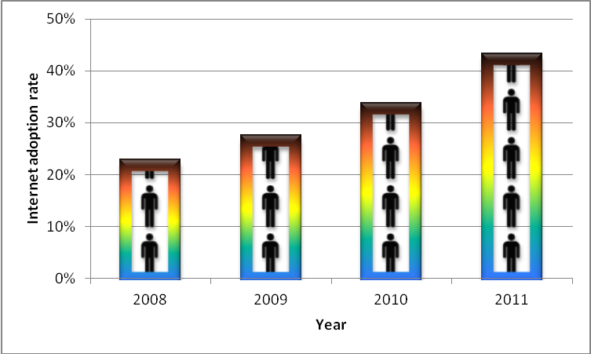
Figure 4 Internet adoption rate in Iran

Pharmer is online software and requires preferably fast internet access in order to transfer data from LOD. As depicted in Figure 4, the rate of internet adoption in Iran is growing dramatically. That facilitates the Pharmer implementation in Iran. As the starting point Pharmer implementation only requires internet access in physician offices and pharmacies.
All in all, Pharmer implementation in Iran with existing challenges is possible; however it needs a comprehensive planning consulting with the collaborative work committees from hospitals to educational organization working hand in hand.

VIII. Conclusion
Providing a consistent connection between patients, physicians, pharmacists, pharmaceutical researchers and drug companies is a crucial step towards enhancing the quality of knowledge management and thereby e-health services in the pharmaceutical domain. With Pharmer we presented in this article an approach for implementation of Semantic Prescriptions as intelligent medical prescriptions to improve the integration and interoperability of e-prescribing systems with other e-health services. Semantic prescriptions include the important meta-data about the content of a prescription, which will increase the awareness of their consumers.

We see the work presented in this article as an initial step in a larger research agenda aiming at promoting the authoring and annotation of semantically enriched medical documents. Regarding future work we envision to extend the Pharmer application towards different modalities, such that the annotation of images and other medical objects is supported. Furthermore, we aim to integrate the other existing linked open datasets (e.g. related to publications, laboratories or insurance documents) into the Pharmer to extend its stakeholders.
REFERENCES
Ankolekar, A., Krötzsch, M., Tran, T., & Vrandecic, D. (2007). The two cultures: mashing up web 2.0 and the semantic web. WWW ’07: Proceedings of the 16th international conference on World Wide Web (pp. 825–834). New York, NY, USA: ACM Press. doi:10.1145/1242572.1242684
Araujo, S., Houben, G.-J., & Schwabe, D. (2010). Linkator: Enriching Web Pages by Automatically Adding Dereferenceable Semantic Annotations. Web Engineering, Lecture Notes in Computer Science (Vol. 6189, pp. 355–369). Springer.
Bizer, C., Heath, T., & Berners-Lee, T. (2009). Linked Data - The Story So Far. (T. Heath, M. Hepp, & C. Bizer, Eds.)International Journal on Semantic Web and Information Systems (IJSWIS), 5(3), 1–22. doi:10.4018/jswis.2009081901
Burel, G., Cano1, A. E., & Lanfranchi, V. (2009). Ozone Browser: Augmenting the Web with Semantic Overlays. CEUR Workshop Proceedings ISSN 1613-0073 (Vol. 449).
Farzandipour, M., Ahmadi, M., Sadoughi, F., & Karimi, I. (2011). Adopting Confidentiality Principles for Electronic Health Records in Iran: A Delphi Study. J. Medical Systems, 35(3), 333–343.
Hasida, Kã´. (2007). Semantic Authoring and Semantic Computing. In A. Sakurai, Kã´. Hasida, & K. Nitta (Eds.), New Frontiers in Artificial Intelligence, Lecture Notes in Computer Science (Vol. 3609, pp. 137–149). Springer.
Khalili, A., & Auer, S. (2012). User Interfaces for Semantic Content Authoring: A Systematic Literature Review. Retrieved from http://svn.aksw.org/papers/2011/journal_SemanticContentAuthoring/public.pdf
Khalili, A., Auer, S., & Hladky, D. (2012). The RDFa Content Editor – From WYSIWYG to WYSIWYM. IEEE Signature Conference on Computers, Software, and Applications (COMPSAC 2012) (pp. 531–540).
Lewis, J., & Sauro, J. (2009). The Factor Structure of the System Usability Scale. Human Centered Design, LNCS (Vol. 5619, pp. 94–103). Berlin, Heidelberg: Springer Berlin / Heidelberg. Retrieved from http://dx.doi.org/10.1007/978-3-642-02806-9_12
Lopez, V., Uren, V., Sabou, M., & Motta, E. (2011). Is question answering fit for the Semantic Web? A survey. Semantic Web ? Interoperability, Usability, Applicability, 2(2), 125–155.
Müller, W., Rojas, I., Eberhart, A., Haase, P., & Schmidt, M. (2011). A-R-E: The Author-Review-Execute Environment. Procedia Computer Science, 4, 627 – 636.
O’Donoghue, S. I., Horn, H., Pafilis, E., Haag, S., Kuhn, M., Satagopam, V. P., Schneider, R., et al. (2010). Reflect: A practical approach to web semantics. Web Semantics: Science, Services and Agents on the World Wide Web, 8(2-3), 182 – 189.
Peyman Rezaeehachesoo, Shafie Habibi, Shahla Fozonkhah. (2007). Information Technology, an Effective Tool in Reducing and Preventing Medical Errors: Suggestions for Improvement. Health Information Management, 4(1).
Puustjärvi, J., & Puustjärvi, L. (2006). The Challenges of Electronic Prescription Systems Based on Semantic Web Technologies. ECEH (pp. 251–261).
Sah, M., Hall, W., Gibbins, N. M., & Roure, D. C. D. (2007). SEMPort ? A Personalized Semantic Portal. 18th ACM Conference on Hypertext and Hypermedia (pp. 31–32). Sheridan printing.
Samwald, M., Jentzsch, A., Bouton, C., Kallesoe, C., Willighagen, E., Hajagos, J., Marshall, M., et al. (2011). Linked open drug data for pharmaceutical research and development. Journal of Cheminformatics, 3(1), 19+. doi:10.1186/1758-2946-3-19
Tunkelang, D. (2009). Faceted Search (Synthesis Lectures on Information Concepts, Retrieval, and Services). Morgan and Claypool Publishers.
Uren, V., Cimiano, P., Iria, J., Handschuh, S., Vargas-Vera, M., Motta, E., & Ciravegna, F. (2006). Semantic annotation for knowledge management: Requirements and a survey of the state of the art. Web Semantics: Science, Services and Agents on the World Wide Web, 4(1), 14 – 28.

http://www.medicinenet.com/
http://www.medicareaustralia.gov.au/
http://www.epsos.eu/
http://www.cms.gov/erxincentive/
http://bio2rdf.org/
http://chem2bio2rdf.wikispaces.com/
http://www.w3.org/wiki/HCLSIG/LODD
http://bitili.com/pharmer
www.usabilitynet.org/trump/documents/Suschapt.doc

