Configure IK Chinese word breaker

## Configuration ideas

1. Add the word breaker jar file to the specified directory
2. Add a reference to the jar file in the solrconfig.xml file
3. Add Chinese word class and fields in the managed-schema file

## Solr single instance mode

1. Upload the jar file to the specified directory, copy all the files in the solr-IK folder to the solr-6.4.2/dist/ directory
2. Add a reference to the jar file in the solrconfig.xml file

Add the following reference in the config tag:

*<lib dir="${solr.install.dir:../../../..}/dist/" regex=".*\.jar" />*

1. Modify the managed-schema file, add the following configuration in schema tag

*<!—configure word breaker start-->*

*<field name='text_ik' type='text_ik' indexed='true' stored='true' multiValued='fasle'/>*

*<fieldType name="text_ik" class="solr.TextField">*

*<analyzer class="org.wltea.analyzer.lucene.IKAnalyzer"/>*

*</fieldType>*

*<!-- configure word breaker end-->*

1. Reload config

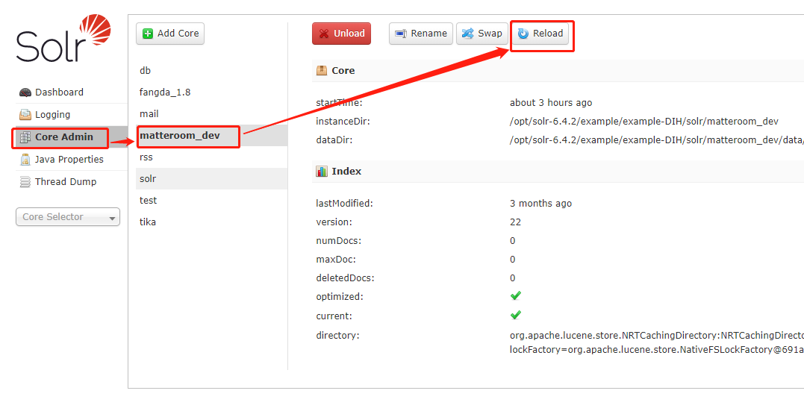

1. Test in GUI:

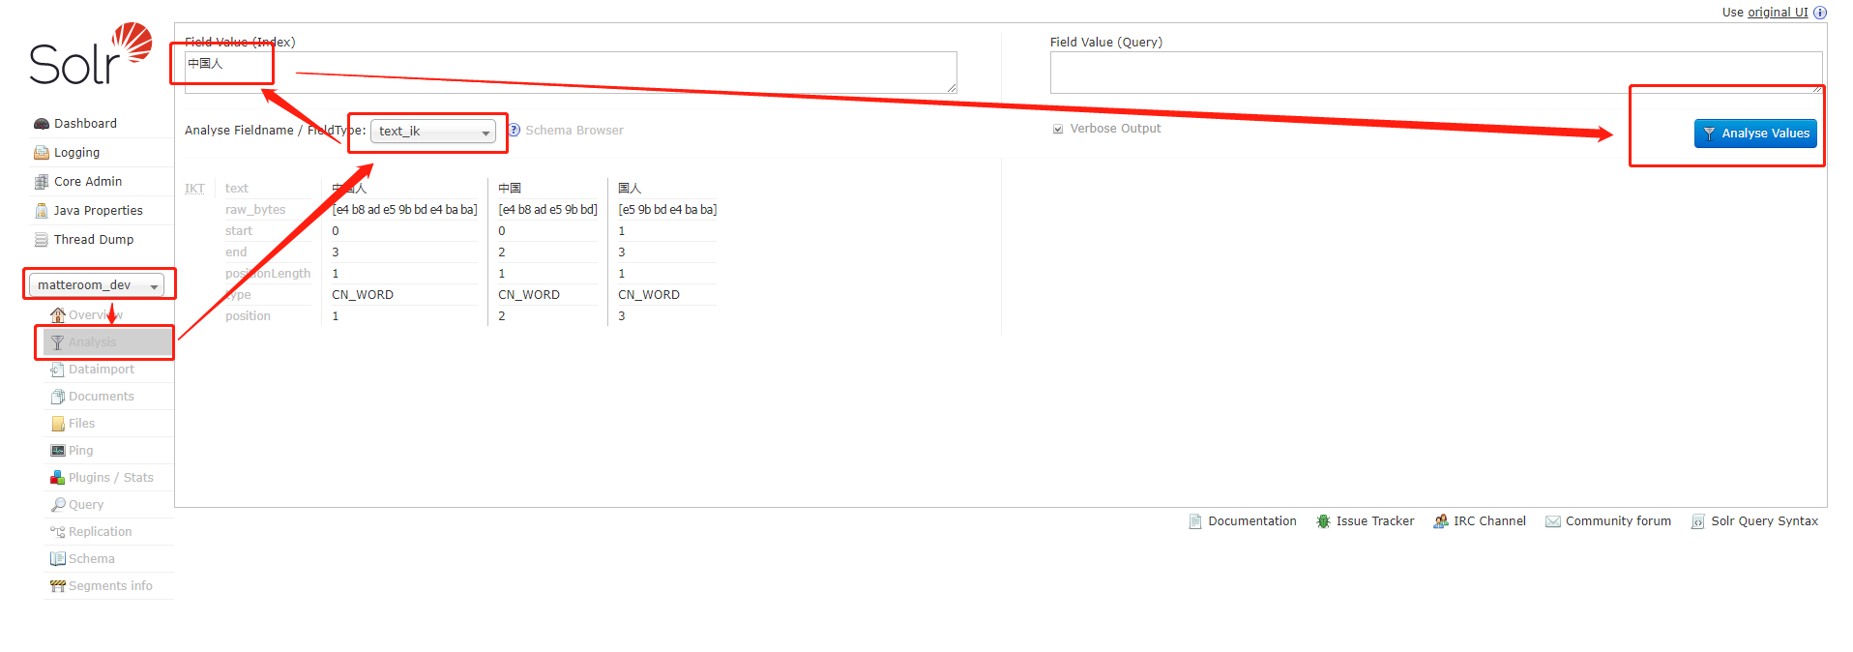

## Solr cloud mode

This mode is the same as the single-instance mode configuration idea. It is just to involve zookeeper to manage the solr cloud configuration file.

* 1. Upload the jar file to the specified directory, copy all the files in the solr-IK folder to the solr-6.4.2/dist/ directory
  2. Download solrconfig.xml of collection inzookeeper，such as the collection of “mycollection3”, may be e 9983，In windows you need replace zkcli.sh with zkcli.bat; Note that some zookeeper ports are not 2181，and configure IP address:port in your envirment.

*solr/server/scripts/cloud-scripts/zkcli.sh -zkhost 192.168.1.236:2181 -cmd getfile /configs/mycollection3/solrconfig.xml solrconfig.xml*

* 1. Modify solrconfig.xml，add reference in config tag：

<lib dir="${solr.install.dir:../../../..}/dist/" regex=".*\.jar" />

* 1. Download managed-schema from zookeeper

*solr/server/scripts/cloud-scripts/zkcli.sh -zkhost 192.168.1.236:2181 -cmd getfile /configs/mycollection3/managed-schema managed-schema*

* 1. Modify managed-schema，add the following configuration in schema:

<!-- *configure word breaker* start-->

<field name='text_ik' type='text_ik' indexed='true' stored='true' multiValued='fasle'/>

<fieldType name="text_ik" class="solr.TextField">

<analyzer class="org.wltea.analyzer.lucene.IKAnalyzer"/>

</fieldType>

<!-- *configure word breaker* end-->

* 1. Upload solrconfig.xml to zookeeper

solr/server/scripts/cloud-scripts/zkcli.sh -zkhost 192.168.1.236:2181 -cmd putfile /configs/mycollection3/solrconfig.xml solrconfig.xml

* 1. Upload managed-schema to zookeeper

solr/server/scripts/cloud-scripts/zkcli.sh -zkhost 192.168.1.236:2181 -cmd putfile /configs/mycollection3/managed-schema managed-schema

* 1. Reload configuration file,and find out your collection，Similar to single-instance mode，the following is singe-instance mode of reload



* 1. Test in GUI ,Similar to single-instance mode.

