Thinkfree Office

  - All-in-One Online Office Suite
Boost productivity with an online office suite that offers comprehensive features and general-purpose collaboration.
- HTML5 based Word, Spreadsheet, and Presentation Editor
- Real-time collaborative editing
- Support for the latest MS Office features and high compatibility
- Native-like high performance and clear rendering
- Compare and review documents with track changes
- Communicate with in-app chat and comment

  - Access the Applications You Need, Whenever You Need Them
Thinkfree Office enables an organization or service provider to empower users to create, modify, collaborate on, and share Office-compatible documents with teammates, customers, and the world at large. All the features expected of a professional-grade word processing, spreadsheet, or presentation graphics application are present in Thinkfree Office. The only thing missing is the need for anything other than a browser to access them.

  - Empowering You, Every Step of the Way
Explore a multitude of advantages and benefits that come with Thinkfree. Experience a world of possibilities, innovation, and growth.

Flexible deployment and integration​ | Stay compliant, stay secure​ | Cost effectiveness​ | High compatibility​
Thinkfree is designed to effortlessly deploy in various environments and seamlessly integrate across a wide variety of service platforms. | Thinkfree prioritizes data safety and compliance, while also enabling on-premises deployment for greater control over data and operations.​ | Our web application offers a cost-effective alternative solution without compromising quality.​ | Our editor allows your users to edit industry standard MS Office documents directly without the need for conversion or concern about losing formatting.

  - Real-time collaborative editing in your browser

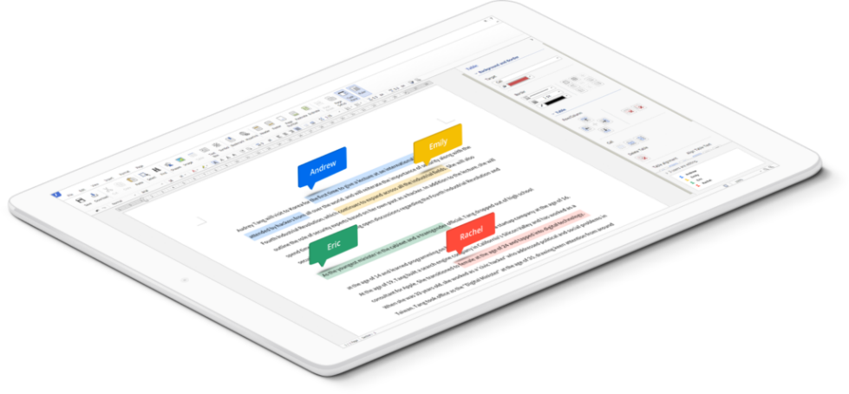


Our Mission

What is Thinkfree? Think of it as the software heart of innovation in every industry—from education to government to finance and beyond.

Companies around the world have been deploying Thinkfree solutions for office productivity, collaborative work, and more. They’re using branded Thinkfree solutions as well as white label solutions embedded into the fabric of everything from enterprise email systems to global scale web applications and secure storage systems.

At Thinkfree, we’re focused on the point where smart solutions meet user and organizational needs. It’s where convergence drives enhanced productivity and user satisfaction. And all indicators suggest that we’re doing it well, as we continue to grow quickly in Korea as well as in IT markets around the world.

So, thank you. Thank you for asking the questions that brought you here. Thank you for thinking about—and seeking—a world driven by smarter solutions. I hope you’ll join us in making that world one we can all share.

Thinkfree Team

