# **Bookmark App**

# Created on May 16 2018

# **Table of Contents**

1.0. Home Page

2.0. Edit Page

3.0. Add Bookmark Page

# **1.0. Home Page**

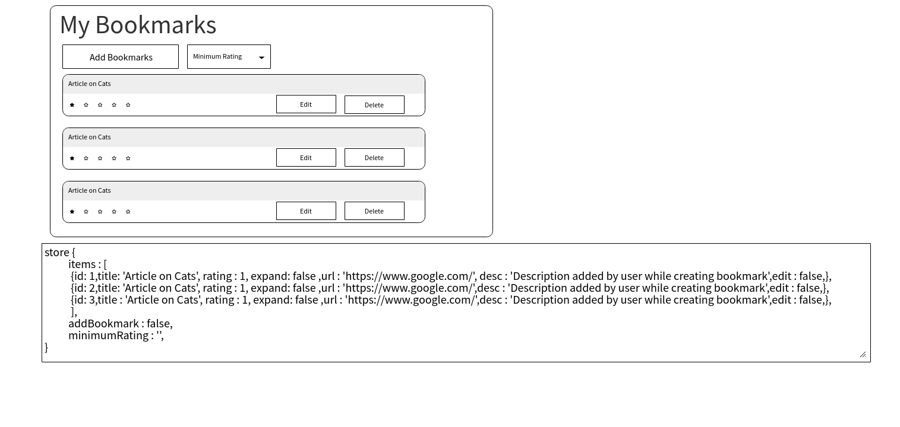

# **2.0. Edit Page**

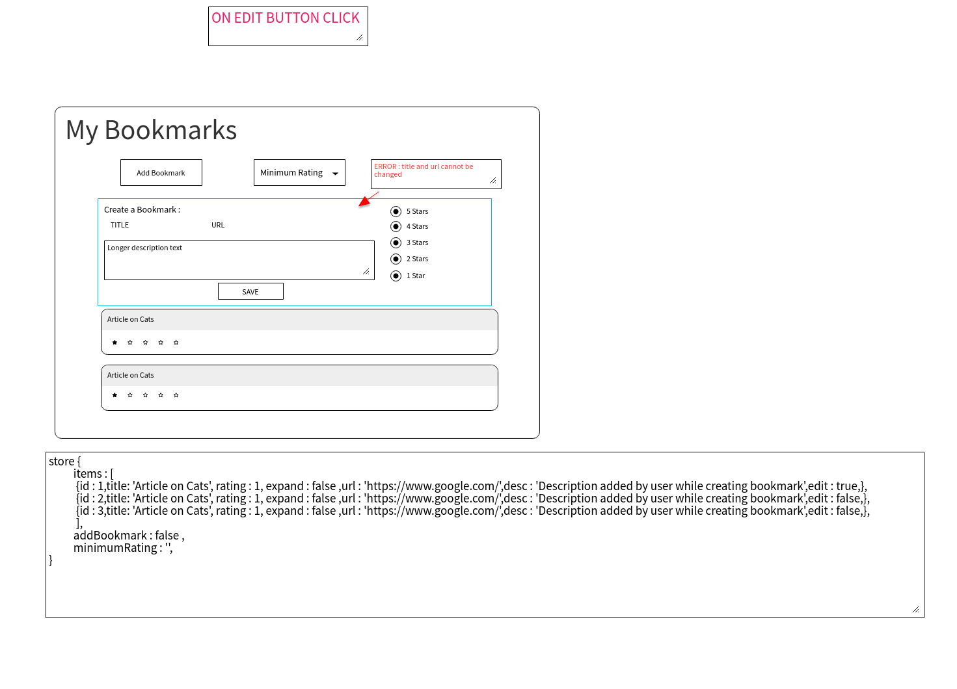

# **3.0. Add Bookmark Page**

