Overall Workflow of the Data Generation Agent
The purpose of the data generation agent is to identify certain weaknesses of the model and then build a high-quality supplementary training set.
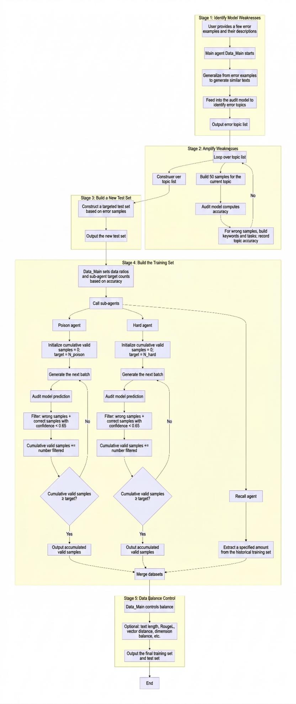

Implicit Data Generation Model

Approach
For example, content like “Wei Garden” or “baozi” can be highly covert policy-violating content. This happens because the model does not understand the relationship between the violating content and these covert data patterns. Therefore, to help the model understand the connection between the two, we proceed in the following steps:
- Analyze the format and structure of violating data and abstract its implicit meaning.
- Use agents to construct corresponding implicit data.
- (Most important) Construct compliant content that corresponds to the implicit violating content above (e.g., change “baozi” to “I love eating baozi”), while ensuring that, at the embedding/vector level, it remains close to the implicit data.
- Merge implicit data and hard (difficult) samples of compliant data into the same training set.

Red Team Testing Agent

Approach 1
The original intention of the red team testing agent is to have a model that performs generalized testing specifically against the current model. But how do we “activate” the red team testing agent so that it can produce diverse data across many scenarios?
A model cannot directly output all scenarios because it needs a trigger phrase. If we do not provide trigger phrases, the model’s outputs will always be homogeneous.
Therefore, we need to build trigger phrases by integrating with business contexts to generate the red team dataset. We proceed in the following steps:
- Use the China Top 500 company list as business background; for each business background, analyze the business scenarios that need to incorporate content safety.
- Use the business scenarios as trigger phrases to generate corresponding keywords and tasks.
- Simulate 10 possible emotional expressions and expression styles to construct corresponding compliant and non-compliant data.
- Output the test recall and FPR.

Approach 2
Based on the error examples I provide, perform various tests on the model to identify weak points. For instance, if the model flags “What activities might Hui people have?” as violating, the red team testing agent will generalize to “Dai people”, “Han people”, etc., and specifically check whether there are other similar errors—then point out the model’s shortcomings and provide analysis.
This workflow can even be done with Cursor: expose our model and use curl to form a skill.

Automated Training Agent

