Innovation Camp System

# Introduction

It is web based community platform where people share Innovation Ideas, involve more people from different Project Teams in brainstorming on Innovation Ideas, and build a team to cooperate on implementing Innovation Ideas.

# Target users

1. Innovation Idea initiator / owner
2. Innovation Idea participant: who don’t have new idea yet but would like to participate Innovation
3. General viewers and activity organizer: who want to check which is the popular ones and also publish the Innovation activities

# Deployment from scratch

1. Install wampserver2.5-Apache-2.4.9-Mysql-5.6.17-php5.5.12-64b.exe (e.g., path under D disk, the following example is supposed this path ), and start the WAMP server. <http://www.wampserver.com/en/#download-wrapper>

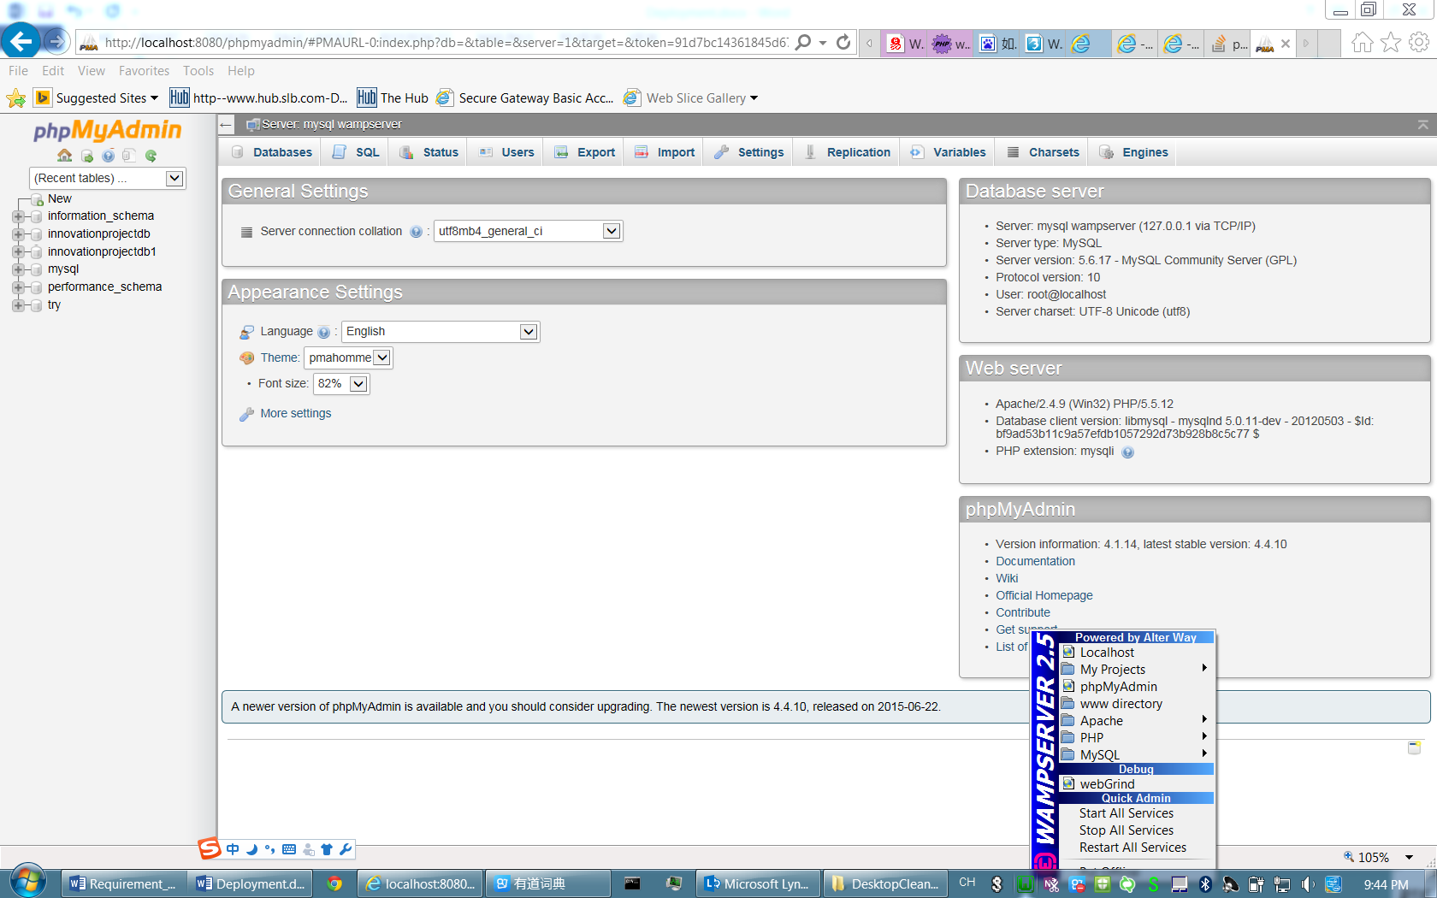

Note: Please make sure you have the latest version of all of these Microsoft C/C++ Redistributable runtime libraries. Or you may meet “Missing MSVCR100.DLL or MSVCR110.DLL SOLUTION”. Refer to <http://forum.wampserver.com/read.php?2,123608>

1. Setup database and import data to database
   1. Start phpMyAdmin, set up user name, password and authority for MySQL database

In Innovation Camp we use (***user name : root, password: 123***)

Add ‘password’ in D:\wamp\apps\phpmyadmin4.1.14\config.inc.php



* 1. Create database and Import data to database

-Create database name as ***“innovationprojectdb”***

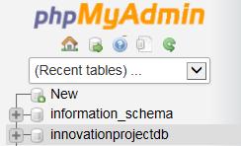

-Import backup database (e.g. “Backup_06232015.sql”) into DB “***innovationprojectdb***”

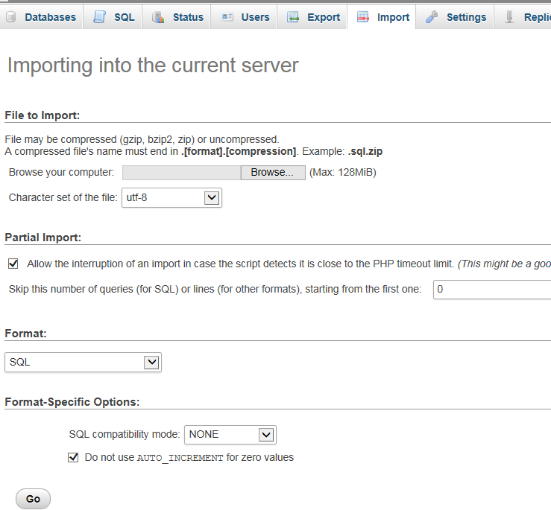

Select the database we backup

Then we can see 12 table generated under “***innovationprojectdb***” database

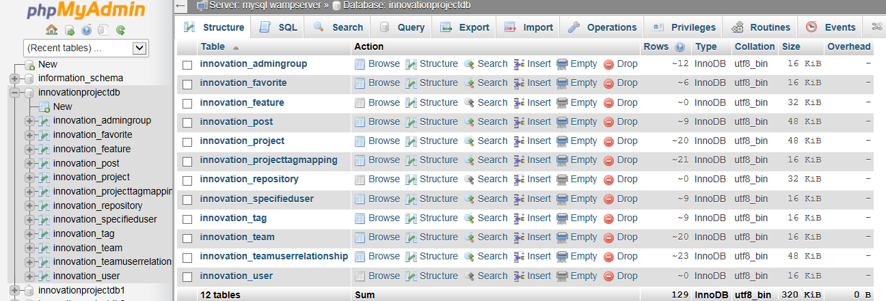

1. Configure the environment variable

Add the php path into the environment variable path: D:\wamp\bin\php\php5.5.12\;D:\wamp\bin\php\php5.5.12\ext\;

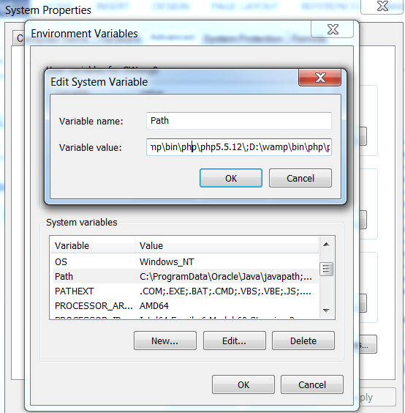

1. Configure the server files for run the website
   1. LDAP enabled

•Go to D:\wamp\bin\apache\apache2.4.9\modules and made sure that mod_ldap.so exists.

•Go to D:\wamp\bin\apache\apache2.4.9\conf\httpd.conf and made sure that this line is not commented out: LoadModule ldap_module modules/mod_ldap.so

•Go to D:\wamp\bin\php\php5.5.12\php.ini and made sure this line is not commented out: extension=php_ldap.dll

•Restart apache

* 1. Allow outside visit

Go to D:\wamp\bin\apache\apache2.4.9\conf\httpd.conf, and modify the following part

-

# onlineoffline tag - don't remove

Require all granted

-

<Directory "d:/wamp/bin/apache/apache2.4.9/cgi-bin">

AllowOverride all

Options None

Require all granted

</Directory>

* 1. Configure website visit path

-go to D:\wamp\bin\apache\apache2.4.9\conf\httpd.conf and made sure that this line is not commented out: LoadModule rewrite_module modules/mod_rewrite.so

And then change DocumentRoot to "d:/wamp/www/InnovationCamp/"

* 1. Configure Https for security issue

Step 1: generate the certificate and encrypt key files

Step 2: go to D:\wamp\bin\apache\apache2.4.9\conf\httpd.conf, and change the configuration file as below:

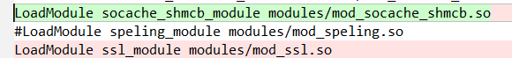



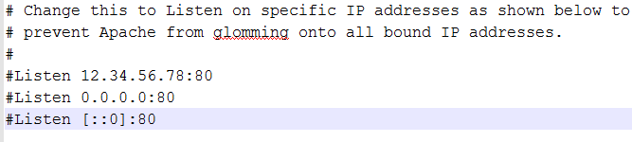

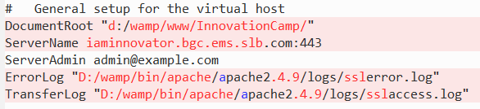

Step3: go to D:\wamp\bin\apache\apache2.4.9\conf\extra\ httpd-ssl.conf

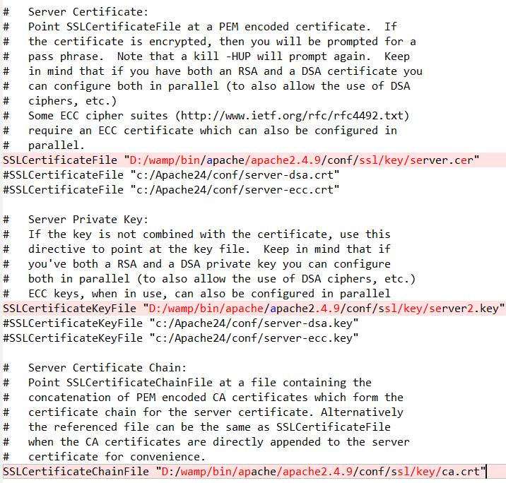

1. Add to automatic startup while server restart

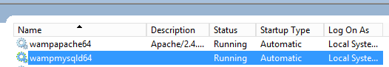

6. Hide ‘index.php’ in URL (added by CJin)

6.1 Allow override in httpd.conf, from none to all

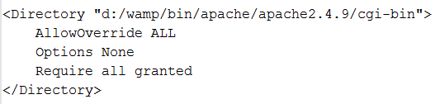

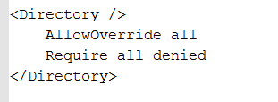

6.2 Uncomment **mod_rewrite.so** in httpd.conf

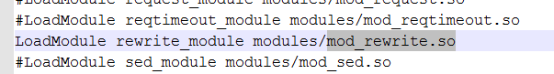

6.3 Change **URL_MODEL** from 1 to 2 in ThinkPHP/Conf/convention.php



6.4 Make sure there is a file named .htaccess(codes are shown as below) under the same root with index.php

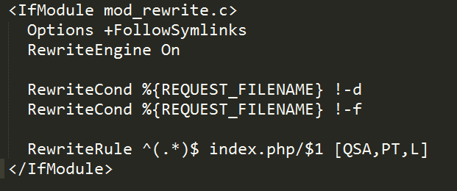

6.5 Restart Apache (very important!)

# Data backup

Add task script “backupInnovationDb.bat” to Task Scheduler for automatically backup to Server

# Architecture and Development

1. Architecture

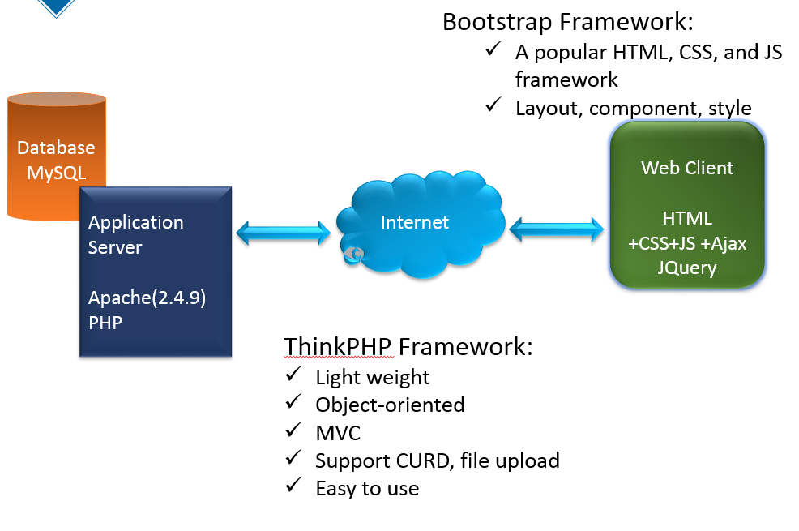

1. Development environment

* Zend Studio IDE to development
* Chrome and IE for debug front end.

1. Version control and code path

Using gitlab, all the code are upload to <https://git.bgc.ems.slb.com/gwang8/innovationcamp>

Please get the copy using:

git clone https://git.bgc.ems.slb.com/gwang8/innovationcamp.git

# Reference

* ThinkPHP API doc