Intro-Project

Team 2
Vince’s Intro about Project 2
Tony’s Intro about Project 9

Team

Name | Company | Role | Location
Hitesh Parekh | AWS | Engagement Manager | Virginia, US
Sanket | AWS | Lead for Use Cases (7-8 use cases)
Taojian | AWS | Sr Delivery Consultant
Sreedhar | AWS | Sr Engagement Manager | Bangalore, India
Alex | AWS | Delivery Consultant
Binayak | Intuit | Consulting | Bangalore, India
Vince | GE Vernova  (customer) | Leading AI transformation for GE Vernova (Justin’s team)
Tony Miles | AWS | Architect ( did initial hackathon for the customer) | US
Chris | AWS | Architect ( did initial hackathon for the customer) | UK

Vince (Customer) Initial Intro about Project
“GE’s power-plant assets require very precise outage planning—sometimes two years in advance—because taking equipment offline affects the entire electrical grid. Today, that planning depends on huge volumes of historical data, reports, and expert judgment, and important risk signals can be easy to miss.
This project focuses on improving that process by analyzing risk at the individual unit level—starting with gas turbines and generators. The initial MVP helps surface early warning signs, improve outage duration estimates, and support proactive maintenance decisions. Over time, this reduces unplanned downtime and also creates opportunities for value-added services.”
“We’re building a unit-level risk analysis capability to support outage planning for power-plant assets. These units have decades of operational history, and critical risk indicators often live in unstructured reports or scattered data sources.
The first phase focuses on a task-oriented ‘agent’ that helps analyze data, flag potential issues, and support planners with better recommendations. We’re deliberately starting with a narrow MVP—one unit at a time—so we can prove value before expanding to fleet-level intelligence.”
Scope of this project (important part):
- This is a big vision, but they’re not doing everything at once
- They’ll deliver it in phases / MVPs
- First MVP focus:
👉 Unit-level risk analysis, not fleet-level
A unit means a single asset in a power plant, typically:
- A gas turbine
- Or a “train” (gas turbine + generator, sometimes more)
They are starting with gas turbines and generators, not steam yet.
Agent:
A “persona” that performs a defined set of tasks
(like analyzing data, flagging risks, summarizing findings)
This project’s first “agent” is focused on unit risk analysis.

Key points from Vince
- People do outage planning differently
  - Different teams and individuals have different experience levels and methods.
  - Part of this project is about bringing consistency and level-setting across how this work is done.
- There is a massive amount of data
  - Some assets have been running for up to 40 years.
  - Not all historical data is equally useful, but there is still a lot that must be analyzed.
The size and condition of these datasets make the problem hard.
- Data science work is urgent
  - A data science team is just spinning up to handle this.
Evaluating, cleaning, and understanding the data is a high priority right now.
- Many stakeholders are involved
  - Outage planning decisions are high-impact and high-visibility.
  - Multiple teams and roles participate, making coordination complex.
- Goal #1: Don’t miss early warning signs
  - Important issues may appear as small notes in reports or a single sentence.
  - The goal is to catch these signals early, before they turn into outage problems.
- Better planning = better customer outcomes
  - If risks are caught early, outages can be planned properly.
  - Customers get accurate downtime estimates and assets come back online as promised.
- Goal #2: Proactive upsell opportunity
  - If the system sees a problem coming that’s outside normal service, GE can alert the customer early.
  - This allows customers to act proactively — and creates additional revenue for GE.
Important points from the transcription (in simple words)
1. Huge manual effort today
- The team spends a massive number of manual hours analyzing data.
- Subject matter experts (SMEs) do a lot of “crystal-ball” work today — trying to predict issues by hand.
- This is seen as the biggest efficiency and process transformation opportunity.

2. Who the customers are
- End customers are power producers around the world.
- Examples:
  - Regional utilities
  - Large power companies (like Duke, Southern Company, etc.)
- They own large gas turbines and generators used in power plants.

3. Two types of “customers” for this project
- Internal customers (primary users):
  - GE SMEs and field service engineers
  - They directly use the tools and see all the data
- External customers (end clients):
  - They do not use the tool directly
  - They see:
    - Outage reports
    - Recommendations explained by GE SMEs
    - Follow-up discussions, not raw data

4. Why customers can’t see everything
- Some data is sensitive at fleet level.
- If GE sees a pattern across many units:
  - They want time to plan parts, fixes, and response
  - This is similar to how auto manufacturers handle early defect signals
- Customers only see their own data + final recommendations.

5. Two business scenarios GE supports
- Contract customers (fixed service contracts):
  - Customer pays upfront or on a schedule
  - GE owns the risk during the contract
  - Goal: don’t miss issues → avoid failures, cost overruns, and safety risks
- Non-contract / ad-hoc customers:
  - Customer calls GE when something is wrong
  - GE analyzes history, past work, and current condition
  - Tool helps GE engage more intelligently and faster

6. Safety is a major driver
- These assets are extremely large and dangerous.
- Failures can cause:
  - Serious safety risks
  - Physical damage (metal shrapnel)
  - Financial loss
- Early detection helps reduce safety + financial risk.

7. Output of the system (very important)
There are two outputs:
- For internal users (SMEs)
  - Full access to analysis and insights
  - Used to make decisions and recommendations
- For customers
  - Static outage reports
  - Followed by live discussions with GE experts
  - Customers choose whether to act immediately or wait

8. UI / platform direction (early stage)
- Backend will use shared platform services.
- Frontend:
  - Will be better than existing Gas Power apps
  - Will follow corporate UI standards
  - Not necessarily a chat-style “agent UI”
- Architecture decisions (containers, agent runtime, Agent Core, etc.) are still being discussed.
- Those decisions will be finalized during upcoming technical architecture sessions.

9. SME knowledge capture
- SMEs already document processes in Confluence.
- Team also:
  - Conducted multiple SME interviews recently
  - Fed that knowledge back into requirements and decision logs
- For MVP:
  - There is a rough but usable understanding of the process
  - Not perfectly documented
  - SMEs still vary in how proactive they are
- One goal is to bring consistency so every customer gets the same quality of service.

Do I understand what a “process map” document is?
Yes — and your instinct to ask Vince about it is very good 👍
What a process map usually means (in this context):
A process map is a clear, step-by-step view of:
- Who does what
- In what order
- What inputs are used
- What decisions are made
- What outputs are produced
Typically includes:
- Actors (SME, system, customer)
- Decision points (“if X, then Y”)
- Hand-offs between people or systems

What Vince is saying (important nuance):
- They don’t have a fully formal process map
- But they have:
  - Confluence docs
  - SME interviews
  - A “pretty close” understanding for the MVP
- There are variations by SME, which they want to reduce
So today it’s more like:
“Process knowledge exists, but it’s spread across people and docs — not fully standardized yet.”

How you could ask Vince tomorrow (clean + smart)
You could ask something like:
“Do we have a documented process map for the current outage planning workflow — even a high-level one — or is that something we’re still inferring from SME interviews and Confluence docs?”
Or slightly more value-driven:
“As we move into the MVP, would it be helpful to formalize a lightweight process map so we’re clear on decision points, SME hand-offs, and where the agent fits in?”

Tony (AWS Architect) Intro about Project & the hackathon he did for customer

This project is about using data from gas turbines and generators to predict serious failures early and decide what service action should be taken, before things turn catastrophic.
Think of it as long-term predictive maintenance, but also tied directly to service decisions and contracts.

How it works today
- GE collects data about assets (gas turbines + generators).
- Most of the detailed data comes from Field Service Reports (FSRs).
- FSRs are created only when an outage happens.
- During an outage, technicians run multiple tests on the equipment.

What the team is trying to do
The goal is to:
- Analyze those FSRs
- Compare the test results against official procedure documents
- Optionally combine that with historical / time-based data
- Then answer a key question:
From a risk perspective, is this asset heading toward a serious failure?

Why this matters (the big risk angle)
Some failures — like DC leakage issues — can lead to catastrophic failure.
- A catastrophic failure can mean 2+ years of downtime
- If caught early, the same issue might be fixed with:
  - rewinding
  - targeted repairs
→ 6–7 months instead of years
So early detection can save years of downtime and massive cost.

What the output looks like
If the system detects high risk:
- It produces a clear recommendation (for example: replace a part, take the unit offline)
- It presents that recommendation in something like a PDF
- The recommendation includes evidence explaining why that action is needed

The contract angle (very important)
Each asset has a service contract, and that changes decisions:
- If GE is responsible for servicing the unit
→ GE may act more conservatively
→ They might proactively take the unit down and fix it to avoid big financial risk
- If the customer is responsible
→ GE provides the risk assessment
→ The customer decides whether to fix it now or “let it ride”
This isn’t about pushing service unfairly — it’s about who owns the risk and cost.

One-line summary you can reuse
Service Demand Generation is about analyzing outage and test data from gas turbines to identify high-risk failure scenarios early, and then recommending the right service action — based on both technical risk and contractual responsibility — to avoid catastrophic downtime.
—---------

What Tony & Chris built in the POC (simple version)
The core idea
GE has very valuable, proprietary engineering procedure documents created by SMEs over many years.
These documents define:
- What tests exist (e.g., DC leakage per phase)
- What values are acceptable, warning, or critical
- What failure patterns usually follow when something goes out of bounds
The POC showed that AI can automatically apply these rules to real service data instead of humans doing it manually.

What data went into the POC
They worked with three main inputs:
- Procedure documents (proprietary PDFs)
  - Define tests, curves, thresholds, acceptable vs critical ranges
  - Encodes SME knowledge
- Field Service Reports (FSRs / SSRs)
  - Unstructured outage reports
  - Tests and measurements spread across many pages
- Engineering Review (ER) cases
  - Additional unstructured engineering documents
  - Used as supporting evidence

What the POC actually did (step by step)
1. Upload procedure documents
- The system ingests all procedure PDFs
- It automatically:
  - Identifies what tests exist
  - Extracts validations and thresholds
  - Converts them into a math / logic model (machine-readable rules)

2. Upload FSRs and ER documents
- The system scans each document
- It:
  - Detects which tests appear
  - Maps tests to pages
  - Pulls out measurements
This is important because FSRs are not structured.

3. Match tests to procedures
For every test found in an FSR:
- Check if a corresponding procedure exists
- If yes:
  - Compare actual values vs SME-defined ranges
  - Decide:
    - In bounds
    - Out of bounds
    - Critical
Some tests (like DC leakage) are so critical that:
- If they fail, no further analysis is needed
- The unit should be shut down immediately
(This introduces an order of operations, not just flat rules.)

4. Generate a final report
The output is a clear, evidence-based report:
- This test appeared in the FSR
- Compared against this procedure document
- Result: pass / fail / critical
- Supporting evidence from documents
This replaces hours or days of manual SME review.

How the POC was built (important constraint)
Because the real documents were too proprietary:
- AWS ProServe built the POC using pseudo-data
- In collaboration, in the same room as SMEs
- Mimicking real thresholds and logic
Afterward:
- GE deployed it internally
- Ran it with real FSRs and real procedure documents
- SMEs validated the results
- Feedback was very positive
That’s why they’re confident it works.

What the hackathon covered (and didn’t)
In scope for the hackathon / POC:
- Assess known failure modes
- Compare field data vs procedures
- Provide recommendations based on history + rules
Out of scope (but desired next):
- Full service demand generation
- Customer profiling
- Contract (CSA) logic
- Supply chain and forecasting
- End-to-end automation

The bigger vision (where this is going)
They want to scale this into a huge system that:
- Works at component level
- Rolls up to equipment level
- Rolls up to system / plant level
- Produces a living risk profile for every asset
Instead of one-time analysis:
- New data automatically updates risk
- High-risk events trigger human review
- Results feed maintenance recommendations

Decision factors beyond engineering
Maintenance recommendations aren’t just technical. They depend on:
- Customer Service Agreement (CSA)
  - Who pays for the repair (GE vs customer)
  - This is often the biggest decision driver
- Customer profile
  - Risk appetite
  - History of saying yes or no
  - Market and operational constraints
- Timing & supply chain
  - Long lead-time repairs (e.g., rewinds)
  - Start early if customer is likely to approve

One-paragraph summary you can reuse
Tony and Chris built a POC that automatically compares unstructured field service reports against GE’s proprietary engineering procedure documents. The system extracts tests and thresholds from SME-authored procedures, maps them to real outage data, determines whether measurements are in or out of bounds, and generates an evidence-backed risk report. The hackathon proved this can scale across hundreds of assets and serve as the foundation for a much larger service demand generation system that rolls component-level risk into maintenance recommendations.

Questions

Step 6 — Questions we should definitely ask while reviewing Taojian’s high-level design

A) Process doc / heat map as “source of truth”
- What is the authoritative format today? (Excel? Confluence? PDF?)
- Who owns versioning + approvals? What’s the release cadence?
- Do rules vary by: frame, component, operation, region, duty cycle?

B) Evidence + citation model
- What counts as a “citation” in the UI? (page number? chunk id? source doc section?)
- Do we need “confidence” per condition? (e.g., extracted measurement vs inferred text)

C) Temporal reasoning (“mitigated by later outage?”)
- How do we represent mitigation/resolution?
  - If an ER from 2017 exists but an outage in 2018 fixed it, how is that recorded?
Jonathan-Unit Risk Agent

D) Plugin isolation & testing
- How do we ensure adding Module C doesn’t change Module A/B results?
  - version pinning, regression test sets, golden outputs

E) Human-in-the-loop data capture
- Where do user-provided answers go? Are they:
  - treated as evidence?
  - written back into a structured store?
  - reviewed/approved later?

F) Security & access
- What’s the permission model (internal SME vs outage engineer vs admin)?
- Are there any data residency constraints (regions, plants, customers)?

Jonathan-UnitRiskAgent

Jonathan - Unit Risk Agent Demo

What the demo is trying to achieve
Refer for slides (Service Demand Generation - PI Planning)
A “research assistant” for engineers that helps evaluate unit/component risk (starting with generator risks like stator rewind and rotor rewind), by:
- Pulling evidence from past documents/data (reports, cases, test results)
- Applying an engineering-controlled rule/pattern document (“process doc”)
- Producing:
  - a line-by-line risk matrix (conditions found/not found + severity + justification)
  - a narrative summary of what the agent found and why
- Keeping a human in the loop to fix gaps, correct mistakes, and improve the controlled docs over time
It is not automating downstream decisions yet (like final outage scope). It’s decision support.

Personas and how they work together
Two main users (plus admin view):
- Reliability engineer
  - Starts first.
  - Uses fleet-level reliability models (example mentioned: PRISM).
  - Combines unit age/lifecycle risk + evidence from documents (symptoms, test outcomes).
  - Produces an overall reliability risk view.
- Outage engineer
  - Uses reliability output as an input.
  - Focus is: “What risks should we plan for in the outage?”
  - Also looks for recommendations from the last outage report and validates/updates them.

End-to-end workflow (what the UI flow represents)

1) Pick the unit (one unit at a time)
- Search by site / serial number / outage ID
- UI concept: “dynamic search / elastic search”
- Units can show train-level context (e.g., generator + gas turbine), but user selects one component (generator in demo).

2) Choose the milestone: 18 months first
- 18-month review = first full assessment (“happy path” to design first)
- 12- and 6-month reviews = incremental updates:
  - don’t “reinvent the wheel”
  - focus on new info / edge cases / changed conditions

3) Data readiness check + optional document upload
Before running the agent, user needs to know:
- “Do we have enough data connected for this unit to do a real evaluation?”
If data is missing:
- allow ad-hoc document upload (ex: customer had an outage done by someone else, or “out-of-contract” work).
- Agent must treat uploaded docs as part of evidence.
This implies a requirement for:
- data availability scoring / visualization (“green/yellow/red” feel)

4) Agent runs, but asks humans to fill missing blanks
The agent sometimes won’t find a required data point (example: DC leakage test results).
So the workflow includes:
- “Human answers required questions” to complete analysis
- Jonathan suggested removing “Skip” to force explicit input (even “Unknown”)
Important: user responses may be unstructured (free text), not always deterministic.

5) Risk evaluation results shown in a structured table
For each risk type (ex: stator rewind risk):
- A list of conditions (Jonathan mentioned ~20+ conditions)
- For each condition, the agent shows:
  - whether it found evidence
  - risk level (light/medium/heavy)
  - justification (must explain why)

6) Engineer feedback is captured at the line-item level
UI requirement:
- thumbs up/down per row
- if thumbs down → require reason (false positive / false negative) + comments
The key is:
- feedback is collected to improve the system over time,
- but not necessarily to automatically re-run analysis immediately.

7) Modular “plug-in” risk patterns (very important requirement)
Design must support adding new independent risk modules later (example mentioned: excitation risk) without breaking existing ones.
In other words:
- “stator rewind risk” and “rotor rewind risk” are independent modules
- adding module C should not impact modules A/B
This is a strong architecture requirement: content/versioning + isolation.

8) Narrative summary + chat for exploration
Besides the table, the agent generates a narrative:
- what it found
- why it concluded risk levels
There’s also a chat feature so engineers can ask follow-ups.
Key constraint: chat answers must be evidence-based only (no open internet / no “model’s own knowledge”).
Jonathan explicitly said:
- responses should be grounded in uploaded/provided docs to avoid hallucinations
- even if models are getting “industry-smart,” keep it controlled (mention of Amazon Bedrock came up as a possible model platform, but the constraint stays the same).

“Process doc” (controlled engineering document) — what it means here
This is the backbone of the system.
A “process doc” is basically:
- an engineering-owned, controlled document that defines:
  - what conditions to check
  - how to interpret evidence
  - how to classify each condition (light/medium/heavy)
  - how to combine multiple conditions into an overall risk rating for that risk module
And the improvement loop is:
- agent runs → engineers give row-level feedback → engineering updates (“revs”) the process doc → next release uses updated doc
So the agent is not “inventing logic.” It’s applying engineering logic stored in controlled content.

Data realities + time-bounded evidence
They called out real constraints:
- Data isn’t perfect; lots is unstructured.
- Evidence should be time-bounded:
  - aspiration: go back up to 10 years
  - but current practice may be closer to 5
  - need logic like: “Found ER case from 2017 → was it mitigated by 2018 outage?”
This implies:
- you can’t just retrieve evidence; you need temporal reasoning and “mitigation/resolution” awareness.

Outputs, storage, traceability, and monitoring (implicit requirements)
From the Q&A near the end:
- Store the agent output as an artifact (even if later corrected).
- Support “override by engineer” (human final call).
- Capture logs/labels needed for:
  - observability
  - drift detection (agent suddenly getting worse)
  - distinguishing data issue vs model/system issue
- Reports like Field Service Reports are treated as “approved truth” (stronger authority than agent output).
Also mentioned:
- likely need export capability (so results can be shared).

What this means for solution design (requirements list you can reuse)

Must-have functional requirements
- Unit search (site/serial/outage ID), one unit at a time
- Milestone workflow (18mo baseline, 12/6 incremental)
- Data readiness indicator + doc upload
- Human-in-the-loop question capture (no silent skipping)
- Risk evaluation UI:
  - row-level conditions
  - evidence + justification
  - severity per condition
- Feedback capture per row (thumbs up/down + reason + comment)
- Narrative summary generation
- Evidence-grounded chat (no external knowledge)

Must-have platform/architecture requirements
- Modular risk “plugins” with isolation (add new risk modules without breaking old ones)
- Controlled engineering content (“process docs”) with versioning and release cycle
- Time-bounded retrieval + mitigation awareness across outages
- Audit trail:
  - agent outputs
  - human overrides
  - feedback + reasons
  - source citations/evidence references
- Observability/drift monitoring hooks
- Export/shareable output

Aaron- High Level

Aaron- High Level
For slides refer to slides - AWS Phase 2 - Tiered Agents for Services AI

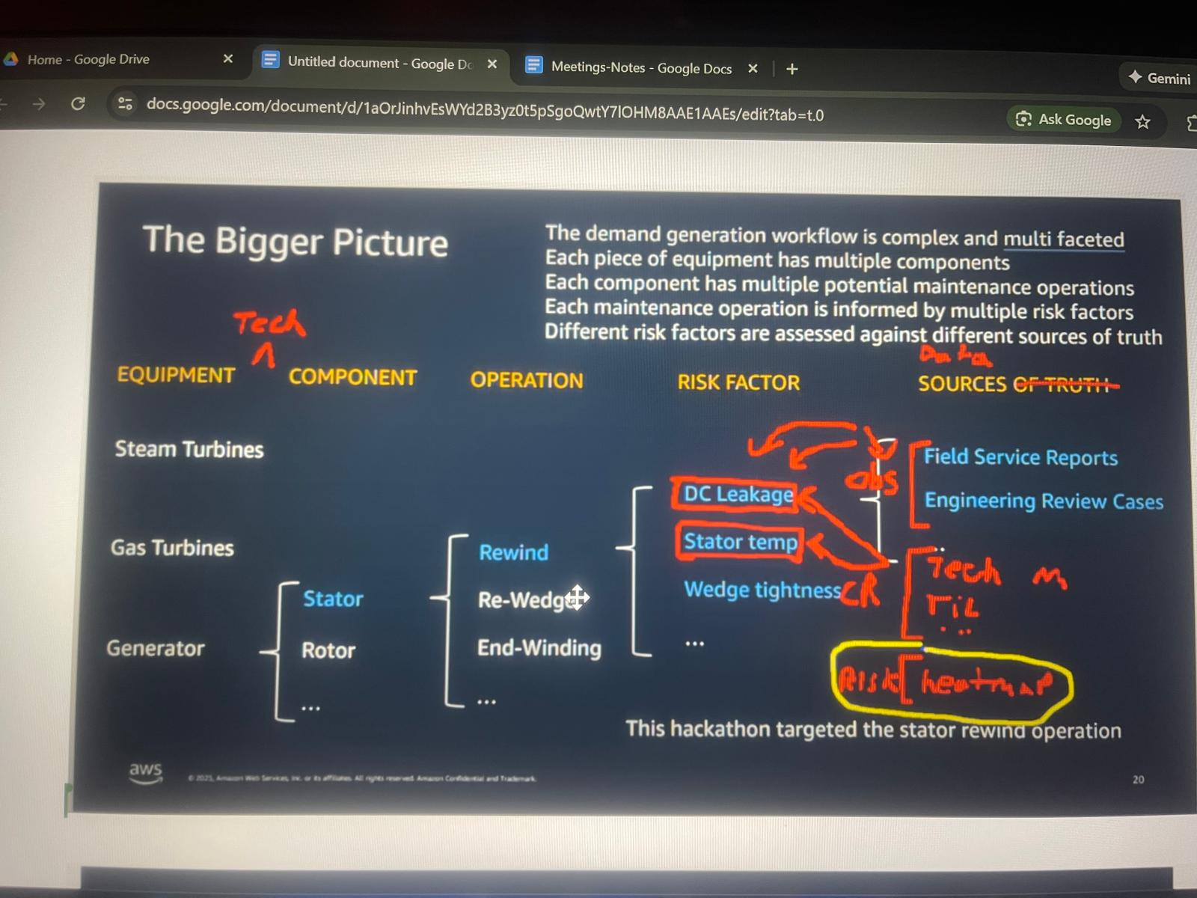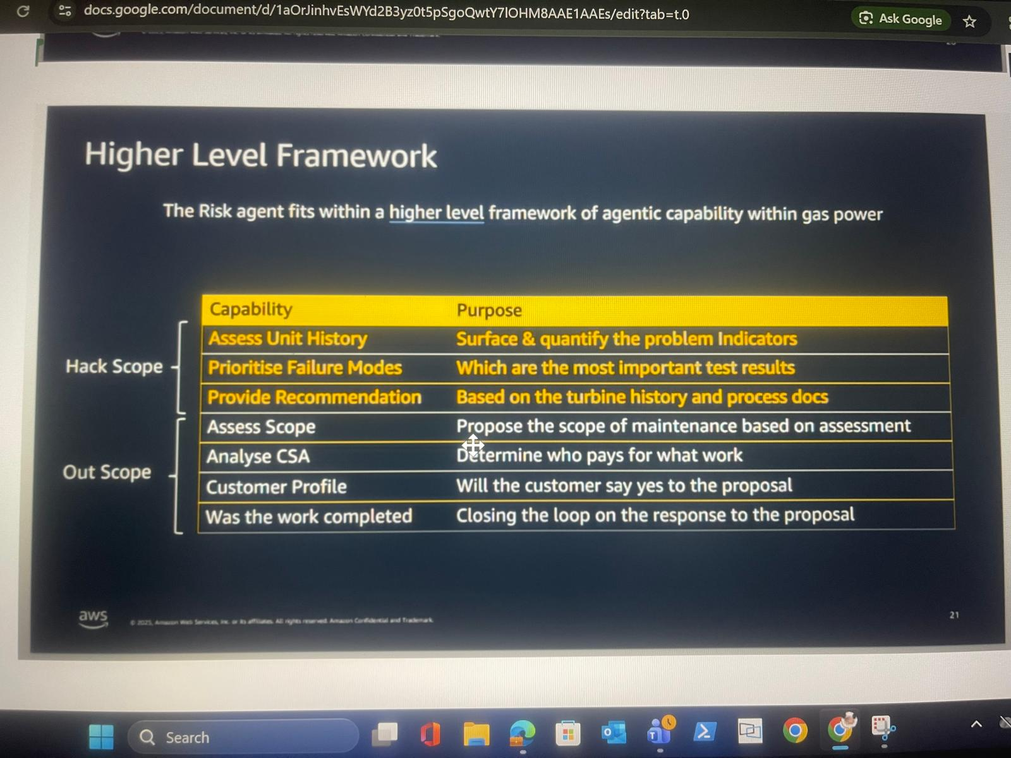

1. The “Big Picture” (How the problem is structured)
At the highest level, demand generation / outage planning is hierarchical and granular:
Equipment → Technology → Component → Operation → Risk Factor → Data

1.1 Equipment & Technology
- Main equipment types:
  - Steam Turbine
  - Gas Turbine
  - Generator
- Each equipment runs on a specific technology / frame
  - Example: 9HA, 7HA, 7FA, etc.
- Technology matters because:
  - Risk rules, thresholds, and procedures depend on the frame
  - The “same” risk (e.g., temperature) may be evaluated differently per tech
👉 This “Technology” layer was missing in the original slide, and Aaron explicitly called it out as important.

1.2 Components → Operations
- Each equipment has components
  - Example (Generator): Stator, Rotor
- Each component has maintenance operations
  - Example: Rewind, Re-wedge, End-winding
The hackathon / MVP is narrowly focused on:
Stator → Rewind operation

1.3 Risk Factors
- Each operation has multiple risk factors
  - Examples:
    - DC leakage
    - Stator temperature
    - Wedge tightness
- Risk factors are finite and known
  - ~20 risk factors total
  - Not open-ended or dynamic
This is key:
Prompt engineering and agent logic will largely live at the risk-factor level.

2. Data Types (Very Important distinction)
Aaron clearly split data into two categories:

2.1 Observations (What was seen in the field)
These are descriptive, noisy, situational.
Examples:
- Field Service Reports (FSRs)
- Engineering Review / Request cases (ERs)
  - L1 / L2 / L3 support cases
- Prior outage scope assessments (called out as a missing but important input)
Characteristics:
- Many documents
- Written by humans
- One observation can relate to multiple risk factors
- Used as evidence
👉 For a given serial number:
“Give me all observations that ever happened.”

2.2 Canonical Records (Engineering truth)
These are authoritative, factual, stable.
Examples:
- Technical manuals
- Engineering guidelines
- TILs
- Control / process documents
- Risk heat-map Excel files
Characteristics:
- Created by engineering
- Define what to do if X is observed
- Map cleanly and directly to specific risk factors
- Do NOT require fuzzy search — you know exactly which doc applies
Key insight Aaron emphasized:
Observations are broad and noisy →
Canonical records are precise and targeted.

3. How Risk Assessment Actually Works (Step-by-step)
This is the core logic of the Risk Agent.

Step 1: Anchor on Serial Number
- Everything starts with a unit serial number
- Pull:
  - All FSRs
  - All ERs
  - All related observations across systems

Step 2: Enumerate Risk Factors
- Based on:
  - Equipment
  - Component
  - Operation
- Example:
  - Generator → Stator → Rewind → DC Leakage

Step 3: Evaluate Each Risk Factor
For each risk factor:
- Look at observations
  - Test results
  - Field conclusions
  - Measurements (e.g., leak-down test)
- Look at canonical records
  - What do engineering manuals say?
  - What thresholds apply?
  - What repair is recommended for these readings?

Step 4: Risk Classification via Heat Map
This was a critical clarification:
- There is (or will be) a heat-map / control document (often Excel)
- It explicitly says:
  - If these conditions are present → risk = High / Medium / Low
- Without this:
  - You cannot aggregate
  - You cannot recommend
  - You risk blowing contracts
This document is:
- The real “source of truth” for risk severity
- Being built / owned by the business (John mentioned)

4. Why Accuracy Matters (Business risk)
Aaron was very explicit here:
- If the agent under- or over-scopes:
  - GE may absorb massive unplanned cost
- Example:
  - Planned: $100M outage
  - Actual: $120M
  - $20M loss due to bad scoping
👉 This is why:
“Provide Recommendation” must be very close to reality

5. Higher-Level Framework (What’s in scope vs out of scope)

5.1 In Scope (MVP / Hackathon)
These are the core agent responsibilities:
- Assess Unit History
  - What problems exist?
- Prioritize Failure Modes
  - Which risks matter most?
- Provide Recommendation
  - What repair should be done?
This is the Risk Agent.

5.2 Out of Scope (Future phases)
Still discussed, but not MVP:
- Assess scope of maintenance cost
- CSA analysis (who pays?)
- Customer profile (will customer accept?)
- Feedback loop (was work completed?)
Some of this already exists as separate systems/services and may be:
- Integrated via API
- Migrated later

6. Agent Design Philosophy
Important architectural guidance emerged:
- Agents should be granular and role-specific
  - Risk agent
  - Recommendation agent
  - Contract / CSA agent (future)
- Avoid:
  - One “mega agent”
  - Overlapping responsibilities
Lifecycle rule (very important):
An agent should:
- Execute its task
- Persist results to state
- Be destroyed
(Unless re-invoked by an event)
This is an engineering responsibility, not data science.

7. Data Scale & Ingestion Reality
- Units live 30+ years
- Data volume:
  - Thousands of ERs per unit
  - ~1 FSR per year
  - Each FSR = hundreds of pages
- Conclusion:
  - This will not fit in one LLM call
  - Requires:
    - Chunking
    - Retrieval
    - Iterative reasoning
Ingestion:
- Mostly batch, weekly cadence
- Orchestrated in Databricks
- App can upload some documents (minor path)

8. Databricks Integration (High level)
Two paths:
- Structured data
  - Queried via LLM-style query layer
  - With user persona + permissions
- Unstructured data
  - Vector store in Databricks
  - Accessed via APIs
Metadata catalog:
- Maps:
  - Site → Unit → Serial Number → Documents
- Sits between app and data layer
- Critical for semantic search (e.g., “Houston” → serial numbers)

9. Immediate Next Actions (from the call)
- Architecture team:
  - Start C4 diagrams
  - Focus on application + orchestration
- Databricks team:
  - Finalize ingestion + storage design
- Everyone:
  - Read the 3 core user stories
  - Align on scope before implementation

One-line summary you can reuse:
“The Risk Agent evaluates a unit at serial-number level by combining noisy field observations with precise engineering canonical records, applies business-defined risk heat maps to classify severity, and produces a highly accurate maintenance recommendation — because bad scoping directly translates to real financial loss.”

