Clientele – Design Document
Tristan MacCrehan - 2018-12-12

Description
Simple Client database for keeping freelance clients for future reference. Uses Json for keeping key-value data and files for project work and correspondence.

Json file schema
Client :
Contact:
Name:
Email:
Phone:
Directory:

Folder Schema
Project Root /
|- work/
|- design/
|- mail/
|- Client.json

QT interface design

Contact Pane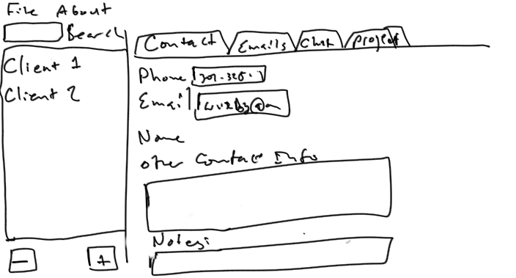

Project Pane
