<Your System Name>

Software Requirements Specification

For <System in scope>

Version <1.0>

Revision History

|  |  |  |  |
| --- | --- | --- | --- |
| **Date** | **Version** | **Description** | **Author** |
| <dd/mmm/yy> | <x.x> | <details> | <name> |
|  |  |  |  |
|  |  |  |  |
|  |  |  |  |

Table of Contents

1. Introduction 4

1.1 Scope 4

1.2 Definitions, Acronyms, and Abbreviations 4

1.3 Overview 4

2. Overall Description 4

2.1 Use-Case Model 4

2.2 Assumptions and Dependencies 4

3. Specific Requirements 4

3.1 Use-Case Specifications 4

3.2 Supplementary Requirements 4

4. Supporting Information 5

Software Requirements Specification

# Introduction

[Provides an overview of the entire document. It includes the purpose, scope, definitions, acronyms, abbreviations, references, and overview of the **SRS**.]

The purpose of this document is to describe in detail the requirements for the “Student Results View” (SRV) software.

It will explain the software functionalities and how the users will interact with it.

It will also include the constraints, the interface and the interaction of this software with other external applications.

To keep this document as clear as possible, it will provide a list of abbreviations and definitions.

This document is intended to be proposed as a reference for developing the first version of the system for the development team.

## Scope

[A brief description of the software application that the **SRS** applies to, the feature or other subsystem grouping, what Use-case model(s) it is associated with, and anything else that is affected or influenced by this document.]

The “Student Result View” (SRV) is a desktop application with database interactivity which helps students at TAFESA to monitor their progress in their courses. It gives an easily accessible overview at what’s to come on a student’s study path, what has been done and what is being done.

Students will also be allowed to request a parchment once their qualification is determined to be complete on the assumption that the database is accurate and current.

The SRV will be initially made available for “**WATHEVER**” course students with the possibility of future expansions to other qualifications.

The system considers the possibility that a student could be enrolled in different qualifications at the same time.

Lecturers can interact with the application by selecting a qualification and a student that belongs to that qualification, to access the student’s results. The lecturers can also request a parchment checklist and can apply their electronic signature on it to submit a parchment checklist to the admin staff.

The admin staff receives a list of students that have completed their qualification. The admin staff can review each student‘s checklist submitted by a lecturer and prompt the creation of a parchment.

The software needs to be able to interact with the database to retrieve students information.

## Definitions, Acronyms, and Abbreviations

[This subsection provides the definitions of all terms, acronyms, and abbreviations required to properly interpret the **Software Requirements Specification**. This information may be provided by reference to the project’s Glossary.]

*Table1 - Definitions*

|  |  |
| --- | --- |
| **Term** | **Definition** |
| SRS | Software Requirements Specification |
| SRV | Student Results View |
| User | Someone who interact with the application |
| Student | Someone who studies at TAFESA. |
| Lecturer | Someone who lectures at TAFESA and need easy access to a student’s records. |
| Admin | Administration staff for a certain qualification at TAFESA. |
| Stakeholder | Any person who interacts with the system who is not a developer. |
| Client | The project sponsor. |

## Overview

[This subsection describes what the rest of the **Software Requirements Specification** contains and explains how the document is organized.]

The remainder of this document includes three more chapters.

The second one will explore the system functionalities, how the system will interact with other systems and will define the different stakeholders and how they will interact with the system.

This chapter will also describe the system’s constraints and the assumptions about the product.

The third chapter will delve into the details concerning the requirements specifications and will give a description of the system interfaces.

The fourth chapter will cover references to other sources and any other graphic resource that can help in defining the software.

# Overall Description

[This section describes the general factors that affect the product and its requirements. This section does not state specific requirements. Instead, it provides a background for those requirements, which are defined in detail in Section 3, and makes them easier to understand. Include such items as product perspective, product functions, user characteristics, constraints, assumptions and dependencies, and requirements subsets.]

This section serves as an overview of the whole system. It explains the context for the system’s creation and operation and it gives a few examples of how the stakeholders can interact with the system.

The last part of this section deals with the constraints and the assumptions considered for the creation of the system.

http://www.cse.chalmers.se/~feldt/courses/reqeng/examples/srs_example_2010_group2.pdf

## Use-Case Model

[Use case diagram & the stakeholder needs]

*Image1 – Use Case Diagram*

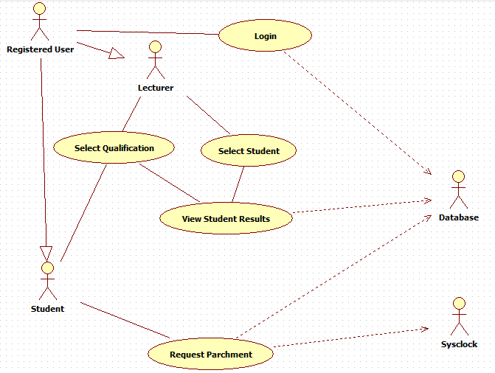

## Product Position

[This section contains how the product is fitted with the other systems.]

The current system adopted by TAFESA, called MyTafeSA, is inefficient when it comes to give to students a clear view of their situation and is too convoluted when it comes to managing the enrolment process, requiring appositely trained lecturers to go through the process, with the students more often than not left completely clueless about what’s going on.

The SRV is part of the larger TAFEBuddy system, whose purpose is to create a portal for students to easily access all the information they may need during their study path.

A student can quickly view his/her progress and can request a parchment.

A lecturer can select a qualification, can select a student, can view a student’s progress, can generate a parchment checklist.

An admin can view a list of students eligible to request a parchment and can prompt.

The admin staff can review the checklists submitted by the lecture.

The SRV needs to communicate with the database to retrieve all the relevant information about a student to then display them to the user. The application will be granted access to the database just to view and retrieve data. No data entry is allowed at this stage.

## Assumptions and Dependencies

[This section describes any key technical feasibility, subsystem or component availability, or other project related assumptions on which the viability of the software described by this **SRS** may be based.]

* The System rely on the database to perform its tasks.
* The database is reliable and secure.
* The dataset inserted in the database are accurate and always up to date.
* The SRV project will only focus on one qualification with room for further expansion.
* The users have access to an internet connection.

# Specific Requirements

[This section contains all software requirements to a level of detail sufficient to enable designers to design a system to satisfy those requirements and testers to test that the system satisfies those requirements. These requirements are captured in the use cases and the applicable supplementary specifications.]

## Use-Case Specifications

[The use cases mainly define the majority of the functional requirements of the system, along with some non-functional requirements**. For each use case** enclose in this section, make sure that each requirement is clearly labeled.]

## Supplementary Requirements

[Supplementary Specifications capture requirements that are not included in the use cases. The specific requirements from the Supplementary Specifications, which are applicable to this subsystem or feature, should be included here and refined to the necessary level of detail to describe this subsystem or feature. These may be captured directly in this document or referred to as separate Supplementary Specifications, which may be used as an enclosure at this point. Make sure that each requirement is clearly labeled.]

# Supporting Information

[May includes:

* Index
* Appendices
* e.g. may include use-case storyboards or user-interface prototypes. When appendices are included, the **SRS** should explicitly state whether or not the appendices are to be considered part of the requirements.]