Student Results View (SRV)

Software Requirements Specification

For TAFEBuddy

Version 0.0.1

Revision History

|  |  |  |  |
| --- | --- | --- | --- |
| **Date** | **Version** | **Description** | **Author** |
| Today | 0.0.01 | Initial draft, pending approval. | Team NAG |
|  |  |  |  |
|  |  |  |  |
|  |  |  |  |

Table of Contents

1. Introduction 4

1.1 Scope 4

1.2 Definitions, Acronyms, and Abbreviations 4

1.3 Overview 4

2. Overall Description 4

2.1 Use-Case Model 4

2.2 Assumptions and Dependencies 4

3. Specific Requirements 4

3.1 Use-Case Specifications 4

3.2 Supplementary Requirements 4

4. Supporting Information 5

Software Requirements Specification

# Introduction

[Provides an overview of the entire document. It includes the purpose, scope, definitions, acronyms, abbreviations, references, and overview of the **SRS**.]

The purpose of the Software Requirements Specification document is to describe in detail the requirements for the “Student Results View” (SRV) software. The document will explain the software functionalities and how the users will interact with it. It will also include the constraints, the interface and the interaction of this software with other external applications.

To keep this document as clear as possible, it will provide a list of abbreviations and definitions.

This document is intended to be proposed as a reference for developing the first version of the system for the development team.

## Scope

[A brief description of the software application that the **SRS** applies to, the feature or other subsystem grouping, what Use-case model(s) it is associated with, and anything else that is affected or influenced by this document.]

The “Student Result View” (SRV) is a multi-platform application with database interactivity that helps students at TAFESA to monitor their progress in their courses. It provides convenient access to the progress of a student’s study path, what has been done and what is being done. Students will also be allowed to request a parchment once their qualification is determined to be complete (on the assumption that the database is accurate and current).

For the purposes of this project, SRV will be initially made available for students studying a course within the ICT field (Certificates and Diplomas related to ICT and software development) with the possibility of future expansion to other qualifications when given approval. The system should consider the possibility that a student could be enrolled in different qualifications at the same time.

Lecturers can interact with the application by entering the details of a qualification and/or a student that belongs to that qualification, in which a lecturer should be able to access the student’s results. The lecturers can also request a parchment checklist and can apply their electronic signature on it to submit a parchment checklist to the admin staff.

The administration staff must have access to a list of students that have completed their qualification. The administration staff can review each students’ checklist submitted by a lecturer and prompt the creation of a parchment.

The system must be able to interact with a given database to retrieve students’ information.

## Definitions, Acronyms, and Abbreviations

[This subsection provides the definitions of all terms, acronyms, and abbreviations required to properly interpret the **Software Requirements Specification**. This information may be provided by reference to the project’s Glossary.]

*Table1 - Definitions*

|  |  |
| --- | --- |
| **Term** | **Definition** |
| SRS | Software Requirements Specification; a document that details the scope and criteria for the project’s solution. Will be used to refer to this document. |
| SRV | Student Results View, the name of the project this document will refer to. |
| TAFEBuddy | Refers to the overarching TAFEBuddy architecture. TAFEBuddy is a previously explored software suite by faculty at TAFESA that seeks to delegate minor administrative functions to the end user (i.e. the student or the lecturer). |
| TAFE | Acronym for Tertiary And Further Education. Term used to refer to government-owned tertiary educational institutes within Australia. TAFESA refers to the entity that exists solely within South Australia (Tertiary And Further Education South Australia) |
| User | A stakeholder who interacts with the software solution. |
| Student | A user who is enrolled as a student at TAFESA. |
| Lecturer | A user who is employed at TAFESA as an instructor for the institution. |
| Admin/Administrator | A user who is employed at TAFESA as faculty for administrative purposes. An actor whose purpose is to maintain the backend of the institution. |
| Stakeholder | Any person who interacts with the system that is not a developer. |
| Client | Refers to the project’s sponsor, liaison or otherwise. |
| ICT | Acronym for Information & Computation Technology. |

## Overview

[This subsection describes what the rest of the **Software Requirements Specification** contains and explains how the document is organized.]

The remainder of this document includes three more chapters:

* The second chapter will explore mission critical functionality, how the software solution will interact with pre-existing systems and will define the different stakeholders as well as how they will interact with the system. This chapter will also describe the assumptions and dependencies needed to be made for the project to succeed.
* The third chapter will delve into the details concerning the requirements specifications and will give a description of the system interfaces.
* The fourth chapter will cover references to additional sources and any other graphic resource that may help in defining the software.

# Overall Description

[This section describes the general factors that affect the product and its requirements. This section does not state specific requirements. Instead, it provides a background for those requirements, which are defined in detail in Section 3, and makes them easier to understand. Include such items as product perspective, product functions, user characteristics, constraints, assumptions and dependencies, and requirements subsets.]

This section serves as an overview of the whole system. It explains the context for the system’s creation and operation, and it gives a few examples of how the stakeholders can possibly interact with the system.

The last part of this section deals with the constraints and the assumptions considered for the creation of the system.

http://www.cse.chalmers.se/~feldt/courses/reqeng/examples/srs_example_2010_group2.pdf

## Use-Case Model

[Use case diagram & the stakeholder needs]

*Image1 – Use Case Diagram*

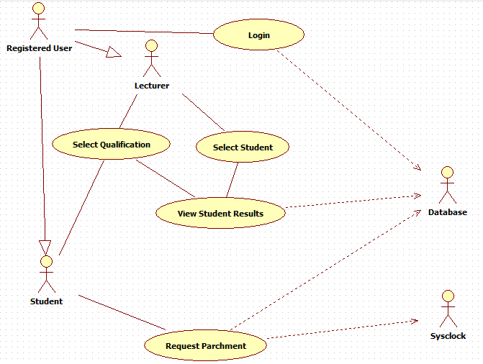

## Product Position

[This section contains how the product is fitted with the other systems.]

The current system in use by TAFESA, called MyTafeSA, is insufficient when it comes to giving students a concise summary of their academic situation and is too convoluted when it comes to managing the enrolment process. The current process in place for dealing with student enrolments has been identified as highly inefficient, requiring appositely trained lecturers to go through the process and often a heavy burden on the student to fully comprehend.

The SRV project is to be part of the larger TAFEBuddy System, whose purpose is to create a portal for students to easily access all the information they may need during their study path.

* A student can quickly view his/her progress and can request a parchment.
* A lecturer can select a qualification, can select a student, can view a student’s progress, can generate a parchment checklist.
* An admin can view a list of students eligible to request a parchment and can prompt.
* The administration staff can review the checklists submitted by the lecture.

The SRV needs to communicate with the database to retrieve all the relevant information about a student to then display them to the user. The application will be granted access to the database just to view and retrieve data. No data entry is allowed at this stage but can be considered in the scope of an administrator type user.

## Assumptions and Dependencies

[This section describes any key technical feasibility, subsystem or component availability, or other project related assumptions on which the viability of the software described by this **SRS** may be based.]

* The System relies on the database to perform its tasks.
* The database is reliable and secure.
* The data entered in the database is accurate and will always be up to date.
* The SRV project will only focus on one type of qualification with room for further expansion.
* The users will have access to an internet connection.

# Specific Requirements

[This section contains all software requirements to a level of detail sufficient to enable designers to design a system to satisfy those requirements and testers to test that the system satisfies those requirements. These requirements are captured in the use cases and the applicable supplementary specifications.]

This section provides a detailed description of the features and functionalities of the system.

## Use-Case Specifications

[The use cases mainly define the majority of the functional requirements of the system, along with some non-functional requirements**. For each use case** enclose in this section, make sure that each requirement is clearly labeled.]

ACTOR – Student

Use Case: **Login**

* Description: A student login to access the result view.

Use Case: **Select Qualification**

* Description: After logging-in a student is presented with the view of the results of the most recent qualification. If more than one enrolment exists, a drop-down list will be populated with all the qualifications. The student can select one of the qualifications to see the related results.

If there are no other qualification the drop-down list will be empty.

Use Case: **Apply for parchment**

* Scenario: A student that has successfully completed all the subjects of a qualification can apply to receive a parchment.

ACTOR – Lecturer

Use Case: **Select Course**

* Description: A Lecturer can select from a drop-down list populated with the courses he is registered as a lecturer.

Use Case: **Select Student**

* Description: After selecting a course, a different drop-down list will be populated with the students enrolled in that course. The lecturer can select one of the students to access that student’s results view.

Use Case: **View Students Eligible for Parchment**

* Description: A lecturer can request a report that list all the students that completed a qualification and are still enrolled.

Use Case: **Require Parchment Checklist**

* Description: A Lecturer can request the system to generate a parchment checklist for each student.

ACTOR – Admin

Use Case: **Manage Student**

* Description: The Admin can add, remove or edit a student and can access a student’s result view.

Use Case: **Manage Lecturer**

* Description: The Admin can add, remove or edit a Lecturer.

Use Case: **Manage Admin**

* Description: The Admin can add, remove or edit another admin.

## Supplementary Requirements

[Supplementary Specifications capture requirements that are not included in the use cases. The specific requirements from the Supplementary Specifications, which are applicable to this subsystem or feature, should be included here and refined to the necessary level of detail to describe this subsystem or feature. These may be captured directly in this document or referred to as separate Supplementary Specifications, which may be used as an enclosure at this point. Make sure that each requirement is clearly labeled.]

* The SRV is going to be responsive. It can be visualized on any kind of devices.
* The color palette comes from TAFESA graphic norm manual.
* The database will be in a web server.

# Supporting Information

[May includes:

* Index
* Appendices
* e.g. may include use-case storyboards or user-interface prototypes. When appendices are included, the **SRS** should explicitly state whether or not the appendices are to be considered part of the requirements.]